Create ALB Security Group for Application Load Balancer

Create SSH Security Group

Create Webserver Security Group

Create Database Security Group

Create EFS Security Group

给EFS Security Group 添加inboud rules

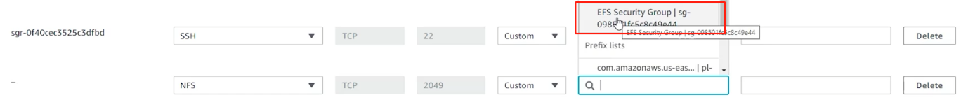

全部创建完毕

