Study Planner
Mobile guide: Android and iPhone
Plan · Focus · Grow
75 features, with Android and iPhone screenshots side by side
November 2026

Contents
Contents 2
About Study Planner 3
How it works: flow diagrams 5
0. Getting around on a phone 9
1. Getting started and accounts 12
2. The dashboard and tasks 16
3. Calendar, exams and timetable 24
4. Focus, flashcards and progress 33
5. Reminders 46
6. Study groups and classrooms 48
7. Cloud, sync and safety 55
8. Personalise and accessibility 61
9. Quality behind the scenes 66

About Study Planner
Study Planner is an app that helps students organise their studies in one place: tasks and homework, exams, the class timetable, breaks, focused study sessions and progress. It works on the web, on Android phones and on iPhones, with the same account everywhere.
It is built for school and college students. It plans each day for them, reminds them at the right time, shows how their studies are going, and lets classmates share timetables and assignments.
About the screenshots: they show the app at the screen size of an Android phone (Pixel 7) and an iPhone (iPhone 15). The app is the same on both; only the phone’s own frame (status bar, notch) differs.
The main ideas
- Everything in one place: tasks, exams, classes, breaks, focus time, grades and attendance.
- It plans for you: a smart daily plan, exam prep plans and a weekly review.
- Works anywhere: phone or computer, online or offline, kept in step through the cloud.
- Better together: live study groups with a shared board of notes and tasks.
- For everyone: four languages, light and dark mode, and accessible to people using screen readers or keyboards.
At a glance
Features marked (new) are the most recent additions.
Area | Features
Getting around on a phone | The tab bar and the + button, The menu, Swipe a task, Notifications on the phone, Outside the app
Getting started and accounts | Welcome slides, Create an account and sign in, Profile, Bring data from the older version
The dashboard and tasks | Dashboard, Smart plan for today, Adding and editing tasks, Quick add and voice, Steps, links and photos, Select several tasks at once, Search, “Coming up” grouped by day, Archive of finished tasks
Calendar, exams and timetable | Month and week views, Exams, Exam prep plans, Link a task to an exam, Weekly timetable and classes, Homework from a class, Attendance, Vacations and breaks, Activities, Import and export a calendar
Focus, flashcards and progress | Focus timer, Subjects, Flashcards, Progress, Weekly review, Progress report for parents and teachers, Achievements and streak protection, AI study helper: what to study now, AI study helper: flashcards, quizzes and prep topics, Grades and GPA, “What do I need?” calculator
Reminders | In-app alerts, Phone notifications, Smart reminders, Home-screen widgets, Shortcuts on the app icon
Study groups and classrooms | Live study groups, Joining a group, Group board: notes, Group board: shared tasks, Replies on the board, Study together, Classrooms for teachers, Joining a classroom
Cloud, sync and safety | Sync across devices, Works offline, with a “not synced” dot, Start offline on a new device, Photos in the cloud, Study Planner Premium, Ads on the Free plan, Privacy & data, Signing out keeps devices private, Backups, Error reports and limits, App updates
Personalise and accessibility | Settings, Light and dark mode, Four languages, Phone, tablet and computer, Text size and an easier-to-read font, Install the web app, Accessible to everyone, Fast with lots of data
Quality behind the scenes | Automatic tests, Checks on every change (CI), Accessibility and performance checks, Demo accounts

How it works: flow diagrams
Four diagrams show how the pieces fit together.
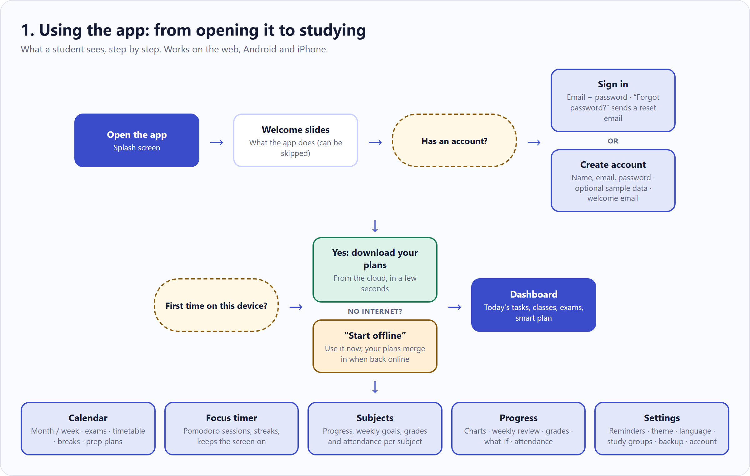
Figure 1: Using the app: from opening it to studying

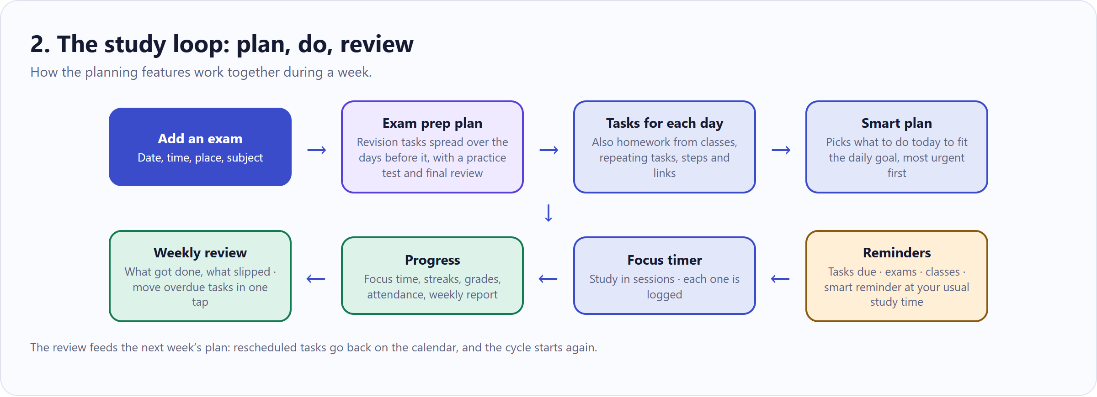
Figure 2: The study loop: plan, do, review

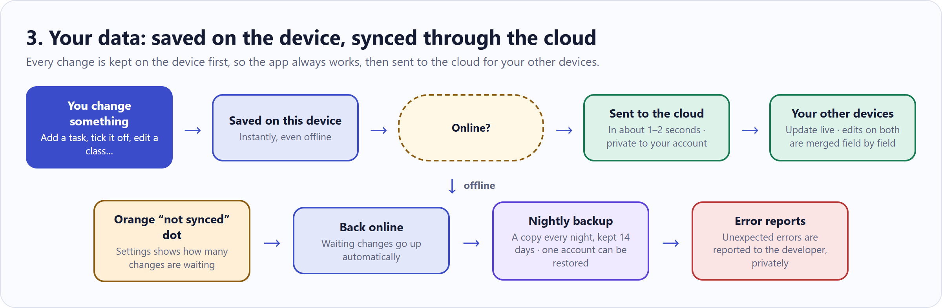
Figure 3: How data is saved and synced

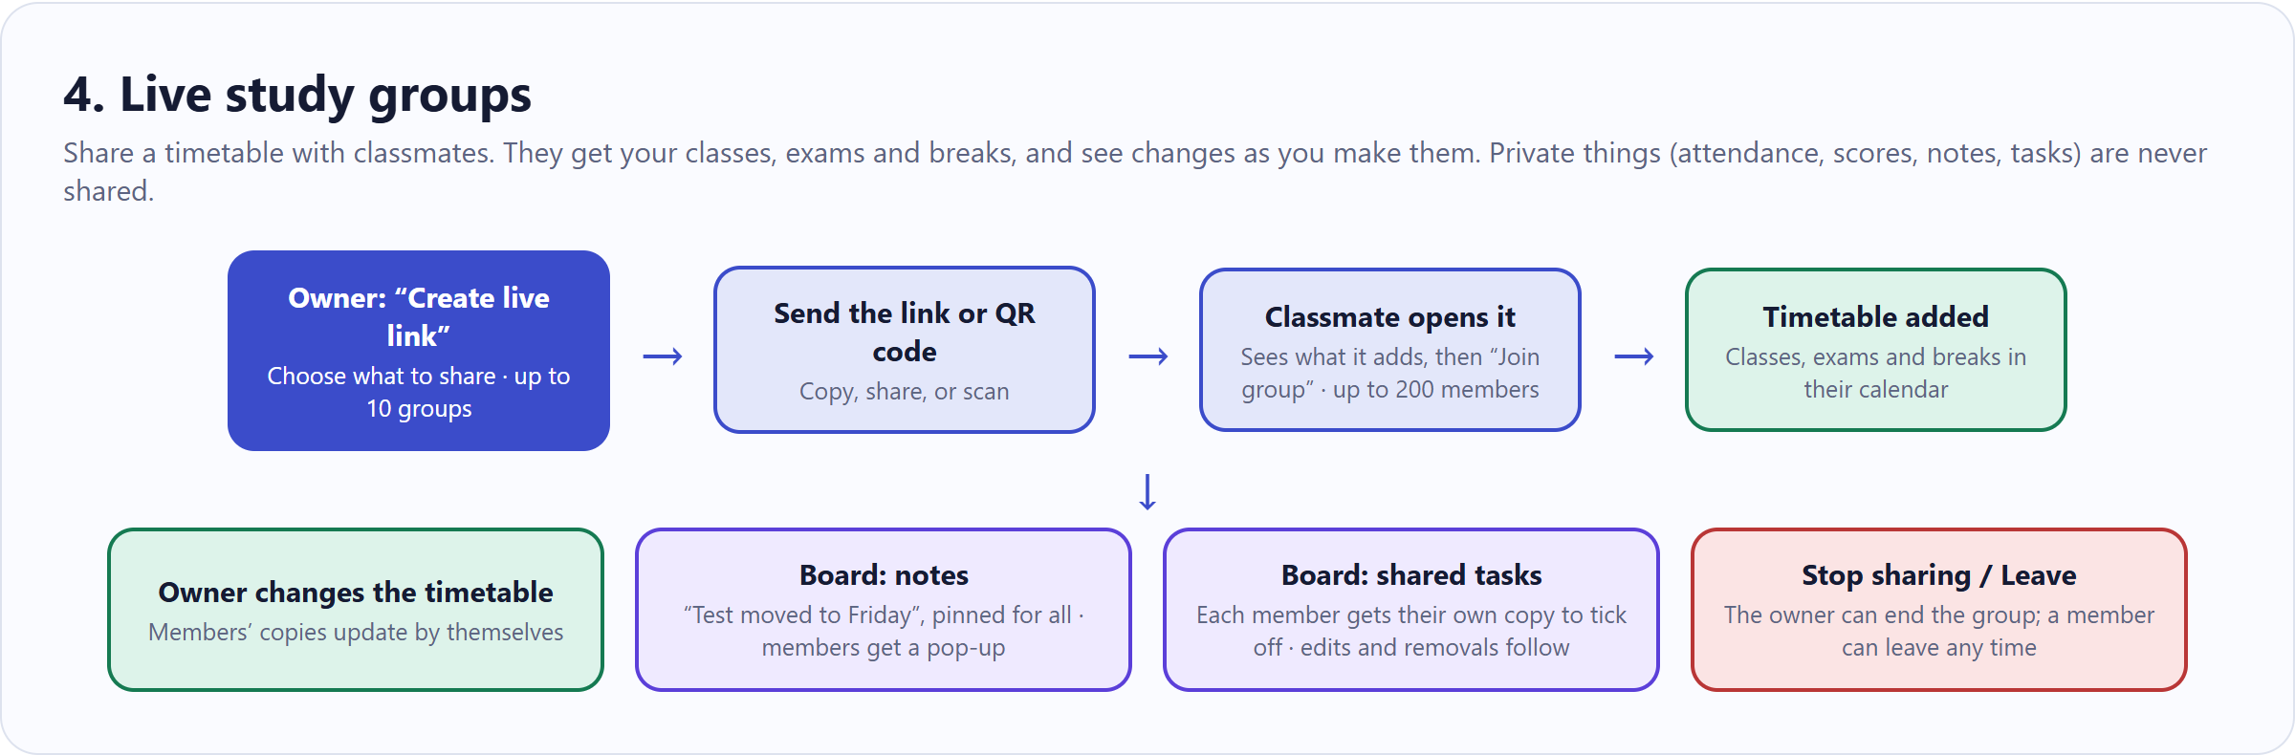
Figure 4: How live study groups work

0. Getting around on a phone
On Android and iPhone the app works the same way. Five things to know first.

The tab bar and the + button
What it does
The bar at the bottom has Home (the dashboard), Calendar, Focus and Progress, with a big + in the middle to add a task from anywhere.
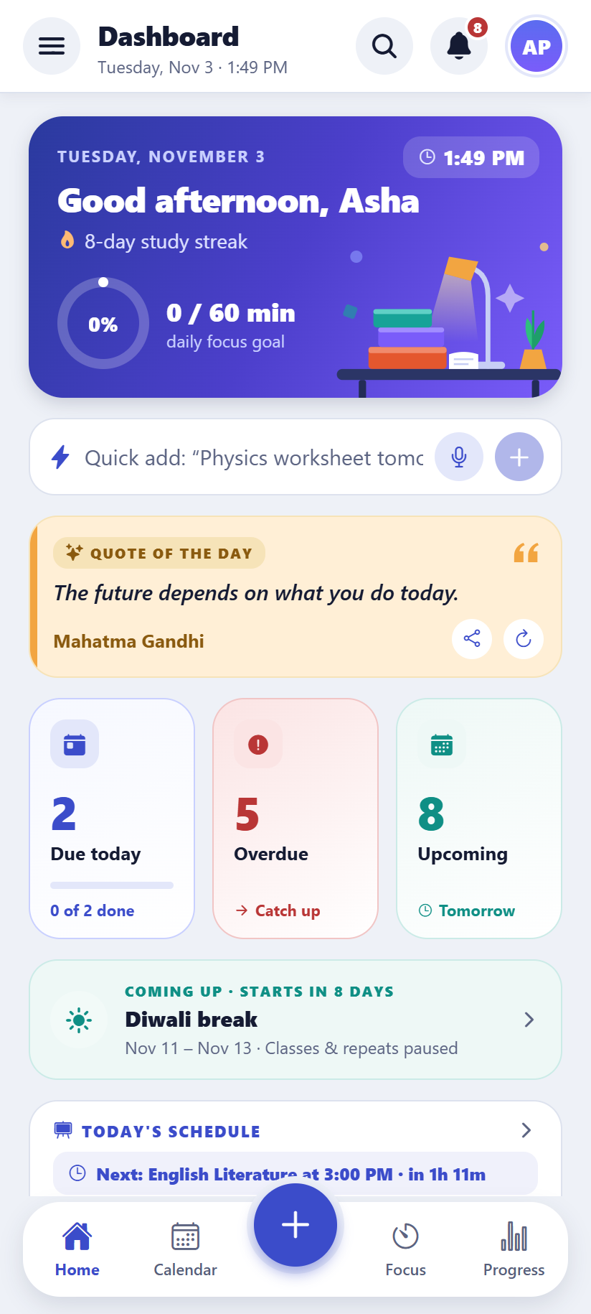  Android | 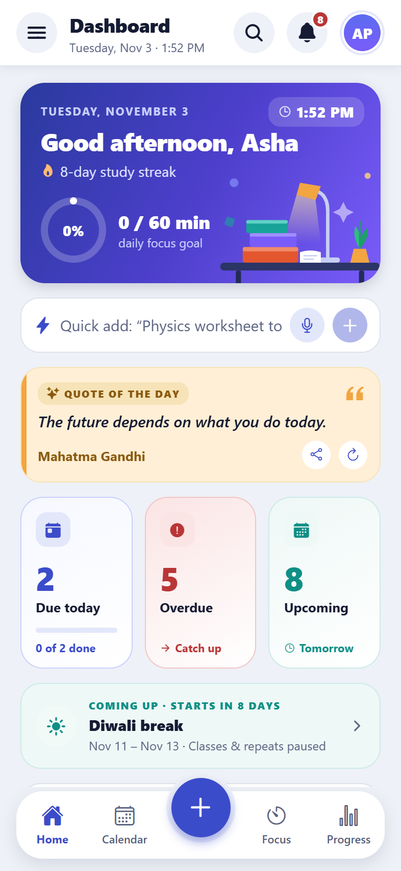  iPhone
Home, with the tab bar at the bottom

The menu
What it does
Subjects, Settings and the profile are in the menu: tap ☰ at the top left of Home. It also shows the subjects and today’s goal.
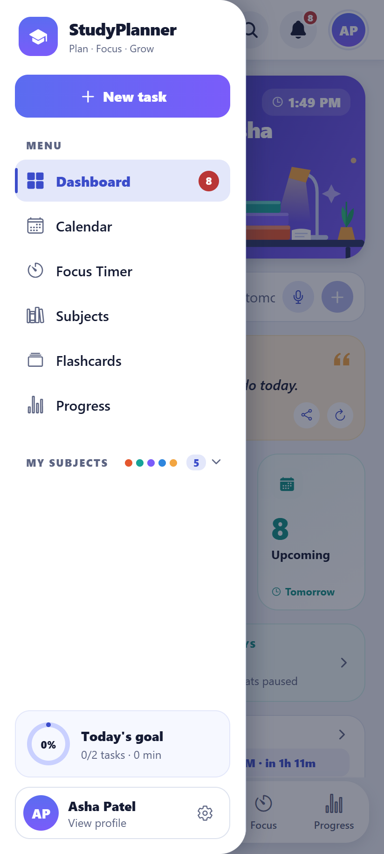  Android | 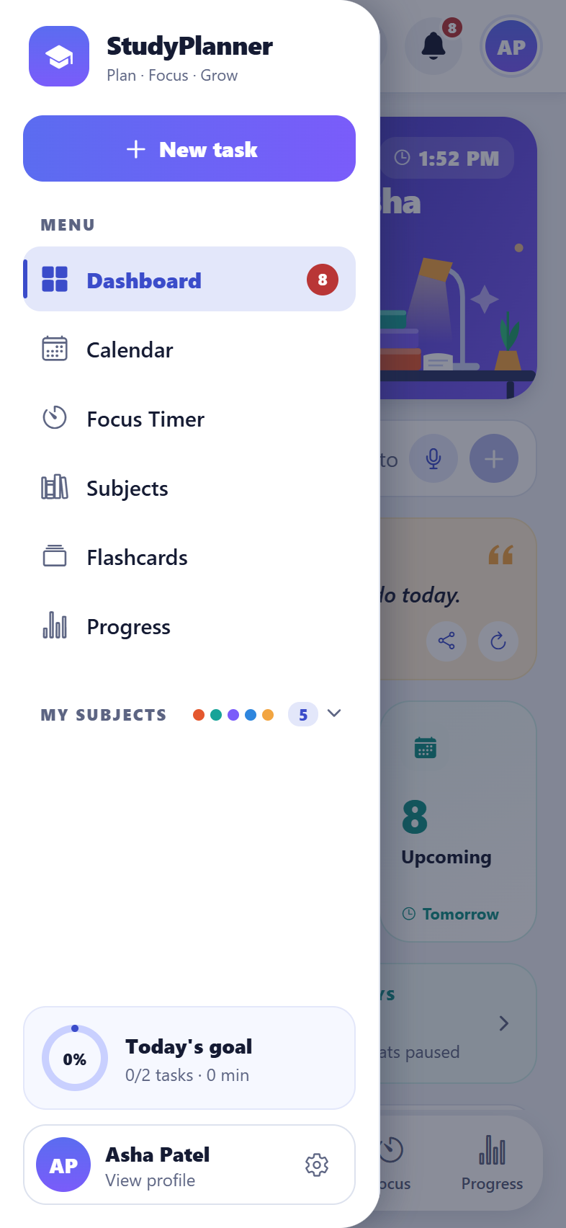  iPhone
The menu

Swipe a task
What it does
Swipe a task to the right to mark it done, or to the left to delete it (an Undo appears). A long press deletes it too.

Notifications on the phone
What it does
Tasks on their due day (with Done and Snooze buttons right in the notification), exams the evening before and on the morning, classes 10 minutes before, a smart reminder at the usual study time, and the weekly report. Turn them on in Settings → Notifications.

Outside the app
What it does
A home-screen widget shows the next class (Android and iPhone). On an iPhone, a running focus session shows on the lock screen and in the Dynamic Island. The screen can stay on while focusing, and the phone can vibrate when a session ends.

1. Getting started and accounts
Everything a student needs to start: a short welcome, an account of their own, and a profile.

Welcome slides
What it does
The first time the app opens, three short slides explain what it does: plan your day, focus, and see your progress. They can be skipped.
How to use it
- Open the app and swipe or tap Next.
- Tap Skip to go straight to signing in.
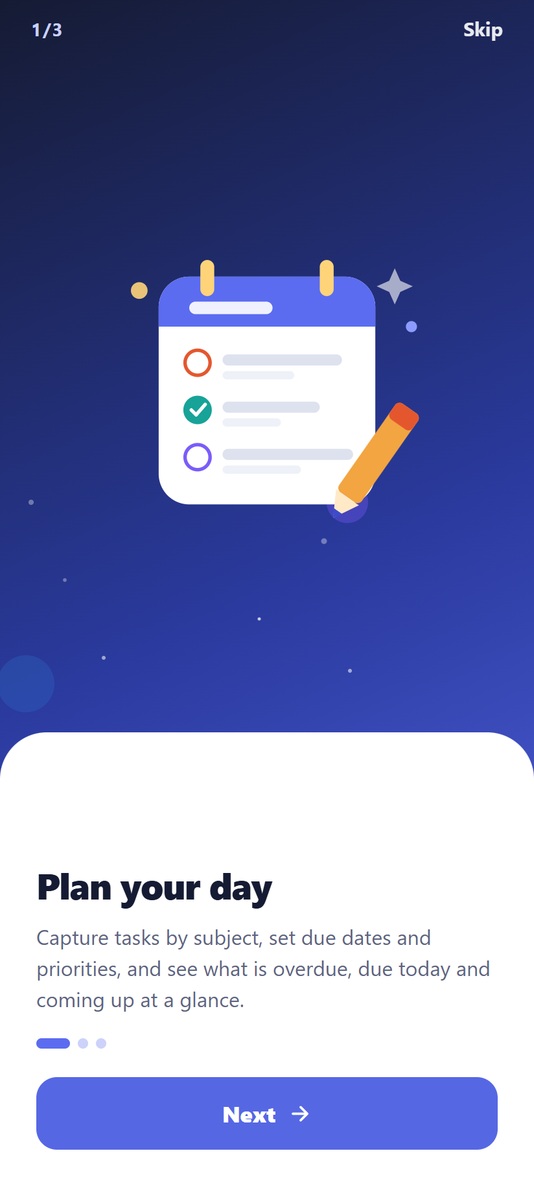  Android | 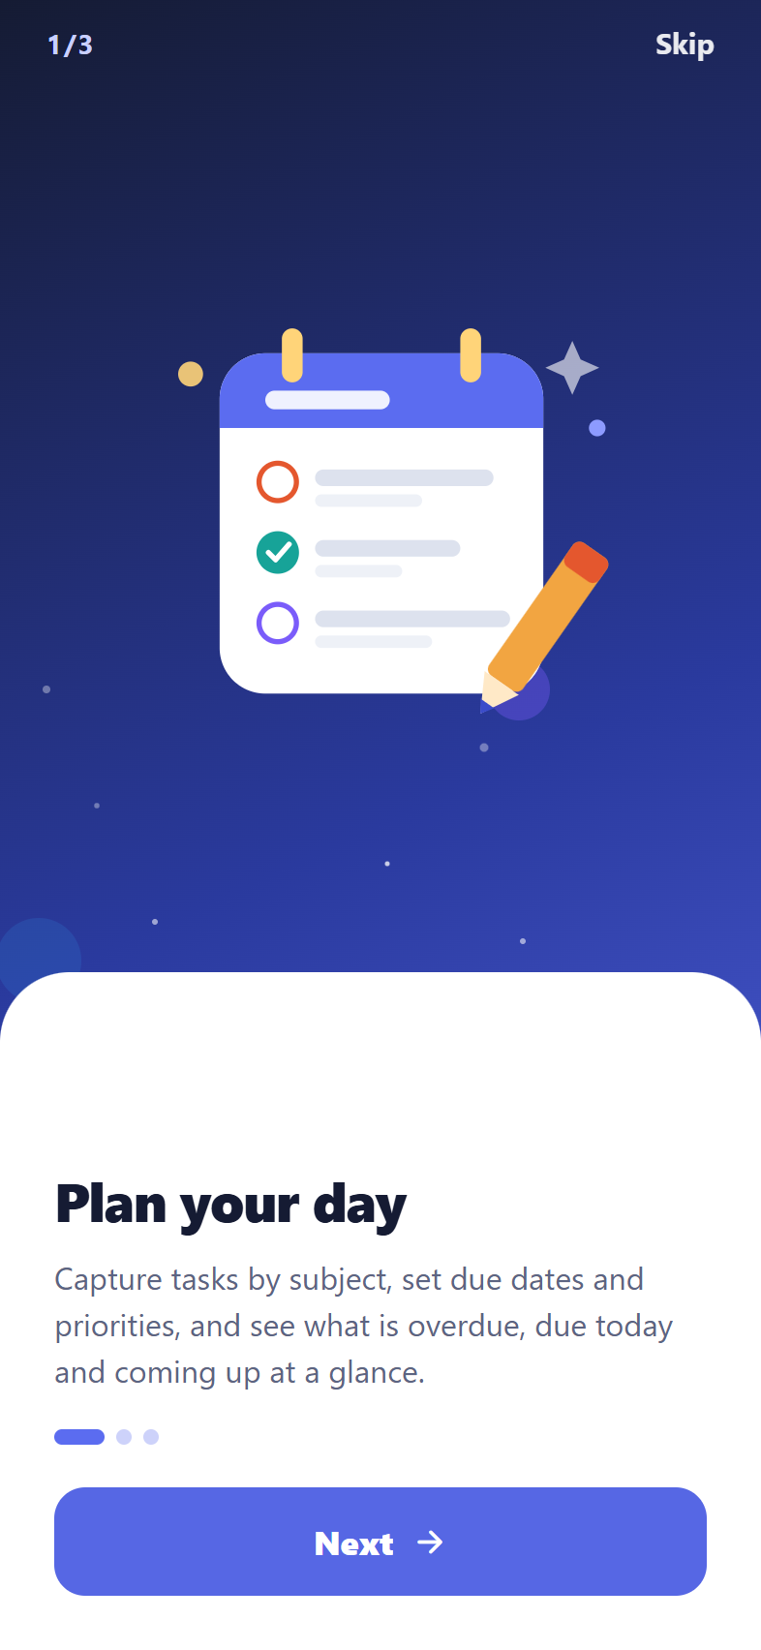  iPhone
The welcome slides

Create an account and sign in
What it does
Each student has their own private account (email and password). Their plans are saved to it, so they can sign in on any phone or computer and find everything there.
How to use it
- Tap Create account and enter a name, email and password. A meter shows how strong the password is.
- In the Development app (StudyPlanner Dev), tick “Start with sample data” to explore with example subjects, classes and tasks. The Production app starts empty, as real students expect.
- Forgot the password? Tap “Forgot password?” and a reset link is emailed.
Good to know: New students get a welcome email (in their language) with a quick guide to the app.
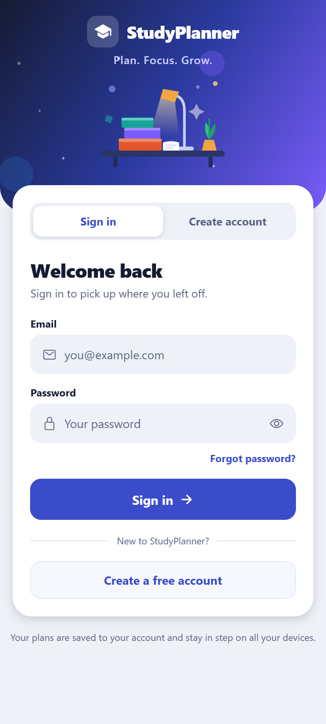  Android | 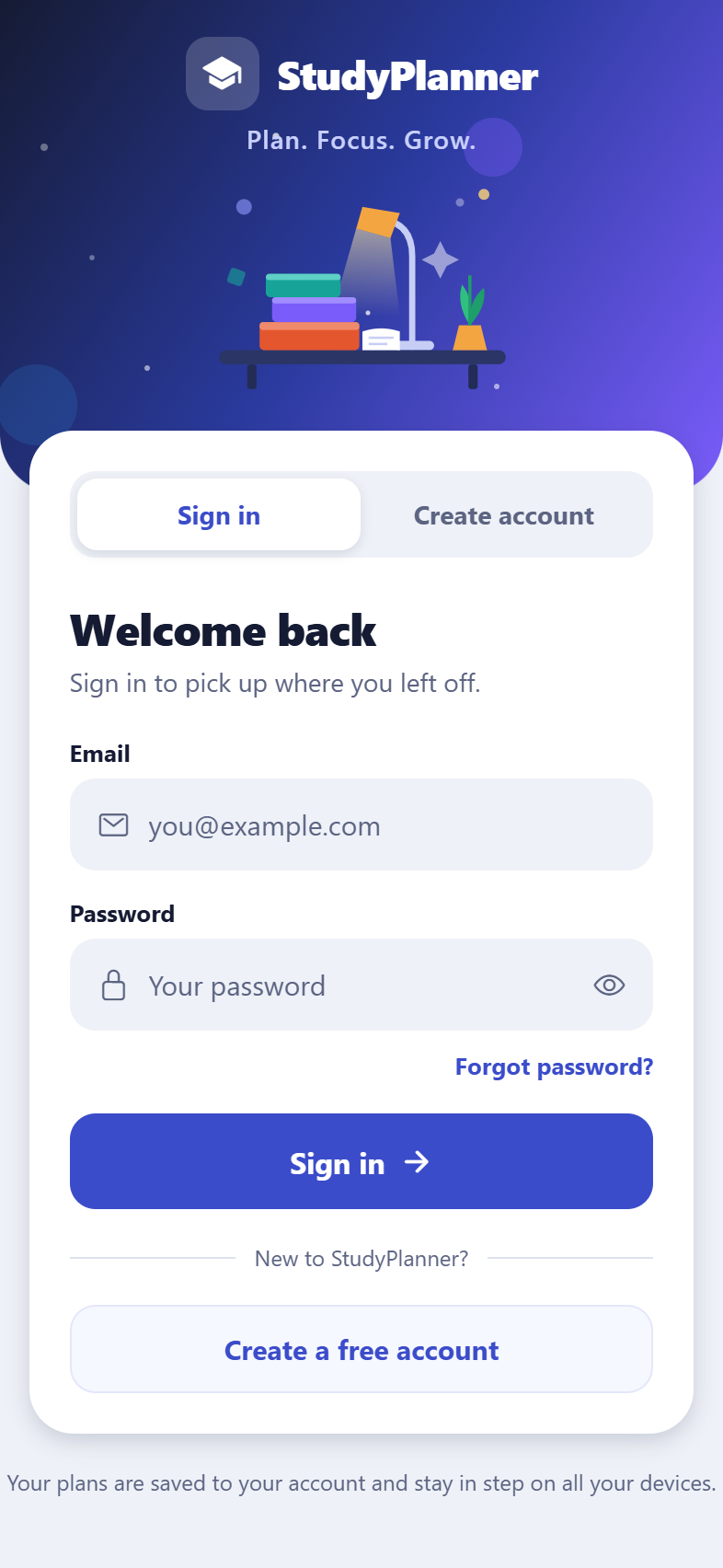  iPhone
Signing in
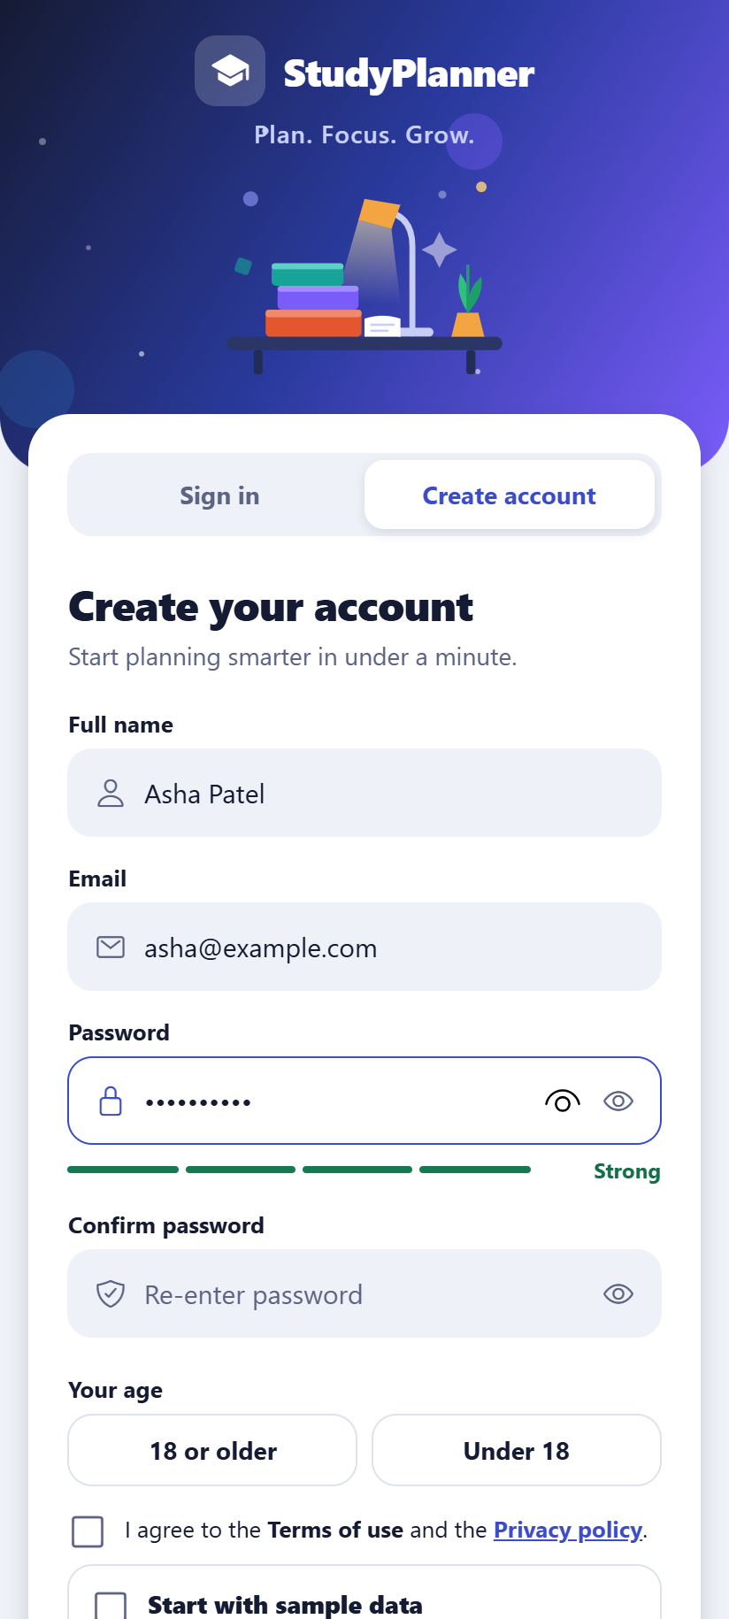  Android | 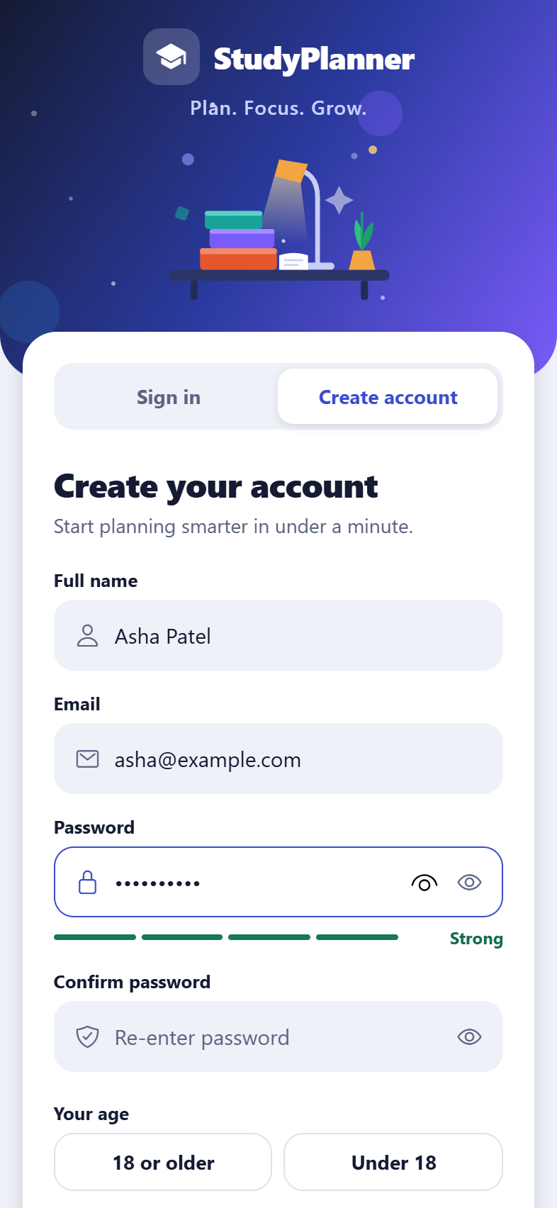  iPhone
Creating an account, with the password strength meter

Profile
What it does
Name, photo or avatar colour, school or college, course and year. The profile also lets the student change their password, sign out, or delete their account and all its data.
How to use it
- Tap your name at the bottom of the menu (or the avatar at the top right).
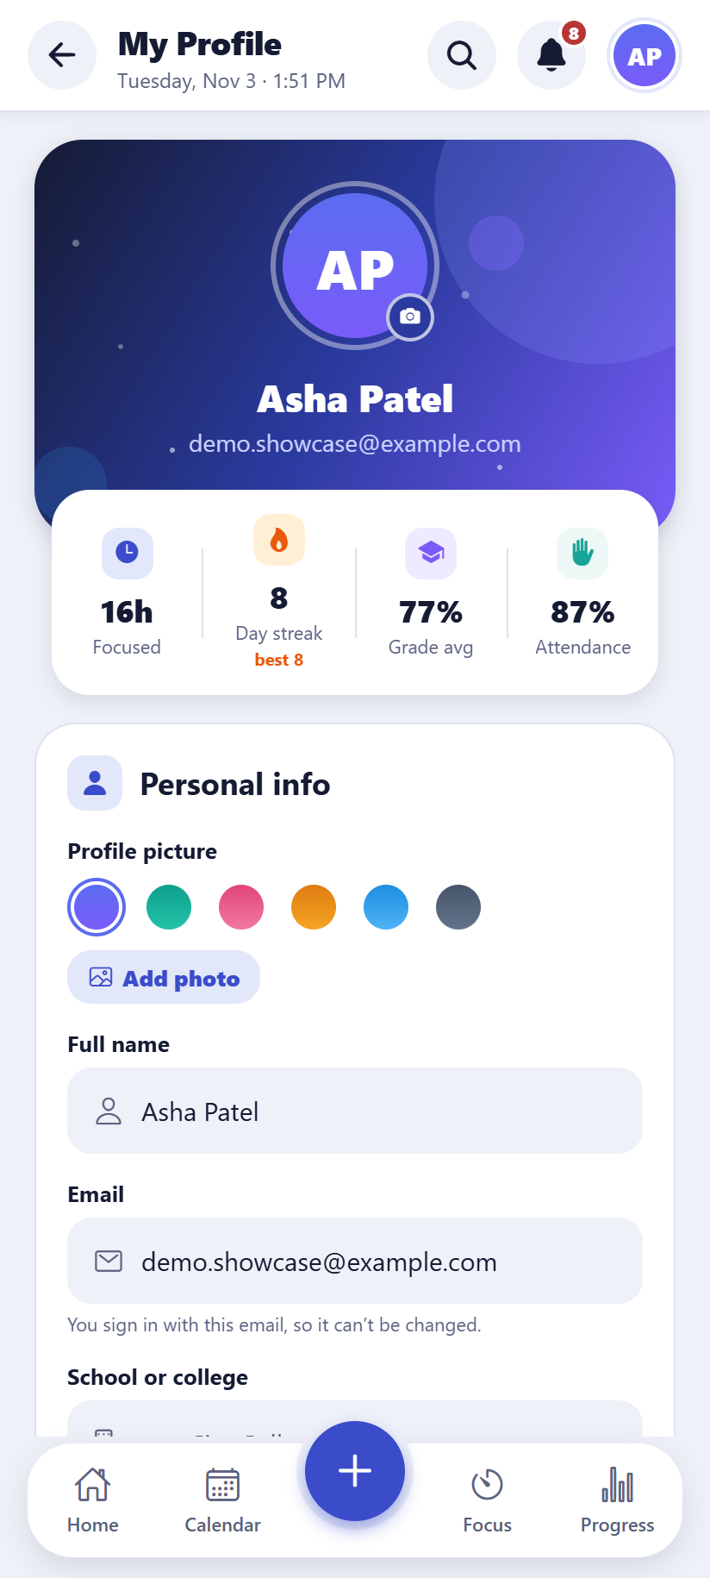  Android | 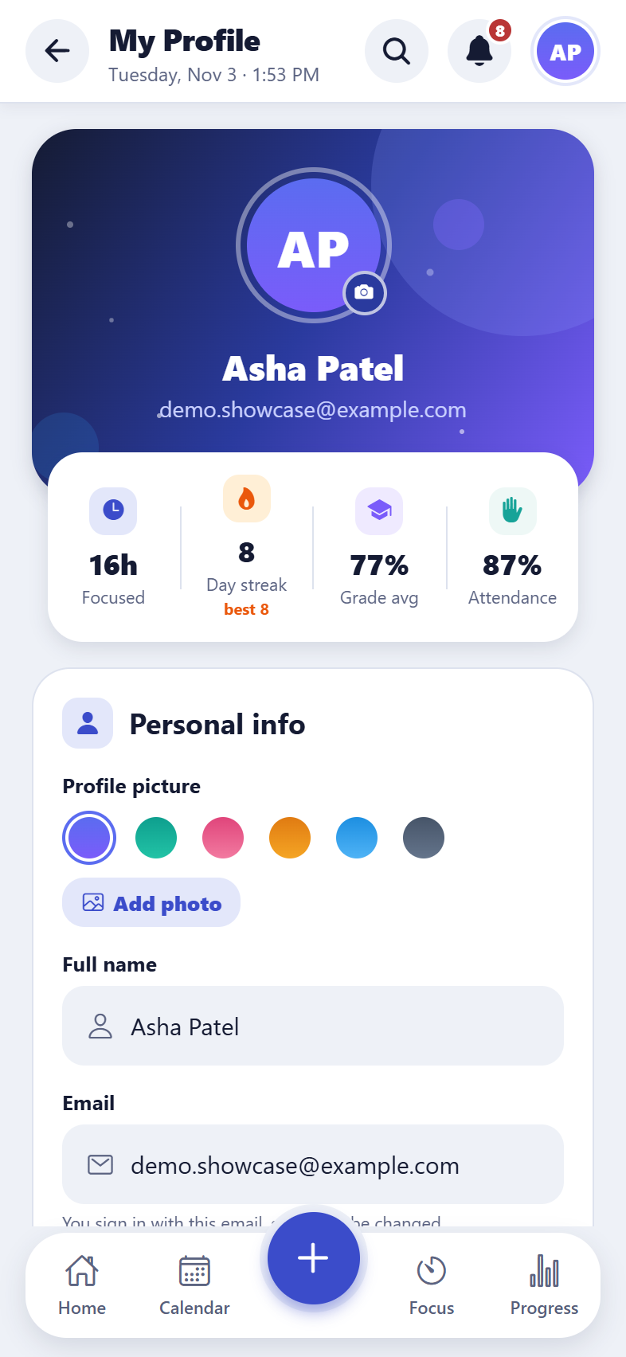  iPhone
The profile page

Bring data from the older version
What it does
Students who used the app before accounts existed can bring their old plans into their new account. Only the old account with the same password can be brought over, and nothing current is lost.
How to use it
- Settings → “Bring in data from the older version”, pick the old account and enter its password. There is an Undo.

2. The dashboard and tasks
The dashboard is the home screen: what’s due today, what’s late, and what’s coming up, with a plan for the day.

Dashboard
What it does
A greeting with today’s focus goal, a quote of the day, three tiles (due today, overdue, upcoming), today’s classes, upcoming exams and breaks, and all tasks grouped by when they’re due. Tapping a tile shows only those tasks.
How to use it
- Tap a task to edit it, tap its circle to mark it done.
- On a phone, swipe a task right to complete it or left to delete it (with Undo).
- Filter by subject, or show only high-priority tasks.
Android | iPhone
The dashboard

Smart plan for today
What it does
The app picks which tasks to do today so they fit the daily study goal, putting the most urgent first (overdue work, high priority, exams coming soon). It shows how much time each takes.
How to use it
- Use “More plan time” or “Less plan time” to change how long the plan is.
- Tap “Start first task” to begin a focus session on it.
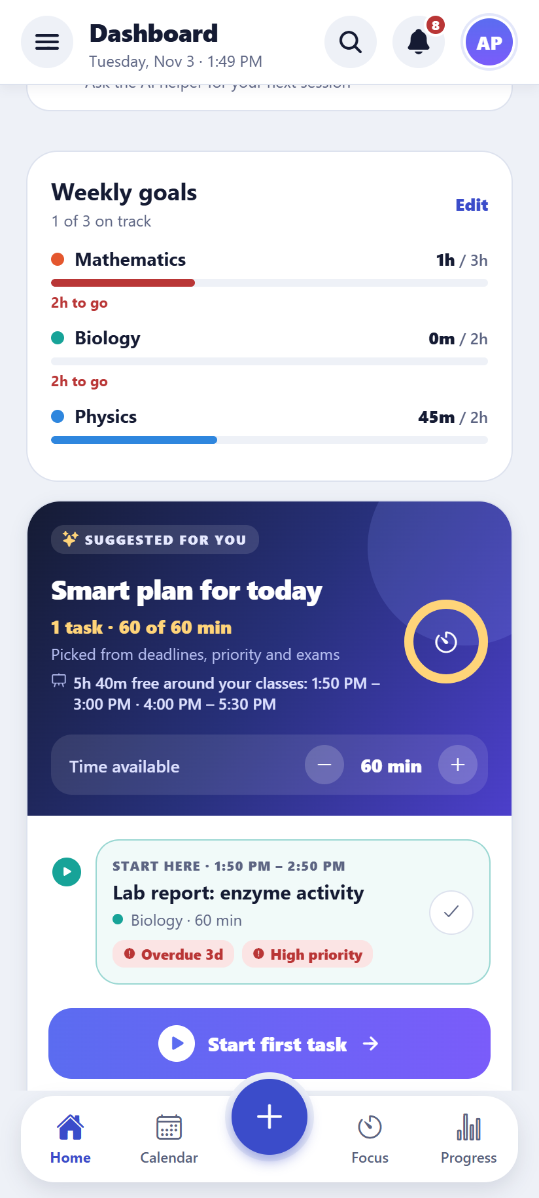  Android | 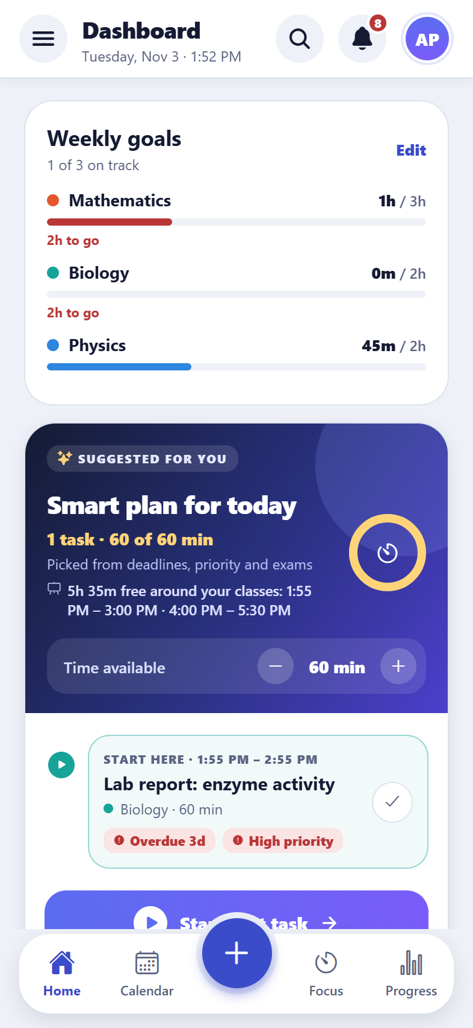  iPhone
The smart plan on the dashboard

Adding and editing tasks
What it does
A task has a title, subject, due date and optional time, priority, how long it should take, notes, and can repeat (daily, weekly or on chosen days). Homework can be linked to a class.
How to use it
- Tap + (phone) or “New task” (computer).
- Press N on a computer keyboard to add a task from anywhere.
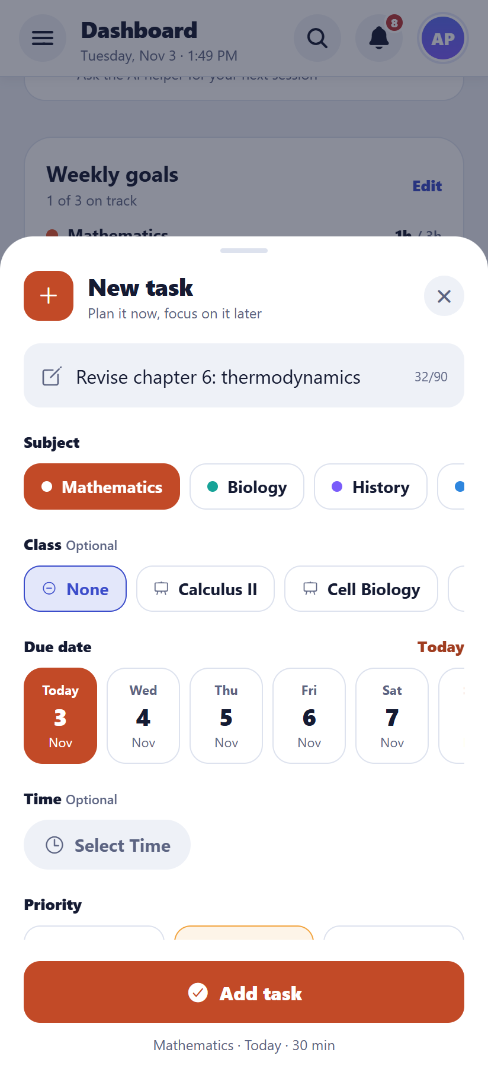  Android | 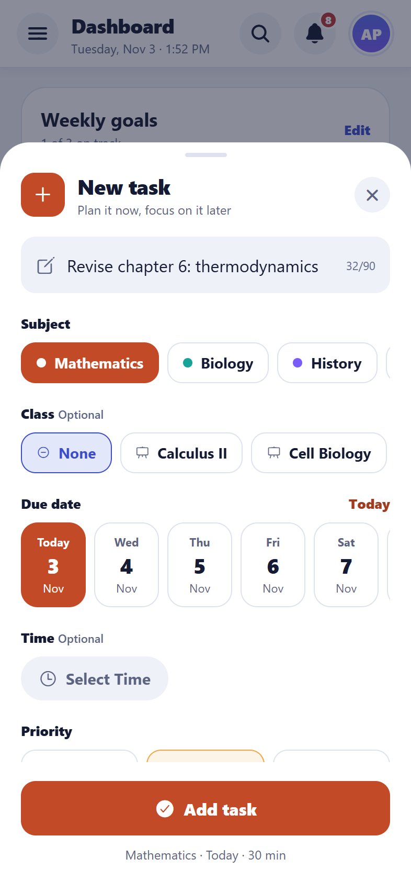  iPhone
Adding a task

Quick add and voice (new)
What it does
A task from one line on the dashboard. Type “Physics worksheet fri 45 min 5pm !” and the app picks up the day (today, tomorrow or a weekday), the time, how long it takes, the subject (by name, or #maths) and ! for important, and shows what it found as you type. It understands the words in all four languages.
How to use it
- Dashboard → the quick add box at the top. Type, then press Enter or +. There is an Undo.
- Or say it (new): tap the mic, say “Biology revision tomorrow 40 minutes at 4 pm”, check what it heard, then press +.
- Without a day the task is due today; without a length it gets the usual focus length.
Good to know: The mic is in the Android and iPhone apps, and in Chrome, Edge and Safari on the web. The first time, the phone or browser asks to use the microphone.
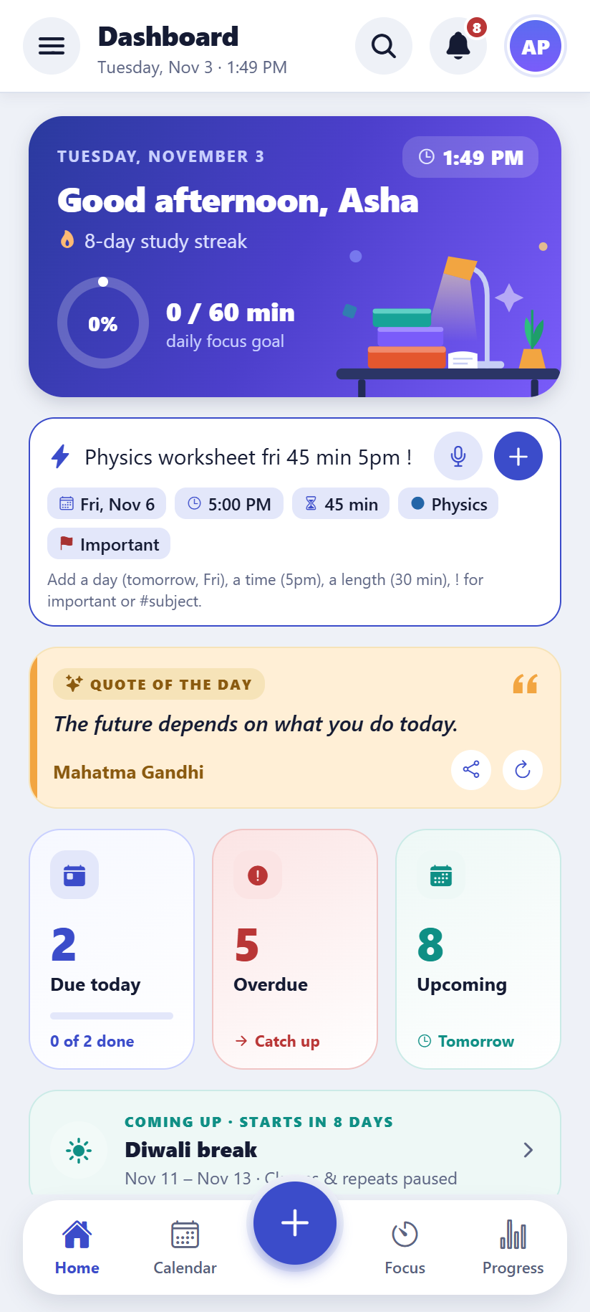  Android | 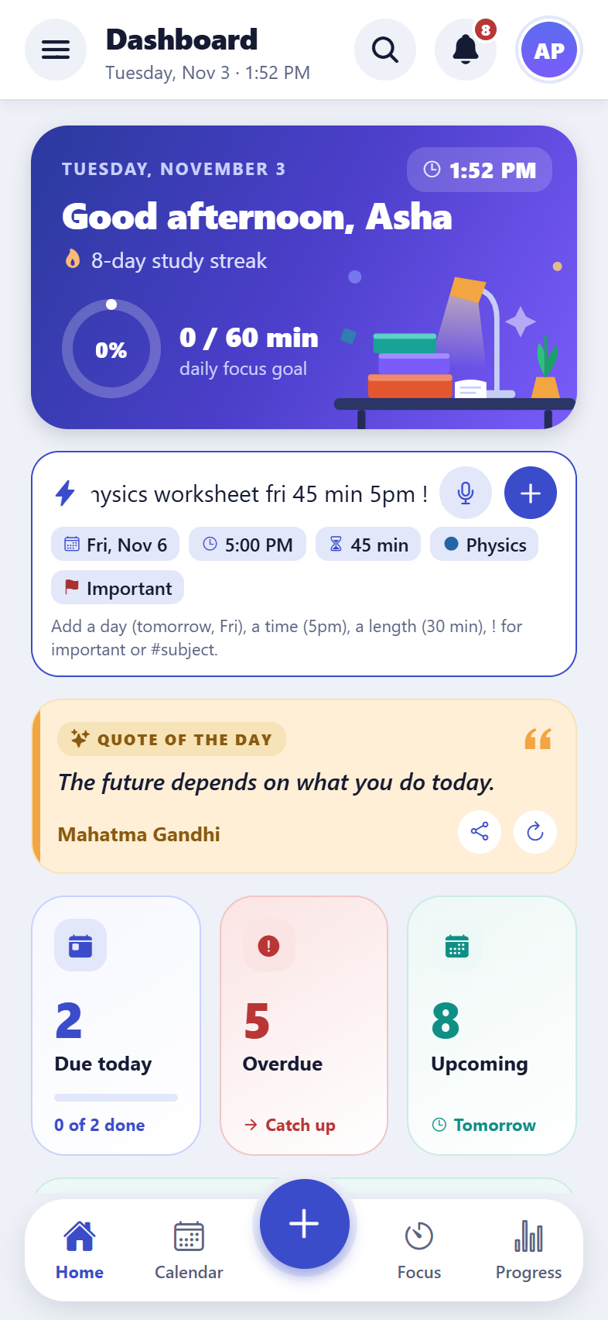  iPhone
Quick add

Steps, links and photos
What it does
Big tasks can be split into steps that are ticked off one by one, with a progress bar. Links (for example a video or website) and photos (for example a page of the textbook) can be attached.
How to use it
- Open a task and add steps under “Steps”, or a link or photo under “Attachments”.
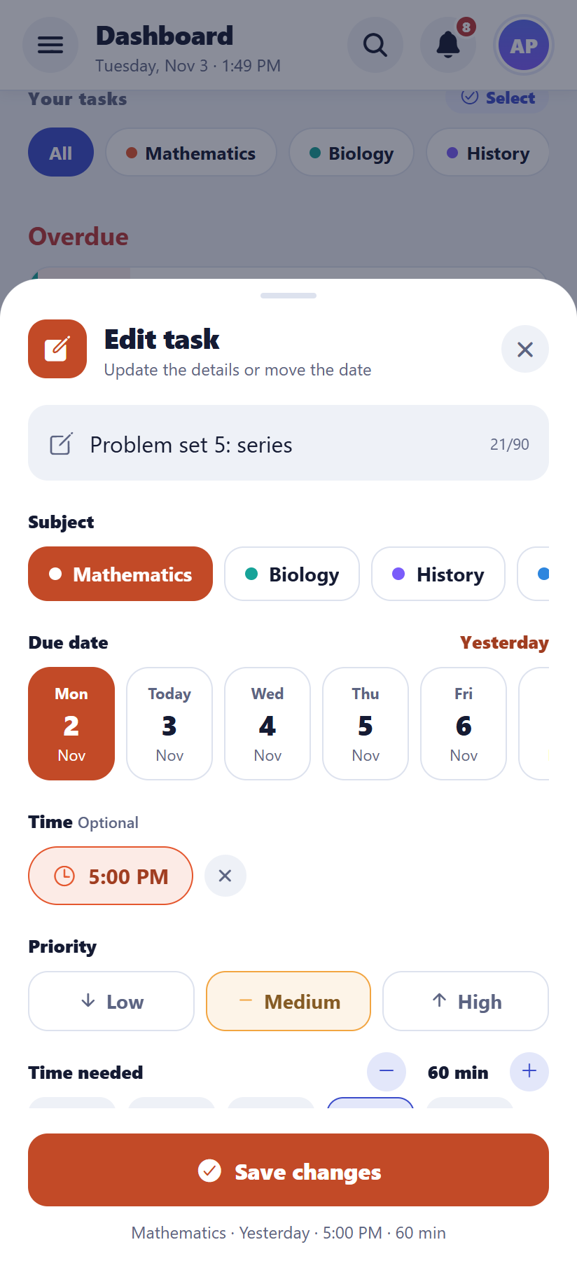  Android | 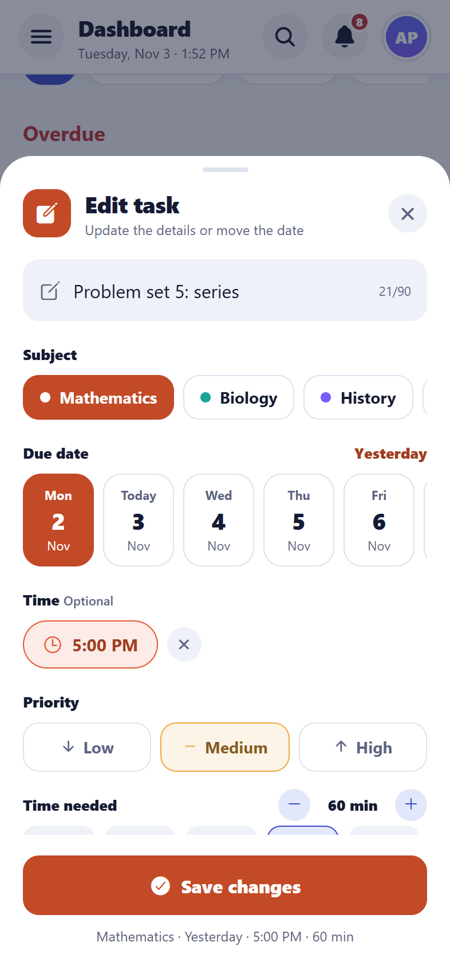  iPhone
A task with steps and a link

Select several tasks at once
What it does
Mark many tasks done, move them to another day, or delete them in one go.
How to use it
- Tap “Select” above the task list, tick the tasks, then choose an action. Works in the Calendar too.
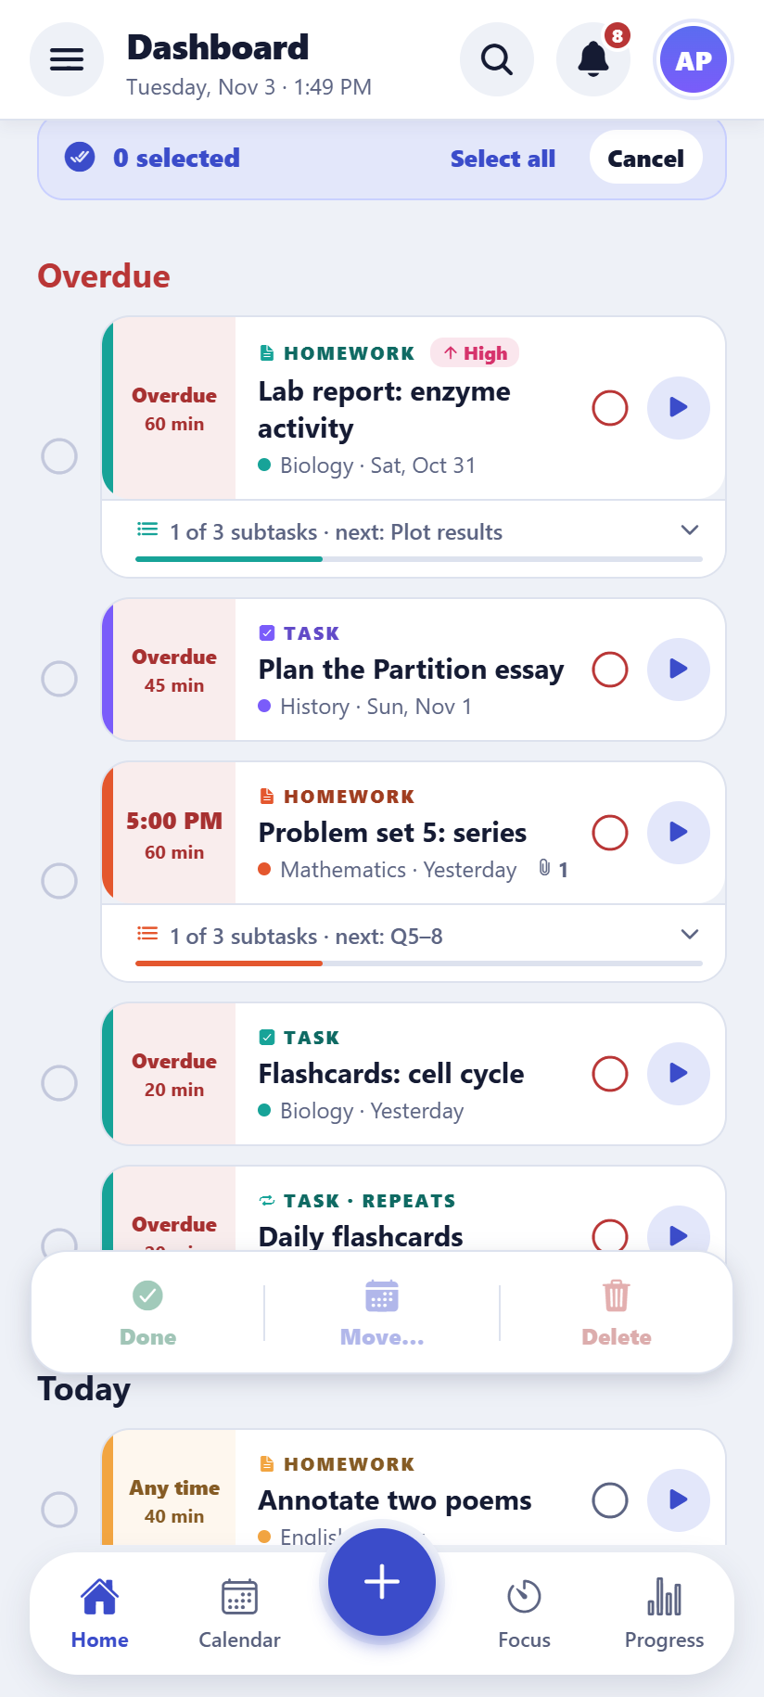  Android | 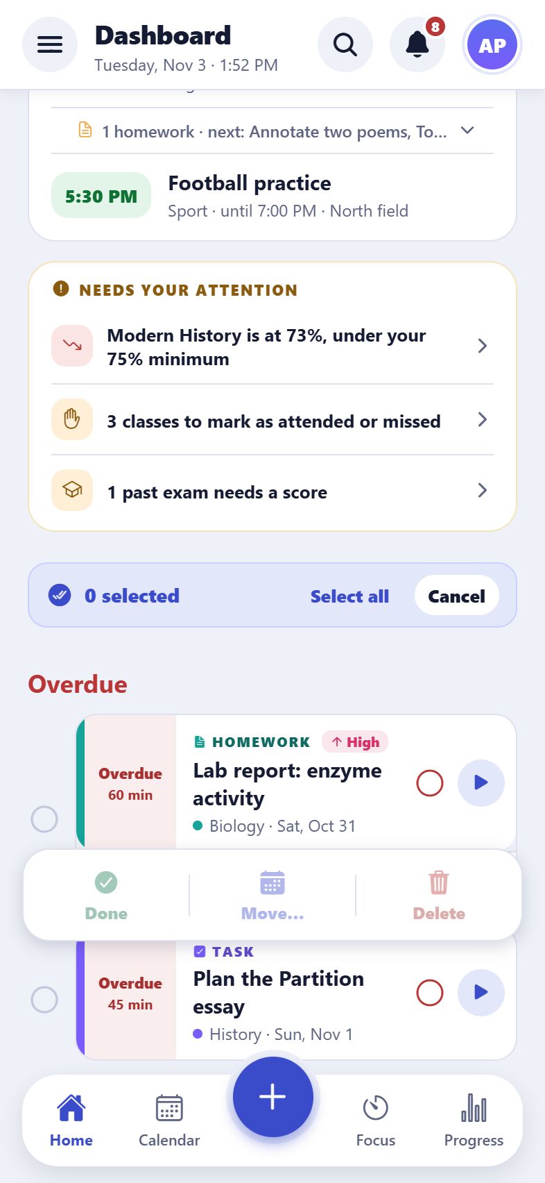  iPhone
Selecting several tasks

Search
What it does
Finds tasks, exams, classes and subjects as you type. Choosing an exam or class opens the calendar on its day.
How to use it
- Type in the search bar at the top, or press / on a computer.
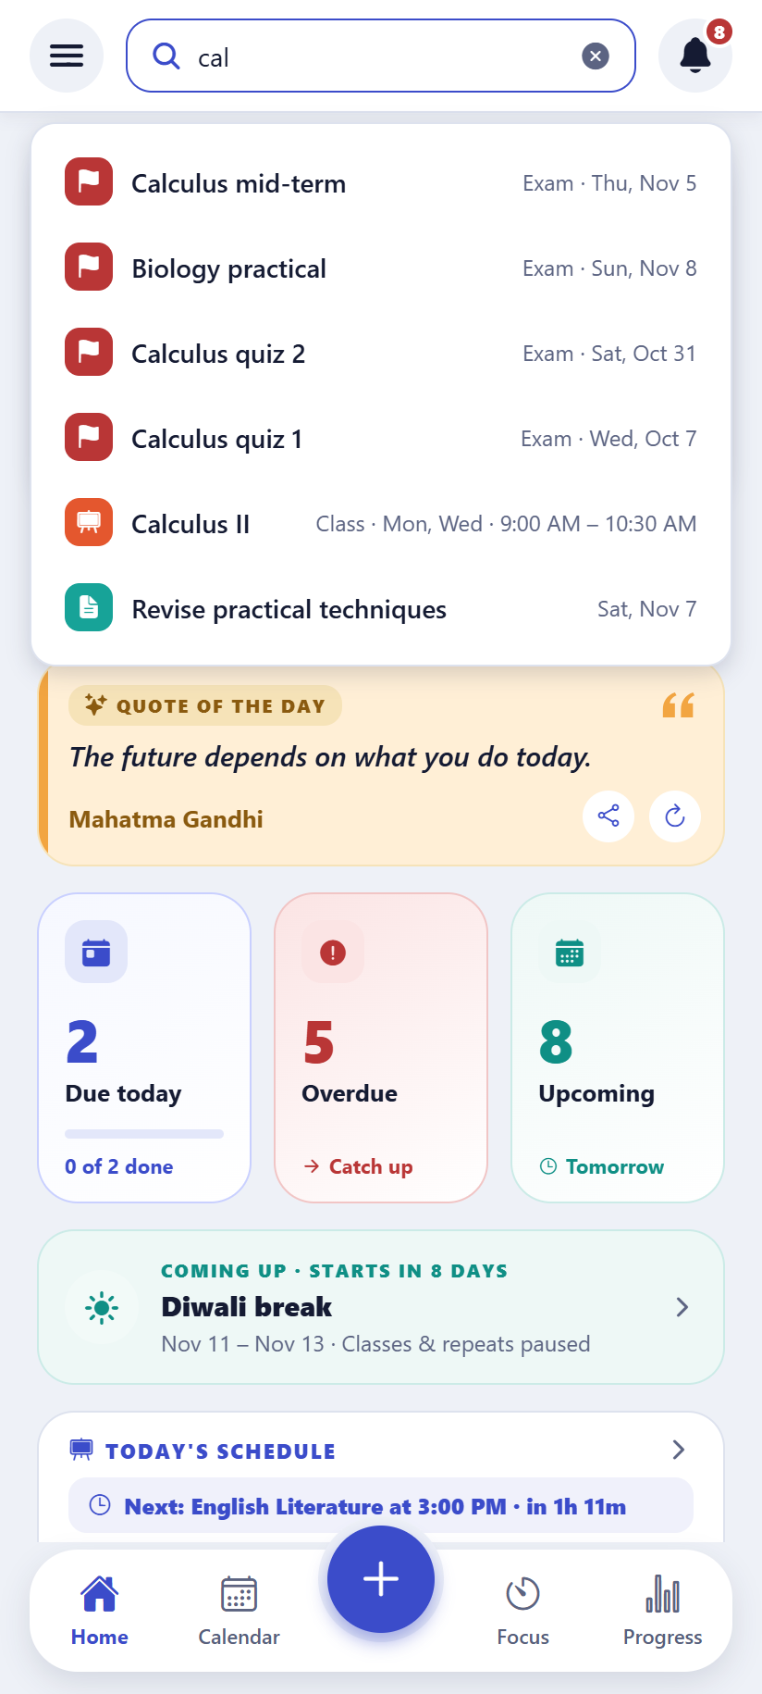  Android | 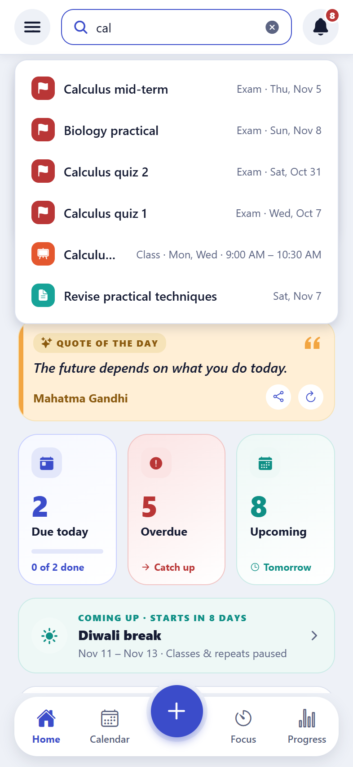  iPhone
Search results

“Coming up” grouped by day
What it does
Upcoming tasks are shown under a heading for each day. A task that repeats (for example daily flashcards) shows once with “+ more”, so the list stays short.

Archive of finished tasks
What it does
Tasks finished long ago can be moved to an archive, keeping the lists tidy. They can be brought back at any time.
How to use it
- Settings → Archive.

3. Calendar, exams and timetable
The calendar brings together tasks, exams, classes and breaks, by month or by week.

Month and week views
What it does
The month view shows each day’s tasks, exams and classes; the week view shows the timetable hour by hour. Tasks and exams can be dragged to another day.
How to use it
- Switch between Month and Week at the top. Tap a day to see everything on it.
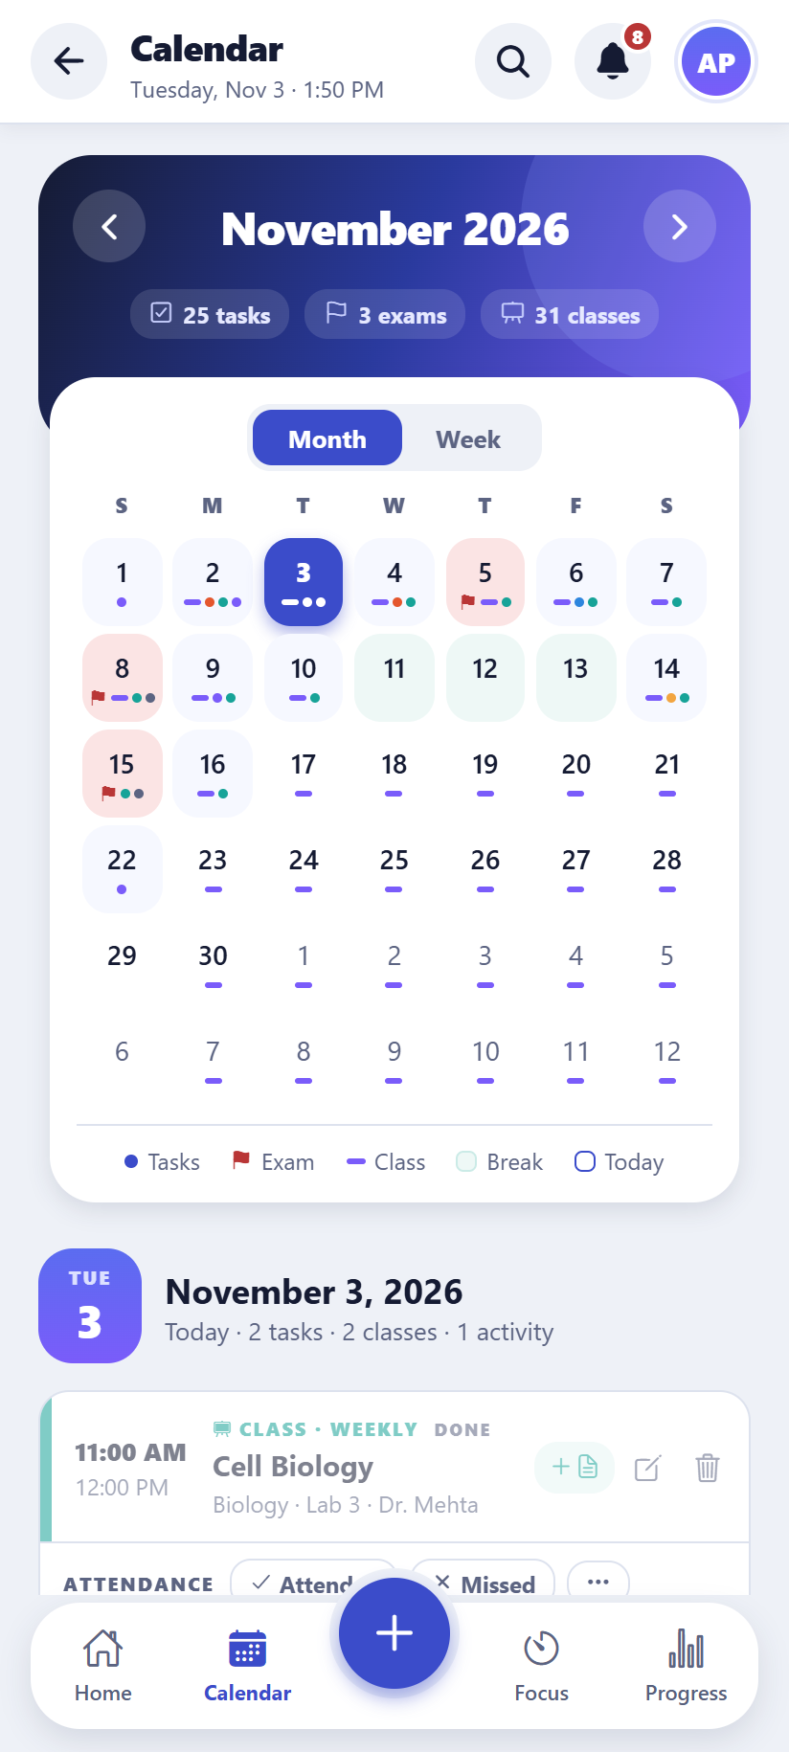  Android | 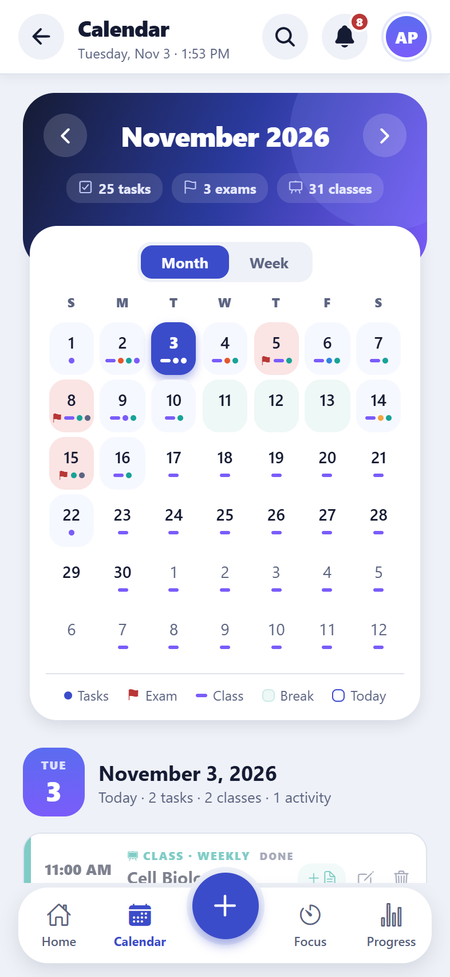  iPhone
Calendar: month view
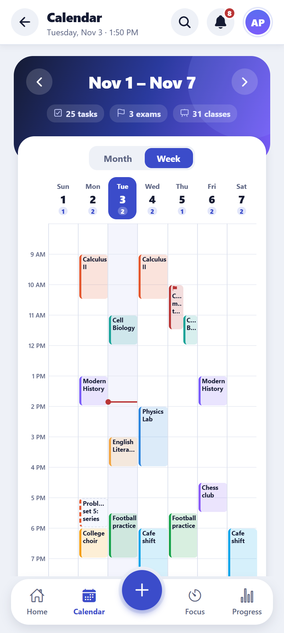  Android | 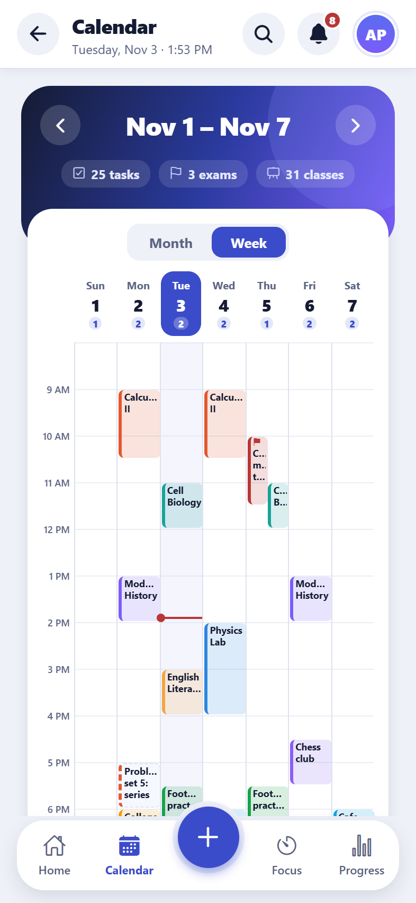  iPhone
Calendar: week view

Exams
What it does
Each exam has a date, time, length, place (or online link) and subject, with a countdown in days. After the exam the score can be added, and whether the student attended.
How to use it
- Calendar → Upcoming exams → Add exam.
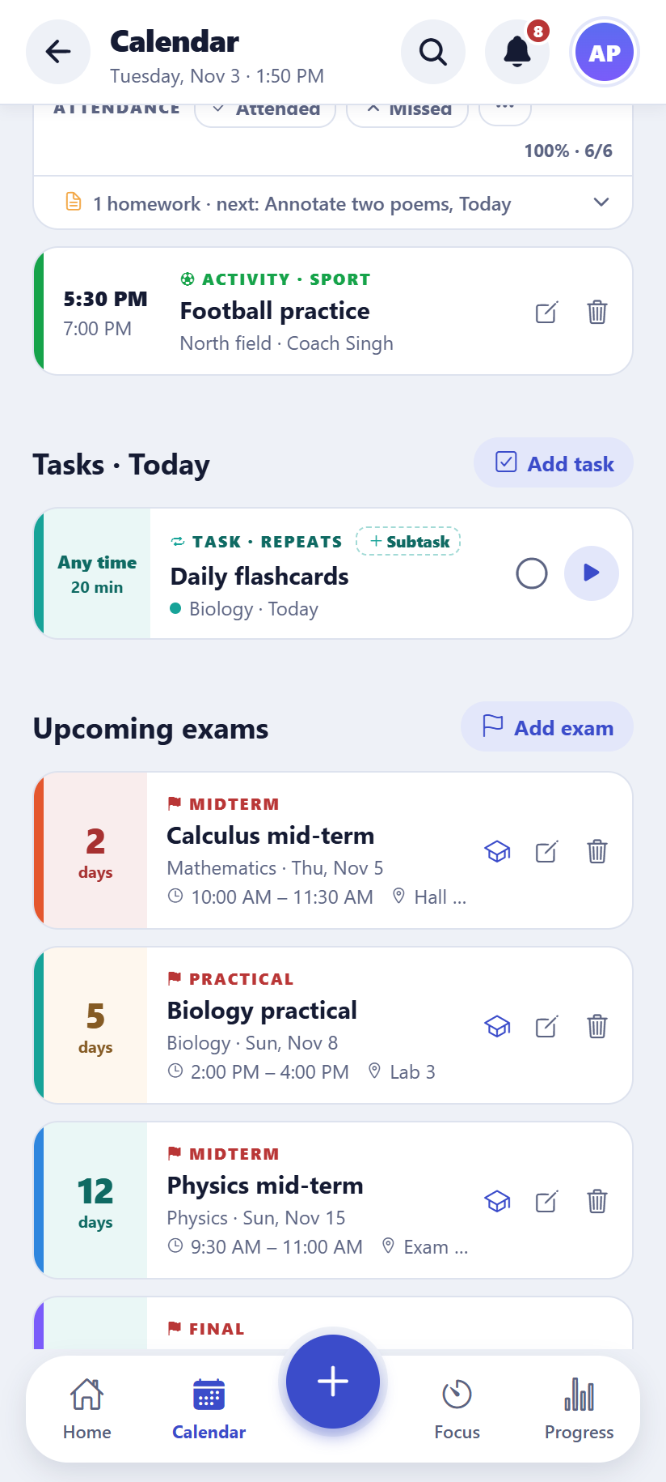  Android | 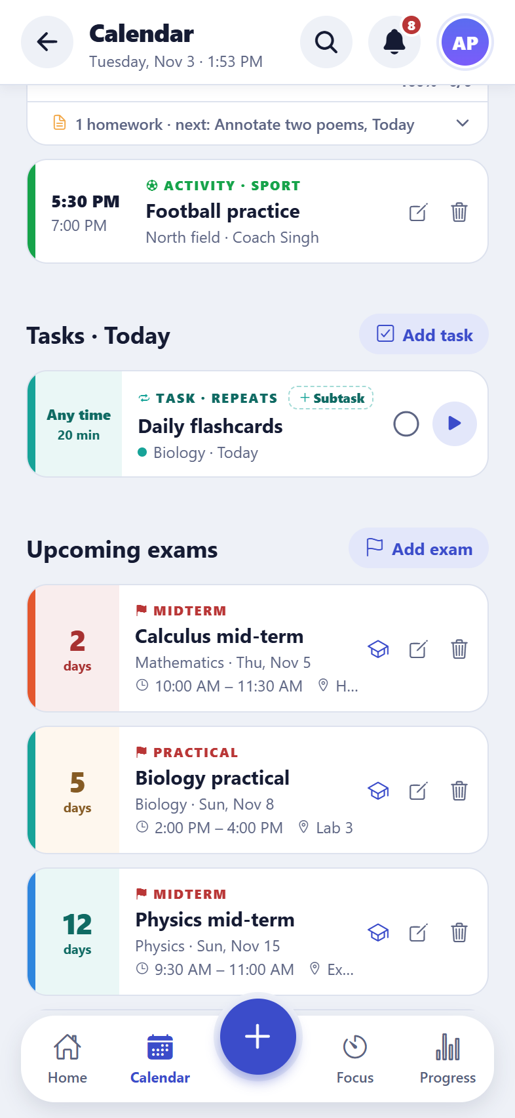  iPhone
Upcoming exams with countdowns

Exam prep plans (new)
What it does
Pick an exam and the app spreads revision sessions over the days before it, ending with a practice test and a final review the day before. If topics are given, each gets its own session. The sessions become ordinary tasks, and the exam shows the plan’s progress (“Prep plan: 2 of 6 done”).
How to use it
- Calendar → Upcoming exams → the cap button on an exam.
- Choose the number of sessions and their length, type the topics, check the preview, then “Add revision tasks”. There is an Undo.
Good to know: Making a new plan replaces only the tasks not yet done.
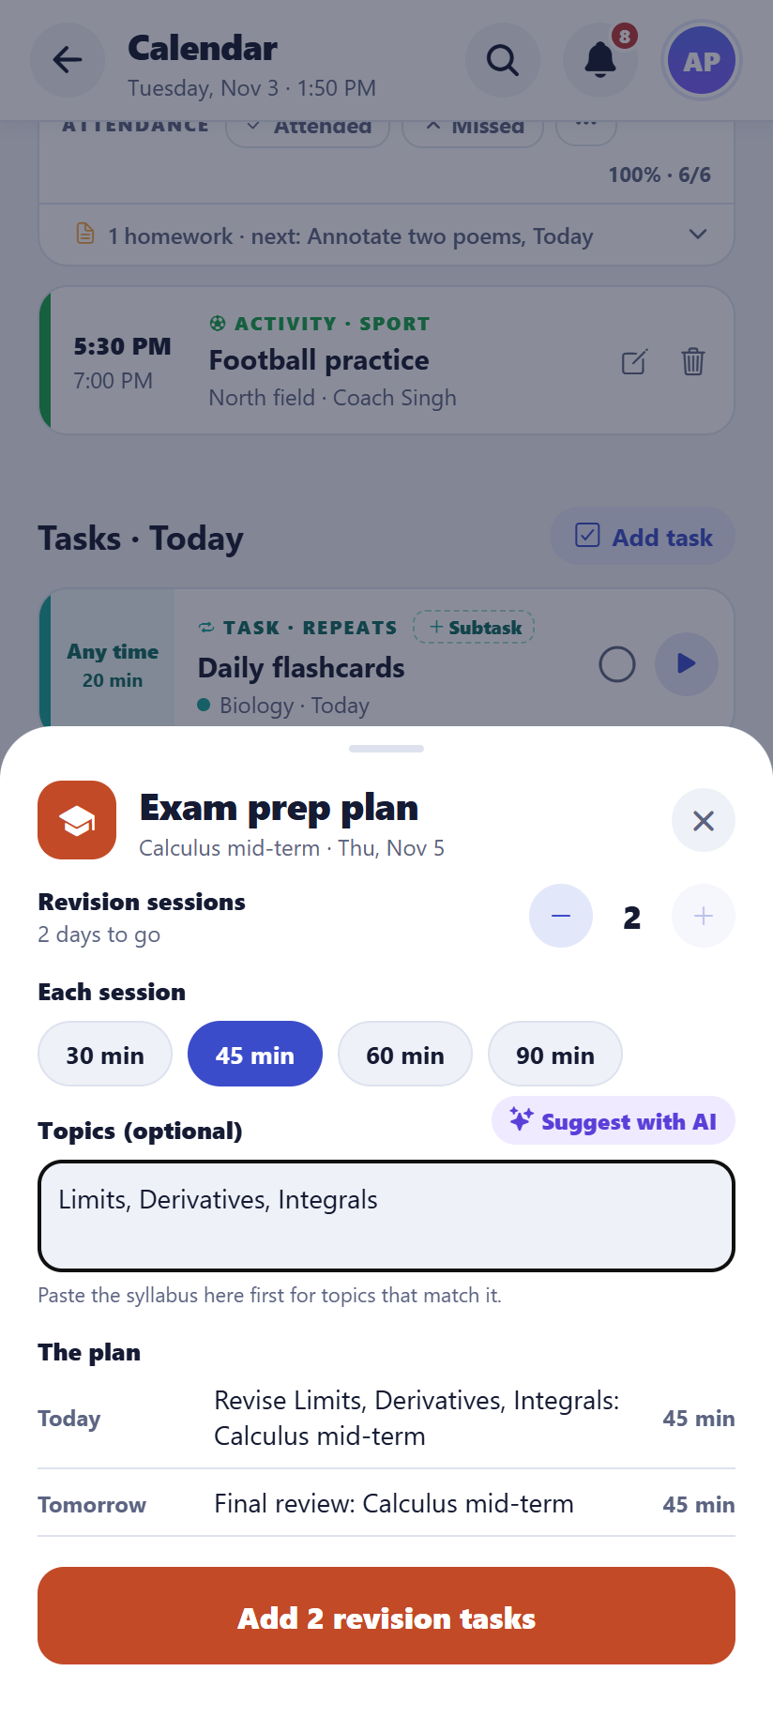  Android | 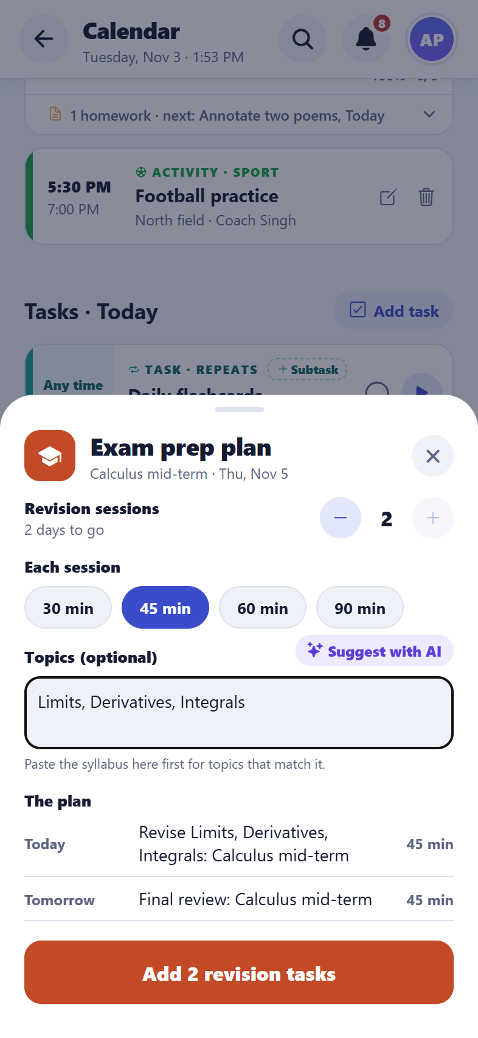  iPhone
Making an exam prep plan

Link a task to an exam (new)
What it does
Link a task to an exam from either side. When you add or edit a task, choose “For exam” (this subject’s exams come first). Or open an exam and tap the link button to tick the tasks that belong to it. A linked task shows a flag line on its card (“For Physics mid-term · Mon, Nov 16”), and linked tasks count in the exam’s “Prep plan: x of y done” progress, next to any generated revision sessions. Linked tasks also rank higher in Today’s smart plan and the Focus queue as the exam gets closer (up to 3 weeks out, more than for a task that only shares the exam’s subject). Deleting an exam keeps its tasks and just unlinks them.
How to use it
- From the task: Add task (or edit one) → For exam → pick the exam. “No exam” unlinks it.
- From the exam: Calendar → Upcoming exams → the link button on an exam → tick the tasks to link (untick to unlink).
Good to know: Regenerating a prep plan never removes tasks you linked by hand.

Weekly timetable and classes
What it does
Classes repeat every week (or on a rotation such as Day A / Day B), with a teacher, room or online link, and the dates of the term. The Today screen shows the next class with a countdown.
How to use it
- Calendar → Weekly timetable → Add class.
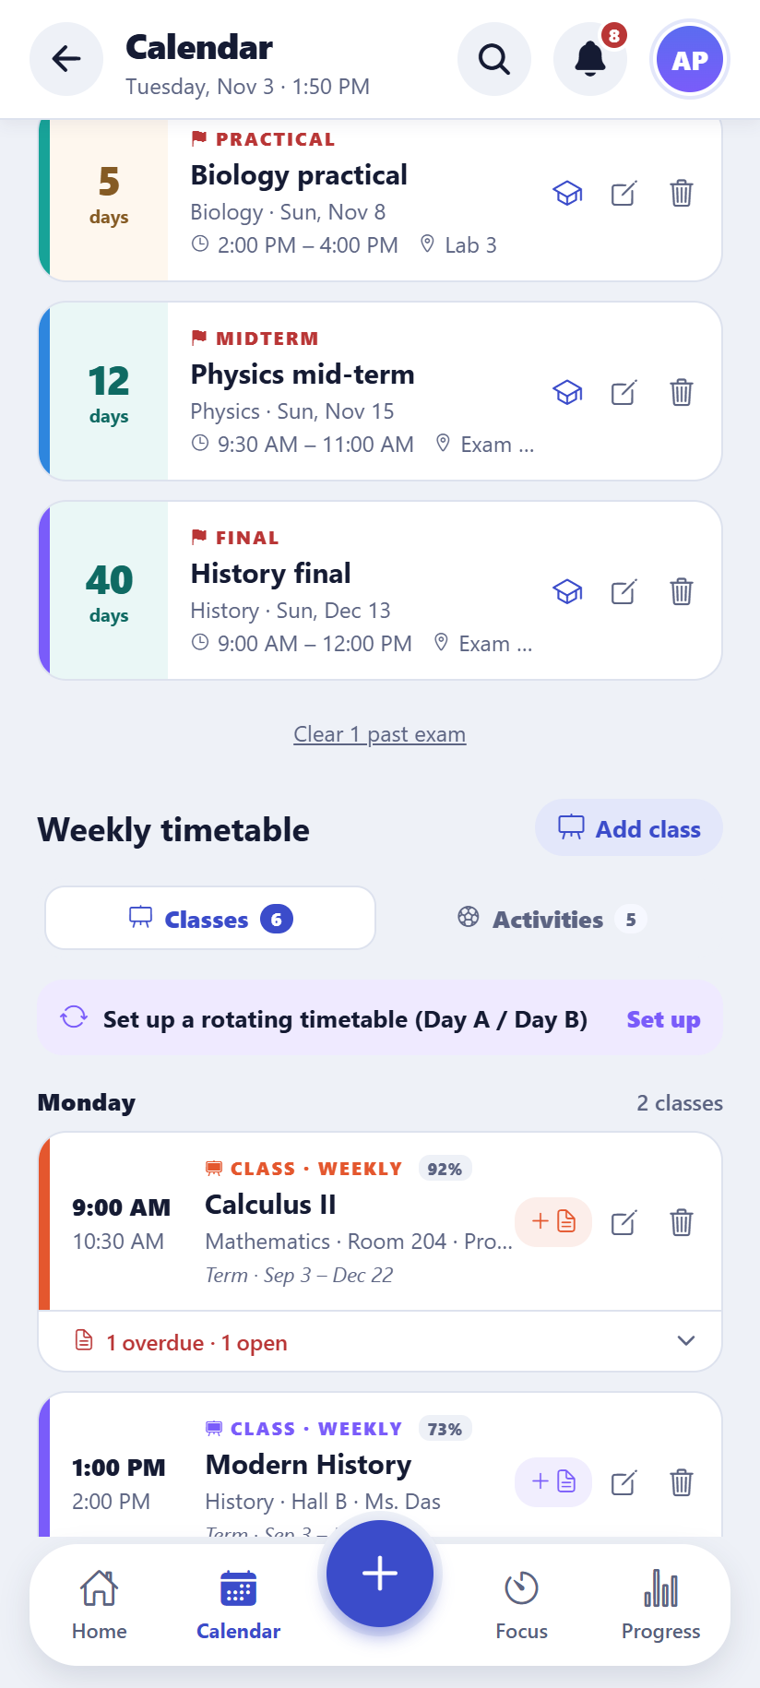  Android | 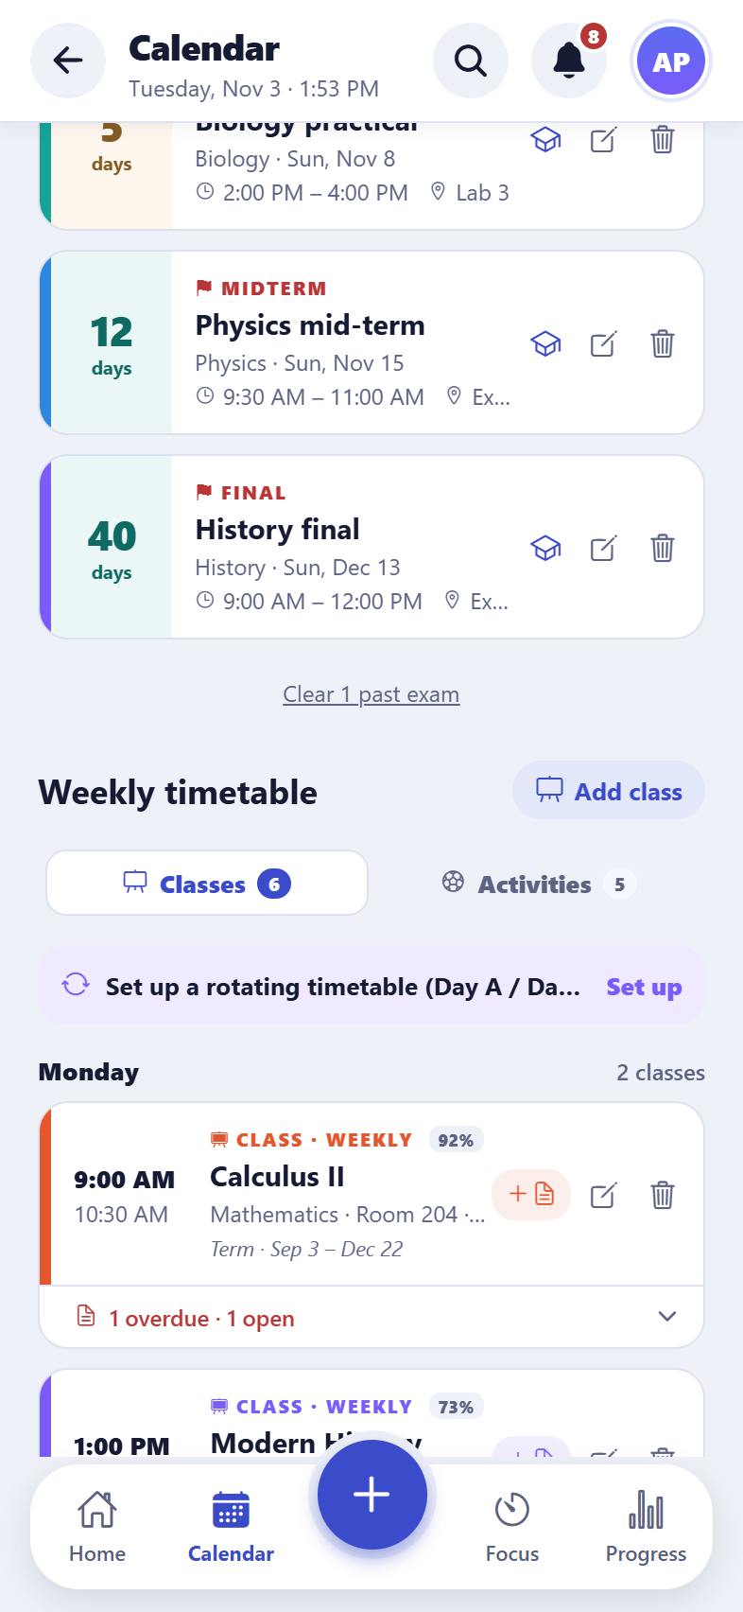  iPhone
The weekly timetable
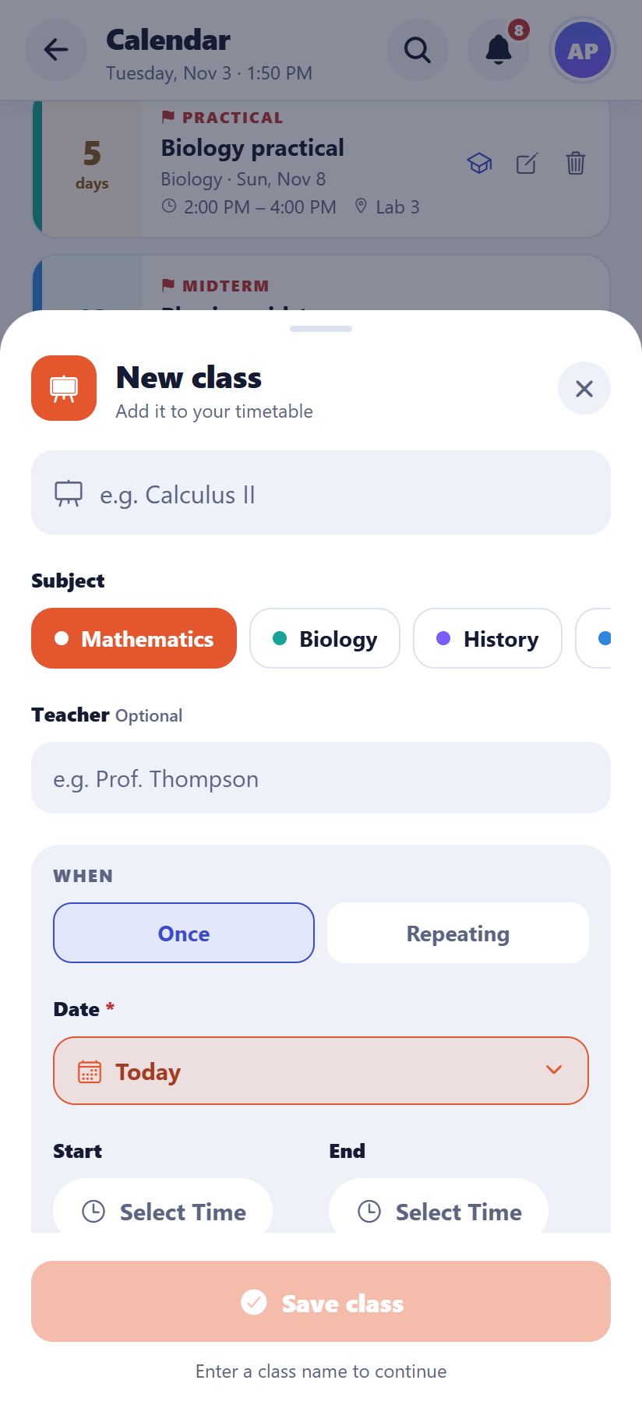  Android | 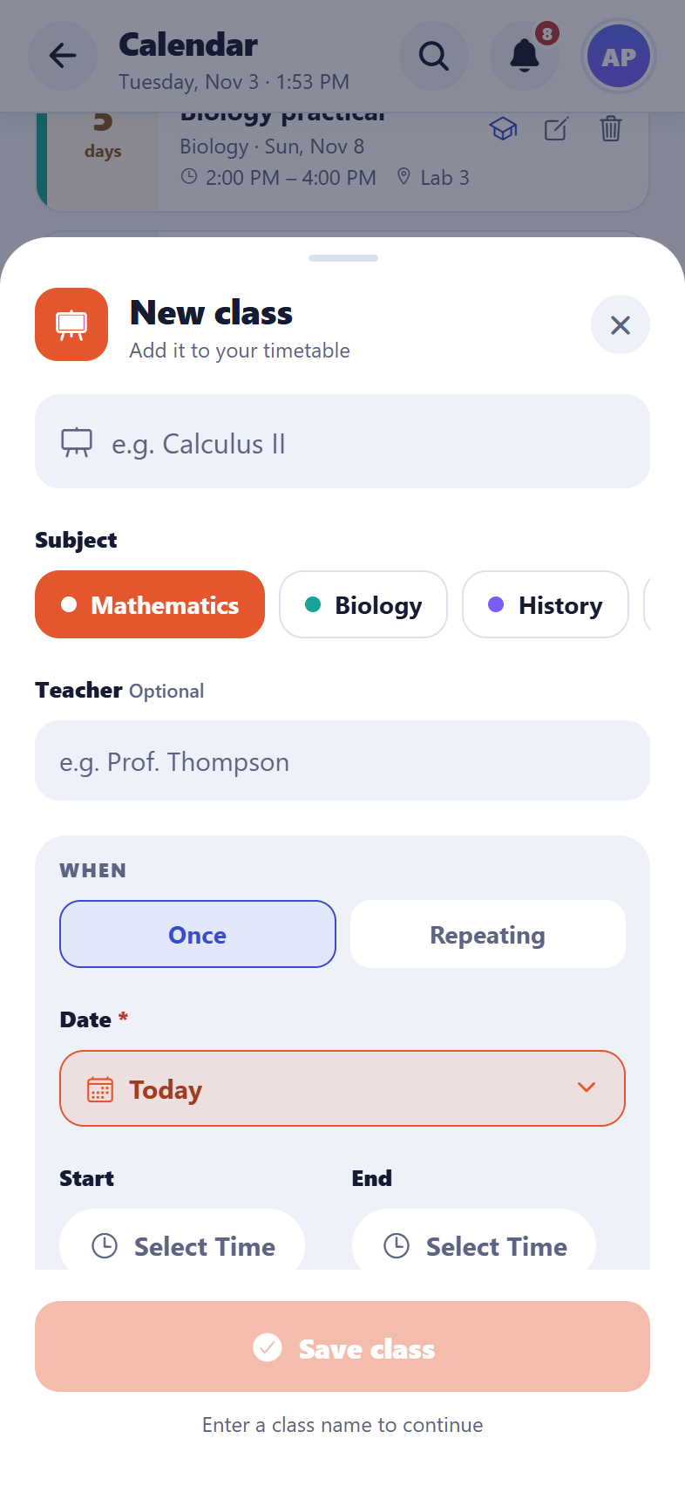  iPhone
Adding a class

Homework from a class
What it does
Homework can be added straight from a class, and each class shows its homework underneath.

Attendance
What it does
Each class session can be marked attended, missed, excused or cancelled. The app shows the attendance percentage per subject and warns when it drops below the target (75% by default).
How to use it
- Mark a class on the Today screen or in the Calendar; a reminder in the evening lists the ones not marked.
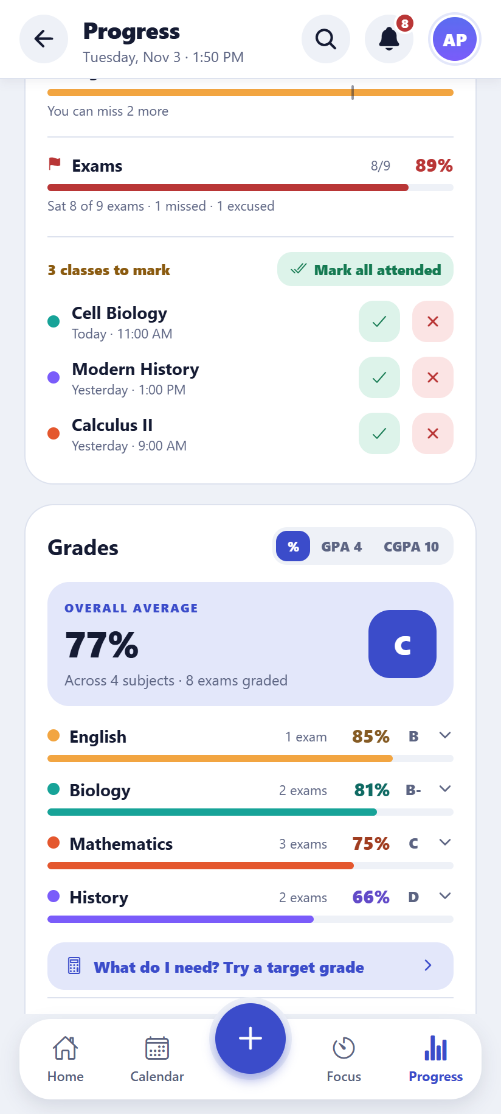  Android | 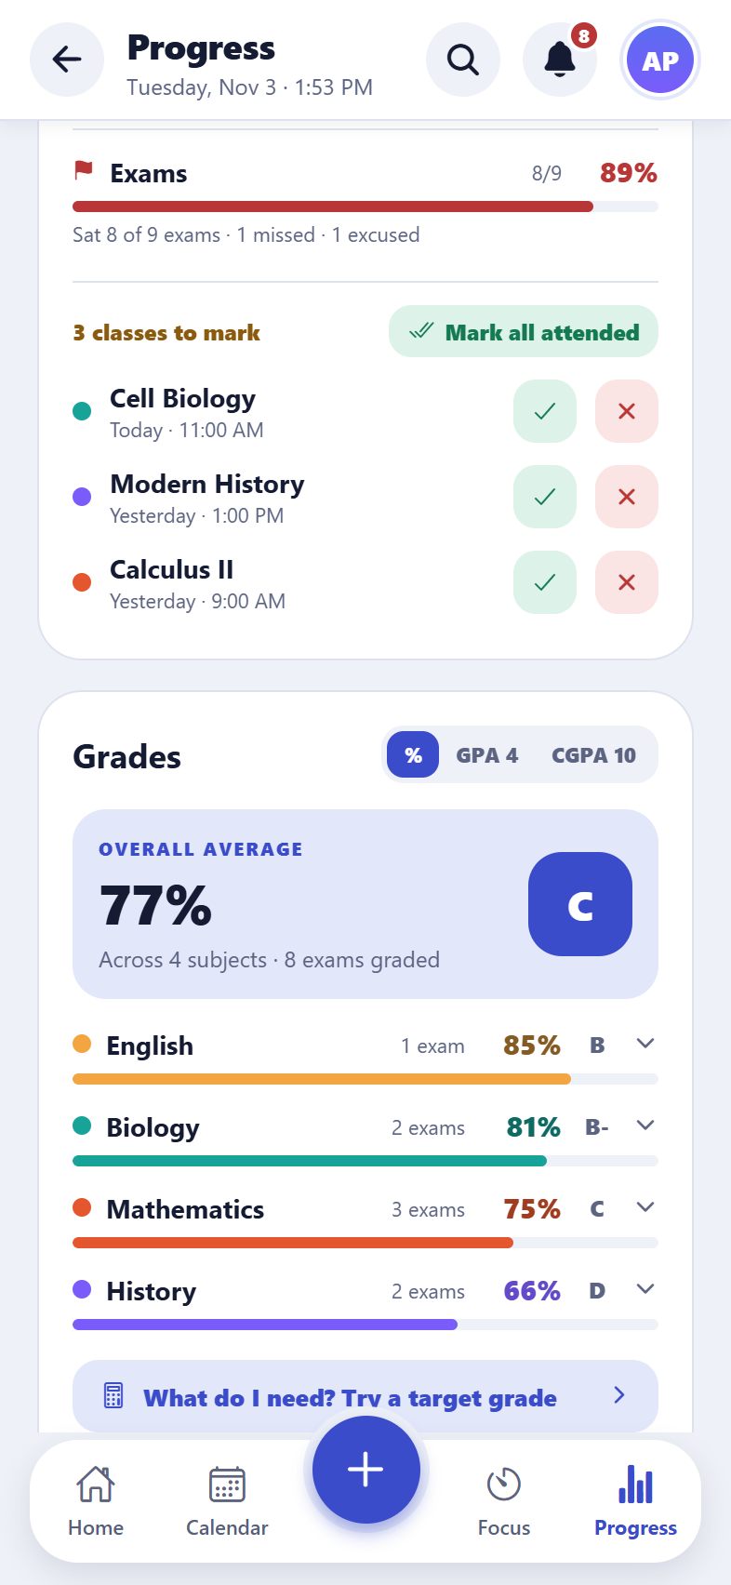  iPhone
Attendance per subject on Progress

Vacations and breaks
What it does
Holidays and breaks pause classes and repeating tasks on those days, so nothing is scheduled while the student is away.
How to use it
- Calendar → Vacations → Add break.
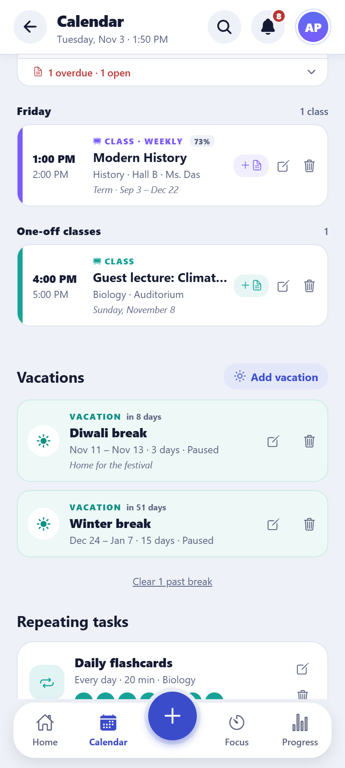  Android | 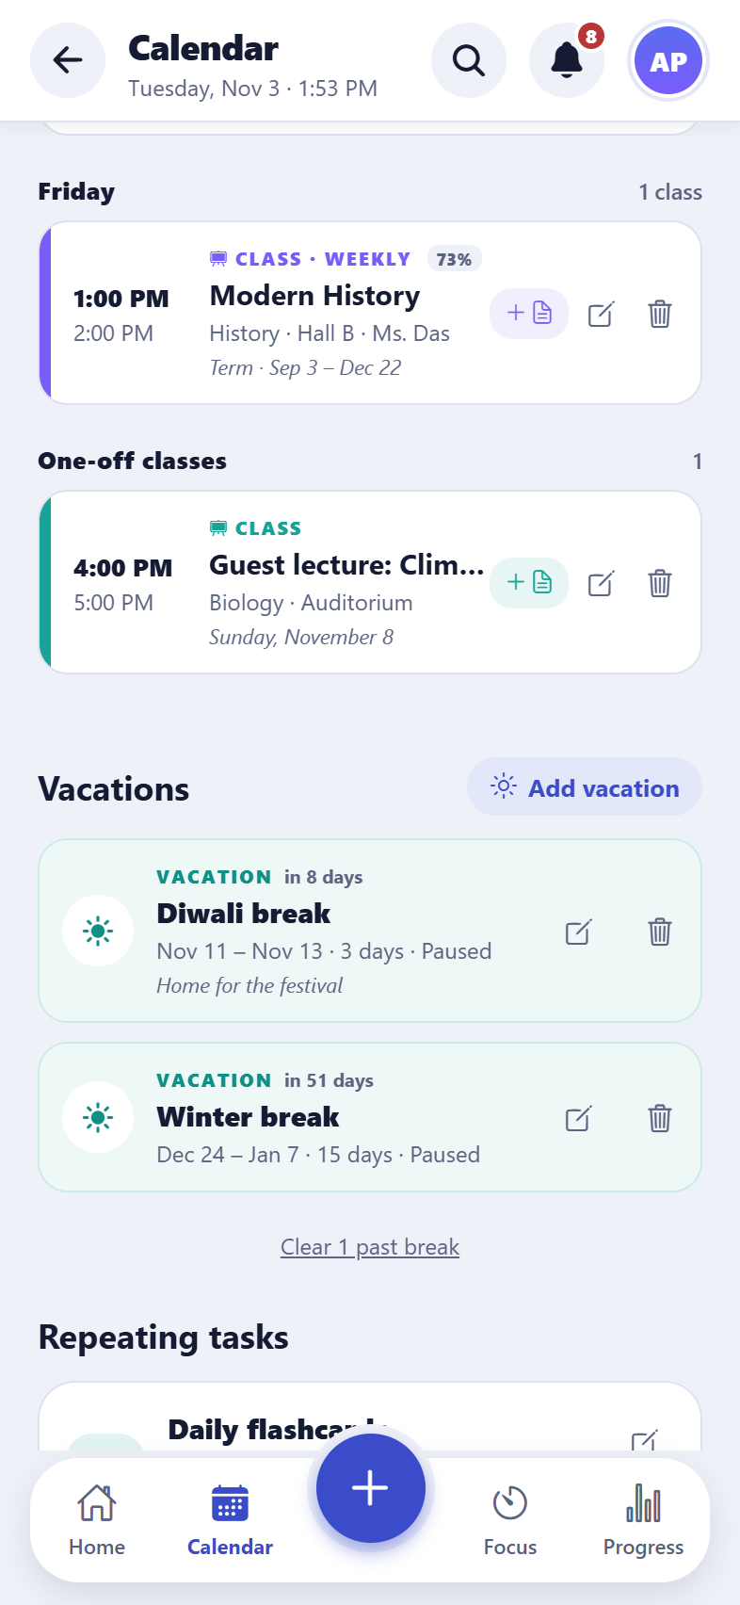  iPhone
Vacations and breaks

Activities
What it does
Clubs, sports and other activities can be added like classes, with a weekly limit on the hours spent on them.

Import and export a calendar
What it does
The timetable and exams can be saved as a calendar file (.ics) to add to Google Calendar or Outlook, and a calendar file from school can be imported.
How to use it
- Settings → Export calendar / Import calendar.

4. Focus, flashcards and progress
Tools to study in focused sessions, remember what was learnt, and see how it’s going, with an AI helper for the next step.

Focus timer
What it does
A Pomodoro-style timer: focus for 25, 45 or 60 minutes (or any length), then take a short break, with a longer break after a round. Each session is logged against its subject and task. The screen can stay on while focusing.
How to use it
- Open Focus Timer, pick a task and a length, tap Start. Focus mode hides everything else.
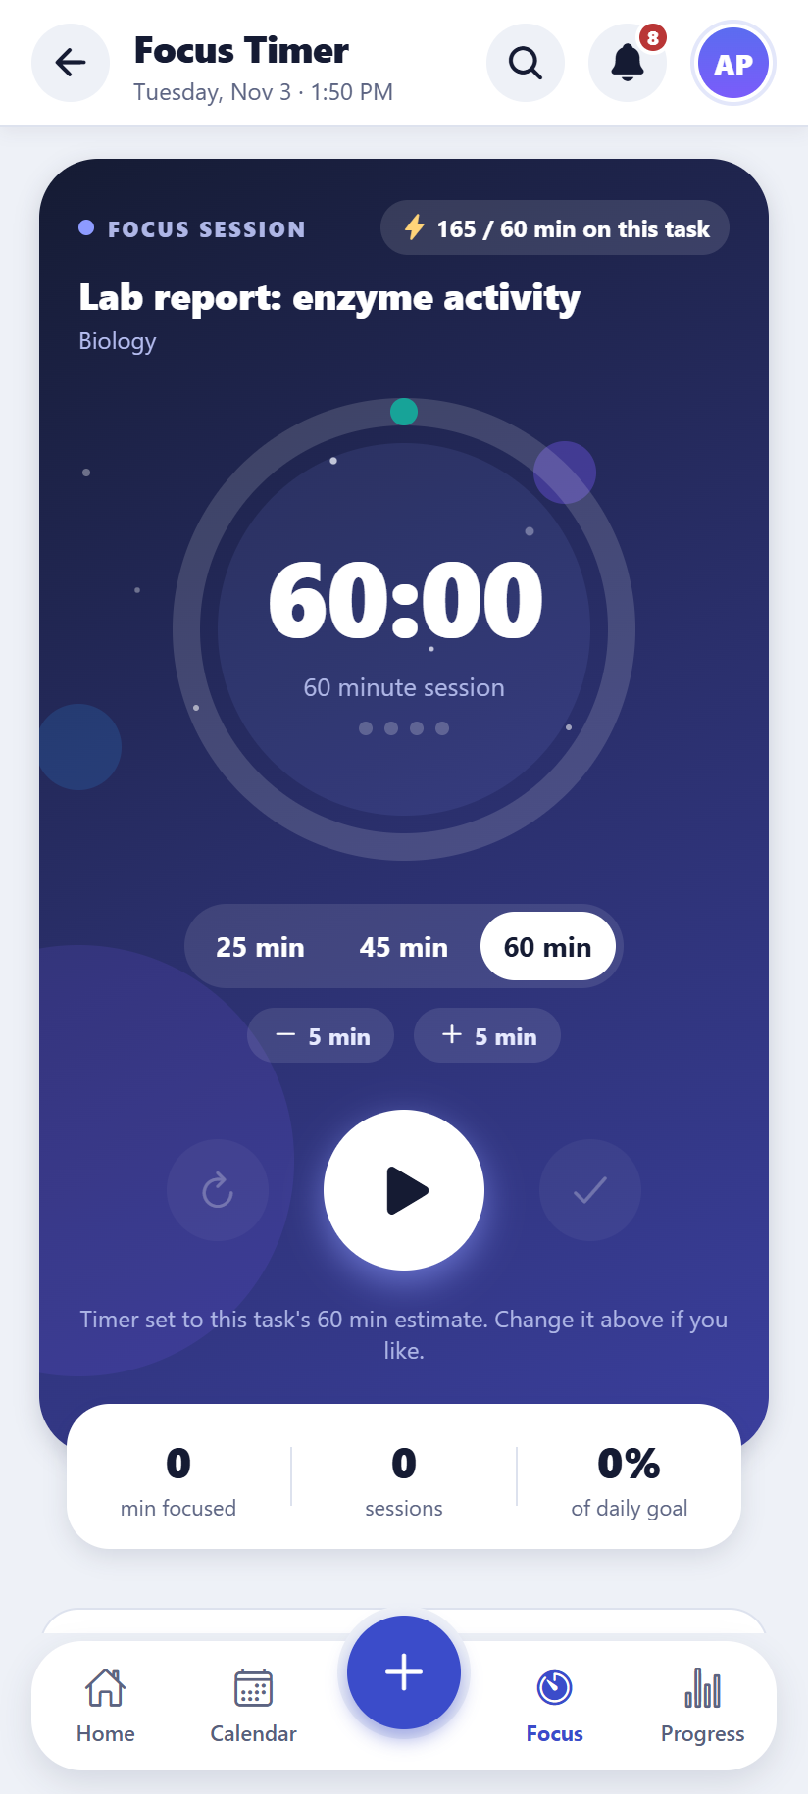  Android | 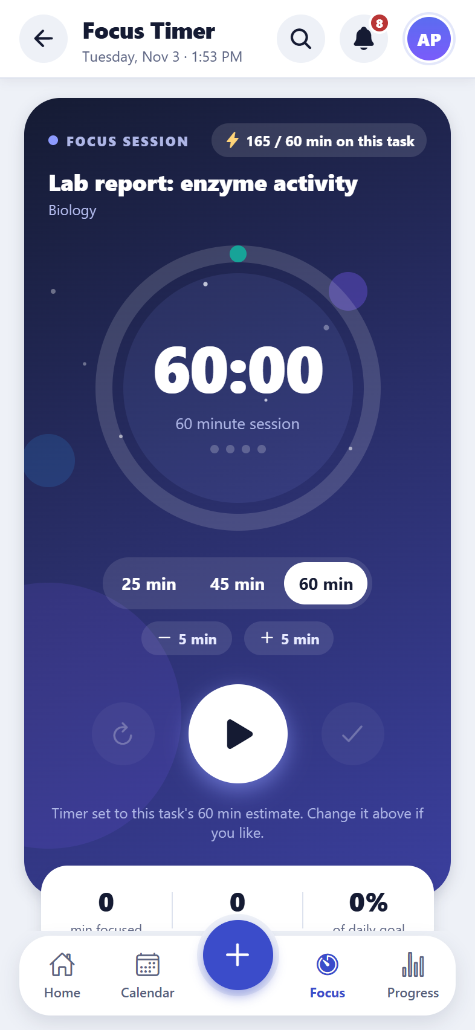  iPhone
The focus timer

Subjects
What it does
Each subject has a colour and an optional weekly study goal. Its card shows progress, open tasks, time studied this week, classes, grade and attendance.
How to use it
- Open Subjects from the menu; tap a subject to edit it.
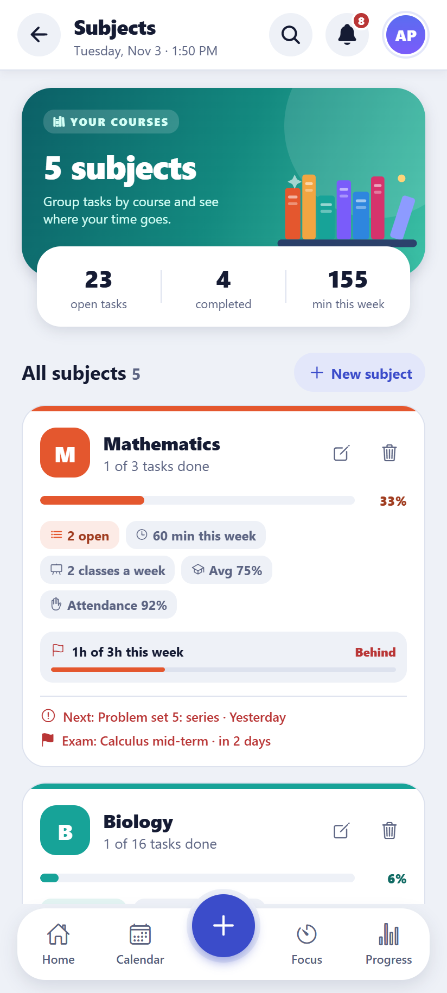  Android | 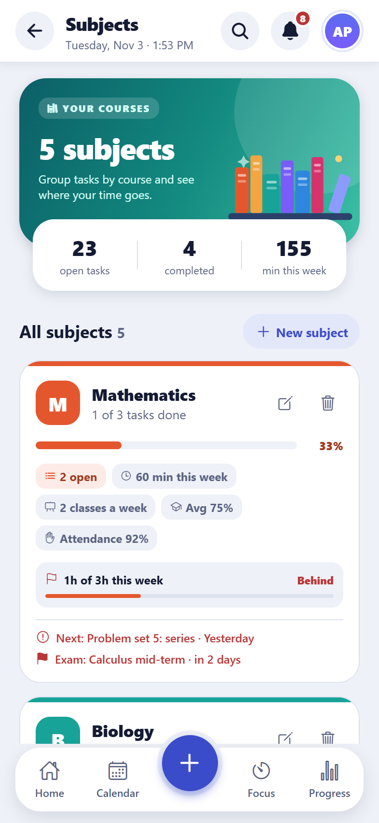  iPhone
Subjects

Flashcards (new)
What it does
Question-and-answer cards, in a deck for each subject. Reviews are spaced out: each card comes back just before it would be forgotten, sooner if it was hard and later if it was easy, so a few minutes a day is enough to remember a lot. The dashboard shows how many cards are due.
How to use it
- Menu → Flashcards → Add cards. Type one card, or choose “Paste many” and paste one card per line as “question | answer”.
- Tap “Review” to go through the cards due today: think of the answer, tap “Show answer”, then say how it went (Again, Hard, Good or Easy). Each button shows when the card will come back.
Good to know: Up to 20 new cards are started a day, so a large deck doesn’t arrive all at once. A card counts as “learnt” after three reviews in a row without “Again”.
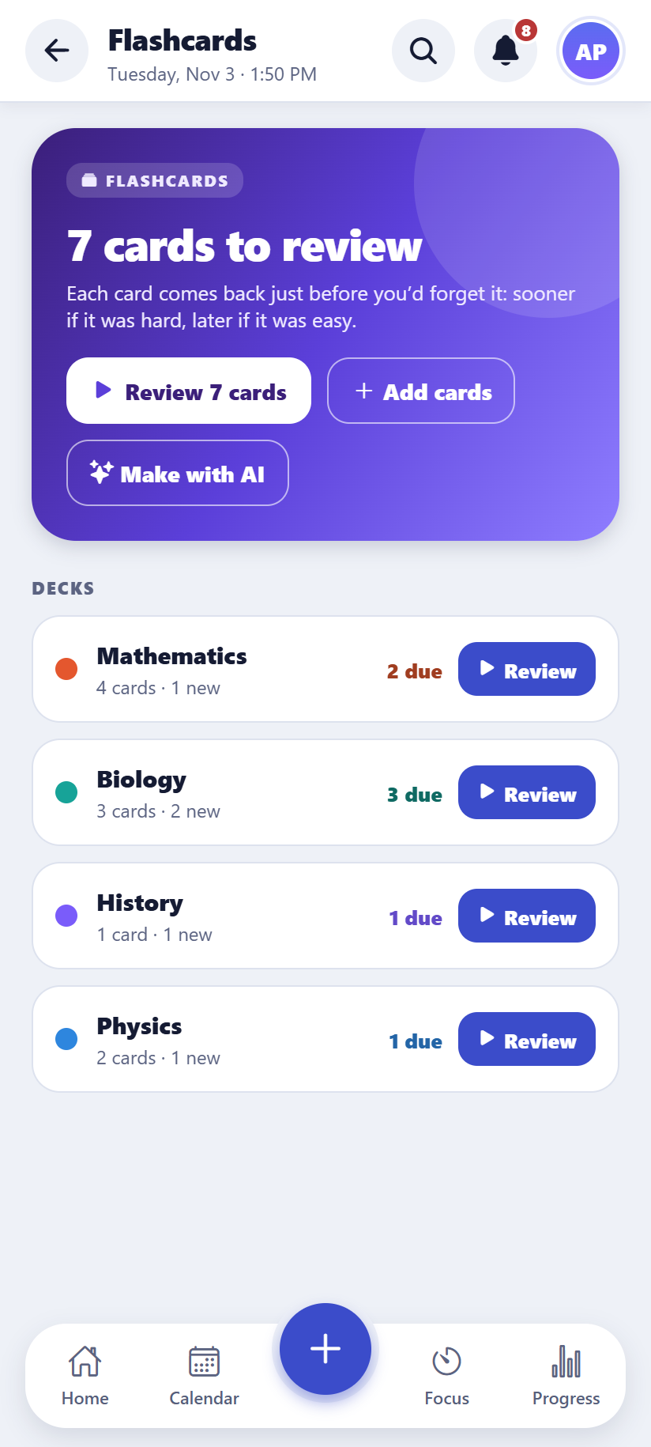  Android | 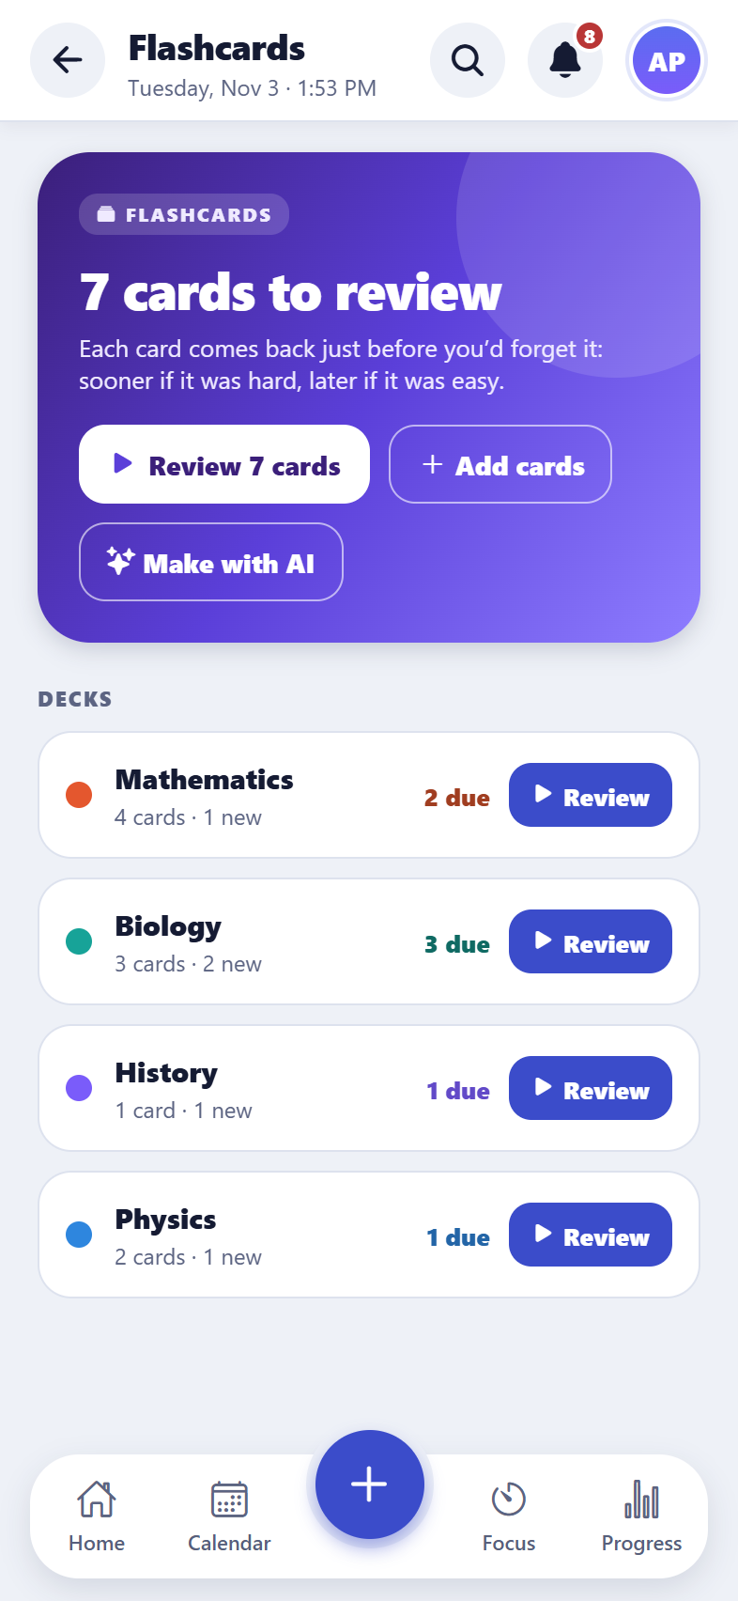  iPhone
Decks and the cards due today
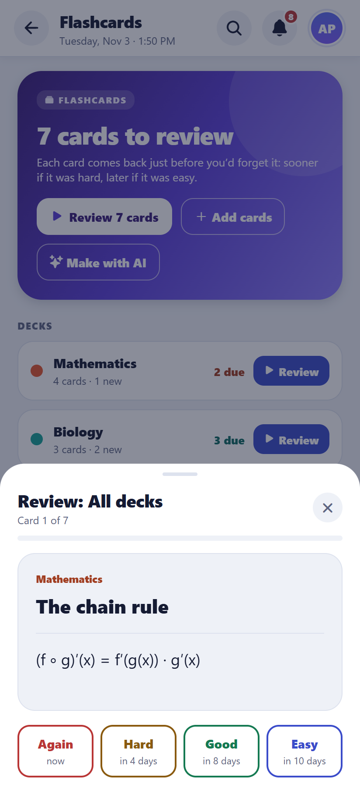  Android | 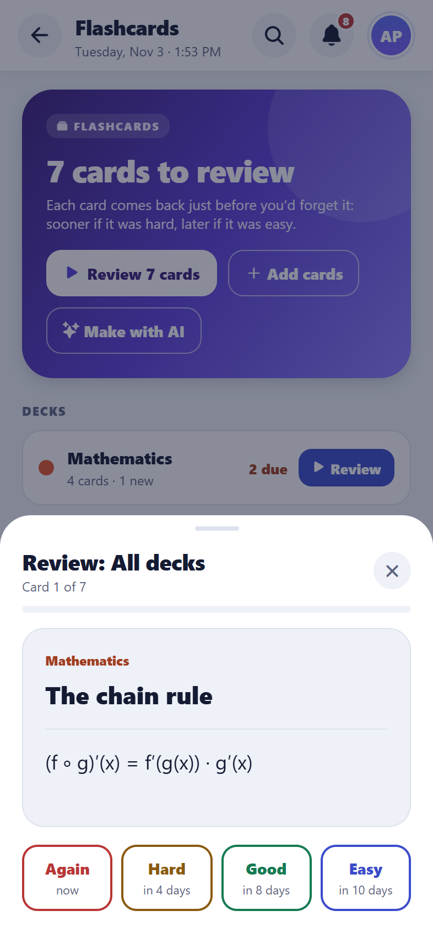  iPhone
Reviewing a card
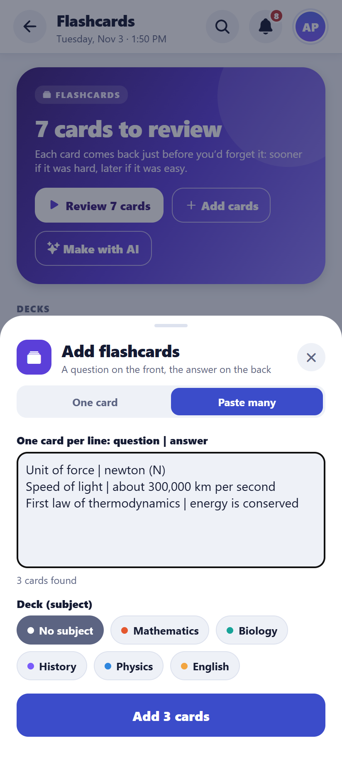  Android | 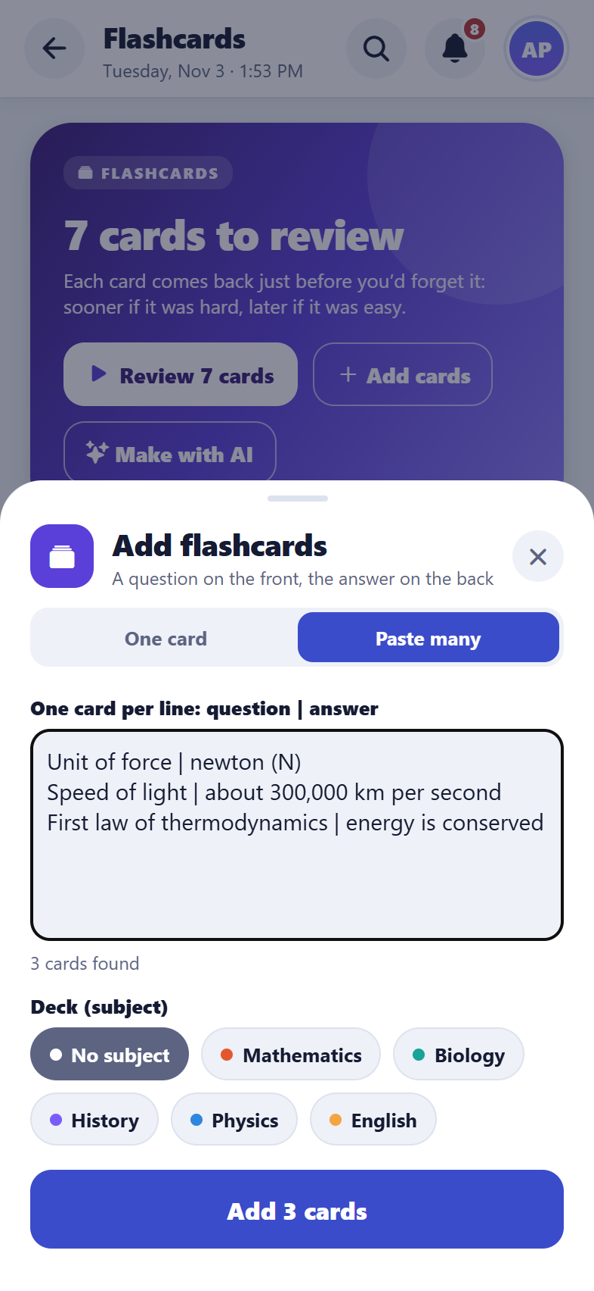  iPhone
Pasting many cards at once

Progress
What it does
Study streaks, minutes studied each day against the daily goal, time per subject, weekly goals and a weekly report.
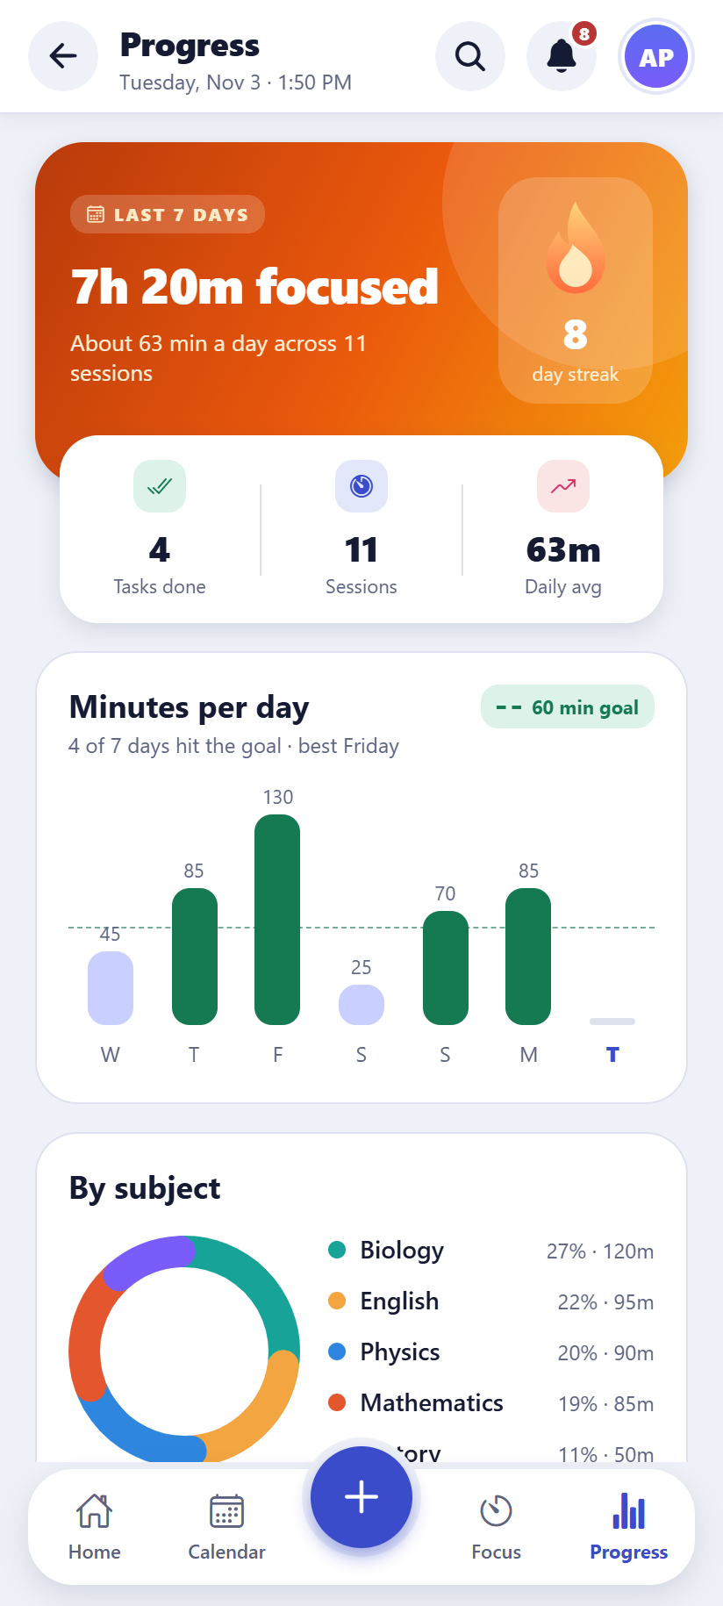  Android | 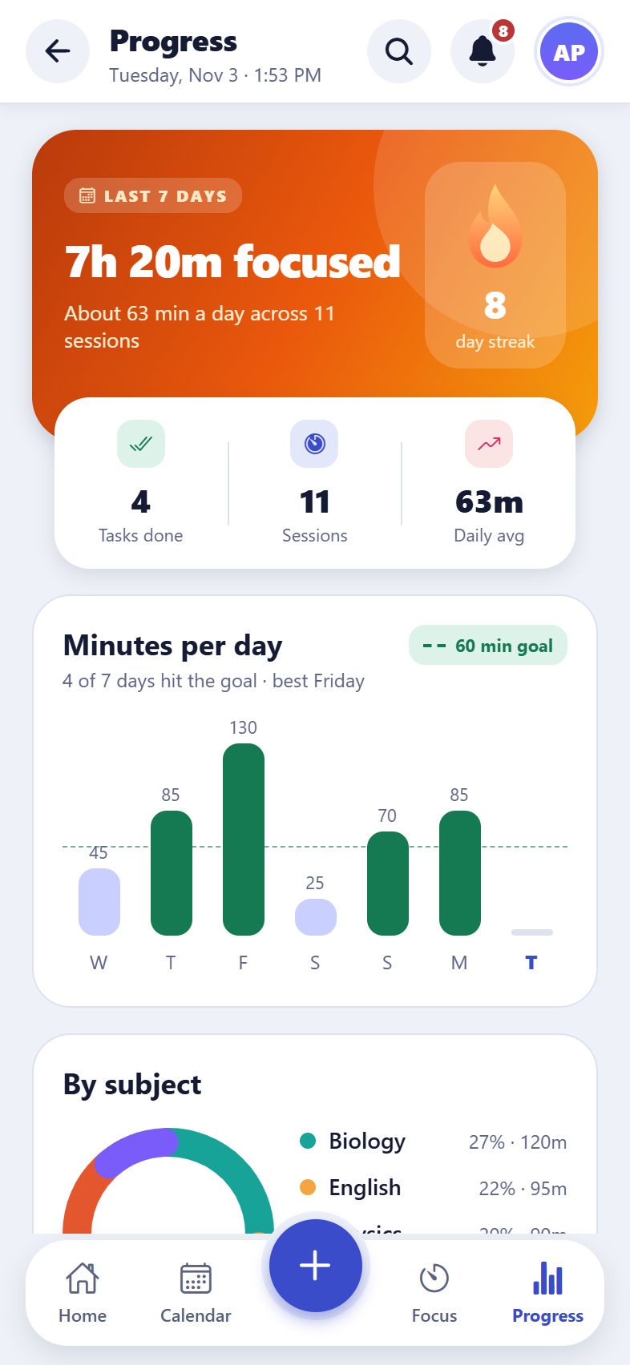  iPhone
The progress page

Weekly review (new)
What it does
A look back at the week (or the week before): tasks done, focus time compared with the week before, time per subject, what slipped, and what’s coming in the next 7 days. Overdue tasks can be moved to today or tomorrow, or spread over the next days, in one tap, with Undo.
How to use it
- Progress → Weekly review.
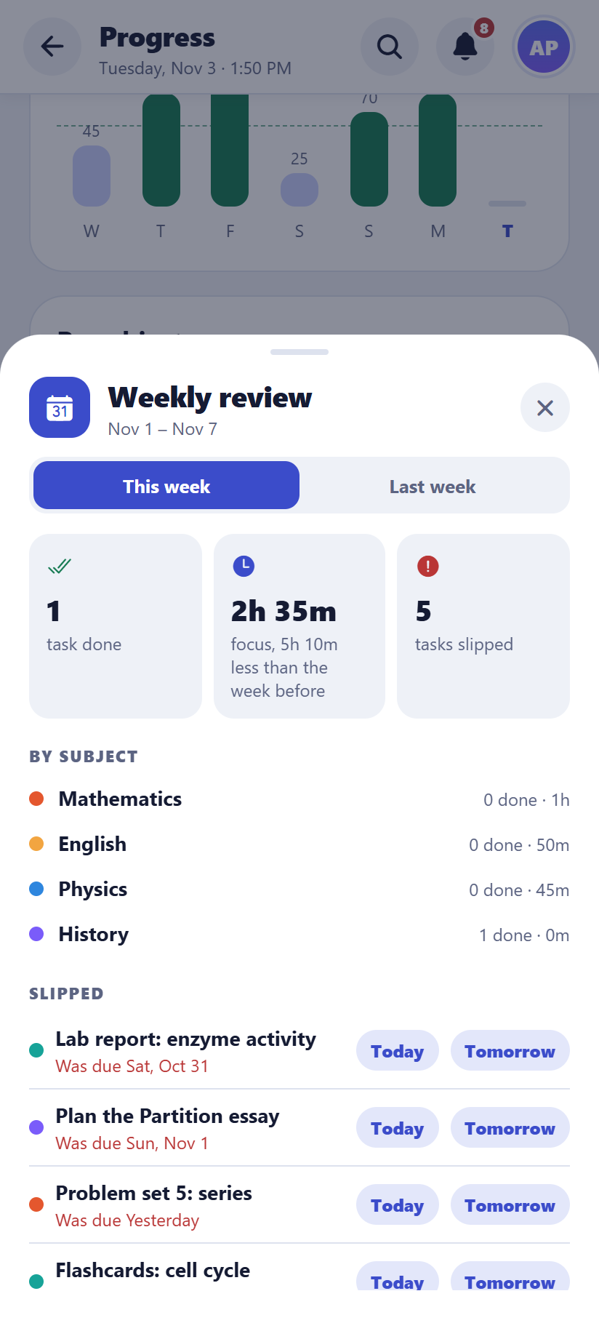  Android | 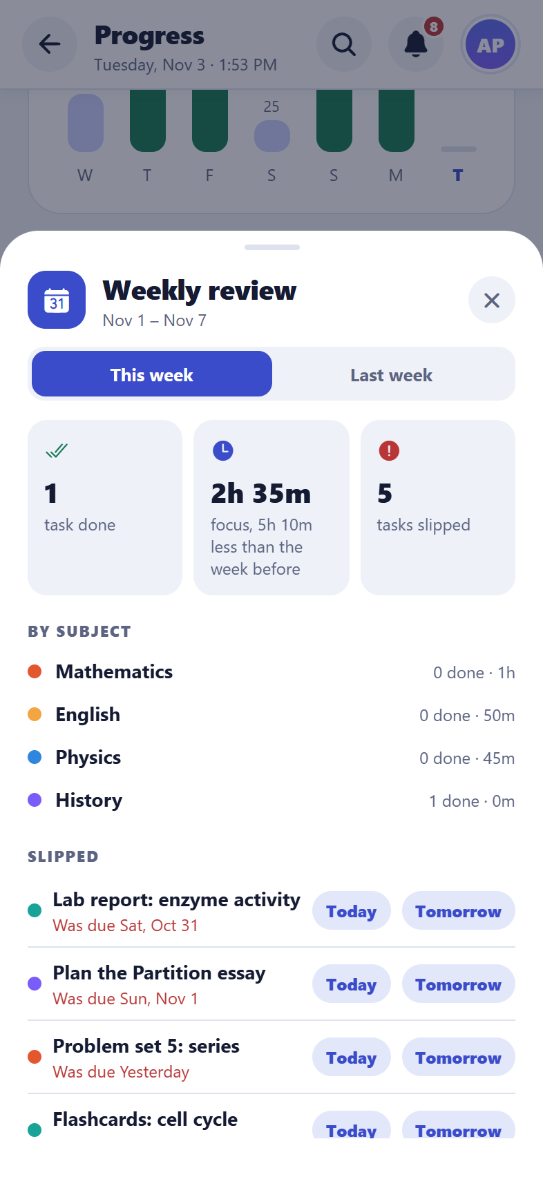  iPhone
The weekly review

Progress report for parents and teachers (new)
What it does
A one-page report for a parent, teacher or mentor, for this week, the last 4 weeks or this term: focus time and streak, tasks done on time, attendance and grades per subject, flashcards learnt and the exams in the next two weeks. The student’s name and school come from the profile. Notes and task details stay private.
How to use it
- Progress → Progress report. Choose the period.
- “Save as PDF” makes a PDF to send or print; “Share summary” shares a short text version (in a chat app, or copied on a computer).
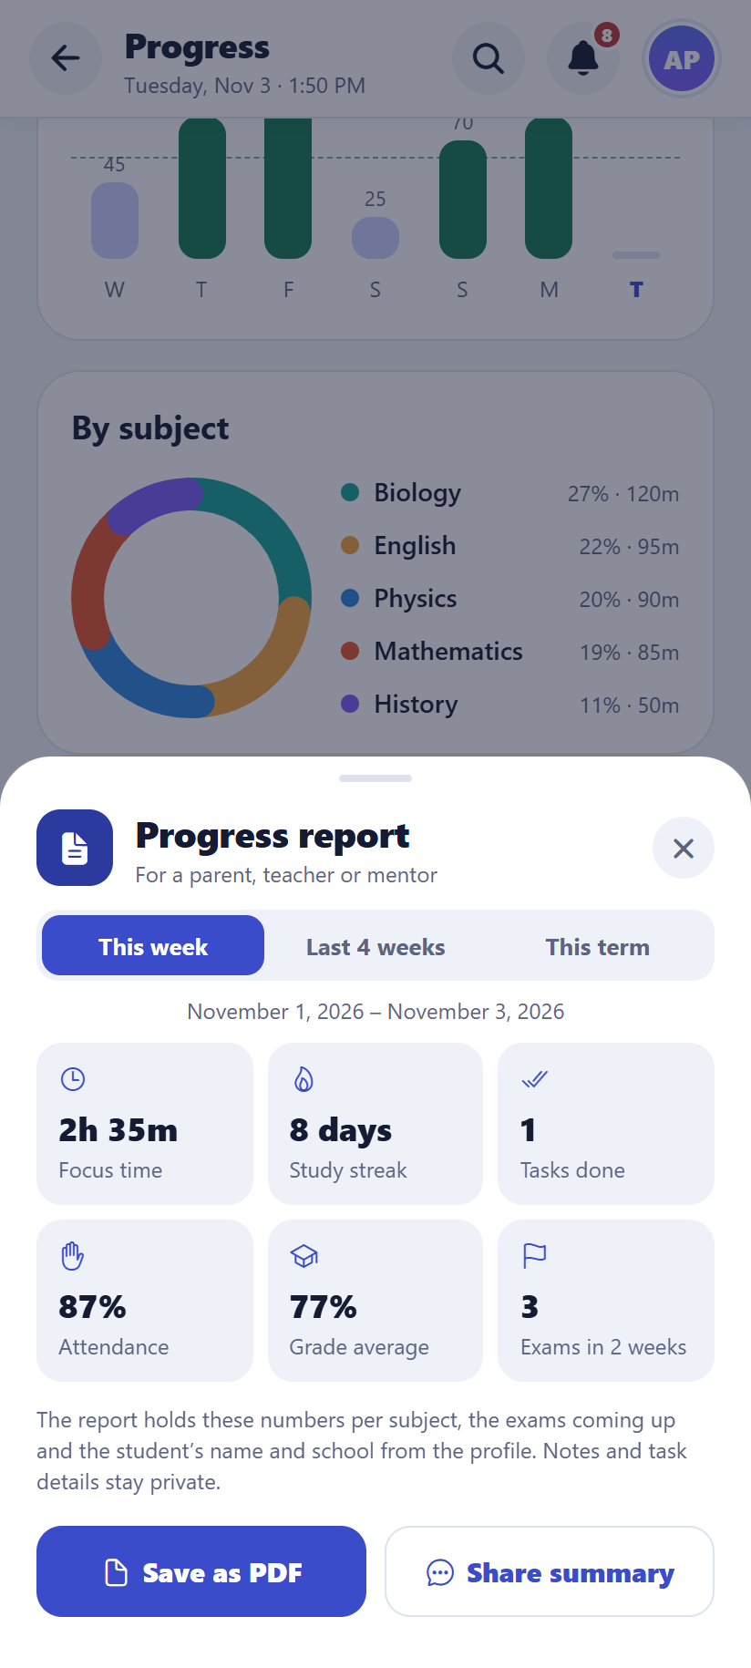  Android | 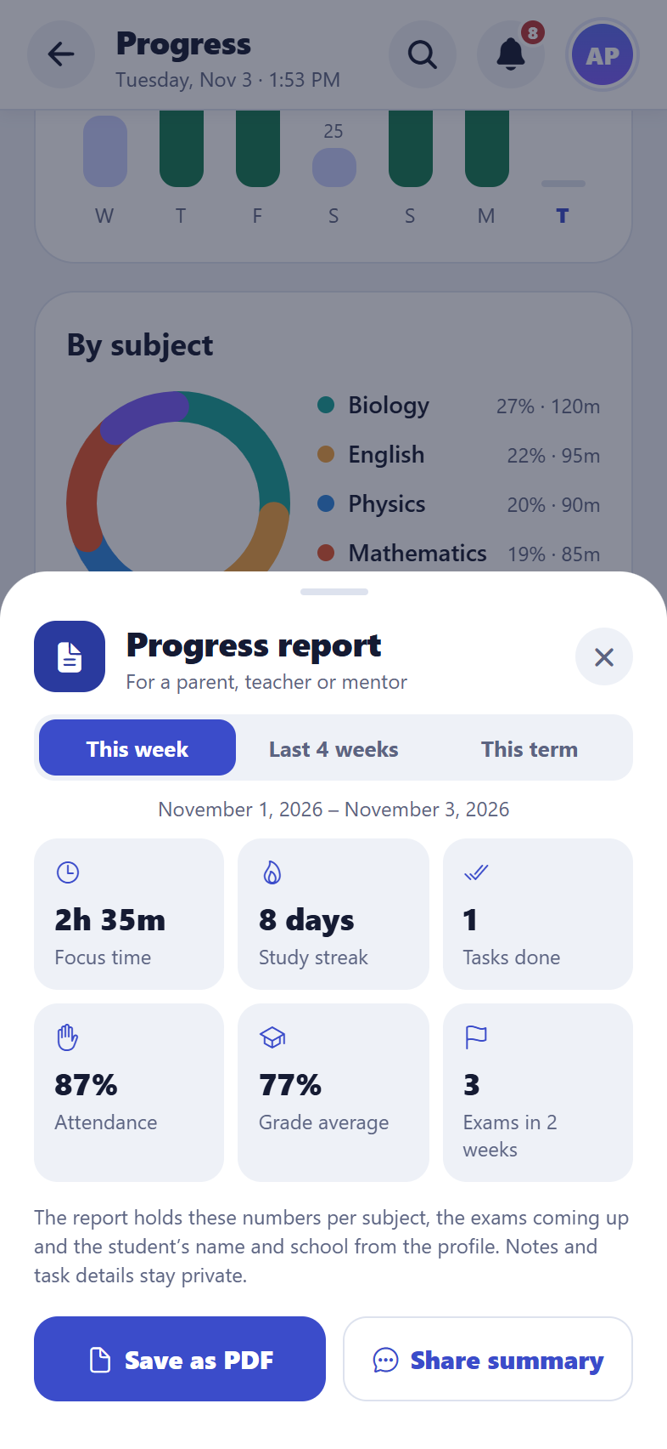  iPhone
The progress report

Achievements and streak protection (new)
What it does
Badges for study streaks, hours of focus, sessions, tasks done, finished exam prep plans and flashcards learnt, 18 in all. Badges not yet earned show how close they are, and a new badge pops up once when it’s earned. Streak protection means one missed day a week doesn’t break a streak, as long as the days either side were studied.
How to use it
- Progress → Achievements. “Almost there” lists the badges closest to being earned.
Good to know: Two missed days in a row still end a streak. The dashboard, profile and report all count the streak the same way.
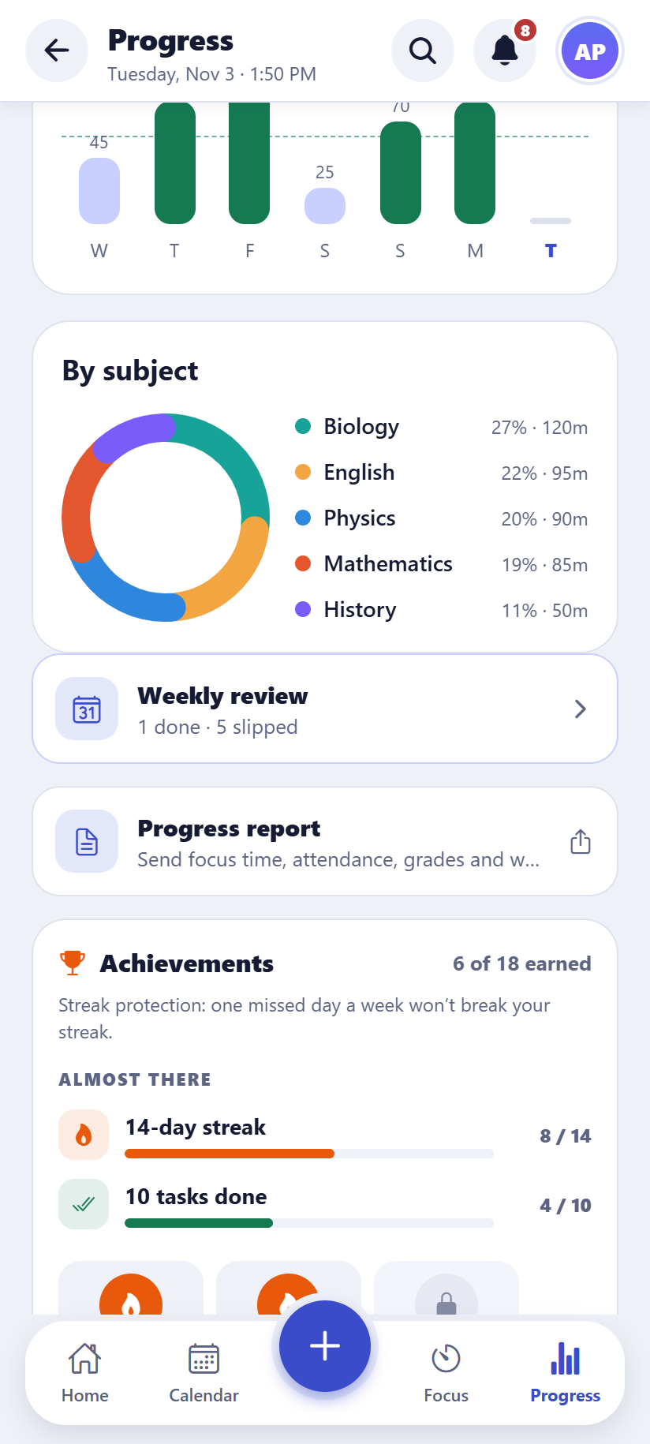  Android | 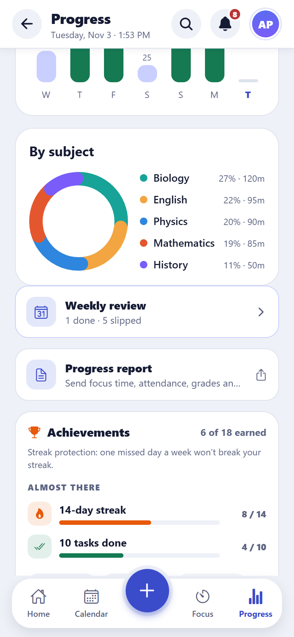  iPhone
Achievements

AI study helper: what to study now (new)
What it does
The AI helper (Claude, by Anthropic) looks at what’s due, the coming exams, weaker subjects and recent focus time, and suggests the next study session: 2 to 4 steps, most urgent first, each with why it matters and how long to spend.
How to use it
- Dashboard → “What should I study now?” → “What should I study now?”. “Ask again” gives a fresh suggestion.
Good to know: Only titles, dates and numbers are sent, never notes or task details, and only when the student asks. Each account can ask 30 times a day.
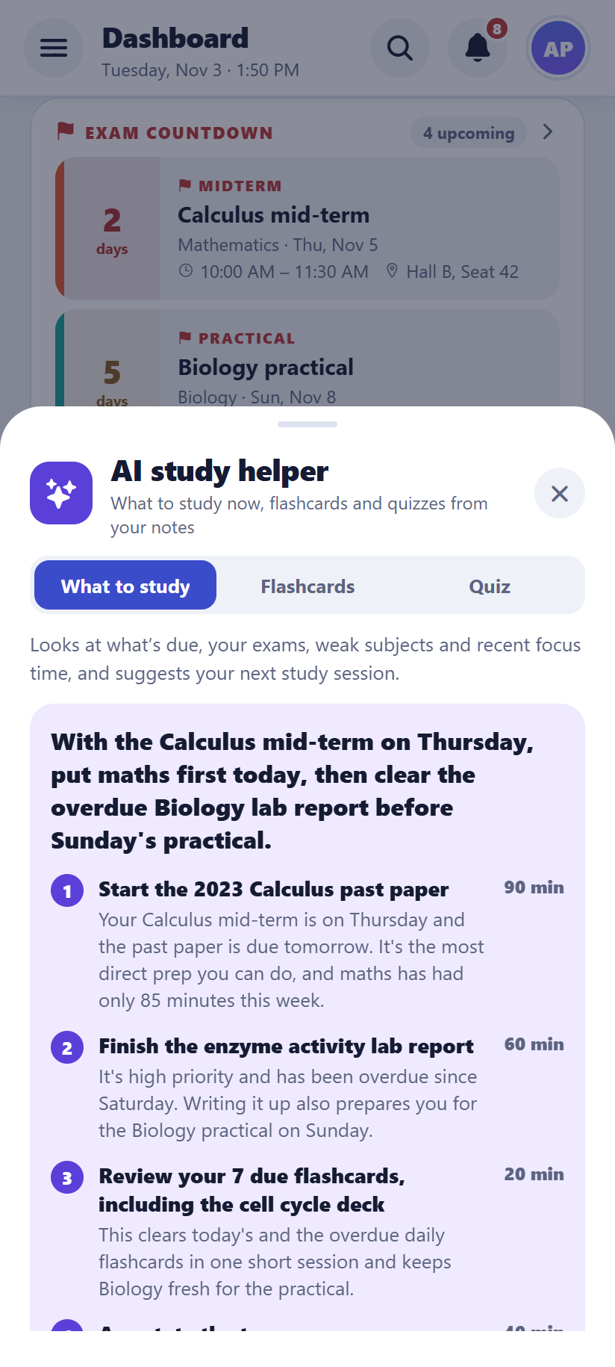  Android | 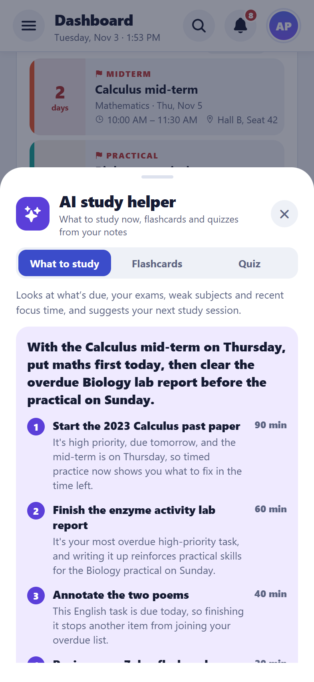  iPhone
A suggested study session

AI study helper: flashcards, quizzes and prep topics (new)
What it does
Paste a page of notes and the helper makes flashcards from the key points (keep the ones you want) or a 5-question practice quiz with explanations. In an exam prep plan, “Suggest with AI” fills in the topics to revise. Answers come in the app’s language.
How to use it
- Flashcards → “Make with AI”, or Dashboard → “What should I study now?” → the Flashcards or Quiz tab. Pick a subject, paste notes, then “Make flashcards” or “Make a quiz”.
- Untick any cards you don’t want, then add them. In a quiz, tap an answer to see if it’s right and why.
Good to know: Notes can be up to 20,000 characters. AI can make mistakes, so check the cards before relying on them.
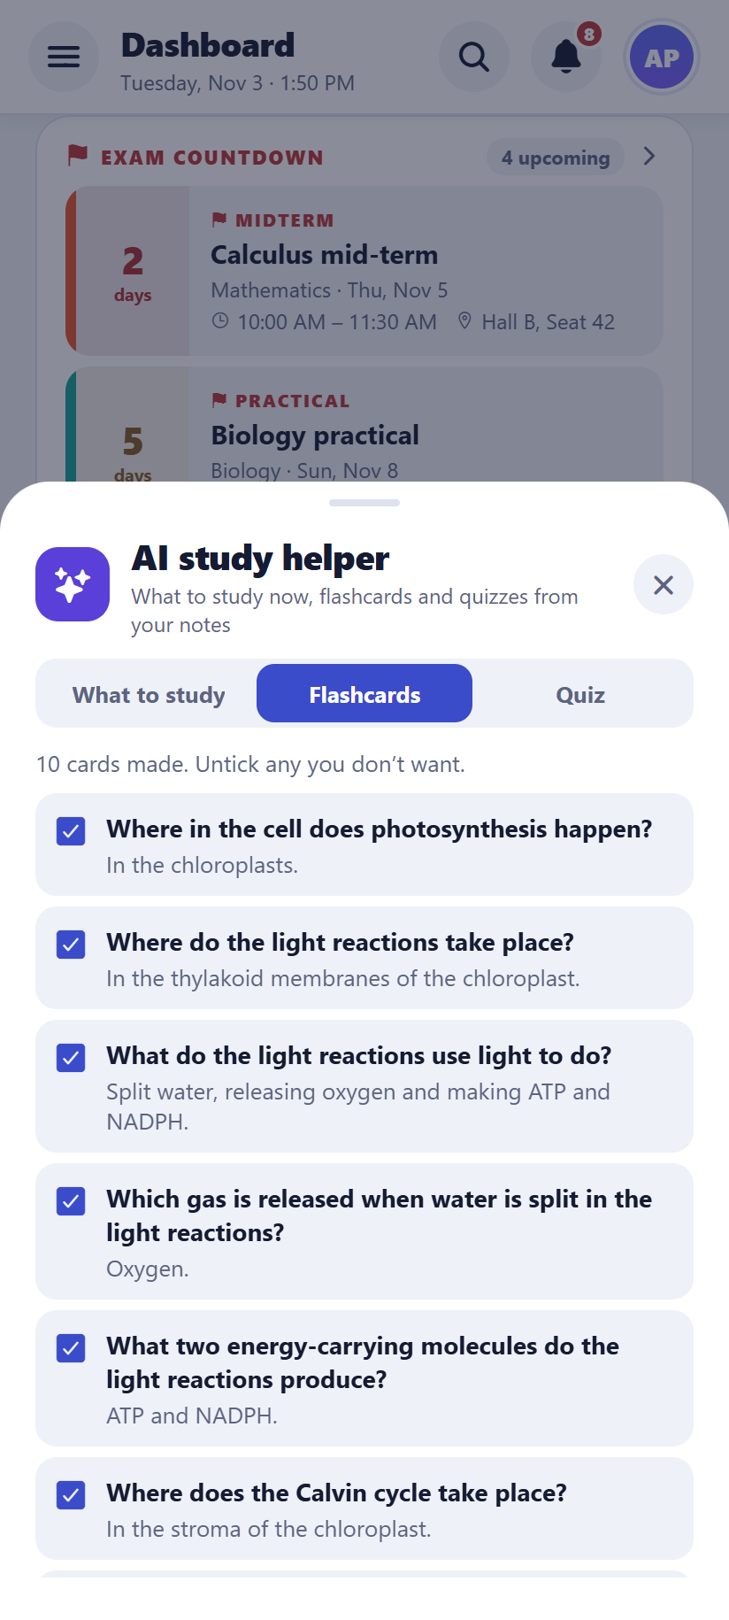  Android | 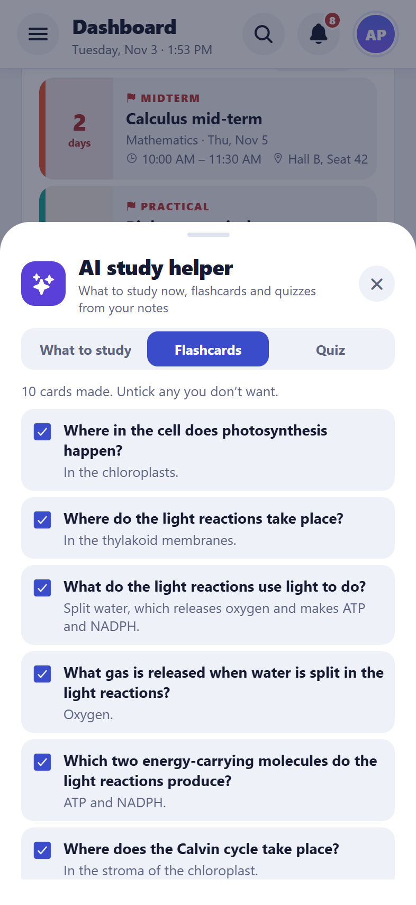  iPhone
Flashcards made from notes

Grades and GPA
What it does
Scores from exams give an average per subject (as a percentage, a 4-point GPA or a 10-point CGPA) and a trend over time.
How to use it
- Add a score to an exam after it has happened.
Android | 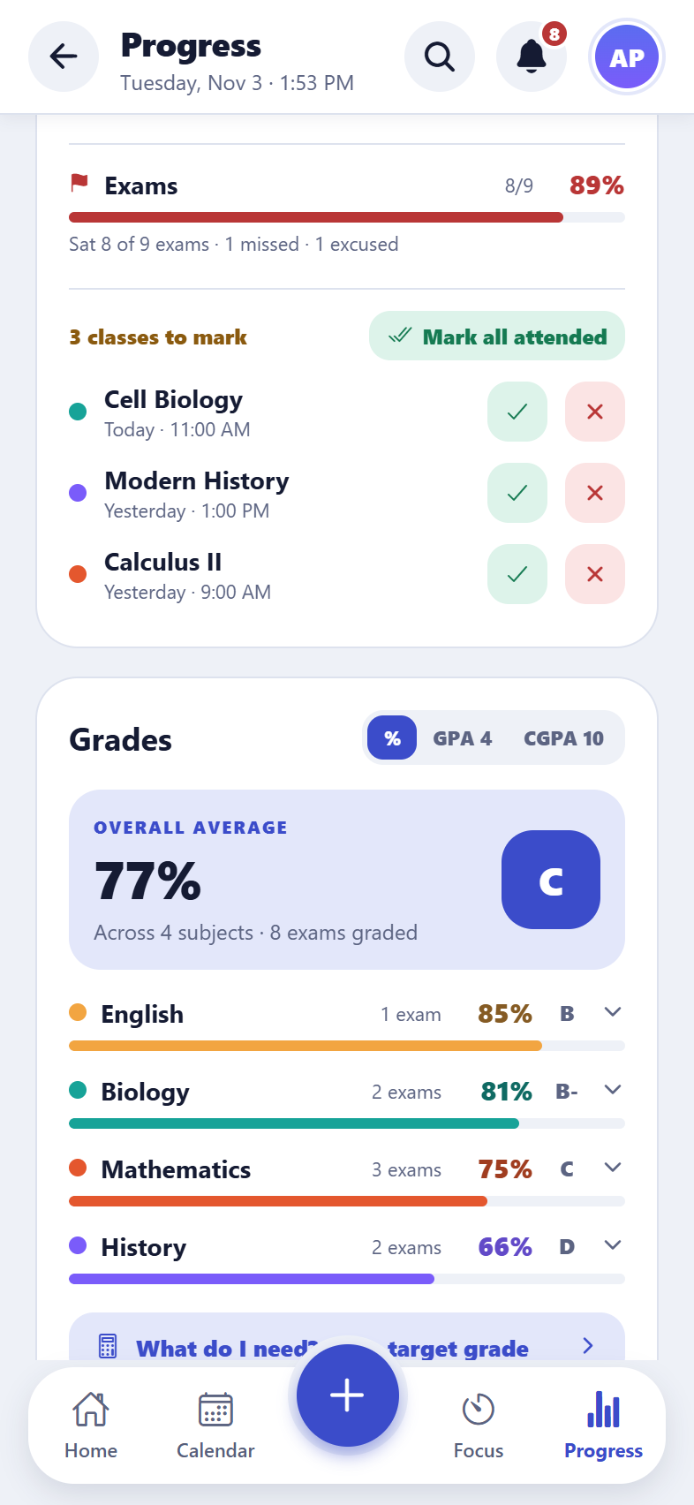  iPhone
Grades on Progress

“What do I need?” calculator
What it does
Pick a target grade and the app says what score is needed in the next exam to reach it, and shows what an average would become with a given score.
How to use it
- Progress → “What do I need? Try a target grade”.
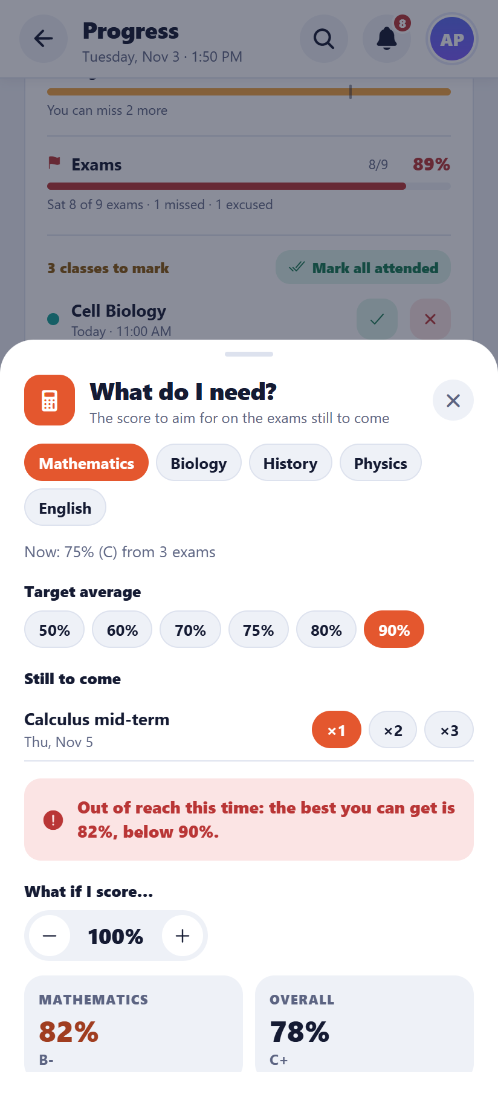  Android | 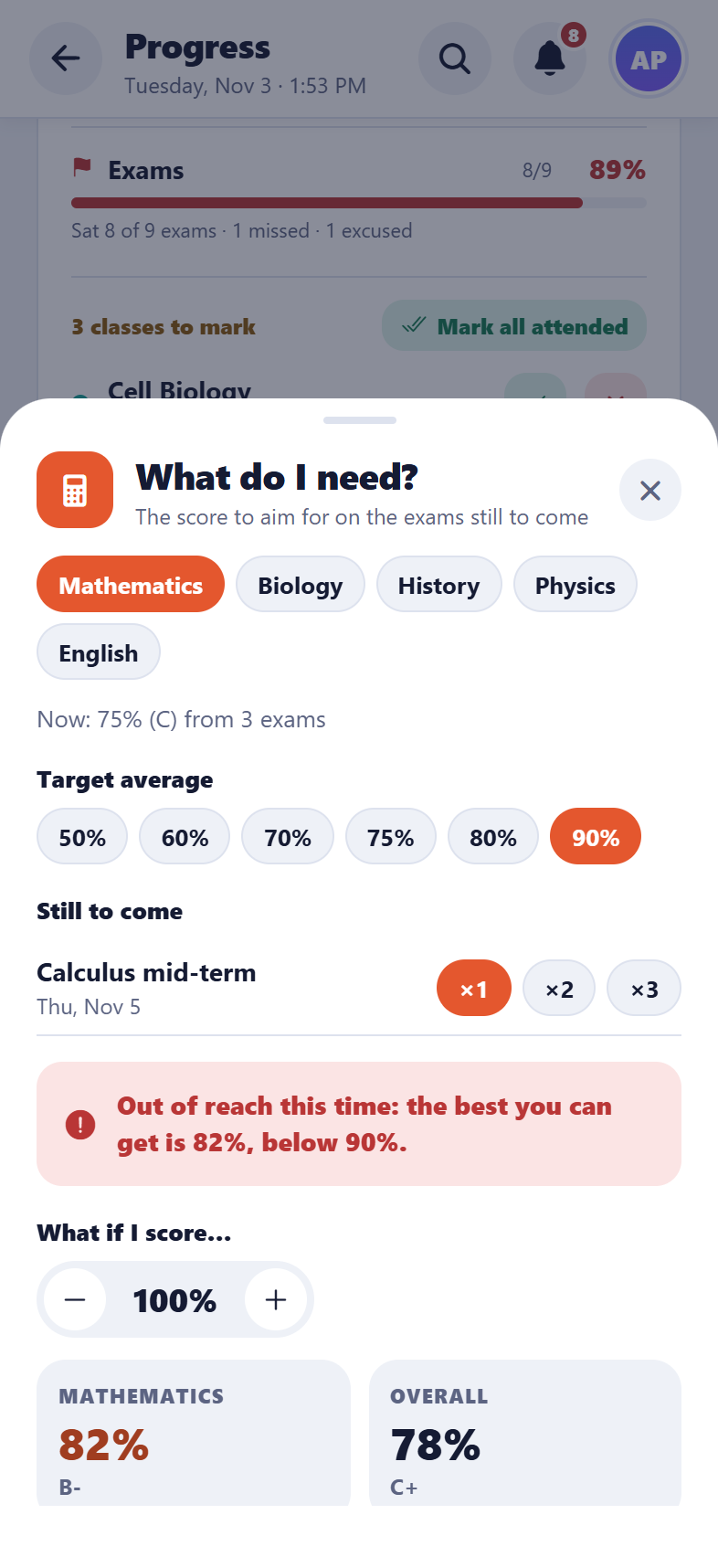  iPhone
The what-if calculator

5. Reminders
Reminders inside the app and, on phones, as notifications.

In-app alerts
What it does
The bell at the top lists overdue tasks, tasks due today and exams in the next three days.
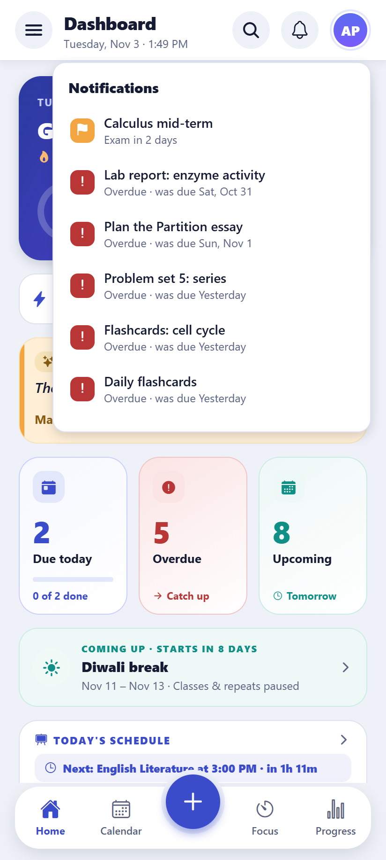  Android | 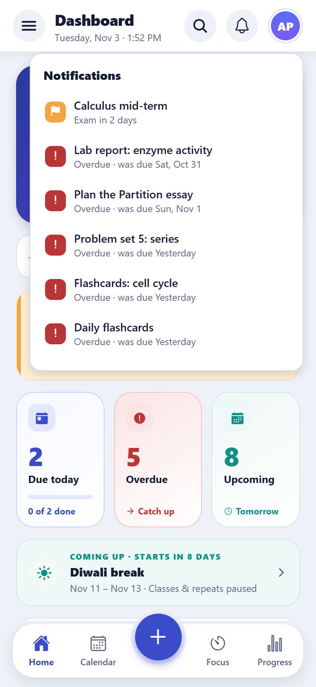  iPhone
The alerts list

Phone notifications
What it does
Notifications for tasks on their due day (with Done and Snooze buttons), the evening before and the morning of an exam, 10 minutes before a class, an evening reminder to mark attendance, a daily study reminder at a chosen hour, and a weekly report.
How to use it
- Settings → Notifications.

Smart reminders (new)
What it does
The app learns when the student usually studies (from their focus sessions) and reminds them at that time about what’s due, for example “You usually study around 6 PM: 3 tasks due tomorrow · Physics mid-term in 3 days”. It stays quiet on days with nothing due, or once they’ve started studying.
How to use it
- On by default: Settings → Smart reminders shows the time it has learnt.

Home-screen widgets
What it does
Two widgets for the home screen of an Android phone or an iPhone. “Next class” shows the next class and when it starts. “Today” (new) shows how many tasks are left today, the first three of them, focus time against the daily goal, and how many flashcards are due.
How to use it
- Long-press the home screen → Widgets → Study Planner, then pick “Next class” or “Today”.
Good to know: Widgets need the installed app (not Expo Go or the web). They refresh whenever the app opens or the tasks change.

Shortcuts on the app icon (new)
What it does
Press and hold the Study Planner icon on the home screen for three shortcuts: New task (opens the new task sheet), Start focus (opens the focus timer) and Review flashcards. They show in the app’s language.
How to use it
- Long-press the app icon, then tap a shortcut.
- On Android, a shortcut can also be dragged onto the home screen as an icon of its own.
Good to know: Shortcuts need the installed app (not Expo Go or the web).

6. Study groups and classrooms
Classmates can share timetables, and the group’s owner can post notes and tasks for everyone. Teachers can share study materials with their own students in a classroom.

Live study groups
What it does
A student shares their classes, exams and breaks with classmates through a link or QR code. Classmates who join get them in their own calendar, and when the owner changes something, everyone’s copy updates by itself. Private things (attendance, scores, notes, homework, tasks) are never shared.
How to use it
- Settings → Share my timetable → choose what to share → Create live link, then copy, share or show the QR code.
- The owner sees how many members each group has, and can stop sharing.
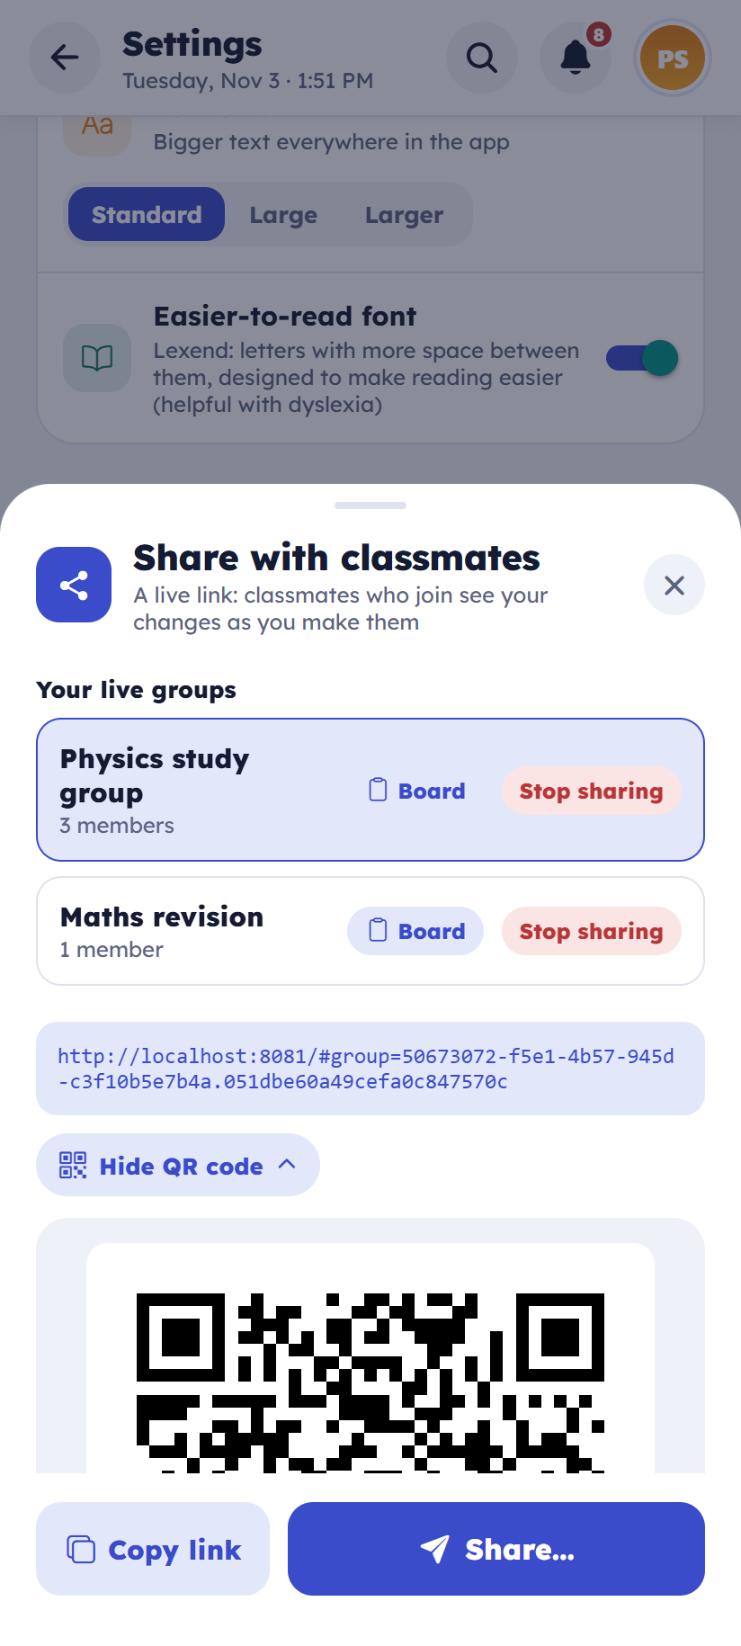  Android | 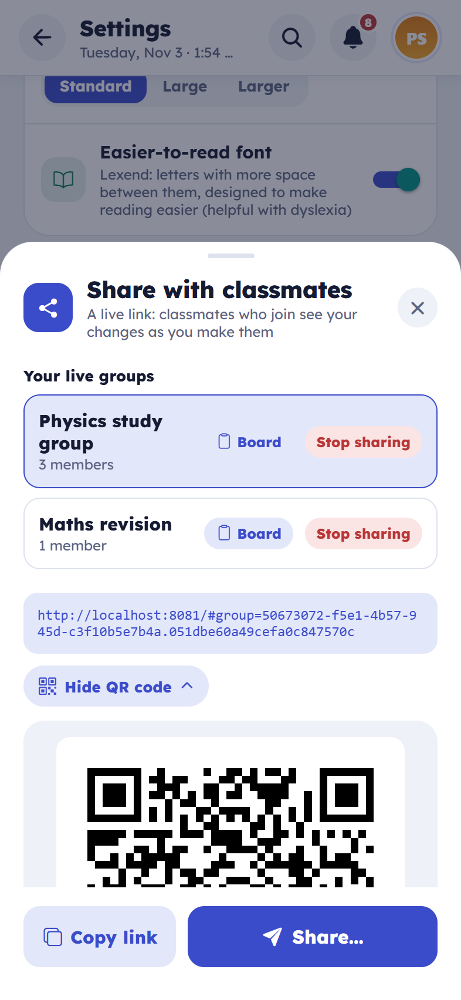  iPhone
Sharing a live group with a link and QR code

Joining a group
What it does
Opening a group link shows the group, who shared it and what it will add, before joining. A member can leave a group at any time.
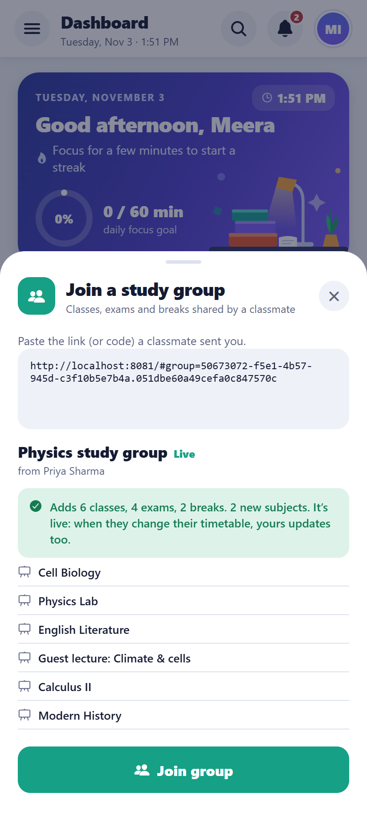  Android | 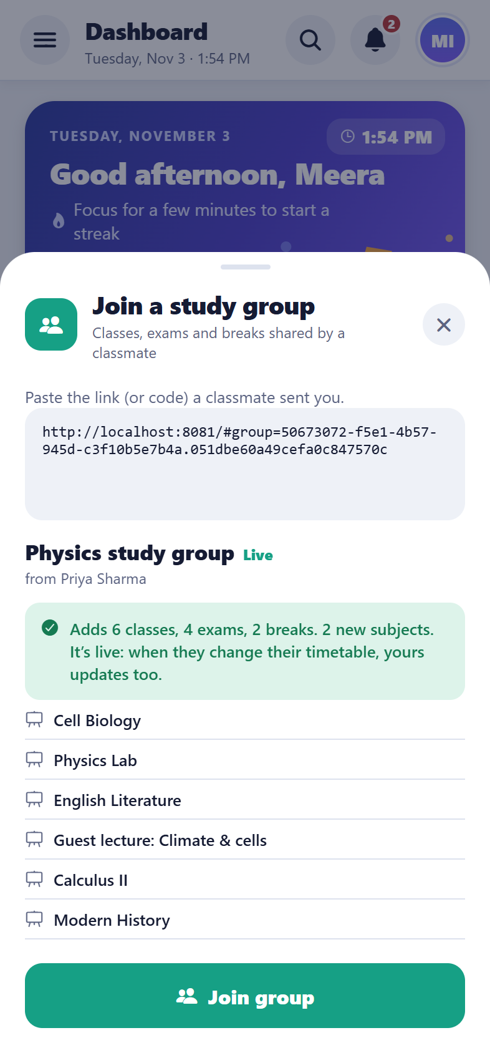  iPhone
Joining a group from a link

Group board: notes (new)
What it does
The group’s owner posts notes such as “Test moved to Friday”, and can pin the important ones to the top. Members see them straight away, with a pop-up when a new one arrives.
How to use it
- Owner: Settings → Share my timetable → Board.
- Member: Settings → the board button next to the group.
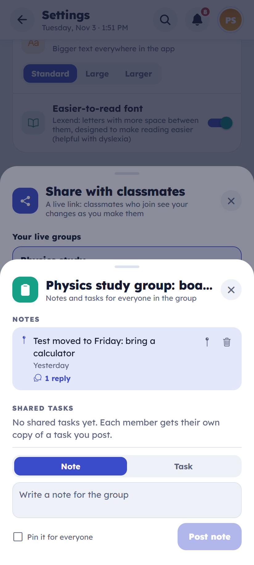  Android | 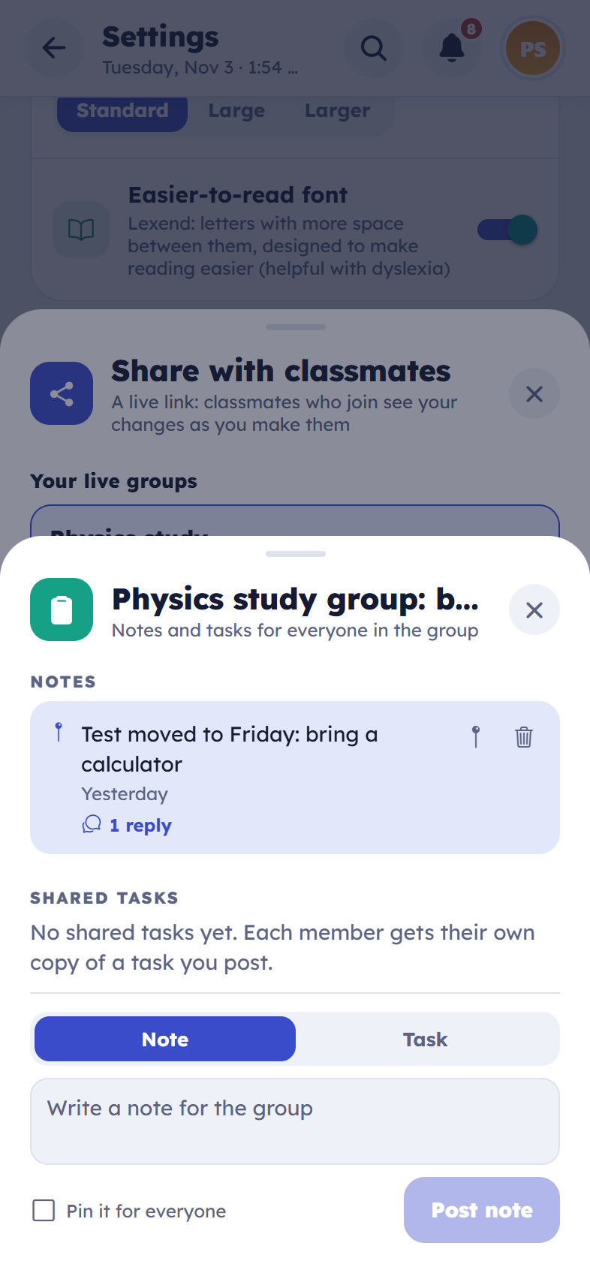  iPhone
The owner’s board

Group board: shared tasks (new)
What it does
The owner posts an assignment (title, due date, length, details) and every member gets their own copy in their task list to tick off. If the owner changes it, the copies not yet done change too; if the owner removes it, the copies not yet done go. A member who deletes their copy doesn’t get it back.
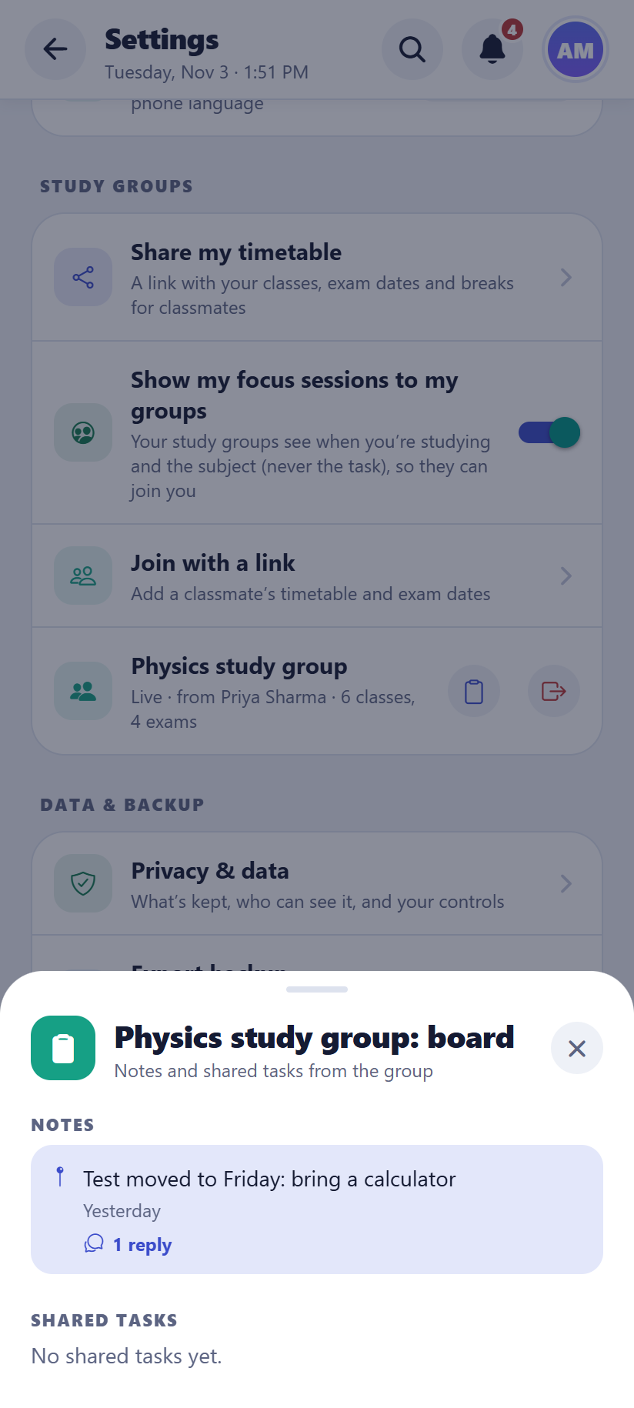  Android | 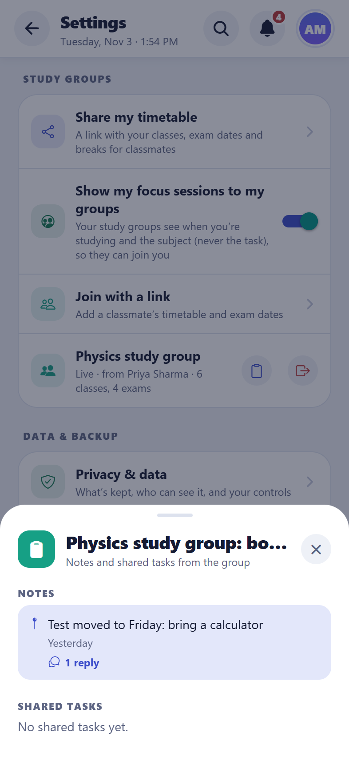  iPhone
A member’s view: the pinned note and the task “In your tasks”

Replies on the board (new)
What it does
Anyone in a group, the owner and every member, can reply under a note or a shared task (“Is it chapters 4 and 5?”). Replies appear for everyone straight away. People delete their own replies, and the owner can delete any. Each reply shows who wrote it and when; the name comes from the account, so it can’t be faked.
How to use it
- Open the group’s board → “Reply” (or “2 replies”) under a post → type → send.
Good to know: Up to 50 replies on each post.
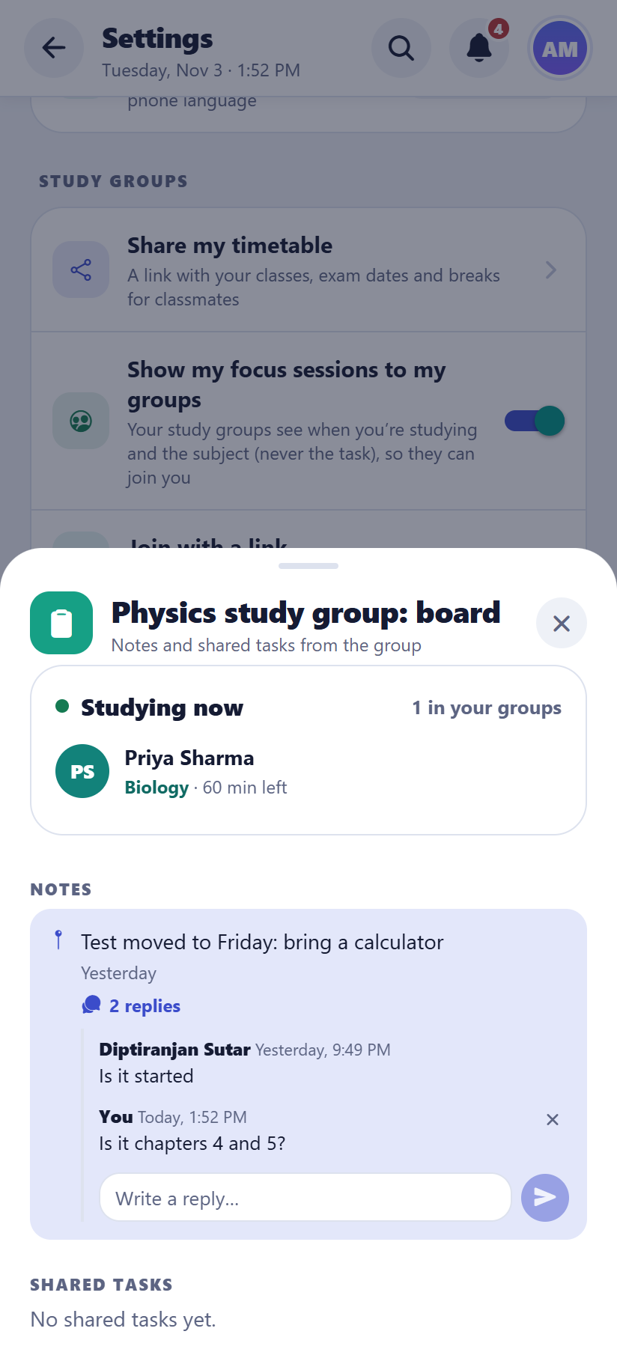  Android | 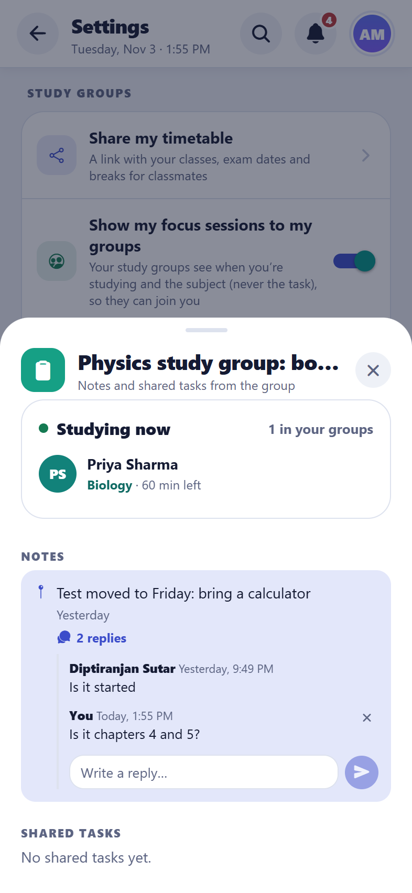  iPhone
A reply under a note

Study together (new)
What it does
The Focus screen shows who in your study groups is studying right now: their name, the subject and how many minutes are left (never the task). “Join” starts your own focus session that ends when theirs does. While focusing, a line under the timer says who else is studying (“Priya is studying too”), and each group’s board shows who in that group is studying.
How to use it
- Focus Timer → Studying now → Join.
- Settings → Study groups → “Show my focus sessions to my groups” turns sharing off; you still see the others.
Good to know: Only the group’s owner and members can see it, and nothing is stored: a status goes when the timer stops or the app closes.
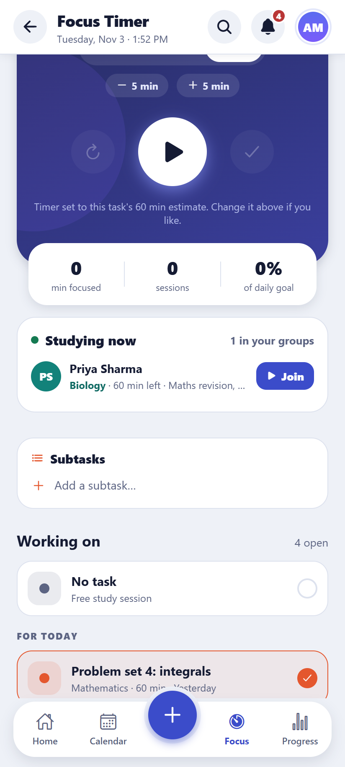  Android | 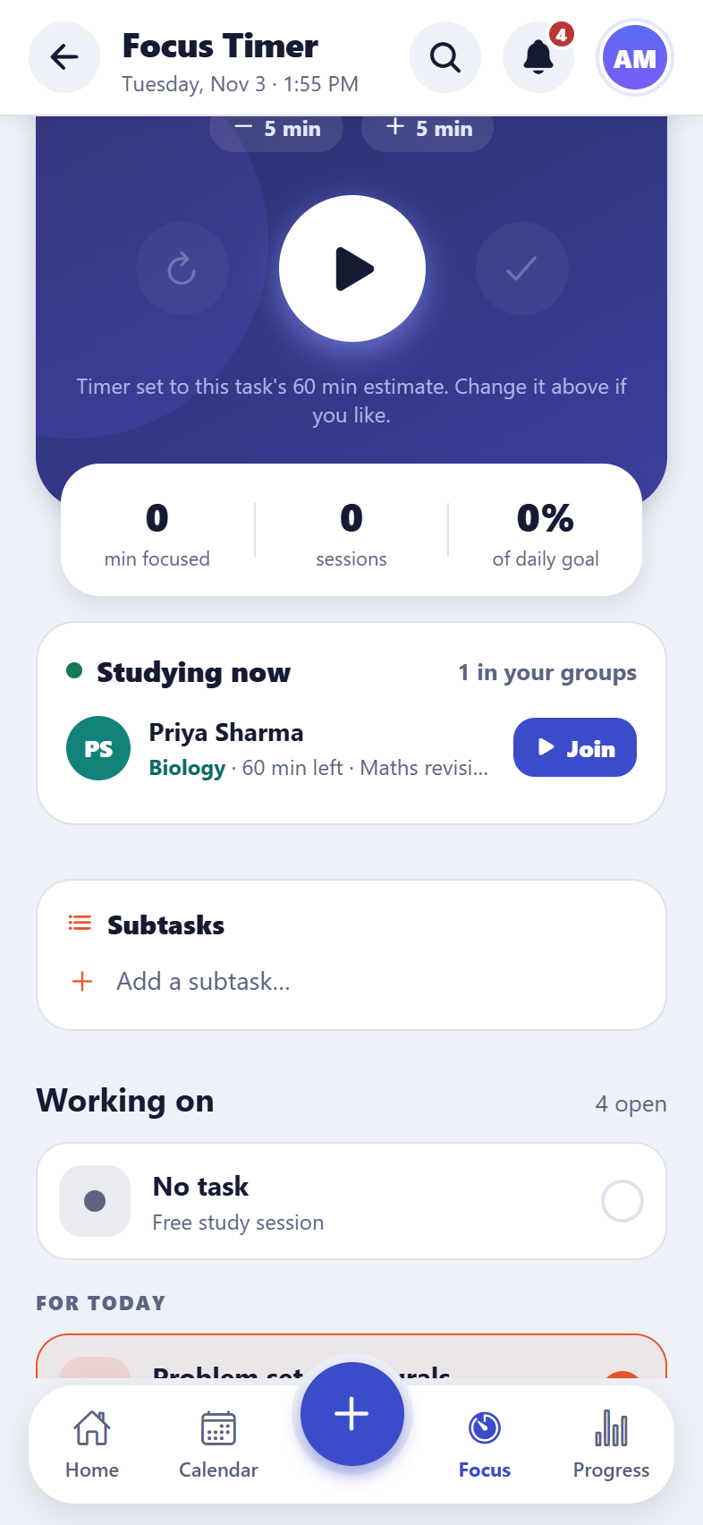  iPhone
Studying now

Classrooms for teachers (new)
What it does
A teacher makes a classroom and shares study materials with their own students only: PDFs, photos of the board, Word, PowerPoint and Excel files (up to 20 MB each), web links such as videos, and notes. Students join with the classroom’s 8-letter code, and the teacher approves each one. Students who aren’t approved, and anyone else, can’t see anything.
How to use it
- Menu → Classrooms → Create → give it a name (e.g. “Physics 10-B”) and a subject → Create classroom.
- Share the code with the class (the Share button sends it by WhatsApp, email and so on).
- Students tab: Approve or Decline each request. Remove a student at any time, or make a new code if the old one is passed around.
- Materials tab → Add material → File, Link or Note. Pin important ones to the top; the bin deletes one (tap twice).
- Reports tab: what students reported about your materials (never who sent it). Resolve a report, or delete the material.
Good to know: Free: 1 classroom and 200 MB of files. Premium: 10 classrooms and 5 GB. Students never see each other’s names; the teacher sees only names, never their tasks or grades.

Joining a classroom (new)
What it does
Students get their teacher’s materials in the app. New materials show a “New” badge, and a message pops up when the teacher adds one while the app is open.
How to use it
- Menu → Classrooms → Join with a code → type the code from the teacher → Ask to join.
- Wait for the teacher to approve (a message says “You’re in!”), then open the classroom.
- Tap a file to open it in the phone’s PDF, Office or photo app; tap a link to open it in the browser.
- The flag button reports a material: the teacher sees the report without the student’s name. “Report this classroom” goes only to the Studyly team.
Good to know: Leave a classroom at any time from inside it. File links work for one hour, so a forwarded link stops working.

7. Cloud, sync and safety
The student’s data is theirs: saved on the device first, kept in step across devices, and backed up.

Sync across devices
What it does
Every change is saved on the device at once and sent to the cloud within a second or two. Other devices signed in to the same account update live. If the same task is changed on two devices, the changes are merged field by field, so neither is lost.
How to use it
- Nothing to do. Settings → Cloud sync shows when it last synced, with a “Sync now” button.
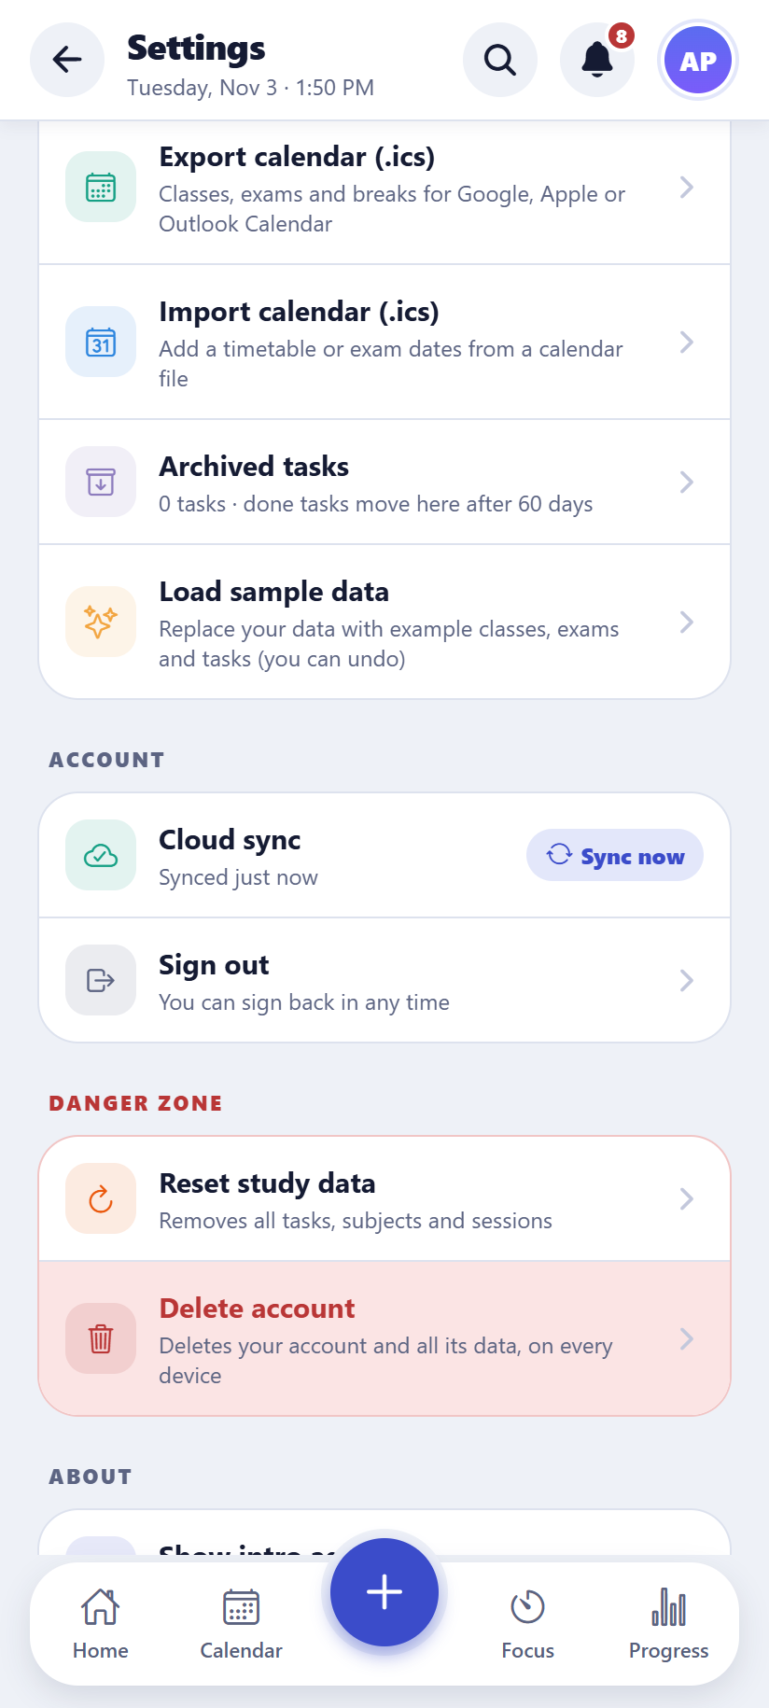  Android | 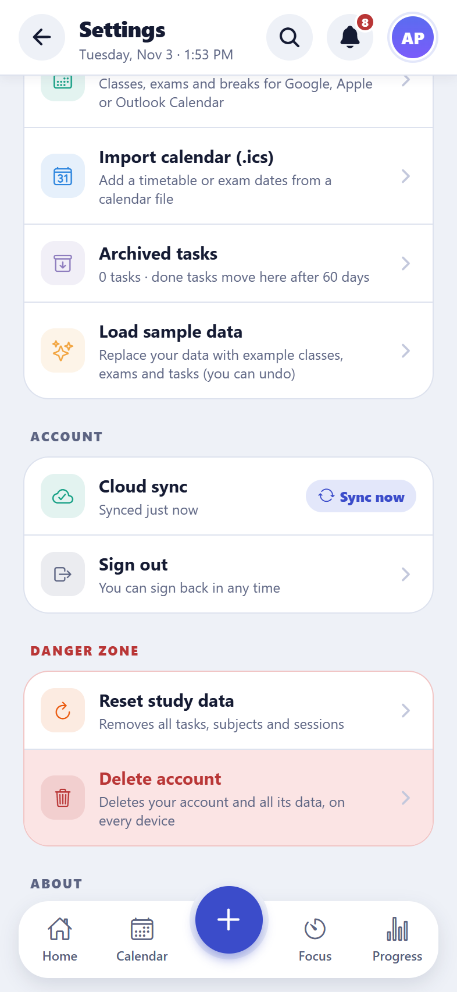  iPhone
Cloud sync and data settings

Works offline, with a “not synced” dot (new)
What it does
The app works without internet. Changes waiting to be sent show an orange dot on the account button, and Settings says how many are waiting. They are sent as soon as the device is back online.
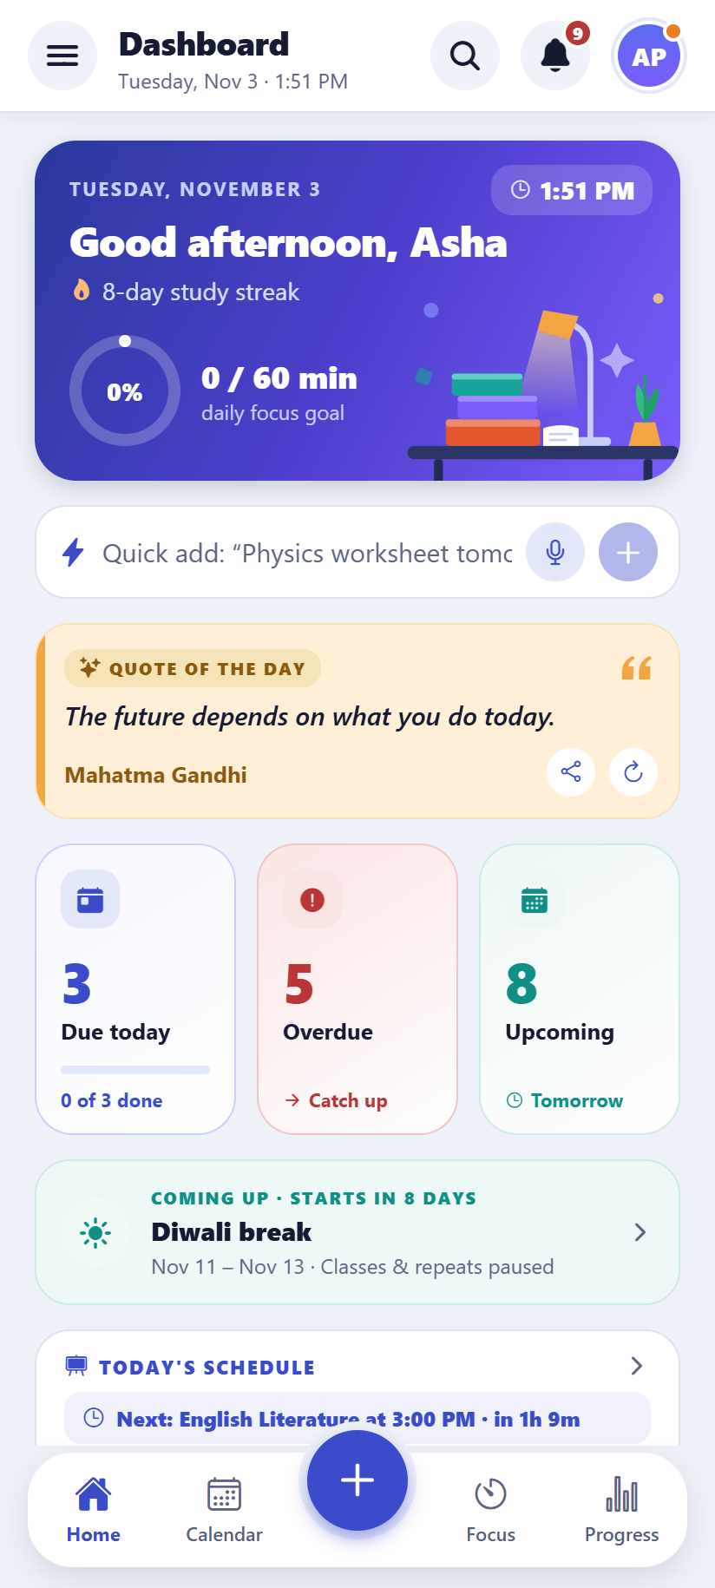  Android | 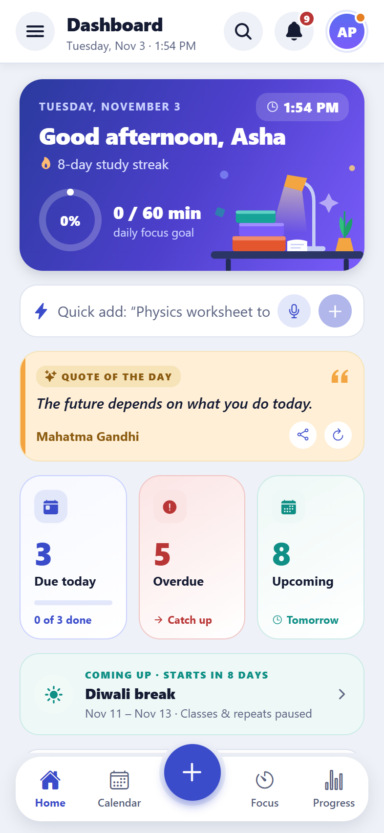  iPhone
The orange “not synced” dot on the account button

Start offline on a new device (new)
What it does
If a new device has no internet, the student can start offline with an empty plan and use the app straight away; their account’s data merges in when they’re back online, and anything they added is kept.

Photos in the cloud
What it does
Photos attached to tasks are stored privately in the cloud, so they appear on the student’s other devices too.

Study Planner Premium (new)
What it does
Everything needed to plan and study stays free. Premium adds more: 30 AI requests a day (Free: 5 a week), unlimited flashcards (Free: 200), 2,000 photos (Free: 50), up to 10 study groups to make (Free: 1), the progress report for a month or a term and as a PDF, and no ads. The Premium page shows the account’s plan, the two side by side and the prices. When a Free limit is reached, the app says so and offers a way to Premium.
How to use it
- Settings → Account → Study Planner Premium.
- In the phone apps: pick monthly or yearly (prices in your currency, from Google Play or the App Store) and buy. Restore purchases brings Premium back on a new phone; Manage opens the store to change or cancel.
Good to know: The limits are checked by the server, so they hold whatever the app does. Until buying Premium is ready, every account gets everything; at launch, existing accounts get 3 months of Premium as a thank-you.
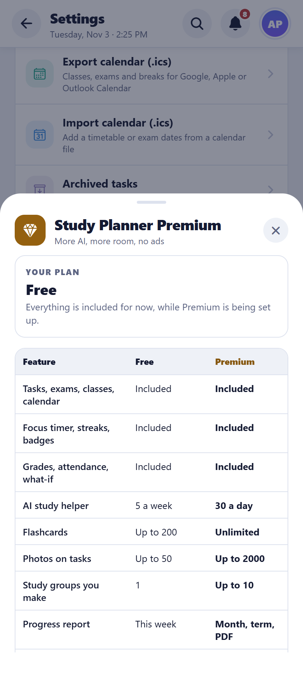  Android | 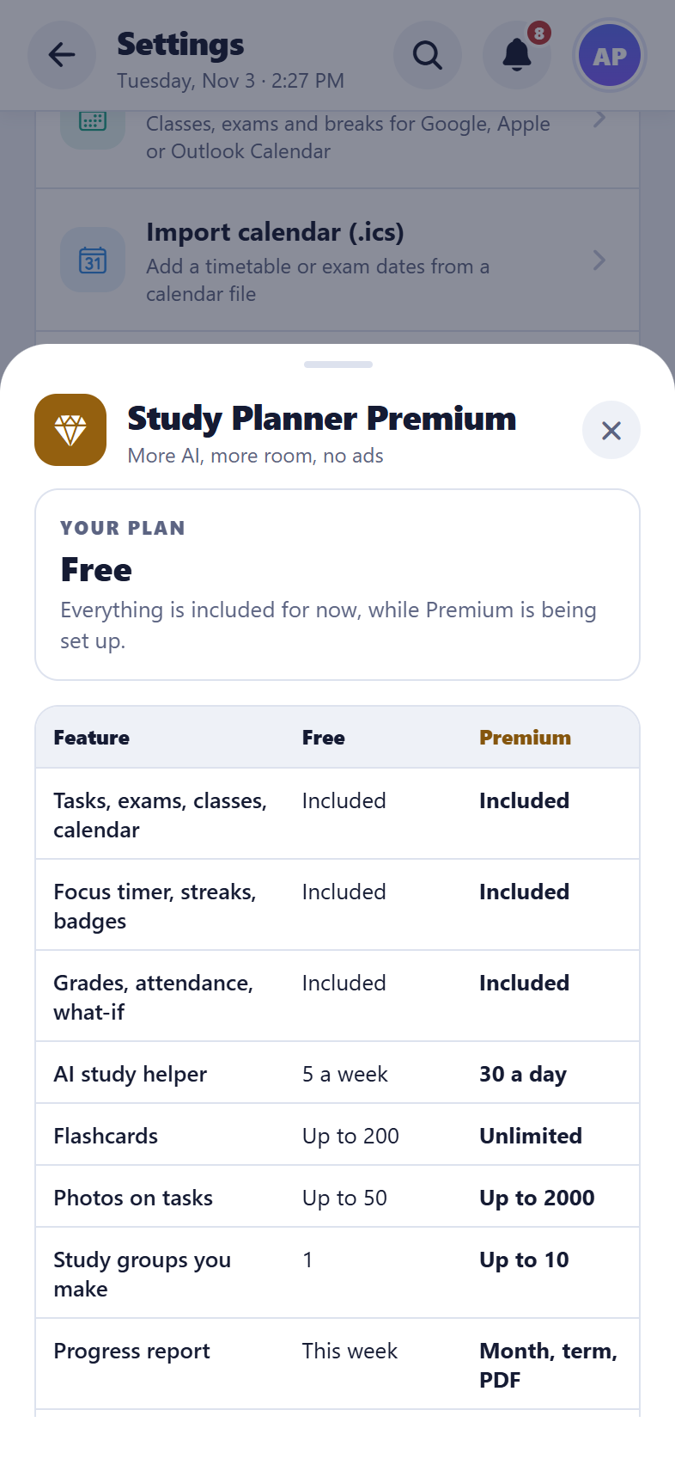  iPhone
Study Planner Premium

Ads on the Free plan (new)
What it does
In the Android and iPhone apps, every account on the Free plan sees a few ads from Google AdMob: a banner under the quote on the Dashboard and one at the bottom of Progress, and now and then a full-screen ad at a natural break (when a break starts after a focus session, or when a finished flashcard review closes; at most once every 10 minutes). When the week’s free AI requests are used, a short ad can be watched for one more (up to 3 a day). Ads are never personalised and never shown during a session, a review or a quiz. Students under 18 (and accounts with no age recorded) get only general-audience (G) ads.
How to use it
- Nothing to do: ads appear only where described. Premium removes them.
Good to know: No ads on Premium or on the web.

Privacy & data (new)
What it does
One page explains, in plain words, what the app keeps, where, who can see it and for how long: your study data (only your account can read it), the copy on each device, what study groups see, what the AI helper receives, error reports (30 days) and backups (14 days). It also says what the app never does: no ads, no tracking and no selling of data. The controls are on the same page: save a copy of your data, turn study-together sharing on or off, and delete your account. Deleting it removes everything, including its copies in the backups.
How to use it
- Settings → Data → Privacy & data.
Good to know: The full privacy policy, for the app stores, is docs/privacy-policy.md.
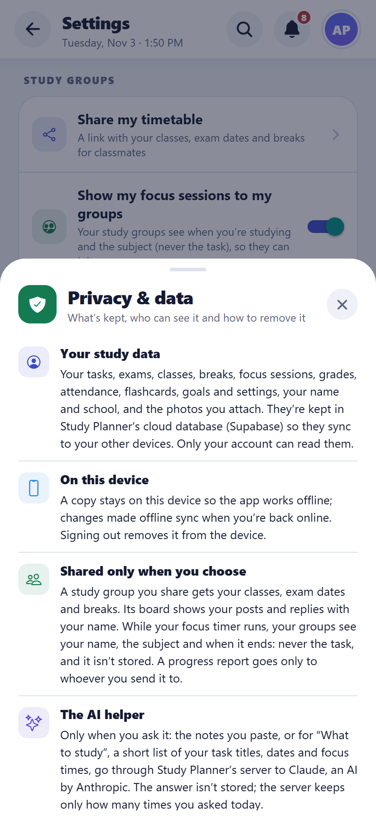  Android | 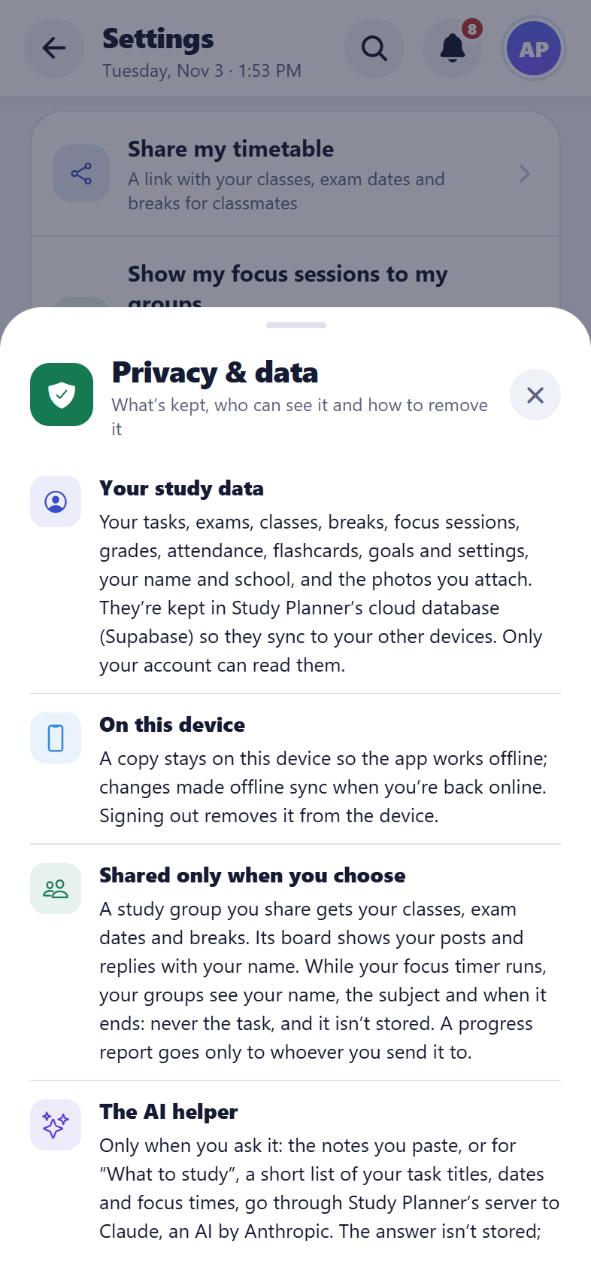  iPhone
Privacy & data

Signing out keeps devices private
What it does
Signing out removes the account’s data from that device (it stays in the cloud). If some changes haven’t been sent yet, the app warns first. An account deleted on one device is signed out on the others.

Backups
What it does
A copy of everyone’s data is taken every night and kept for 14 days, so a student’s data can be restored to an earlier day if something goes wrong. Students can also save their own backup file and restore it.
How to use it
- Settings → Export backup / Restore from backup.

Error reports and limits
What it does
If something goes wrong in the app, a short private report is sent to the developer so it can be fixed. Sensible limits keep the service healthy: up to 10 live groups per person, 200 members per group and 100 posts on a group board.

App updates (new)
What it does
When a new version is out, the phone app asks the student to update. For an important release the old version shows an “Update required” screen that can’t be skipped, so everyone moves to the version that works with the latest data. For other releases, an “Update available” message can be put off with Later and comes back only when there is a newer version.
How to use it
- Tap Update now to open the app’s page in Google Play, then tap Update.
- The student’s tasks and subjects are safe: they are in their account and appear again after the update.
Good to know: Only in the phone apps. The web version is always the newest.

8. Personalise and accessibility
The app adapts to the student, their language and their device.

Settings
What it does
Daily focus goal, timer lengths, reminders, theme, language, week start day, study groups, backups and the account.
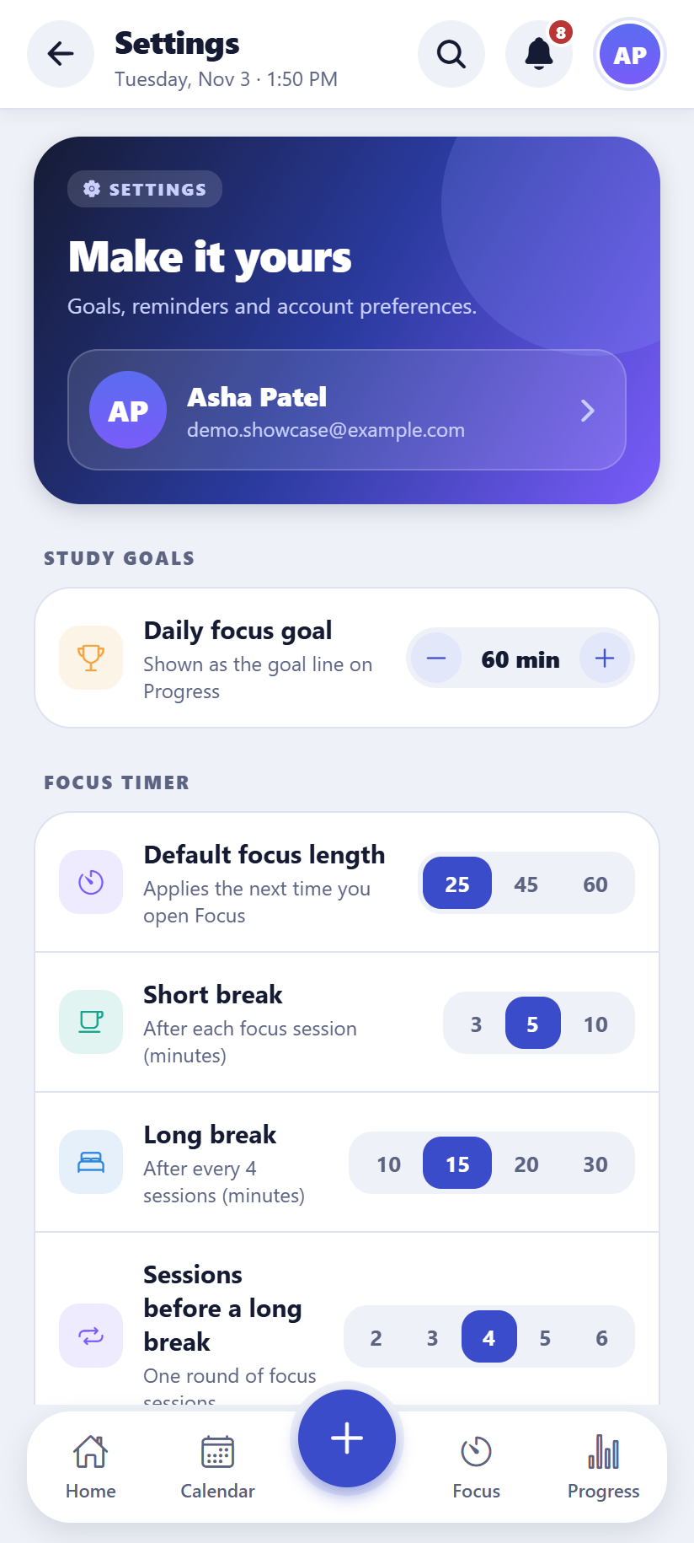  Android | 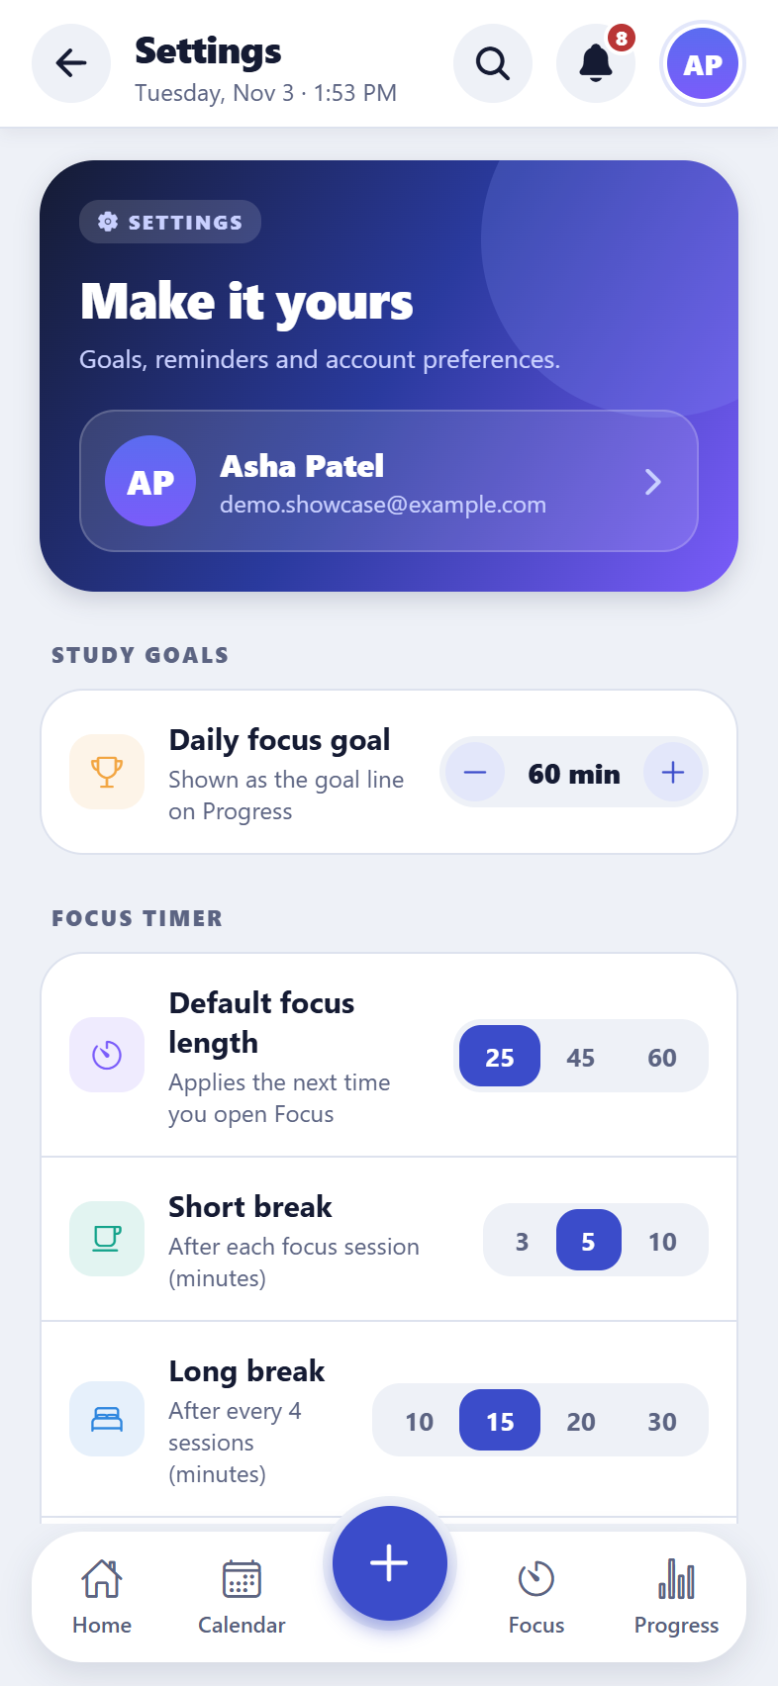  iPhone
Settings

Light and dark mode
What it does
The app opens in the light look. A dark look is one tap away, or “System” makes it follow the phone’s own light or dark setting.
How to use it
- Settings → Theme: Light (the default), Dark or System.
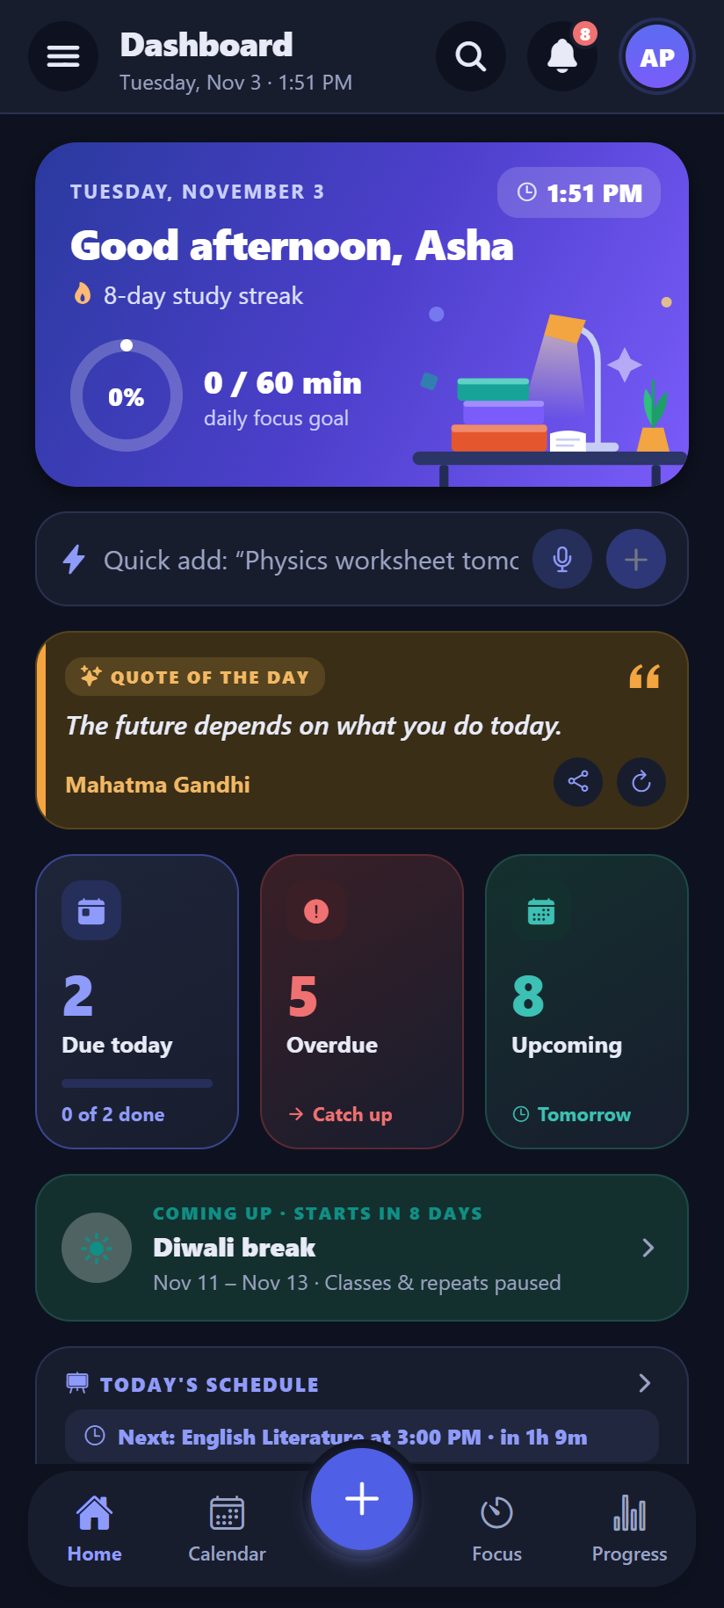  Android | 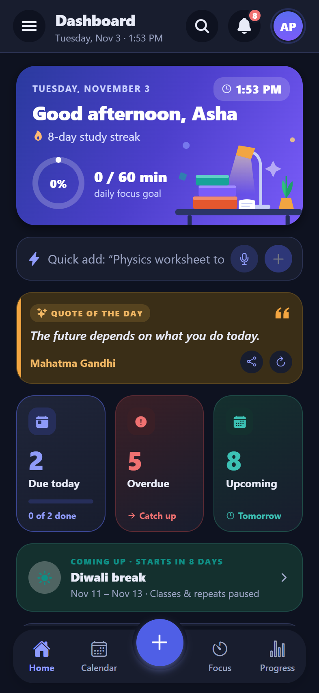  iPhone
Dark mode

Four languages
What it does
English, Hindi, Odia and Spanish, including dates and times in the local style.
How to use it
- Settings → Language.
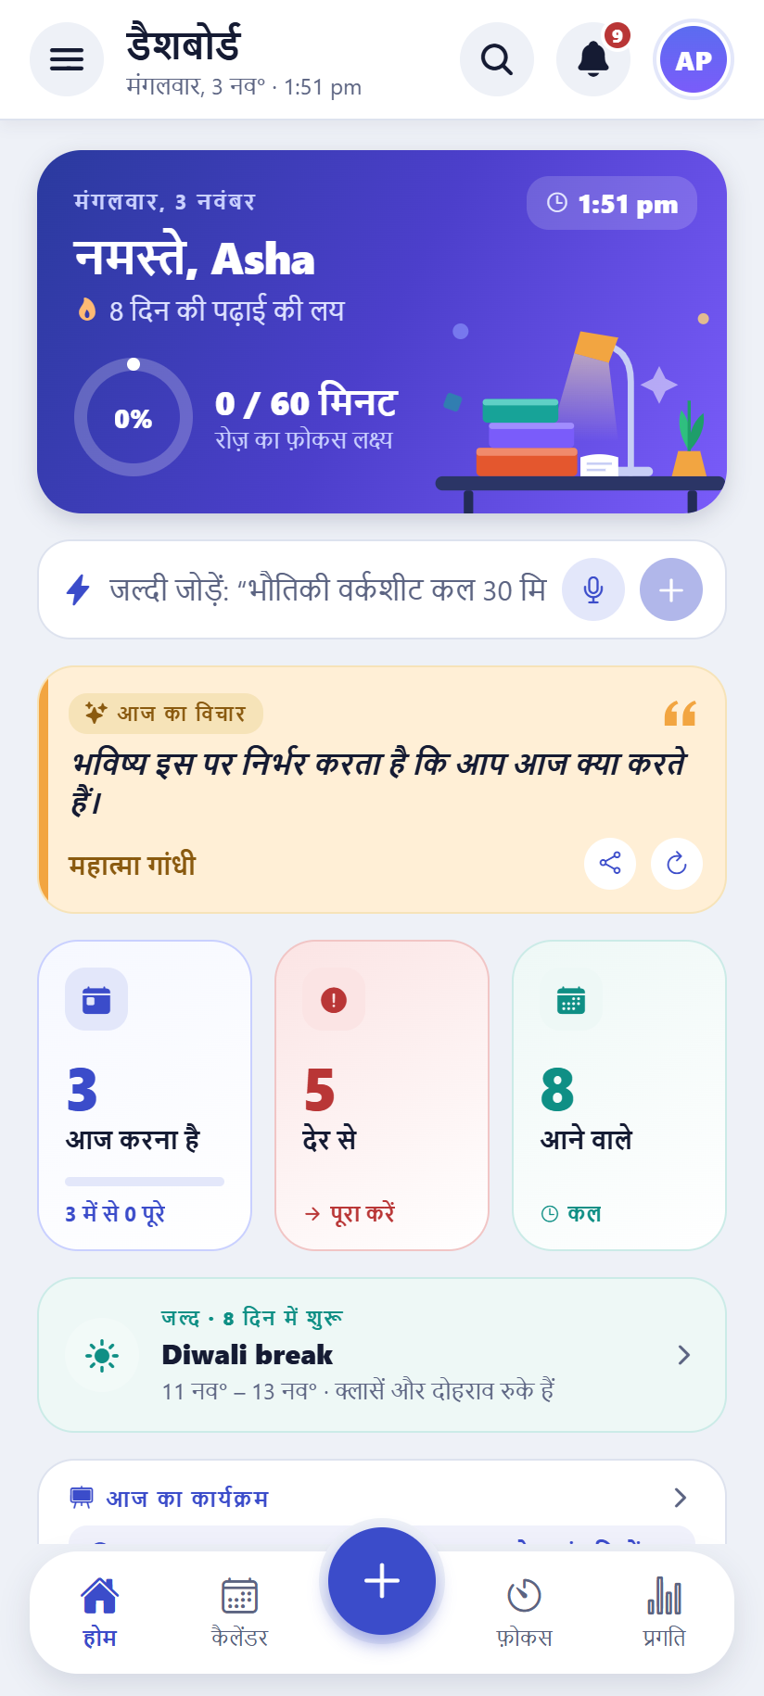  Android | 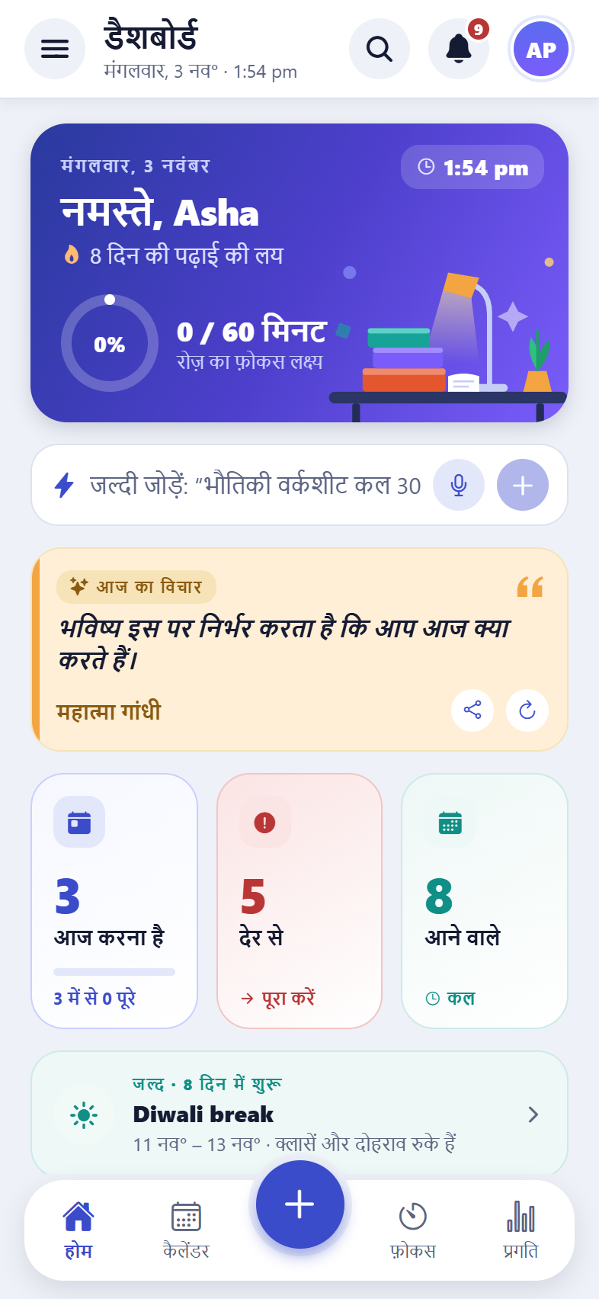  iPhone
The dashboard in Hindi

Phone, tablet and computer
What it does
On a phone the app has a bottom tab bar and a + button; on a computer it has a side menu and two columns. The same account works on the web, Android and iPhone.

Text size and an easier-to-read font (new)
What it does
Text can be made bigger everywhere in the app (Standard, Large or Larger), and the letters can be switched to Lexend, a font with more space between letters that was designed to make reading easier. It can help students with dyslexia or tired eyes. Both settings follow the account to every device.
How to use it
- Settings → Appearance → Text size: Standard, Large or Larger.
- Settings → Appearance → “Easier-to-read font”.
Good to know: On a phone the app also follows the phone’s own text size setting.
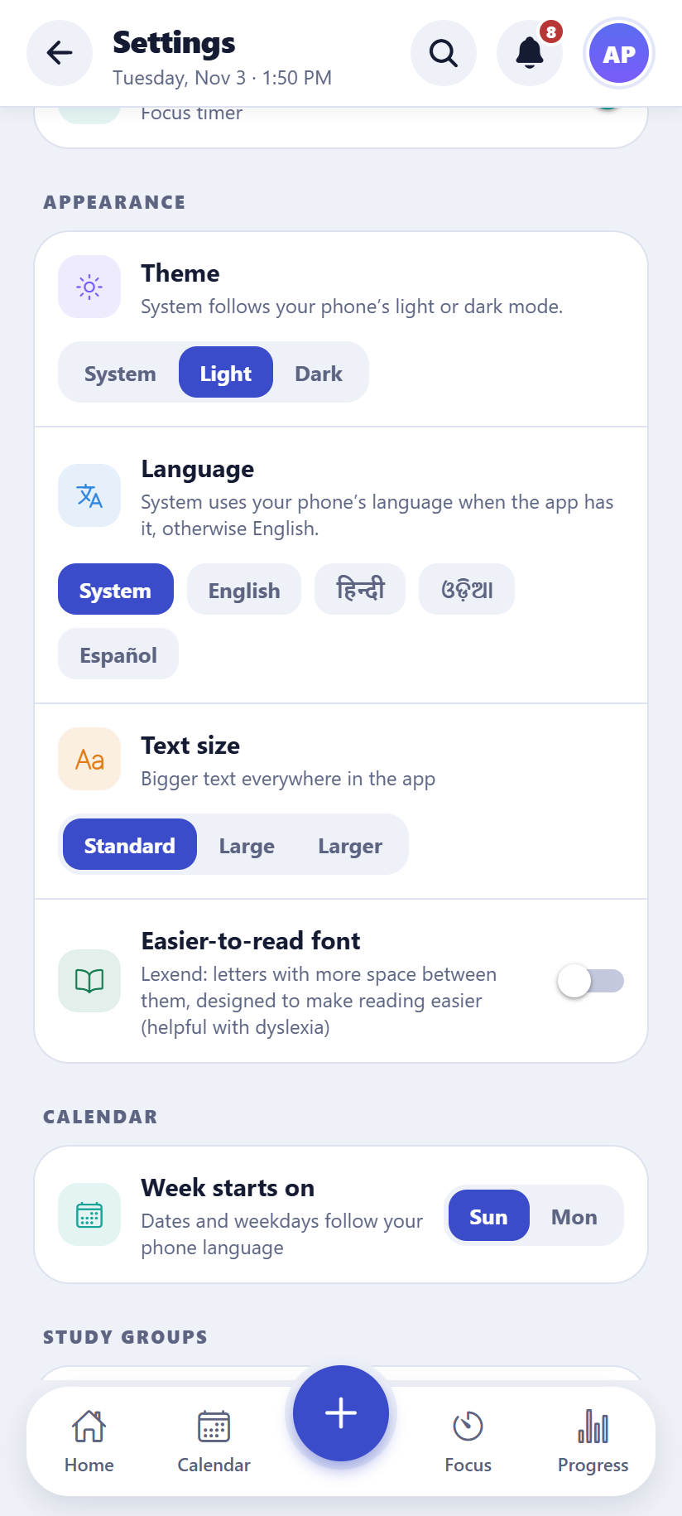  Android | 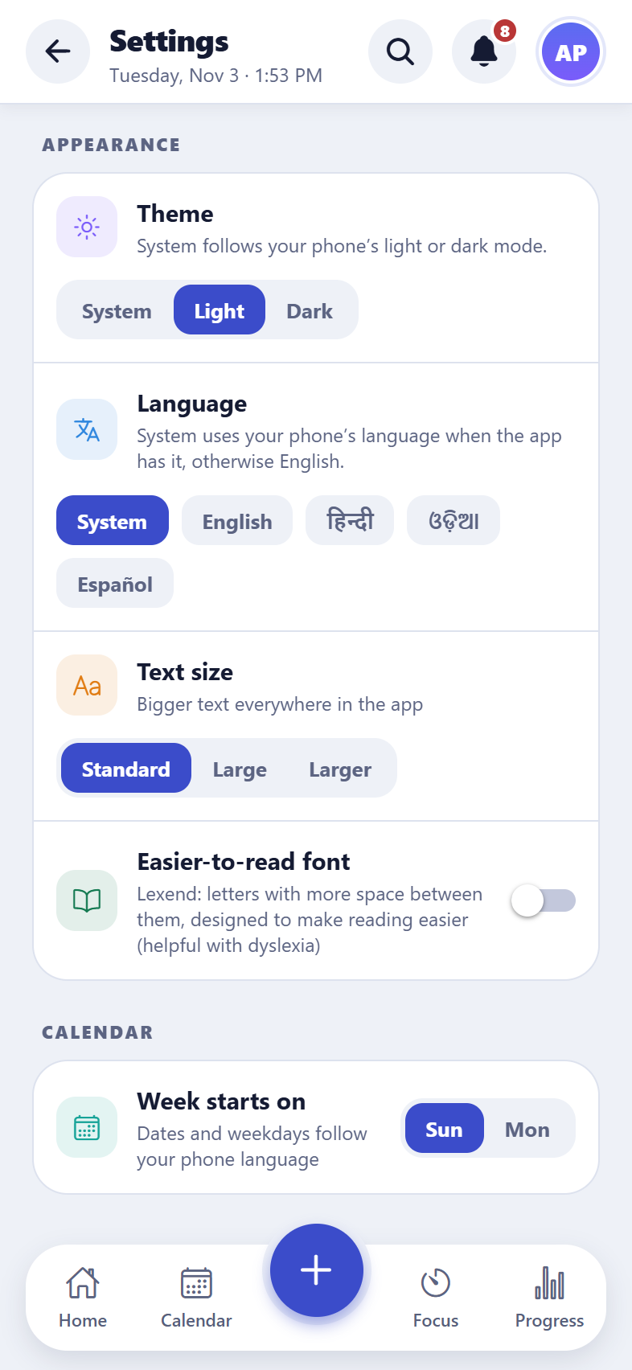  iPhone
Text size and the easier-to-read font

Install the web app (new)
What it does
The web version can be installed like an app: it gets its own icon on the home screen or desktop and opens in its own window, without the browser’s address bar. It is the same app and the same account, so nothing needs setting up again.
How to use it
- Chrome or Edge (computer or Android): Settings → About → “Install the app”.
- iPhone or iPad: open the app in Safari, tap Share, then “Add to Home Screen” (Settings → About → “Install the app” shows how).
Good to know: Once installed the row disappears. To remove it, uninstall it like any other app.

Accessible to everyone
What it does
Text is readable for people with low vision (it meets the WCAG 2.1 AA contrast standard in light and dark mode), every button has a name for screen readers (which also hear which option is chosen, such as the current theme), and everything works with a keyboard. An automatic check runs on every screen.

Fast with lots of data
What it does
Tested with a heavy year of data (2,000 tasks, 150 exams, 1,500 focus sessions): screens open in a quarter of a second.

9. Quality behind the scenes
How the app is kept working as it grows. Useful for a technical reviewer.

Automatic tests
What it does
About 200 browser tests drive the real app (on a phone and a computer screen) through every feature, and 30 sets of unit tests check the logic: planning, sync and merging, prep plans, reminders, grades, attendance and more.

Checks on every change (CI)
What it does
Each time the code is pushed to GitHub, the code style checks and unit tests run automatically; the browser tests can be run on demand.

Accessibility and performance checks
What it does
A script checks every screen against the WCAG 2.1 accessibility rules in light and dark mode, and another measures the app’s speed with a large amount of data.

Demo accounts
What it does
Ready-made demo accounts (a group owner, two members and one with full sample data) make it easy to show the app.

