Micro Project
(Course Code: 202044502)
On
Hospital Management
By

Divy R.Shah
Enr.No.: 12402080603002



A Microproject of Programming with Java
Submitted to
Information Technology Department,
A D PATEL IINSTITUTE OF TECHNOLOGY
(A Constituent Collage of CVM University),
New V.V Nagar, Anand - 388121

Internal Faculty Head of the Department External Faculty

Index

- Introduction 2
- Objectives of the Project 3
- Modules of the System 5
    - Patient Management 5
    - Appointment Management 5
    - Doctor Management 5
    - Prescription Management 5
    - Billing Management 5
    - File Management 5
- System Design 6
    - Class Diagram 6
    - Flow Chart 6
- Implementation Detail 7
    - Inheritance 7
    - Inner Class 7
    - Exception Handling 7
    - Multithreading 8
    - Collection Framework 8
    - File Handling 8
- Code Snippets 9
- Outputs Screenshots 13
- Limitations & Future Enhancements 16
- Conclusion 18
- References 19

            - Introduction

The Hospital Management System is a Java-based application designed to manage various hospital activities such as maintaining patient records, managing appointments, storing prescriptions, and generating bills. This project utilizes core object-oriented programming concepts and Java features to provide a simple, yet functional management system.

- What to do:-
- Objective: Develop a system to manage patient records, appointments, and billing in a hospital.

- Concepts:
- Inheritance: Different user types (Doctor, Patient, Admin) inherit from a base User class.
- Inner Class: Implement an inner class for managing prescriptions within the Patient class.
- Exception Handling: Handle scheduling conflicts and invalid billing information.
- Threading: Manage simultaneous appointment bookings and patient updates.
- Collection API: Use List and Map for managing patients, doctors, and appointments.
- File Handling: Store patient records and billing information in files.

            - Objectives

- Automate Patient Management:
  - Allow easy addition, modification, deletion, and retrieval of patient details such as name, age, gender, disease, and admission status.
  - Maintain patient history and keep records for future references.
- Efficient Appointment Handling:
  - Provide functionality to book appointments between patients and available doctors.
  - Prevent overlapping appointments and maintain appointment schedules.
- Doctor Information Management:
  - Store and manage doctor details like name, specialization, availability, and years of experience.
  - Help assign patients to appropriate doctors based on specialization.
- Prescription Handling:
  - Allow doctors to generate and save prescriptions for patients.
  - Maintain a list of medications and prescribed treatments for each patient.
- Billing System:
  - Automatically generate bills based on consultations, medications, and additional services.
  - Ensure accuracy in financial calculations and maintain payment records.

- Implement Java OOP Concepts:
  - Use inheritance, polymorphism, encapsulation, and abstraction to make the system modular and maintainable.
  - Implement inner classes to handle related data within parent classes.
- Use of Java Collection Framework:
  - Manage dynamic lists of patients, doctors, and appointments using ArrayList, HashMap, and other collections.
- Exception Handling:
  - Improve system stability by handling input errors and exceptional conditions using try-catch blocks and custom exceptions.
- File Handling for Data Persistence:
  - Store all data in text files using Java I/O to ensure that information is not lost after the program is closed.
- Multithreading (if applicable):
- Implement background processes like autosaving, data loading, or timed reminders using threads.
- Console-Based Interface:
- Provide a simple user interface through the command line to allow users to interact with the system.

            - Modules Used

- Patient Management:
- Allows adding, updating, viewing, and deleting patient records including name, age, gender, and disease details.

- Appointment Scheduling:
- Helps patients schedule appointments with available doctors and allows admins to view all upcoming appointments.

- Doctor Management:
- Stores doctor information like specialization, available times, and experience.

- Prescription Handling:
- Manages and stores prescriptions provided to patients after diagnosis.

- Billing System:
- Generates bills based on consultation fees, medicines, and other charges.

- File Handling:
- All records (patients, doctors, bills) are stored using Java File I/O for persistent storage.

            - System Design

- Class Diagram:
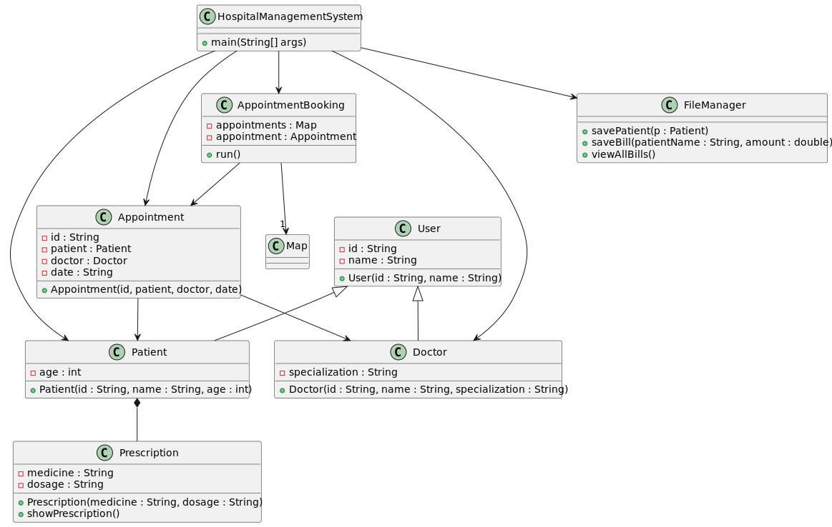
- Flow Chart:
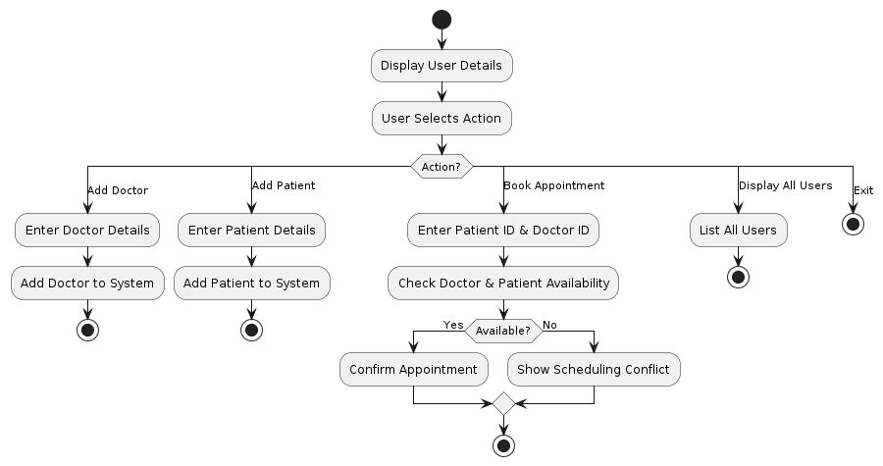

            - Implementation Details
🧬Inheritance:
- A base class User is defined with common fields like id and name.
- Doctor and Patient classes extend User, inheriting shared attributes and behavior.
- This promotes code reusability and a clear class hierarchy.
🧩 Inner Classes:
- The Patient class contains an inner class Prescription, used to manage patient-specific prescriptions.
- This allows Prescription to access Patient’s data directly and logically groups related functionalities.
🛑 Exception Handling:
- Basic validation is done through try-catch blocks to handle user input errors (e.g., selecting non-existent patient index).
- Custom messages are shown for errors like duplicate appointment IDs or missing billing data.
- Prevents the program from crashing due to invalid operations.
🧵 Multithreading:
- Appointment booking is handled using a separate Thread (AppointmentBooking) to simulate real-time and concurrent booking processes.
- The run() method adds appointments safely using synchronization to prevent data conflicts.
🗃️ Collection Framework:
- ArrayList<Patient> and ArrayList<Doctor> are used to store dynamic lists of patients and doctors.

- HashMap<String, Appointment> is used for fast retrieval and uniqueness of appointments by ID.
- Makes the system scalable and easy to manipulate data structures.
📁 File Handling:
- All patient details are stored in patients.txt using FileWriter for persistent storage.
- Billing records are stored in bills.txt and can be retrieved and displayed using Scanner.
- This allows the system to preserve data between runs and acts as a simple database alternative.

            - Code

- User.java
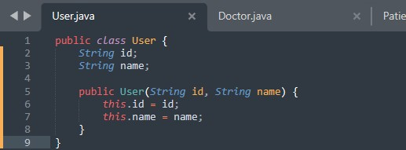
- Doctor.java
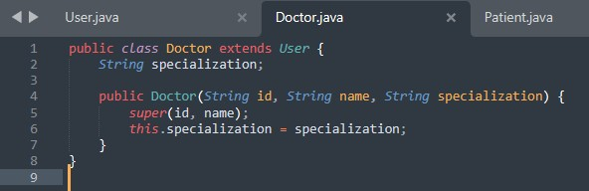
- Patient.java
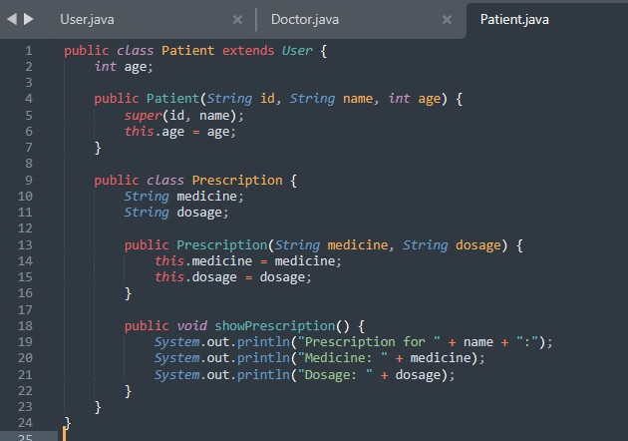

- Appointment.java
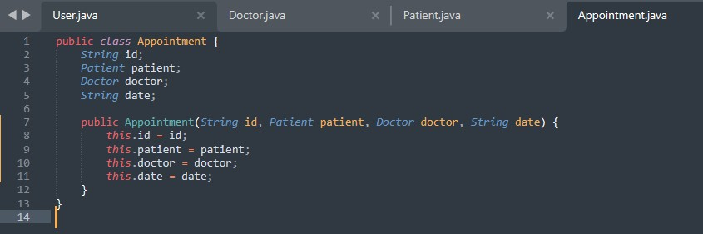
- AppoinmentBooking.java
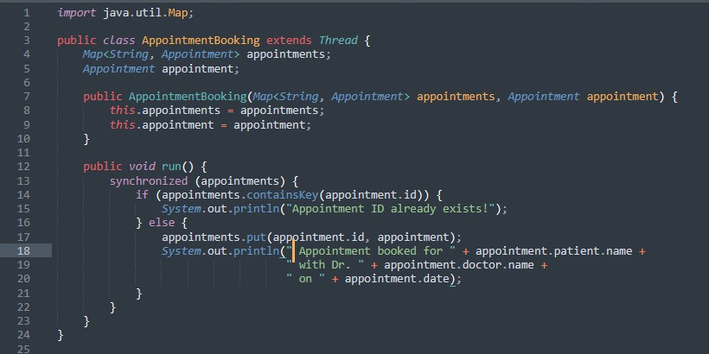
- FileManager.java
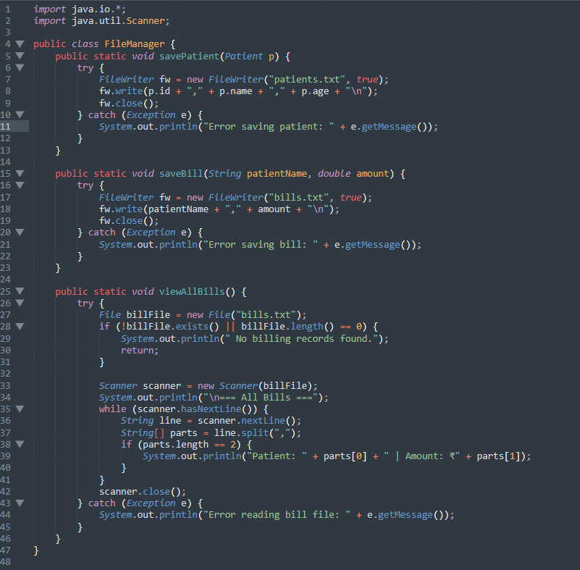

- HospitalManagementSystem.java(Main File)
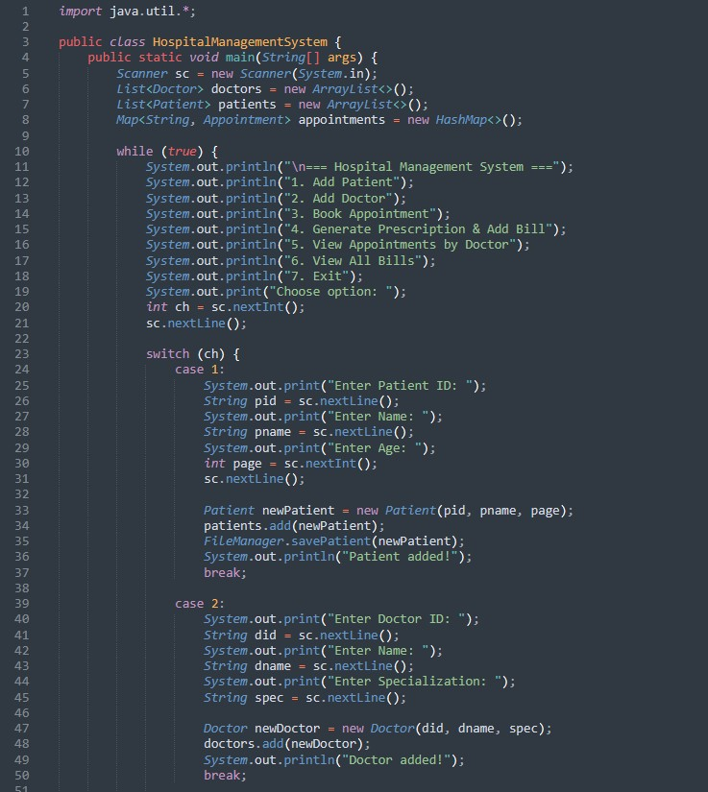
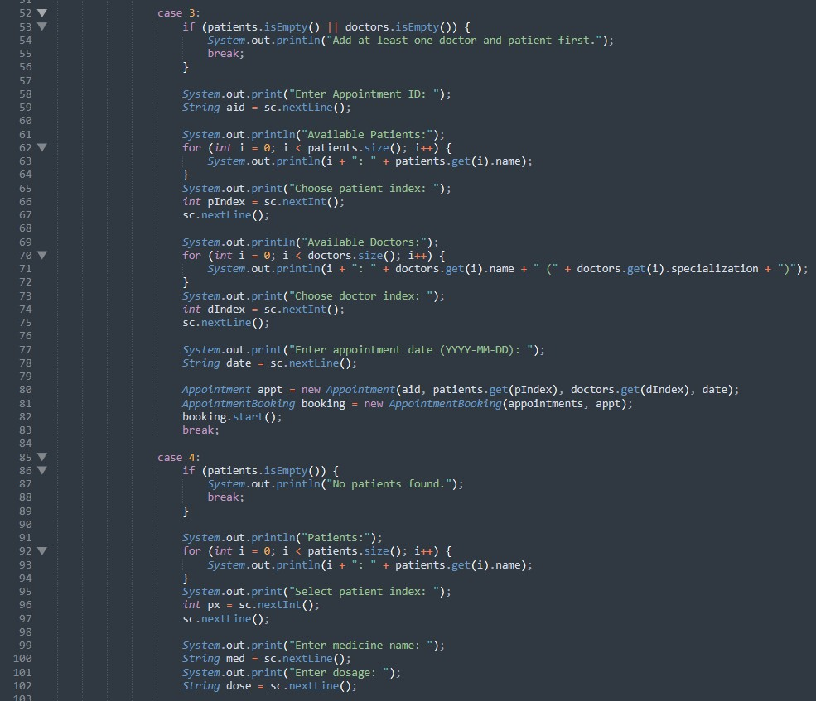

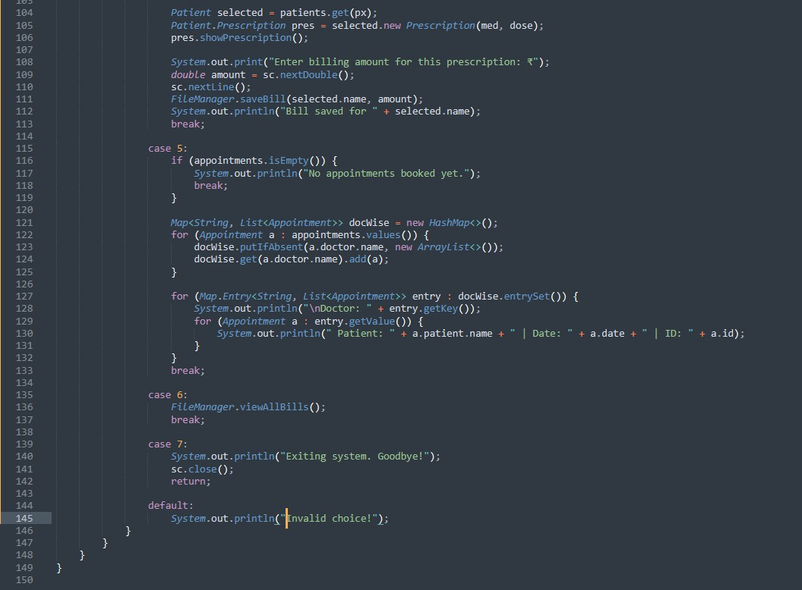

            - Outputs
- Adding Patient & Doctor
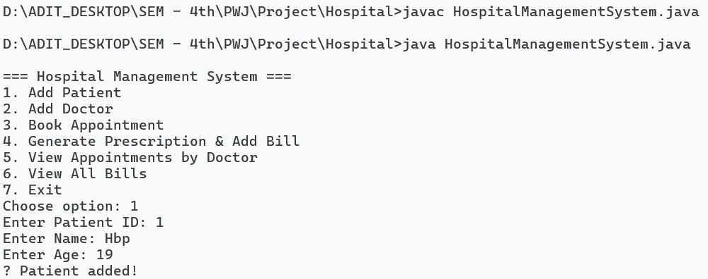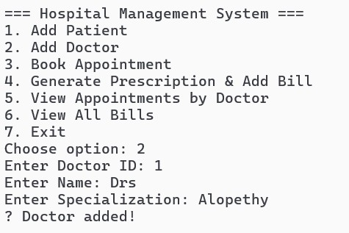
- Make the Appointment
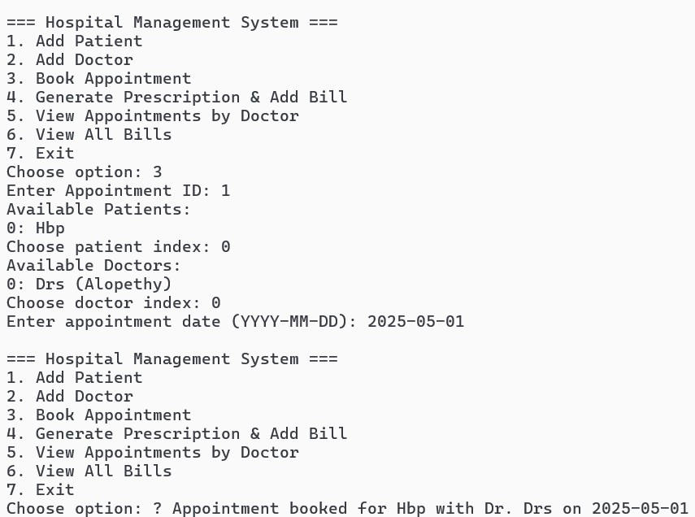

- Viewing the Appointments & Making the Prescription
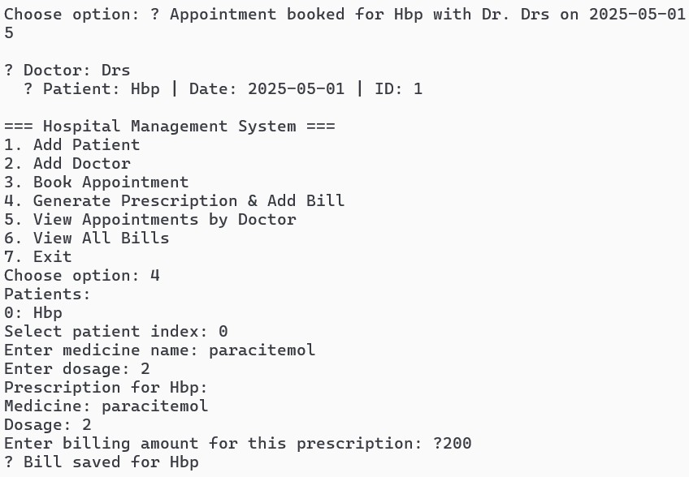
- Viewing the Bills From the Text file
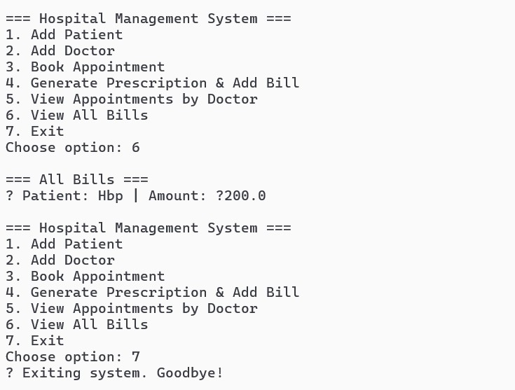

- Patient.txt
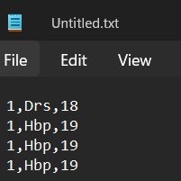
- Bills.txt
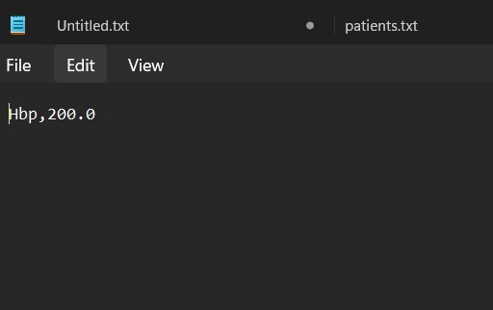

            - Limitations & Future Enhancements

- Limitations:
- No GUI Interface
  - The system uses a command-line interface which may not be user-friendly for hospital staff.
- No Database Integration
  - Data is stored in .txt files, which can lead to data inconsistency, no encryption, and limited scalability.
- Limited Error Handling
  - While basic exception handling is present, it doesn't cover all edge cases or provide detailed feedback.
- Single Prescription per Patient
  - Currently, each patient can have only one prescription at a time.
- No Login or Authentication System
  - All users (patients, doctors, admin) have unrestricted access to the system without security checks.
- Limited Reporting & Search Functionality
  - There is no feature to search for patients/doctors by name or generate detailed reports.

- Future Enhancements:
- Graphical User Interface (GUI)
  - Develop a user-friendly GUI using JavaFX or Swing for better usability and navigation.

- Database Integration
  - Replace file handling with a database like MySQL or SQLite for efficient and secure data storage.
- Advanced Prescription Handling
  - Allow multiple prescriptions per patient with support for tracking history and dosage timelines.
- User Authentication System
  - Add login functionality with roles (Admin, Doctor, Patient) and permission-based access.
- Search & Filter Features
  - Implement search, filter, and sort capabilities for appointments, patients, and billing data.
- Analytics & Reporting
  - Generate detailed reports for hospital management (e.g., most visited doctors, billing summaries).
- Cloud Backup & Auto-Save
  - Enable background auto-save and cloud syncing to prevent data loss.

9. Conclusion

The Hospital Management System developed in Java demonstrates the effective use of core object-oriented programming concepts such as inheritance, inner classes, exception handling, multithreading, collections, and file handling. The system provides a functional solution to manage hospital operations including patient records, doctor information, appointment scheduling, prescription management, and billing.

Although the system is currently console-based and uses file storage, it successfully simulates real-world hospital activities in a simplified yet structured manner. It serves as a strong foundation for further expansion into a full-fledged application with GUI, database connectivity, user authentication, and advanced reporting.

This project not only fulfills academic objectives but also enhances practical understanding of Java programming and system design.

10. References

- https://docs.oracle.com/javase/
- https://www.w3schools.com/java/
- https://www.geeksforgeeks.org/java/
- https://www.javatpoint.com/java-filewriter-class
- https://www.javatpoint.com/collections-in-java
- https://plantuml.com/class-diagram
- Head First Java by Kathy Sierra & Bert Bates – for core Java concepts and OOP fundamentals

