21 Days Internship on AI
M&T TechnoGuide Infosoft Pvt. Ltd.
Learn. Build. Innovate. Become AI Engineer.
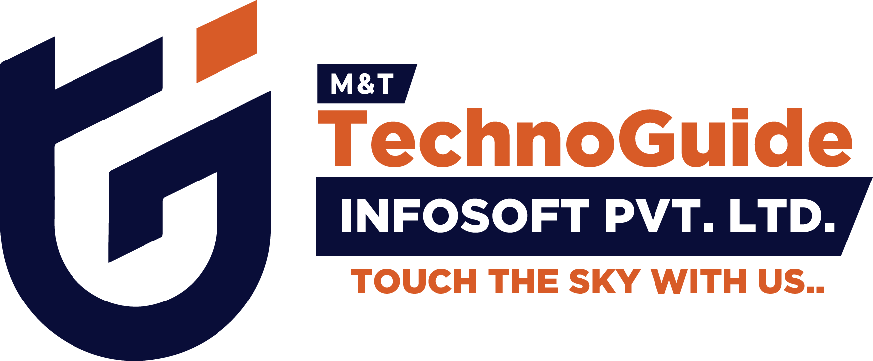
This internship program is designed to provide practical AI engineering skills through hands-on projects, coding exercises, AI tools, and real-world applications.

Day 1 – Introduction to AI & Setup
- Install Python, VS Code, and Git
- Create GitHub account
- Understand AI, ML, Deep Learning basics
- Run first Python program

Day 2 – Python Basics
- Learn variables, loops, conditions
- Create calculator application
- Build age calculator mini project

Day 3 – Python Data Structures
- Learn lists, tuples, dictionaries
- Build student management system
- Store and retrieve student records

Day 4 – Data Handling
- Learn Pandas basics
- Read CSV files
- Analyze student marks dataset
- Generate simple charts

Day 5 – AI Mathematics
- Understand mean, median, and averages
- Learn linear regression concept
- Predict marks using study hours

Day 6 – Machine Learning Basics
- Install Scikit-learn
- Train ML model
- Build house price predictor

Day 7 – Deployment Project
- Install Streamlit
- Convert ML project into web app
- Deploy prediction application

Day 8 – ChatGPT API
- Learn API integration
- Create AI chatbot
- Generate AI responses dynamically

Day 9 – Prompt Engineering
- Create marketing prompts
- Understand zero-shot & few-shot prompting
- Test prompts in ChatGPT

Day 10 – AI Image Generation
- Generate posters using AI
- Create festival and business creatives
- Learn prompt writing for images

Day 11 – Computer Vision
- Install OpenCV
- Build face detection app
- Capture webcam feed

Day 12 – NLP Basics
- Text processing basics
- Build spam detector
- Classify text data

Day 13 – Voice AI Assistant
- Speech recognition basics
- Build mini voice assistant
- Execute voice commands

Day 14 – AI Automation
- Use Zapier and Make.com
- Automate social media content
- Generate AI captions

Day 15 – AI Website
- Build AI support chatbot website
- Integrate chatbot into webpage

Day 16 – AI Resume Builder
- Generate resumes using AI
- Create resume templates

Day 17 – AI Video Generation
- Create AI promo videos
- Learn Runway ML basics

Day 18 – AI Business Tool
- Build invoice generator
- Create AI caption tool

Day 19 – Major Project Planning
- Choose final AI project
- Prepare project workflow
- Design UI and features

Day 20 – Portfolio Building
- Create LinkedIn profile
- Upload projects to GitHub
- Build portfolio website

Day 21 – Final AI Project
- Build complete AI product
- Present final project
- Deploy and showcase project

Final Outcome
- 10+ Practical AI Projects
- AI Portfolio & GitHub Repository
- Internship Completion Certificate
- Real-world AI Development Experience
- Industry-Level Practical Knowledge

