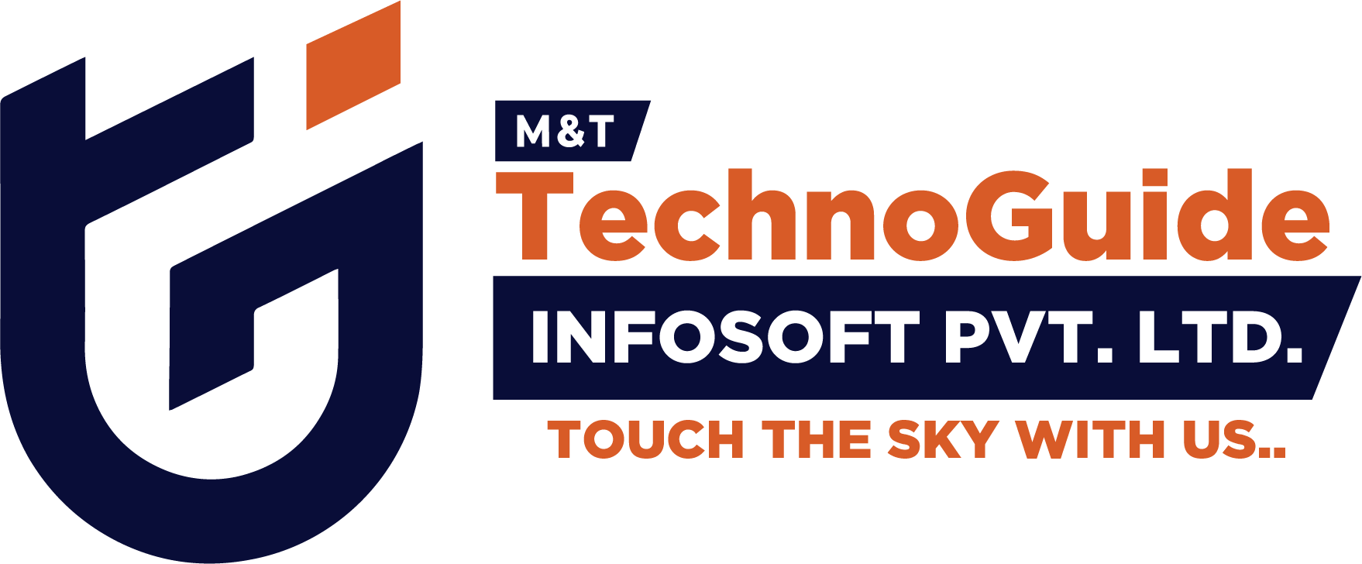

Internship Report - Day 1
30-Day MERN Stack with AI Internship
TechnoGuide Infosoft Pvt. Ltd., Anand

Day 1 - Introduction to AI & Setup
On the first day of the internship at TechnoGuide Infosoft Pvt. Ltd., I was introduced to the fundamentals of Artificial Intelligence (AI), Machine Learning (ML), and Deep Learning (DL). The session also included the installation and setup of important development tools required during the internship.

Tasks Completed
- Installed Python programming language.
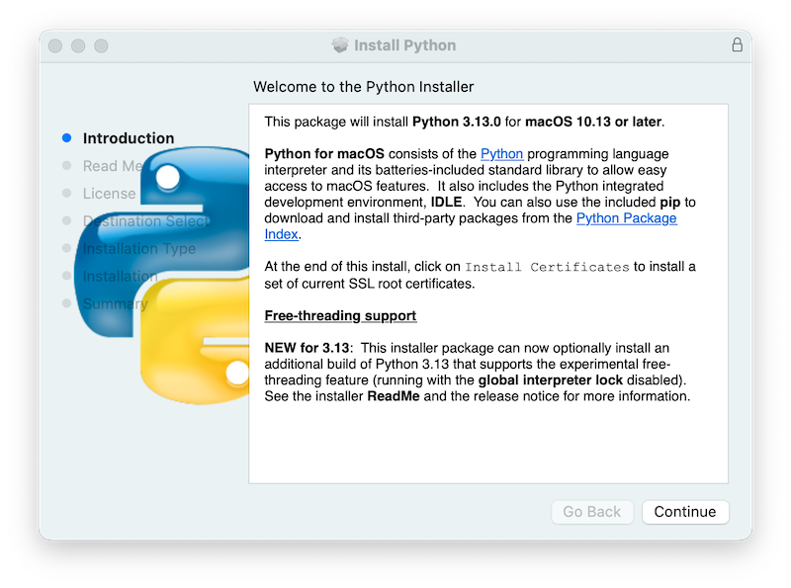

- Installed Visual Studio Code (VS Code).
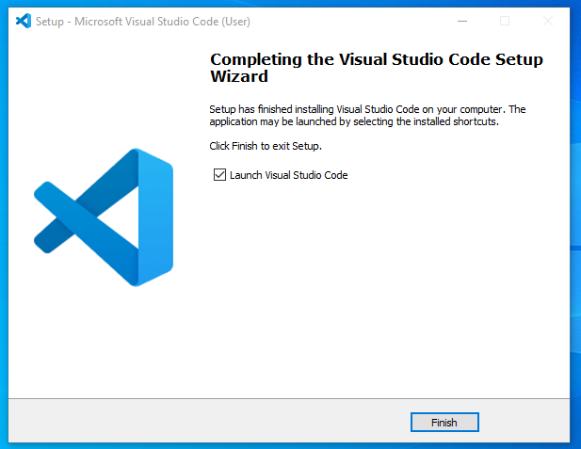
- Installed and configured Git.
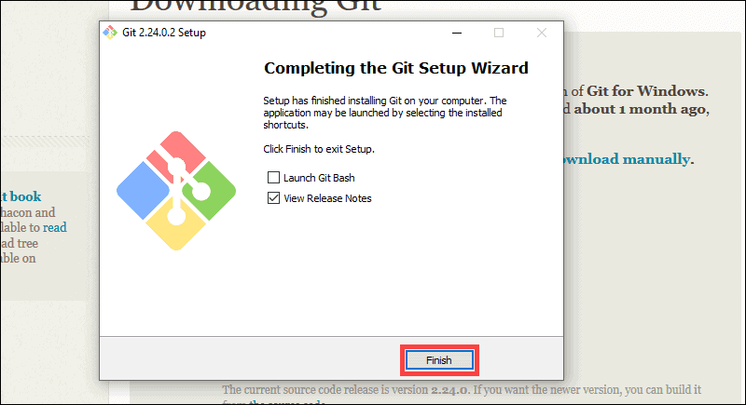
- Created a GitHub account for version control and project management.
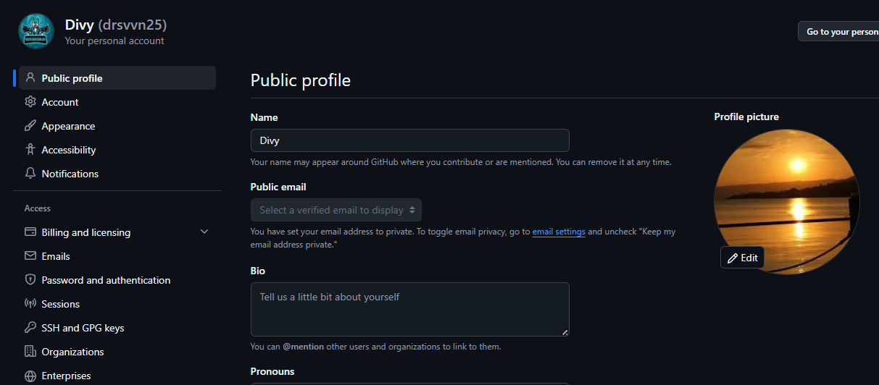

- Git Desktop
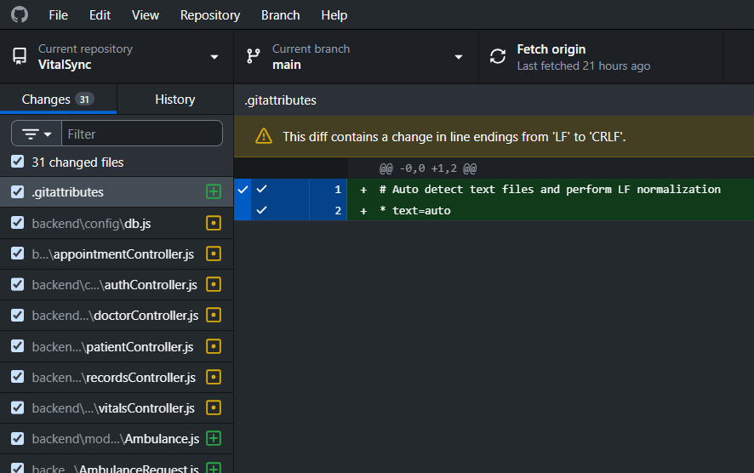

Understanding AI, ML, and Deep Learning

Artificial Intelligence (AI)
Artificial Intelligence is the concept of making machines capable of performing tasks that normally require human intelligence such as learning, reasoning, and decision-making.

Machine Learning (ML)
Machine Learning is a subset of AI where machines learn patterns from data and improve their performance automatically without being explicitly programmed.

Deep Learning (DL)
Deep Learning is a specialized area of Machine Learning that uses neural networks with multiple layers to process complex data such as images, speech, and text.

First Python Program
print("Hello, World!")
This was the first Python program executed successfully to verify the Python installation.

Learning Outcome
By the end of Day 1, I gained basic knowledge about AI technologies and successfully set up the required development environment for future internship tasks.

Conclusion
The first day of the internship was informative and helped in building a strong foundation for upcoming technical learning and project development activities.

