
Internship Report - Day 11
30-Day MERN Stack with AI Internship
TechnoGuide Infosoft Pvt. Ltd., Anand
Day 11 – Emotion Recognition System
On the eleventh day of the internship, I learned about Emotion Recognition Systems using Artificial Intelligence, TensorFlow, and OpenCV. The session focused on real-time facial emotion detection using webcam and mobile camera feeds. I explored how AI models classify human emotions such as Happy, Sad, Angry, Fear, Neutral, Disgust, and Surprised using facial analysis techniques.
The project improved my understanding of Computer Vision, image processing, TensorFlow model integration, OpenCV face detection, and real-time emotion classification systems.
Topics Covered
- Introduction to Emotion Recognition
- TensorFlow and OpenCV Integration
- Face Detection using Haar Cascade
- Real-time Webcam Emotion Detection
- Android Mobile Camera Integration
- Emotion Classification
- Transfer Learning
- Dataset Preparation
- Model Training and Testing
- AI-based Facial Analysis
1. Introduction to Emotion Recognition
Emotion Recognition is a Computer Vision application that detects and classifies human emotions using facial expressions.
The system recognizes emotions such as Happy, Sad, Angry, Fear, Neutral, Disgust, and Surprised.
2. Technologies Used
The project uses multiple AI and Computer Vision technologies.
Technologies:
• Python
• TensorFlow
• OpenCV
• NumPy
• Haar Cascade XML
3. Installation Process
Required Python libraries are installed using pip.
Command:
pip install tensorflow opencv-python numpy
Folder Structure:-
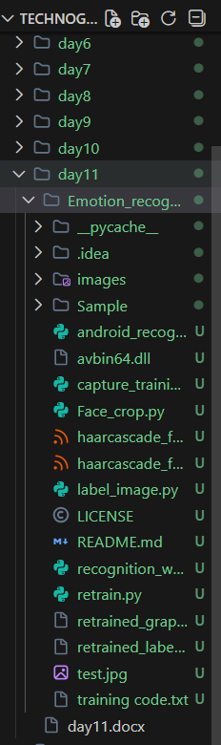
4. Face Detection using OpenCV
OpenCV uses Haar Cascade classifiers for detecting human faces from images and video frames.
XML Files Used:
• haarcascade_frontalface_alt.xml
• haarcascade_frontalface_default.xml
5. Webcam Emotion Recognition
The system captures live webcam feed and predicts emotions in real-time.
#Coded by:- Divy Shah
#From:- Technoguide Infosoft
import time
import cv2
import label_image
import os,random
import subprocess
os.environ['TF_CPP_MIN_LOG_LEVEL'] = '2'

size = 4
# We load the xml file
classifier = cv2.CascadeClassifier('haarcascade_frontalface_alt.xml')
global text
webcam = cv2.VideoCapture(0) # Using default WebCam connected to the PC.
while True:
(rval, im) = webcam.read()
im = cv2.flip(im, 1, 0) # Flip to act as a mirror
# Resize the image to speed up detection
mini = cv2.resize(im, (int(im.shape[1] / size), int(im.shape[0] / size)))
# detect MultiScale / faces
faces = classifier.detectMultiScale(mini)
# Draw rectangles around each face
for f in faces:
(x, y, w, h) = [v * size for v in f] # Scale the shapesize backup
sub_face = im[y:y + h, x:x + w]
FaceFileName = "test.jpg" # Saving the current image from the webcam for testing.
cv2.imwrite(FaceFileName, sub_face)
text = label_image.main(FaceFileName) # Getting the Result from the label_image file, i.e., Classification Result.
text = text.title() # Title Case looks Stunning.
font = cv2.FONT_HERSHEY_TRIPLEX

if text == 'Angry':
cv2.rectangle(im, (x, y), (x + w, y + h), (0, 25, 255), 7)
cv2.putText(im, text, (x + h, y), font, 1, (0, 25,255), 2)

if text == 'Smile':
cv2.rectangle(im, (x, y), (x + w, y + h), (0,260,0), 7)
cv2.putText(im, text, (x + h, y), font, 1, (0,260,0), 2)

if text == 'Fear':
cv2.rectangle(im, (x, y), (x + w, y + h), (0, 255, 255), 7)
cv2.putText(im, text, (x + h, y), font, 1, (0, 255, 255), 2)

if text == 'Sad':
cv2.rectangle(im, (x, y), (x + w, y + h), (0,191,255), 7)
cv2.putText(im, text, (x + h, y), font, 1, (0,191,255), 2)

# Show the image/
cv2.imshow('Emotion recognition', im)
key = cv2.waitKey(30)& 0xff

if key == 27: # The Esc key
break

Run Command:
python recognition_webcam.py
6. Android Mobile Camera Support
The project also supports Android mobile camera feed using the IPWebcam application.
Users must replace the IP address in android_recognition.py with their mobile IP address.
import cv2
import label_image
import os
import numpy as np
from urllib.request import urlopen
import time
from playsound import playsound
os.environ['TF_CPP_MIN_LOG_LEVEL'] = '2'

size = 4

# We load the xml file
classifier = cv2.CascadeClassifier('haarcascade_frontalface_alt.xml')
mobile_video="http://192.168.0.101:8080/shot.jpg"
# Using default WebCam connected to the PC.

while True:
img_resp = urlopen(mobile_video)
img_arr = np.array(bytearray(img_resp.read()), dtype=np.uint8)

cap = cv2.imdecode(img_arr, -1)
im=cv2.flip(cap,1,0)
mini = cv2.resize(im, (int(im.shape[1] / size), int(im.shape[0] / size)))

# detect MultiScale / faces
faces = classifier.detectMultiScale(mini)
# Draw rectangles around each face
for f in faces:
(x, y, w, h) = [v * size for v in f] # Scale the shapesize backup
sub_face = im[y:y + h, x:x + w]
FaceFileName = "test.jpg" # Saving the current image from the webcam for testing.
cv2.imwrite(FaceFileName, sub_face)
text = label_image.main(FaceFileName) # Getting the Result from the label_image file, i.e., Classification Result.
text = text.title() # Title Case looks Stunning.
font = cv2.FONT_HERSHEY_TRIPLEX

if text == 'Angry':
cv2.rectangle(im, (x, y), (x + w, y + h), (0, 25, 255), 7)
cv2.putText(im, text, (x + h, y), font, 1, (0, 25,255), 2)

if text == 'Smile':
cv2.rectangle(im, (x, y), (x + w, y + h), (0,260,0), 7)
cv2.putText(im, text, (x + h, y), font, 1, (0,260,0), 2)

if text == 'Fear':
cv2.rectangle(im, (x, y), (x + w, y + h), (0, 255, 255), 7)
cv2.putText(im, text, (x + h, y), font, 1, (0, 255, 255), 2)

if text == 'Sad':
cv2.rectangle(im, (x, y), (x + w, y + h), (0,191,255), 7)
cv2.putText(im, text, (x + h, y), font, 1, (0,191,255), 2)

# Show the image/
cv2.imshow('Emotion recognition from Android screen', im)
key = cv2.waitKey(30)& 0xff
if key == 27: # The Esc key
break
7. Dataset Preparation
Training datasets are organized into separate folders for each emotion category.
Emotion Folders:
• Happy
• Sad
• Angry
• Fear
• Neutral
• Disgust
• Surprised
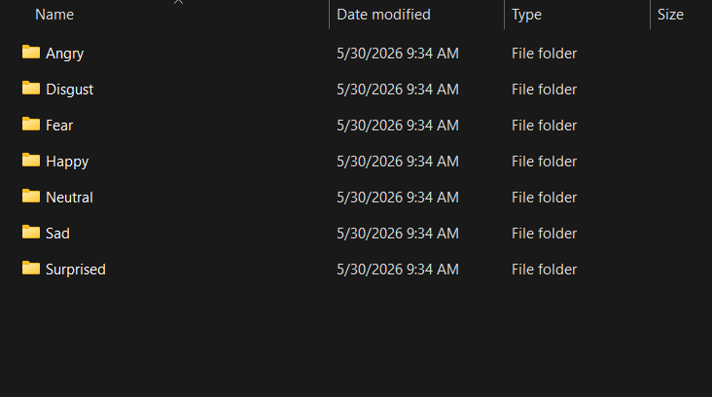
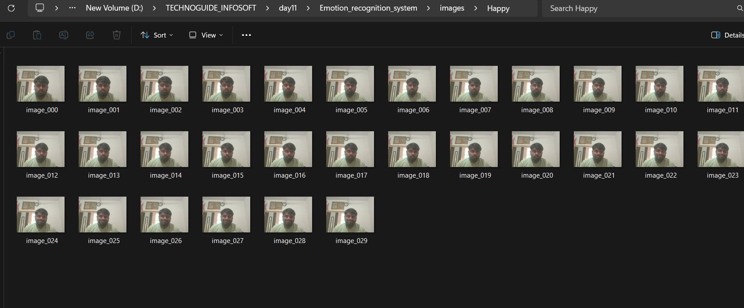
8. Training the AI Model
TensorFlow transfer learning is used for emotion classification training.
Training creates:
• retrained_graph.pb
• retrained_labels.txt
9. Working of the System
The system detects faces, crops the face region, classifies emotions, and displays predictions in real-time.
Process:
Face Detection → Face Cropping → Emotion Classification → Display Result
10. Advantages of the System
Emotion Recognition Systems are useful in modern AI applications.
Advantages:
• Real-time emotion analysis
• AI-powered face recognition
• Smart surveillance support
• Human-computer interaction
11. Real-World Applications
Emotion Recognition is used in various industries and smart AI systems.
Applications:
• Healthcare
• Education
• Security Systems
• AI Assistants
• Customer Analysis
12. Learning Outcome
- Basics of Emotion Recognition Systems
- TensorFlow and OpenCV Integration
- Real-time Face Detection
- Webcam and Mobile Camera Handling
- Emotion Classification Techniques
- Transfer Learning Concepts
- AI-based Facial Analysis
- Computer Vision Applications
13. Conclusion
The eleventh day of the internship introduced Emotion Recognition Systems using TensorFlow and OpenCV. The practical implementation demonstrated how Artificial Intelligence can analyze human facial expressions and classify emotions in real-time through webcam and mobile camera feeds.
The session enhanced my understanding of Computer Vision, facial analysis, TensorFlow model integration, and AI-powered emotion classification systems. Emotion Recognition technology plays an important role in healthcare, security, education, smart surveillance, and human-computer interaction applications.

