

Internship Report - Day 2
30-Day MERN Stack with AI Internship
TechnoGuide Infosoft Pvt. Ltd., Anand

Day 2 - Python Basics
On the second day of the internship, I learned the basics of Python programming including variables, loops, and conditional statements. I also created a calculator application and developed an age calculator mini project using Python.

Topics Covered
- Python Variables
- Loops in Python
- Conditional Statements
- Calculator Application
- Age Calculator Mini Project

1. Variables in Python
Variables are used to store data values in Python. Python automatically assigns the data type based on the value.
name = "Divy"
age = 20
print(name)
print(age)

2. Loops in Python
Loops are used to execute a block of code repeatedly.
- For loop:
for i in range(1, 6):
print(i)

- While Loops:
i = 0
while i < 5:
print(i)
i += 1
- Loop Control Statements
break → stops the loop completely
for i in range(5):
if i == 3:
break
print(i)

continue → skips current iteration
for i in range(5):
if i == 2:
continue
print(i)

pass → does nothing (placeholder)
for i in range(5):
pass

- Nested loops (loop inside another loop)
for i in range(3):
for j in range(2):
print(i, j)

3. Conditional Statements
Conditional statements are used to make decisions in programs.
num = 10
if num > 0:
print("Positive Number")
else:
print("Negative Number")

4. Calculator Application
A simple calculator application was created using Python to perform basic arithmetic operations like addition, subtraction, multiplication, and division.
num1 = float(input("Enter first number: "))
num2 = float(input("Enter second number: "))
print("1. Addition")
print("2. Subtraction")
print("3. Multiplication")
print("4. Division")
choice = int(input("Enter choice: "))
if choice == 1:
print("Result:", num1 + num2)
elif choice == 2:
print("Result:", num1 - num2)
elif choice == 3:
print("Result:", num1 * num2)
elif choice == 4:
print("Result:", num1 / num2)
else:
print("Invalid Choice")
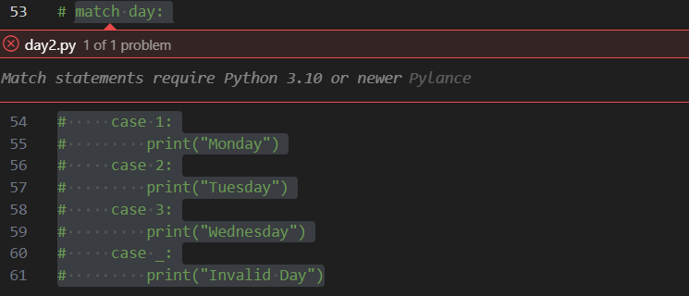

5. Age Calculator Mini Project
An age calculator mini project was created to calculate the user's age based on the birth year.
from datetime import date
birth_year = int(input("Enter your birth year: "))
current_year = date.today().year
age = current_year - birth_year
print("Your age is:", age)

Learning Outcome
By the end of Day 2, I understood Python basics including variables, loops, and conditions. I also gained practical experience by building simple Python projects.

Conclusion
The second day of the internship helped strengthen my programming fundamentals and improved my understanding of Python development.

