

Internship Report - Day 4
30-Day MERN Stack with AI Internship
TechnoGuide Infosoft Pvt. Ltd., Anand

Day 4 - Data Handling
On the fourth day of the internship, I learned data handling using Pandas. I understood how to read CSV files, analyze datasets, calculate student averages, find topper students, and sgenerate charts using Matplotlib.

Topics Covered
- Introduction to Pandas
- Reading CSV Files
- Analyzing Student Marks Dataset
- Generating Simple Charts
- Real-Life Data Analysis

1. Introduction to Pandas
Pandas is a Python library used for data analysis and handling structured data.
pip install pandas

2. Reading CSV Files
CSV stands for Comma Separated Values. It stores data in table format.
import pandas as pd
data = pd.read_csv("students.csv")
print(data)
The read_csv() function reads CSV file data and converts it into a DataFrame.

3. Student Marks Dataset
import pandas as pd
df = pd.read_csv("students.csv")
print(df)
A DataFrame is a table structure in Pandas containing rows and columns.
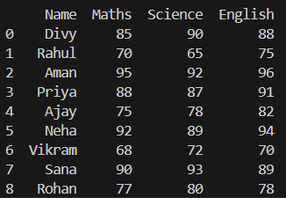

4. Calculating Average Marks
df["Average"] = (
df["Maths"] +
df["Science"] +
df["English"]
) / 3
print(df)
This code creates a new Average column and calculates average marks.
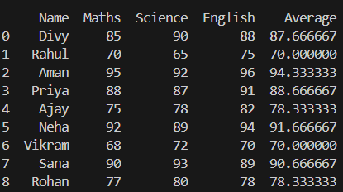

5. Finding Topper Student
topper = df[df["Average"] == df["Average"].max()]
print(topper)

The max() function finds the highest average marks and filters topper student data.
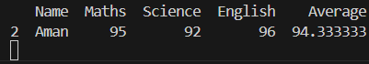

6. Generating Charts
import matplotlib.pyplot as plt
plt.bar(df["Name"], df["Average"])
plt.title("Average Marks")
plt.xlabel("Students")
plt.ylabel("Average")
plt.show()
Matplotlib is used to generate charts and visualize student performance.
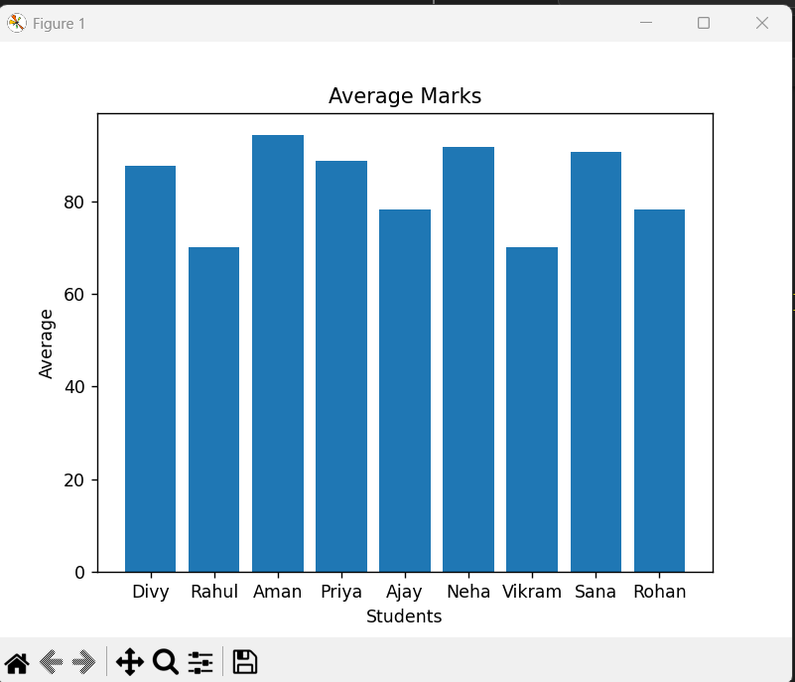

7. Real-Life Applications
- Schools use data analysis for student results.
- Businesses use charts for analytics.
- Hospitals analyze patient records.
- Banks process transaction datasets.
- AI projects use Pandas for preprocessing.

8.Learning Outcome
By the end of Day 4, I learned CSV handling, data analysis, chart generation, and practical dataset processing using Pandas and Matplotlib.

9.Conclusion
The fourth day of the internship improved my understanding of real-world data handling and visualization techniques.

