
Internship Report - Day 5
30-Day MERN Stack with AI Internship
TechnoGuide Infosoft Pvt. Ltd., Anand

Day 5 - AI Mathematics and Data Visualization
On the fifth day of the internship, I learned how to analyze student data using Python libraries such as Pandas, Statistics, Matplotlib, and Scikit-learn. I performed statistical calculations like mean and median, created data visualizations using pie charts and histograms, and built a simple Linear Regression model to predict student marks based on study hours.

Topics Covered
- Loading CSV Data using Pandas
- Mean and Median Calculation
- Pie Chart Visualization
- Histogram Visualization
- Introduction to Linear Regression
- Prediction using Machine Learning
- Data Analysis using Python

1. Loading Student Data using Pandas
Pandas is a Python library used for handling datasets. The student marks data was loaded from a CSV file using the read_csv() function.
import pandas as pd
df_students = pd.read_csv("../day4/students.csv")
print(df_students)

2. Mean and Median Calculation
Mean is the average of all values, while median is the middle value after arranging the data in sorted order.
import statistics
for subject in ["Maths", "Science", "English"]:
marks = df_students[subject].tolist()
mean = sum(marks) / len(marks)
median = statistics.median(marks)
print(f"{subject} - Mean: {mean:.1f}, Median: {median:.1f}")

3. Pie Chart Visualization
A pie chart was created to visualize the average marks distribution for Maths, Science, and English subjects.
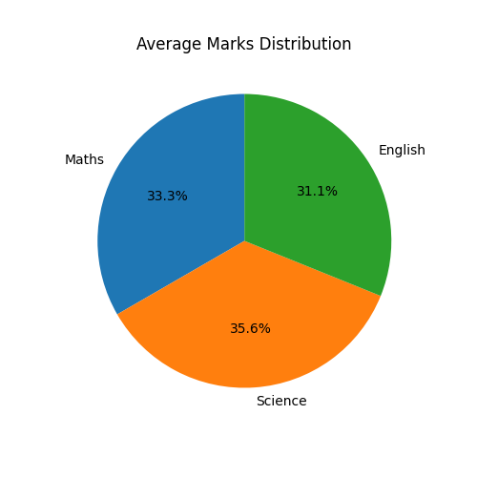

4. Histogram Visualization
Histograms were used to analyze the marks distribution for each subject. It helps in understanding how student marks are spread across different ranges.
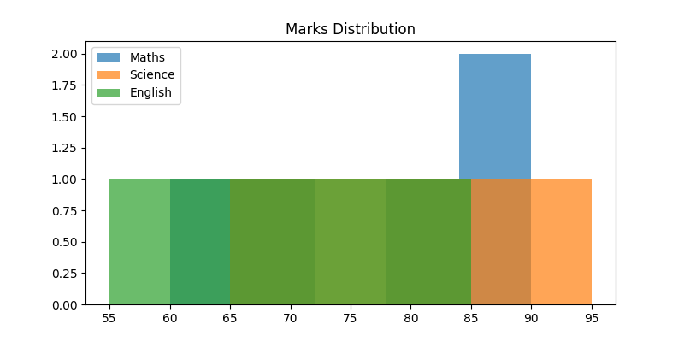

5. Linear Regression for Prediction
Linear Regression is a Machine Learning algorithm used to predict values based on previous data patterns.
Linear Regression Formula:
y = mx + b
Where:
y = predicted value
m = slope
x = input value
b = intercept
from sklearn.linear_model import LinearRegression
data = {
"Hours": [1, 2, 3, 4, 5],
"Marks": [20, 40, 60, 80, 100]
}
df = pd.DataFrame(data)
X = df[["Hours"]]
y = df["Marks"]
model = LinearRegression()
model.fit(X, y)
prediction_df = pd.DataFrame({"Hours": [6]})
prediction = model.predict(prediction_df)
print("Predicted Marks:", prediction)
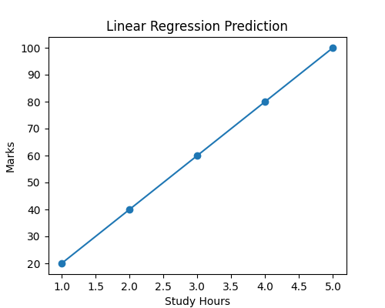

Real-Life Applications
- Student performance prediction
- Business forecasting
- Sales prediction
- Weather forecasting
- AI recommendation systems
- Medical data analysis

Learning Outcome
By the end of Day 5, I learned how to analyze datasets using Pandas, perform statistical calculations, create charts for visualization, and build simple Machine Learning models using Linear Regression.

Conclusion
The fifth day of the internship improved my understanding of AI mathematics, data visualization, and Machine Learning concepts. It helped me understand how AI models analyze patterns and make predictions from datasets.

