
Internship Report - Day 6
30-Day MERN Stack with AI Internship
TechnoGuide Infosoft Pvt. Ltd., Anand

Day 6 - Machine Learning House Price Prediction
On the sixth day of the internship, I learned the fundamentals of Machine Learning and Linear Regression using Python. I created a House Price Prediction system using Pandas, Matplotlib, and Scikit-learn. The project predicts house prices based on house size using Machine Learning.

Topics Covered
- Introduction to Machine Learning
- Dataset Handling using Pandas
- Linear Regression
- Model Training
- House Price Prediction
- Currency Conversion
- Graph Visualization

1. Introduction to Machine Learning
Machine Learning is a branch of Artificial Intelligence where computers learn from data and make predictions automatically.

Real-Life Applications
- House Price Prediction
- Weather Forecasting
- Netflix Recommendations
- Fraud Detection
- Medical Diagnosis
- Sales Forecasting

2. House Price Dataset
The dataset contains house sizes and corresponding prices. This dataset is used to train the Machine Learning model.

House Size (sq ft) | Price (USD)
1000 | 200000
1500 | 300000
2000 | 400000
2500 | 500000
3000 | 600000

3. Linear Regression
Linear Regression is a Machine Learning algorithm used to predict continuous values based on input data.
Equation:
y = mx + b
Where:
y = predicted value
m = slope
x = input value
b = intercept

4. House Price Prediction Program
# Import Required Libraries
import pandas as pd
import matplotlib.pyplot as plt
from sklearn.linear_model import LinearRegression
data = {
"Size": [1000, 1500, 2000, 2500, 3000],
"Price": [200000, 300000, 400000, 500000, 600000]
}
df = pd.DataFrame(data)
X = df[["Size"]]
y = df["Price"]
model = LinearRegression()
model.fit(X, y)
house_size = 3500
prediction = model.predict(pd.DataFrame({"Size": [house_size]}))
print(prediction)
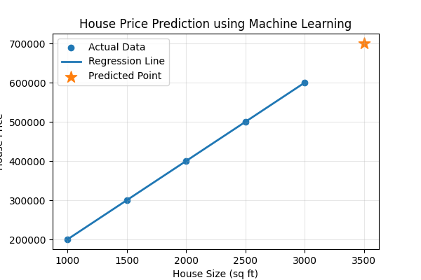

5. Output
Predicted House Price for 3500 sq ft:
USD: $700,000.00
INR: ₹58,100,000.00

6. Graph Visualization
- Scatter plot shows the actual dataset
- Regression line represents the learning pattern
- Predicted point shows estimated house price
- Graph helps understand the relationship between size and price

Learning Outcome
By the end of Day 6, I learned how Machine Learning models are trained using datasets, how Linear Regression works, and how predictions are made using AI algorithms.

Conclusion
The sixth day of the internship improved my understanding of Machine Learning, prediction systems, and graph visualization. The House Price Prediction project demonstrated how AI models can analyze data and predict future values.

