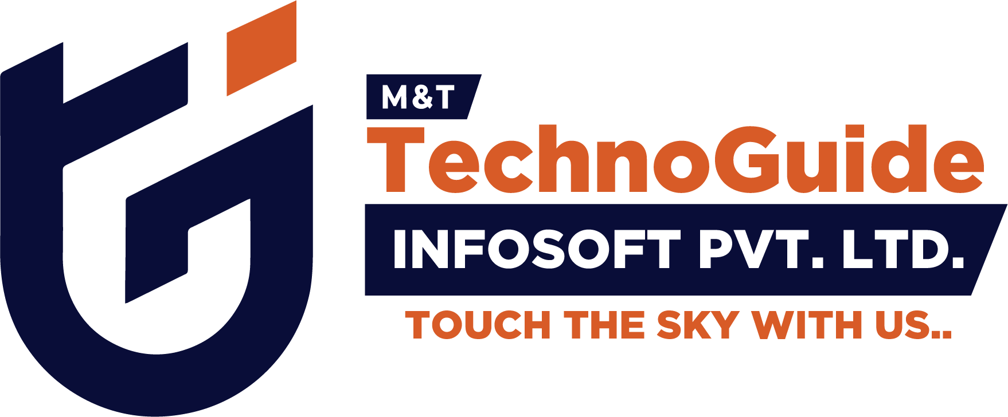
Internship Report - Day 9
30-Day MERN Stack with AI Internship
TechnoGuide Infosoft Pvt. Ltd., Anand

Day 9 – Prompt Engineering and AI Marketing Prompts
On the ninth day of the internship, I learned about Prompt Engineering and explored how Artificial Intelligence tools like ChatGPT can generate high-quality responses using properly structured prompts. The session focused on Zero-shot Prompting, Few-shot Prompting, marketing prompt creation, and prompt testing techniques. I also practiced creating AI prompts for product descriptions, social media content, email marketing, and content generation.
The project improved my understanding of AI communication, prompt optimization, response generation, and AI-assisted marketing content creation.
Topics Covered
- Introduction to Prompt Engineering
- Zero-shot Prompting
- Few-shot Prompting
- Marketing Prompt Creation
- AI Content Generation
- Prompt Optimization Techniques
- ChatGPT Testing
- Prompt Evaluation and Refinement
- AI-based Content Writing

1. Introduction to Prompt Engineering
Prompt Engineering is the process of designing effective instructions for Artificial Intelligence systems like ChatGPT.
Write a professional product description for a wireless keyboard.

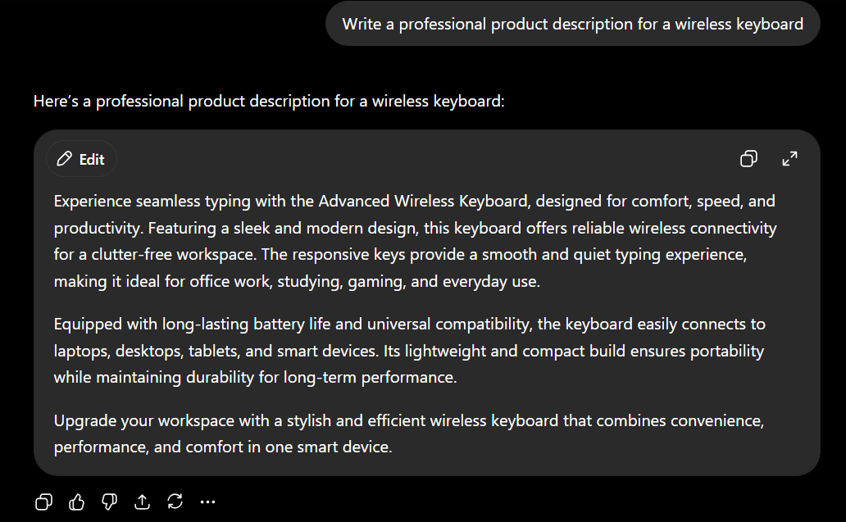

2. Zero-shot Prompting
Zero-shot prompting means asking AI to perform a task without providing examples.
Write a social media caption for a fitness product.
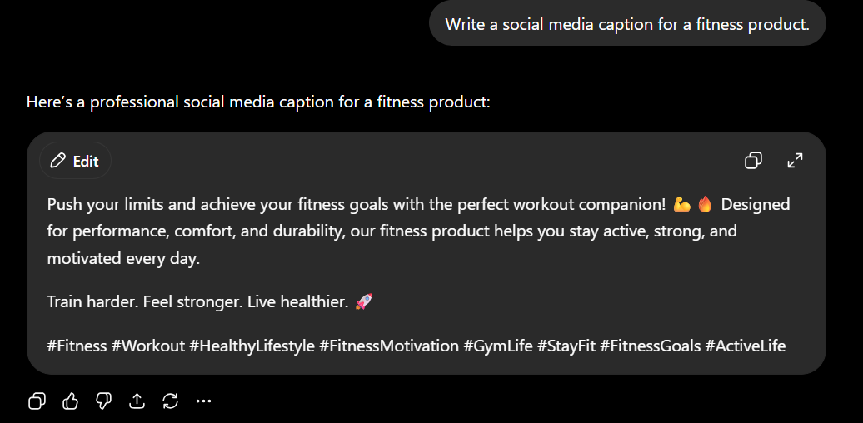

3. Few-shot Prompting
Few-shot prompting provides examples before asking AI to perform a task.
Example:
Product: Smart Watch
Description: A modern smartwatch with fitness tracking.
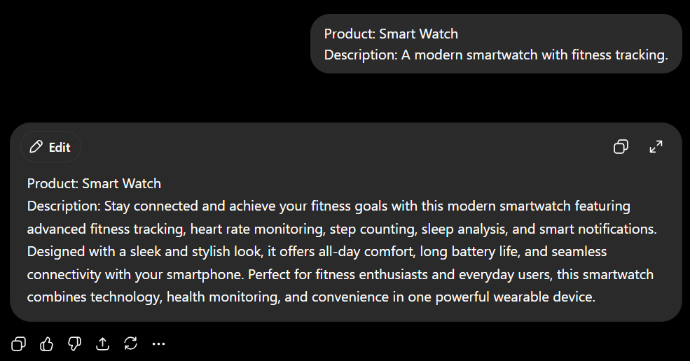

Now write for:
Product: Wireless Earbuds
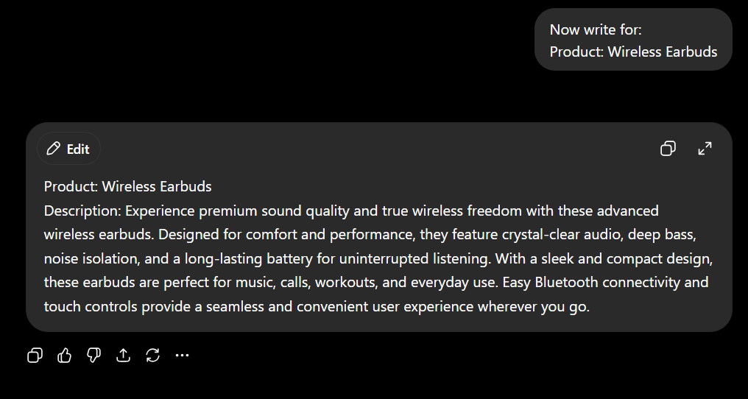

4. Marketing Prompt Creation
Marketing prompts help generate promotional content using AI.
Write an engaging advertisement for a new energy drink targeting college students.
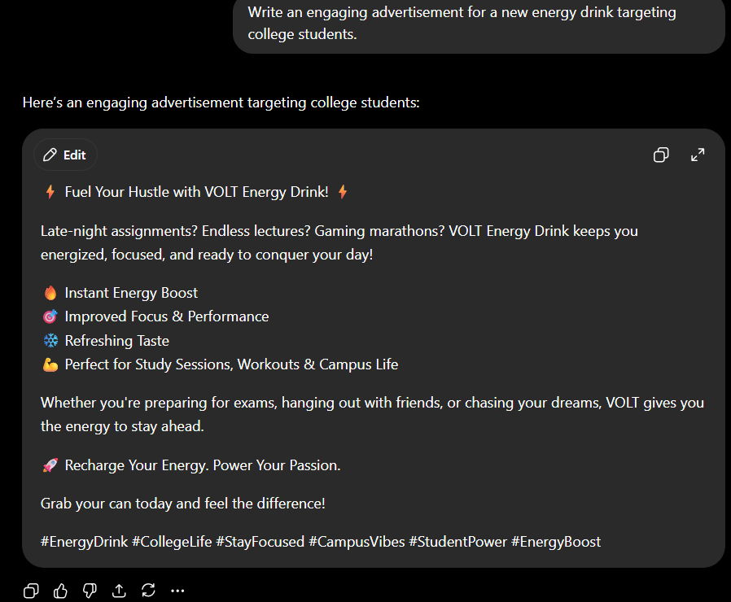

5. Product Description Generation
AI can generate product descriptions using prompts.
Write a 100-word product description for a Bluetooth speaker.
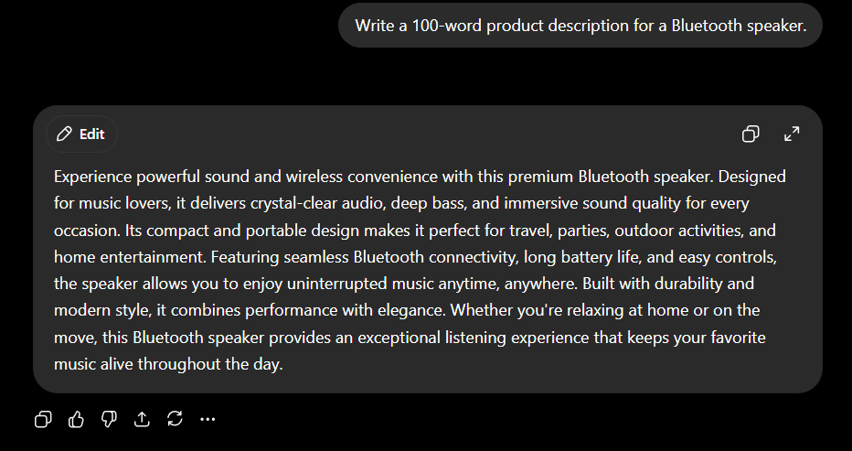

6. Social Media Prompting
Prompt Engineering can generate social media content.
Write an Instagram caption for a fashion brand sale.
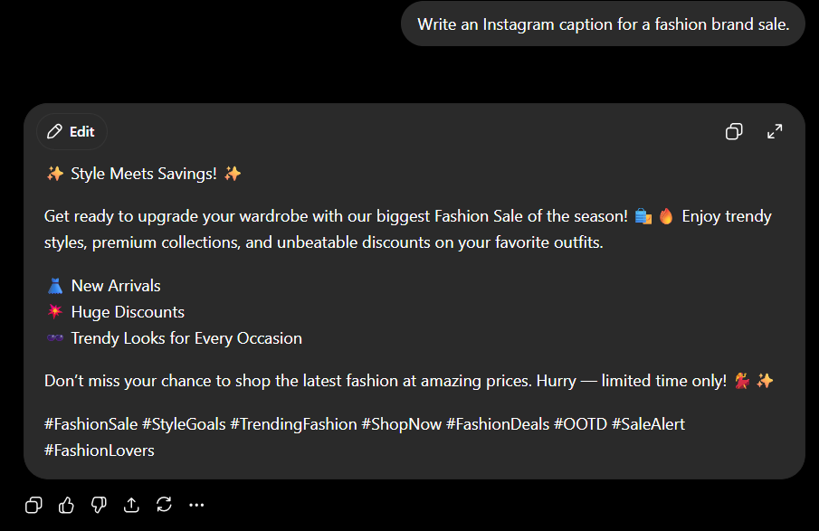

7. Email Marketing Prompting
AI can generate professional email content.
Write a promotional email for a summer clothing sale.
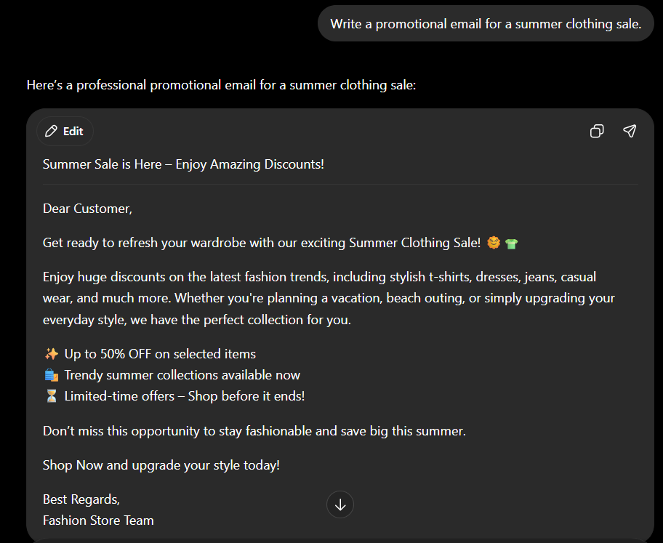

8. Prompt Structure Optimization
A well-structured prompt improves AI responses.
Write a professional LinkedIn post for a software internship completion in under 150 words.
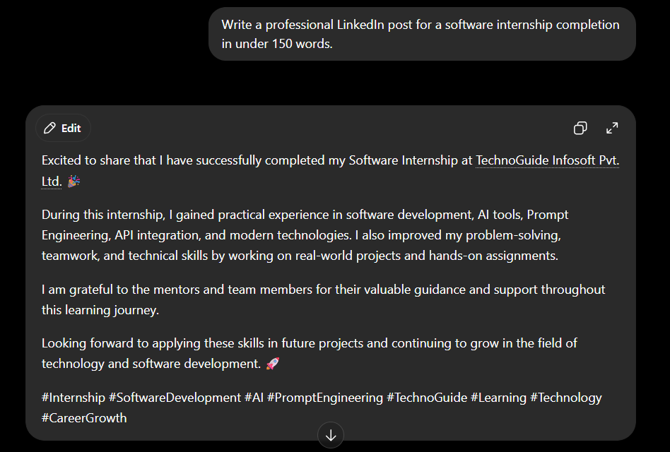

9. Prompt Testing in ChatGPT
Prompts are tested in ChatGPT to evaluate response quality.
Enter prompt → Analyze output → Improve prompt structure → Re-test

10. Prompt Refinement Techniques
Prompt refinement improves generated content.
Initial Prompt: Write a product description.
Refined Prompt: Write a professional 100-word product description for wireless headphones targeting gamers.
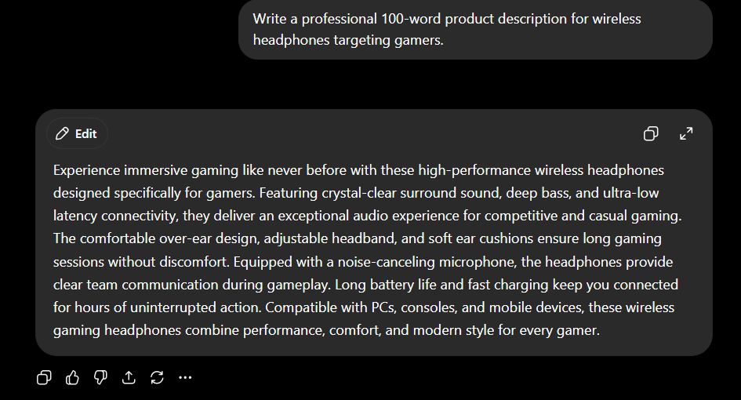

11. AI Content Generation
Prompt Engineering supports automatic content creation such as:
• Product Descriptions
• Blog Content
• Social Media Captions
• Email Marketing
• Advertisements
• Website Content

12. Real-Life Applications
- Digital Marketing
- Content Writing
- Social Media Management
- E-commerce Product Promotion
- Customer Communication
- Blogging and SEO
- AI Chatbot Training
- Business Advertising

13. Learning Outcome
By the end of Day 9, I learned:
• Basics of Prompt Engineering
• Zero-shot Prompting
• Few-shot Prompting
• AI Marketing Prompt Creation
• Prompt Optimization Techniques
• AI Content Generation
• Prompt Testing and Refinement
• Professional AI Communication

14. Conclusion
The ninth day of the internship introduced Prompt Engineering techniques for effective AI communication. The practical activities demonstrated how properly structured prompts improve AI-generated responses. The session enhanced my understanding of ChatGPT interaction, AI-based marketing content generation, and prompt optimization techniques.
Prompt Engineering is an important skill for modern AI applications and digital marketing solutions.

