Cerbo Supplement Ordering: Diagrams
All 33 diagrams for the in-house supplement ordering slice, rendered from the Mermaid sources in docs/diagrams. The first section covers the essentials; the rest is the full reference set.

Start here

System at a glance
The React app talks to the FastAPI backend with a user ID header. Every route checks role and ownership, services do the work, money.py is the only place the split is computed, and payments, notifications, and shipping are stubbed.
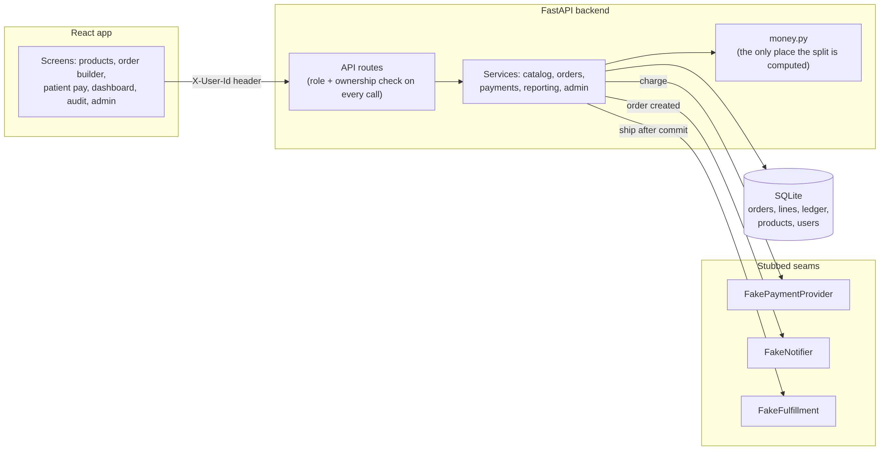

Order states
An order is pending until it is paid or cancelled. A declined card or missing stock changes nothing, so the patient can retry.
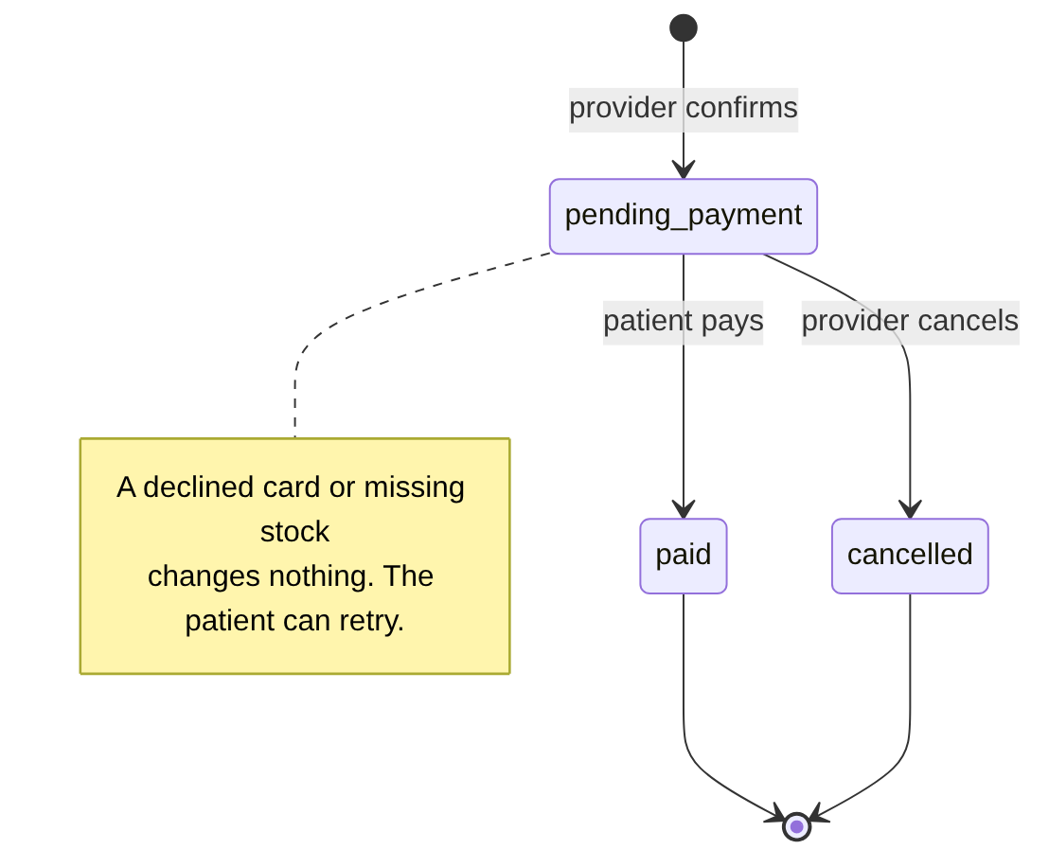

Data model
Six tables, all money in integer cents. Order lines copy price and cost at creation, and every paid order gets exactly four ledger rows.
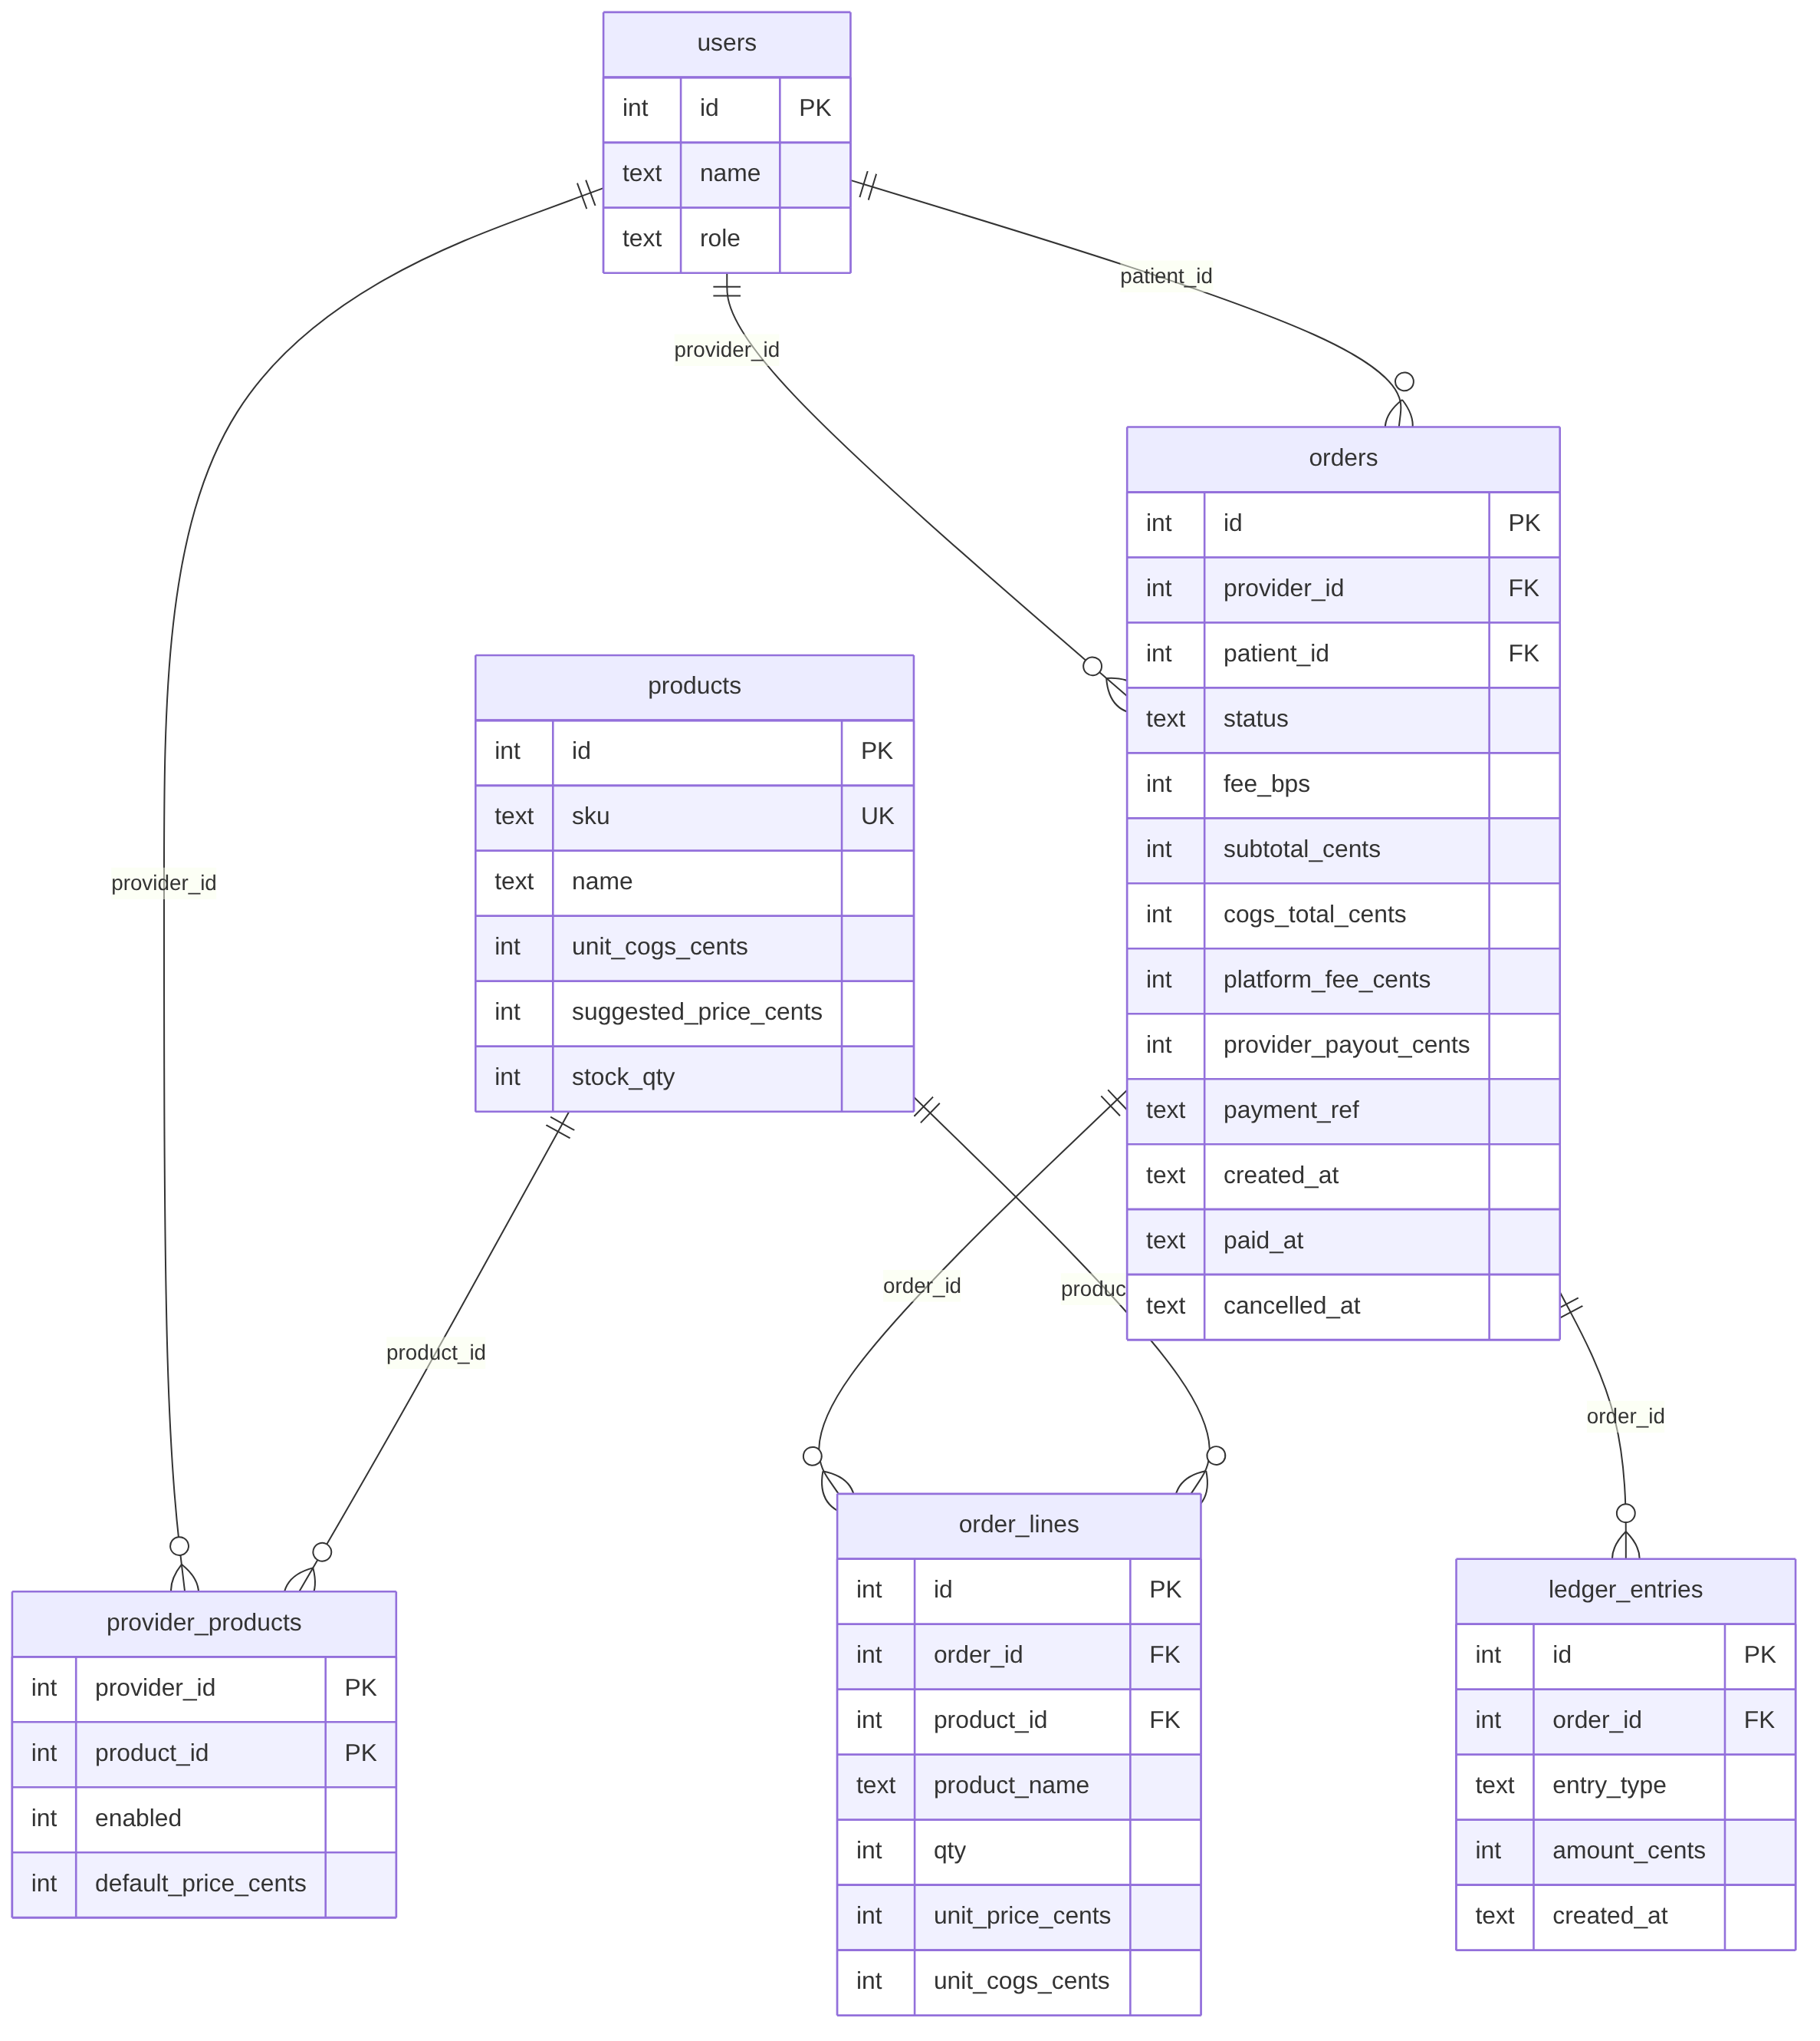

The payment step
Claim the order, take the stock, charge, write the ledger, commit, then ship. Every failure path rolls back, and a repeat request returns the original receipt without charging again.
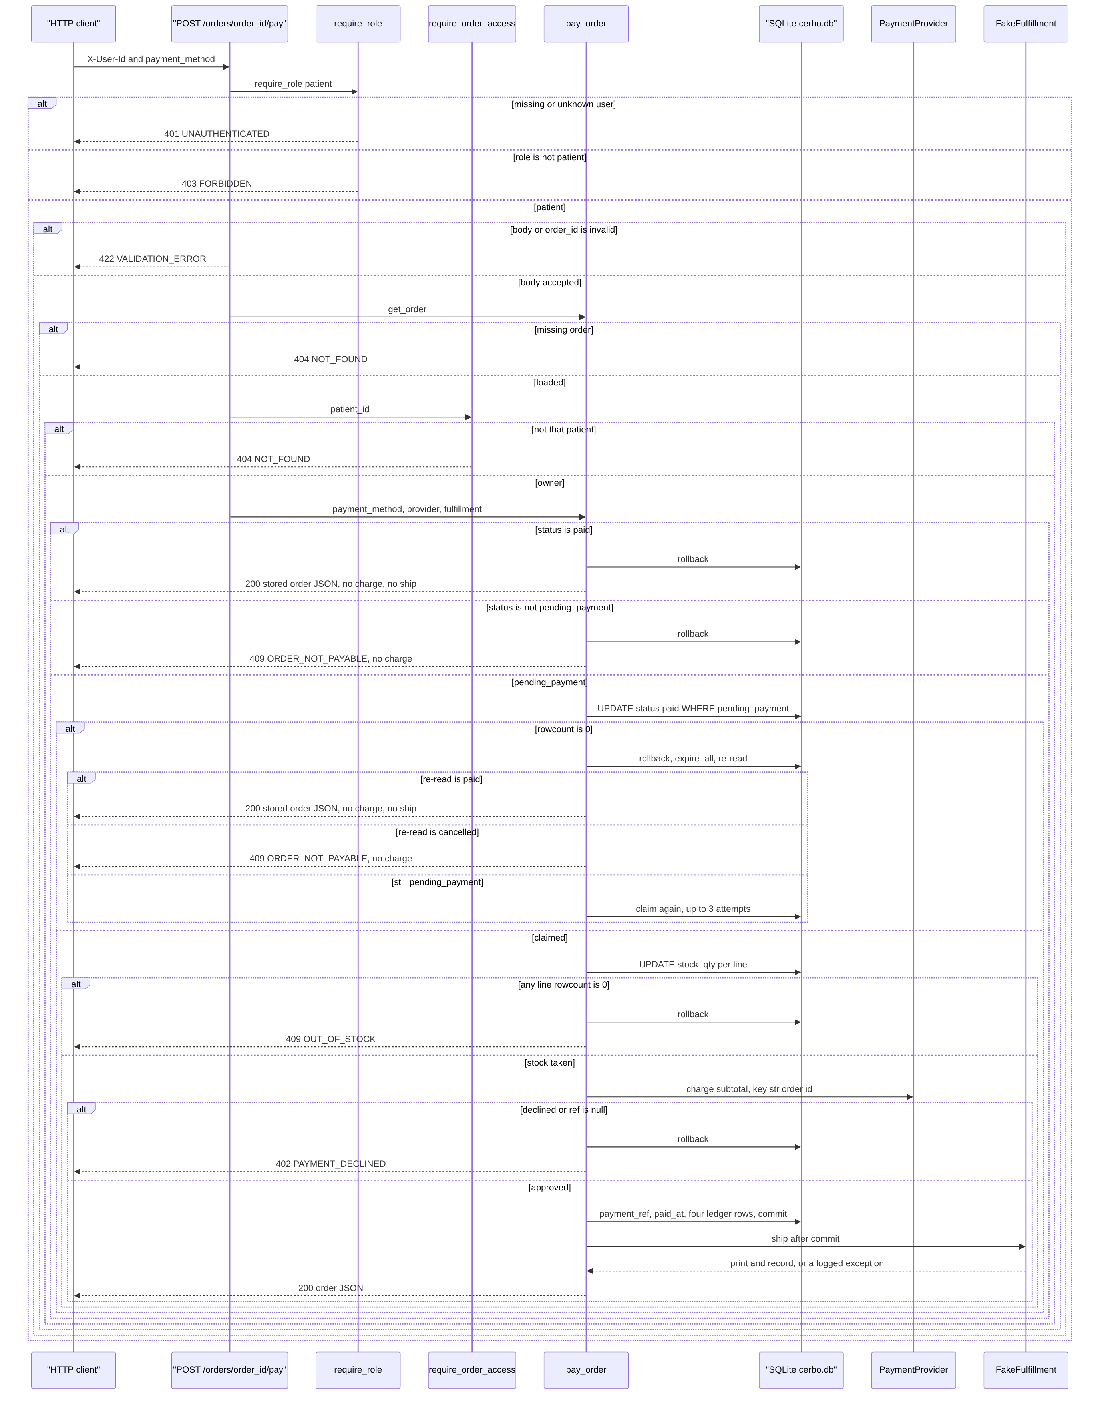

How each task was built
Tester writes failing tests, the agent implements, the verifier and reviewer gate it, the diagrammer updates docs, then Claude reviews and you commit.
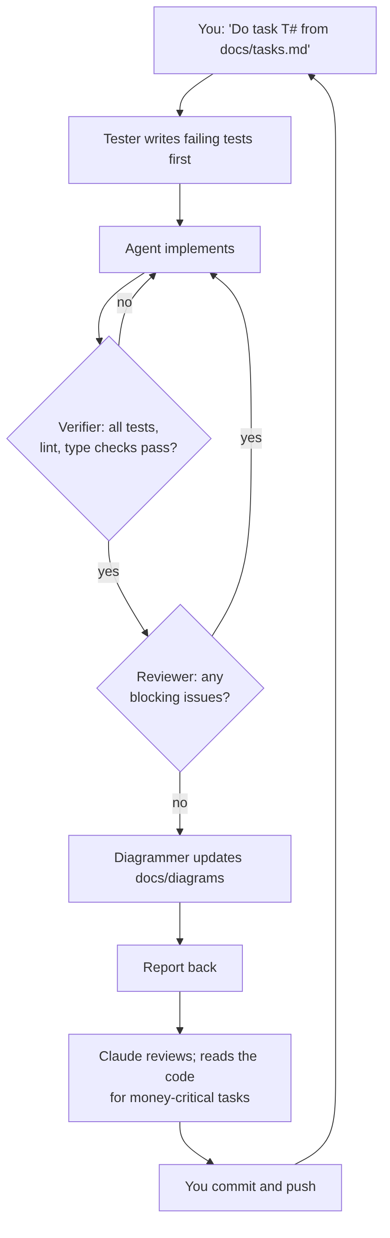

System overview (full)

Every route and dependency
The complete route-by-route map from docs/diagrams/overview.md. Dense by design: it shows every API route, the checks it runs, and the services and stubs it reaches.
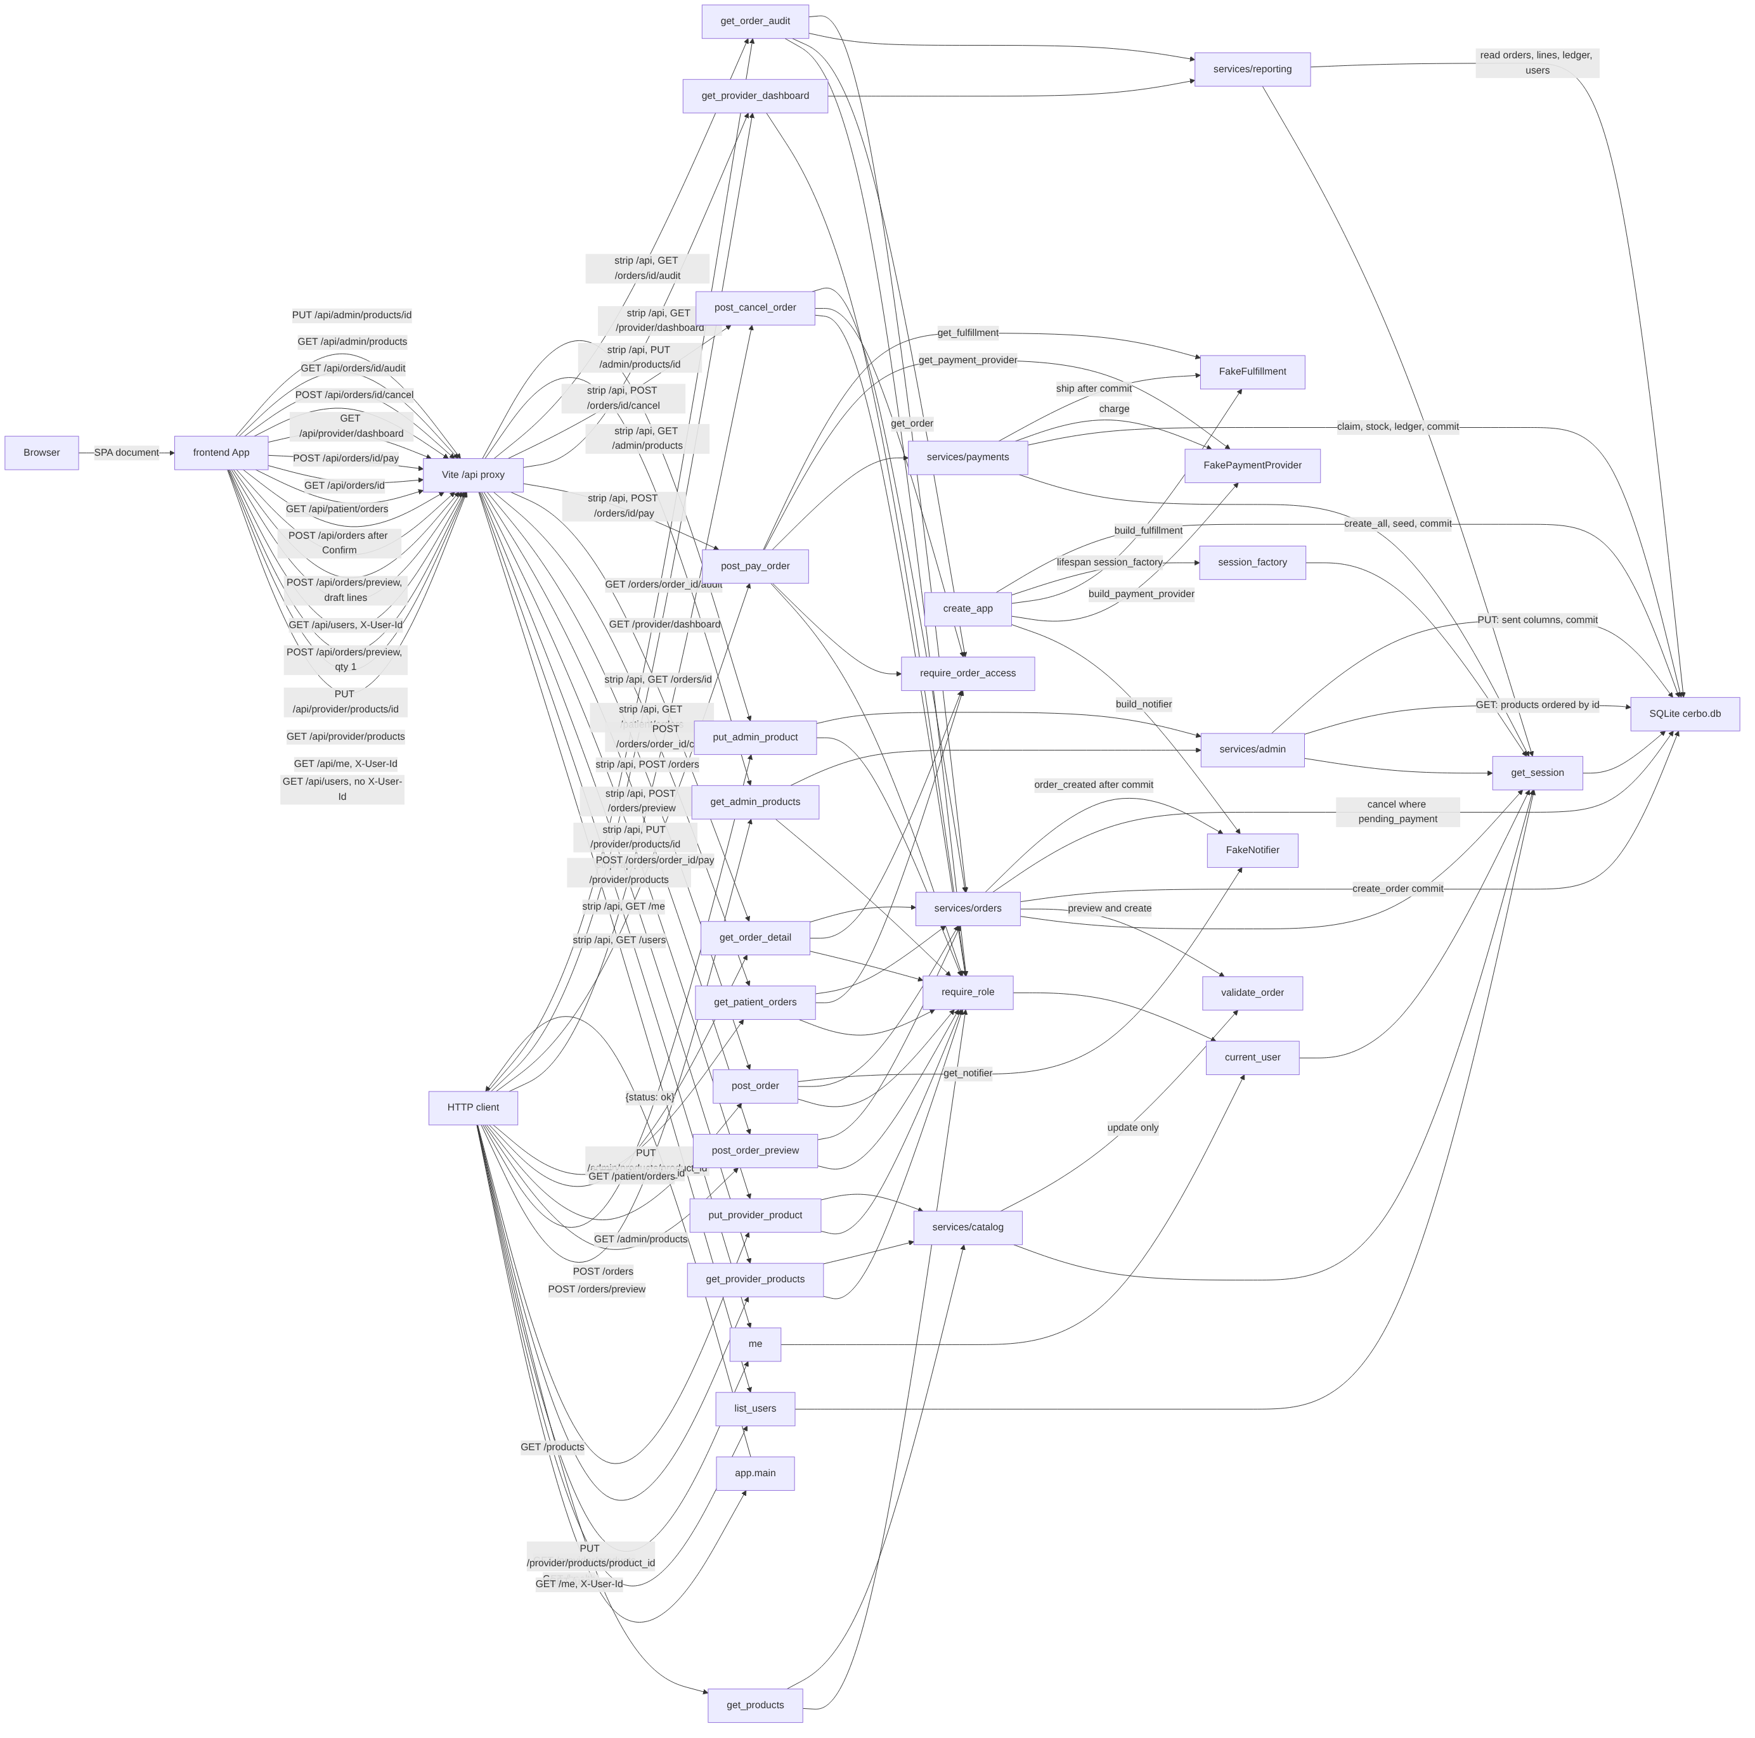

Data flow

Data flow 1 of 6
From docs/diagrams/data-flow.md.
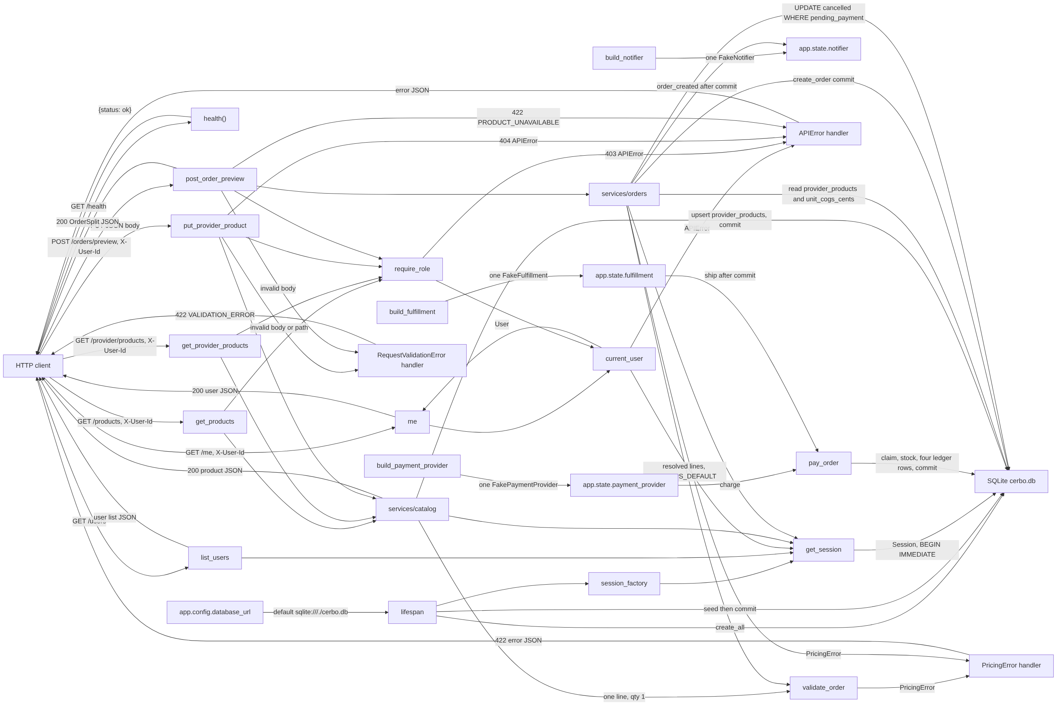

Data flow 2 of 6
From docs/diagrams/data-flow.md.
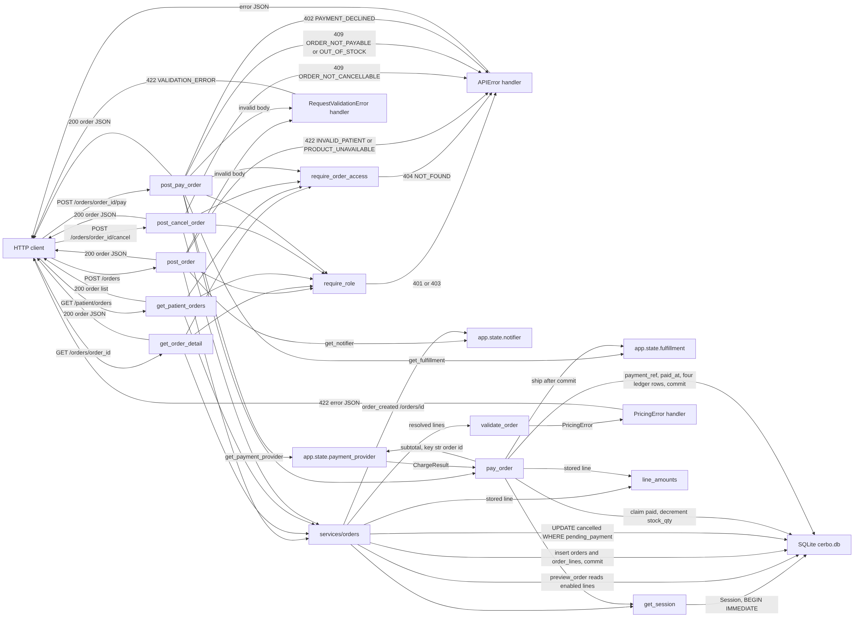

Data flow 3 of 6
From docs/diagrams/data-flow.md.
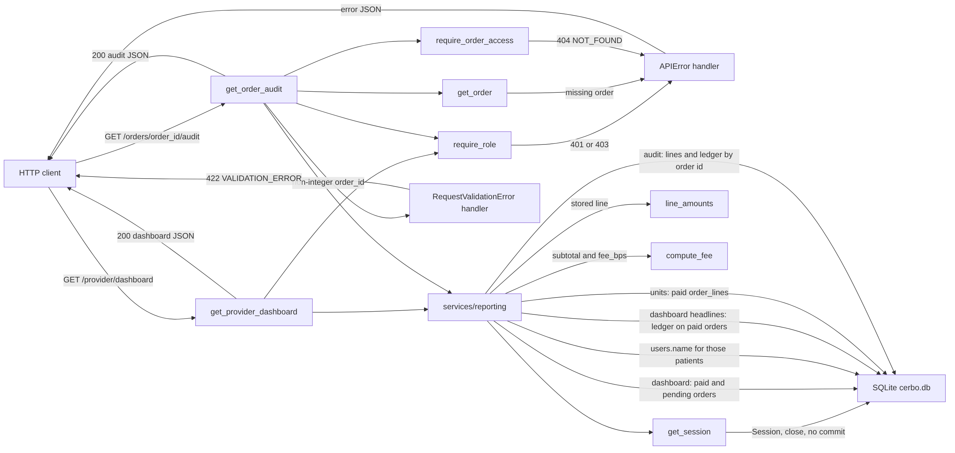

Data flow 4 of 6
From docs/diagrams/data-flow.md.
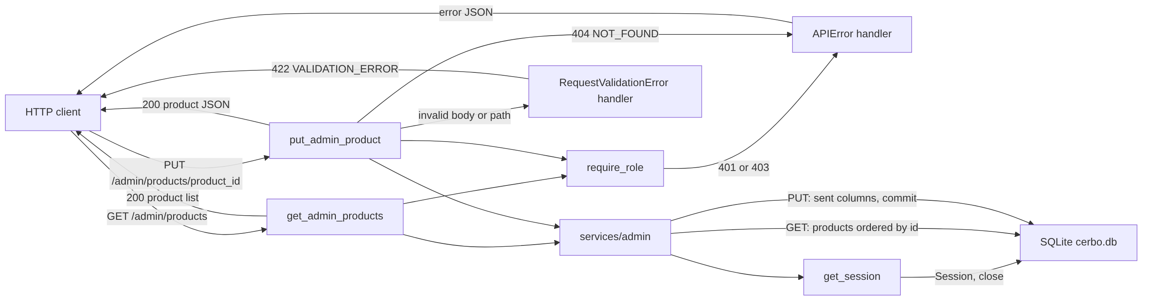

Data flow 5 of 6
From docs/diagrams/data-flow.md.
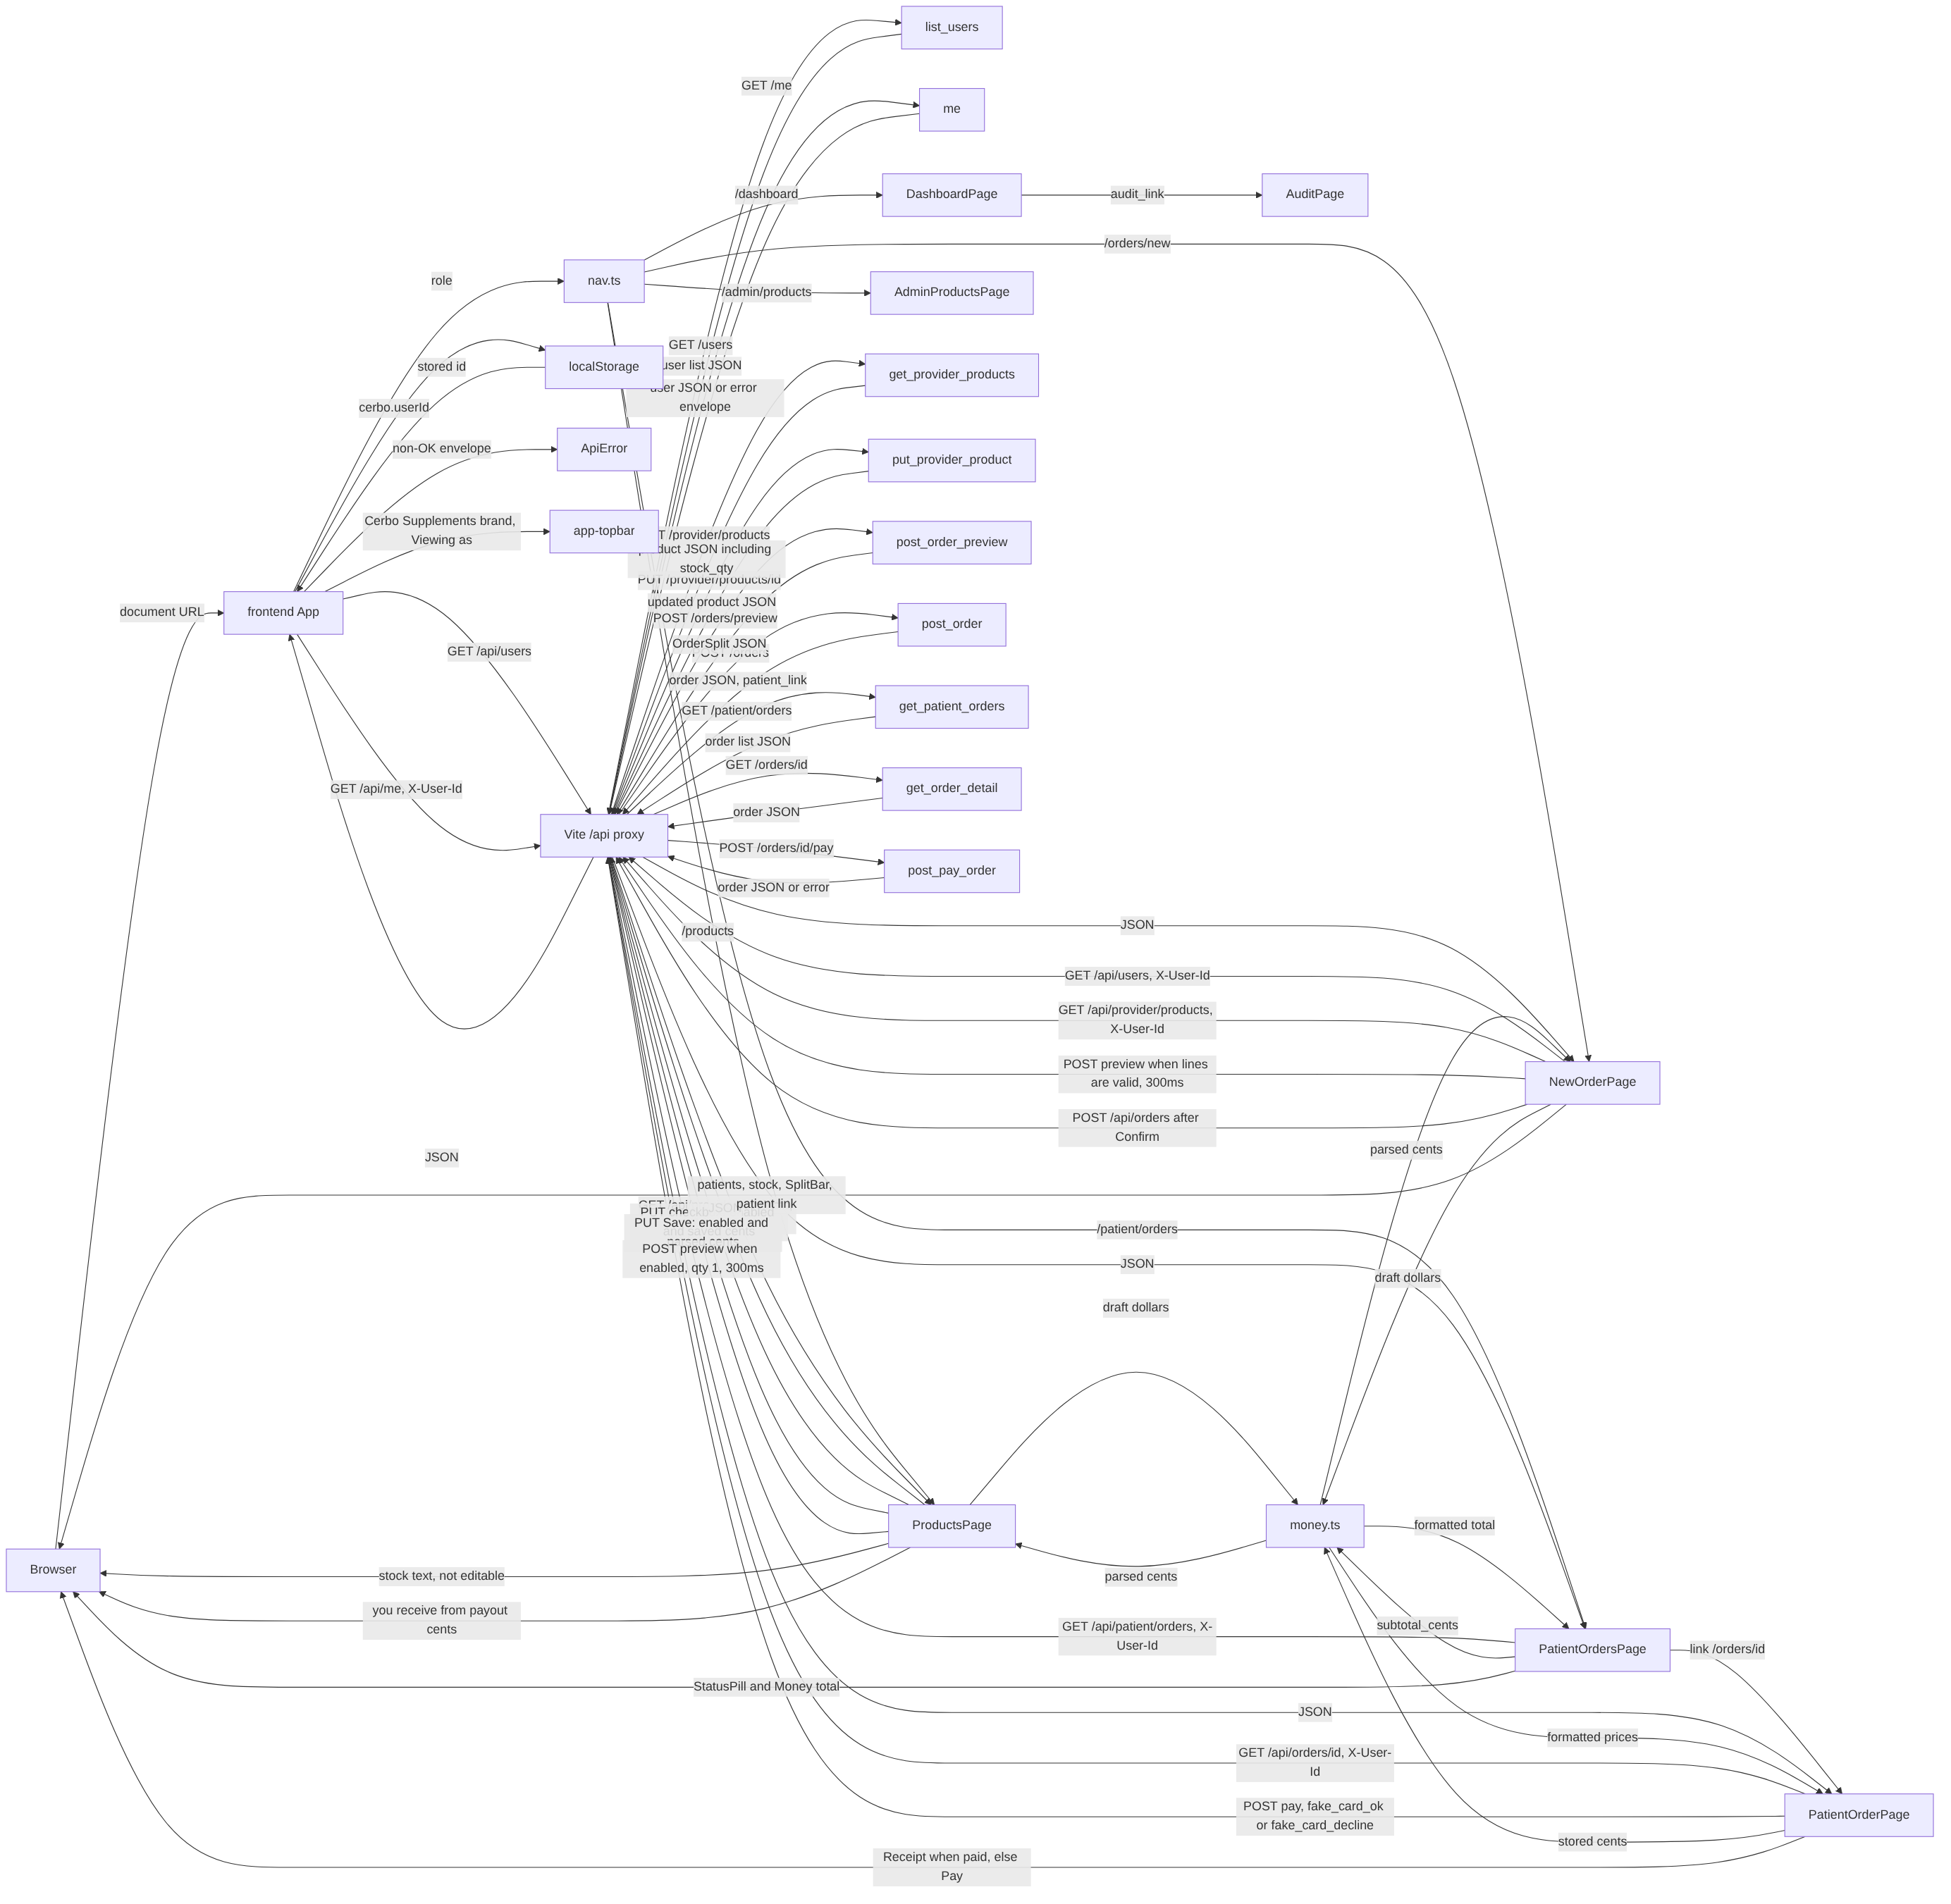

Data flow 6 of 6
From docs/diagrams/data-flow.md.
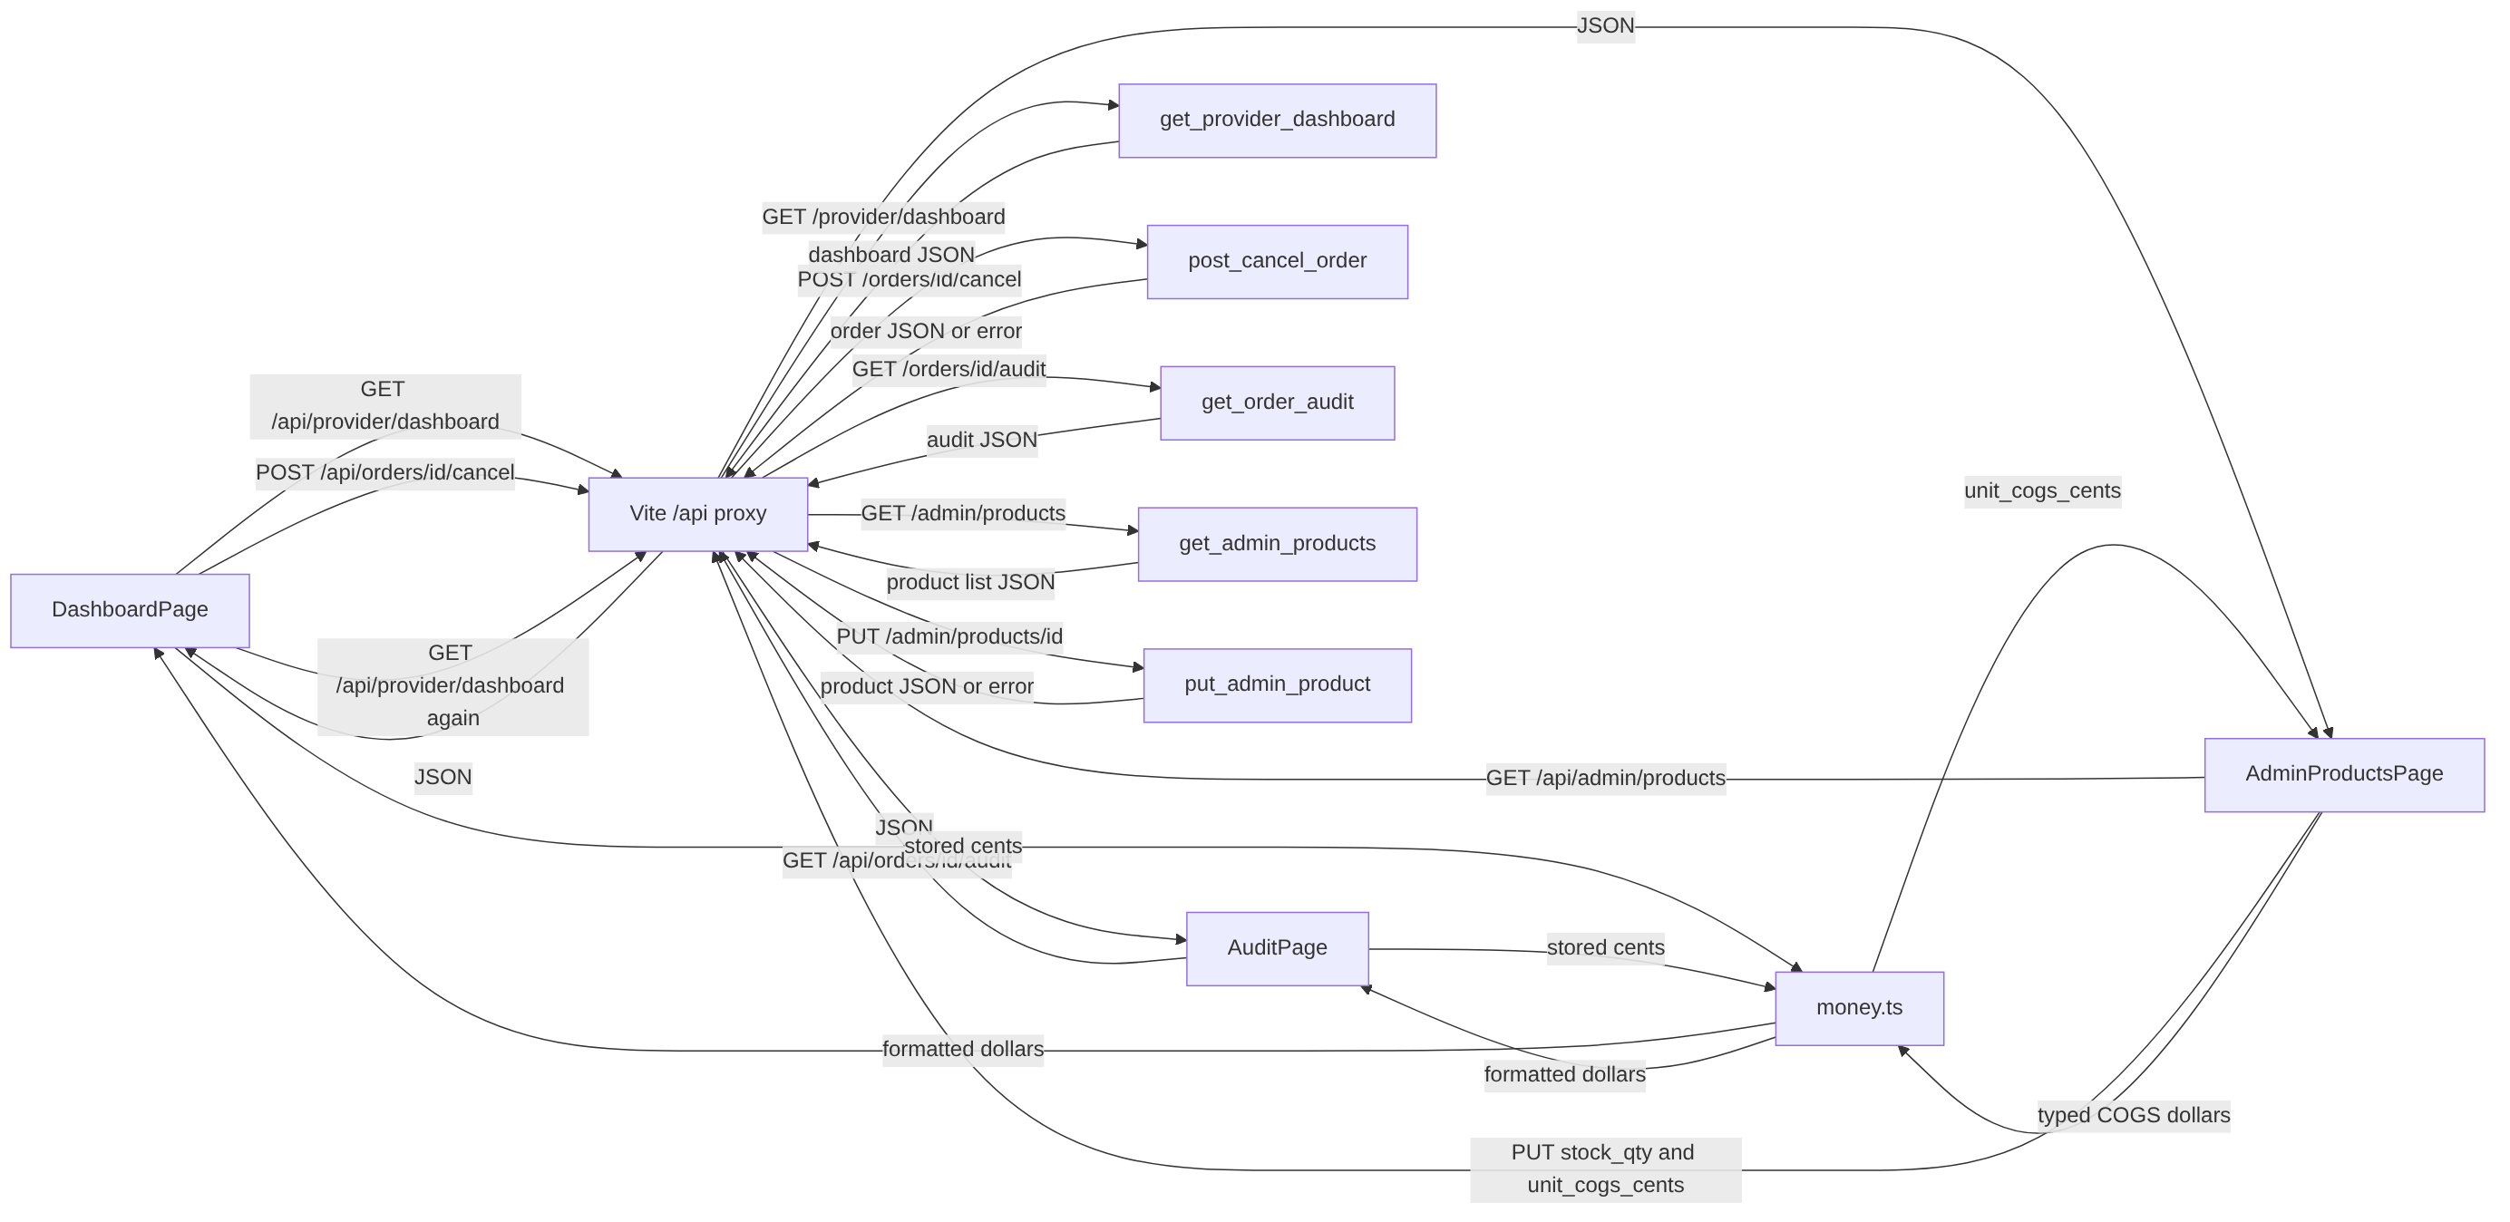

Feature flows

Auth
How the user ID header becomes the current user, and the 401 and 403 cases.
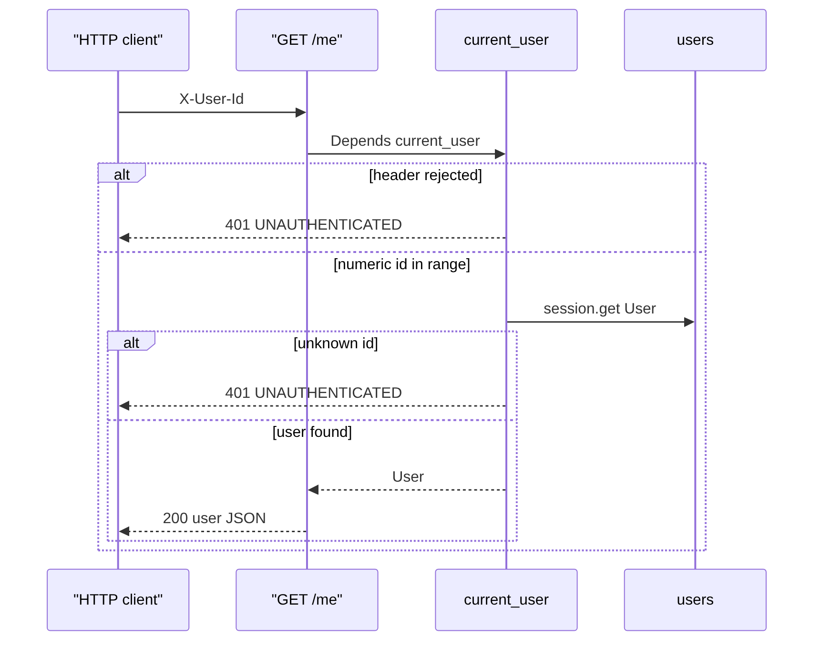

Provider products 1 of 2
Reading a provider's product list.
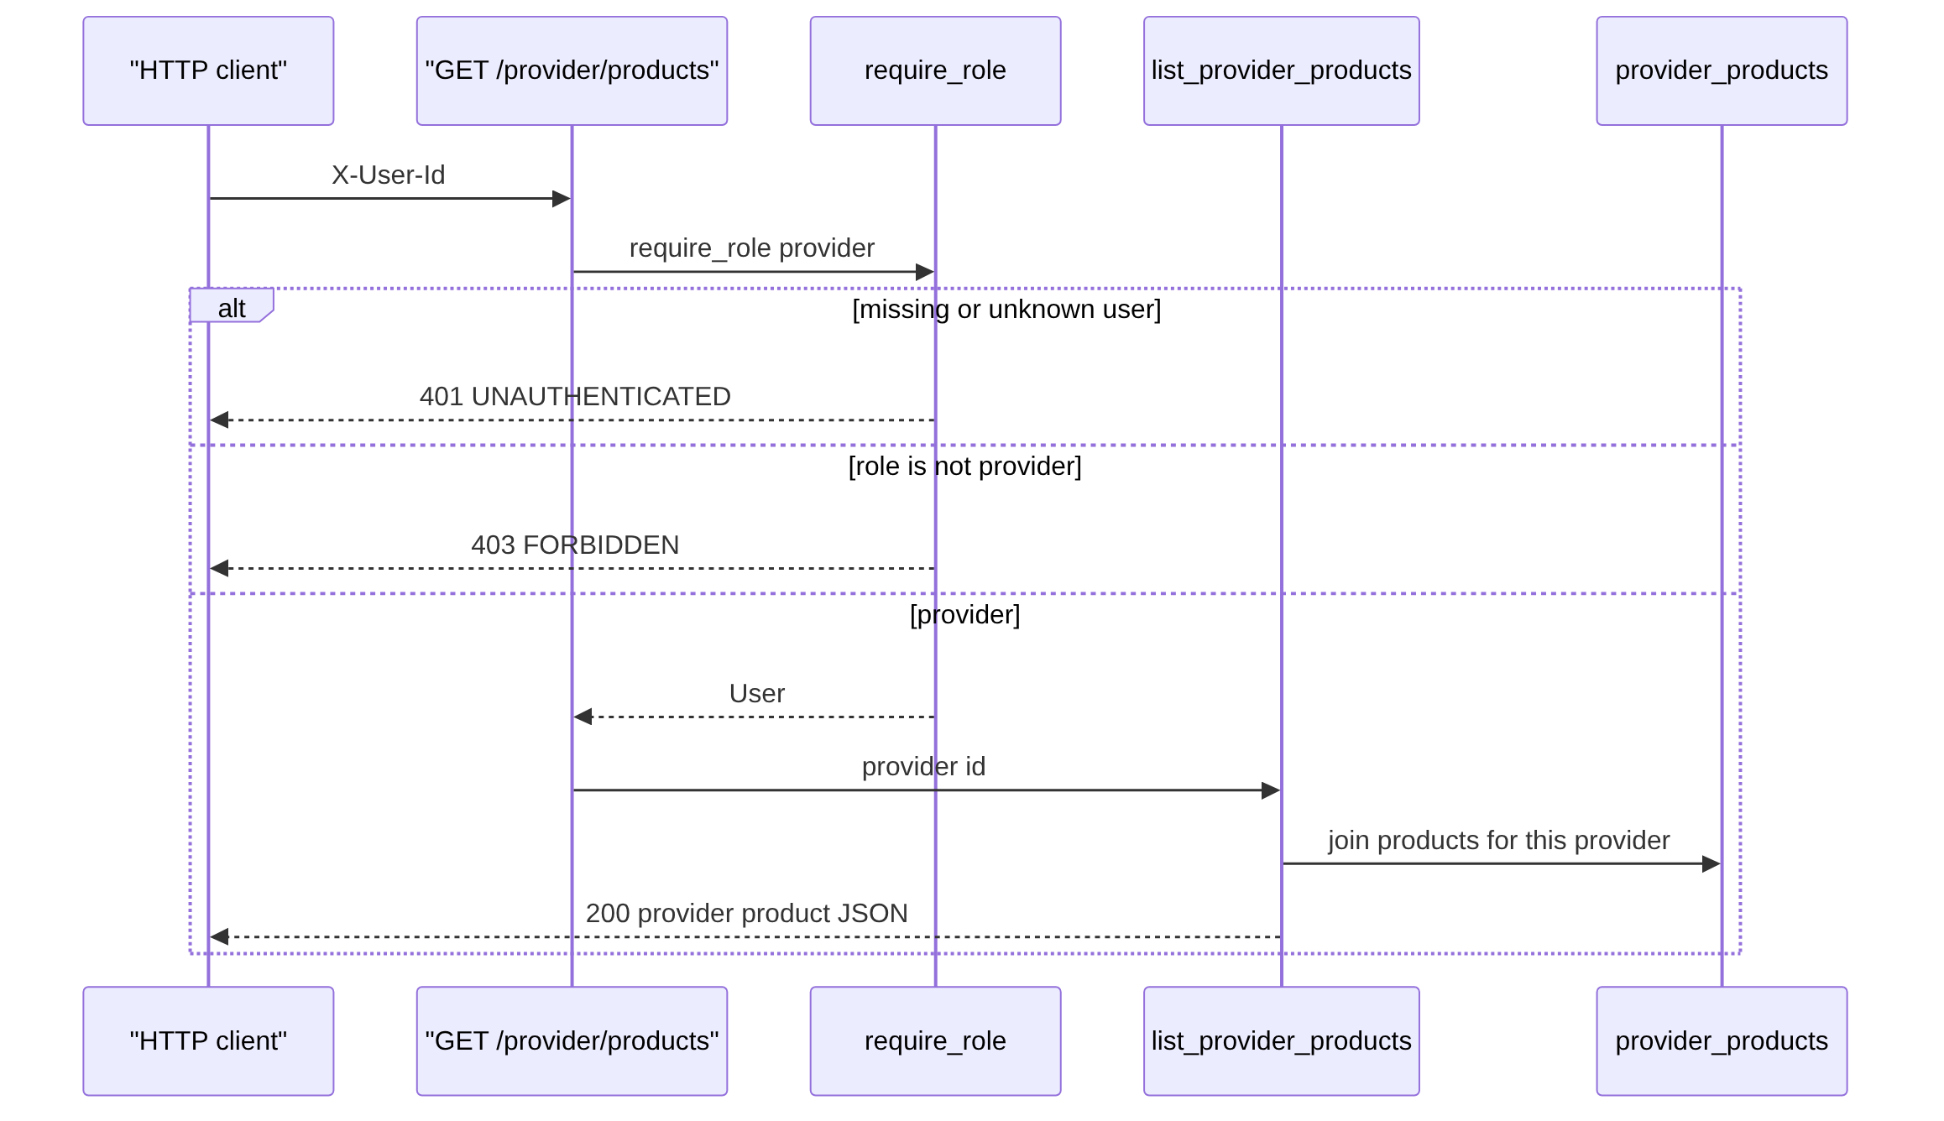

Provider products 2 of 2
Saving a default price, checked with the same money rules as real orders.
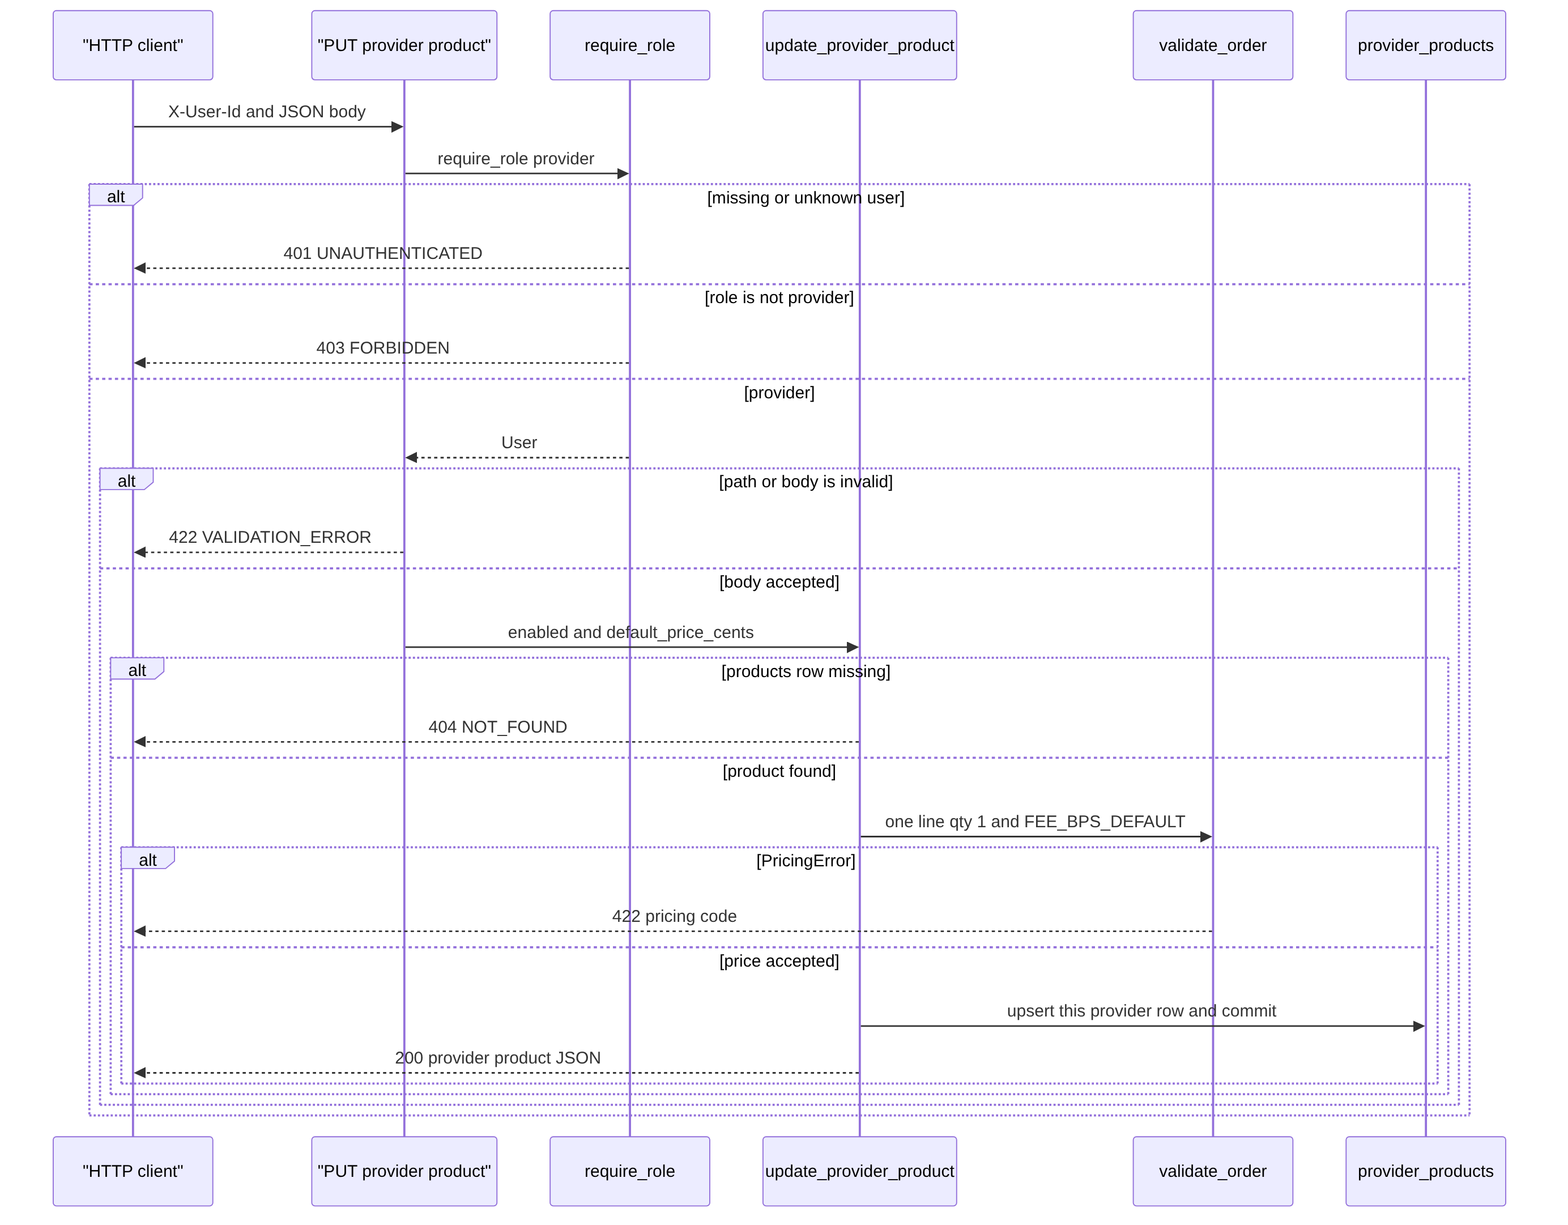

Order preview
The live split preview: validated with the real money code, nothing written.
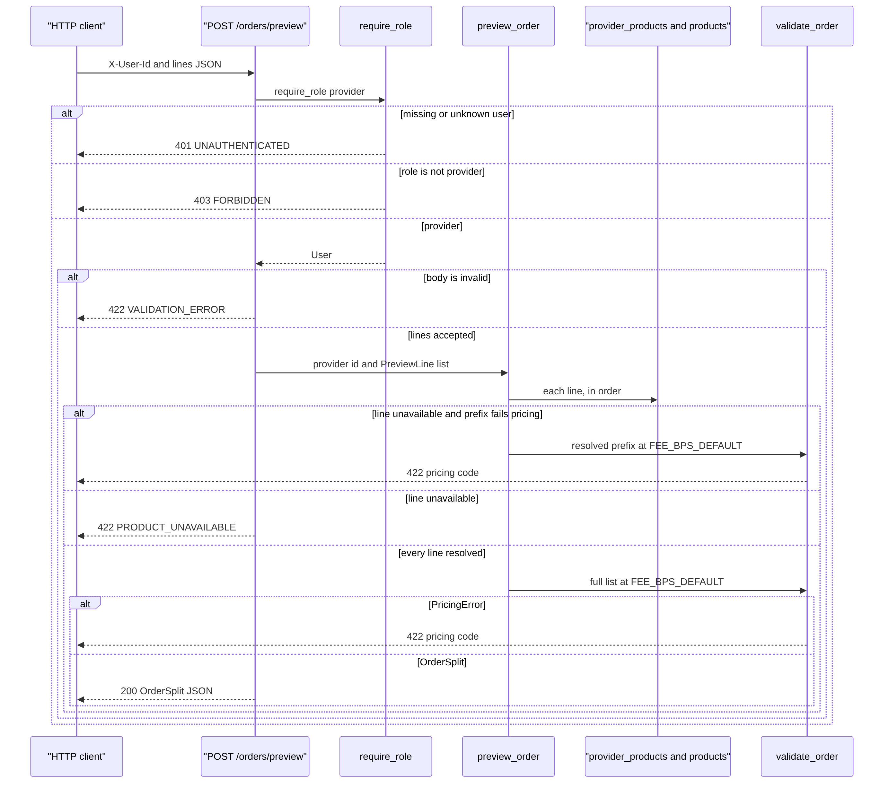

Create order
Validate, snapshot prices and costs onto the order, commit, then notify.
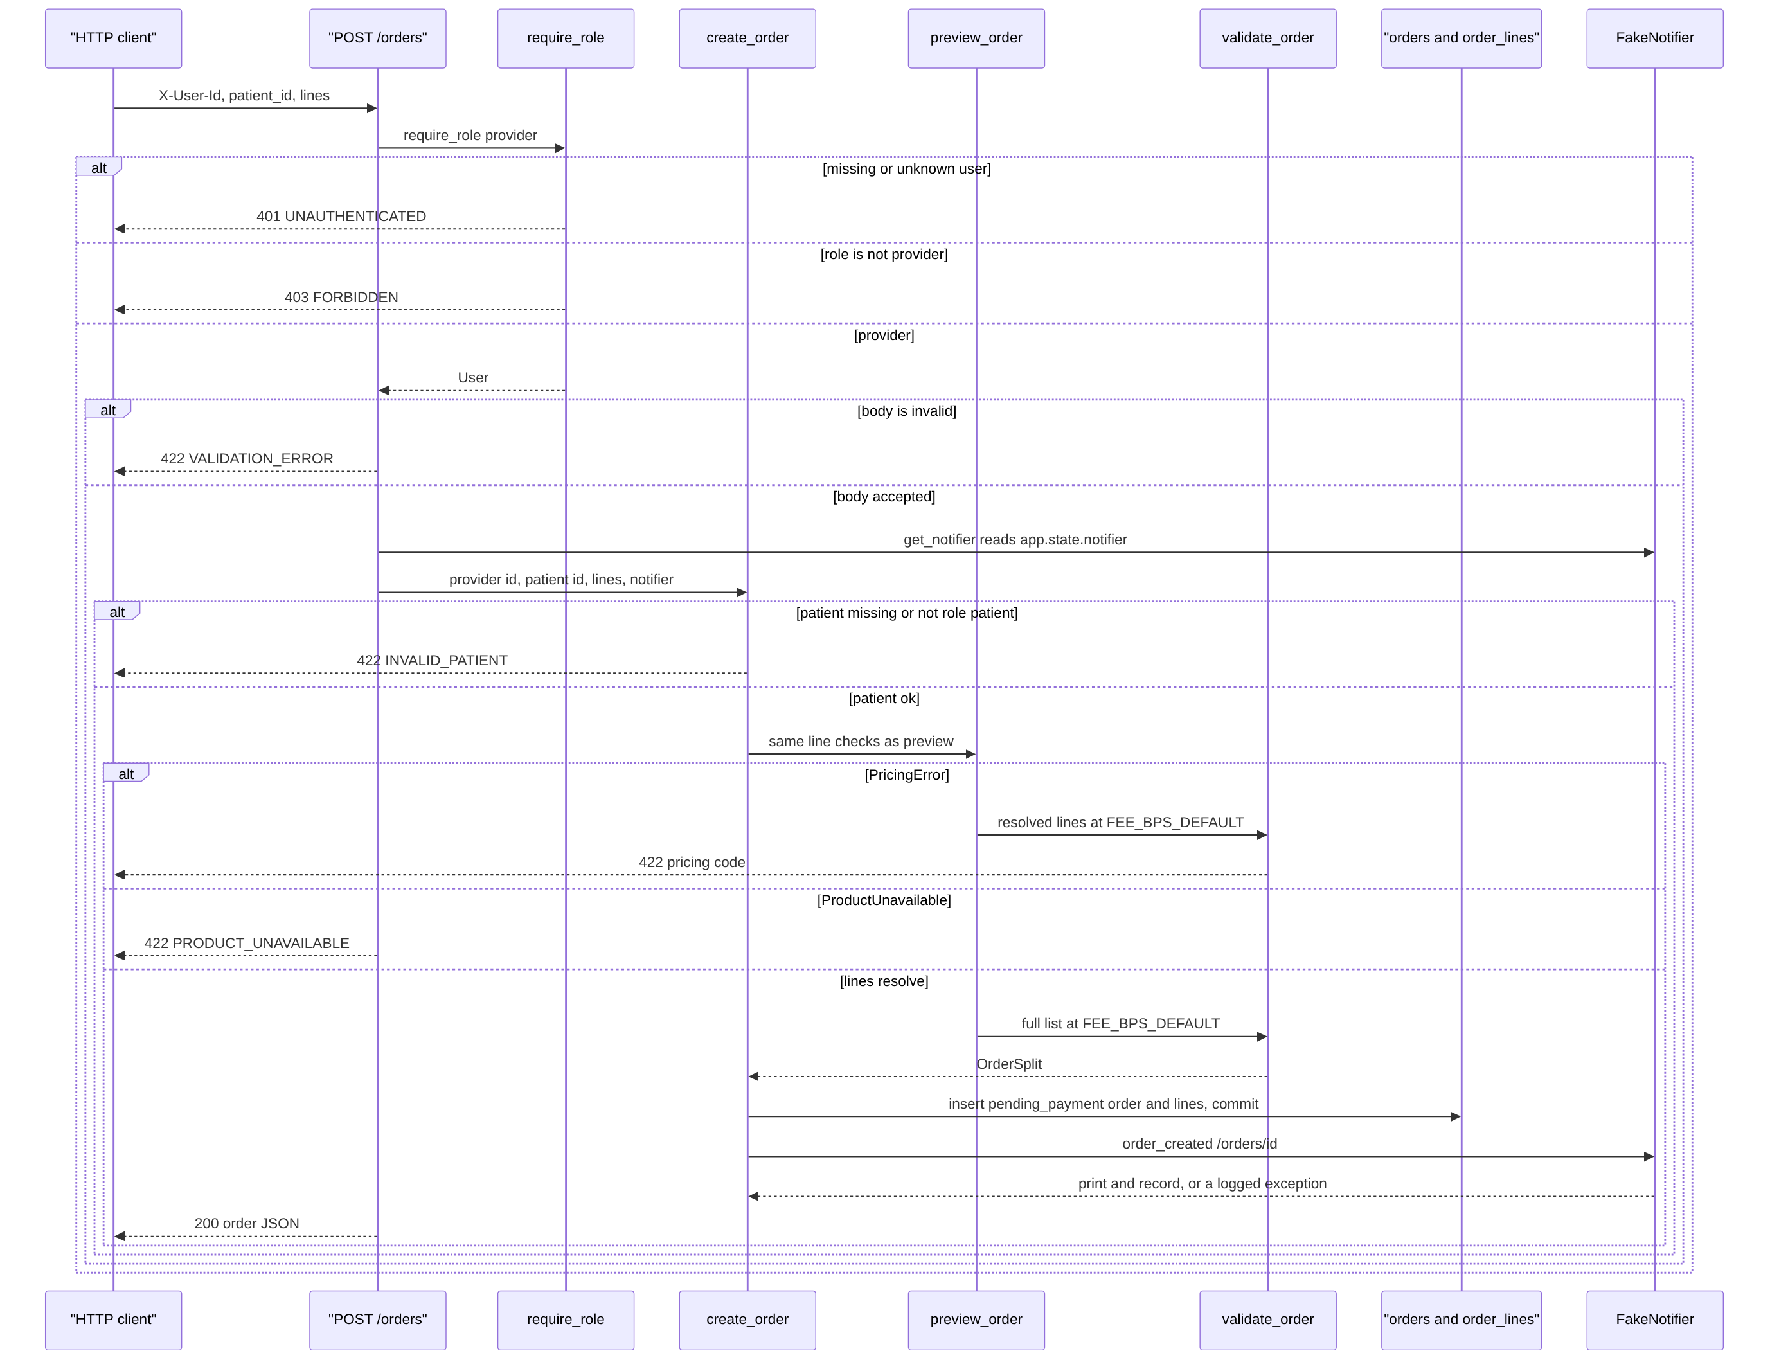

View orders
One order for its provider or patient, and a patient's order list.
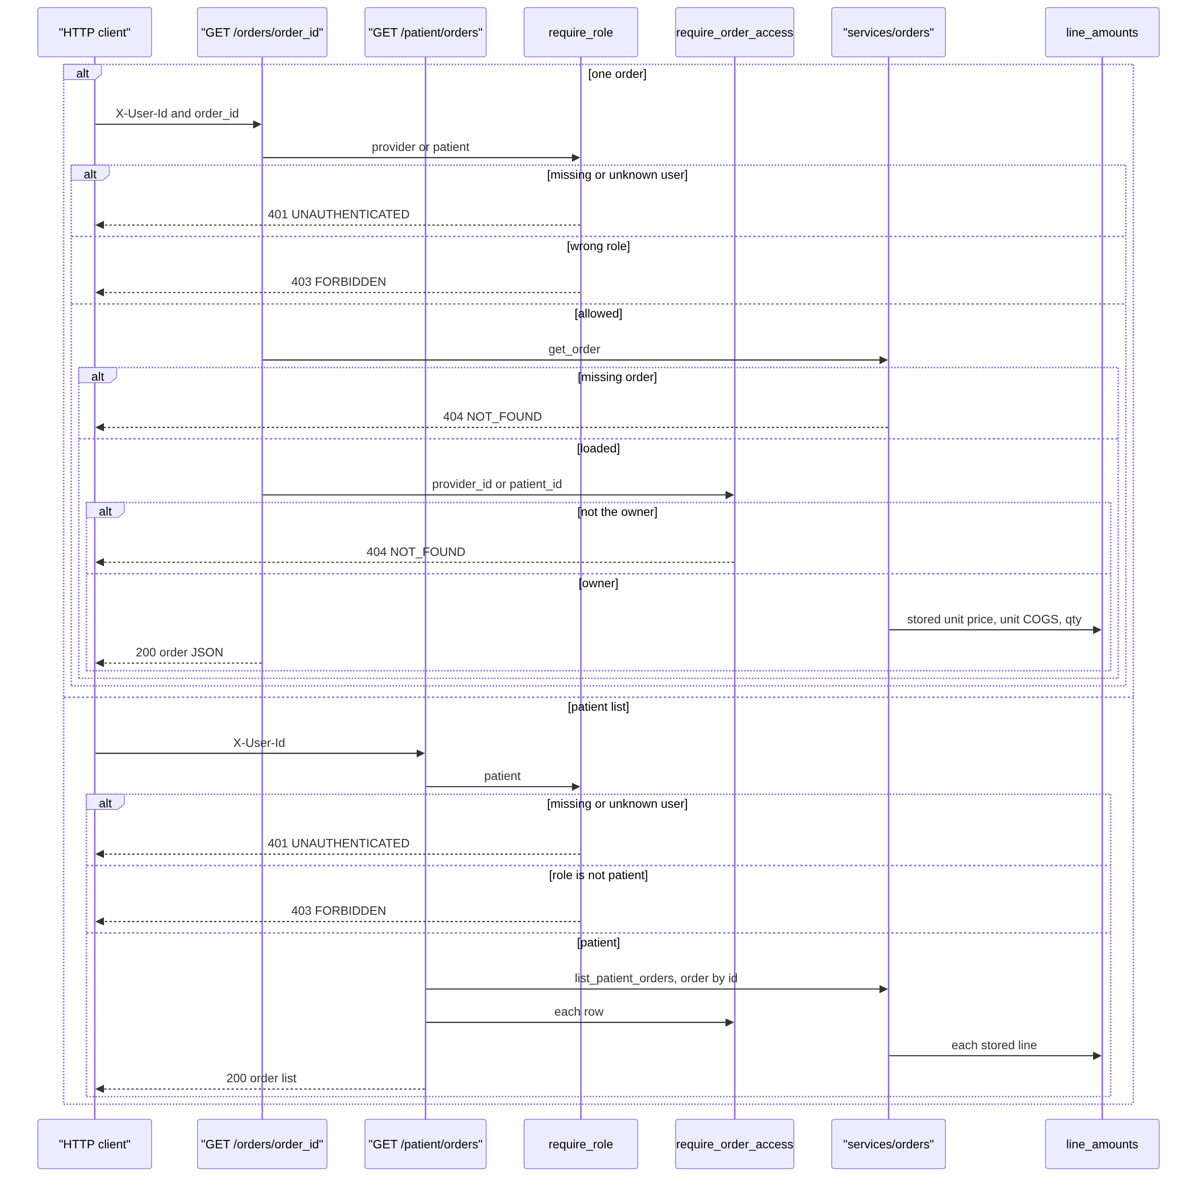

Cancel order
Cancel only if still pending, using a conditional update.
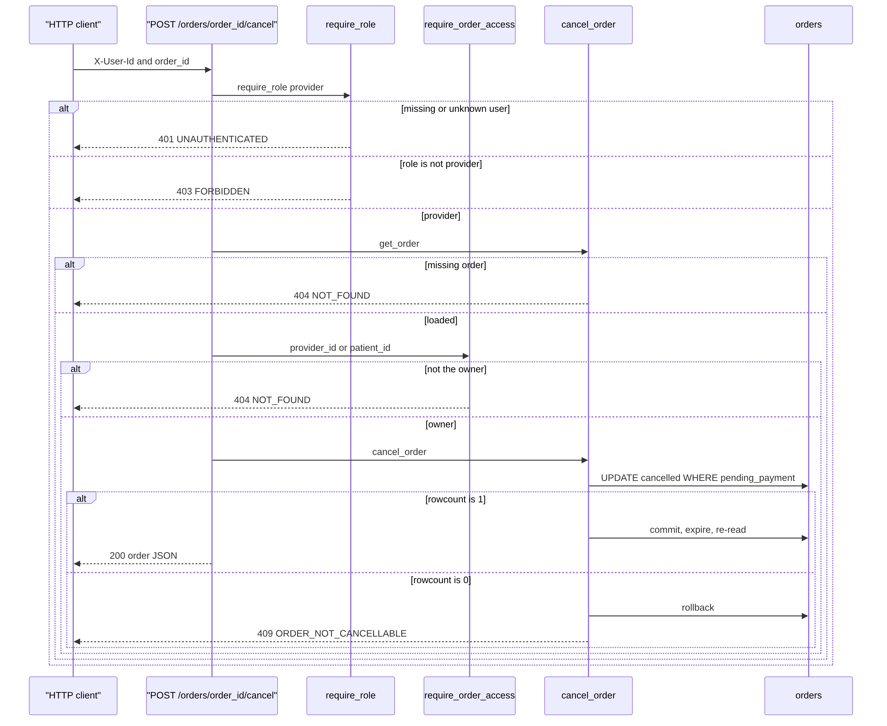

Dashboard
Headline totals from the ledger, plus paid and pending orders and units sold.
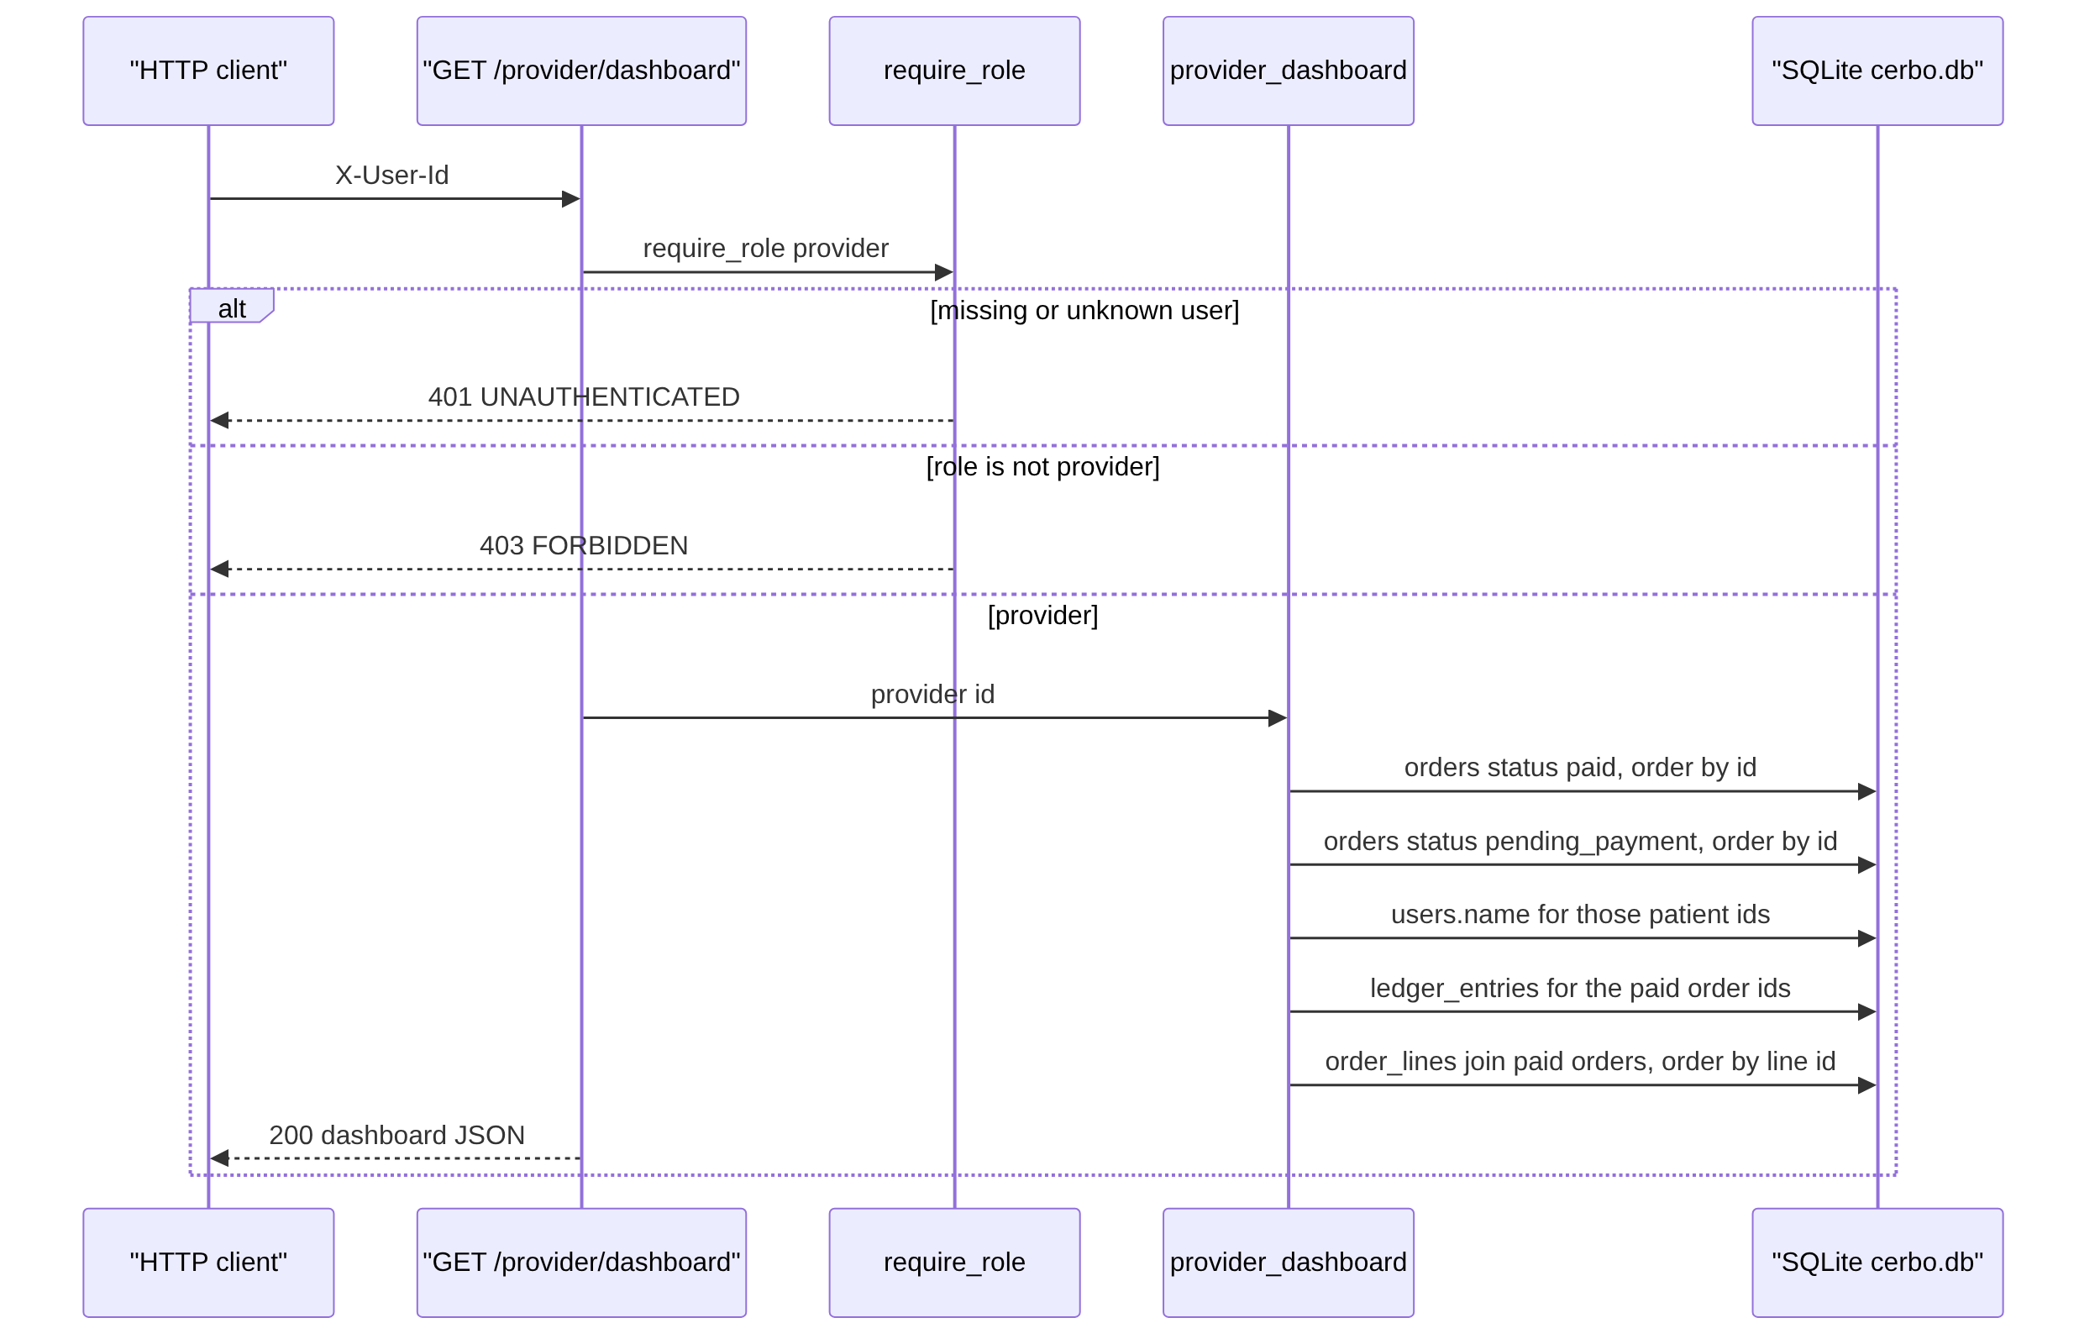

Audit
Lines, stored split, ledger rows, and the three integrity checks.
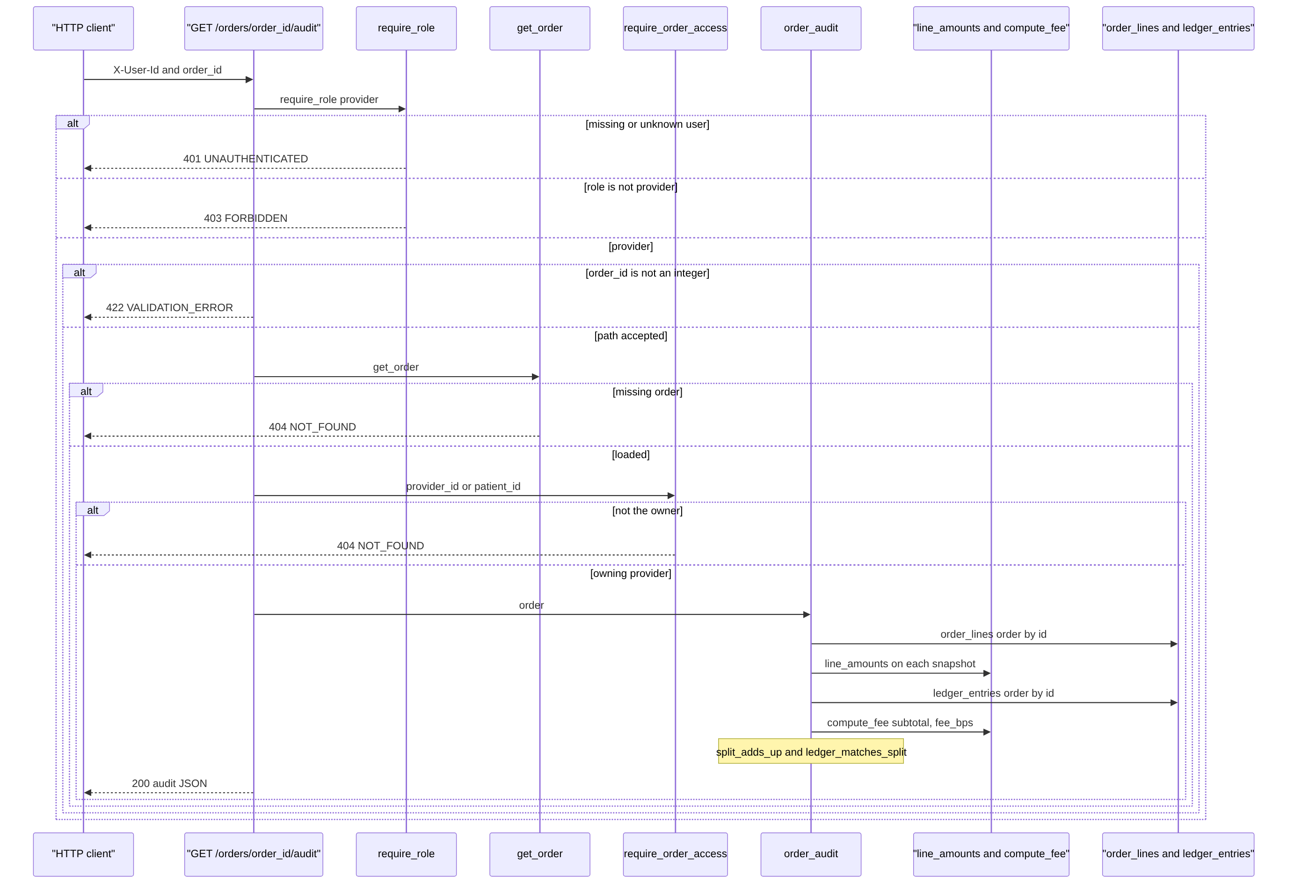

Admin products 1 of 2
Listing stock and cost.
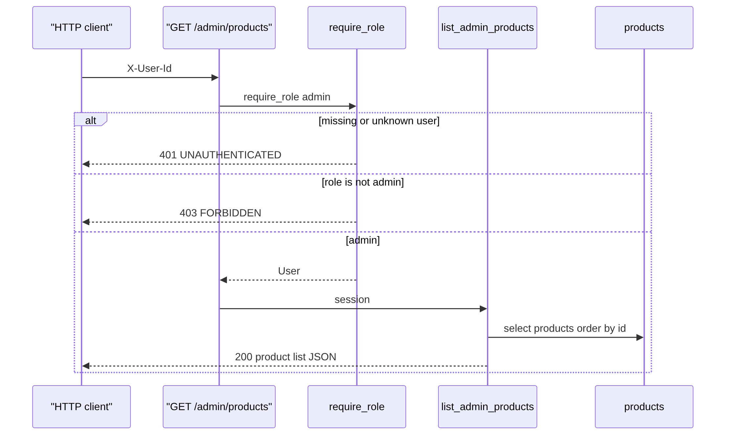

Admin products 2 of 2
Updating stock and cost; existing orders are unaffected.
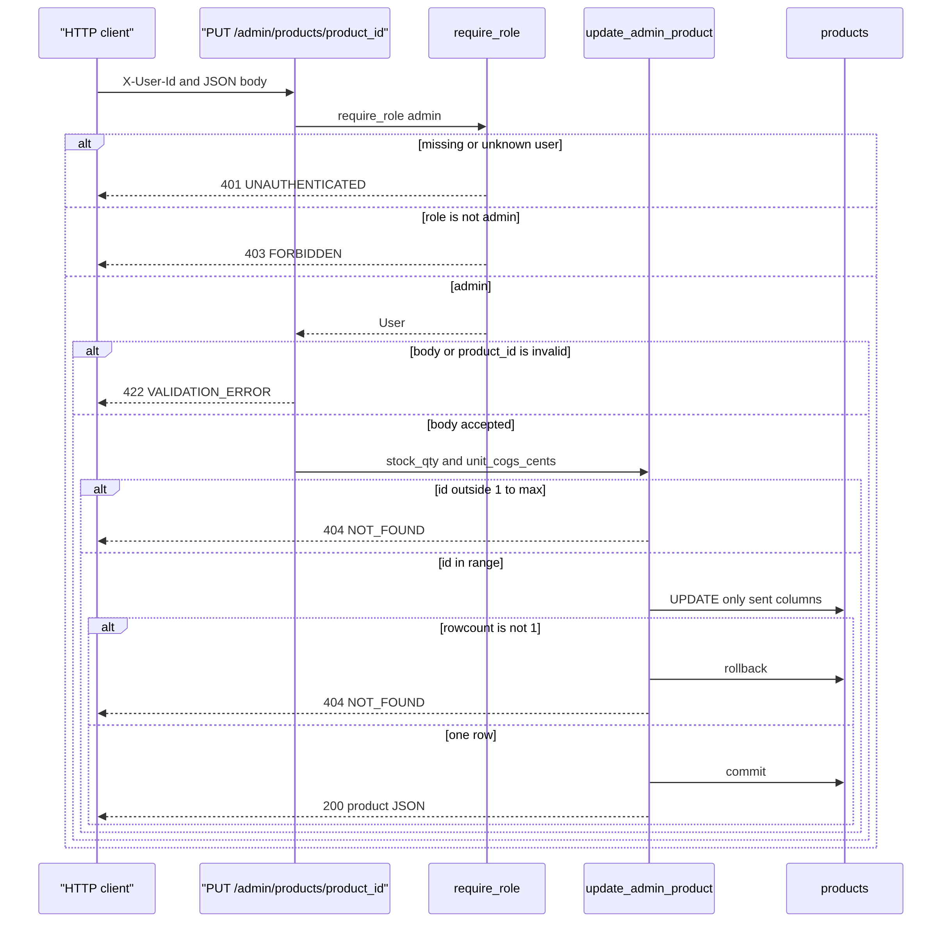

Frontend screens

Frontend flow 1 of 10
From docs/diagrams/flows/frontend-shell.md.
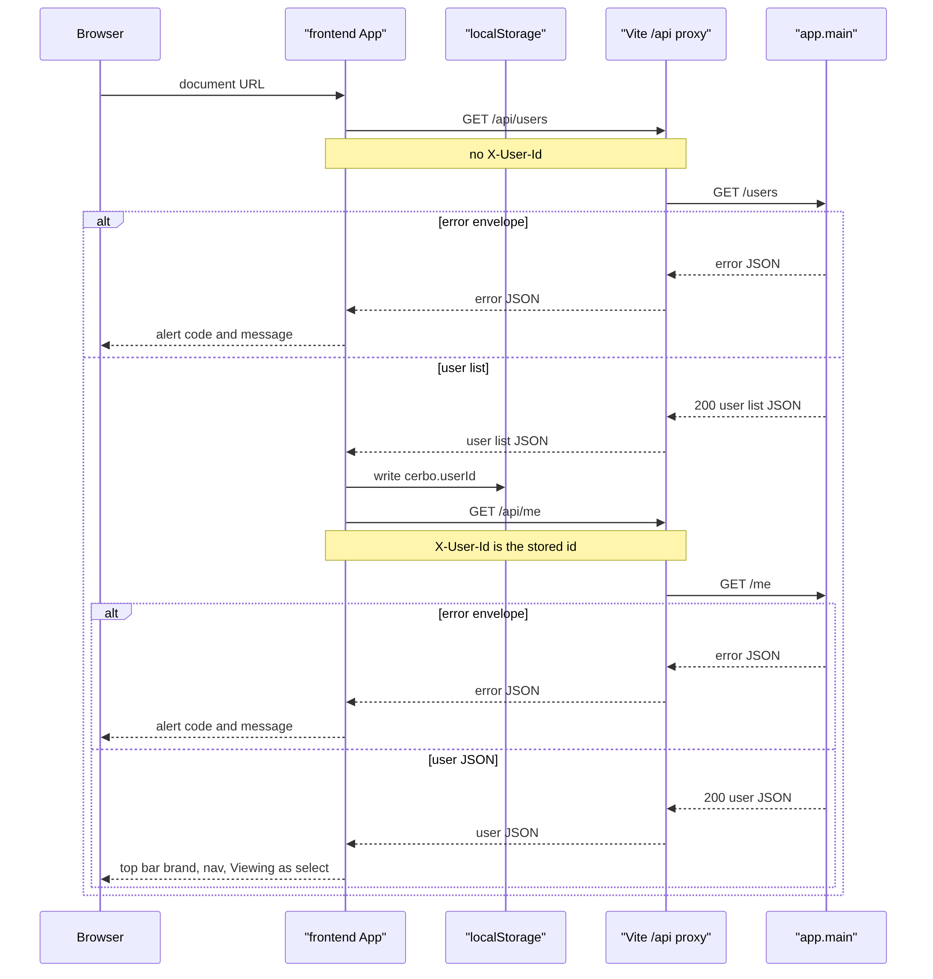

Frontend flow 2 of 10
From docs/diagrams/flows/frontend-shell.md.
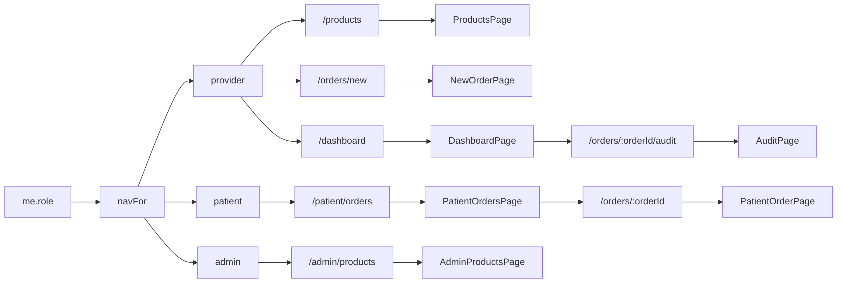

Frontend flow 3 of 10
From docs/diagrams/flows/frontend-shell.md.
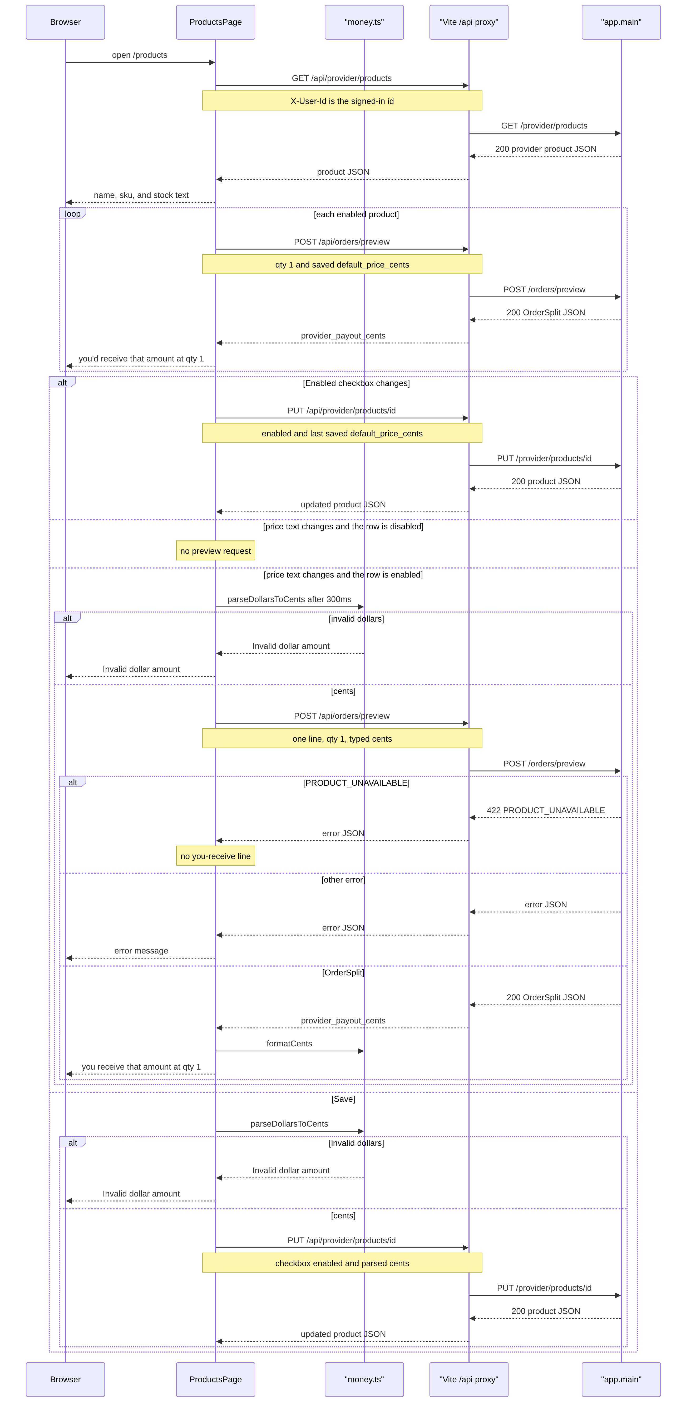

Frontend flow 4 of 10
From docs/diagrams/flows/frontend-shell.md.
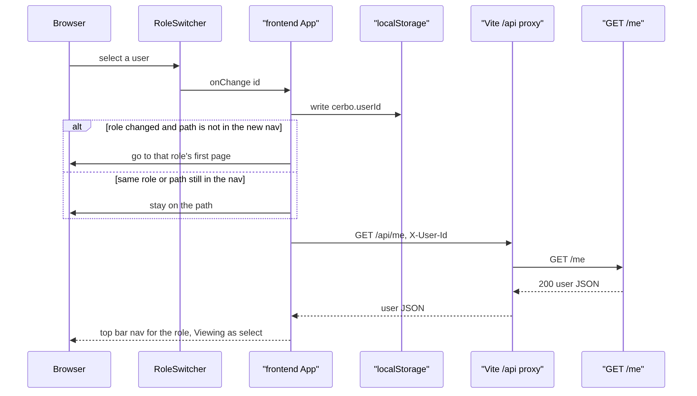

Frontend flow 5 of 10
From docs/diagrams/flows/frontend-shell.md.
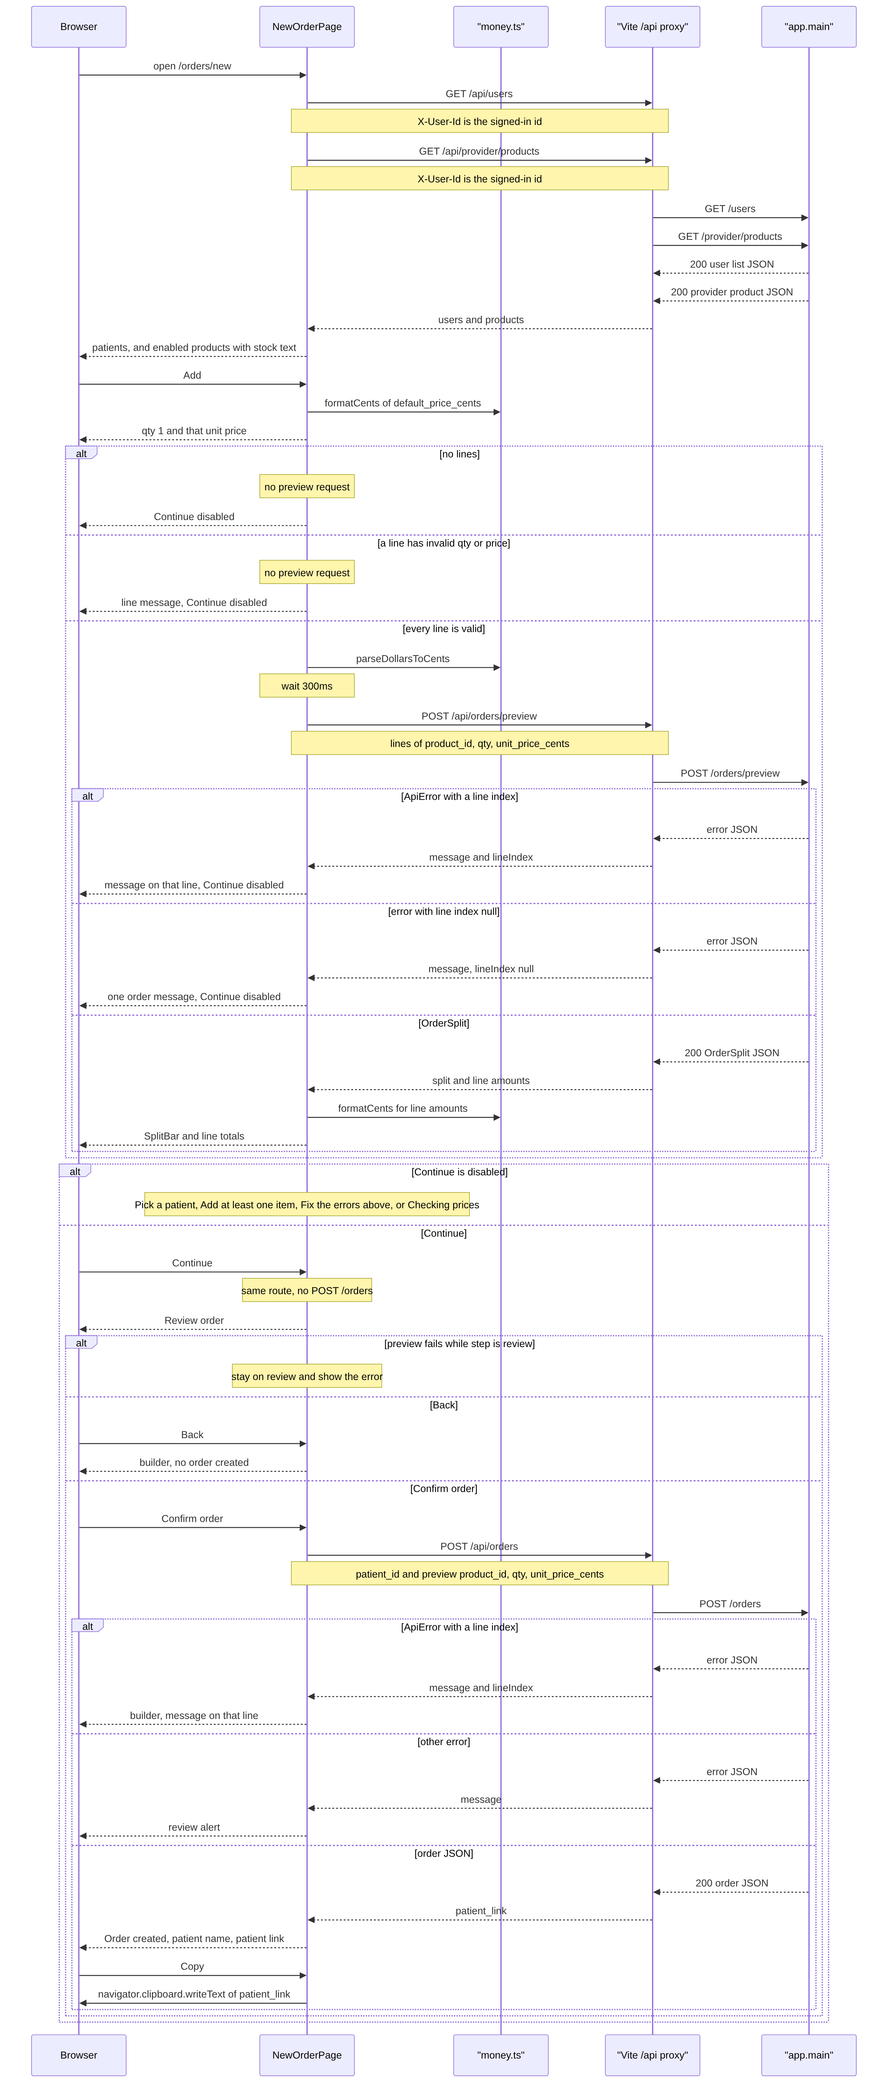

Frontend flow 6 of 10
From docs/diagrams/flows/frontend-shell.md.
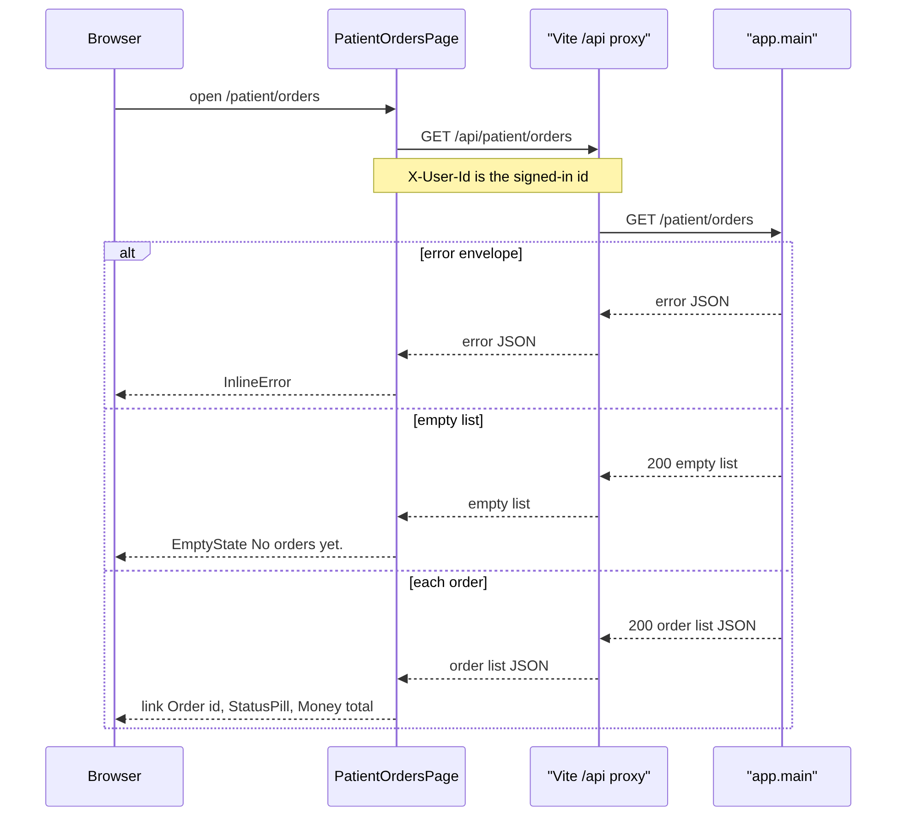

Frontend flow 7 of 10
From docs/diagrams/flows/frontend-shell.md.
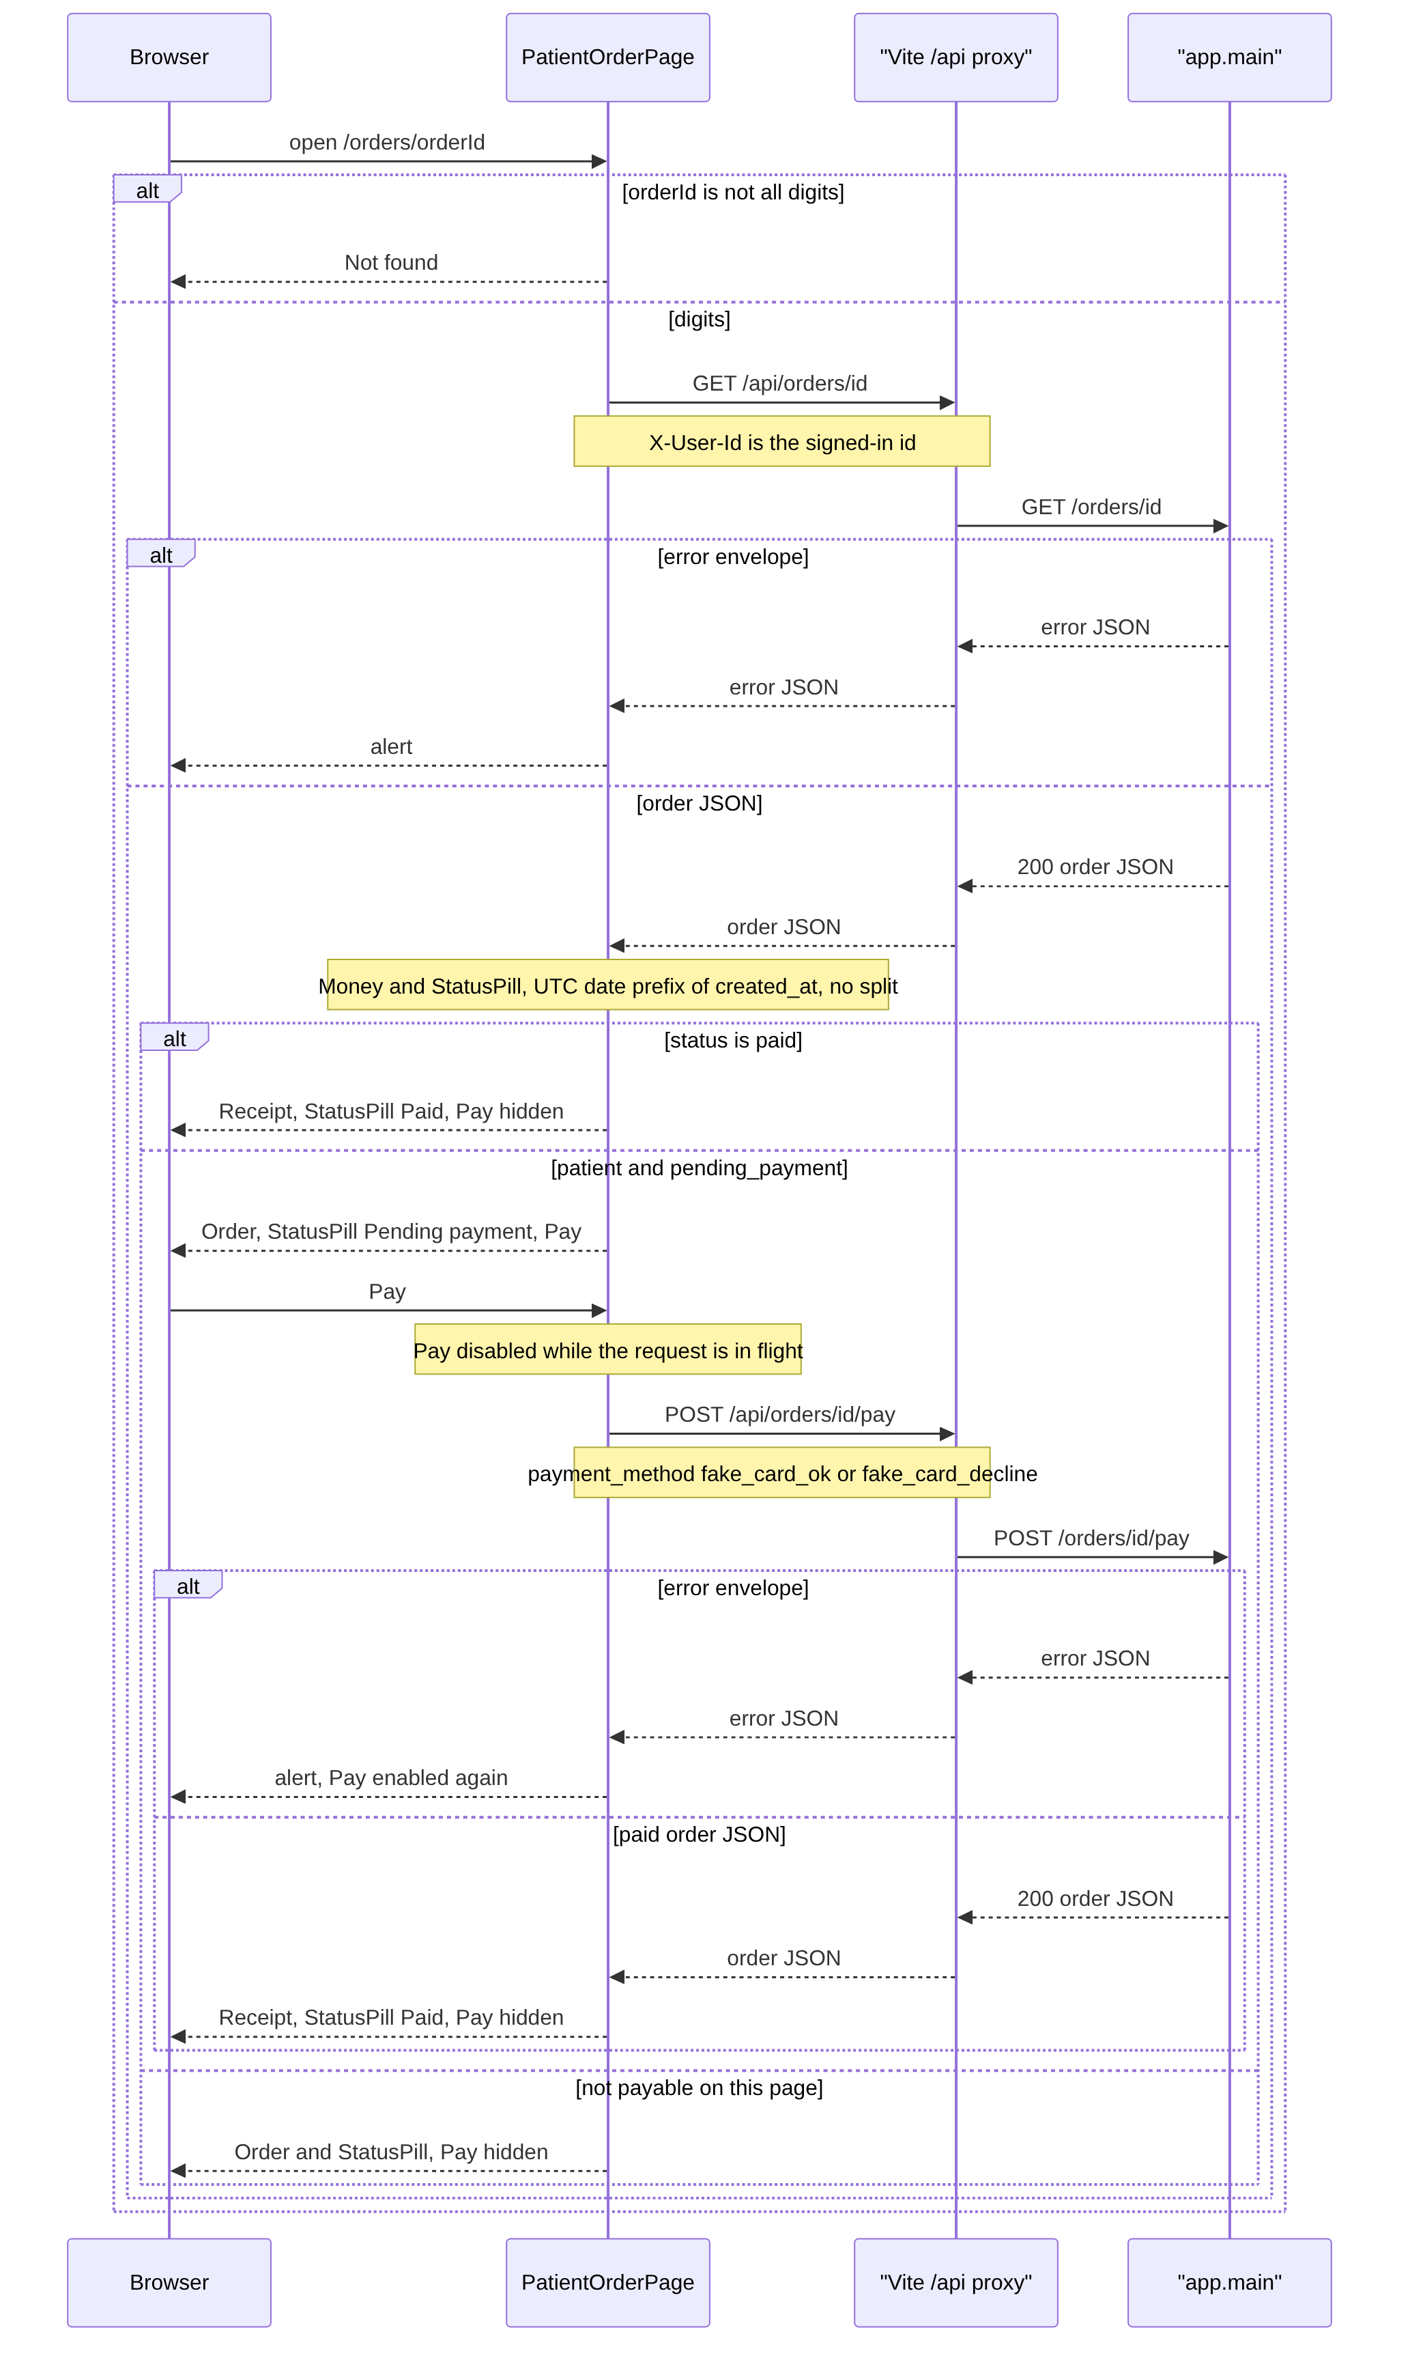

Frontend flow 8 of 10
From docs/diagrams/flows/frontend-shell.md.
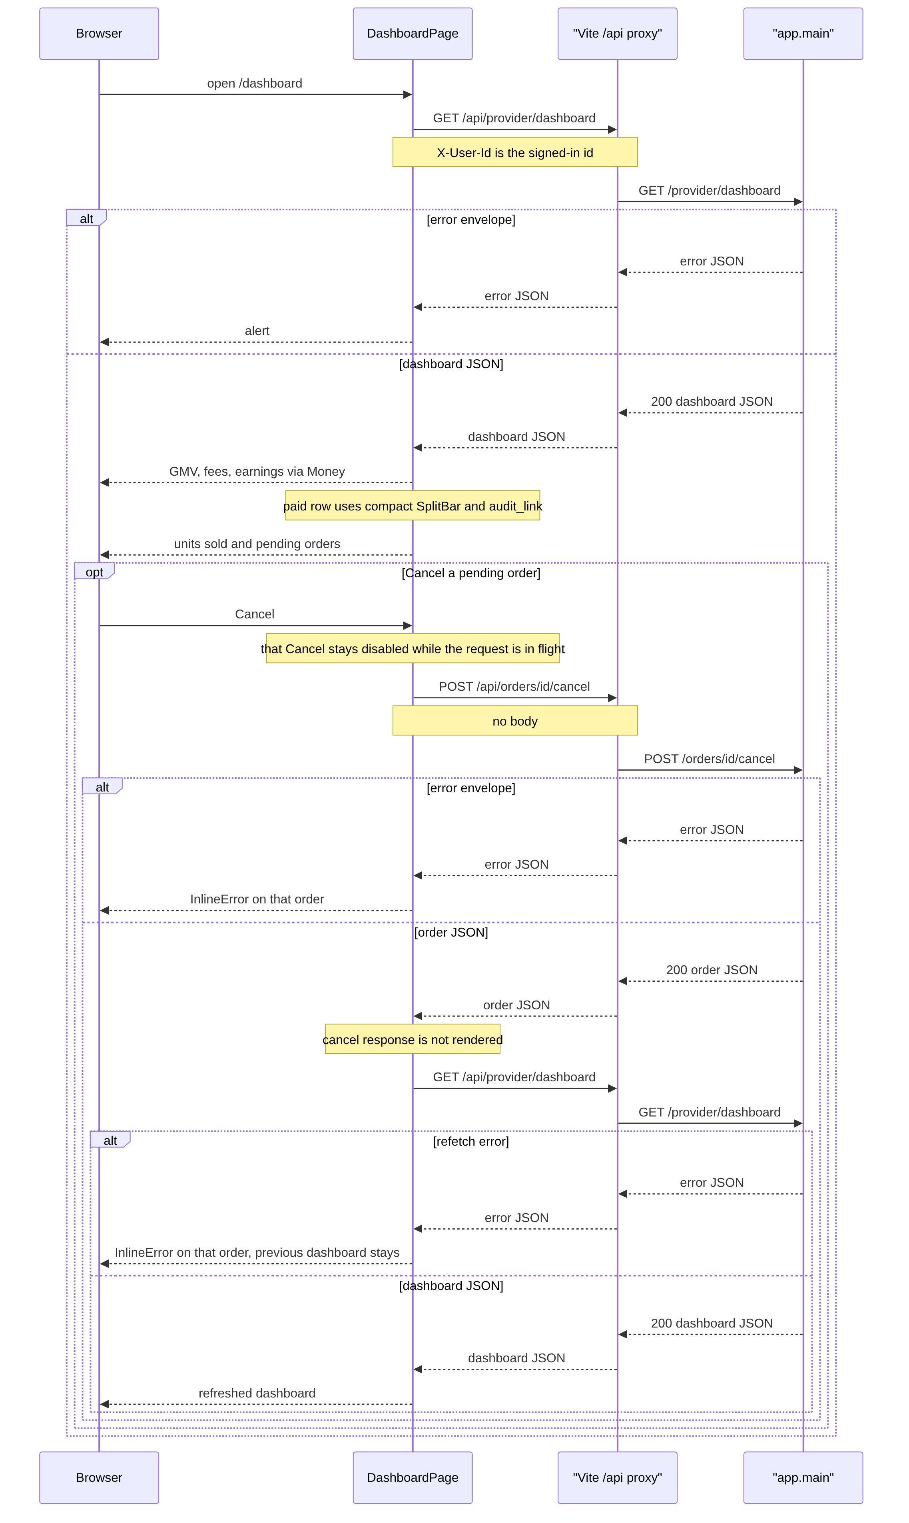

Frontend flow 9 of 10
From docs/diagrams/flows/frontend-shell.md.
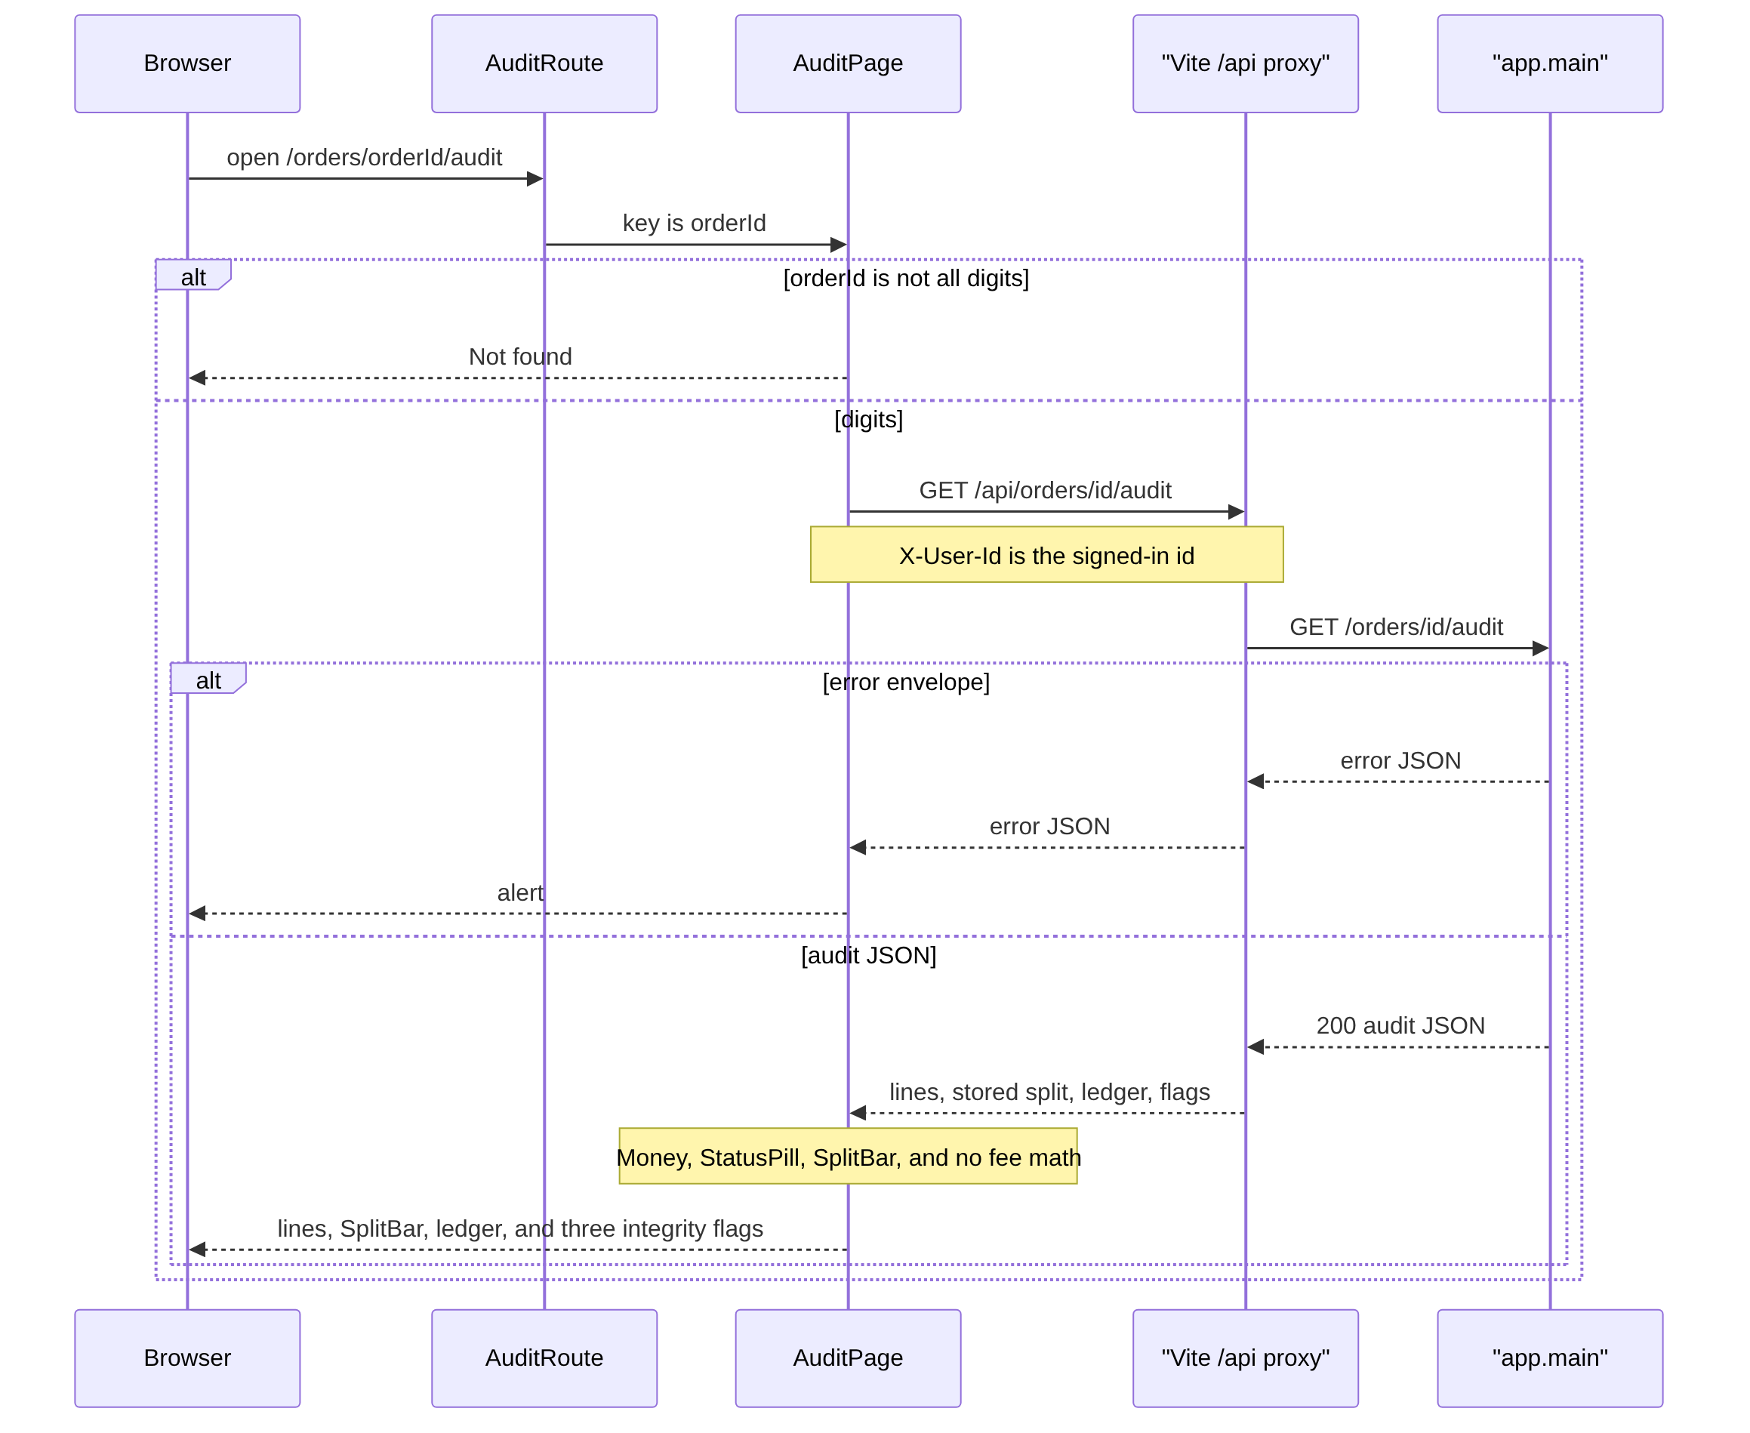

Frontend flow 10 of 10
From docs/diagrams/flows/frontend-shell.md.
