Describe how to compile and run your program in detail

**Launching the database**

-Windows : Get WAMP

-Start your mysql database

-Parse (or execute) the script “SQLScript.sql” into your database.

-Modify the gameServer.conf file (in Project/server-side) to reflect your parameters. (Database IP (localhost), DatabasePort, database username, database password)

**Launching the server**

Two ways :

-Launch the .jar file ( java -jar HW2.jar ) in 'Complete jar' from your cmd. Don’t forget to put the 'gameServer.conf' file in the same directory as your HW2.jar file

-Get the code on your IDE (e.g. : Eclipse) and run it.

**Running the client**

-Edit the config.son file (in Project/client-side ) to reflect your parameters. (IP and port of your server)

-Run “python main.py”

Describe your DB schema and defined protocols

You get also can these informations formatted on <https://github.com/drthomas21/CS454-Homework2>

DB schema

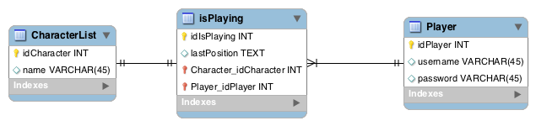

Player table : Represent a player with a username and a password.

isPlaying : Represents the link between a player and a character. A player can have as many links as he wants. This table stores the last position (“x, y, z, h” in a String : x, y, z as coordinates, h for orientation)

CharacterList : available character list - 3 for this project.

Protocols

**Code: 101 = Authentication request**

- String: username

- String: password

- Return values Code: 201

- Short : 2 for already logged in

- Short : 1 for successful authentication

- Short : 0 for failure

**Code: 103 = Register request (+Authentication)**

- String: username

- String: password

- Return values Code: 203

- Short : 1 for successful register and authentication

- Short : 0 for failure

**Code: 105 = Moving request (let other clients know that this player moved)**

- String: position (formatted as "x, y, z, h" h for orientation)

- Return values Code: 205

- *To all other clients* String : username

- *To all other clients* String : position

**Code: 106 = Character selection request**

- String: character name

- Return values

- Code: 206 String : position (Last position of this character, empty for the first time)

- Code: 207 *To all other clients* String : character (Let everyone know this client is online)

**Code: 112 = Chat request (from a user to every connected player)**

- String: message

- Return values Code 212

- *To all other clients* String : username

- *To all other clients* String : message

**Code: 113 = Heartbeat request (demanding all the queue)**

- Return values

- All the responses in the queue

- Code: 213 Heartbeat response (used as an “alive” signal)

**Code: 115 = Privatechat request (from a user to an other player)**

- String: message

- Return values Code 215

- *To the target user* String : username

- *To the target user* String : message

**Code: 119 = Save and exit request**

- String: position

- Return values Code 219

- Short : 1 for success

- Short : 0 for failure

**Disconnected**

- Return values Code 208

- *To all other clients* String: username