

**Napha & Atthapon**

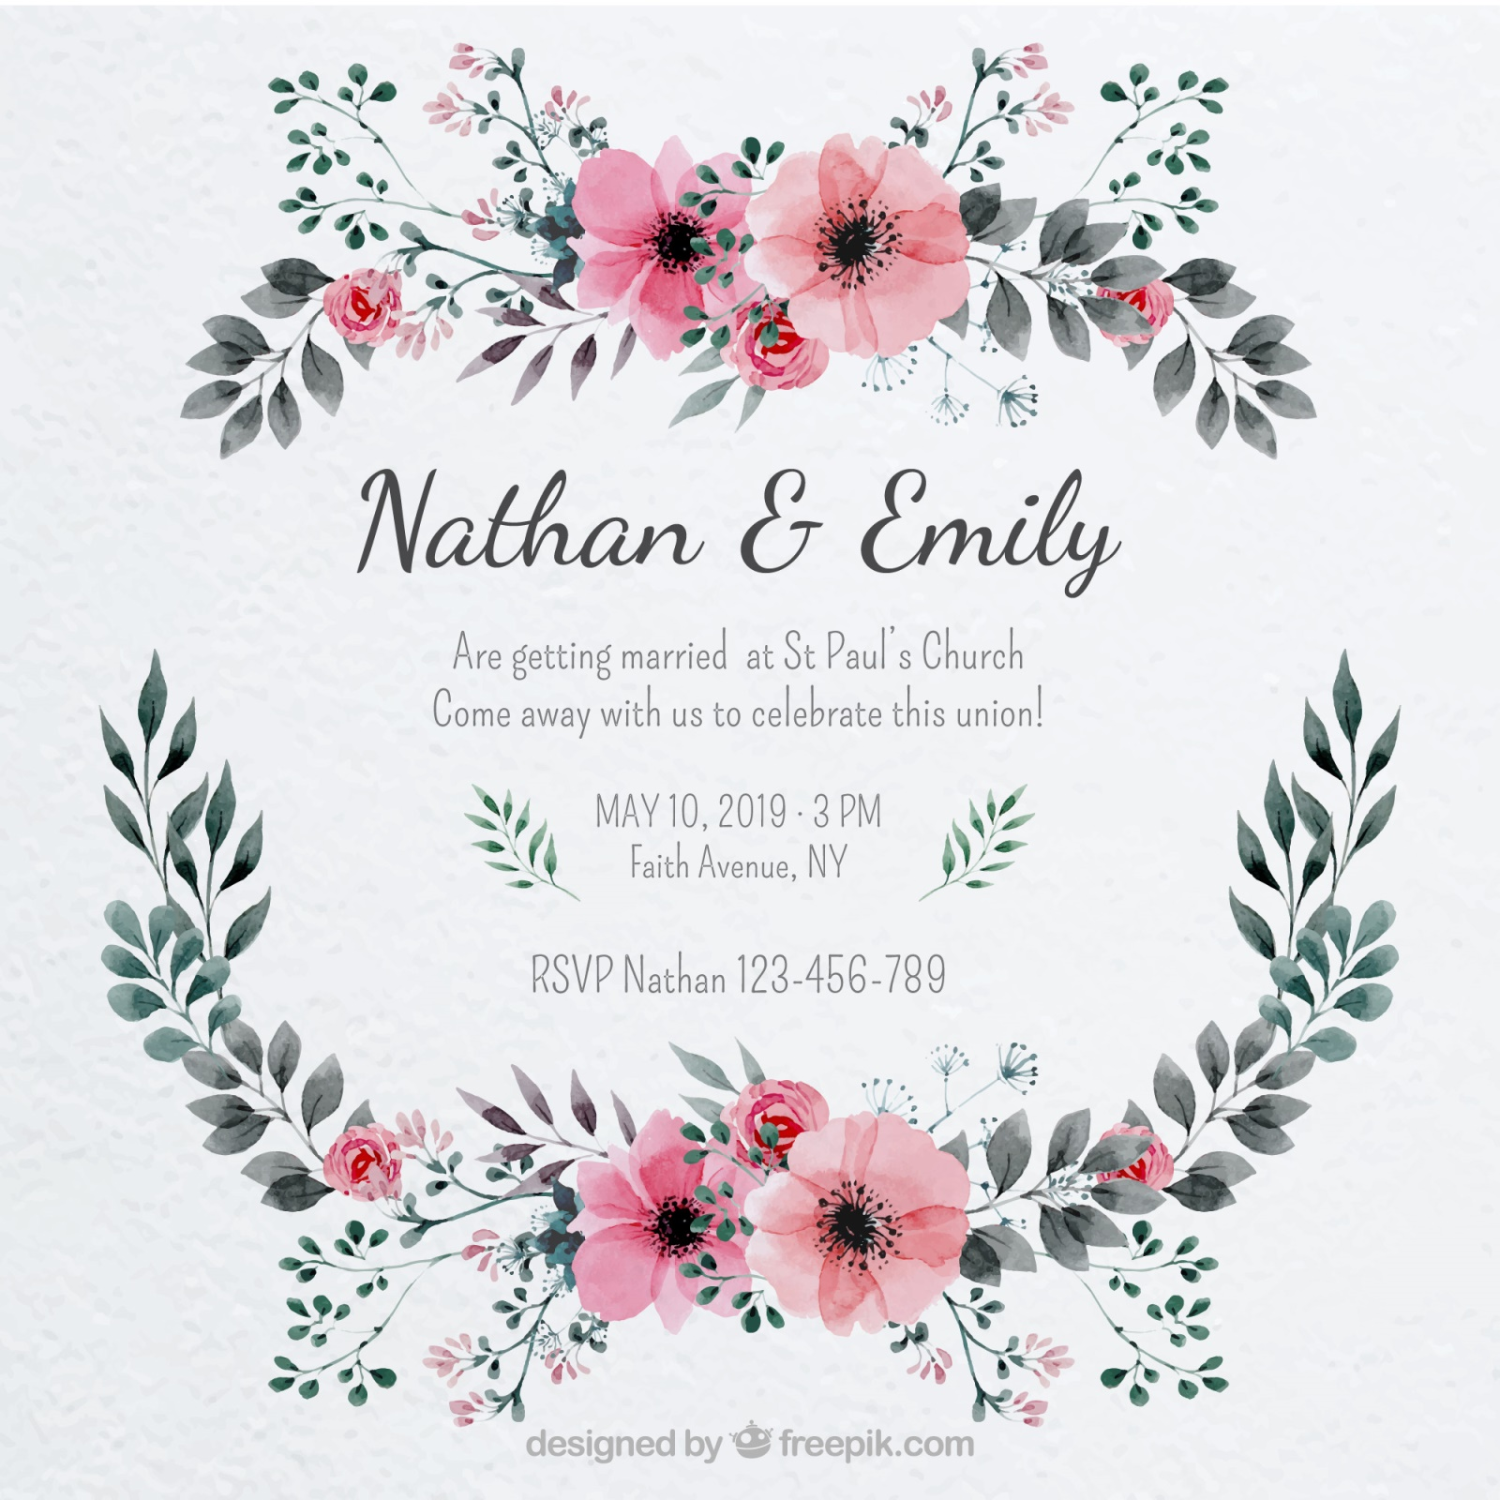

NOV 24, 2018 6PM

Are getting married at Chaophya Park Hotel

**Napha & Atthapon**