ADDIS MCDA Tutorials

Tutorial 1: manual data entry
This tutorial guides you through the process of manually entering data, so that you can create your own effects tables.

Subjects covered
- Manual data entry interface
- Defining criteria and alternatives
- Specifying data sources
- Filling in the data entry table

Example effects table
The data that you are going to enter in this tutorial is taken from the effects table for lixisenatide as included in the EMA Guidance document for critical assessment reports (see page 72). For didactic purposes, we are going to work with a simplified version of that table which includes HbA1c as a favourable effect and nausea as an unfavourable effect (Table 1).
Table 1 - Simplified effects table for lixisenatide, a treatment for type 2 diabetes mellitus
Effect | Description | U | LIX | PBO | Uncertainties /  Strength of evidence | Reference
Favourable Effects
HbA1c | Mean change in HbA1c from baseline | % | -0.83  (-0.91, -0.75) | -0.39  (-0.51, -0.28) | Unc: The effect of lixisenatide was more pronounced in Asian patients compared to Caucasian patients. The lower effect in Caucasians is partly explained by a large placebo effect especially in some geographical regions. | Pooled data from EFC6014 and EFC10743
HbA1c | Mean change in HbA1c from baseline | % | -0.82  (-0.91, -0.73) | -0.10  (-0.24, 0.04) |  | EFC6015
Unfavourable Effects
Nausea | Incidence of nausea | % | 26.9 | 7.3 |  | pooled data from all phase 2/3 controlled studies

Sign in to MCDA.drugis.org
👉 Open your browser and navigate to https://mcda.drugis.org. Use your Google account to sign in. You will be redirected to your personal homepage, containing your previously created workspaces, both finished and unfinished (if any).

Create a new workspace
👉 Press the ‘Create workspace’ button, select the option ‘Manual input’, and press the ‘Create button’. This leads to the first step of the manual entry process.
🎓 A workspace contains the clinical efficacy and safety data that you have entered for a particular benefit-risk assessment. Within a workspace you can build effects tables and perform quantitative benefit-risk analyses. Existing workspaces are opened by clicking on their name, or navigating to their URL directly via a link or bookmark. Workspaces can only be accessed by their owner.
💡 Here, we cover the manual workspace creation process; besides this you can also create workspaces based on example data uploaded by the ADDIS team, and upload JSON files created (e.g. through downloading a workspace) by you or another user.

Enter general information
👉 Enter a descriptive title in the ‘Workspace title’ field at the top of the page. For example, “lixisenatide data entry tutorial”.
👉 Enter the indication and other relevant context for your assessment in the ‘Therapeutic context’ field. For example, “Assessment of lixisenatide for the treatment of adults with type 2 diabetes mellitus to achieve glycaemic control in patients not adequately controlled on oral antidiabetics.”
💡 At any stage during the data entry process you can press the ‘Save’ button at the bottom of the page to store the current state. This lets you continue later. You can navigate to your home page by pressing the mcda.drugis.org link on the menu bar at the top-left of the screen.

Enable favorability
👉 The effects table for lixisenatide divides the criteria into favourable and unfavourable effects. To enable the this classification, check the ‘Use favorability’ box below the ‘Criteria’ heading.
🎓 Criteria are the clinical efficacy and safety outcomes in terms of which the treatments under consideration are evaluated. A criterion has a name (a short identifier, such as “HbA1c” or “Nausea”), a description, and optionally a unit of measurement. The description specifies how the effect of a treatment on the selected outcome variable is measured statistically. For example, for “HbA1c” this could be “mean change from baseline” or “proportion of patients with a normal HbA1c value at week 24”.
🎓 For regulatory purposes, criteria can additionally be classified as favourable or unfavourable, with favourable criteria being ones where the new treatment under consideration outperforms the status quo.

Add the HbA1c criterion
👉 Click the ‘Add Criterion’ button and fill in the dialog as specified in Figure 1. You can leave the uncertainties blank or take them from the source document as we have done here. See also Table 1.
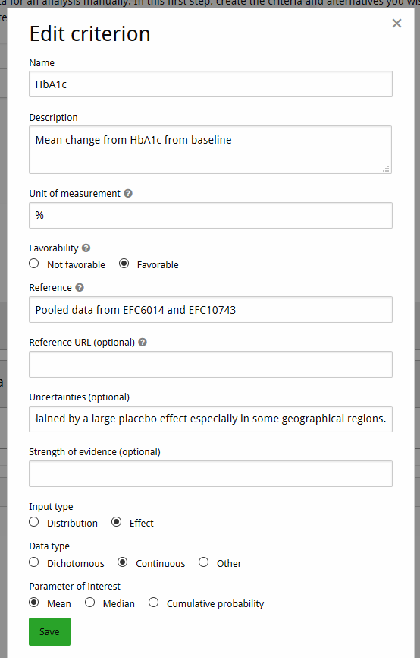Figure 1: Edit criterion dialog for HbA1c
🎓 The upper section of the Edit criterion dialog (title, description, unit, and favorability) defines the criterion, and the lower section specifies the characteristics of the data source from which summary statistics (input type ‘Distribution’) or treatment effect estimates (input type ‘Effect’) are taken. Creating a criterion implicitly also involves specification of a data source. Further data sources can be added later (see the ‘Add a second data source for HbA1c’ step of this tutorial).
🎓 A data source is a study from which summary statistics or treatment effect estimates are taken. This can be a single pivotal study but could also be a pooled analysis, such as a combined safety pool or a (network-) meta-analysis. A data source’s origin are specified via its name (the ‘Reference’ field) and optionally its URL. The subsequent ‘Uncertainties’ and ‘Strength of evidence’ fields describe any strengths and weaknesses of the study design, quality of the data collection and analysis, generalizability of the study findings, etc. The remaining fields are used to specify the type of data to be entered during the second stage of the data entry process (see the ‘Enter data’ step of this tutorial). For more details on the different types of data that can be entered into the system, see the Appendix.

Add a second data source for HbA1c
👉 On the HbA1c criterion, click the ‘Add data source’ button. In the dialog, specify the reference “EFC6015” and leave the other fields unchanged (the data from this study will be entered in the same format as specified in the previous step). Then click ‘Add.’ Now there should be a second row in the data sources for the criterion.

Add nausea as an unfavourable effect
👉 Click the ‘Add criterion’ button, fill in the dialog as specified in Figure 2, and click ‘Add’ (note that favorability is now ‘Not favorable’ and that the units are left blank). The reference for the data source is “Pooled data from all phase 2/3 controlled studies.” There are no further data sources for this criterion.

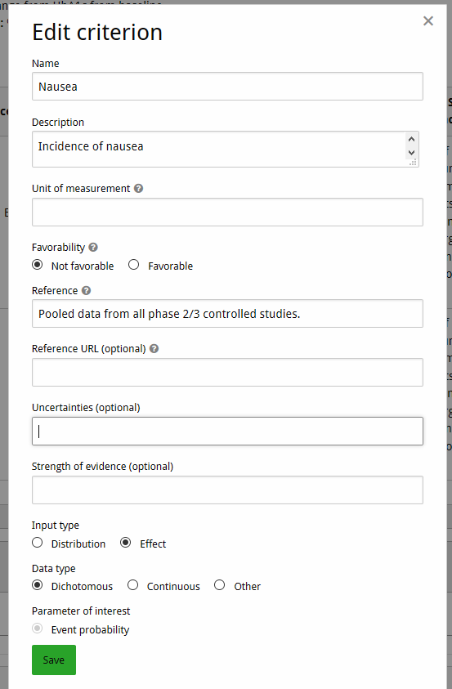Figure 2: Edit criterion dialog for Nausea

Add lixisenatide and placebo as alternatives
👉 Under the ‘Alternatives’ header, fill in “lixisenatide” in the text box and click the ‘Add alternative’ button to the right, or hit the enter key. Now do the same for “placebo”.
💡 You can press the ‘Save’ button at any time to save your work in progress.

Proceed to data entry
👉 Click the ‘Enter data’ button. Take a moment to inspect the data entry table that the system has generated based on your work in the previous steps. If you spot any errors or inconsistencies, you can always click the ‘Back’ button to correct them.
⚠️ To prevent inconsistencies, changing the characteristics of a criterion’s data source will delete any values you entered for the row corresponding to that data source.

Enter data
👉 Click on the ‘Missing or invalid input’ link in the HbA1c, pooled data from EFC6014 and EFC10743 row of the lixisenatide column. Fill out the dialog as shown in Figure 3, and click anywhere on the page outside of the dialog to close it.
👉 Proceed to fill out the remaining three cells for HbA1c with the point estimates and 95% confidence intervals from Table 1.
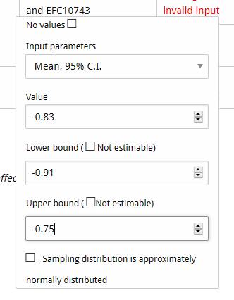Figure 3: Data entry dialog for HbA1c
👉 Similarly, fill out the cells for Nausea with the values from Table 1, selecting ‘Percentage’ as the input parameter.
Your final data entry table should look like Figure 4.
Figure 4: Final data entry table for lixisenatide
🎓 For each row, which input fields are available depends on the meta-data that you provided for that row’s data source in Step 1 of the manual entry process. An overview of the various data entry possibilities is provided in the Appendix.
💡 If required, cells can be left empty by checking the checkbox ‘No values’ at the top of the dialog.

Finalize entry
You have now finished preparing your effects table for analysis.
👉 Click ‘Done’ and you will go to the overview page of your newly-created workspace where you will find the entered effects table.
🎓 After finishing the manual entry process, cosmetic properties such as names and descriptions can still be edited, and the criteria can be re-ordered using the arrow buttons. However, to prevent breaking the analyses that are based on them, measurements cannot be modified. Changing measurements can be done by creating a copy of the workspace on your homepage. This begins a new manual entry process as detailed above, but all criteria, alternatives and measurements are already filled out based on the old workspace, and can be changed at will.

Export and share with others
👉 On your newly-created workspace, click ‘Download workspace’ in the top-left to save a .json file which contains all the data you just entered. When creating a new workspace, you can upload this file (using the ‘local file’ option) and the new workspace will contain a copy of your data.
💡 Sending this file via e.g. email to someone else is the recommended way to share workspace data with other users.

Appendix tutorial 1: data source characteristics and data entry options
A treatment effect is a statistical parameter that describes how a given treatment affects the distribution of a criterion in the target population (i.e., all patients for which the evaluated treatment is indicated). The representation of that parameter’s uncertainty in the effects table depends on the specified characteristics of the row’s data source. Indicating that the input type is ‘Distribution’ corresponds to a Bayesian perspective, where the uncertainty is quantified by means of probability distributions. The option ‘Effect’ corresponds to a frequentist perspective where parameters are treated as fixed but unknown constants for which point and interval estimates (e.g., 95% confidence intervals) are provided.

Meta-data required for entering distributions (Bayesian)
The ‘Input method’ determines how the data source’s probability distributions are to be entered. Distributions can either be specified directly by choosing a distributional family and entering its parameters (‘manual distribution’) or derived indirectly from summary statistics from a clinical study (option ‘assisted distribution’). When this latter option is selected, a Bayesian posterior distribution (i.e., a beta distribution for the event probability of a dichotomous outcome variable and a normal distribution for the mean of a continuous outcome variable) is estimated from the summary statistics supplied by the user and a reference prior set by the system.
The following distributional families are supported for the ‘Manual distribution’ input type:
- Beta
- Normal
- Gamma
- Exact (i.e., degenerate distribution that always results in the same value)
The following summary statistics are supported for the ‘Assisted distribution’ input type:
- Dichotomous outcome
  - number of events / sample size
- Continuous outcome
  - mean / standard error / sample size
  - mean / standard deviation / sample size

Meta-data required for entering effects (Frequentist)
The ‘Data type’ radio buttons serve to specify the data type of the outcome variable under consideration. Here, a choice can be made between dichotomous, continuous, and other. The latter option provides an aggregate category for data types that are neither dichotomous nor continuous, such as count data. The subsequent ‘Parameter of interest’ choice specifies the treatment effect measure. If the data type is dichotomous, the parameter of interest is always ‘Event probability’. If the data type is continuous, a choice can be made between ‘Mean’, ‘Median’, and ‘Cumulative probability’. Finally, if the data type is other, the parameter of interest is unknown, and we use the generic identifier ‘Value’.
The input fields that appear on the data entry dialogs in the second stage of the manual data entry process depend on the selected parameter of interest. The following data entry options are currently available. An asterisk (*) means that you can indicate that the sampling distribution of the parameter of interest is approximately normal. Doing so lets us use the sampling distribution to estimate the uncertainty in stochastic multicriteria acceptability analysis (SMAA) analyses.
- Dichotomous – event probability
  - Decimal
  - Decimal, sample size *
  - Percentage
  - Percentage, sample size *
  - Fraction (i.e., events / sample size) *
- Continuous – mean
  - Mean
  - Mean, standard error *
  - Mean, 95% confidence interval *
- Continuous – median
  - Median
  - Median, standard error
- Continuous – cumulative probability
  - Decimal
  - Decimal, 95% confidence interval
  - Percentage
  - Percentage, 95% confidence interval
- Other – value
  - Mean
  - Mean, standard error
  - Mean, 95% confidence interval

Tutorial 2: effects table building
This tutorial guides you through the process of making analysable effects tables from larger datasets.

Subjects covered
- Problem definition interface
- Creating effects tables of subsets of your measurements data
- Switching between effects tables

Example effects table
The data that you are going to enter in this tutorial is taken from the effects table for lixisenatide as included in the EMA Guidance document for critical assessment reports (see page 72). We use a similar table to the previous tutorial, with one more criterion and alternative.

Sign in to MCDA.drugis.org
👉 Open your browser and navigate to https://mcda.drugis.org. Use your Google account to sign in. You will be redirected to your personal homepage, containing your previously created workspaces, both finished and unfinished (if any).

Create a new workspace
👉 Press the ‘Create workspace’ button, load the ‘Lixisenatide simplified’ example, and press the ‘Create button’. This takes you to the overview screen. Take a moment to look at the criteria, alternatives, and data sources.

Create an analysable effects table
👉 Click on the ‘Problem definition’ tab. Note that the currently-selected problem (in the dropdown at the top of the screen) is the ‘Default’ problem. This problem is always automatically generated by the system and includes all criteria, alternatives, and data sources shown on the ‘Overview’ tab.
🎓 A ‘problem’ is our term for an analysable selection of criteria, alternatives, and data sources from those available in the workspace. This selection can include everything in the workspace, but several restrictions apply:
- Only one data source can be selected per criterion
- No missing measurements (empty cells) are allowed for any combination of the selected criteria/alternatives
An exception is the ‘Default’ problem, which may contain multiple data sources as well as empty cells. Should this be the case, the ‘Default’ problem is considered to be not analysable, resulting in an inactive ‘Preference’ tab. Hovering your mouse over the ‘Preference’ tab will then show a tooltip explaining why this tab is inactive.
👉 Click the ‘+’ icon next to the ‘Problem’ dropdown (Figure 5). This opens the problem creation dialog.
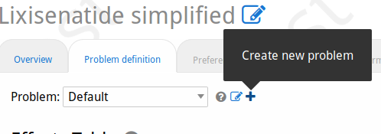Figure 5: Problem creation button

👉 Take a look at the warnings in red near the bottom of the dialog. These explain why the current selection of criteria, alternatives, and data sources is not analysable. To make the effects table analysable, first, deselect the Exenatide criterion and then deselect the data source rows for EFC6019. This should cause the warning about missing values to disappear. Next, deselect the data source rows for EFC6015, so that we end up with a lixisenatide/placebo comparison based on pooled data EFC6014 and EFC10743 for HbA1c and Hypoglycaemia. Now the warning about multiple data sources should have disappeared (Figure 6). The controls for setting the scale ranges (the breadth of possible values to asses on the ‘Preferences’ tab, see next tutorial) are now also accessible; these are not part of this tutorial. Give the problem an informative name such as ‘Lixi-PBO pooled’ and click ‘Create’ at the bottom of the dialog.
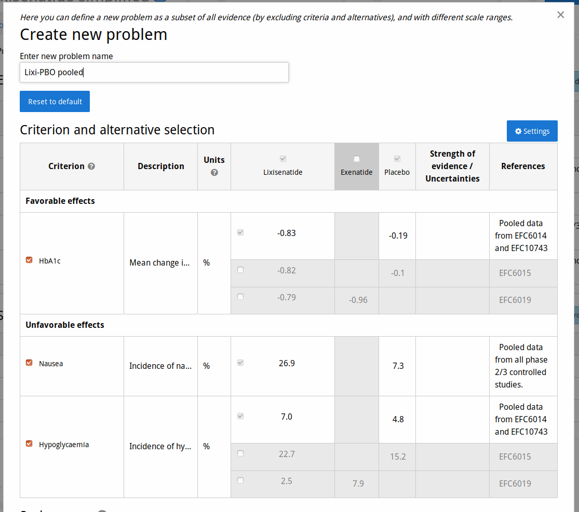Figure 6: Creating a problem
👉 Observe the effects table for the new problem. Note that the ‘Preferences’ tab has now become enabled. That tab and the ones to its right are subject of the following tutorials.

Create more effects tables
👉 Create another problem, this time selecting EFC6015 as data source for HbA1c and Hypoglycaemia, and indicate this fact in the title.
💡 When creating a new problem, the initially-selected criteria and alternatives are based on those of the current problem. The initial ‘Default’ problem always has everything selected, and thus may not be usable for analysis.
👉 Create another problem, but now to compare Lixisenatide and Exenatide. Note that, since there is no data source with measurements for Nausea for both alternatives, this problem must omit Nausea as a criterion.
👉 Use the ‘Problem’ dropdown at the top of the tab to switch between your effects tables. Observe that the effects table and browser URL changes whenever you switch problem.
🎓 Creating a set of problems that all look at different aspects of your workspace’s data lets you contrast the alternatives in different ways. For each problem you can then define a further set of scenarios with different preferences regarding the importance of your criteria, and compare their benefit-risk balances (subject of the next tutorial).

Workspace and view settings
👉 Click on the ‘settings’ button at the top-right of the tab (Figure 7). This lets you customise your view of the effects table and measurements in general. Take a moment to study the different settings you can choose. Play with the top three settings by changing their value and clicking ‘Save’, and observe the results. What should happen:
- Changing to Median/Mode does nothing (this only applies when the values shown in the effects table are sampled from probability distributions)
- Changing from ‘Effects’ to ‘Source data’ shows the confidence interval (this uncertainty is not part of the effect, because we’ve not indicated its distribution when entering the data; however we did enter it as source data)
- Changing between percentages and decimals changes the shown values and units for Nausea and Hypoclycaemia but not HbA1c (this setting only affects dichotomous criteria)
👉 Uncheck e.g. the ‘Description’ and ‘Uncertainties / Strength of evidence’ checkboxes in the bottom section of the settings dialog to make the effects table more compact. Click ‘Save’ and study the result.

Export effects table
👉 Open a rich text editor, such as MS Word, LibreOffice or Google Docs. Choose one of your effect tables, and click the ‘Copy to clipboard’ button (Figure 7). This should result in a structured table similar to the one in the browser. Depending on your editor and its settings, you may want to adjust the table’s properties such as borders around cells.
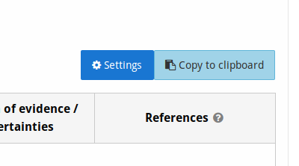Figure 7: Settings and copy buttons

Final words

In this tutorial we covered how to go from a wider data set to a more smaller effects table that can be used to analytically study the benefit-risk balance of selected alternatives for selected criteria. We’ve also shown how to switch between such problems at will. Finally, we’ve shown how to change several aspects of how the effects table is displayed, and how to export your effects table to text editors, e.g. for report writing.

Tutorial 3: Multi-criteria decision analysis

Subjects covered
- Creating a new workspace based on an example dataset
- Exploring different methods for preference elicitation, that is, quantifying how important the benefits and risks of treatments are to you
- Seeing how these preferences impact the relative value of the evaluated treatments

Sign in to MCDA.drugis.org
👉 Open your browser of choice and navigate to https://mcda.drugis.org. Use your Google account to sign in.

Create the example workspace
👉 Click the ‘Create workspace’ button. In the dialog that appears, choose the ‘Zinbryta initial assessment simplified’ option. You should now be on the Overview screen of a fresh workspace, like on Figure 8.

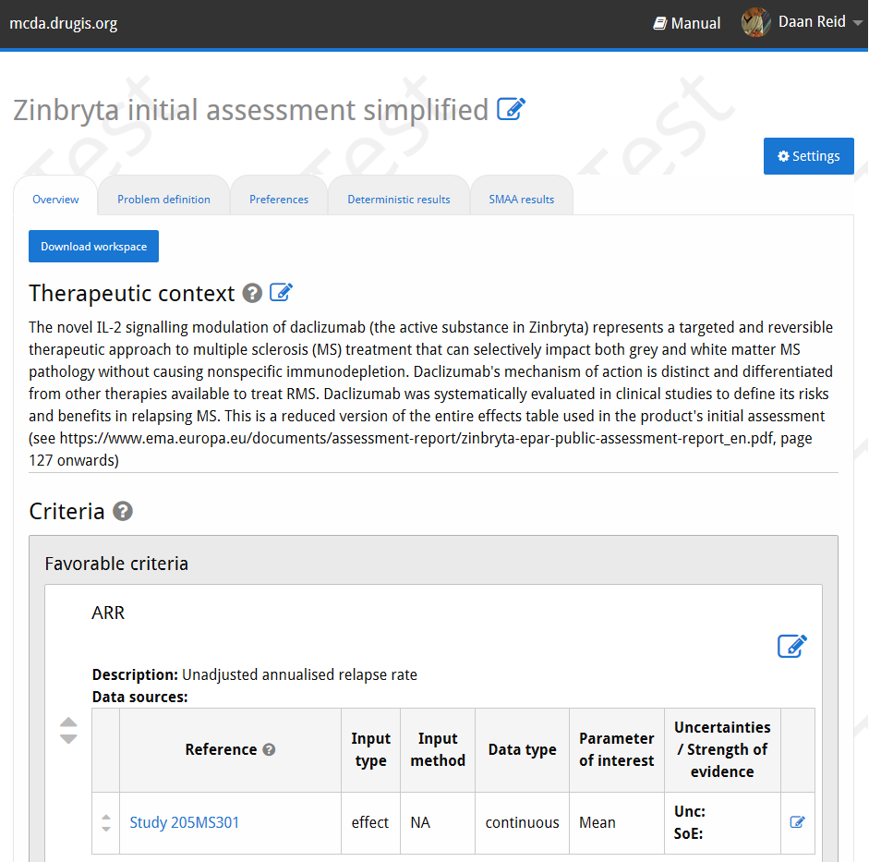Figure 8: Workspace overview
🎓 The overview screen shows you the criteria and their data sources, the alternatives, and the table with measurement data.

💡 Many elements in the interface have a contextual help icon (Figure 9) that you can click for explanation and links to the relevant section in the manual.

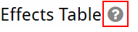Figure 9: Contextual help icon, outlined in red

🎓 The example concerns a simplified version of the Zinbryta assessment. The criteria are the primary endpoint (Annualised Relapse Rate) and several adverse events. Only data from the 205MS301 study are included, as can be seen in the effects table. The references column contains links to the clinicaltrials.gov registry version of this study, which lets you look at the source data.

Evaluate evidence
👉 Take a moment to look at the effects table at the bottom of the overview tab. Do you have a clear preference for one of the two treatments? What makes this treatment better in your view?
We are now going to quantify your preferences in several ways to see whether your intuitive answer in the previous step matches the outcome of the MCDA.
🎓 MCDA is a quantitative approach to benefit-risk assessment and ranks the evaluated treatments from least to most preferable. How preferable a treatment is, is reflected by its utility score. In ADDIS, a treatment’s utility score is the sum of its per-criterion utility values. This method is called the additive value model.
🎓 Utility, as a constructed measure of well-being, has no natural scale. For simplicity, ADDIS (arbitrarily) uses the scale from 0 to 1, with 0 meaning the worst and 1 the best possible combination of the criteria scale values.

Preferences: partial value functions
👉 Go to the ‘Preferences’ tab.
🎓 At the top are the partial value functions, which indicate how utility changes as a function of the criteria scale values. Below this is the weights section which is the main focus of this tutorial. Before setting weights, the partial value functions need to be defined.
👉 Click on the ‘Define partial value function’ button for ARR. Lower relapse rate is better, and we are going to assume that utility changes linearly with the relapse rate, so the type of function is ‘Linear’. Click on ‘Save’.

The range over which the partial value functions are defined depends on the data included in the effects table. These ranges can be modified in the ‘Problem definition’ tab, but this goes beyond the scope of this tutorial.
👉 Also define linear partial value functions for the adverse event criteria, with low values being best. The result should look like Figure 10.

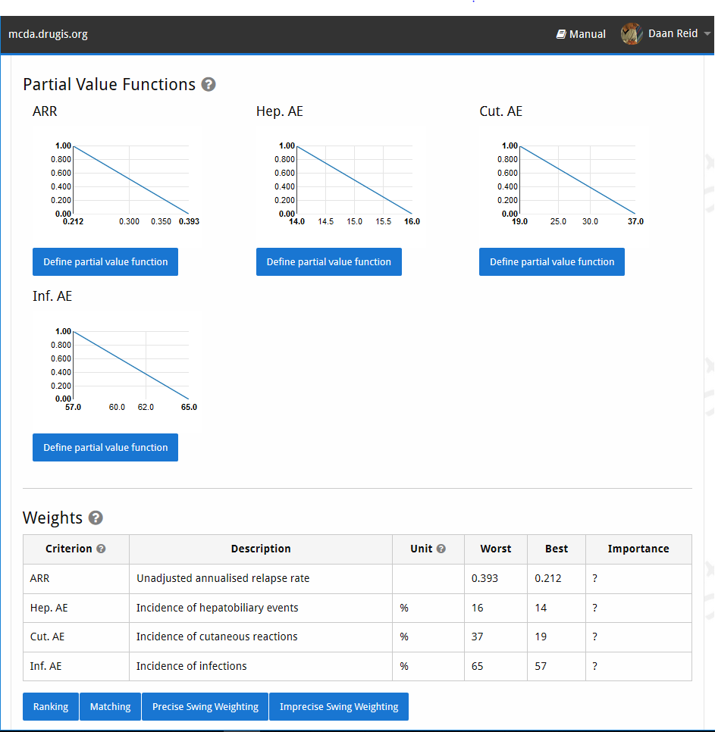Figure 10: Preferences with defined partial value functions
👉 (optional) Explore the process for defining non-linear partial value functions by clicking the ‘Define partial value function’ button under any of the functions, choosing the ‘Piecewise-linear’ option, and adjusting the sliders in the following steps. You can leave the definition process at any time by clicking on the ‘Preferences’ tab again.
🎓 Non-linear partial value functions are needed when equivalent changes on a criterion’s measurement scale do not result in equivalent changes in utility. For example, one can imagine that going from severe depression to mild depression is more valuable than improving from mild to no depression (diminishing marginal utility).

Preferences: ranking elicitation
First let’s see how the treatments compare if we only give an ordinal ranking, with efficacy as the most important.
👉 Click the ‘Ranking’ button below the weights table, then indicate that ARR is the most important criterion, by selecting the ‘decreasing ARR from 0.393 to 0.212’ option and clicking the ‘Next’ button. Then do the same for ‘Hep. AE’, then for ‘Inf. AE’ and click ‘Finish’. Then click on the ‘Deterministic results’ tab.
🎓 The deterministic results screen shows the effects table, with values that can be changed to perform sensitivity analysis (subject of a later tutorial). Below this are the representative weights, showing which weights the system has used to calculate the value profiles. Because we did not supply direct numerical weights but did ordinal ranking instead, the system has generated a default set of weights consistent with the ranking provided. These so-called representative weights are shown in the table.
🎓 The total value indicates an alternative’s overall utility according to the weights you supplied and the data in the effects table. The value profile plot below the total value table shows the contributions of each criterion to these overall utility values (Figure 11). In the current situation, we can see that Daclizumab is much better at reducing the relapse rate, while the other treatment is better as far as all the adverse events goes. Because we have indicated that ARR is much more important than the adverse events, it follows that we should prefer Daclizumab.
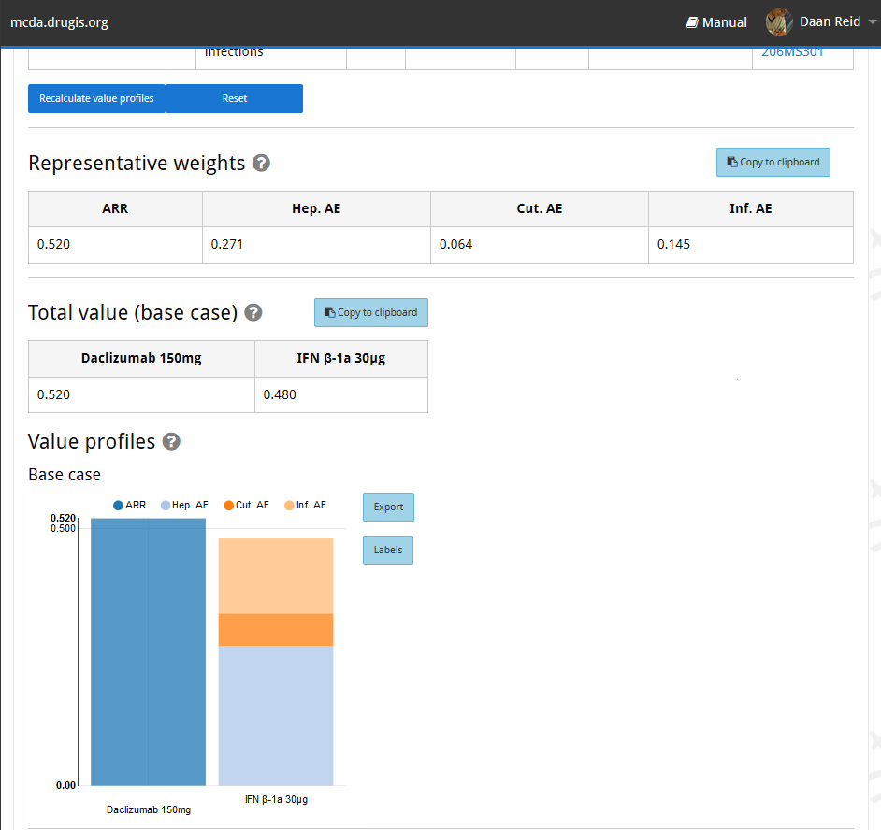Figure 11: Deterministic analysis

Preferences: equal weights
Let’s see how the picture changes if we weight all criteria equally.
👉 Go back to the ‘Preferences’ tab, and click the copy icon next to the scenario dropdown (Figure 12). Give the new scenario an intuitive name like ‘Equal weights.’
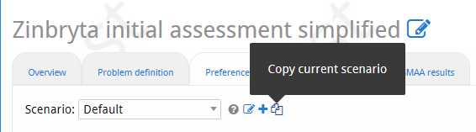Figure 12: Copy scenario button
🎓 Scenarios let you save different configurations of partial value functions and weights, and allow you to switch between them at will. New scenarios can be created as either a copy of the currently selected one, or completely blank, ie. without defined partial value functions and weights.
👉 Click the ‘Precise Swing weighting’ button below the weights table, indicate that ARR is the most important, and then leave all the sliders at 100% and click ‘Save’. Now navigate to the ‘Deterministic results’ tab again, and the results should be quite different. The representative weights are 0.25 for each criterion, and IFN β-1a 30µg is now better than Daclizumab. Because there are simply more adverse event criteria, they together outweigh the higher effectiveness of Daclizumab.
💡 You can switch between scenarios using the dropdown at the top of the tab, and the results will reload.
🎓 Precise Swing weighting lets you manually and precisely set the weights of all criteria relative to the most important one, as you have just done. Leaving all weights at 100% means they are all equally important. Imprecise Swing weighting similarly lets you set the weights, but allows you to specify probable intervals for the weights, for when you are less certain about your preferences or wish to see the consequences in stochastic analysis of uncertain weights.

Preferences: matching elicitation
You can also determine your preferences by comparing alternative outcome scenarios, in the Matching elicitation process.
👉 Click the ‘Matching’ button under the weights table on the preferences tab. Select ‘ARR’ as the most important criterion in Step 1. In step 2, click the blue question mark in the row for ‘Hep. AE.’ In the dialog that appears (Figure 13), you are presented a graph and two alternative scenarios. The graph is the indifference curve. You can change the value for ARR in Alternative B by clicking on it and moving the slider. This will update the graph. Change the value until you feel that the two alternatives are approximately equal, that is decreasing ARR by a certain amount is ‘worth’ about that much increase in Hep. AE. For example, you could indicate that an increase in Hep. AE by 0.02 could be exactly compensated by reducing the ARR from 0.393 to 0.2844 like in Figure 13. Then click ‘Save’. The table will now have updated with the corresponding weight (Figure 14).
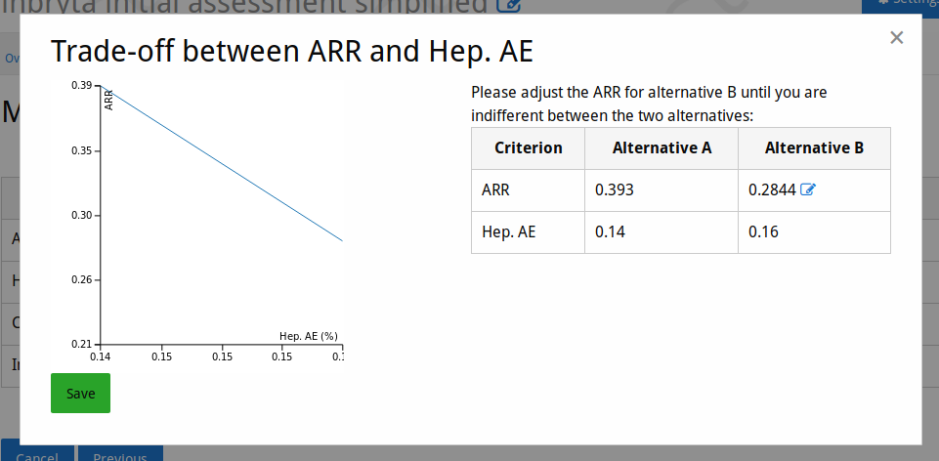Figure 13: Matching elicitation (for one tradeoff)
🎓 The indifference curve which is used during matching elicitation shows a line on which, according to your preferences, each point is equivalent, ie. you should be indifferent between all the scenarios which the points on the line represent. The shape of the indifference curve depends on 1) your weights and 2) your partial value functions (pfvs). If the pvfs for both criteria are linear, the indifference curve is always a straight line, but in the case of nonlinear pvfs the curve may become non-linear. Feel free to experiment with this.
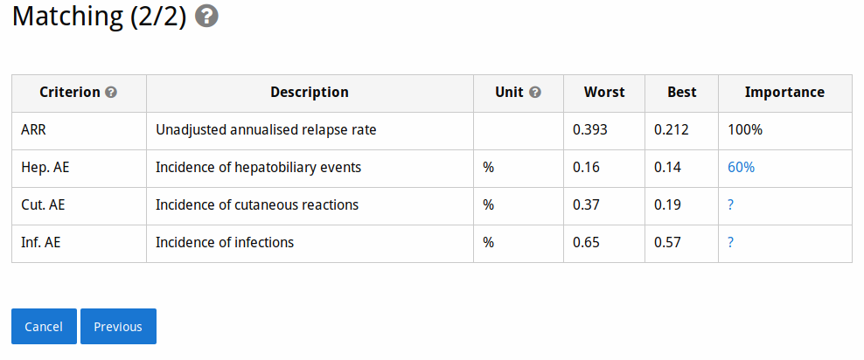Figure 14: Matching elicitation: overview

👉 Finish filling out your preferences in the Matching elicitation by clicking on each of the question marks, click ‘Finish’ and go to the Deterministic results tab to see how the values of the treatments have changed. Are these results in line with your intuitive assessment at the beginning of the tutorial?

Final words
This tutorial has demonstrated how assigning different importance to criteria can drastically change the relative value of the evaluated treatments. We’ve also shown how quantifying these importances by expressing them as numerical weighs makes it easy to see where these differences originate. Finally, we’ve shown that in the MCDA interface it is easy to input different preference scenarios and switch between them.

Tutorial 4: sensitivity analysis
MCDA requires exact preference weights. However, in most benefit-risk assessment situations such exact weights are not available; they might lie on a range or simply be unknown. Further, the supplied data might have significant variance. In this tutorial we will investigate several ways to determine how sensitive the results of analyses are to such uncertainties.

Subjects covered
- Uncertainty in data and preferences
- Deterministic sensitivity analysis
- Stochastic sensitivity analysis
⚠️ Note that this tutorial continues from the simplified version of the Zinbryta assessment used in the previous tutorial about benefit-risk analysis. At several points we ask you to compare results to those of the previous tutorial, so it is helpful to have your work from the previous tutorial open in a separate browser tab or window.

Sign in to MCDA.drugis.org
👉 Open your browser of choice and navigate to https://mcda.drugis.org. Use your Google account to sign in.

Create the example workspace
👉 Click the ‘Create workspace’ button. In the dialog that appears, choose the ‘Zinbryta initial assessment simplified, stochastic’ option. You should now be on the Overview screen of a fresh workspace. Open the settings dialog and switch the ‘Effects table display mode’ to ‘SMAA’. Note that the point estimates now have confidence intervals for all measurements.
🎓 For this tutorial example, we indicated explicitly when entering the data that we assume they are approximately normally distributed for their given point estimate and confidence interval (see Figure 3 in the first tutorial). This lets their distributions be used to perform stochastic sensitivity analysis, as explained towards the end of this tutorial.
👉 Click on the ‘Problem definition’ tab. Consider how the confidence intervals for each criterion’s measurements are connected to the ‘Observed Range’ column in the scale ranges table.
🎓 The scale ranges for each criterion determine which highest and lowest values to consider when defining their partial value functions. Scale ranges can be wider than the observed data, but never narrower. If the data include uncertainty the confidence intervals are included in the scale ranges.

Deterministic sensitivity analysis
👉 Click on the ‘Preferences’ tab and define your partial value functions, as in our previous tutorial on benefit-risk analysis. Remember that lower is better for all criteria in this analysis. Note that the X-axis of each pvf corresponds to the scale range for that criterion.
👉 Perform an ordinal ranking, with ARR most important, and the AEs in decreasing importance from top to bottom. Go to the deterministic analysis tab, and look at the value plot. Compare it to the value plot of the previous tutorial’s ordinal ranking scenario. Note that both alternatives derive some value from each criterion. Also note that now that uncertainty is included, Daclizumab actually has higher value.
🎓 Widening the scale ranges of your criteria is one way of incorporating uncertainty in your analyses. Since the partial value function for a criterion by definition returns an extreme value (either 0 or 1) at the minimum or maximum value of the scale range, measurements at these extremes will therefore have either maximally positive or maximally negative value. If you widen your scale ranges so that your measurements are never at these extreme ends, they will always have some positive contribution to that alternative’s value.
👉 Let’s see what happens if we want to look at the consequences when the point estimate for ARR is too high for IFN β-1a 30µg. Click on this value in the effects table at the top of the page, and change it to approximately 0.353: the lowest value within the 95% C.I. (Figure 15). Click the ‘Recalculate value profiles’ button below the effects table, and take a look at the new results. As it turns out, this single change is not sufficient to change the benefit-risk balance.
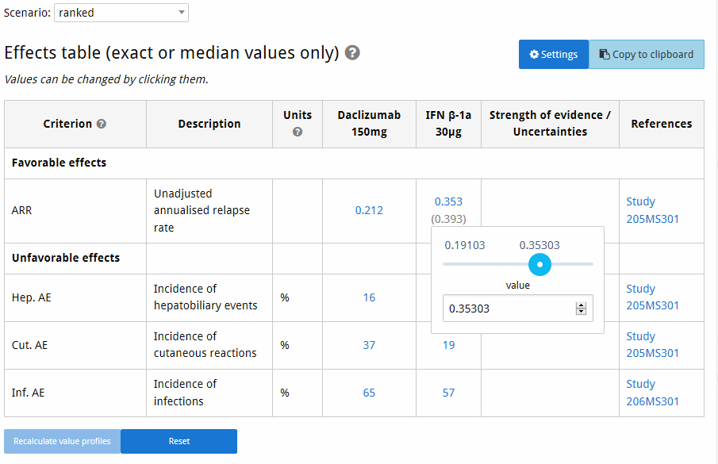Figure 15: Changing the effect value
👉 Scroll down to the bottom of the page and take a look at the plots in the ‘One-way sensitivity analysis’ section. These give some insight into what the consequences of changing a single value would be. In the left (‘Measurements’) plot select IFN β-1a 30µg as the alternative and observe the changes. Pay particular attention to the intersection point of the two lines.
🎓 The measurements plot of the one-way sensitivity analysis shows you how the total value of a criterion changes if you change its measurement for a specific alternative, while keeping all other values constant. In other words, we could have predicted that the change we made in the previous step (to 0.353) would not be sufficient to upset the benefit-risk balance, because the intersection point with the Daclizumab is only at approximately 0.3125. The measurements plot thus lets you explore the sensitivity of the benefit-risk balance to each individual effect. Note that for linear pvfs this is rather straightforward, but nonlinear ones make it more interesting.
🎓 Similarly, the ‘Preferences’ plots let you see how the value of all alternatives changes with the weight of a specific criterion. Note that, since all weights should always sum to 1, this means that the weights of the other criteria also change implicitly. Instead of their value, their proportional share of the remaining weight is kept constant.
🎓 Deterministic analysis lets you easily predict the results of a single change, and check the consequences of different measurement data. However, it would be extremely labour-intensive to manually make a lot of changes and aggregate the results into an overview of the possibilities given the measurements, your preferences, and their uncertainties. This need is addressed by stochastic multicriteria acceptability analysis (SMAA) which we’ll briefly discuss in the next section.

Stochastic sensitivity analysis
👉 Go to the ‘SMAA results’ tab. Take a moment to look at the outputs. Most important are the rank acceptability plot and table at the top of the page (Figure 16). These indicate how frequently each alternative had a specific rank in the different configurations of measurements and preferences that were generated.
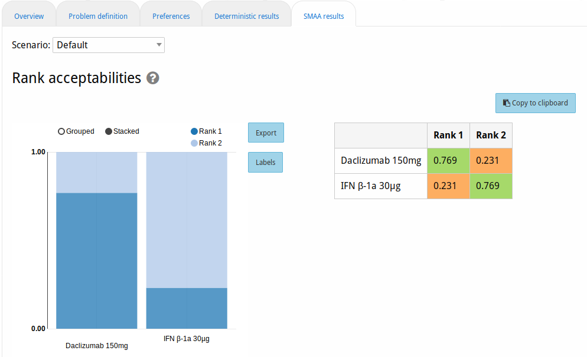Figure 16: Rank acceptabilities
🎓 SMAA models explore uncertainties in the measurements and preferences by systematically varying their values. The set of variations (of which there can be hundreds of thousands) can be analysed in several ways. We here use the rank acceptability: for each variation the alternatives are ranked according to their calculated value, and then the proportion of variations in which an alternative had each specific rank is reported.
👉 Go to the ‘Preferences’ tab, create a new scenario called ‘100-75-50-25’ and use Precise Swing to set the Criteria weights as: ARR 100%, Hep. AE 75%, Cut. AE 50% and Inf. AE 25%. Go to the ‘Deterministic results’ tab, and you should see that the value of both alternatives is approximately equal. Now navigate to the ‘SMAA’ tab and observe the results. You should see that each alternative is ranked as best in roughly 50% of all cases. This is consistent with the deterministic analysis, where the value for both alternatives is approximately equal.
👉 Switch to your workspace from the previous tutorial. Create a scenario in the Preferences tab called ‘ranked weights’, then use Precise swing to specify the weights as: ARR 100%, Hep. AE 50%, Cut. AE 25% and Inf. AE 12%. This results in a representative weight distribution approximately equal to the one automatically generated for deterministic analysis of the case where the criteria are ranked.
👉 Go to the ‘Deterministic results’ tab and use the scenario switching to go back and forth between the ‘ranked weights’ scenario and the ‘Default’ one (assuming you kept that scenario as using ranking; otherwise do a new ranking elicitation). The results and representative weights should be similar.

👉 Switch to the ‘SMAA results’ tab and again switch back and forth between the two scenarios. Now you should see a great difference. For the specific weight distribution we picked, there is no uncertainty in either the measurements or the preferences, and thus all scenarios result in the same ranking. However, in the ‘Default’ scenario where only ranks are specified, the different ways in which the weights can be distributed while preserving their ranking are taken into account, showing that for only approximately half such rankings Daclizumab 150mg is better than IFN β-1a 30µg.
🎓 Uncertainty can also lie in the preferences. If only a ranking is specified, there are infinitely many ways to pick the actual weight values for the criteria that still satisfy the given ranking. SMAA also varies the preferences if there is uncertainty there.

Final words
This tutorial showed how to explore potential consequences of uncertainty in your measurements and preferences for the benefit-risk balance. It also demonstrated how to determine the sensitivity of the benefit-risk balance to changes in measurements and preferences. Finally, we’ve shown how to interpret the output of SMAA models and their bird’s eye view of what is possible.

SMAA samples from probabilistic distributions for these values - for a more in-depth explanation of the process, see the MCDA manual and Tervonen & Lahdelma (2007)

