Tutorial 1: manual data entry
This tutorial guides you through the process of manually entering data, so that you can create your own effects tables.

Subjects covered
- Manual data entry interface
- Defining criteria and alternatives
- Specifying data sources
- Filling in the data entry table

Example effects table
The data that you are going to enter in this tutorial is taken from the effects table for lixisenatide as included in the EMA Guidance document for critical assessment reports (see page 72). For didactic purposes, we are going to work with a simplified version of that table which includes HbA1c as a favourable effect and nausea as an unfavourable effect (Table 1).
Table 1 - Simplified effects table for lixisenatide, a treatment for type 2 diabetes mellitus
Effect | Description | U | LIX | PBO | Uncertainties /  Strength of evidence | Reference
Favourable Effects
HbA1c | Mean change in HbA1c from baseline | % | -0.83  (-0.91, -0.75) | -0.39  (-0.51, -0.28) | Unc: The effect of lixisenatide was more pronounced in Asian patients compared to Caucasian patients. The lower effect in Caucasians is partly explained by a large placebo effect especially in some geographical regions. | Pooled data from EFC6014 and EFC10743
HbA1c | Mean change in HbA1c from baseline | % | -0.82  (-0.91, -0.73) | -0.10  (-0.24, 0.04) |  | EFC6015
Unfavourable Effects
Nausea | Incidence of nausea | % | 26.9 | 7.3 |  | pooled data from all phase 2/3 controlled studies

Sign in to MCDA.drugis.org
👉 Open your browser and navigate to https://mcda.drugis.org. Use your Google account to sign in. You will be redirected to your personal homepage, containing your previously created workspaces, both finished and unfinished (if any).

Create a new workspace
👉 Press the ‘Create workspace’ button, select the option ‘Manual input’, and press the ‘Create button’. This leads to the first step of the manual entry process.
🎓 A workspace contains the clinical efficacy and safety data that you have entered for a particular benefit-risk assessment. Within a workspace you can build effects tables and perform quantitative benefit-risk analyses. Existing workspaces are opened by clicking on their name, or navigating to their URL directly via a link or bookmark. Workspaces can only be accessed by their owner.
💡 We here cover the manual workspace creation process; besides this you can also create workspaces based on example data uploaded by the ADDIS team, and upload JSON files exported by you or another user.

Enter general information
👉 Enter a descriptive title in the ‘Workspace title’ field at the top of the page. For example, “lixisenatide data entry tutorial”.
👉 Enter the indication and other relevant context for your assessment in the ‘Therapeutic context’ field. For example, “Assessment of lixisenatide for the treatment of adults with type 2 diabetes mellitus to achieve glycaemic control in patients not adequately controlled on oral antidiabetics.”
💡 At any stage during the data entry process you can press the ‘Save’ button at the bottom of the page to store the current state. This lets you continue later. You can navigate to your home page by pressing the mcda.drugis.org link on the menu bar at the top-left of the screen.

Enable favorability
👉 The effects table for lixisenatide divides the criteria into favourable and unfavourable effects. To enable the this classification, check the ‘Use favorability’ box below the ‘Criteria’ heading.
🎓 Criteria are the clinical efficacy and safety outcomes in terms of which the treatments under consideration are evaluated. A criterion has a name (a short identifier, such as “HbA1c” or “Nausea”), a description, and optionally a unit of measurement. The description specifies how the effect of a treatment on the selected outcome variable is measured statistically. For example, for “HbA1c” this could be “mean change from baseline” or “proportion of patients with a normal HbA1c value at week 24”.
🎓 For regulatory purposes, criteria can additionally be classified as favourable or unfavourable, with favourable criteria being ones where the new treatment under consideration outperforms the status quo.

Add the HbA1c criterion
👉 Click the ‘Add Criterion’ button and fill in the dialog as specified in Figure 1.
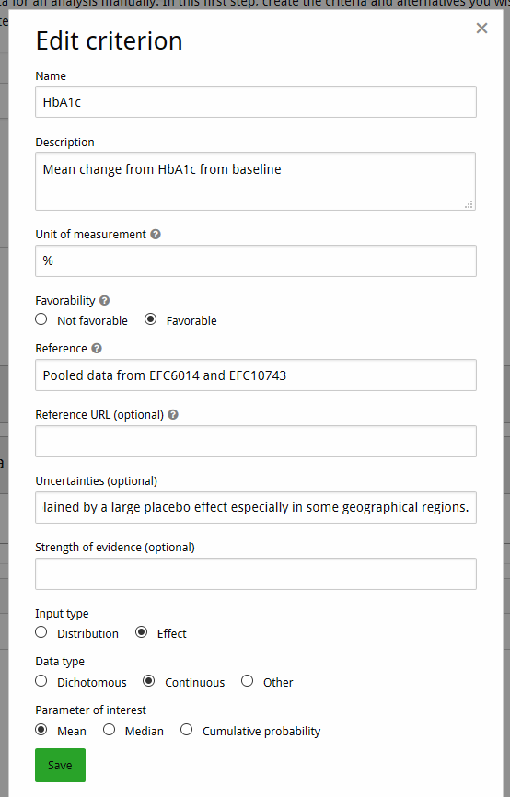Figure 1: Edit criterion dialog for HbA1c
🎓 The upper section of the Edit criterion dialog (title, description, unit, and favorability) defines the criterion, and the lower section specifies the characteristics of the data source from which summary statistics (input type ‘Distribution’) or treatment effect estimates (input type ‘Effect’) are taken. Creating a criterion implicitly also involves specification of a data source. Further data sources can be added later (see the ‘Add a second data source for HbA1c’ step of this tutorial).
🎓 A data source is a study from which summary statistics or treatment effect estimates are taken. This can be a single pivotal study but could also be a pooled analysis, such as a combined safety pool or a (network-) meta-analysis. A data source’s origin are specified via its name (the ‘Reference’ field) and optionally its URL. The subsequent ‘Uncertainties’ and ‘Strength of evidence’ fields describe any strengths and weaknesses of the study design, quality of the data collection and analysis, generalizability of the study findings, etc. The remaining fields are used to specify the type of data to be entered during the second stage of the data entry process (see the ‘Enter data’ step of this tutorial). For more details on the different types of data that can be entered into the system, see the Appendix.

Add a second data source for HbA1c
👉 On the HbA1c criterion, click the ‘Add data source’ button. In the dialog, specify the reference “EFC6015” and leave the other fields unchanged (the data from this study will be entered in the same format as specified in the previous step). Then click ‘Add.’ Now there should be a second row in the data sources for the criterion.

Add nausea as an unfavourable effect
👉 Click the ‘Add criterion’ button, fill in the dialog as specified in Figure 2, and click ‘Add’ (note that favorability is now ‘Not favorable’ and that the units are left blank). The reference for the data source is “Pooled data from all phase 2/3 controlled studies.” There are no further data sources for this criterion.

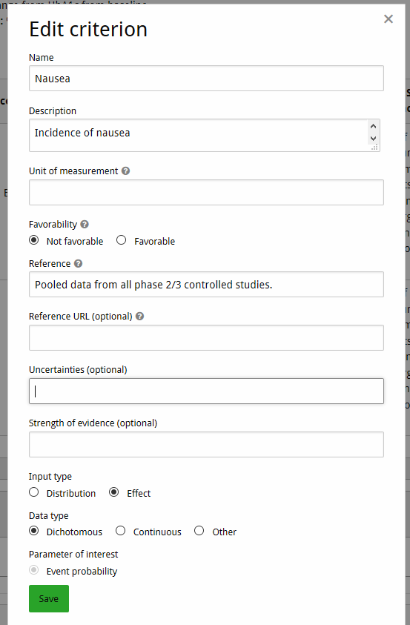Figure 2: Edit criterion dialog for Nausea

Add lixisenatide and placebo as alternatives
👉 Under the ‘Alternatives’ header, fill in “lixisenatide” in the text box and click the ‘Add alternative’ button to the right, or hit the enter key. Now do the same for “placebo”.
💡 You can press the ‘Save’ button at any time to save your work in progress.

Proceed to data entry
👉 Click the ‘Enter data’ button. Take a moment to inspect the data entry table that the system has generated based on your work in the previous steps. If you spot any errors or inconsistencies, you can always click the ‘Back’ button to correct them.
⚠️ To prevent inconsistencies, changing the characteristics of a criterion’s data source will delete any values you entered for the row corresponding to that data source.

Enter data
👉 Click on the ‘Missing or invalid input’ link in the HbA1c, pooled data from EFC6014 and EFC10743 row of the lixisenatide column. Fill out the dialog as shown in Figure 3, and click anywhere on the page outside of the dialog to close it.
👉 Proceed to fill out the remaining three cells for HbA1c with the point estimates and 95% confidence intervals from Table 1.
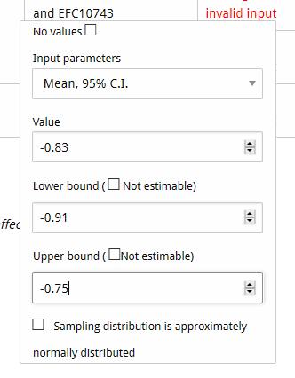Figure 3: Data entry dialog for HbA1c
👉 Similarly, fill out the cells for Nausea with the values from Table 1, selecting ‘Percentage’ as the input parameter.
Your final data entry table should look like Figure 4.
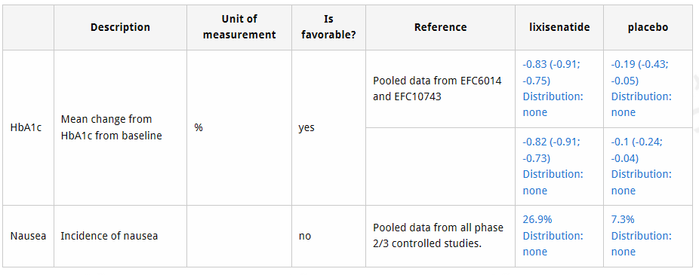Figure 4: Final data entry table for lixisenatide
🎓 For each row, which input fields are available depends on the meta-data that you provided for that row’s data source in Step 1 of the manual entry process. An overview of the various data entry possibilities is provided in the Appendix.
💡 If required, cells can be left empty by checking the checkbox ‘No values’ at the top of the dialog.

Finalize entry
You have now finished preparing your effects table for analysis.
👉 Click ‘Done’ and you will go to the overview page of your newly-created workspace where you will find the entered effects table.
🎓 After finishing the manual entry process, cosmetic properties such as names and descriptions can still be edited, and the criteria can be re-ordered using the arrow buttons. However, to prevent breaking the analyses that are based on them, measurements cannot be modified. Changing measurements can be done by creating a copy of the workspace on your homepage. This begins a new manual entry process as detailed above, but all criteria, alternatives and measurements are already filled out based on the old workspace, and can be changed at will.

Export and share with others
👉 On your newly-created workspace, click ‘Download workspace’ in the top-left to save a .json file which contains all the data you just entered. When creating a new workspace, you can upload this file (using the ‘local file’ option) and the new workspace will contain a copy of your data.
💡 Sending this file via e.g. email to someone else is the recommended way to share workspace data with other users.

Appendix: data source characteristics and data entry options
A treatment effect is a statistical parameter that describes how a given treatment affects the distribution of a criterion in the target population (i.e., all patients for which the evaluated treatment is indicated). The representation of that parameter’s uncertainty in the effects table depends on the specified characteristics of the row’s data source. Indicating that the input type is ‘Distribution’ corresponds to a Bayesian perspective, where the uncertainty is quantified by means of probability distributions. The option ‘Effect’ corresponds to a frequentist perspective where parameters are treated as fixed but unknown constants for which point and interval estimates (e.g., 95% confidence intervals) are provided.

Meta-data required for entering distributions (Bayesian)
The ‘Input method’ determines how the data source’s probability distributions are to be entered. Distributions can either be specified directly by choosing a distributional family and entering its parameters (‘manual distribution’) or derived indirectly from summary statistics from a clinical study (option ‘assisted distribution’). When this latter option is selected, a Bayesian posterior distribution (i.e., a beta distribution for the event probability of a dichotomous outcome variable and a normal distribution for the mean of a continuous outcome variable) is estimated from the summary statistics supplied by the user and a reference prior set by the system.
The following distributional families are supported for the ‘Manual distribution’ input type:
- Beta
- Normal
- Gamma
- Exact (i.e., degenerate distribution that always results in the same value)
The following summary statistics are supported for the ‘Assisted distribution’ input type:
- Dichotomous outcome
  - number of events / sample size
- Continuous outcome
  - mean / standard error / sample size
  - mean / standard deviation / sample size

Meta-data required for entering effects (Frequentist)
The ‘Data type’ radio buttons serve to specify the data type of the outcome variable under consideration. Here, a choice can be made between dichotomous, continuous, and other. The latter option provides an aggregate category for data types that are neither dichotomous nor continuous, such as count data. The subsequent ‘Parameter of interest’ choice specifies the treatment effect measure. If the data type is dichotomous, the parameter of interest is always ‘Event probability’. If the data type is continuous, a choice can be made between ‘Mean’, ‘Median’, and ‘Cumulative probability’. Finally, if the data type is other, the parameter of interest is unknown, and we use the generic identifier ‘Value’.
The input fields that appear on the data entry dialogs in the second stage of the manual data entry process depend on the selected parameter of interest. The following data entry options are currently available. An asterisk (*) means that you can indicate that the sampling distribution of the parameter of interest is approximately normal. Doing so lets us use the sampling distribution to estimate the uncertainty in SMAA analyses.
- Dichotomous – event probability
  - Decimal
  - Decimal, sample size *
  - Percentage
  - Percentage, sample size *
  - Fraction (i.e., events / sample size) *
- Continuous – mean
  - Mean
  - Mean, standard error *
  - Mean, 95% confidence interval *
- Continuous – median
  - Median
  - Median, standard error
- Continuous – cumulative probability
  - Decimal
  - Decimal, 95% confidence interval
  - Percentage
  - Percentage, 95% confidence interval
- Other – value
  - Mean
  - Mean, standard error
  - Mean, 95% confidence interval

