**Universal Edition:**

https://www.universaledition.com/Les-11/P0316279

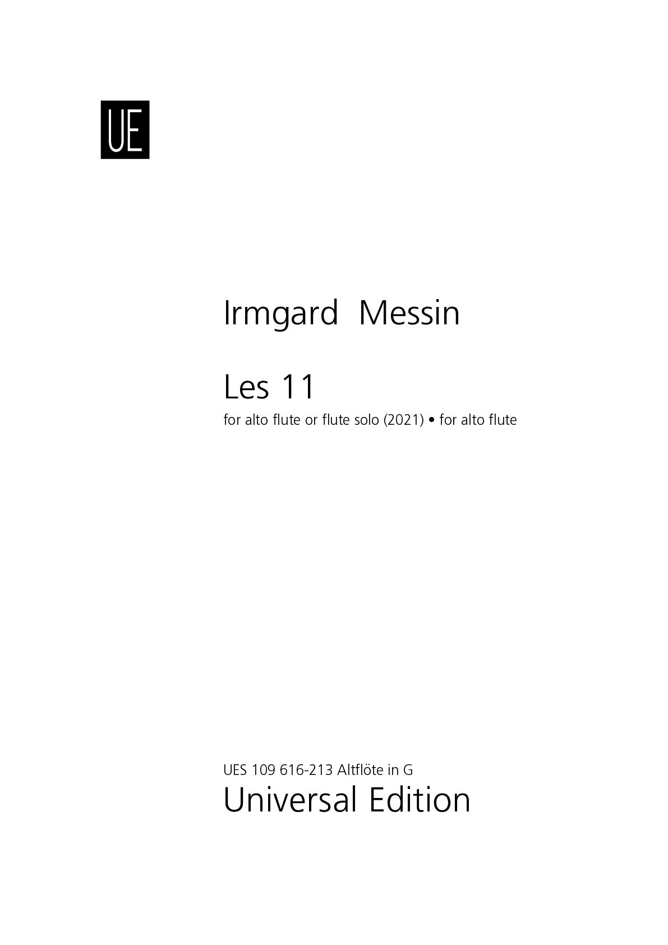

<https://www.universaledition.com/Werke/Elle-et-Guy/P0316274>

