Nathan Donaldson/U0632803

CS4150/PS10 – 2

/* Objective function */

max:r + 1.50s;

/* Variable bounds */

r>=0;

s>=0;

r>=2s;

r+s<=3000;

|  |  |  |
| --- | --- | --- |
| Regular Duff Beer | Strong Duff Beer | Value |
| r = 0 | s = 0 | 0 |
| r = 2000 | s = 1000 | 3500 |
| r = 3000 | s = 0 | 3000 |

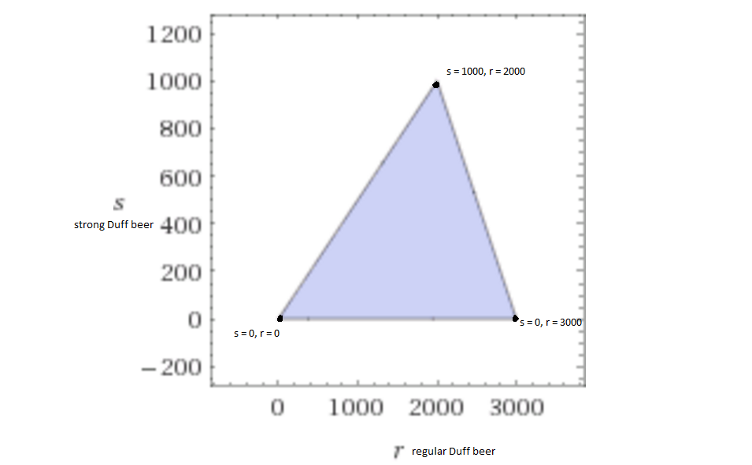

The maximum profit is achieved by buying and selling 2000 regular Duff beers and 1000 strong Duff beers.