Nathan Donaldson/U0632803

CS4150/PS10 – 3

/\* Objective function \*/

min: a;

/\* Variable bounds \*/

a >= 3 - m - b;

a >= m - 3 + b;

a >= 5 - 2m - b;

a >= 2m - 5 + b;

a >= 7 - 3m - b;

a >= 3m - 7 + b;

a >= 11 - 5m - b;

a >= 5m - 11 + b;

a >= 14 - 7m - b;

a >= 7m - 14 + b;

a >= 15 - 8m - b;

a >= 8m - 15 + b;

a >= 19 - 10m - b;

a >= 10m - 19 + b;

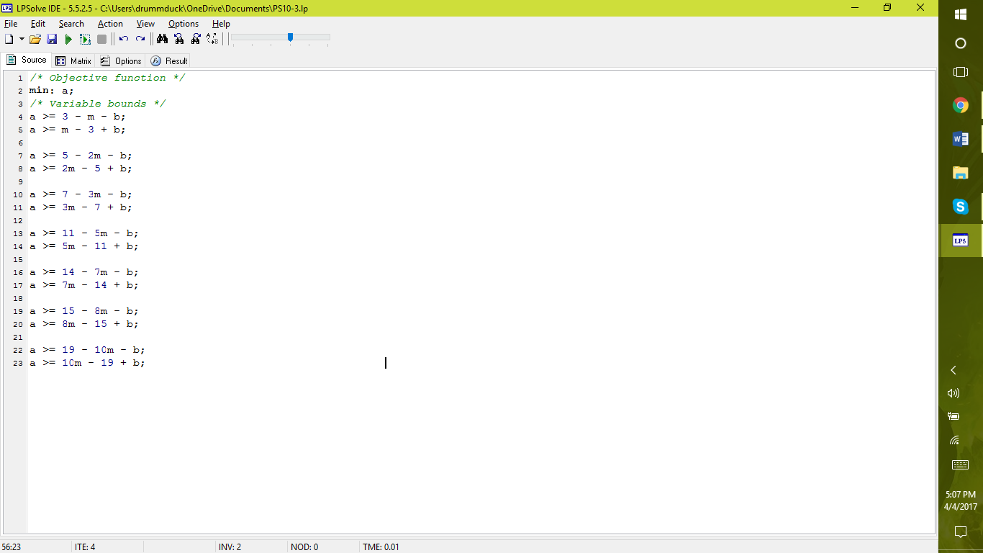

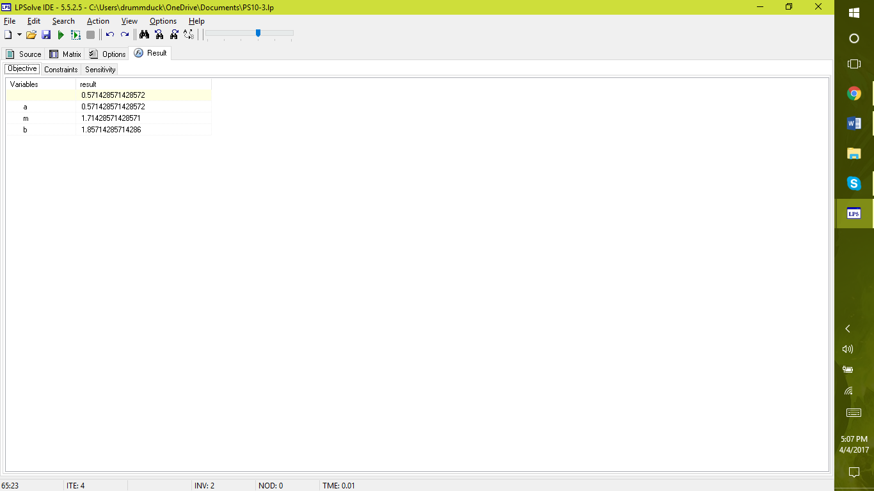

The optimum value for m is 1.71428571428571 and the optimum value for b is 1.85714285714286.

The maximum absolute error calculated by the solver is 0.571428571428572.