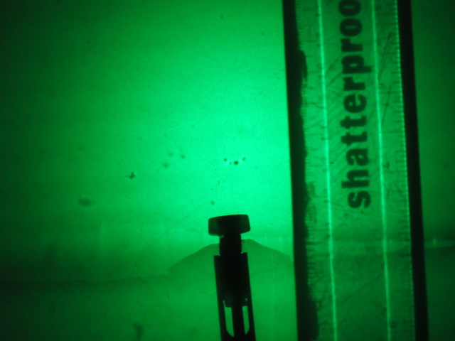

1cm Marks on Ruler

*x*

*y*