**Ex. No: 8 Date: 16-10-2023**

**CLASSIC SYNCHRONIZATION USING SEMAPHORE**

**Aim:**

To simulate classic synchronization problems like Dining Philosophers and Producer Consumer in C language using Semaphore.

1. **Dining Philosopher’s Problem:**

**Program:**

#include <stdio.h>

#include <stdlib.h>

#include <pthread.h>

#include <semaphore.h>

typedef struct{

int position;

int count;

sem_t *forks;

sem_t *lock;

} params_t;

void initialize_semaphores(sem_t *lock, sem_t *forks, int num_forks);

void run_all_threads(pthread_t *threads, sem_t *forks, sem_t *lock, int num_philosophers);

void *philosopher(void *params);

void think(int position);

void eat(int position);

int main(int argc, char *args[]){

int num_philosophers = 5;

sem_t lock;

sem_t forks[num_philosophers];

pthread_t philosophers[num_philosophers];

initialize_semaphores(&lock, forks, num_philosophers);

run_all_threads(philosophers, forks, &lock, num_philosophers);

pthread_exit(NULL);

}

void initialize_semaphores(sem_t *lock, sem_t *forks, int num_forks){

int i;

for (i = 0; i < num_forks; i++){

sem_init(&forks[i], 0, 1);

}

sem_init(lock, 0, num_forks - 1);

}

void run_all_threads(pthread_t *threads, sem_t *forks, sem_t *lock, int num_philosophers){

int i;

for (i = 0; i < num_philosophers; i++){

params_t *arg = malloc(sizeof(params_t));

arg->position = i;

arg->count = num_philosophers;

arg->lock = lock;

arg->forks = forks;

pthread_create(&threads[i], NULL, philosopher, (void *)arg);

}

}

void *philosopher(void *params){

int i;

params_t self = *(params_t *)params;

for (i = 0; i < 3; i++){

think(self.position);

sem_wait(self.lock);

sem_wait(&self.forks[self.position]);

sem_wait(&self.forks[(self.position + 1) % self.count]);

eat(self.position);

sem_post(&self.forks[self.position]);

sem_post(&self.forks[(self.position + 1) % self.count]);

sem_post(self.lock);

}

think(self.position);

pthread_exit(NULL);

}

void think(int position){

printf("Philosopher %d thinking...\n", position);

}

void eat(int position){

printf("Philosopher %d eating...\n", position);

}

**Output:**

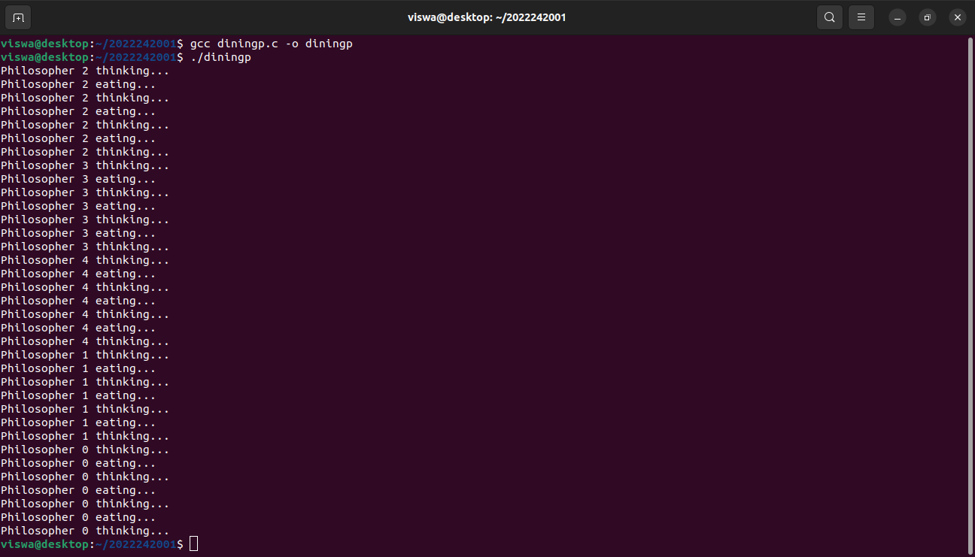

1. **Producer Consumer Problem:**

**Program:**

#include <pthread.h>

#include <semaphore.h>

#include <stdlib.h>

#include <stdio.h>

#define MaxItems 5

#define BufferSize 5

sem_t empty;

sem_t full;

int in = 0;

int out = 0;

int buffer[BufferSize];

pthread_mutex_t mutex;

void *producer(void *pno){

int item;

for (int i = 0; i < MaxItems; i++){

item = rand();

sem_wait(&empty);

pthread_mutex_lock(&mutex);

buffer[in] = item;

printf("Producer %d: Insert Item %d at %d\n", *((int *)pno), buffer[in], in);

in = (in + 1) % BufferSize;

pthread_mutex_unlock(&mutex);

sem_post(&full);

}

}

void *consumer(void *cno){

for (int i = 0; i < MaxItems; i++){

sem_wait(&full);

pthread_mutex_lock(&mutex);

int item = buffer[out];

printf("Consumer %d: Remove Item %d from %d\n", *((int *)cno), item, out);

out = (out + 1) % BufferSize;

pthread_mutex_unlock(&mutex);

sem_post(&empty);

}

}

int main(){

pthread_t pro[5], con[5];

pthread_mutex_init(&mutex, NULL);

sem_init(&empty, 0, BufferSize);

sem_init(&full, 0, 0);

int a[5] = {1, 2, 3, 4, 5};

for (int i = 0; i < 5; i++){

pthread_create(&pro[i], NULL, (void *)producer, (void *)&a[i]);

}

for (int i = 0; i < 5; i++){

pthread_create(&con[i], NULL, (void *)consumer, (void *)&a[i]);

}

for (int i = 0; i < 5; i++){

pthread_join(pro[i], NULL);

}

for (int i = 0; i < 5; i++){

pthread_join(con[i], NULL);

}

pthread_mutex_destroy(&mutex);

sem_destroy(&empty);

sem_destroy(&full);

return 0;

}

**Output:**

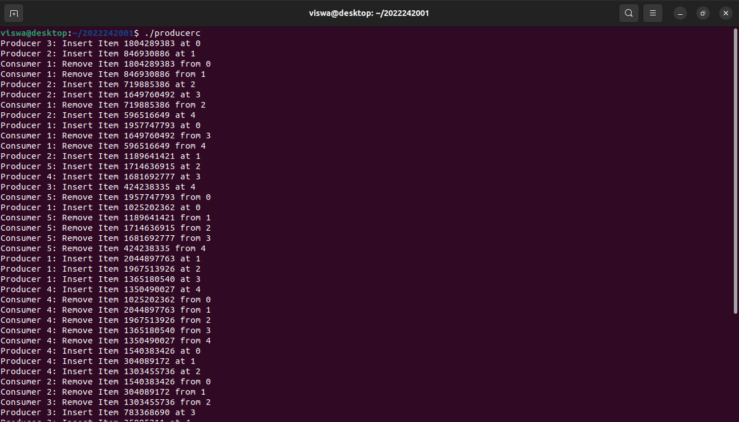

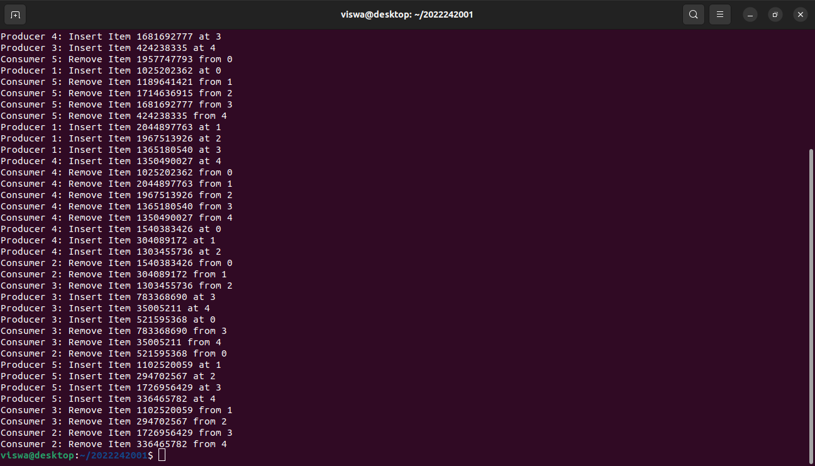

**Result:**

Thus, the classic synchronization problems like Dining Philosophers and Producer

Consumers are successfully simulated in C Program using semaphores