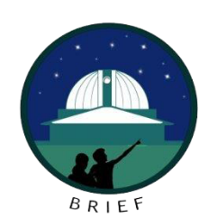
BAROspection - Intro to Spectroscopy Seminar

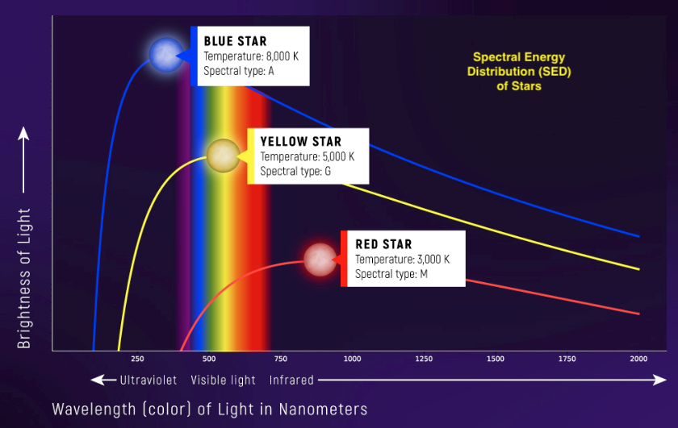
In this seminar we will cover introductory and historically significant astronomical & spectroscopy topics. We will not only learn the basics of spectroscopy, we will also use the Boyce Astro BARO telescope to obtain spectra. Then we will analyze the spectra using RSpec Software. We will publish our spectra and analysis results in a Hertzsprung Russell diagram (HRD) as a poster or scientific paper at the end of the course.

We will use Jupyter Notebooks with embedded Python in our analysis and publications of our findings. As a student of science research, you will learn many widely used skills including Markdown Syntax, LaTeX for equations and use of Python in analysis and visualizations of our findings.

We will learn to use RSpec, a very popular desktop application that can be used to analyze your own spectra that you can get from your backyard scopes using a diffraction grating. We will place the stars we analyzed in a HertzSprung Russel Diagram (HRD) of well known stars of multiple classifications.

Date  Pacific Time | Topic | Description
8/15/2025  6:30-8 PM | Intro to Spectroscopy & Jupyter Notebooks | What is Spectroscopy? What are Jupyter Notebooks
8/15/2025  8-11 PM | OPTIONAL - Obtain Spectra from BARO telescope | Obtain live spectra from the BARO telescope for use in this seminar. This is an optional session due to the late hour for East Coast participants. Dark sky in San Diego prevents doing this at other times.
8/22/2025  6:30-8 PM | Light & Matter. Absorption & Emission Spectra & Types of Spectroscopy | What are light and matter and how do they interact with each other? How Absorption and Emission Spectra Work? Why do different elements have different spectral patterns? What can we learn from different types of spectra?
8/29/2025  6:30-8 PM | Star Classifications and RSpec analysis of BARO spectra obtained | Analyse Spectra using RSpec. We will also create a specific instrument response (IR) for the BARO telescope spectrograph. We will use the IR to compare published SED curves and predict star temperatures etc.
9/5/2025  6:30-8 PM | Properties of Stars and Galaxies using Spectra | What can we learn about the properties of Stars and Galaxies by analyzing their Spectra? Analyze Star spectra we obtained via BARO. Plot the stars we analyzed on the HertsSprung Russel Diagram
9/12/2025  6:30-8 PM | Share our final results by sharing our published data in Jupyter Notebooks | Learn to download analyze JWST NIR and other spectra from the Space Telescope Science Institute. Extra credit: Build your own digital spectroscope with a raspberry pi and diffraction grating!

