**Supplementary Information**

**Lenticel damage of avocado cv. Hass depends on spatiotemporal factors and influences the fungal structure community**

Sandra Mosquera1, Carolina Cataño1, Susan Saavedra2, Valeska Villegas-Escobar1*

1 *CIBIOP Research Group, Biological Sciences Department, Universidad EAFIT, Carrera 49 No. 7 Sur - 50, Medellin, Colombia.*

*2 Grupo Cartama. Carrera 33 # 7 – 41, Medellín, Colombia. ORCID ID: 0000-0003-4809-5531*

*\*Corresponding author,* [*vvilleg2@eafit.edu.co*](mailto:vvilleg2@eafit.edu.co)*, ORCID ID: 0000-0002-9636-3644*

**Supplementary Figure 1.** Lenticel damage for avocado cv. Hass fruits used for the microbial-community analysis. Fruits were collected from the La Escondida and El Sinai farms during the traviesa harvest of 2020. Shown are the means and standard deviations for the severity (A) and incidence (B) of the damage for the fruits with deferent levels of affection. The points show the severity and incidence for the fruits and the asterisk denote statistic differences at the 99.0% (**) and 99.9% (***) confidence level according to the t test (n: 6). C) representative photographs of mild and severe damage of lenticels.

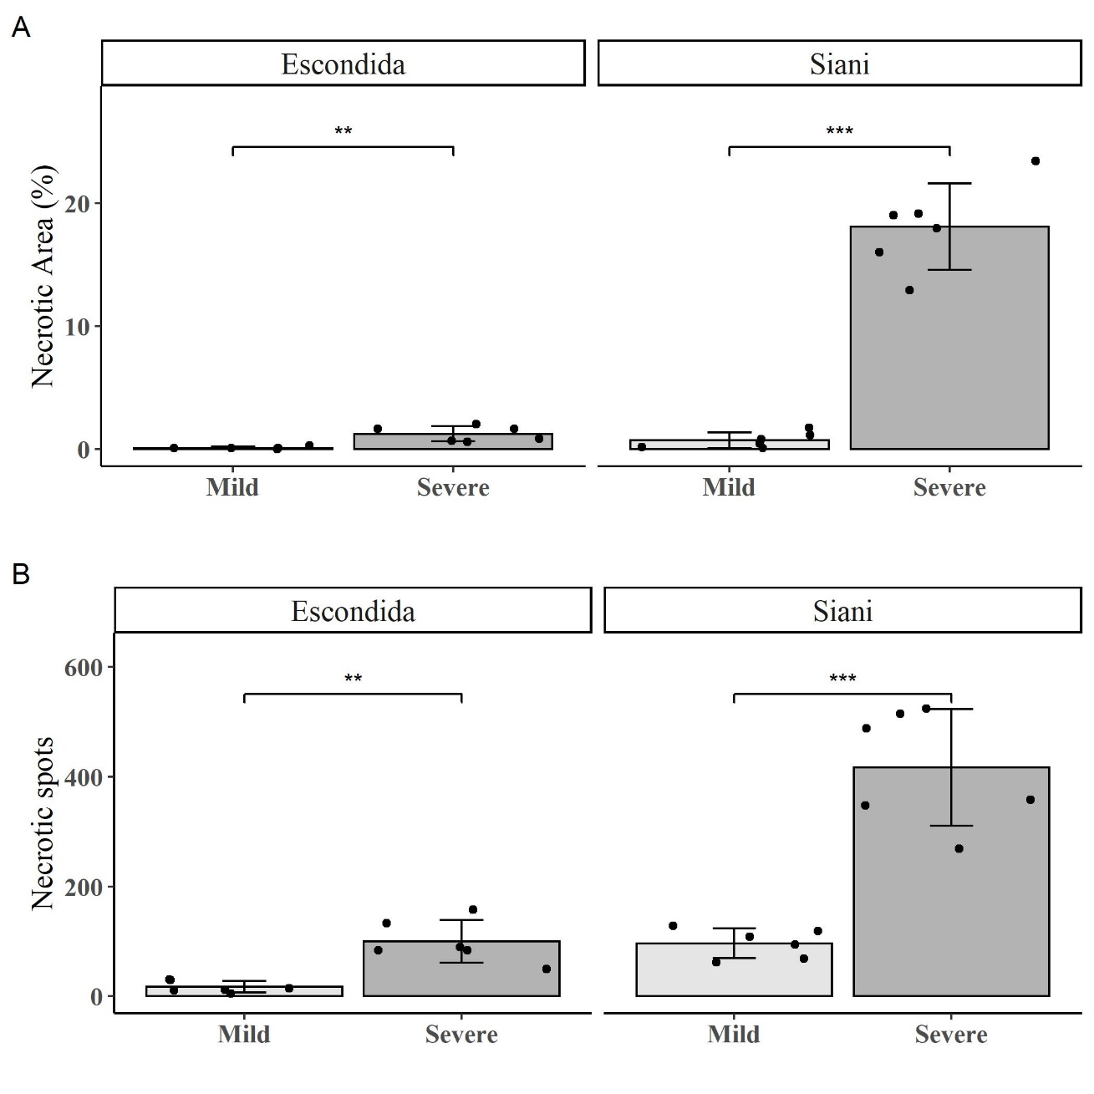

**C**

Mild

Severe

**Supplementary Figure 2.** Rarefraction curves for the fungal communities of the avocado cv. Hass fruits with different severities of lenticel damage (Mild and Severe) collected from the La Escondida and El Sinai during the traviesa harvest of 2020, before (A) and after (B) normalizing the samples to the refraction depth of 18145 sequences.

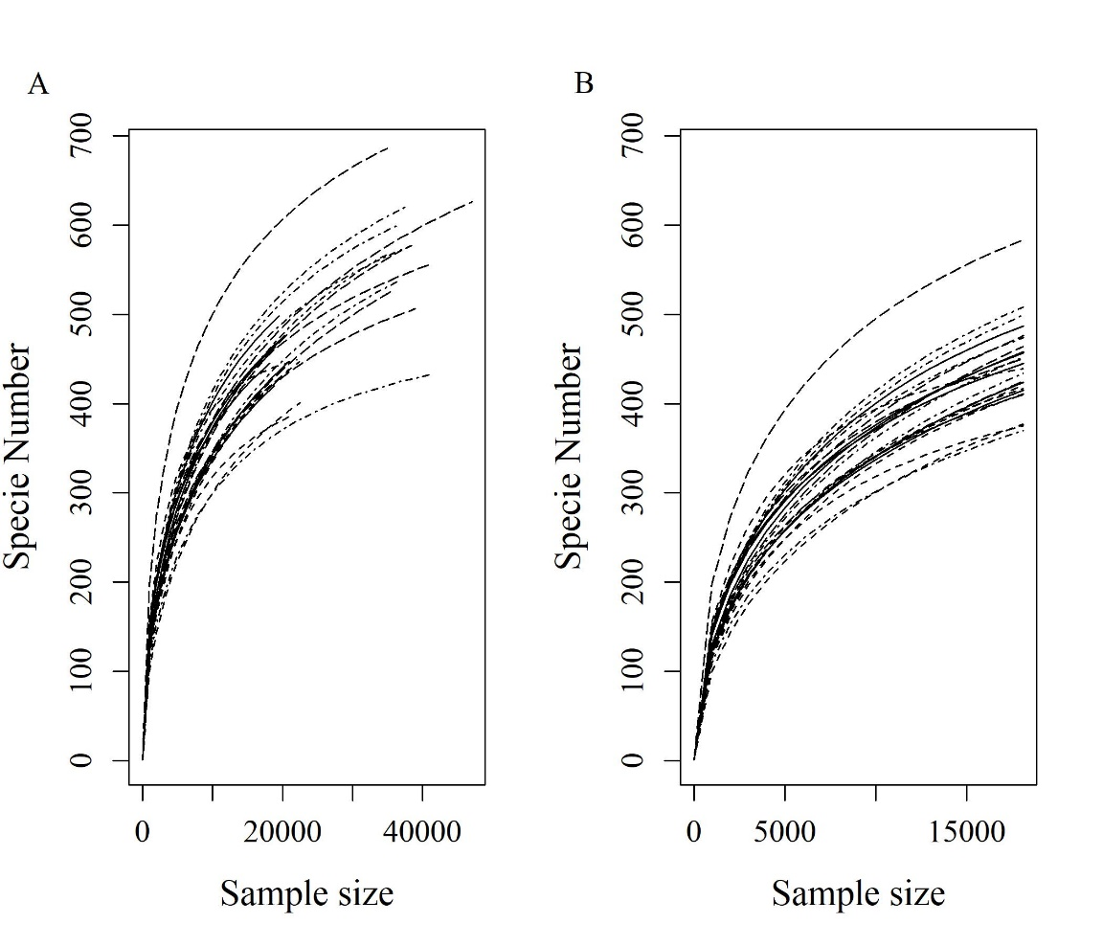

**Supplementary Figure 3.** Venn diagram showing the genera (A), families (B), order (C) and clases (D) unique and shared between theavocado cv. Hass fruits with different severities of lenticel damage (Mild (_M) and Severe (_S)) collected from the La Escondida (Esc) and El Sinai (Sin) farms during the traviesa harvest of 2020.

**Supplementary Table 1**. Geographic location and climatic characteristics of the La Escondida and El Sinai farms. Shown are the average daily precipitation, lowest and highest temperatures, and relative humidity. Climatic variables were measured in situ using a Davis Vantage Pro2 weather station.

|  |  |  |  |  |  |
| --- | --- | --- | --- | --- | --- |
| **La Escondida** | | | | | |
| **Location** | Rionegro, Antioquia (Latitud: 6° 5’58.27”N; Longitude:75°26’ 30.8”O) | | | | |
| **AMSLa** | 2200 | | | | |
| **Harvest** | **Weatherb** | | | |
| **Precipitation (mm)** | **lowest temperature (⁰C)** | **Highest temperature (⁰C)** | **Maximun relative humidity (%)** | |
| 2019_mc | 4.9 ± 2.0 | 12.6 ± 0.2 | 22.5 ± 0.3 | 82.2 ± 5.9 | |
| 2020_t | 7.2 ± 2.3 | 12.9 ± 0.1 | 22.1 ± 0.2 | 88.4 ± 3.9 | |
| 2020_m | 3.9 ± 2.0 | 12.9 ± 0.2 | 22.5 ± 0.2 | 86.4 ± 7.7 | |
| 2021_t | 7.4 ± 3.9 | 15.8± 1.8 | 20.8 ± 1.4 | 75.2 ± 6.3 | |
| **El Sinai** | | | | | |
| **Location** | Anserma, Caldas (Latitud: 5°16’57.12"N; Longitude:75°47’59.23"O) | | | | |
| **AMSL** | 2000 | | | | |
| **Harvest weather** | **Precipitation (mm)** | **lowest temperature (⁰C)** | **Highest temperatura (⁰C)** | **Maximun relative humidity (%)** | |
| 2019_m | 5.9 ± 3.7 | 15.0 ± 1.1 | 22.5 ± 1.4 | 81.6 ± 7.8 | |
| 2020_t | 8.6 ± 2.9 | 13.9 ± 0.12 | 21.6 ± 0.7 | 90.9 ± 3.8 | |
| 2020_m | 4.7 ± 1.7 | 14.2 ± 0.52 | 22.6 ± 0.8 | 83.5 ± 5.6 | |
| 2021_t | 10.0 ± 8.2 | 14.6 ± 0.83 | 22.5 ± 0.6 | 86.2 ± 9.4 | |

aAMSL: Hight above mean see level

b Shown are the means and standard deviation for the climatic variables measured during the six-month period comprising each harvest

c The letter after the year denotes main (m) and traviesa (t) harvest

**Supplementary Table 2**. Plots, trees, and fruits of avocado cv. Hass use for the lenticel damage assessment for each farm during the study in each harvest.

|  |  |  |  |
| --- | --- | --- | --- |
| **La Escondida** | **Plot** | Trees | Fruits |
|  | 1 | 5 | 50 |
|  | 3 | 5 | 50 |
|  | 4 | 2 | 20 |
|  | 5 | 9 | 90 |
|  | 6 | 9 | 90 |
| **Total** | 5 | n = 30 | n = 300 |
| **El Sinai** | **Plot** | Trees | Fruits |
|  | Bosque | 7 | 70 |
|  | Tanque | 2 | 20 |
|  | Eucalipto | 7 | 70 |
|  | Costa Rica | 3 | 30 |
|  | Fuego Verde | 2 | 20 |
|  | Topacio | 5 | 50 |
|  | Entre Carreteras | 1 | 10 |
|  | Frijolera | 3 | 30 |
| **Total** | 8 | 30 | 300 |

**Supplementary Table 3.** Severity and incidence of the lenticel damage of avocado cv. Hass at 0 days and 21 days postharvest (0dph and 21dpc) for fruits collected from the La Escondida and El Sinai farms between 2019 and 2021. Bars and error bars represent the severity (A) and incidence (B) means and standard deviations of the damage. The * show differences between the 0dph and 21dpc incidences and severities for each farm harvest according to the generalized linear mixed analysis at a 95 % confidence level (p-value < 0.05), and the letter after the year denotes main (m) and traviesa (t) harvest.

.

|  |  |  |  |  |  |  |  |
| --- | --- | --- | --- | --- | --- | --- | --- |
| **Farm** | **Harvest** | **Severity (mean ± SEa)** | | | **Incidence (mean ± SE)** | | |
| **0 dph** | **21 dph** | **Incrementb** | **0 dph** | **21 dph** | **Increment** |
| Escondida | 2019_mc | 0.17 ± 0.01 | 0.91 ± 0.06 | 5.4 | 22 ± 2 | 78 ± 4 | 3.5 |
|  | 2020_t | 0.97 ± 0.06 | 2.1 ± 0.11 | 2.2 | 79 ± 4 | 152 ± 6 | 1.9 |
|  | 2020_m | 0.33 ± 0.02 | 0.62 ± 0.05 | 1.9 | 38 ± 2 | 58 ± 3 | 1.5 |
|  | 2021_t | 0.38 ± 0.04 | 4.3 ± 0.22 | 11.3 | 37 ± 3 | 187 ± 7 | 5.1 |
| Sinai | 2019_m | 0.51 ± 0.05 | 2.48 ± 0.14 | 4.9 | 69 ± 5 | 221 ± 11 | 3.2 |
|  | 2020_t | 1.66 ± 0.08 | 4.22 ± 0.14 | 2.5 | 127 ± 5 | 202 ± 7 | 1.6 |
|  | 2020_m | 0.21 ± 0.02 | 5 ± 0.21 | 23.8 | 34 ± 3 | 242 ± 7 | 7.1 |
|  | 2021_t | 1.47 ± 0.07 | 3.3 ± 0.13 | 2.2 | 101 ± 4 | 173 ± 5 | 1.7 |

a SE: Standarderror.

b Increment = 21dph/0dph

c m: main Harvest; t: traviesa harvest.

**Supplementary Table 4.** Estimates for the general linear mixed model evaluating the differences between the lenticel damage severities and incidences at 0 days postharvest (0dph) of avocado cv. Hass collected from La Escondida and El Siani farms between 2019 and 2021. The letter after the year denotes main (m) and traviesa (t) harvest.

|  |  |  |  |  |  |  |
| --- | --- | --- | --- | --- | --- | --- |
| **Analysis of the lenticel damage severity** | | | | | | |
| Family: beta (logit) | | | | | | |
| Best-fitted model: y ~ Farm * Harvest + (1 | farm) + (1 | fp) + (1 | fpt) | | | | | | |
| Zero inflation: ~1 | | | | | | |
| **Fixed effects** |  | | **Estimate** | **SEb** | **z value** | **p-value (>|z|)** |
|  | Intercept | | -6.00 | 0.10 | -62.59 | < 1x10-3 |
|  | Sinai | | 0.59 | 0.12 | 4.78 | < 1x10-3 |
|  | 2020_t | | 1.31 | 0.07 | 18.77 | < 1x10-3 |
|  | 2020_m | | 0.52 | 0.07 | 6.93 | < 1x10-3 |
|  | 2021_t | | 0.48 | 0.10 | 4.81 | < 1x10-3 |
|  | Sinai*2020_t | | -0.03 | 0.09 | -0.36 | 0.72 |
|  | Sinai*2020_m | | -0.94 | 0.10 | -9.19 | < 1x10-3 |
|  | Sinai*2021_t | | 0.63 | 0.12 | 5.46 | < 1x10-3 |
| **Random effectsa** | | |  |  | **Variance** | **SD** |
|  |  |  | farm | Intercept | 5.86x10-9 | 7.65x10-5 |
|  |  | | fp | Intercept | 0.02 | 0.14 |
|  |  | | fpt | Intercept | 0.04 | 0.20 |
| **Zero-inflation model:** | |  | **Estimate** | **SE** | **z value** | **p-value (>|z|)** |
|  | Intercept | | -4.02 | 0.17 | -23.89 | < 1x10-3 |
| **Analysis of the lenticel damage incidence** | | | | | | |
| Family: nbinom2 (log) | | | | | | |
| Best-fitted model: y ~ Farm * Harvest + (1 | farm) + (1 | fp) + (1 | fpt) | | | | | | |
| Zero inflation: ~1 | | | | | | |
| **Fixed effects** |  |  | **Estimate** | **SE** | **z value** | **p-value (>|z|)** |
|  | Intercept | | 2.96 | 0.11 | 27.63 | < 1x10-3 |
|  | Sinai | | 1.22 | 0.14 | 8.52 | < 1x10-3 |
|  | 2020_t | | 1.43 | 0.07 | 20.79 | < 1x10-3 |
|  | 2020_m | | 0.65 | 0.07 | 9.53 | < 1x10-3 |
|  | 2021_t | | 0.58 | 0.11 | 5.45 | < 1x10-3 |
|  | Sinai*2020_t | | -0.79 | 0.09 | -8.36 | < 1x10-3 |
|  | Sinai*2020_m | | -1.35 | 0.10 | -14.13 | < 1x10-3 |
|  | Sinai*2021_t | | -0.18 | 0.13 | -1.46 | 0.145 |
| **Random effects** | | |  |  | **Variance** | **SD** |
|  |  |  | farm | Intercept | 8.33x10-9 | 9.13x10-5 |
|  |  | | fp | Intercept | 0.03 | 0.18 |
|  |  | | fpt | Intercept | 0.07 | 0.25 |
| **Zero-inflation model:** | |  | **Estimate** | **SE** | **z value** | **p-value (>|z|)** |
|  | Intercept | | -5.35 | 0.45 | -11.87 | < 1x10-3 |

afp: Nested effect of tree in plot; fpt: Nested effect of tree in plot in farm

bSD: Standard deviation; SE: Standard error

**Supplementary Table 5.** Estimates for the general linear mixed model evaluating the differences between the lenticel damage severities and incidences at 0 days postharvest (0dph) and 21 dph of avocado cv. Hass collected from La Escondida and El Siani farms between 2019 and 2021. The letter after the year denotes main (m) and traviesa (t) harvest.

|  |  |  |  |  |  |  |
| --- | --- | --- | --- | --- | --- | --- |
|  |  |  |  |  |  |  |
| **Analysis of the lenticel damage severity** | | | | | | |
| Family: beta (logit) | | | | | | |
| Best-fitted model: y ~ Days*Farm * Harvest + (1 | fruit) | | | | | | |
| Zero inflation: ~1 | | | | | | |
| **Fixed effects** |  | | **Estimate** | **SEa** | **z value** | **p-value (>|z|)** |
|  | Intercept | | -6.19 | 0.08 | -81.71 | < 1x10-3 |
|  | 21dph |  | 1.39 | 0.08 | 18.40 | < 1x10-3 |
|  | Sinai | | 0.67 | 0.10 | 6.67 | < 1x10-3 |
|  | 2020_t | | 1.41 | 0.09 | 15.67 | < 1x10-3 |
|  | 2020_m | | 0.56 | 0.09 | 5.99 | < 1x10-3 |
|  | 2021_t | | 0.45 | 0.10 | 4.33 | < 1x10-3 |
|  | Sinai*2020_t | | -0.07 | 0.12 | -0.56 | 0.578 |
|  | Sinai*2020_m | | -1.08 | 0.13 | -8.14 | < 1x10-3 |
|  | Sinai*2021_t | | 0.74 | 0.13 | 5.56 | < 1x10-3 |
|  | Sinai*21dph | | 0.29 | 0.10 | 3.04 | 0.002 |
|  | 21dph*2020_t | | -0.60 | 0.09 | -6.91 | < 1x10-3 |
|  | 21dph*2020_m | | -0.94 | 0.10 | -9.82 | < 1x10-3 |
|  | 21dph*2021_t | | 1.13 | 0.10 | 11.40 | < 1x10-3 |
|  | Sinai*2020_t*21dph | | 2.21 | 0.13 | 17.16 | < 1x10-3 |
|  | Sinai*2020_m*21dph | | -0.10 | 0.11 | -0.87 | 0.387 |
|  | Sinai*2021_t*21dph | | -1.98 | 0.12 | -16.24 | < 1x10-3 |
| **Random effectsa** | | |  |  | **Variance** | **SD** |
|  |  |  | fruit | Intercept | 0.25 | 0.51 |
| **Zero-inflation model:** | |  | **Estimate** | **SE** | **z value** | **p-value (>|z|)** |
|  | Intercept | | -4.79 | 0.17 | -24.31 | < 1x10-3 |
| **Analysis of the lenticel damage incidence** | | | | | | |
| Family: nbinom2 (log) | | | | | | |
| Best-fitted model: y ~ Days*Farm * Harvest + (1 | fruit) | | | | | | |
| Zero inflation: ~1 | | | | | | |
| **Fixed effects** |  |  | **Estimate** | **SE** | **z value** | **p-value (>|z|)** |
|  | Intercept | | -2.83 | 0.29 | -9.74 | < 1x10-3 |
|  | 21dph |  | 2.64 | 0.30 | 8.83 | < 1x10-3 |
|  | Sinai | | 1.09 | 0.33 | 3.34 | < 1x10-3 |
|  | 2020_t | | 2.67 | 0.30 | 8.91 | < 1x10-3 |
|  | 2020_m | | 1.35 | 0.33 | 4.04 | < 1x10-3 |
|  | 2021_t | | 1.87 | 0.32 | 5.91 | < 1x10-3 |
|  | Sinai*2020_t | | -1.62 | 0.34 | -4.72 | < 1x10-3 |
|  | Sinai*2020_m | | -1.81 | 0.31 | -5.82 | < 1x10-3 |
|  | Sinai*2021_t | | 0.22 | 0.34 | 0.64 | 0.520 |
|  | Sinai*21dph | | -0.85 | 0.33 | -2.59 | 0.010 |
|  | 21dph*2020_t | | -2.55 | 0.41 | -6.18 | < 1x10-3 |
|  | 21dph*2020_m | | -1.26 | 0.33 | -3.78 | < 1x10-3 |
|  | 21dph*2021_t | | -0.11 | 0.36 | -0.29 | 0.772 |
|  | Sinai*2020_t*21dph | | 3.79 | 0.43 | 8.82 | < 1x10-3 |
|  | Sinai*2020_m*21dph | | 0.94 | 0.35 | 2.71 | 0.007 |
|  | Sinai*2021_t*21dph | | -1.19 | 0.37 | -3.19 | 0.001 |
| **Random effects** | | |  |  | **Variance** | **SD** |
|  |  | | fruit | Intercept | 0.14 | 0.38 |
| **Zero-inflation model:** | |  | **Estimate** | **SE** | **z value** | **p-value (>|z|)** |
|  | Intercept | | -18.12 | 251.54 | -0.94 | 0.943 |

aSD: Standard deviation; SE: Standard error

**Supplementary Table 6.** Alfa diversity for the fungal communities of the avocado cv. Hass fruits with different severities of lenticel damage (Mild and Severe) collected from the La Escondida and El Sinai farms during the traviesa harvest of 2020.

|  |  |  |  |  |  |  |
| --- | --- | --- | --- | --- | --- | --- |
| **Damage** | **ASVs** | **Chao1** | **Shannon** | **Faith_pd** | | **Evenness** |
| **Sinai** | | | | | | |
| Severe | 415 | 578 | 4.9 | 46.5 | | 0.56 |
|  | 457 | 592 | 5.6 | 48.1 | | 0.63 |
|  | 445 | 570 | 5.8 | 48.0 | | 0.66 |
|  | 424 | 575 | 4.6 | 47.4 | | 0.53 |
|  | 458 | 595 | 5.2 | 53.3 | | 0.59 |
|  | 487 | 592 | 5.5 | 60.5 | | 0.62 |
| Mean ± SDa | 448 ± 26 | 584 ± 11 | 5.3 ± 0.4 | 50.6 ± 5.4 | | 0.6 ± 0.05 |
| Mild | 377 | 516 | 4.4 | 50.3 | | 0.51 |
|  | 420 | 593 | 5.2 | 53.6 | | 0.6 |
|  | 411 | 520 | 5.1 | 59.5 | | 0.58 |
|  | 417 | 540 | 4.5 | 54.8 | | 0.52 |
|  | 439 | 469 | 5.9 | 61.9 | | 0.67 |
|  | 375 | 434 | 4.9 | 52.4 | | 0.57 |
| Mean ± SD | 407 ± 25 | 512 ± 55 | 5.0 ± 0.5 | 55.4 ± 4.4 | | 0.58 ± 0.06 |
| p-valueb | **0.020** | **0.013** | 0.339 | 0.124 | | 0.466 |
| **Escondida** | | | | | | |
| Severe | 464 | 656 | 5.0 | 55.6 | | 0.56 |
|  | 583 | 691 | 6.5 | 67.1 | | 0.71 |
|  | 476 | 637 | 6.0 | 61.5 | | 0.67 |
|  | 450 | 548 | 5.9 | 53.9 | | 0.67 |
|  | 425 | 626 | 4.7 | 43.3 | | 0.54 |
|  | 410 | 512 | 5.0 | 46.1 | | 0.57 |
| Mean ± SD | 468 ± 61 | 612 ± 68 | 5.5 ± 0.7 | 54.6 ± 9 | | 0.62 ± 0.07 |
| Mild | 474 | 609 | 5.8 | 52.0 | | 0.65 |
|  | 508 | 661 | 5.1 | 54.7 | | 0.57 |
|  | 434 | 602 | 5.0 | 50.8 | | 0.57 |
|  | 499 | 662 | 5.3 | 49.8 | | 0.6 |
|  | 370 | 524 | 5.0 | 45.0 | 0.59 | |
|  | 452 | 609 | 5.2 | 45.5 | 0.59 | |
| Mean ± SD | 456 ± 51 | 611 ± 50 | 5.2 ± 0.3 | 49.6 ± 3.8 | 0.6 ± 0.03 | |
| p-value | 0.723 | 0.990 | 0.401 | 0.255 | 0.456 | |

aSD: Standar deviation

bp-value denoting differences between the alfa diversity metrics of the mildly and severely damaged fruits of each farm according to the t-student test with the Welch approximation (Shannon, evenness, and Faith) or general linearized models (glm) with the Poisson distribution (Poisson(link = "log")) (Richness and Chao) .

**Supplementary Table 7.** Permutational multivariate analysis of variance assessing the dissimilarity of the fungal communities of the avocado cv. Hass fruits with different severities of lenticel damage (Mild and Severe) collected from the La Escondida and El Sinai farms during the traviesa harvest of 2020

|  |  |  |  |  |
| --- | --- | --- | --- | --- |
| **Permutational multivariate analysis of variance (PERMANOVA)** | | | | |
| Farm: El Sinai and La Escondida | | | | |
| model: y ~ Damage | | | | |
| Permutations: 999 | | | | |
|  | **Df** | **SumOfSqs** | **F** | **p-value (>|F)** | |
| model | 1 | 0.009 | 2.17 | 0.1 | |
| Residual | 22 | 0.094 |  |  | |
| Farm: Sinai and Escondida | | | | | |
| model: y ~ Damage *Farm | | | | | |
| Permutations: 999 | | | | | |
|  | **Df** | **SumOfSqs** | **F** | **p-value (>|F)** | |
| model | 3 | 0.072 | 15.46 | 1x10-3 | |
| Residual | 20 | 0.031 |  |  | |
| Farm: El Sinai | | | | | |
| model: y ~ Populations | | | | | |
| Permutations: 999 | | | | | |
|  | **Df** | **SumOfSqs** | **F** | **p-value (>|F)** | |
| model | 1 | 0.010 | 7.29 | 0.004 | |
| Residual | 10 | 0.014 |  |  | |
| Farm: La Escondida | | | | | |
| model: y ~ Populations | | | | | |
| Permutations: 999 | | | | | |
|  | **Df** | **SumOfSqs** | **F** | **p-value (>|F)** | |
| model | 1 | 0.004 | 2.15 | 0.006 | |
| Residual | 10 | 0.017 |  |  | |

aFarm: La Escondida and El Sinai; Damage: mild and severe.

bDf: degrees of freedom, SumOfSqs: sum of squares

**Supplementary Table 8.** Relative abundance for the most abundant (i.e., > 3% of abundance) Phylum and Classes composing the fungal communities of the avocado cv. Hass with different severities of lenticel damage (Mild and Severe) collected from the La Escondida and El Sinai farms during the traviesa harvest of 2020

|  |  |  |  |  |  |
| --- | --- | --- | --- | --- | --- |
| **Taxa** | **Escondida** | | **Sinai** | | |
| **Mild** | **Severe** | **Mild** | **Severe** | |
| **Relative abundance (mean ± SD)** | | | | |
| **Phylum** | | | | | |
| Ascomycota | 38.7 ± 15.4 | 58.6 ± 6.1 | 27.3 ± 8.1 | 48.1 ± 13.1 | |
| Basidiomycota | 23.8 ± 12.9 | 13.4 ± 5 | 34.6 ± 6.4 | 12.5 ± 4.8 | |
| Not classified | 37.4 ± 11.6 | 29.8 ± 11.2 | 38.1 ± 6.8 | 39.3 ± 14.9 | |
| **Class** | | | | | |
| Cystobasidiomycetes | 6.5 ± 2.1 | 5.9 ± 1 | 12.1 ± 4.7 | 0 ± 0 | |
| Dothideomycetes | 12.4 ± 6.3 | 32.7 ± 11.5 | 14.1 ± 7.2 | 20.6 ± 2.8 | |
| Eurotiomycetes | 6 ± 2.9 | 6.1 ± 2.4 | 0 ± 0 | 5.1 ± 2 | |
| Exobasidiomycetes | 6.7 ± 5 | 7.3 ± 1 | 5.7 ± 0.8 | | 0 ± 0 |
| Lecanoromycetes | 6.6 ± 2.1 | 6.8 ± 2.5 | 0 ± 0 | | 0 ± 0 |
| Leotiomycetes | 12.6 ± 12.1 | 15.5 ± 0 | 6.7 ± 3.9 | | 0 ± 0 |
| Sordariomycetes | 0 ± 0 | 4.1 ± 0.9 | 4.6 ± 0 | | 3.6 ± 0.4 |
| Spiculogloeomycetes | 0 ± 0 | 0 ± 0 | 10.6 ± 6.1 | | 7.2 ± 3.4 |
| Taphrinomycetes | 8.1 ± 0 | 4.5 ± 0 | 0 ± 0 | | 0 ± 0 |
| Tremellomycetes | 12.7 ± 8.9 | 4.5 ± 0.4 | 7.6 ± 3.9 | | 6.9 ± 3 |
| Not classified | 21.8 ± 18.2 | 20.2 ± 13.9 | 21.9 ± 17.6 | | 29 ± 17.1 |

**Supplementary Table 9.** Taxonomy and relative abundance of the amplicon sequence variants (ASVs) enriched (p-value < 0.05) in the fungal communities of avocado cv. Hass fruits with different severities of lenticel damage (Mild and Severe) collected from La Escondida during the traviesa harvest of 2020. In Black are the ASVs enriched in fruits with severe lenticel damage.

|  |  |  |  |  |  |  |
| --- | --- | --- | --- | --- | --- | --- |
| **Sequence variant** | **Relative abundance (%)** | | **Taxonomy** | | | |
| **Mild damage** | **Severe damage** | **Class** | **Order** | **Family** | **Genus** |
| ASV_22 | 1.60 | 1.30 | Not classified | Not classified | Not classified | Not classified |
| ***Basidiomycota*** | | | | | | |
| ASV_57 | 0.86 | 0.10 | *Cystobasidiomycetes* | *Erythrobasidiales* | *Erythrobasidiaceae* | *Erythrobasidium* |
| **ASV_31** | **0.64** | **0.70** | ***Cystobasidiomycetes*** | **Not classified** | **Not classified** | **Not classified** |
| **ASV_30** | **0.97** | **1.10** | ***Cystobasidiomycetes*** | ***Cystobasidiales*** | ***Cystobasidiaceae*** | ***Cystobasidium*** |
| ASV_53 | 0.86 | 0.17 | *Exobasidiomycetes* | *Golubeviales* | *Golubeviaceae* | *Golubevia* |
| ASV_25 | 1.50 | 0.90 | *Exobasidiomycetes* | *Exobasidiales* | *Brachybasidiaceae* | *Meira* |
| ASV_75 | 0.62 | 0.02 | *Tremellomycetes* | *Tremellales* | *Bulleribasidiaceae* | *Vishniacozyma* |
| ASV_11 | 5.40 | 0.72 | *Tremellomycetes* | *Tremellales* | *Bulleribasidiaceae* | *Vishniacozyma* |
| ASV_15 | 4.50 | 0.91 | *Tremellomycetes* | *Tremellales* | *Bulleribasidiaceae* | *Vishniacozyma* |
| **Ascomycetes** | | | | | | |
| **ASV_24** | **0.02** | **2.60** | ***Dothideomycetes*** | ***Pleosporales*** | ***Phaeosphaeriaceae*** | ***Setophoma*** |
| ASV_34 | 1.00 | 0.62 | *Lecanoromycetes* | *Lecanorales* | *Ramalinaceae* | *Bacidina* |
| **ASV_18** | **1.60** | **2.30** | ***Lecanoromycetes*** | ***Lecanorales*** | ***Ramalinaceae*** | ***Bacidina*** |
| ASV_6 | 4.90 | 2.60 | *Leotiomycetes* | *Thelebolales* | *Pseudeurotiaceae* | *Hyphozyma* |
| ASV_4 | 4.60 | 3.00 | *Dothideomycetes* | *Capnodiales* | *Cladosporiaceae* | *Cladosporium* |
| **ASV_1** | **17.00** | **18.00** | **Not classified** | **Not classified** | **Not classified** | **Not classified** |
| ASV_2 | 3.60 | 1.20 | Not classified | Not classified | Not classified | Not classified |
| ASV_12 | 0.80 | 0.47 | Not classified | Not classified | Not classified | Not classified |
| ASV_3 | 6.20 | 2.90 | Not classified | Not classified | Not classified | Not classified |
| ASV_7 | 2.10 | 0.94 | Not classified | Not classified | Not classified | Not classified |
| **ASV_42** | **0.64** | **0.81** | **Not classified** | **Not classified** | **Not classified** | **Not classified** |
| **ASV_41** | **0.72** | **0.74** | **Not classified** | **Not classified** | **Not classified** | **Not classified** |
| ASV_60 | 0.51 | 0.35 | *Dothideomycetes* | *Capnodiales* | *Neodevriesiaceae* | *Neodevriesia* |
| ASV_9 | 0.65 | 0.37 | Not classified | Not classified | Not classified | Not classified |
| ASV_10 | 3.90 | 2.10 | *Eurotiomycetes* | *Chaetothyriales* | Not classified | Not classified |
| ASV_13 | 3.40 | 2.30 | Not classified | Not classified | Not classified | Not classified |

**Supplementary Table 10.** Taxonomy and relative abundance of the amplicon sequence variants (ASVs) enriched (p-value < 0.05) in the fungal communities of avocado cv. Hass fruits with different severities of lenticel damage (Mild and Severe) collected from El Sinai during the traviesa harvest of 2020. In Black are the ASVs enriched in fruits with severe lenticel damage.

|  |  |  |  |  |  |  |
| --- | --- | --- | --- | --- | --- | --- |
| **Sequence variant** | **Relative abundance (%)** | | **Taxonomy** | | | |
| **Mild damage** | **Severe damage** | **Class** | **Order** | **Family** | **Genus** |
| ASV_37 | 2.00 | 0.73 | Not classified | Not classified | Not classified | Not classified |
| **ASV_96** | **0.09** | **0.57** | **Not classified** | **Not classified** | **Not classified** | **Not classified** |
| **Basidiomycetes** | | | | | | |
| ASV_33 | 2.30 | 0.03 | *Cystobasidiomycetes* | *Cystobasidiomycetes* | *Symmetrosporaceae* | *Symmetrospora* |
| ASV_20 | 5.80 | 0.60 | *Cystobasidiomycetes* | *Cystobasidiomycetes* | *Symmetrosporaceae* | *Symmetrospora* |
| ASV_31 | 1.30 | 0.05 | *Cystobasidiomycetes* | Not classified | Not classified | Not classified |
| ASV_54 | 1.10 | 0.01 | *Cystobasidiomycetes* | Not classified | Not classified | Not classified |
| ASV_11 | 1.70 | 0.57 | *Tremellomycetes* | *Tremellales* | *Bulleribasidiaceae* | *Vishniacozyma* |
| ***Ascomycetes*** | | | | | | |
| **ASV_65** | **0.06** | **0.69** | ***Sordariomycetes*** | ***Glomerellales*** | ***Glomerellaceae*** | ***Colletotrichum*** |
| ASV_26 | 4.20 | 0.18 | *Dothideomycetes* | *Dothideales* | *Aureobasidiaceae* | *Aureobasidium* |
| **ASV_40** | **0.27** | **2.60** | ***Dothideomycetes*** | ***Capnodiales*** | ***Mycosphaerellaceae*** | ***Geastrumia*** |
| **ASV_14** | **0.50** | **9.70** | ***Dothideomycetes*** | ***Capnodiales*** | ***Mycosphaerellaceae*** | ***Pseudocercospora*** |  | ***Dothideomycetes*** | ***Capnodiales*** |
| ASV_4 | 5.10 | 1.50 | *Dothideomycetes* | *Capnodiales* | *Cladosporiaceae* | *Cladosporium* |
| ASV_2 | 21.00 | 2.30 | Not classified | Not classified | Not classified | Not classified |
| **ASV_3** | **2.40** | **8.40** | **Not classified** | **Not classified** | **Not classified** | **Not classified** |
| **ASV_7** | **2.40** | **7.90** | **Not classified** | **Not classified** | **Not classified** | **Not classified** |
| **ASV_70** | **0.08** | **1.20** | **Not classified** | **Not classified** | **Not classified** | **Not classified** |
| **ASV_10** | **0.52** | **2.10** | ***Eurotiomycetes*** | ***Chaetothyriales*** | **Not classified** | **Not classified** |
| **ASV_13** | **0.02** | **1.10** | **Not classified** | **Not classified** | **Not classified** | **Not classified** |

**Supplementary Table 7.** Fungal and bacteria strains isolated from healthy and necrotic lenticels of avocado cv. Hass fruits collected from the La Escondida during the principal harvest of 2019 and traviesa Harvest 2021.

|  |  |  |  |  |  |
| --- | --- | --- | --- | --- | --- |
| Strain | Origina | Harvest | Molecular identity | | |
| Closest sequence | GB ANc | HId |
| EAFIT-F0009 | SNL | 2019 | *Diaporthe* sp. | KR812224 | 100 |
| EAFIT-F0010 | SNL | 2019 | *Phyllosticta* sp. | MT729894 | 100 |
| EAFIT-F0011 | SNL | 2019 | *Phyllosticta* sp. | MT729894 | 100 |
| EAFIT-F0012 | SNL | 2019 | *Colletotrichum* sp. | MT568600 | 100 |
| EAFIT-F0013 | SNL | 2019 | *Phyllosticta* sp. | MT729894 | 100 |
| EAFIT-F0014 | SNL | 2019 | *Colletotrichum* sp. | MT568600 | 100 |
| EAFIT-F0015 | SNL | 2019 | ND | ND | ND |
| EAFIT-F0016 | SNL | 2019 | ND | ND | ND |
| EAFIT-F0017 | SNL | 2019 | *Colletotrichum siamense* | MN296058 | 99.8 |
| EAFIT-F0018 | SNL | 2019 | *Colletotrichum fructicola* | MN296075 | 100 |
| EAFIT-F0019 | SNL | 2019 | *Colletotrichum* sp. | MT611204 | 100 |
| EAFIT-F0020 | SNL | 2019 | *Colletotrichum* sp. | MT611204 | 100 |
| EAFIT-F0022 | SNL | 2019 | *Colletotrichum siamense* | MT769246 | 100 |
| EAFIT-F0031 | ENL | 2019 | *Colletotrichum* sp. | EF672318 | 100 |
| EAFIT-F0033 | ENL | 2019 | ND | ND | ND |
| EAFIT-F0034 | ENL | 2019 | *Colletotrichum siamense* | MN296061 | 99.8 |
| EAFIT-F0035 | ENL | 2019 | *Cytospora* sp. | KT777722 | 99.4 |
| EAFIT-F0037 | ENL | 2019 | *Colletotrichum* sp. | MN744302 | 100 |
| EAFIT-F0038 | ENL | 2019 | *Neurospora* sp. | MG664722 | 99.8 |
| EAFIT-F0040 | ENL | 2019 | ND | ND | ND |
| EAFIT-F0041 | ENL | 2019 | *Neurospora* sp. | MG664722 | 99.8 |
| EAFIT-F0042 | ENL | 2019 | *Cytospora* sp. | KP133193 | 99.5 |
| EAFIT-F0044 | ENL | 2019 | ND | ND | ND |
| EAFIT-F0046 | ENL | 2019 | *Cytospora* sp. | KP133193 | 99.8 |
| EAFIT-F0047 | ENL | 2019 | ND | ND | ND |
| EAFIT-F0049 | ENL | 2019 | *Colletotrichum scovillei* | MT645274 | 100 |
| EAFIT-F0050 | ENL | 2019 | *Colletotrichum siamense* | MT434661 | 100 |
| EAFIT-F0051 | ENL | 2019 | ND | ND | ND |
| EAFIT-F0052 | ENL | 2019 | *Cytospora* sp. | JN153082 | 99.6 |
| EAFIT-F0053 | ENL | 2019 | *Alternaria* sp. | MZ701972 | 100 |
| EAFIT-F0054 | SHL | 2021 | *Colletotrichum karsti* | MW995570 | 100 |
| EAFIT-F0055 | SHL | 2021 | *Cytospora* sp. | JN153082 | 99.1 |
| EAFIT-F0056 | SHL | 2021 | *Diaporthe phaseolorum* | MN997107 | 99.8 |
| EAFIT-F0057 | SHL | 2021 | *Cytospora* sp. | KT777722 | 99.7 |
| EAFIT-F0058 | SHL | 2021 | *Cytospora* sp. | KP133194 | 99.5 |
| EAFIT-F0059 | EHL | 2021 | *Alternaria argyroxiphii* | NR136074 | 100 |
| EAFIT-F0060 | EHL | 2021 | *Colletotrichum cordylinicola* | MZ725045 | 99.2 |
| EAFIT-F0061 | EHL | 2021 | ND | ND | ND |
| EAFIT-F0062 | EHL | 2021 | *Neofusicoccum algeriense* | MW391027 | 100 |
| EAFIT-F0063 | EHL | 2021 | *Colletotrichum fructicola* | MZ724774 | 99.5 |
| EAFIT-F0064 | EHL | 2021 | *Colletotrichum karsti* | MW995519 | 100 |
| EAFIT-F0065 | EHL | 2021 | *Cytospora* sp. | MT854330 | 99.3 |
| EAFIT-F0066 | EHL | 2021 | *Colletotrichum siamense* | MZ066745 | 99.1 |
| EAFIT-F0067 | EHL | 2021 | *Colletotrichum alienum* | MK379590 | 98.8 |
| EAFIT-F0068 | ENL | 2021 | ND | ND | ND |
| EAFIT-F0069 | ENL | 2021 | *Cytospora* sp. | MG253920 | 98.4 |
| EAFIT-F0070 | ENL | 2021 | *Cytospora* sp. | KP133193 | 99.8 |
| EAFIT-F0071 | ENL | 2021 | *Colletotrichum fructicola* | MZ724774 | 100 |
| EAFIT-F0072 | SNL | 2021 | ND | ND | ND |

aFarm and vegetal tissue from which strains originated. E La Escondida, S El Sinai, NL Necrotic lentic, HL Healthy lenticel.

b Fungal strain with the highest ITS sequence similarity according to BLAST. ND not defined.

c GeneBank accession number. ND not defined.

d Highest Identity, values between 0 and 100 %. ND not defined.