1. 根据植物种名查找植物属于哪个科，哪个属，别名，以及分布区域

SELECT

planttable.species_name,

classificationtable.family_name,

classificationtable.genus_name,

distributiontable.province,

distributiontable.city,

distributiontable.town

FROM

planttable

INNER JOIN

classificationtable

ON

planttable.species_name = classificationtable.species_name

INNER JOIN

distributiontable

ON

classificationtable.distribution_id = distributiontable.distribution_id  
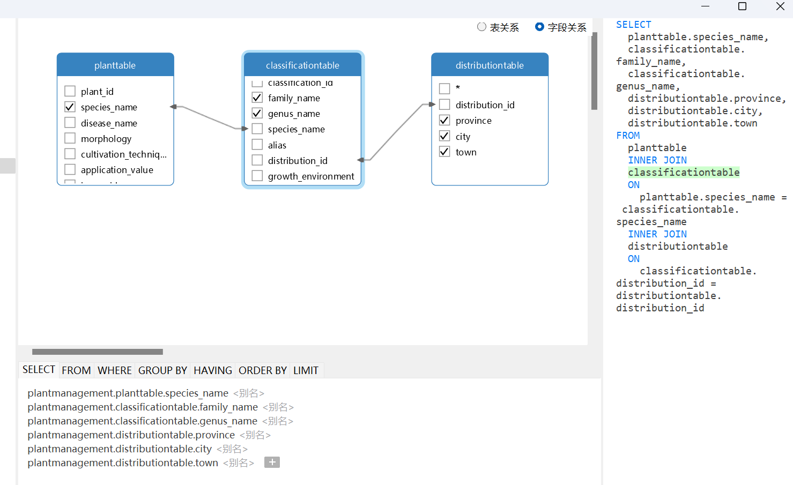  
  
2.植物用药  
SELECT

planttable.species_name,

treatmenttable.disease_name,

treatmenttable.treat_people,

preventtable.drug_name,

preventtable.drug_amount

FROM

planttable

INNER JOIN

treatmenttable

ON

planttable.plant_id = treatmenttable.plant_id

INNER JOIN

preventtable

ON

treatmenttable.prevent_method = preventtable.prevent_method  
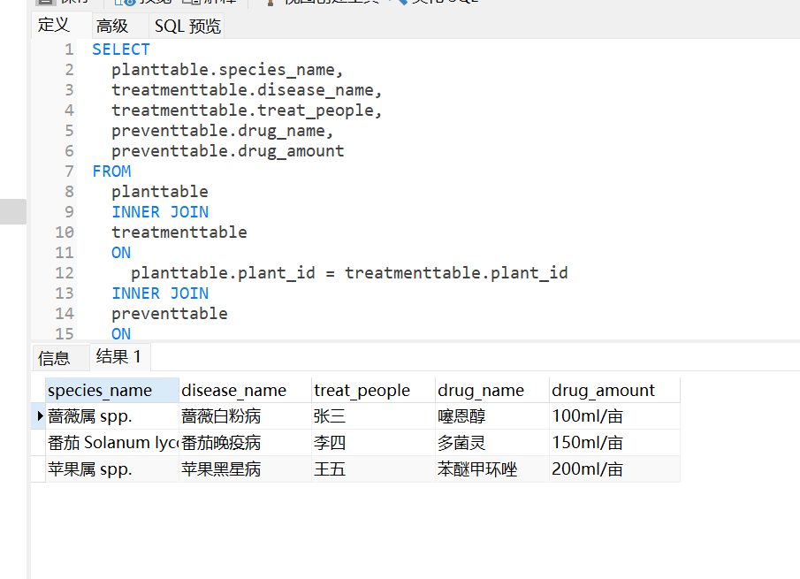  
3.监测人的监测设备

SELECT

monitortable.monitor_people,

planttable.species_name,

equipmentable.equipment_name

FROM

monitortable

INNER JOIN

planttable

ON

monitortable.plant_id = planttable.plant_id

INNER JOIN

equipmentable

ON

planttable.equipment_name = equipmentable.equipment_name

4.植物具体信息  
SELECT

planttable.species_name,

classificationtable.family_name,

classificationtable.genus_name,

classificationtable.species_name,

classificationtable.alias,

classificationtable.growth_environment

FROM

planttable

INNER JOIN

classificationtable

ON

planttable.species_name = classificationtable.family_name  
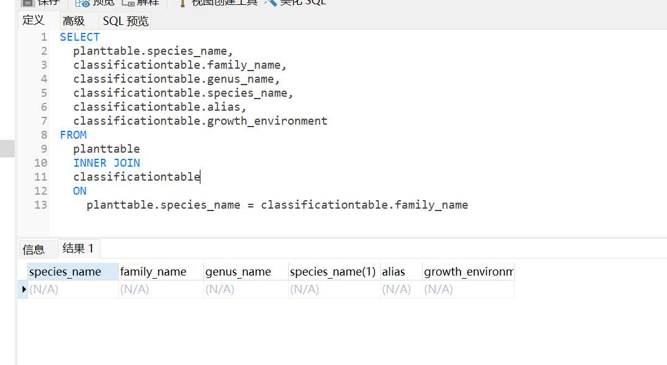

5. TreatByspecies_name  
SELECT

planttable.species_name,

treatmenttable.disease_name,

treatmenttable.treat_people,

treatmenttable.treat_time,

preventtable.prevent_method,

preventtable.drug_name,

preventtable.drug_amount

FROM

planttable

INNER JOIN

treatmenttable

ON

planttable.plant_id = treatmenttable.plant_id

INNER JOIN

preventtable

ON

treatmenttable.prevent_method = preventtable.prevent_method  
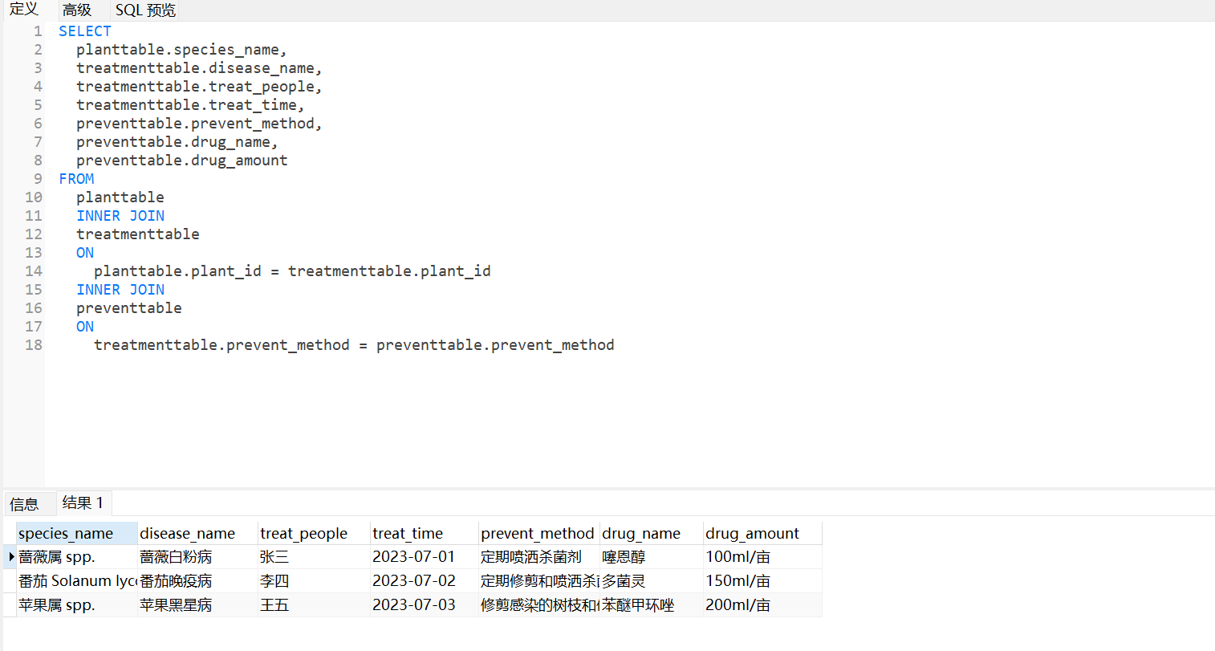

6. EquipmentByMonitorpeople  
select `monitortable`.`monitor_people` AS `monitor_people`,`planttable`.`species_name` AS `species_name`,`equipmentable`.`equipment_name` AS `equipment_name` from ((`monitortable` join `planttable` on((`monitortable`.`plant_id` = `planttable`.`plant_id`))) join `equipmentable` on((`planttable`.`equipment_name` = `equipmentable`.`equipment_name`)))

7. DrugByTreatPeople

SELECT

treatmenttable.treat_people,

planttable.species_name,

planttable.disease_name,

preventtable.drug_name,

preventtable.drug_amount

FROM

treatmenttable

INNER JOIN

planttable

ON

treatmenttable.treat_id = planttable.plant_id

INNER JOIN

preventtable

ON

treatmenttable.prevent_method = preventtable.prevent_method  
