**Bamboo Paper: An Eco-Friendly Solution**

Paper is a valuable commodity that plays an active role in our daily lives; whether it’s as a student reading or taking class notes, at work printing reports or handling contracts, or simply jotting down some personal notes of your own on this substrate. Paper also provides a convenient avenue for various media outlets to provide and distribute their information to the masses. A worldwide impact that greatly benefits us people, but significantly harms our environment. Currently, wood pulp is the most popular and commonly used fiber in the production of paper. Unfortunately, the production of paper leads to the deforestation of about four million acres of natural forest annually. Once these forests are cut down, several of them fail to rejuvenate which permanently destroys animal’s habitats, forcing them towards extinction. These trees need approximately fifteen to twenty years before they reach maturity, thus why several of the lumber companies find it easier to just keep cutting and not bother replanting. After some research, bamboo rose as an exceptional alternative to using wood for the production of paper that will save our forests and continue to provide all the amazing benefits we are all accustomed to. Bamboo fiber functions the same as wood fiber in pulping and paper manufacturing along with possessing special qualities that make it a desirable alternative that I hope will soon be adopted as the new mainstream form of paper for print and writing purposes.

One hundred years ago there were no worries of the depletion of this natural resource but now it has become a main concern in our society. Very little was known back when the logging industry was first founded in the sixteen hundreds about how it would affect our world over time. Trees obviously maintain the responsibility of cleaning the air of carbon dioxide and providing oxygen for us to breathe. They are also responsible for the cleaning of the soil and filtering of water. Currently our government has instilled a policy of having to plant a tree for each one that is cut down in efforts to maintain a balance. The issue encountered here is that there have been accounts of this not being properly followed through, regardless, it takes roughly 20 years before the tree matures to the size it once was. This means the once thriving animal habitat will not return for a few decades. The displacement has proven to lead towards the extinction of differing animal species. The United Nations has reported that deforestation in the Amazon rainforest region has recently led to the extinction of twenty-six animal and plant species along with six hundred forty-four species of animals and plants in danger of extinction. The UN estimates that over ten million trees are cut down in a single day worldwide. In the United States, about half of the lumber cut down is used to produce paper. Of all the paper produced in the United States, only about one percent is made from materials other than wood pulp. Recycling efforts do make a difference as the process generates seventy-four percent less air pollution and uses fifty percent less water instead of making it from virgin wood. Unfortunately not everyone adopts the recycling lifestyle as approximately one billion trees worth of paper are thrown away every year in the Unites States. The United States forest and paper industry represents eight percent of our county’s total manufacturing output, which generates sales of about two hundred-forty billion dollars annually. A very well established industry as it employs one and a half million Americans. The production of paper is the third largest industrial polluter to air, water, and land in both the United States and Canada. This doesn’t mean that switching to bamboo will alleviate these industrial pollutants but the possibility of maintaining the trees that would have otherwise been cut down for paper can help fight against these pollutants.

Bamboo currently grows almost everywhere here on Earth. Its ancient origin is believed to be China and there are about fifteen hundred known species. Bamboo is one of the most versatile plant species possessing both the strength of hardwood and the sustainability of grass. Being a very hardy plant allows it to thrive and grow in a diverse range of climates. Bamboo falls under the category of grass and holds the title for being the fasting growing plant. In about three to five years, most species of bamboo reach maturity with certain species known to grow double in size in a single day. It is an evergreen plant that doesn’t change its appearance with the seasons. Throughout time, bamboo has been utilized as a source of food, medicine, tools, musical instruments, weapons, building material, flooring, clothing, bedding, paper, and much more. Bamboo is viewed as a symbol of traditional Chinese values that depicts the harmony between nature and human beings.

The multiple benefits of adopting bamboo as an alternative to wood for paper production will hopefully highlight the Chinese values. Bamboo is a much quicker renewable resource when compared to trees. Bamboo, as mentioned, is the single fastest growing plant on Earth with some species able to grow more than a meter a day. In contrast, oak and redwood trees need about one hundred twenty years to reach maturity and most other tree species need a few decades. Bamboo needs roughly three to five years to reach maturity, as mentioned before. A major advantage of bamboo is its ability to regenerate after the stem has been cut, which ensures a continuous abundance of supply. Because bamboo carries the same characteristics of grass, it can continuously cover large areas as it expands exponentially year after year producing its shoots. There are only a handful of insects that negatively affect bamboo resulting in very little to no pesticides needed. Furthermore, it takes about a third less water to produce an acre of bamboo than it does to grow an acre of trees. Just like trees, bamboo is known to help reduce soil erosion and helps prevent silt from choking rivers and streams, which affects aquatic life. Many are unaware that a grove of bamboo takes in four times as much carbon dioxide than a grove of trees and releases thirty-five percent more oxygen into the air. Thus, proving to be a stronger fighter against pollutants and global warming. Bamboo’s versatility allows it to thrive even in depleted soil especially in environmentally stressed areas where rainforests have been cut down and burned. Unlike trees, bamboo can easily grow in these areas and begin the process of returning nutrients to the soil. The paper produced from bamboo is just as recyclable as paper produced from wood fibers. Very few limitations as to where it can grow since it can also thrive on mountainsides and on steep slopes where few other cash crops can. These great benefits allow bamboo to be grown close to the pulping facilities, alleviating expensive transportation fees and the amount of carbon dioxide taken in and the oxygen released by them will provide additional help in fighting off the air pollutants these facilities generate. Overall, bamboo is a commercially viable way to make paper without being dependent on the timber industry.

In conclusion, bamboo is a commercially viable way to make paper without being dependent on the timber industry. This transition would save millions of acres of trees annually as we soon could begin to enjoy the benefits of bamboo paper without harming the environment in the way we currently are. Some companies are already making this eco-friendly transition and promoting the adoption of bamboo paper. Dell is currently providing packaging made from bamboo for their portable devices with the goal of having two thirds of them shipping in bamboo by the end of this year. This is just the beginning, it would be great to soon find magazines, notebooks, and other types of product packaging join Dell towards this alternative solution. It’s argued that the print industry is on the decline because everything is now going digital but regardless of the outcome, there will still be a need for paper because of how easy and conveniently it is to distribute and carry information. Bamboo’s various special characteristics clearly outshine those of the trees used for paper and its benefits are one more step towards a more sustainable world.

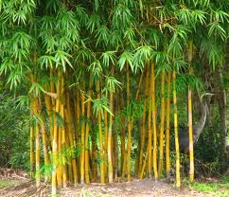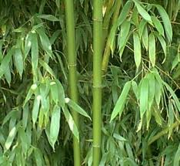

Bamboo Paper

An Eco-Friendly Solution

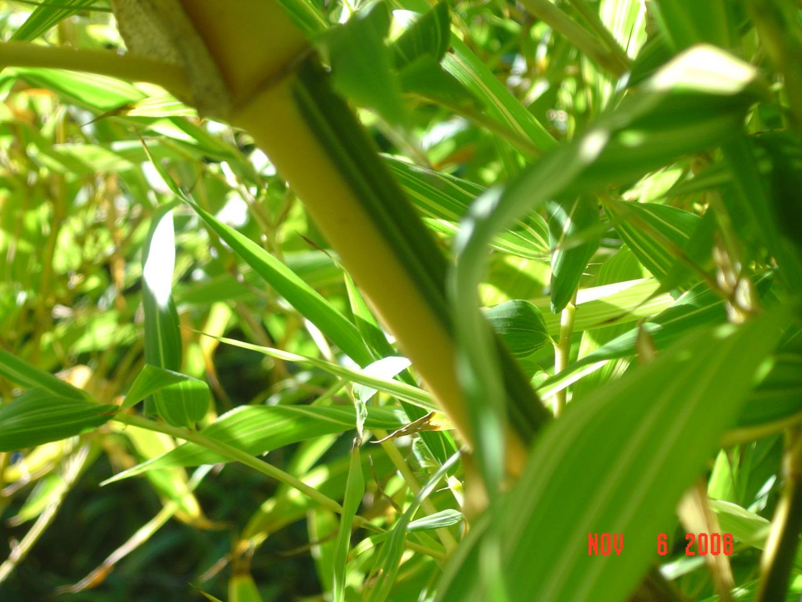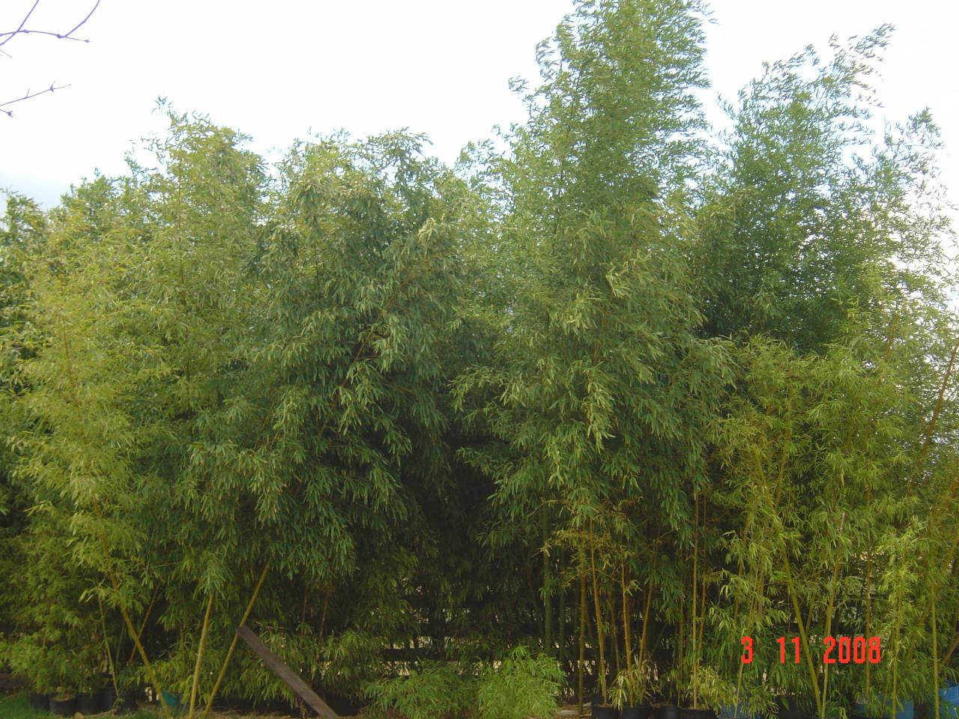

Villa, Xavier

5/31/2012

Cal Poly, SLO

Dr. Ken Macro

GrC 101

Abstract

Paper is a valuable commodity that provides many great benefits to us but is intensely harmful to our environment. Bamboo is an eco-friendly alternative that provides the same characteristics as wood fibers as well as possessing various other special attributes that clearly outshines those of trees. I hope to persuade you into seeing why transitioning away from trees and towards bamboo for our source of paper is the direction we should head in.

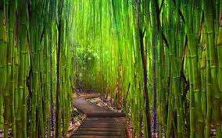

References

"Bamboo Paper." *- Bamboo Renewable Resource*. 2008. Web. 28 May 2012. <http://www.bamboogrove.com/bamboo-paper.html>

Cordero, Marcos. "Can There Ever Be Tree-Less Paper." *Green Business Bureau*. 11 Oct. 2011. Web. 28 May 2012. <http://www.gbb.org/news/can-there-ever-be-tree-less-paper/>

Dominey, Montana. "Trees and How The Paper Industry Is Effecting Us And Them." *BSC: Living in the Environment*. 23 Nov. 2011. Web. 28 May 2012. <http://livingintheenvironmentblog1.blogspot.com/2011/11/normal-0-false-false-false-en-us-x-none.html>

"Empires of Collusion: Pulp Wars." *The United States Paper Industry*. Pulp Wars, 2010. Web. 28 May 2012. <http://pulpwars.com/empires_of_collusion/s/4>

"Forest & Paper Industry." *Forest & Paper Industry*. The Bugwood Network, 25 Aug. 1999. Web. 28 May 2012. <http://www.bugwood.org/intensive/forestpaperindustry.html>

"Making Bamboo Paper." *Making Paper from Bamboo Sheaths.* JM Bamboo, 2011. Web. 28 May 2012. <http://www.jmbamboo.com/2011/04/making-bamboo-paper/>

"Paper Industry Facts." *The Center for Paper Business and Industry Studies*. 2007. Web. 28 May 2012. <http://www.paperstudies.org/resources/industryfacts/today.htm>

"The History of Bamboo Plants." *GardenGuides*. 2010. Web. 28 May 2012. <http://www.gardenguides.com/81160-history-bamboo-plants.html>