**Supplementary**

**A Overview**

This supplementary material provides more details on experiments in this paper and includes more experiments to validate and analyze our proposed method.

In Sec B, we provide the main threshold parameters used for experiments in this paper. In Sec C we show more experimental results including feature ablation experiments and time complexity.

**B Details in Experiments**

The proposed algorithm uses the improved ISODATA algorithm to cluster local points with similar properties into point sets. As a clustering method (unsupervised learning), ISODATA does not need to learn in advance or train the point cloud model with fixed parameters. Compared with other traditional clustering algorithms, ISODATA algorithm does not need to specify the number of clustering in advance, , and can carry out clustering adaptively according to point cloud data, with stronger robustness.

The following are main threshold parameters used for experiments in this paper. For different point cloud data, the parameters may be slightly changed, which can be adjusted according to the parameters recommended in this paper.

Calculation of local dispersion of point cloud: Calculation radius *r* = 0.5, interval M=20, threshold T∈[200,220], random sampling parameter ratio∈[0.015,0.02].

The point cloud aggregation voting function: The weight coefficient follows the condition α+β+γ+λ=1, in this paper, α=β=γ=λ=0.25.

Construction of multi-scale features: Three different calculation radius *R* of FPFH and spin image are selected according to the rules of geometric sequence. For different data, the choice of R may be different. Normally, the smallest *R*1 is selected within the range of [0.4,0.6] and *R*3=2\**R*2=4\**R*1. The parameters of proposed method are: *R*={0.6,1.2,2.4}.

**C More Experiments**In this section we provide more experiment results to validate and analyze our proposed method.

**C.1 Ablation Experiments**

To prove the effect of each module of the proposed algorithm, we use Scene3 to conduct a comparative experiment. Scene3 is selected from Semantic3D point cloud datasets and can be downloaded from http://www.semantic3d.net/. The dispersion of Scene3 is about 40-50 $points/m^{2}$. Fig. 7 shows the training data and testing data.

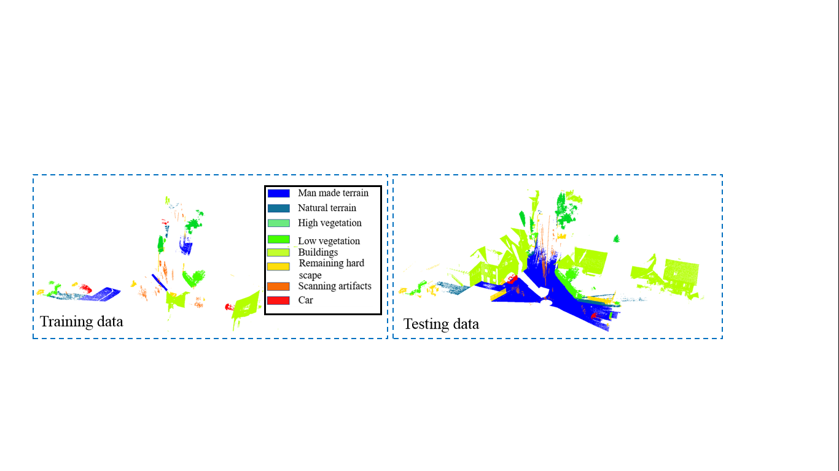

Fig. 7 Experimental data. The training data and testing data of Scene3

The comparison methods include: **MA1**: A method uses unimproved ISODATA to cluster the point cloud, then extracts the multi-scale features of the point sets and classifies point sets by random forest; **MA2**: A method uses improved ISODATA to cluster the point cloud, then extracts the multi-scale features of the point sets and classifies point sets by SVM.

As shown in Table 2, by comparing the classification accuracy of MA1 and our method, the overall accuracy of our method is improved by 0.9%, which proves that the improvement of ISODATA clustering algorithm can improve the classification accuracy, and the clustering effectiveness of our method. The accuracy of our method is 9.6% higher than MA2, which proves that the random forest classifier is more effective than the SVM classifier. In all experiments, the overall accuracy and mF1 of our method are the highest, which proves that our method has better classification performance and stronger robustness.

Table 2 Precision/Recall, Accuracy and mF1 (%) of our algorithm and other algorithms on Semantic3D data

|  |  |  |  |
| --- | --- | --- | --- |
| Class | MA1 | MA2 | Our method |
| man-made terrain | 98.6/87.8/92.8 | 95.6/90.7/93.1 | 98.4/85.7/91.6 |
| natural terrain | 30.3/85.6/44.8 | 27.3/57.3/37.0 | 27.5/84.6/41.5 |
| high vegetation | 73.1/92.4/81.6 | 49.8/88.6/63.8 | 75.4/89.9/82.0 |
| low vegetation | 80.1/83.9/81.9 | 83.5/60.7/70.3 | 81.4/87.0/84.1 |
| buildings | 94.7/91.8/93.2 | 92.8/76.8/84.0 | 94.0/93.5/93.8 |
| hard scape | 23.6/12.9/16.6 | 18.5/12.4/14.9/ | 31.5/8.4/13.3 |
| scanning artefacts | 53.1/56.8/54.9 | 30.7/73.2/43.2 | 84.0/58.6/69.0 |
| cars | 8.2/1.9/3.1 | 10.9/13.0/11.9 | 72.1/21.2/32.8 |
| Accuracy | 85.0 | 76.3 | 85.9 |
| mF1 | 58.6 | 52.3 | 63.5 |

The classification results of Scene3 are shown in Fig.8. Quantitative comparison results are shown in Table 2. As shown in Fig.8, the classification performance of our method on Scene3 is superior to the other two comparison methods, and most of the point clouds can be correctly classified by our method, which can prove that our method has a good effect on the point cloud classification task. It can be seen from the black boxes that our method has a better classification effect on buildings and trees.

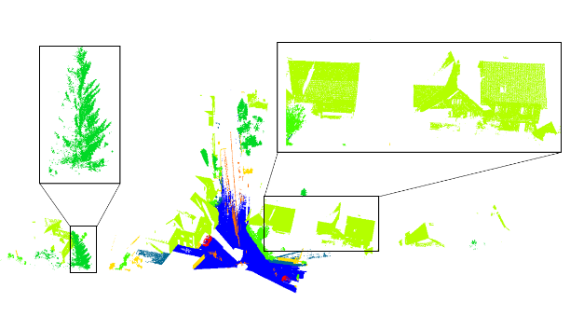 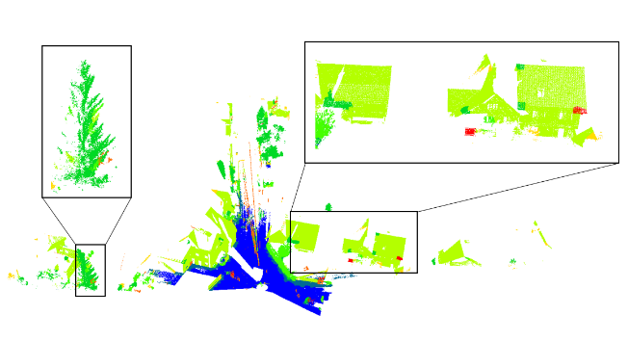

(a) (b)

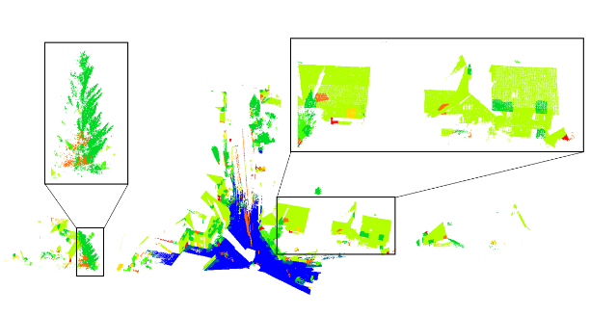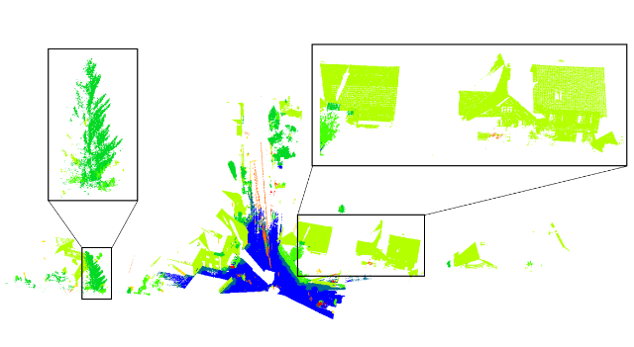

(c) (d)

Fig. 8 Classification results of Scene3. (a) Groundtruth, (b) MA1, (c) MA2, (d) Our method.

In order to verify the effectiveness of this algorithm, we conducted point set features ablation experiments, classification experiments of Spin images with different dimensions, and effectiveness comparison experiments of each module of the proposed algorithm.

Table 3 shows the results of characteristic ablation experiments on Scene1. **MF 1** is the method, which does not use local dispersion of points; **MF 2** does not use Z value feature; **MF 3** does not use normal vector; **MF 4** does not use covariance feature; **MF 5** does not use FPFH and Spin image. Meanwhile, all other parameter settings are the same as the proposed algorithm. **Our method** is the proposed algorithm in this paper.

It can be seen from Table 3 that the overall classification results of the proposed method are the best, which proves each feature is contribute to the point cloud classification performance, and the validity and necessity of feature selection in this paper.

Table 3 Precision/Recall ,Accuracy and F1-score(%) of our algorithm and other algorithms on Scene1

|  |  |  |  |  |  |
| --- | --- | --- | --- | --- | --- |
| **Scene1** | **Tree** | **Building** | **Car** | **OA** | **F1-score** |
| **MF1** | 91.3/98.9 | 98.8/90.5 | 70.6/49.7 | 94.4 | 94.9/94.4/58.3 |
| **MF 2** | 94.0/97.2 | 97.5/93.2 | 28.2/37.7 | 94.7 | 95.6/95.3/32.2 |
| **MF3** | 92.7/98.5 | 98.7/91.8 | 55.7/59.5 | 94.9 | 95.5/95.1/57.5 |
| **MF 4** | 89.3/98.2 | 98.2/87.8 | 57.1/49.7 | 92.8 | 93.6/92.7/53.1 |
| **MF 5** | 81.5/99.4 | 99.3/75.0 | 48.3/65.8 | 87.4 | 89.6/85.4/55.7 |
| **Our method** | 93.0/98.2 | 98.4/92.3 | 54.0/55.7 | 95.0 | 95.5/92.3/55.8 |

Table 4 shows the three groups of classification results when Spin images of different dimensions are used on Scene1. SP1 uses 15-D Spin image. SP2 uses 153-D Spin image. Meanwhile, all other parameter settings are the same as the proposed algorithm. Our method uses 45-D Spin image. From the table, we can see that the dimension of our method can achieve better performance.

Table 4 Precision/Recall, Accuracy and F1-score(%) of Different spin image dimensions on Scene1

|  |  |  |  |  |  |
| --- | --- | --- | --- | --- | --- |
| **Scene1** | **Tree** | **Building** | **Car** | **OA** | **F1-score** |
| **SP1** | 93.1/98.5 | 98.5/91.9 | 38.7/47.7 | 94.8 | 95.7/95.1/42.7 |
| **SP2** | 93.3/98.6 | 98.6/92.1 | 42.5/51.0 | 95.0 | 95.8/95.3/46.4 |
| **Our method** | 93.0/98.2 | 98.4/92.3 | 54.0/55.7 | 95.0 | 95.5/92.3/55.8 |

In this paper, we calculate the local dispersion degree of the point cloud. Then the initial points are selected through the local dispersion degree distribution histogram. On the one hand, we do not have to specify the number of point clouds to initialize, which can achieve adaptive initialization. On the other hand, since the initialization point cloud changes with different scenarios, the influence of the lack of part clustering information caused by the fixed number initialization is eliminated. The initialization results before and after the improvement are shown in Fig. 4. As shown in Fig. 4(c), the random selection of seed points will result in the loss of details, while the improved initialization method does not lose too many cloud details, which provides a guarantee for the subsequent clustering results.

Table 5 shows the comparison of experimental results before and after improvement. The drop rate is the ratio of the lost points to the total points after clustering, which is used to test whether the two initialization methods have the problem of missing point cloud details. Accuracy is the accuracy of point cloud classification, which is used to judge the influence of two initialization methods on the classification performance. **MC 1**: the method clusters the point cloud through the unimproved ISODATA algorithm. Then the point cloud is classified based on the point set features (the same as the proposed method) and random forest classifier. **MC 2**: the method improves the initialization mode of ISODATA according to the proposed method. This method only uses Euclidean distance as clustering criterion. Other steps of **MC 2** are the same **MC 1**. Because the improved clustering algorithm does not lose point cloud, the final classification accuracy of **MC 2** is 0.84% higher than **MC 1**, indicating that the improved algorithm has better effect.

Table 5 Comparison before and after improvement

|  |  |  |
| --- | --- | --- |
|  | MC 1 | MC 2 |
| Drop rate | 0.013% | 0% |
| Accuracy | 91.10% | 91.94% |

**C.2 Time Complexity**

Since the time complexity of Method4[18] and Method5[19] is not given, the running time of the proposed algorithm is compared with Method1 and Method2. The overall running time of each algorithm is as follows: Our method: 221.8s , Method1: 200.3s, Method2: 221.3s.

It can be seen that the improvement of ISODATA in this paper greatly improves the accuracy of point cloud classification without increasing the time complexity too much, which proves the effectiveness of the proposed algorithm.