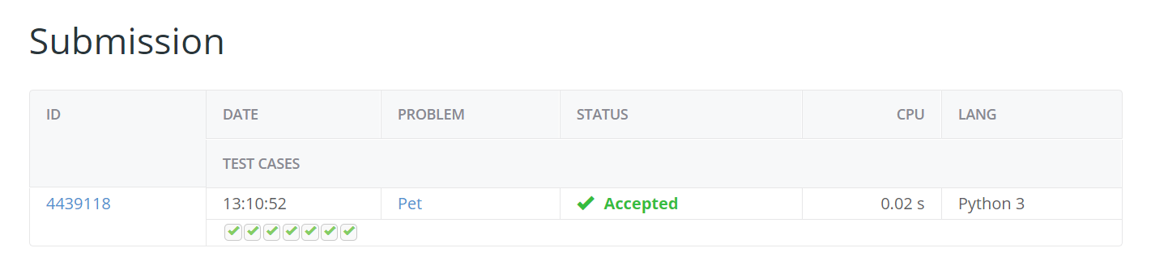

Author: David Runowski

Date: 09/05/2019

