Linux Architecture
Linux is primarily divided into User Space & Kernel Space. These two components interact through a System Call Interface – which are predefined and matured interface to Linux Kernel for User space applications. The below image will give you the basic understanding.

Kernel Space
Kernel space is where the kernel (i.e., the core of the operating system) executes (i.e., runs) and provides its services.

User Space
User Space is where the user applications are executed.

Linux Kernel Modules
Kernel modules are pieces of code that can be loaded and unloaded into the kernel upon demand. They extend the functionality of the kernel without the need to reboot the system.
Custom codes can be added to Linux kernels via two methods.
- The basic way is to add the code to the kernel source tree and recompile the kernel.
- A more efficient way is to do this is by adding code to the kernel while it is running. This process is called loading the module, where module refers to the code that we want to add to the kernel.
Since we are loading these codes at runtime and they are not part of the official Linux kernel, these are called loadable kernel module(LKM), which is different from the “base kernel”. Base kernel is located in /boot directory and is always loaded when we boot our machine whereas LKMs are loaded after the base kernel is already loaded. Nonetheless, these LKM are very much part of our kernel and they communicate with base kernel to complete their functions.
LKMs can perform a variety of task, but basically they come under three main categories,
- Device drivers
- Filesystem drivers
- System calls

Device drivers
A device driver is designed for a specific piece of hardware. The kernel uses it to communicate with that piece of hardware without having to know any details of how the hardware works.

Filesystem drivers
A filesystem driver interprets the contents of a filesystem (which is typically the contents of a disk drive) as files and directories and such. There are lots of different ways of storing files and directories and such on disk drives, on network servers, and in other ways. For each way, you need a filesystem driver. For example, there’s a filesystem driver for the ext2 filesystem type used almost universally on Linux disk drives. There is one for the MS-DOS filesystem too, and one for NFS.

System calls
User space programs use system calls to get services from the kernel. For example, there are system calls to read a file, to create a new process, and to shut down the system. Most system calls are integral to the system and very standard, so are always built into the base kernel (no LKM option).
But you can invent a system call of your own and install it as an LKM. Or you can decide you don’t like the way Linux does something and override an existing system call with an LKM of your own.

Advantages of LKM
- One major advantage they have is that we don’t need to keep rebuilding the kernel every time we add a new device or if we upgrade an old device. This saves time and also helps in keeping our base kernel error free.
- LKMs are very flexible, in the sense that they can be loaded and unloaded with a single line of command. This helps in saving memory as we load the LKM only when we need them.

Differences Between Kernel Modules and User Programs
- Kernel modules have separate address space. A module runs in kernel space. An application runs in user space. System software is protected from user programs. Kernel space and user space have their own memory address spaces.
- Kernel modules have higher execution privilege. Code that runs in kernel space has greater privilege than code that runs in user space.
- Kernel modules do not execute sequentially. A user program typically executes sequentially and performs a single task from beginning to end. A kernel module does not execute sequentially. A kernel module registers itself in order to serve future requests.
- Kernel modules use different header files. Kernel modules require a different set of header files than user programs require.

Difference Between Kernel Drivers and Kernel Modules
- A kernel module is a bit of compiled code that can be inserted into the kernel at run-time, such as withinsmod or modprobe.
- A driver is a bit of code that runs in the kernel to talk to some hardware device. It “drives” the hardware. Most every bit of hardware in your computer has an associated driver.

Device Driver
A device driver is a particular form of software application that is designed to enable interaction with hardware devices. Without the required device driver, the corresponding hardware device fails to work.
A device driver usually communicates with the hardware by means of the communications subsystem or computer bus to which the hardware is connected. Device drivers are operating system-specific and hardware-dependent. A device driver acts as a translator between the hardware device and the programs or operating systems that use it.

Types
In the traditional classification, there are three kinds of device:
- Character device
- Block device
- Network device
In Linux everything is a file. I mean Linux treat everything as a File even hardware.

Character Device
A char file is a hardware file which reads/write data in character by character fashion. Some classic examples are keyboard, mouse, serial printer. If a user use a char file for writing data no other user can use same char file to write data which blocks access to other user. Character files uses synchronize Technic to write data. Of you observe char files are used for communication purpose and they can not be mounted.

Block Device
A block file is a hardware file which read/write data in blocks instead of character by character. This type of files are very much useful when we want to write/read data in bulk fashion. All our disks such are HDD, USB and CDROMs are block devices. This is the reason when we are formatting we consider block size. The write of data is done in asynchronous fashion and it is CPU intensive activity. These devices files are used to store data on real hardware and can be mounted so that we can access the data we written.

Network Device
A network device is, so far as Linux’s network subsystem is concerned, an entity that sends and receives packets of data. This is normally a physical device such as an ethernet card. Some network devices though are software only such as the loopback device which is used for sending data to yourself.

First Device Driver

Module Information
- License
- Author
- Module Description
- Module Version
These all informations are present in the linux/module.h as a macros.

License
GPL, or the GNU General Public License, is an open source license meant for software. If your software is licensed under the terms of the GPL, it is free. However, “free” here does not essentially mean freeware—it can also be a paid software. Instead, “free” as per the GPL means freedom. As proponents of GPL proudly proclaim, free as in freedom, not free beer.
The following license idents are currently accepted as indicating free software modules.
"GPL" [GNU Public License v2 or later]
"GPL v2" [GNU Public License v2]
"GPL and additional rights" [GNU Public License v2 rights and more]
"Dual BSD/GPL" [GNU Public License v2 or BSD license choice]
"Dual MIT/GPL" [GNU Public License v2 or MIT license choice]
"Dual MPL/GPL" [GNU Public License v2 or Mozilla license choice]
The following other idents are available
"Proprietary" [Non free products]
There are dual licensed components, but when running with Linux it is the GPL that is relevant so this is a non issue. Similarly LGPL linked with GPL is a GPL combined work.
This exists for several reasons,
- modinfo can show license info for users wanting to vet their setup is free
- The community can ignore bug reports including proprietary modules
- Vendors can do likewise based on their own policies
We can give the License for our driver (module) like below. For this you need to include the Linux/module.h header file.
1  2  3 | MODULE_LICENSE("GPL");  MODULE_LICENSE("GPL v2");  MODULE_LICENSE("Dual BSD/GPL");
Note : It is not strictly necessary, but your module really should specify which license applies to its code.

Author
Using this Macro we can mention that who is wrote this driver or module. So modinfo can show author name for users wanting to know. We can give the Author name for our driver (module) like below. For this you need to include the Linux/module.h header file.
MODULE_AUTHOR("Author");
1 | MODULE_AUTHOR("Author");

Note: Use “Name <email>” or just “Name”, for multiple authors use multiple MODULE_AUTHOR() statements/lines.

Module Description
Using this Macro we can give the description of the module or driver. So modinfo can show module description for users wanting to know. We can give the description for our driver (module) like below. For this you need to include the linux/module.h header file.

1 | MODULE_DESCRIPTION("A sample driver");

Module Version
Using this Macro we can give the version of the module or driver. So modinfo can show module version for users wanting to know.
Version of form [<epoch>:]<version>[-<extra-version>].
<epoch>: A (small) unsigned integer which allows you to start versions anew. If not mentioned, it’s zero. eg. “2:1.0” is after “1:2.0”.
<version>: The <version> may contain only alphanumerics and the character `.’. Ordered by numeric sort for numeric parts, ascii sort for ascii parts (as per RPM or DEB algorithm).
<extraversion>: Like <version>, but inserted for local customizations, eg “rh3” or “rusty1”.
Example
MODULE_VERSION("2:1.0");
1 | MODULE_VERSION("2:1.0");

Simple Kernel Module Programming
So as of now we know the very basic things that needed for writing driver. Now we will move into programming. In every programming language, how we will start to write the code? Any ideas? Well, in all programming there would be a starting point and ending point. If you take C Language, starting point would be the main function, Isn’t it? It will start from the starting of the main function and run through the functions which is calling from main function. Finally it exits at the main function closing point. But Here two separate functions used for that starting and ending.
- Init function
- Exit function
Kernel modules require a different set of header files than user programs require.And keep in mind, Module code should not invoke user space Libraries or API’s or System calls.

Init function
This is the function which will executes first when the driver is loaded into the kernel. For example when we load the driver using insmod, this function will execute. Please see below to know the syntax of this function.
static int __init hello_world_init(void) /* Constructor */ { return 0; } module_init(hello_world_init);
1  2  3  4  5 | static int __init hello_world_init(void) /* Constructor */  {  return 0;  }  module_init(hello_world_init);
This function should register itself by using module_init() macro.

Exit function
This is the function which will executes last when the driver is unloaded from the kernel. For example when we unload the driver using rmmod, this function will execute. Please see below to know the syntax of this function.
void __exit hello_world_exit(void) { } module_exit(hello_world_exit);
1  2  3  4  5 | void __exit hello_world_exit(void)  {  }  module_exit(hello_world_exit);
This function should register itself by using module_exit() macro.

Printk()
In C programming how we will print the values or whatever? Correct. Using printf() function. printf() is a user space function. So we cant use this here. So they created one another function for kernel which is printk().
One of the differences is that printk lets you classify messages according to their severity by associating different loglevels, or priorities, with the messages. You usually indicate the loglevel with a macro. I will explain about the macros now. There are several macros used for printk.
KERN_EMERG:
Used for emergency messages, usually those that precede a crash.
KERN_ALERT:
Situation requiring immediate action.
KERN_CRIT:
Critical conditions, often related to serious hardware or software failures.
KERN_ERR:
Used to report error conditions; device drivers often use KERN_ERR to report hardware difficulties.
KERN_WARNING:
Warnings about problematic situations that do not, in themselves, create serious problems with the system.
KERN_NOTICE:
Situations that are normal, but still worthy of note. A number of security-related conditions are reported at this level.
KERN_INFO:
Informational messages. Many drivers print information about the hardware they find at startup time at this level.
KERN_DEBUG:
Used for debugging messages.
Example
printk(KERN_INFO "Welcome To EmbeTronicX");
1 | printk(KERN_INFO "Welcome To EmbeTronicX");

Difference between printf and printk
- Printk() is a kernel level function, which has the ability to print out to different loglevels as defined in . We can see the prints using dmesg command.
- Printf() will always print to a file descriptor – STD_OUT. We can see the prints in STD_OUT console.

Simple Driver
This is the complete code for our simple device driver (hello_world_module.c). You can download the Project By clicking below link.

Compiling our driver
Once we have the C code, it is time to compile it and create the module file hello_world_module.ko. creating a Makefile for your module is straightforward.

With the C code (hello_world_module.c) and Makefile ready, all we need to do is invoke make to build our first driver (hello_world_module .ko).
In Terminal you need to enter sudo make like below image.
Now we got hello_world_module .ko. This is the kernel object which is loading into kernel.

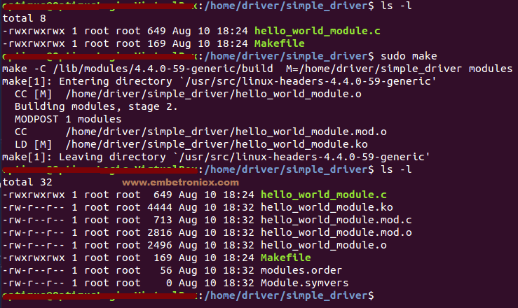

Loading and Unloading the Device driver
A Kernel Module is a small file that may be loaded into the running Kernel, and unloaded.

Loading
To load a Kernel Module, use the insmod command with root privileges.
For example our module file name is hello_world_module.ko
sudo insmod hello_world_module.ko
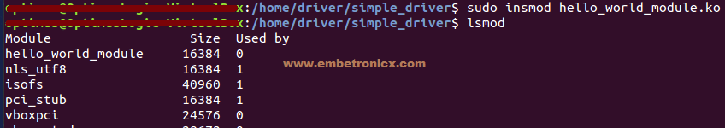
lsmod used to see the modules were inserted. In below image, i’ve shown the prints in init function. Use dmesg to see the kernel prints.
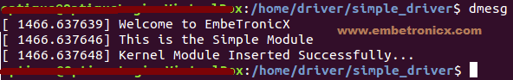
So when i load the module, it executes the init function.

Listing the Modules
In order to see the list of currently loaded Modules, use the lsmod command. In above image you can see that i have used lsmod command.

Unloading
To un-load a Kernel Module, use the rmmod command with root privileges.
In our case,
sudo rmmod hello_world_module.ko or sudo rmmod hello_world_module

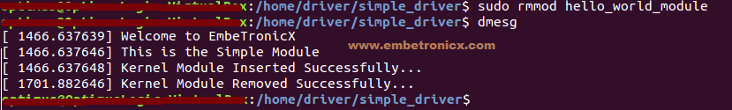
So when i unload the module, it executes the exit function.

Getting Module Details
In order to get information about a Module (author, supported options), we may use the modinfo command.
For example
modinfo hello_world_module.ko
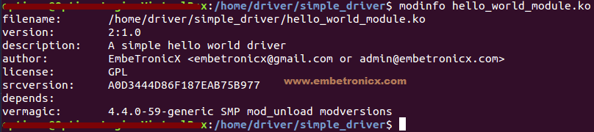

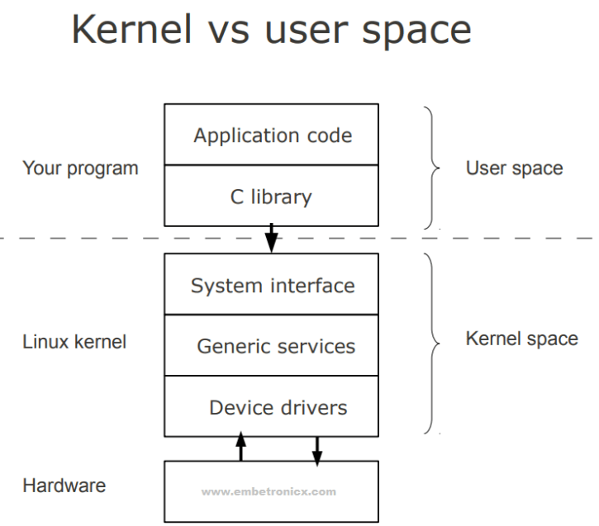

Passing Arguments to Device Driver
We can pass the arguments to any other functions in same program. But Is it possible to pass any arguments to any program? I think Probably yes. Right? Well, we can. In C Programming we can pass the arguments to the program. For that we need to add argc and argv in main function definition. I hope everyone knows that. Now come to our topic. Is it possible to pass the argument to the Device Driver? Fine. In this tutorial we are going to see that topic.

Module Parameters Macros
- module_param()
- module_param_array()
- module_param_cb()
Before discuss these macros we have to know about permissions of the variable.
There are several types of permissions:
- S_IWUSR
- S_IRUSR
- S_IXUSR
- S_IRGRP
- S_IWGRP
- S_IXGRP
In this S_I is common header.
R = read ,W =write ,X= Execute.
USR =user ,GRP =Group
Using OR ‘|’ (or operation) we can set multiple permissions at a time.

module_param()
This macro used to initialize the arguments. module_param takes three parameters: the name of the variable, its type, and a permissions mask to be used for an accompanying sysfs entry. The macro should be placed outside of any function and is typically found near the head of the source file. module_param() macro, defined in linux/moduleparam.h.
module_param(name, type, perm);
module_param() macro creates the sub-directory under /sys/module. For example
module_param(valueETX, int, S_IWUSR|S_IRUSR);
1 | module_param(valueETX, int, S_IWUSR|S_IRUSR);
This will create the sysfs entry. (/sys/module/hello_world_module/parameters/valueETX)
Numerous types are supported for module parameters:
- bool
- invbool
A boolean (true or false) value (the associated variable should be of type int). The invbool type inverts the value, so that true values become false and vice versa.
- charp
A char pointer value. Memory is allocated for user-provided strings, and the pointer is set accordingly.
- int
- long
- short
- uint
- ulong
- ushort
Basic integer values of various lengths. The versions starting with u are for unsigned values.

module_param_array();
This macro is used to send the array as a argument. Array parameters, where the values are supplied as a comma-separated list, are also supported by the module loader. To declare an array parameter, use:
module_param_array(name,type,num,perm);
Where,
name is the name of your array (and of the parameter),
type is the type of the array elements,
num is an integer variable (optional) otherwise NULL, and
perm is the usual permissions value.

module_param_cb()
This macro used to register the callback whenever the argument (parameter) got changed. I think you don’t understand. Let me explain properly.
For Example,
I have created one parameter by using module_param().
module_param(valueETX, int, S_IWUSR|S_IRUSR);
1 | module_param(valueETX, int, S_IWUSR|S_IRUSR);
This will create the sysfs entry. (/sys/module/hello_world_module/parameters/valueETX)
You can change the value of valueETX from command line by
echo 1 > /sys/module/hello_world_module/parameters/valueETX
This will update the valueETX variable. But there is no way to notify your module that “valueETX” has changed.
By using this module_param_cb() macro, we can get notification.
If you want to get notification whenever value got change. we need to register our handler function to its file operation structure.
struct kernel_param_ops { int (*set)(const char *val, const struct kernel_param *kp); int (*get)(char *buffer, const struct kernel_param *kp); void (*free)(void *arg); };
1  2  3  4  5 | struct kernel_param_ops {  int (*set)(const char *val, const struct kernel_param *kp);  int (*get)(char *buffer, const struct kernel_param *kp);  void (*free)(void *arg);  };
For further explanation, please refer below program.

When we will need this notification?
I will tell you the practical scenario. Whenever value is set to 1, you have to write a something in to a hardware register. How can you do this if the change of value variable is not notified to you? Got it? I think you have understood. If you didn't understood, just see the explanation posted below.

Programming
In this example, i explained all (module_param, module_param_array, module_param_cb).
For module_param(), i have created two variables. One is integer (valueETX) and another one is string (nameETX).
For module_param_array(), i have created one integer array variable ().
For module_param_cb(), i have created one integer variable (cb_valueETX).
You can change the all variable using their sysfs entry which is under /sys/module/hello_world_module/parameters/
But you want get any notification when they got change except the variable which is created by module_param_cb() macro.
Download the code by clicking below link.

