Memory Management

In operating systems, Memory Management is the function responsible for allocating and managing computer’s main memory. Memory Management function keeps track of the status of each memory location, either allocated or free to ensure effective and efficient use of Primary Memory.

There are two Memory Management Techniques: Contiguous, and Non-Contiguous. In Contiguous Technique, executing process must be loaded entirely in main-memory. Contiguous Technique can be divided into:
- Fixed (or static) partitioning
- Variable (or dynamic) partitioning

Fixed Partitioning:

This is the oldest and simplest technique used to put more than one processes in the main memory. In this partitioning, number of partitions (non-overlapping) in RAM are fixed but size of each partition may or may not be same. As it is contiguous allocation, hence no spanning is allowed. Here partition are made before execution or during system configure

As illustrated in above figure, first process is only consuming 1MB out of 4MB in the main memory.
Hence, Internal Fragmentation in first block is (4-1) = 3MB.
Sum of Internal Fragmentation in every block = (4-1)+(8-7)+(8-7)+(16-14)= 3+1+1+2 = 7MB.
Suppose process P5 of size 7MB comes. But this process cannot be accommodated inspite of available free space because of contiguous allocation (as spanning is not allowed). Hence, 7MB becomes part of External Fragmentation.
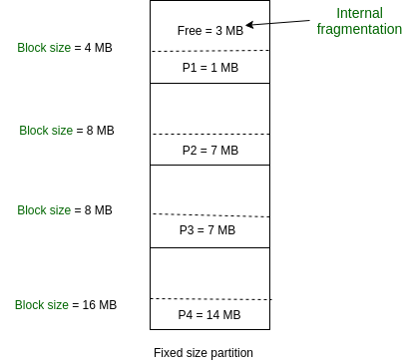

There are some advantages and disadvantages of fixed partitioning.
Advantages of Fixed Partitioning –
- Easy to implement:
Algorithms needed to implement Fixed Partitioning are easy to implement. It simply requires putting a process into certain partition without focussing on the emergence of Internal and External Fragmentation.
- Little OS overhead:
Processing of Fixed Partitioning require lesser excess and indirect computational power.
Disadvantages of Fixed Partitioning –
- Internal Fragmentation:
Main memory use is inefficient. Any program, no matter how small, occupies an entire partition. This can cause internal fragmentation.
- External Fragmentation:
The total unused space (as stated above) of various partitions cannot be used to load the processes even though there is space available but not in the contiguous form (as spanning is not allowed).
- Limit process size:
Process of size greater than size of partition in Main Memory cannot be accommodated. Partition size cannot be varied according to the size of incoming process’s size. Hence, process size of 32MB in above stated example is invalid.
- Limitation on Degree of Multiprogramming:
Partition in Main Memory are made before execution or during system configure. Main Memory is divided into fixed number of partition. Suppose if there are partitions in RAM and are the number of processes, then condition must be fulfilled. Number of processes greater than number of partitions in RAM is invalid in Fixed Partitioning.

Variable (or dynamic) Partitioning in Operating System

It is a part of Contiguous allocation technique. It is used to alleviate the problem faced by Fixed Partitioning. In contrast with fixed partitioning, partitions are not made before the execution or during system configure. Various features associated with variable Partitioning-
- Initially RAM is empty and partitions are made during the run-time according to process’s need instead of partitioning during system configure.
- The size of partition will be equal to incoming process.
- The partition size varies according to the need of the process so that the internal fragmentation can be avoided to ensure efficient utilisation of RAM.
- Number of partitions in RAM is not fixed and depends on the number of incoming process and Main Memory’s size.
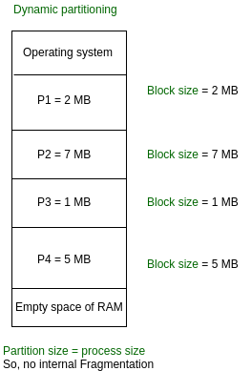
There are some advantages and disadvantages of variable partitioning over fixed partitioning as given below.

Advantages of Variable Partitioning –
- No Internal Fragmentation:
In variable Partitioning, space in main memory is allocated strictly according to the need of process, hence there is no case of internal fragmentation. There will be no unused space left in the partition.
- No restriction on Degree of Multiprogramming:
More number of processes can be accommodated due to absence of internal fragmentation. A process can be loaded until the memory is not empty.
- No Limitation on the size of the process:
In Fixed partitioning, the process with the size greater than the size of the largest partition could not be loaded and process can not be divided as it is invalid in contiguous allocation technique. Here, In variable partitioning, the process size can’t be restricted since the partition size is decided according to the process size.
Disadvantages of Variable Partitioning –
- Difficult Implementation:
Implementing variable Partitioning is difficult as compared to Fixed Partitioning as it involves allocation of memory during run-time rather than during system configure.
- External Fragmentation:
There will be external fragmentation inspite of absence of internal fragmentation.
For example, suppose in above example- process P1(2MB) and process P3(1MB) completed their execution. Hence two spaces are left i.e. 2MB and 1MB. Let’s suppose process P5 of size 3MB comes. The empty space in memory cannot be allocated as no spanning is allowed in contiguous allocation. The rule says that process must be contiguously present in main memory to get executed. Hence it results in External Fragmentation.

Now P5 of size 3 MB cannot be accommodated in spite of required available space because in contiguous no spanning is allowed.

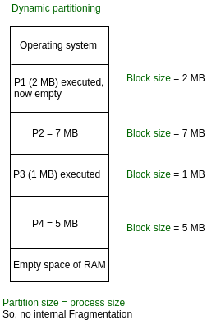

Non-Contiguous Allocation in Operating System

Paging and Segmentation are the two ways which allow a process’s physical address space to be non-contiguous. It has advantage of reducing memory wastage but it increases the overheads due to address translation. It slows the execution of the memory because time is consumed in address translation.
In non-contiguous allocation, Operating system needs to maintain the table which is called Page Table for each process which contains the base address of the each block which is acquired by the process in memory space. In non-contiguous memory allocation, different parts of a process is allocated different places in Main Memory. Spanning is allowed which is not possible in other techniques like Dynamic or Static Contiguous memory allocation. That’s why paging is needed to ensure effective memory allocation. Paging is done to remove External Fragmentation.
Working:
Here a process can be spanned across different spaces in main memory in non-consecutive manner. Suppose process P of size 4KB. Consider main memory have two empty slots each of size 2KB. Hence total free space is, 2*2= 4 KB. In contiguous memory allocation, process P cannot be accommodated as spanning is not allowed.

In contiguous allocation, space in memory should be allocated to whole process. If not, then that space remains unallocated. But in Non-Contiguous allocation, process can be divided into different parts and hence filling the space in main memory. In this example, process P can be divided into two parts of equal size – 2KB. Hence one part of process P can be allocated to first 2KB space of main memory and other part of processP can be allocated to second 2KB space of main memory. Below diagram will explain in better way:
But, in what manner we divide a process to allocate them into main memory is very important to understand. Process is divided after analysing the number of empty spaces and their size in main memory. Then only we divide our process. It is very time consuming process. Their number as well as their sizes changing every time due to execution of already present processes in main memory.
In order to avoid this time consuming process, we divide our process in secondary memory in advance before reaching the memory memory for its execution. Every process is divided into various parts of equal size called Pages. We also divide our main memory into different parts of equal size called Frames. It is important to understand that:

Size of page in process
= Size of frame in memory
Although their numbers can be different. Below diagram will make you understand in better way: consider empty main memory having size of each frame is 2 KB, and two processes P1 and P2 are 2 KB each.
Resolvent main memory,
In conclusion we can say that, Paging allows memory address space of a process to be non-contiguous. Paging is more flexible as only pages of a process are moved. It allows more processes to reside in main memory than Contiguous memory allocation.

Logical vs Physical Address in Operating System

Logical Address is generated by CPU while a program is running. The logical address is virtual address as it does not exist physically, therefore, it is also known as Virtual Address. This address is used as a reference to access the physical memory location by CPU. The term Logical Address Space is used for the set of all logical addresses generated by a program’s perspective.
The hardware device called Memory-Management Unit is used for mapping logical address to its corresponding physical address.
Physical Address identifies a physical location of required data in a memory. The user never directly deals with the physical address but can access by its corresponding logical address. The user program generates the logical address and thinks that the program is running in this logical address but the program needs physical memory for its execution, therefore, the logical address must be mapped to the physical address by MMU before they are used. The term Physical Address Space is used for all physical addresses corresponding to the logical addresses in a Logical address space.
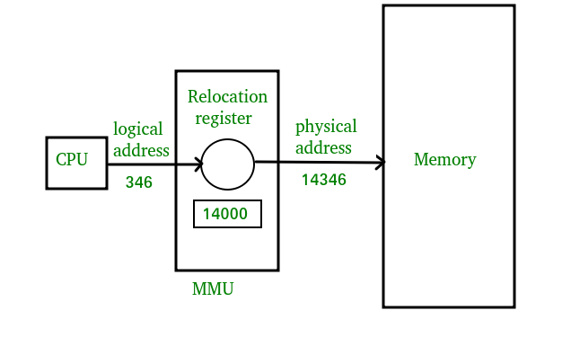
Mapping virtual-address to physical-addresses
Differences Between Logical and Physical Address in Operating System
- The basic difference between Logical and physical address is that Logical address is generated by CPU in perspective of a program whereas the physical address is a location that exists in the memory unit.
- Logical Address Space is the set of all logical addresses generated by CPU for a program whereas the set of all physical address mapped to corresponding logical addresses is called Physical Address Space.
- The logical address does not exist physically in the memory whereas physical address is a location in the memory that can be accessed physically.
- Identical logical addresses are generated by Compile-time and Load time address binding methods whereas they differs from each other in run-time address binding method. Please refer this for details.
- The logical address is generated by the CPU while the program is running whereas the physical address is computed by the Memory Management Unit (MMU).

Paging

Paging is a memory management scheme that eliminates the need for contiguous allocation of physical memory. This scheme permits the physical address space of a process to be non – contiguous.
- Logical Address or Virtual Address (represented in bits): An address generated by the CPU
- Logical Address Space or Virtual Address Space( represented in words or bytes): The set of all logical addresses generated by a program
- Physical Address (represented in bits): An address actually available on memory unit
- Physical Address Space (represented in words or bytes): The set of all physical addresses corresponding to the logical addresses
Example:
- If Logical Address = 31 bit, then Logical Address Space = 231 words = 2 G words (1 G = 230)
- If Logical Address Space = 128 M words = 27 * 220 words, then Logical Address = log2 227 = 27 bits
- If Physical Address = 22 bit, then Physical Address Space = 222 words = 4 M words (1 M = 220)
- If Physical Address Space = 16 M words = 24 * 220 words, then Physical Address = log2 224 = 24 bits
The mapping from virtual to physical address is done by the memory management unit (MMU) which is a hardware device and this mapping is known as paging technique.

The Physical Address Space is conceptually divided into a number of fixed-size blocks, called frames.
- The Logical address Space is also splitted into fixed-size blocks, called pages.
- Page Size = Frame Size
Let us consider an example:
- Physical Address = 12 bits, then Physical Address Space = 4 K words
- Logical Address = 13 bits, then Logical Address Space = 8 K words
- Page size = frame size = 1 K words (assumption)

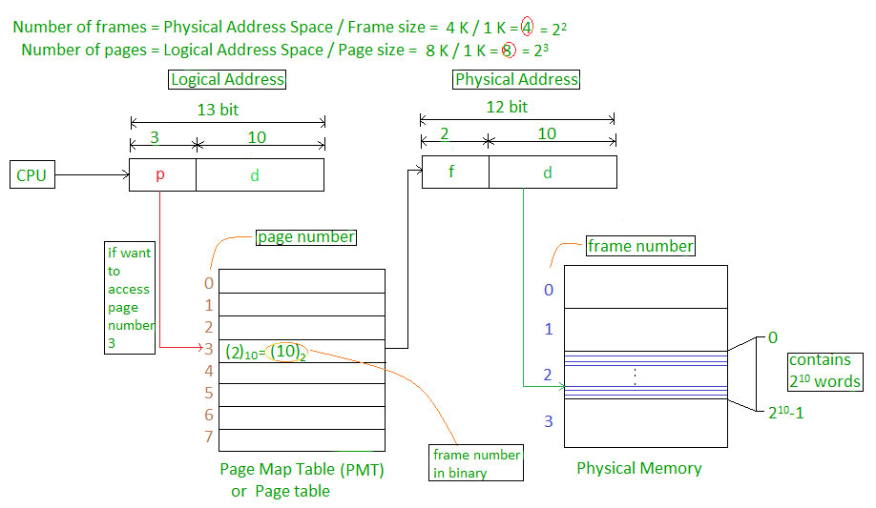

Address generated by CPU is divided into

- Page number(p): Number of bits required to represent the pages in Logical Address Space or Page number
- Page offset(d): Number of bits required to represent particular word in a page or page size of Logical Address Space or word number of a page or page offset.
Physical Address is divided into
- Frame number(f): Number of bits required to represent the frame of Physical Address Space or Frame number.
- Frame offset(d): Number of bits required to represent particular word in a frame or frame size of Physical Address Space or word number of a frame or frame offset.

The hardware implementation of page table can be done by using dedicated registers. But the usage of register for the page table is satisfactory only if page table is small. If page table contain large number of entries then we can use TLB(translation Look-aside buffer), a special, small, fast look up hardware cache.
- The TLB is associative, high speed memory.
- Each entry in TLB consists of two parts: a tag and a value.
- When this memory is used, then an item is compared with all tags simultaneously.If the item is found, then corresponding value is returned.

Page Fault Handling
A page fault occurs when a program attempts to access data or code that is in its address space, but is not currently located in the system RAM. So when page fault occurs then following sequence of events happens :
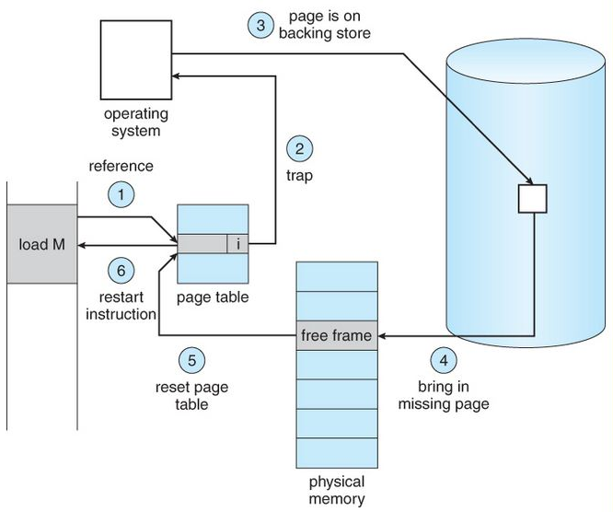
- The computer hardware traps to the kernel and program counter (PC) is saved on the stack. Current instruction state information is saved in CPU registers.
- An assembly program is started to save the general registers and other volatile information to keep the OS from destroying it.
- Operating system finds that a page fault has occurred and tries to find out which virtual page is needed. Some times hardware register contains this required information. If not, the operating system must retrieve PC, fetch instruction and find out what it was doing when the fault occurred.
- Once virtual address caused page fault is known, system checks to see if address is valid and checks if there is no protection access problem.
- If the virtual address is valid, the system checks to see if a page frame is free. If no frames are free, the page replacement algorithm is run to remove a page.
- If frame selected is dirty, page is scheduled for transfer to disk, context switch takes place, fault process is suspended and another process is made to run until disk transfer is completed.
- As soon as page frame is clean, operating system looks up disk address where needed page is, schedules disk operation to bring it in.
- When disk interrupt indicates page has arrived, page tables are updated to reflect its position, and frame marked as being in normal state.
- Faulting instruction is backed up to state it had when it began and PC is reset. Faulting is scheduled, operating system returns to routine that called it.
- Assembly Routine reloads register and other state information, returns to user space to continue execution.

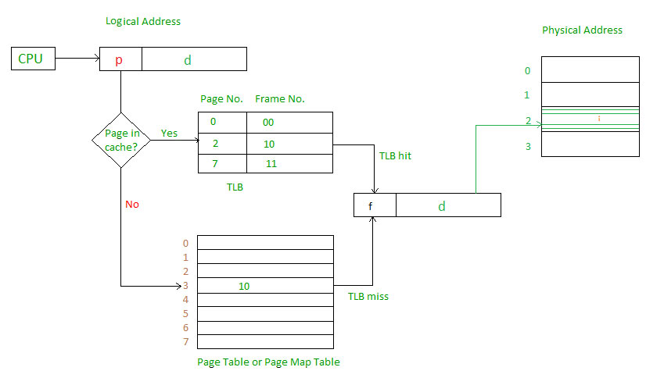

Main memory access time = m
If page table are kept in main memory,
Effective access time = m(for page table) + m(for particular page in page table)
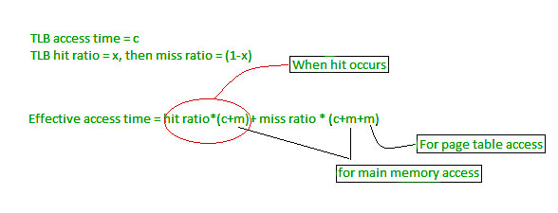

Page Fault Handling
A page fault occurs when a program attempts to access data or code that is in its address space, but is not currently located in the system RAM. So when page fault occurs then following sequence of events happens :
- The computer hardware traps to the kernel and program counter (PC) is saved on the stack. Current instruction state information is saved in CPU registers.
- An assembly program is started to save the general registers and other volatile information to keep the OS from destroying it.
- Operating system finds that a page fault has occurred and tries to find out which virtual page is needed. Some times hardware register contains this required information. If not, the operating system must retrieve PC, fetch instruction and find out what it was doing when the fault occurred.
- Once virtual address caused page fault is known, system checks to see if address is valid and checks if there is no protection access problem.
- If the virtual address is valid, the system checks to see if a page frame is free. If no frames are free, the page replacement algorithm is run to remove a page.
- If frame selected is dirty, page is scheduled for transfer to disk, context switch takes place, fault process is suspended and another process is made to run until disk transfer is completed.
- As soon as page frame is clean, operating system looks up disk address where needed page is, schedules disk operation to bring it in.
- When disk interrupt indicates page has arrived, page tables are updated to reflect its position, and frame marked as being in normal state.
- Faulting instruction is backed up to state it had when it began and PC is reset. Faulting is scheduled, operating system returns to routine that called it.
- Assembly Routine reloads register and other state information, returns to user space to continue execution.

Memory management – mapping virtual address to physical addresses

Memory consists of large array of words or arrays, each of which has address associated with it. Now the work of CPU is to fetch instructions from the memory based program counter. Now further these instruction may cause loading or storing to specific memory address.
Address binding is the process of mapping from one address space to another address space. Logical address is address generated by CPU during execution whereas Physical Address refers to location in memory unit(the one that is loaded into memory).Note that user deals with only logical address(Virtual address). The logical address undergoes translation by the MMU or address translation unit in particular. The output of this process is the appropriate physical address or the location of code/data in RAM.
An address binding can be done in three different ways:
Compile Time – If you know that during compile time where process will reside in memory then absolute address is generated i.e physical address is embedded to the executable of the program during compilation. Loading the executable as a process in memory is very fast. But if the generated address space is preoccupied by other process, then the program crashes and it becomes necessary to recompile the program to change the address space.
Load time – If it is not known at the compile time where process will reside then relocatable address will be generated. Loader translates the relocatable address to absolute address. The base address of the process in main memory is added to all logical addresses by the loader to generate absolute address. In this if the base address of the process changes then we need to reload the process again.

Execution time- The instructions are in memory and are being processed by the CPU. Additional memory may be allocated and/or deallocated at this time. This is used if process can be moved from one memory to another during execution(dynamic linking-Linking that is done during load or run time). e.g – Compaction.
MMU(Memory Management Unit)-
The run time mapping between Virtual address and Physical Address is done by hardware device known as MMU.
In memory management, Operating System will handle the processes and moves the processes between disk and memory for execution . It keeps the track of available and used memory.
Instruction-execution cycle Follows steps:
- First instruction is fetched from memory e.g. ADD A,B
- Then these instructions are decoded i.e., Addition of A and B
- And further loading or storing at some particular memory location takes place.
Basic Hardware
As main memory and registers are built into processor and CPU can access these only.So every instructions should be written in direct access storage
devices.
- If CPU access instruction from register then it can be done in one CPU clock cycle as registers are built into CPU.
- If instruction resides in main memory then it will be accessed via memory bus that will take lot of time. So remedy to this add fast memory in between CPU and main memory i.e. adding cache for transaction.
- Now we should insure that process resides in legal address.
- Legal address consists of base register(holds smallest physical address) and limit register(size of range).
For example:
Base register = 300040
limit register = 120900
then legal address = (300040+120900)= 420940(inclusive).
legal address = base register+ limit register
How processes are mapped from disk to memory
- Usually process resides in disk in form of binary executable file.
- So to execute process it should reside in main memory.
- Process is moved from disk to memory based on memory management in use.
- The processes waits in disk in form of ready queue to acquire memory.
Procedure of mapping of disk and memory
Normal procedure is that process is selected from input queue and loaded in memory. As process executes it accesses data and instructions from memory and as soon as it completes it will release memory and now memory will be available for other processes.

MMU scheme –
CPU------- MMU------Memory
- CPU will generate logical address for eg: 346
- MMU will generate relocation register(base register) for eg:14000
- In Memory physical address is located eg:(346+14000= 14346)

Virtual Memory

Virtual Memory is a storage allocation scheme in which secondary memory can be addressed as though it were part of main memory. The addresses a program may use to reference memory are distinguished from the addresses the memory system uses to identify physical storage sites, and program generated addresses are translated automatically to the corresponding machine addresses.
The size of virtual storage is limited by the addressing scheme of the computer system and amount of secondary memory is available not by the actual number of the main storage locations.
It is a technique that is implemented using both hardware and software. It maps memory addresses used by a program, called virtual addresses, into physical addresses in computer memory.
- All memory references within a process are logical addresses that are dynamically translated into physical addresses at run time. This means that a process can be swapped in and out of main memory such that it occupies different places in main memory at different times during the course of execution.
- A process may be broken into number of pieces and these pieces need not be continuously located in the main memory during execution. The combination of dynamic run-time addres translation and use of page or segment table permits this.
If these characteristics are present then, it is not necessary that all the pages or segments are present in the main memory during execution. This means that the required pages need to be loaded into memory whenever required. Virtual memory is implemented using Demand Paging or Demand Segmentation.

Demand Paging :
The process of loading the page into memory on demand (whenever page fault occurs) is known as demand paging.
The process includes the following steps :
- If CPU try to refer a page that is currently not available in the main memory, it generates an interrupt indicating memory access fault.
- The OS puts the interrupted process in a blocking state. For the execution to proceed the OS must bring the required page into the memory.
- The OS will search for the required page in the logical address space.
- The required page will be brought from logical address space to physical address space. The page replacement algorithms are used for the decision making of replacing the page in physical address space.
- The page table will updated accordingly.
- The signal will be sent to the CPU to continue the program execution and it will place the process back into ready state.
Hence whenever a page fault occurs these steps are followed by the operating system and the required page is brought into memory.
Advantages :
- More processes may be maintained in the main memory: Because we are going to load only some of the pages of any particular process, there is room for more processes. This leads to more efficient utilization of the processor because it is more likely that at least one of the more numerous processes will be in the ready state at any particular time.
- A process may be larger than all of main memory: One of the most fundamental restrictions in programming is lifted. A process larger than the main memory can be executed because of demand paging. The OS itself loads pages of a process in main memory as required.
- It allows greater multiprogramming levels by using less of the available (primary) memory for each process.
Page Fault Service Time :
The time taken to service the page fault is called as page fault service time. The page fault service time includes the time taken to perform all the above six steps.
Let Main memory access time is: m
Page fault service time is: s
Page fault rate is : p
Then, Effective memory access time = (p*s) + (1-p)*m
Swapping:
Swapping a process out means removing all of its pages from memory, or marking them so that they will be removed by the normal page replacement process. Suspending a process ensures that it is not runnable while it is swapped out. At some later time, the system swaps back the process from the secondary storage to main memory. When a process is busy swapping pages in and out then this situation is called thrashing.
Thrashing :
At any given time, only few pages of any process are in main memory and therefore more processes can be maintained in memory. Furthermore time is saved because unused pages are not swapped in and out of memory. However, the OS must be clever about how it manages this scheme. In the steady state practically, all of main memory will be occupied with process’s pages, so that the processor and OS has direct access to as many processes as possible. Thus when the OS brings one page in, it must throw another out. If it throws out a page just before it is used, then it will just have to get that page again almost immediately. Too much of this leads to a condition called Thrashing. The system spends most of its time swapping pages rather than executing instructions. So a good page replacement algorithm is required.
In the given diagram, initial degree of multi programming upto some extent of point(lamda), the CPU utilization is very high and the system resources are utilized 100%. But if we further increase the degree of multi programming the CPU utilization will drastically fall down and the system will spent more time only in the page replacement and the time taken to complete the execution of the process will increase. This situation in the system is called as thrashing.
Causes of Thrashing :
- High degree of multiprogramming : If the number of processes keeps on increasing in the memory than number of frames allocated to each process will be decreased. So, less number of frames will be available to each process. Due to this, page fault will occur more frequently and more CPU time will be wasted in just swapping in and out of pages and the utilization will keep on decreasing.
For example:
Let free frames = 400
Case 1: Number of process = 100
Then, each process will get 4 frames.
Case 2: Number of process = 400
Each process will get 1 frame.
Case 2 is a condition of thrashing, as the number of processes are increased,frames per process are decreased. Hence CPU time will be consumed in just swapping pages.
- Lacks of Frames:If a process has less number of frames then less pages of that process will be able to reside in memory and hence more frequent swapping in and out will be required. This may lead to thrashing. Hence sufficient amount of frames must be allocated to each process in order to prevent thrashing.
Recovery of Thrashing :
- Do not allow the system to go into thrashing by instructing the long term scheduler not to bring the processes into memory after the threshold.
- If the system is already in thrashing then instruct the mid term schedular to suspend some of the processes so that we can recover the system from thrashing.

