Fork

Fork system call use for creates a new process, which is called child process, which runs concurrently with process (which process called system call fork) and this process is called parent process. After a new child process created, both processes will execute the next instruction following the fork() system call. A child process uses the same pc(program counter), same CPU registers, same open files which use in the parent process.
It takes no parameters and returns an integer value. Below are different values returned by fork().
Negative Value: creation of a child process was unsuccessful.
Zero: Returned to the newly created child process.
Positive value: Returned to parent or caller. The value contains process ID of newly created child process.

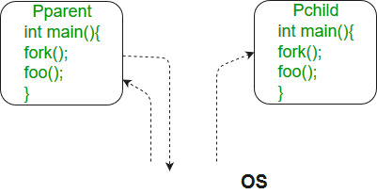

#include <stdio.h>
#include <sys/types.h>
#include <unistd.h>
void forkexample()
{
// child process because return value zero
if (fork() == 0)
printf("Hello from Child!\n");

// parent process because return value non-zero.
else
printf("Hello from Parent!\n");
}
int main()
{
forkexample();
return 0;
}

In the above code, a child process is created, fork() returns 0 in the child process and positive integer to the parent process.
Here, two outputs are possible because the parent process and child process are running concurrently. So we don’t know if OS first give control to which process a parent process or a child process.
Important: Parent process and child process are running the same program, but it does not mean they are identical. OS allocate different data and state for these two processes and also control the flow of these processes can be different. See next example

Zombie and Orphan Processes in C

A process which has finished the execution but still has entry in the process table to report to its parent process is known as a zombie process. A child process always first becomes a zombie before being removed from the process table. The parent process reads the exit status of the child process which reaps off the child process entry from the process table.

Orphan Process:
A process whose parent process no more exists i.e. either finished or terminated without waiting for its child process to terminate is called an orphan process.
In the following code, parent finishes execution and exits while the child process is still executing and is called an orphan process now.
However, the orphan process is soon adopted by init process, once its parent process dies.

Zombie Processes and their Prevention

Zombie state : When a process is created in UNIX using fork() system call, the address space of the Parent process is replicated. If the parent process calls wait() system call, then the execution of parent is suspended until the child is terminated. At the termination of the child, a ‘SIGCHLD’ signal is generated which is delivered to the parent by the kernel. Parent, on receipt of ‘SIGCHLD’ reaps the status of the child from the process table. Even though, the child is terminated, there is an entry in the process table corresponding to the child where the status is stored. When parent collects the status, this entry is deleted. Thus, all the traces of the child process are removed from the system. If the parent decides not to wait for the child’s termination and it executes its subsequent task, then at the termination of the child, the exit status is not read. Hence, there remains an entry in the process table even after the termination of the child. This state of the child process is known as the Zombie state.
Why do we need to prevent the creation of Zombie process?
There is one process table per system. The size of the process table is finite. If too many zombie processes are generated, then the process table will be full. That is, the system will not be able to generate any new process, then the system will come to a standstill. Hence, we need to prevent the creation of zombie processes.
Different ways in which creation of Zombie can be prevented
1. Using wait() system call : When the parent process calls wait(), after the creation of child, it indicates that, it will wait for the child to complete and it will reap the exit status of the child. The parent process is suspended(waits in a waiting queue) until the child is terminated. It must be understood that during this period, the parent process does nothing just waits.

2. By ignoring the SIGCHLD signal :
When a child is terminated, a corresponding SIGCHLD signal is delivered to the parent, if we call the ‘signal(SIGCHLD,SIG_IGN)’, then the SIGCHLD signal is ignored by the system, and the child process entry is deleted from the process table. Thus, no zombie is created. However, in this case, the parent cannot know about the exit status of the child.

3. By using a signal handler : The parent process installs a signal handler for the SIGCHLD signal. The signal handler calls wait() system call within it. In this senario, when the child terminated, the SIGCHLD is delivered to the parent.On receipt of SIGCHLD, the corresponding handler is activated, which in turn calls the wait() system call. Hence, the parent collects the exit status almost immediately and the child entry in the process table is cleared. Thus no zombie is created.

Maximum number of Zombie process a system can handle

Zombie Process or Defunct Process are those Process which has completed their execution by exit() system call but still has an entry in Process Table. It is a process in terminated state.
When child process is created in UNIX using fork() system call, then if somehow parent process were not available to reap child process from Process Table, then this situation arise. Basically, Zombie Process is neither completely dead nor completely alive but it has having some state in between.
Since, there is an entry for all the process in process table, even for Zombie Processes. It is obvious that size of process table is Finite. So, if zombie process is created in large amount, then Process Table will get filled up and program will stop without completing their task.
Here, our task is to find out Maximum Number of Zombie Process created so that Program will not stop its execution. Approach for this problem is to create a zombie process within a loop and count it until the program does not stop the execution.

Microkernel

Kernel is the core part of an operating system which manages system resources. It also acts like a bridge between application and hardware of the computer. It is one of the first programs loaded on start-up (after the Bootloader).
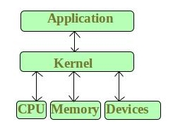

Kernel mode and User mode of CPU operation
The CPU can execute certain instruction only when it is in the kernel mode. These instruction are called privilege instruction.

The operating system puts the CPU in kernel mode when it is executing in the kernel so, that kernel can execute some special operation.
- The operating system puts the CPU in user mode when a user program is in execution so, that user program cannot interface with the operating system program.
- User-level instruction does not require special privilege. Example are ADD,PUSH,etc.

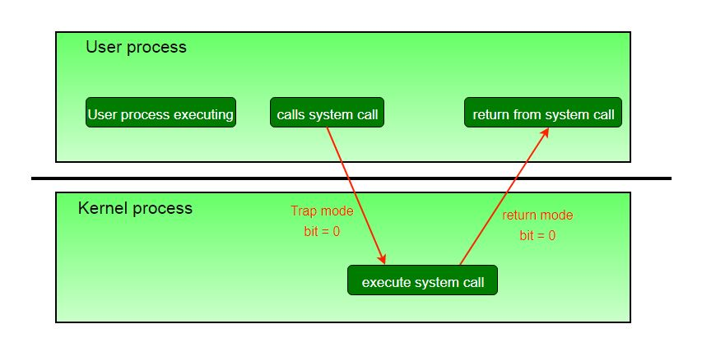

System calls are typically implemented in the form of software interrupts, which causes the hardware’s interrupt handler to transfer control over to an appropriate interrupt handler, which is part of the operating system, switching the mode bit to kernel mode in the process.

What is Microkernel?
Microkernel is one of the classification of the kernel. Being a kernel it manages all system resources. But in a microkernel, the user services and kernel services are implemented in different address space. The user services are kept in user address space, and kernel services are kept under kernel address space, thus also reduces the size of kernel and size of operating system as well.

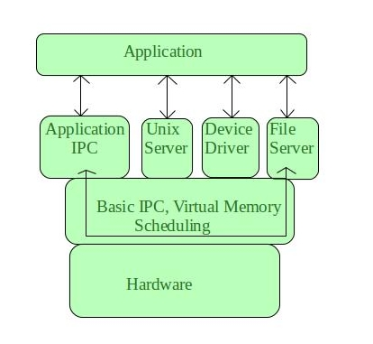

It provides minimal services of process and memory management. The communication between client program/application and services running in user address space is established through message passing, reducing the speed of execution microkernel. The Operating System remains unaffected as user services and kernel services are isolated so if any user service fails it does not affect kernel service. Thus it adds to one of the advantages in a microkernel.

Microkernel Architecture –
Since kernel is the core part of the operating system, so it is meant for handling the most important services only. Thus in this architecture only the most important services are inside kernel and rest of the OS services are present inside system application program. Thus users are able to interact with those not-so important services within the system application. And the microkernel is solely responsible for the most important services of operating system they are named as follows:
- Inter process-Communication
- Memory Management
- CPU-Scheduling
Advantages of Microkernel –
- The architecture of this kernel is small and isolated hence it can function better.
- Expansion of the system is easier, it is simply added in the system application without disturbing the kernel.

Monolithic Kernel and key differences from Microkernel

Apart from microkernel, Monolithic Kernel is another classification of Kernel. Like microkernel this one also manages system resources between application and hardware, but user services and kernel services are implemented under same address space. It increases the size of the kernel, thus increases size of operating system as well.
This kernel provides CPU scheduling, memory management, file management and other operating system functions through system calls. As both services are implemented under same address space, this makes operating system execution faster.
Below is the diagrammatic representation of Monolithic Kernel:

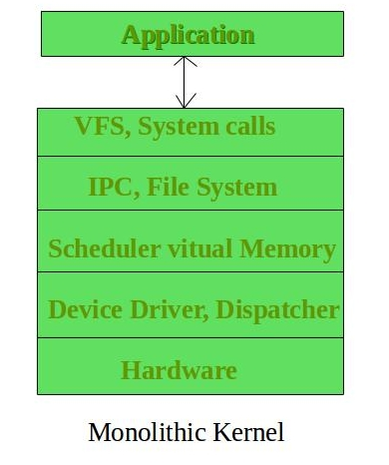

If any service fails the entire system crashes, and it is one of the drawbacks of this kernel. The entire operating system needs modification if user adds a new service.

Advantages of Monolithic Kernel –
- One of the major advantage of having monolithic kernel is that it provides CPU scheduling, memory management, file management and other operating system functions through system calls.
- The other one is that it is a single large process running entirely in a single address space.
- It is a single static binary file. Example of some Monolithic Kernel based OSs are: Unix, Linux, Open VMS, XTS-400, z/TPF.
Disadvantages of Monolithic Kernel –
- One of the major disadvantage of monolithic kernel is that, if anyone service fails it leads to entire system failure.
- If user has to add any new service. User needs to modify entire operating system.

Key differences between Monolithic Kernel and Microkernel –

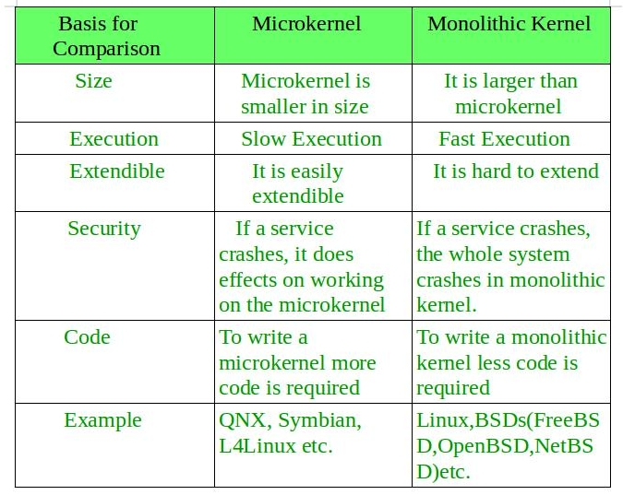

The Linux Kernel

The main purpose of a computer is to run a predefined sequence of instructions, known as a program. A program under execution is often referred to as a process. Now, most special purpose computers are meant to run a single process, but in a sophisticated system such a general purpose computer, are intended to run many processes simulteneously. Any kind of process requires hardware resources such are Memory, Processor time, Storage space, etc.
In a General Purpose Computer running many processes simulteneously, we need a middle layer to manage the distribution of the hardware resources of the computer efficiently and fairly among all the various processes running on the computer. This middle layer is referred to as the kernel. Basically the kernel virtualizes the common hardware resources of the computer to provide each process with its own virtual resources. This makes the process seem as it is the sole process running on the machine. The kernel is also responsible for preventing and mitigating conflicts between different processes.

This schematically represented below:
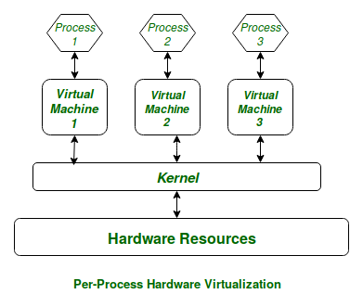
Figure: Virtual Resources for each Process

The Core Subsystems of the Linux Kernel are as follows:
The Process Scheduler
- The Memory Management Unit (MMU)
- The Virtual File System (VFS)
- The Networking Unit
- Inter-Process Communication Unit

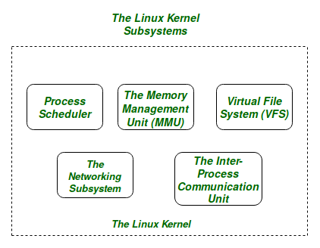

- The Process Scheduler:
This kernel subsystem is responsible for fairly distributing the CPU time among all the processes running on the system simulteneously.
- The Memory Management Unit:
This kernel sub-unit is responsible for proper distribution of the memory resources among the various processes running on the system. The MMU does more than just simply provide separate virtual address spaces for each of the processes.
- The Virtual File System:
This subsystem is responsible for providing a unified interface to access stored data across different filesystems and physical storage media.

Introduction of System Call

In computing, a system call is the programmatic way in which a computer program requests a service from the kernel of the operating system it is executed on. A system call is a way for programs to interact with the operating system. A computer program makes a system call when it makes a request to the operating system’s kernel. System call provides the services of the operating system to the user programs via Application Program Interface(API). It provides an interface between a process and operating system to allow user-level processes to request services of the operating system. System calls are the only entry points into the kernel system. All programs needing resources must use system calls.
Services Provided by System Calls :
- Process creation and management
- Main memory management
- File Access, Directory and File system management
- Device handling(I/O)
- Protection
- Networking, etc.
Types of System Calls : There are 5 different categories of system calls –
  - Process control:
end, abort, create, terminate, allocate and free memory.
  - File management:
create, open, close, delete, read file etc.
  - Device management
SetConsoleMode()
ReadConsole()
WriteConsole()
  - Information maintenance
getpid()
alarm()
sleep()
  - Communication
pipe()
shmget()
mmap()

Get/Set process resource limits in C

The getrlimit() and setrlimit() system calls can be used to get and set the resource limits such as files, CPU, memory etc. associated with a process.

Dual Mode operations in OS
An error in one program can adversely effect many processes, it might modify data of another program, or also can effect the operating system. For example, if a process stuck in infinite loop then this infinite loop could effect correct operation of other processes. So to ensure the proper execution of the operating system there are two modes of operation:
User mode –
When the computer system run user application like creating a text document or using any application program, then the system is in user mode. When the user application requests for a service from the operating system or an interrupt occurs or system call, then there there will be a transition from user to kernel mode to fulfill the requests.
Note: To switch from kernel mode to user mode, mode bit should be 1.
Given below image describes what happen interrupt occurs:
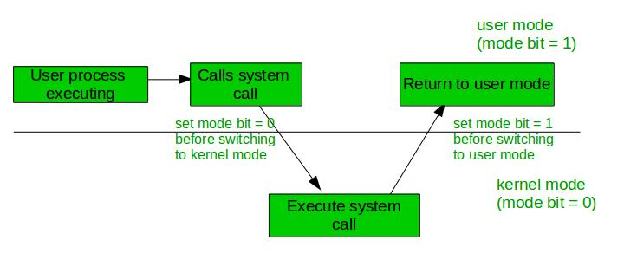
Kernel Mode –
When system boots then hardware starts in kernel mode and when operating system is loaded then it start user application in user mode. To provide protection to the hardware, we have privileged instructions which execute only in kernel mode. If user attempt to run privileged instruction in user mode then it will treat instruction as illegal and traps to OS. Some of the privileged instructions are:
- Handling Interrupts
- To switch from user mode to kernel mode.
- Input Output management.
Note: To switch from user mode to kernel mode mode bit should be 0.

Introduction of Operating System

An operating system acts as an intermediary between the user of a computer and computer hardware. The purpose of an operating system is to provide an environment in which a user can execute programs in a convenient and efficient manner.

An operating system is a software that manages the computer hardware. The hardware must provide appropriate mechanisms to ensure the correct operation of the computer system and to prevent user programs from interfering with the proper operation of the system.
Operating System – Definition:
- An operating system is a program that controls the execution of application programs and acts as an interface between the user of a computer and the computer hardware.
Every general purpose computer consists of the hardware, operating system, system programs, and application programs. The hardware consists of memory, CPU, ALU, and I/O devices, peripheral device, and storage device. System program consists of compilers, loaders, editors, OS, etc. The application program consists of business programs, database programs.
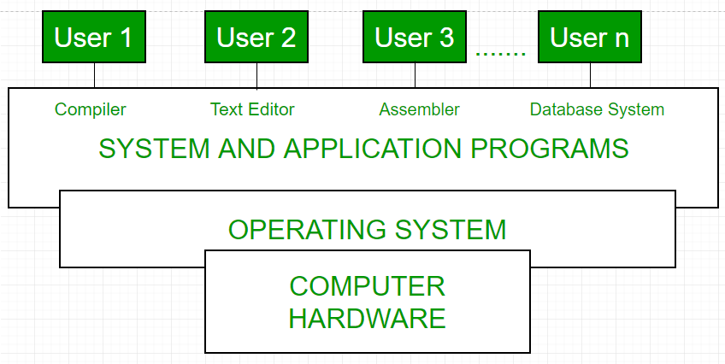

Types of Operating Systems

1. Batch Operating System –
This type of operating system does not interact with the computer directly. There is an operator which takes similar jobs having same requirement and group them into batches. It is the responsibility of operator to sort the jobs with similar needs.

Advantages of Batch Operating System:

It is very difficult to guess or know the time required by any job to complete. Processors of the batch systems know how long the job would be when it is in queue
- Multiple users can share the batch systems
- The idle time for batch system is very less
- It is easy to manage large work repeatedly in batch systems
Disadvantages of Batch Operating System:
- The computer operators should be well known with batch systems
- Batch systems are hard to debug
- It is sometime costly
- The other jobs will have to wait for an unknown time if any job fails
Examples of Batch based Operating System: Payroll System, Bank Statements etc.

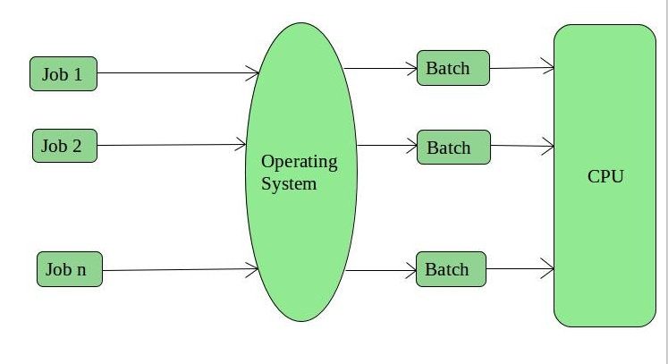

2. Time-Sharing Operating Systems –
Each task is given some time to execute, so that all the tasks work smoothly. Each user gets time of CPU as they use single system. These systems are also known as Multitasking Systems. The task can be from single user or from different users also. The time that each task gets to execute is called quantum. After this time interval is over OS switches over to next task.

Advantages of Time-Sharing OS:
- Each task gets an equal opportunity
- Less chances of duplication of software
- CPU idle time can be reduced
Disadvantages of Time-Sharing OS:
- Reliability problem
- One must have to take care of security and integrity of user programs and data
- Data communication problem
Examples of Time-Sharing OSs are: Multics, Unix etc.

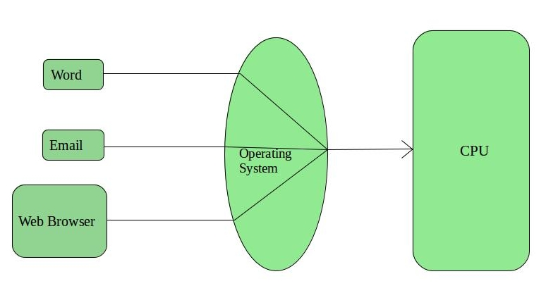

3. Distributed Operating System –
These types of operating system is a recent advancement in the world of computer technology and are being widely accepted all-over the world and, that too, with a great pace. Various autonomous interconnected computers communicate each other using a shared communication network. Independent systems possess their own memory unit and CPU. These are referred as loosely coupled systems or distributed systems. These system’s processors differ in size and function. The major benefit of working with these types of operating system is that it is always possible that one user can access the files or software which are not actually present on his system but on some other system connected within this network i.e., remote access is enabled within the devices connected in that network.

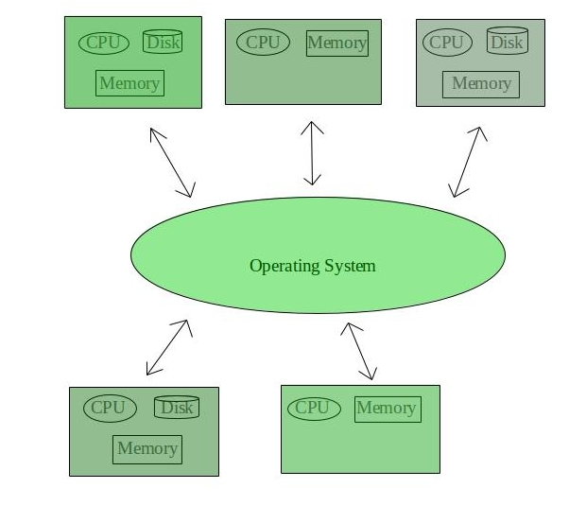

Advantages of Distributed Operating System:
- Failure of one will not affect the other network communication, as all systems are independent from each other
- Electronic mail increases the data exchange speed
- Since resources are being shared, computation is highly fast and durable
- Load on host computer reduces
- These systems are easily scalable as many systems can be easily added to the network
- Delay in data processing reduces
Disadvantages of Distributed Operating System:
- Failure of the main network will stop the entire communication
- To establish distributed systems the language which are used are not well defined yet
- These types of systems are not readily available as they are very expensive. Not only that the underlying software is highly complex and not understood well yet
Examples of Distributed Operating System are- LOCUS etc.

4. Network Operating System –
These systems run on a server and provide the capability to manage data, users, groups, security, applications, and other networking functions. These type of operating systems allow shared access of files, printers, security, applications, and other networking functions over a small private network. One more important aspect of Network Operating Systems is that all the users are well aware of the underlying configuration, of all other users within the network, their individual connections etc. and that’s why these computers are popularly known as tightly coupled systems.
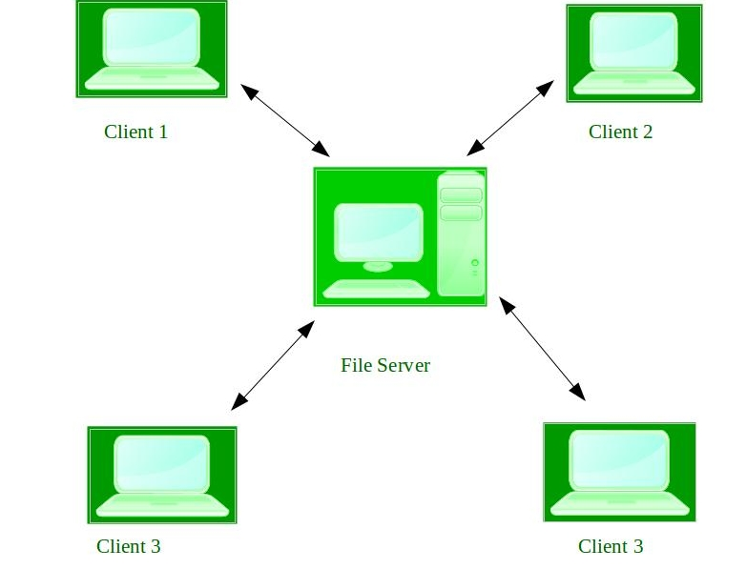

Advantages of Network Operating System:
- Highly stable centralized servers
- Security concerns are handled through servers
- New technologies and hardware up-gradation are easily integrated to the system
- Server access are possible remotely from different locations and types of systems
Disadvantages of Network Operating System:
- Servers are costly
- User has to depend on central location for most operations
- Maintenance and updates are required regularly
Examples of Network Operating System are: Microsoft Windows Server 2003, Microsoft Windows Server 2008, UNIX, Linux, Mac OS X, Novell NetWare, and BSD etc.

5. Real-Time Operating System –
These types of OSs serves the real-time systems. The time interval required to process and respond to inputs is very small. This time interval is called response time.
Real-time systems are used when there are time requirements are very strict like missile systems, air traffic control systems, robots etc.
Two types of Real-Time Operating System which are as follows:
- Hard Real-Time Systems:
These OSs are meant for the applications where time constraints are very strict and even the shortest possible delay is not acceptable. These systems are built for saving life like automatic parachutes or air bags which are required to be readily available in case of any accident. Virtual memory is almost never found in these systems.
- Soft Real-Time Systems:
These OSs are for applications where for time-constraint is less strict.

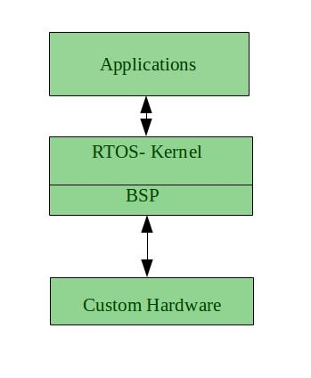
Advantages of RTOS:
- Maximum Consumption: Maximum utilization of devices and system,thus more output from all the resources
- Task Shifting: Time assigned for shifting tasks in these systems are very less. For example in older systems it takes about 10 micro seconds in shifting one task to another and in latest systems it takes 3 micro seconds.
- Focus on Application: Focus on running applications and less importance to applications which are in queue.
- Real time operating system in embedded system: Since size of programs are small, RTOS can also be used in embedded systems like in transport and others.
- Error Free: These types of systems are error free.
- Memory Allocation: Memory allocation is best managed in these type of systems.
Disadvantages of RTOS:
- Limited Tasks: Very few tasks run at the same time and their concentration is very less on few applications to avoid errors.
- Use heavy system resources: Sometimes the system resources are not so good and they are expensive as well.
- Complex Algorithms: The algorithms are very complex and difficult for the designer to write on.
- Device driver and interrupt signals: It needs specific device drivers and interrupt signals to response earliest to interrupts.
- Thread Priority: It is not good to set thread priority as these systems are very less prone to switching tasks.
Examples of Real-Time Operating Systems are: Scientific experiments, medical imaging systems, industrial control systems, weapon systems, robots, air traffic control systems, etc.

Functions of Operating System

An Operating System acts as a communication bridge (interface) between the user and computer hardware. The purpose of an operating system is to provide a platform on which a user can execute programs in a convenient and efficient manner.
An operating system is a piece of software that manages the allocation of computer hardware. The coordination of the hardware must be appropriate to ensure the correct working of the computer system and to prevent user programs from interfering with the proper working of the system.
What is Operating System ?
An operating system is a program on which application programs are executed and acts as an communication bridge (interface) between the user and the computer hardware.
The main task an operating system carries out is the allocation of resources and services, such as allocation of: memory, devices, processors and information. The operating system also includes programs to manage these resources, such as a traffic controller, a scheduler, memory management module, I/O programs, and a file system.
Important functions of an operating System:

- Security –
The operating system uses password protection to protect user data and similar other techniques. it also prevents unauthorized access to programs and user data.

- Control over system performance –
Monitors overall system health to help improve performance. records the response time between service requests and system response to have a complete view of the system health. This can help improve performance by providing important information needed to troubleshoot problems.

- Job accounting –
Operating system Keeps track of time and resources used by various tasks and users, this information can be used to track resource usage for a particular user or group of user.

- Error detecting aids –
Operating system constantly monitors the system to detect errors and avoid the malfunctioning of computer system.

- Coordination between other software and users –
Operating systems also coordinate and assign interpreters, compilers, assemblers and other software to the various users of the computer systems.

- Memory Management –
The operating system manages the Primary Memory or Main Memory. Main memory is made up of a large array of bytes or words where each byte or word is assigned a certain address. Main memory is a fast storage and it can be accessed directly by the CPU. For a program to be executed, it should be first loaded in the main memory. An Operating System performs the following activities for memory management:
It keeps tracks of primary memory, i.e., which bytes of memory are used by which user program. The memory addresses that have already been allocated and the memory addresses of the memory that has not yet been used. In multi programming, the OS decides the order in which process are granted access to memory, and for how long. It Allocates the memory to a process when the process requests it and deallocates the memory when the process has terminated or is performing an I/O operation.

- Processor Management –
In a multi programming environment, the OS decides the order in which processes have access to the processor, and how much processing time each process has. This function of OS is called process scheduling. An Operating System performs the following activities for processor management.
Keeps tracks of the status of processes. The program which perform this task is known as traffic controller. Allocates the CPU that is processor to a process. De-allocates processor when a process is no more required.

- Device Management –
An OS manages device communication via their respective drivers. It performs the following activities for device management. Keeps tracks of all devices connected to system. designates a program responsible for every device known as the Input/Output controller. Decides which process gets access to a certain device and for how long. Allocates devices in an effective and efficient way. Deallocates devices when they are no longer required.

- File Management –
A file system is organized into directories for efficient or easy navigation and usage. These directories may contain other directories and other files. An Operating System carries out the following file management activities. It keeps track of where information is stored, user access settings and status of every file and more… These facilities are collectively known as the file system.

Types of computer memory (RAM and ROM)

Memory is the most essential element of a computing system because without it computer can’t perform simple tasks. Computer memory is of two basic type – Primary memory / Volatile memory and Secondary memory / non-volatile memory. Random Access Memory (RAM) is volatile memory and Read Only Memory (ROM) is non-volatile memory.

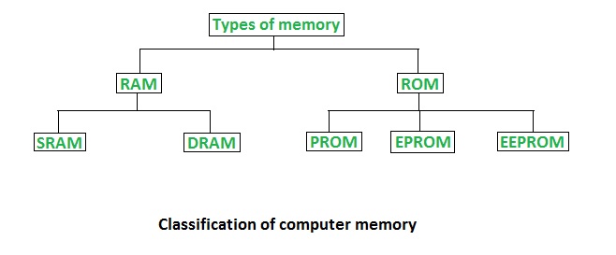

1. Random Access Memory (RAM) –
- It is also called as read write memory or the main memory or the primary memory.
- The programs and data that the CPU requires during execution of a program are stored in this memory.
- It is a volatile memory as the data loses when the power is turned off.
- RAM is further classified into two types- SRAM (Static Random Access Memory) and DRAM (Dynamic Random Access Memory).
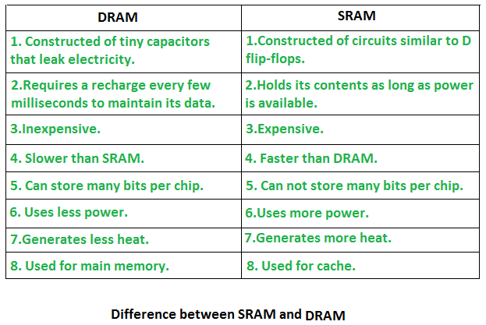

2. Read Only Memory (ROM) –
- Stores crucial information essential to operate the system, like the program essential to boot the computer.
- It is not volatile.
- Always retains its data.
- Used in embedded systems or where the programming needs no change.
- Used in calculators and peripheral devices.
- ROM is further classified into 4 types- ROM, PROM, EPROM, and EEPROM.

Types of Read Only Memory (ROM) –
- PROM (Programmable read-only memory) – It can be programmed by user. Once programmed, the data and instructions in it cannot be changed.
- EPROM (Erasable Programmable read only memory) – It can be reprogrammed. To erase data from it, expose it to ultra violet light. To reprogram it, erase all the previous data.
- EEPROM (Electrically erasable programmable read only memory) – The data can be erased by applying electric field, no need of ultra violet light. We can erase only portions of the chip.

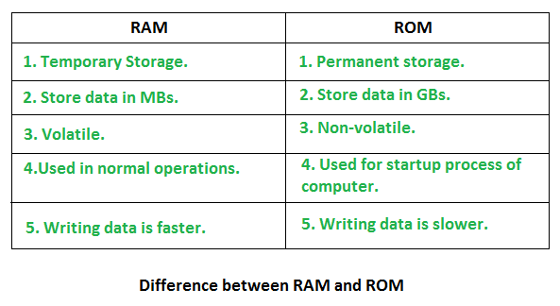

Difference between 32-bit and 64-bit operating systems

In computing, there exist two type processor i.e., 32-bit and 64-bit. These processor tells us how much memory a processor can have access from a CPU register. For instance,
A 32-bit system can access 232 memory addresses, i.e 4 GB of RAM or physical memory.
A 64-bit system can access 264 memory addresses, i.e actually 18-Quintillion GB of RAM. In short, any amount of memory greater than 4 GB can be easily handled by it.
Most computers made in the 1990s and early 2000s were 32-bit machines. The CPU register stores memory addresses, which is how the processor accesses data from RAM. One bit in the register can reference an individual byte in memory, so a 32-bit system can address a maximum of 4 GB (4,294,967,296 bytes) of RAM. The actual limit is often less around 3.5 GB, since part of the register is used to store other temporary values besides memory addresses. Most computers released over the past two decades were built on a 32-bit architecture, hence most operating systems were designed to run on a 32-bit processor.
A 64-bit register can theoretically reference 18,446,744,073,709,551,616 bytes, or 17,179,869,184 GB (16 exabytes) of memory. This is several million times more than an average workstation would need to access. What’s important is that a 64-bit computer (which means it has a 64-bit processor) can access more than 4 GB of RAM. If a computer has 8 GB of RAM, it better have a 64-bit processor. Otherwise, at least 4 GB of the memory will be inaccessible by the CPU.
A major difference between 32-bit processors and 64-bit processors is the number of calculations per second they can perform, which affects the speed at which they can complete tasks. 64-bit processors can come in dual core, quad core, six core, and eight core versions for home computing. Multiple cores allow for an increased number of calculations per second that can be performed, which can increase the processing power and help make a computer run faster. Software programs that require many calculations to function smoothly can operate faster and more efficiently on the multi-core 64-bit processors, for the most part.

Advantages of 64-bit over 32-bit
- Using 64-bit one can do a lot in multi-tasking, user can easily switch between various applications without any windows hanging problems.
- Gamers can easily plays High graphical games like Modern Warfare, GTA V, or use high-end softwares like Photoshop or CAD which takes a lot of memory, since it makes multi-tasking with big softwares easy and efficient for users. However upgrading the video card instead of getting a 64-bit processor would be more beneficial.

Note:
- A computer with a 64-bit processor can have a 64-bit or 32-bit version of an operating system installed. However, with a 32-bit operating system, the 64-bit processor would not run at its full capability.
- On a computer with a 64-bit processor, we can’t run a 16-bit legacy program. Many 32-bit programs will work with a 64-bit processor and operating system, but some older 32-bit programs may not function properly, or at all, due to limited or no compatibility.

What happens when we turn on computer?

A computer without a program running is just an inert hunk of electronics. The first thing a computer has to do when it is turned on is to start up a special program called an operating system. The operating system’s job is to help other computer programs to work by handling the messy details of controlling the computer’s hardware.
An overview of the boot process
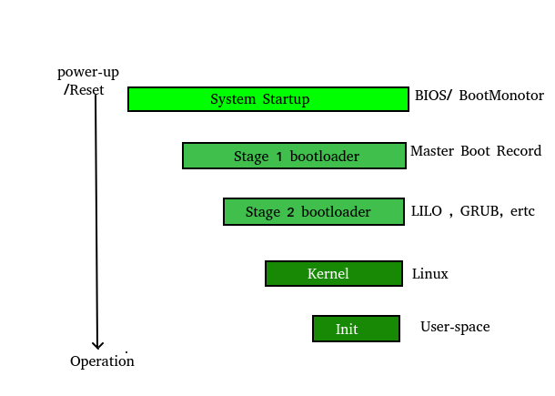

The boot process is something that happens every time you turn your computer on. You don’t really see it, because it happens so fast. You press the power button come back a few minutes later and Windows XP, or Windows Vista, or whatever Operating System you use is all loaded.

The BIOS chip tells it to look in a fixed place, usually on the lowest-numbered hard disk (the boot disk) for a special program called a boot loader (under Linux the boot loader is called Grub or LILO). The boot loader is pulled into memory and started. The boot loader’s job is to start the real operating system.
Functions of BIOS
POST (Power On Self Test) The Power On Self Test happens each time you turn your computer on. It sounds complicated and that’s because it kind of is. Your computer does so much when its turned on and this is just part of that.
It initializes the various hardware devices. It is an important process so as to ensure that all the devices operate smoothly without any conflicts. BIOSes following ACPI create tables describing the devices in the computer.
The POST first checks the bios and then tests the CMOS RAM. If there is no problem with this then POST continues to check the CPU, hardware devices such as the Video Card, the secondary storage devices such as the Hard Drive, Floppy Drives, Zip Drive or CD/DVD Drives. If some errors found then an error message is displayed on the screen or a number of beeps are heard. These beeps are known as POST beep codes.
Master Boot Record
The Master Boot Record (MBR) is a small program that starts when the computer is booting, in order to find the operating system (eg. Windows XP). This complicated process (called the Boot Process) starts with the POST (Power On Self Test) and ends when the Bios searches for the MBR on the Hard Drive, which is generally located in the first sector, first head, first cylinder (cylinder 0, head 0, sector 1).
A typical structure looks like:
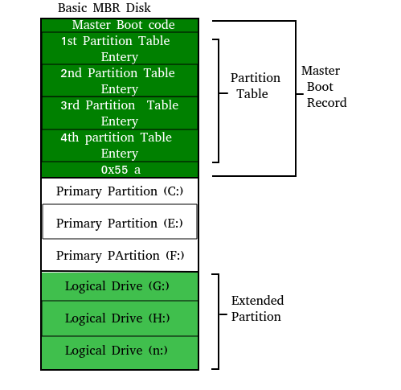
The bootstrap loader is stored in the master boot record (MBR) on the computer’s hard drive. When the computer is turned on or restarted, it first performs the power-on-self-test, also known as POST. If the POST is successful and no issues are found, the bootstrap loader will load the operating system for the computer into memory. The computer will then be able to quickly access, load, and run the operating system.
init
init is the last step of the kernel boot sequence. It looks for the file /etc/inittab to see if there is an entry for initdefault. It is used to determine initial run-level of the system. A run-level is used to decide the initial state of the operating system.
Some of the run levels are:

Level
- 0 –> System Halt
- 1 –> Single user mode
- 3 –> Full multiuser mode with network
- 5 –> Full multiuser mode with network and X display manager
- 6 –> Reboot
The above design of init is called SysV- pronounced as System five. Several other implementations of init have been written now. Some of the popular implementatios are systemd and upstart. Upstart is being used by ubuntu since 2006. More details of the upstart can be found here.
The next step of init is to start up various daemons that support networking and other services. X server daemon is one of the most important daemon. It manages display, keyboard, and mouse. When X server daemon is started you see a Graphical Interface and a login screen is displayed.

Boot Block

Basically for a computer to start running to get an instance when it is powered up or rebooted it need to have an initial program to run. And this initial program which is known as bootstrap need to be simple. It must initialize all aspects of the system, from CPU registers to device controllers and the contents of the main memory and then starts the operating system.
To do this job the bootstrap program basically finds the operating system kernel on disk and then loads the kernel into memory and after this, it jumps to the initial address to begin the operating-system execution.
Why ROM:
For most of today’s computer bootstrap is stored in Read Only Memory (ROM).
This location is good for storage because this place doesn’t require initialization and moreover location here it is fixed so that processor can start executing when powered up or reset.
- ROM is basically read-only memory and hence it cannot be affected by the computer virus.
The problem is that changing the bootstrap code basically requires changes in the ROM hardware chips.Because of this reason, most system nowadays has the tiny bootstrap loader program in the boot whose only job is to bring the full bootstrap program from the disk. Through this now we are able to change the full bootstrap program easily and the new version can be easily written onto the disk.
Full bootstrap program is stored in the boot blocks at a fixed location on the disk. A disk which has a boot partition is called a boot disk. The code in the boot ROM basically instructs the read controller to read the boot blocks into the memory and then starts the execution of code. The full bootstrap program is more complex than the bootstrap loader in the boot ROM, It is basically able to load the complete OS from a non-fixed location on disk to start the operating system running. Even though the complete bootstrap program is very small.
Example:
Let us try to understand this using an example of the boot process in Windows 2000.
The Windows 2000 basically stores its boot code in the first sector on the hard disk. Moreover, Windows 2000 allows the hard disk to be divided into one or more partition. In this one partition is basically identified as the boot partition which basically contains the operating system and the device drivers.
Booting in Windows 2000 starts by running the code that is placed in the system’s ROM memory. This code basically directs the system to read code directly from MBR. In addition to this boot code also contain the table which lists the partition for the hard disk and also a flag which basically indicates which partition is to be boot from the system. Once the system identifies the boot partition it reads the first sector from the memory which is basically known as boot sector and continue the process with the remainder of the boot process which basically includes loading of various system services.
The following figure shows the Booting from disk in Windows 2000.
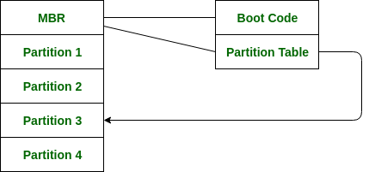

Privileged and Non-Privileged Instructions

In any Operating System, it is necessary to have Dual Mode Operation to ensure protection and security of the System from unauthorized or errant users . This Dual Mode separates the User Mode from the System Mode or Kernel Mode.
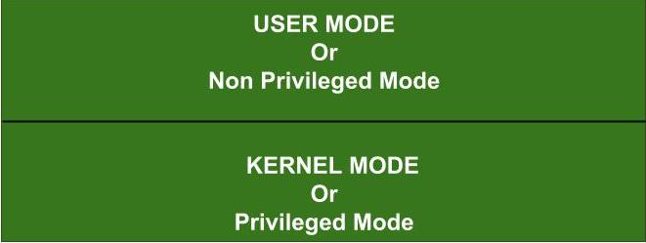

What are Privileged Instructions?
The Instructions that can run only in Kernel Mode are called Privileged Instructions .
Privileged Instructions possess the following characteristics :
(i) If any attempt is made to execute a Privileged Instruction in User Mode, then it will not be executed and treated as an illegal instruction. The Hardware traps it to the Operating System.
(ii) Before transferring the control to any User Program, it is the responsibility of the Operating System to ensure that the Timer is set to interrupt. Thus, if the timer interrupts then the Operating System regains the control.
Thus, any instruction which can modify the contents of the Timer is a Privileged Instruction.
(iii) Privileged Instructions are used by the Operating System in order to achieve correct operation.
(iv) Various examples of Privileged Instructions include:
- I/O instructions and Halt instructions
- Turn off all Interrupts
- Set the Timer
- Context Switching
- Clear the Memory or Remove a process from the Memory
- Modify entries in Device-status table
What are Non-Privileged Instructions?
The Instructions that can run only in User Mode are called Non-Privileged Instructions .
Various examples of Non-Privileged Instructions include:
- Reading the status of Processor
- Reading the System Time
- Generate any Trap Instruction
- Sending the final prinout of Printer
Also, it is important to note that in order to change the mode from Privileged to Non-Privileged, we require a Non-privileged Instruction that does not generate any interrupt.

Difference between Static and Shared libraries

In programming, a library is a collection of pre-compiled pieces of code that can be reused in a program. Libraries simplify life for programmers, in that they provide reusable functions, routines, classes, data structures and so on
which they can be reused in the programs.

Static Libraries : A Static library or statically-linked library is a set of routines, external functions and variables which are resolved in a caller at compile-time and copied into a target application by a compiler, linker, or binder, producing an object file and a stand-alone executable. This executable and the process of compiling it are both known as a static build of the program. Historically, libraries could only be static.
They are usually faster than the shared libraries because a set of commonly used object files is put into a single library executable file. One can build multiple executables without the need to recompile the file. Because it is a single file to be built, use of link commands are simpler than shared library link commands, because you specify the name of the static library.

Shared Libraries :
Shared libraries are .so (or in Windows .dll, or in OS X .dylib) files.
These are linked dynamically simply including the address of the library (whereas static linking is a waste of space). Dynamic linking links the libraries at the run-time. Thus, all the functions are in a special place in memory space, and every program can access them, without having multiple copies of them.

Static and Dynamic Libraries | Set 1

When a C program is compiled, the compiler generates object code. After generating the object code, the compiler also invokes linker. One of the main tasks for linker is to make code of library functions (eg printf(), scanf(), sqrt(), ..etc) available to your program. A linker can accomplish this task in two ways, by copying the code of library function to your object code, or by making some arrangements so that the complete code of library functions is not copied, but made available at run-time.

Static Linking and Static Libraries is the result of the linker making copy of all used library functions to the executable file. Static Linking creates larger binary files, and need more space on disk and main memory. Examples of static libraries (libraries which are statically linked) are, .a files in Linux and .lib files in Windows.

Steps to create a static library Let us create and use a Static Library in UNIX or UNIX like OS.
1. Create a C file that contains functions in your library.
filter_none
edit
play_arrow
brightness_4
/* Filename: lib_mylib.c */
#include <stdio.h>
void fun(void)
{
printf("fun() called from a static library");
}
We have created only one file for simplicity. We can also create multiple files in a library.

2. Create a header file for the library

filter_none
edit
play_arrow
brightness_4
/* Filename: lib_mylib.h */
void fun(void);

3. Compile library files.
gcc -c lib_mylib.c -o lib_mylib.o
4. Create static library. This step is to bundle multiple object files in one static library (see ar for details). The output of this step is static library.
ar rcs lib_mylib.a lib_mylib.o
5. Now our static library is ready to use. At this point we could just copy lib_mylib.a somewhere else to use it. For demo purposes, let us keep the library in the current directory.
Let us create a driver program that uses above created static library.
1. Create a C file with main function
filter_none
edit
play_arrow
brightness_4
/* filename: driver.c */
#include "lib_mylib.h"
void main()
{
fun();
}
2. Compile the driver program.
gcc -c driver.c -o driver.o
3. Link the compiled driver program to the static library. Note that -L. is used to tell that the static library is in current folder (See this for details of -L and -l options).
gcc -o driver driver.o -L. -l_mylib
4. Run the driver program
./driver
fun() called from a static library
Following are some important points about static libraries.
1. For a static library, the actual code is extracted from the library by the linker and used to build the final executable at the point you compile/build your application.
2. Each process gets its own copy of the code and data. Where as in case of dynamic libraries it is only code shared, data is specific to each process. For static libraries memory footprints are larger. For example, if all the window system tools were statically linked, several tens of megabytes of RAM would be wasted for a typical user, and the user would be slowed down by a lot of paging.
3. Since library code is connected at compile time, the final executable has no dependencies on the the library at run time i.e. no additional run-time loading costs, it means that you don’t need to carry along a copy of the library that is being used and you have everything under your control and there is no dependency.

4. In static libraries, once everything is bundled into your application, you don’t have to worry that the client will have the right library (and version) available on their system.
5. One drawback of static libraries is, for any change(up-gradation) in the static libraries, you have to recompile the main program every time.
6. One major advantage of static libraries being preferred even now “is speed”. There will be no dynamic querying of symbols in static libraries. Many production line software use static libraries even today.
Dynamic linking and Dynamic Libraries Dynamic Linking doesn’t require the code to be copied, it is done by just placing name of the library in the binary file. The actual linking happens when the program is run, when both the binary file and the library are in memory. Examples of Dynamic libraries (libraries which are linked at run-time) are, .so in Linux and .dll in Windows.
We will soon be covering more points on Dynamic Libraries and steps to create them.

Working with Shared Libraries | Set 1
This article is not for those algo geeks. If you are interested in systems related stuff, just read on…
Shared libraries are useful in sharing code which is common across many applications. For example, it is more economic to pack all the code related to TCP/IP implementation in a shared library. However, data can’t be shared as every application needs its own set of data. Applications like, browser, ftp, telnet, etc… make use of the shared ‘network’ library to elevate specific functionality.
Every operating system has its own representation and tool-set to create shared libraries. More or less the concepts are same. On Windows every object file (*.obj, *.dll, *.ocx, *.sys, *.exe etc…) follow a format called Portalbe Executable. Even shared libraries (called as Dynamic Linked Libraries or DLL in short) are also represented in PE format. The tool-set that is used to create these libraries need to understand the binary format. Linux variants follow a format called Executable and Linkable Format (ELF). The ELF files are position independent (PIC) format. Shared libraries in Linux are referred as shared objects (generally with extension *.so). These are similar to DLLs in Windows platform. Even shared object files follow the ELF binary format.
Remember, the file extensions (*.dll, *.so, *.a, *.lib, etc…) are just for programmer convenience. They don’t have any significance. All these are binary files. You can name them as you wish. Yet ensure you provide absolute paths in building applications.
In general, when we compile an application the steps are simple. Compile, Link and Load. However, it is not simple. These steps are more versatile on modern operating systems.

When you link your application against static library, the code is part of your application. There is no dependency. Even though it causes the application size to increase, it has its own advantages. The primary one is speed as there will be no symbol (a program entity) resolution at runtime. Since every piece of code part of the binary image, such applications are independent of version mismatch issues. However, the cost is on fixing an issue in library code. If there is any bug in library code, entire application need to be recompiled and shipped to the client. In case of dynamic libraries, fixing or upgrading the libraries is easy. You just need to ship the updated shared libraries. The application need not to recompile, it only need to re-run. You can design a mechanism where we don’t need to restart the application.
When we link an application against a shared library, the linker leaves some stubs (unresolved symbols) to be filled at application loading time. These stubs need to be filled by a tool called, dynamic linker at run time or at application loading time. Again loading of a library is of two types, static loading and dynamic loading. Don’t confuse between static loading vs static linking and dynamic loading vs dynamic linking.
For example, you have built an application that depends on libstdc++.so which is a shared object (dynamic libary). How does the application become aware of required shared libraries? (If you are interested, explore the tools tdump from Borland tool set, objdump or nm or readelf tools on Linux).
Static loading:
- In static loading, all of those dependent shared libraries are loaded into memory even before the application starts execution. If loading of any shared library fails, the application won’t run.
- A dynamic loader examines application’s dependency on shared libraries. If these libraries are already loaded into the memory, the library address space is mapped to application virtual address space (VAS) and the dynamic linker does relocation of unresolved symbols.
- If these libraries are not loaded into memory (perhaps your application might be first to invoke the shared library), the loader searches in standard library paths and loads them into memory, then maps and resolves symbols. Again loading is big process, if you are interested write your own loader :).
- While resolving the symbols, if the dynamic linker not able to find any symbol (may be due to older version of shared library), the application can’t be started.
Dynamic Loading:
- As the name indicates, dynamic loading is about loading of library on demand.
- For example, if you want a small functionality from a shared library. Why should it be loaded at the application load time and sit in the memory? You can invoke loading of these shared libraries dynamically when you need their functionality. This is called dynamic loading. In this case, the programmer aware of situation ‘when should the library be loaded’. The tool-set and relevant kernel provides API to support dynamic loading, and querying of symbols in the shared library.
More details in later articles.
Note: If you come across terms like loadable modules or equivalent terms, don’t mix them with shared libraries. They are different from shared libraries The kernels provide framework to support loadable modules.

Working with Shared Libraries | Set 2

We have covered basic information about shared libraries in the previous post. In the current article we will learn how to create shared libraries on Linux.
Prior to that we need to understand how a program is loaded into memory, various (basic) steps involved in the process.
Let us see a typical “Hello World” program in C. Simple Hello World program screen image is given below.

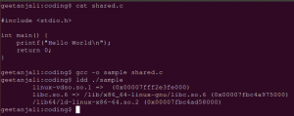

We were compiling our code using the command “gcc -o sample shared.c” When we compile our code, the compiler won’t resolve implementation of the function printf(). It only verifies the syntactical checking. The tool chain leaves a stub in our application which will be filled by dynamic linker. Since printf is standard function the compiler implicitly invoking its shared library. More details down.

We are using ldd to list dependencies of our program binary image. In the screen image, we can see our sample program depends on three binary files namely, linux-vdso.so.1, libc.so.6 and /lib64/ld-linux-x86-64.so.2.
The file VDSO is fast implementation of system call interface and some other stuff, it is not our focus (on some older systems you may see different file name in liue of *.vsdo.*). Ignore this file. We have interest in the other two files.
The file libc.so.6 is C implementation of various standard functions. It is the file where we see printf definition needed for our Hello World. It is the shared library needed to be loaded into memory to run our Hello World program.
The third file /lib64/ld-linux-x86-64.so.2 is infact an executable that runs when an application is invoked. When we invoke the program on bash terminal, typically the bash forks itself and replaces its address space with image of program to run (so called fork-exec pair). The kernel verifies whether the libc.so.6 resides in the memory. If not, it will load the file into memory and does the relocation of libc.so.6 symbols. It then invokes the dynamic linker (/lib64/ld-linux-x86-64.so.2) to resolve unresolved symbols of application code (printf in the present case). Then the control transfers to our program main. (I have intensionally omitted many details in the process, our focus is to understand basic details).
Creating our own shared library:
Let us work with simple shared library on Linux. Create a file library.c with the following content.
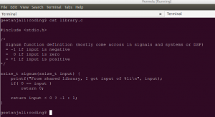
The file library.c defines a function signum which will be used by our application code. Compile the file library.c file using the following command.
gcc -shared -fPIC -o liblibrary.so library.c
The flag -shared instructs the compiler that we are building a shared library. The flag -fPIC is to generate position independent code (ignore for now). The command generates a shared library liblibrary.so in the current working directory. We have our shared object file (shared library name in Linux) ready to use.

Create another file application.c with the following content.
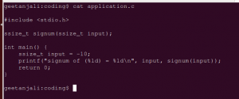
In the file application.c we are invoking the function signum which was defined in a shared library. Compile the application.c file using the following command.
gcc application.c -L /home/geetanjali/coding/ -llibrary -o sample
The flag -llibrary instructs the compiler to look for symbol definitions that are not available in the current code (signum function in our case). The option -L is hint to the compiler to look in the directory followed by the option for any shared libraries (during link time only). The command generates an executable named as “sample“.
If you invoke the executable, the dynamic linker will not be able to find the required shared library. By default it won’t look into current working directory. You have to explicitly instruct the tool chain to provide proper paths. The dynamic linker searches standard paths available in the LD_LIBRARY_PATH and also searches in system cache (for details explore the command ldconfig). We have to add our working directory to the LD_LIBRARY_PATH environment variable. The following command does the same.
export LD_LIBRARY_PATH=/home/geetanjali/coding/:$LD_LIBRARY_PATH
You can now invoke our executable as shown.
./sample
Sample output on my system is shown below.

