Program vs Process
A process is a program in execution. For example, when we write a program in C or C++ and compile it, the compiler creates binary code. The original code and binary code are both programs. When we actually run the binary code, it becomes a process.
A process is an ‘active’ entity, as opposed to a program, which is considered to be a ‘passive’ entity. A single program can create many processes when run multiple times; for example, when we open a .exe or binary file multiple times, multiple instances begin (multiple processes are created).
What does a process look like in memory?
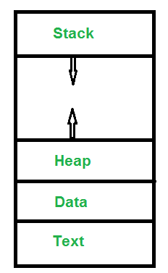
Text Section:A Process, sometimes known as the Text Section, also includes the current activity represented by the value of the Program Counter.
Stack: The Stack contains the temporary data, such as function parameters, returns addresses, and local variables.
Data Section: Contains the global variable.
Heap Section: Dynamically allocated memory to process during its run time.

Attributes or Characteristics of a Process
A process has following attributes.
1. Process Id: A unique identifier assigned by the operating system
2. Process State: Can be ready, running, etc.
3. CPU registers: Like the Program Counter (CPU registers must be saved and
restored when a process is swapped in and out of CPU)
5. Accounts information:
6. I/O status information: For example, devices allocated to the process,
open files, etc
8. CPU scheduling information: For example, Priority (Different processes
may have different priorities, for example
a short process may be assigned a low priority
in the shortest job first scheduling)

All of the above attributes of a process are also known as the context of the process.
Every process has its own program control block(PCB), i.e each process will have a unique PCB. All of the above attributes are part of the PCB.

States of Process:
A process is in one of the following states:
1. New: Newly Created Process (or) being-created process.

2. Ready: After creation process moves to Ready state, i.e. the
process is ready for execution.

3. Run: Currently running process in CPU (only one process at
a time can be under execution in a single processor).

4. Wait (or Block): When a process requests I/O access.

5. Complete (or Terminated): The process completed its execution.

6. Suspended Ready: When the ready queue becomes full, some processes
are moved to suspended ready state

7. Suspended Block: When waiting queue becomes full.

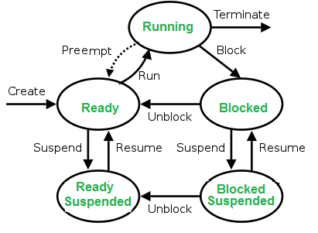
Context Switching
The process of saving the context of one process and loading the context of another process is known as Context Switching. In simple terms, it is like loading and unloading the process from running state to ready state.
When does context switching happen?
1. When a high-priority process comes to ready state (i.e. with higher priority than the running process)
2. An Interrupt occurs
3. User and kernel mode switch (It is not necessary though)
4. Preemptive CPU scheduling used.
Context Switch vs Mode Switch
A mode switch occurs when CPU privilege level is changed, for example when a system call is made or a fault occurs. The kernel works in more a privileged mode than a standard user task. If a user process wants to access things which are only accessible to the kernel, a mode switch must occur. The currently executing process need not be changed during a mode switch.
A mode switch typically occurs for a process context switch to occur. Only the kernel can cause a context switch.
CPU-Bound vs I/O-Bound Processes:
A CPU-bound process requires more CPU time or spends more time in the running state.
An I/O-bound process requires more I/O time and less CPU time. An I/O-bound process spends more time in the waiting state.

States of a process
- New (Create) – In this step, process is about to be created but not yet created, it is the program which is present in secondary memory that will be picked up by OS to create the process.
- Ready – New -> Ready to run. After creation of a process, the process enters the ready state i.e. the process is loaded into the main memory. The process here is ready to run and is waiting to get the CPU time for its execution. Processes that are ready for execution by the CPU are maintained in a queue for ready processes.
- Run – The process is chosen by CPU for execution and the instructions within the process are executed by any one of the available CPU cores.
- Blocked or wait – Whenever the process requests access to I/O or needs an input from user or needs access to a critical region(the lock for which is already acquired) it enters the blocked or wait state. The process continues to wait in the main memory and does not require CPU. Once the I/O operation is completed the process goes to ready state.
- Terminated or completed – Process is killed as well as PCB is deleted.
- Suspend ready – Process that were initially in ready state but were swapped out of main memory(refer Virtual Memory topic) and placed onto external storage by scheduler are said to be in suspend ready state. The process will transition back to ready state whenever the process is again brought onto the main memory.
- Suspend wait or suspend blocked – Similar to suspend ready but uses the process which was performing I/O operation and lack of main memory caused them to move to secondary memory.
When work is finished it may go to suspend ready.
CPU and IO Bound Processes:
If process is intensive in terms of CPU operations then it is called CPU bound process. Similarly, If process is intensive in terms of I/O operations then it is called IO bound process.

Types of schedulers:
- Long term – performance – Makes decision about how many processes should be made to stay in the ready state this decides the degree of multiprogramming. Once decision is taken it lasts for long time hence called long term scheduler.
- Short term – Context switching time – Short term scheduler will decide which process to be executed next and then it will call dispatcher. Dispatcher is a software that moves process from ready to run and vice versa. In other words, it is context switching.
- Medium term – Swapping time – Suspension decision is taken by medium term scheduler. Medium term scheduler is used for swapping that is moving the process from main memory to secondary and vice versa.

Multiprogramming – We have many processes ready to run. There are two types of multiprogramming:

- Pre-emption – Process is forcefully removed from CPU. Pre-emption is also called as time sharing or multitasking.
- Non pre-emption – Processes are not removed until they complete the execution.

Degree of multiprogramming –
The number of process that can reside in the ready state at maximum decides the degree of multiprogramming, e.g., if degree of programming = 100 means 100 processes can reside in the ready state at maximum.

Process Table and Process Control Block (PCB)
While creating a process the operating system performs several operations. To identify these process, it must identify each process, hence it assigns a process identification number (PID) to each process. As the operating system supports multi-programming, it needs to keep track of all the processes. For this task, the process control block (PCB) is used to track the process’s execution status. Each block of memory contains information about the process state, program counter, stack pointer, status of opened files, scheduling algorithms, etc. All these information is required and must be saved when the process is switched from one state to another. When the process made transitions from one state to another, the operating system must update information in the process’s PCB.
A process control block (PCB) contains information about the process, i.e. registers, quantum, priority, etc. The process table is an array of PCB’s, that means logically contains a PCB for all of the current processes in the system.
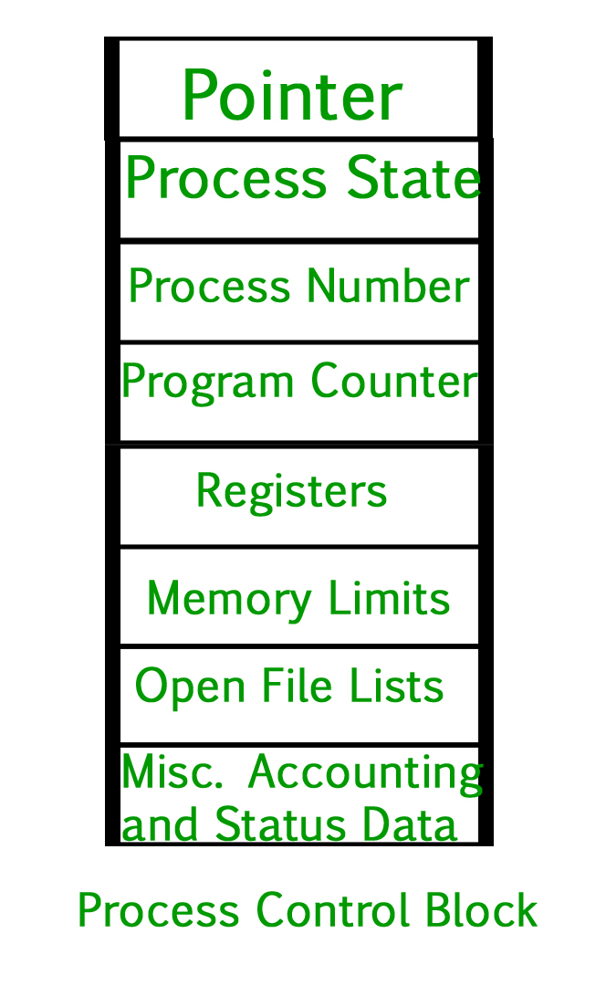
- Pointer – It is a stack pointer which is required to be saved when the process is switched from one state to another to retain the current position of the process.
- Process state – It stores the respective state of the process.
- Process number – Every process is assigned with a unique id known as process ID or PID which stores the process identifier.
- Program counter – It stores the counter which contains the address of the next instruction that is to be executed for the process.
- Register – These are the CPU registers which includes: accumulator, base, registers and general purpose registers.
- Memory limits – This field contains the information about memory management system used by operating system. This may include the page tables, segment tables etc.
- Open files list – This information includes the list of files opened for a process.
Miscellaneous accounting and status data – This field includes information about the amount of CPU used, time constraints, jobs or process number, etc.
The process control block stores the register content also known as execution content of the processor when it was blocked from running. This execution content architecture enables the operating system to restore a process’s execution context when the process returns to the running state. When the process made transitions from one state to another, the operating system update its information in the process’s PCB. The operating system maintains pointers to each process’s PCB in a process table so that it can access the PCB quickly.
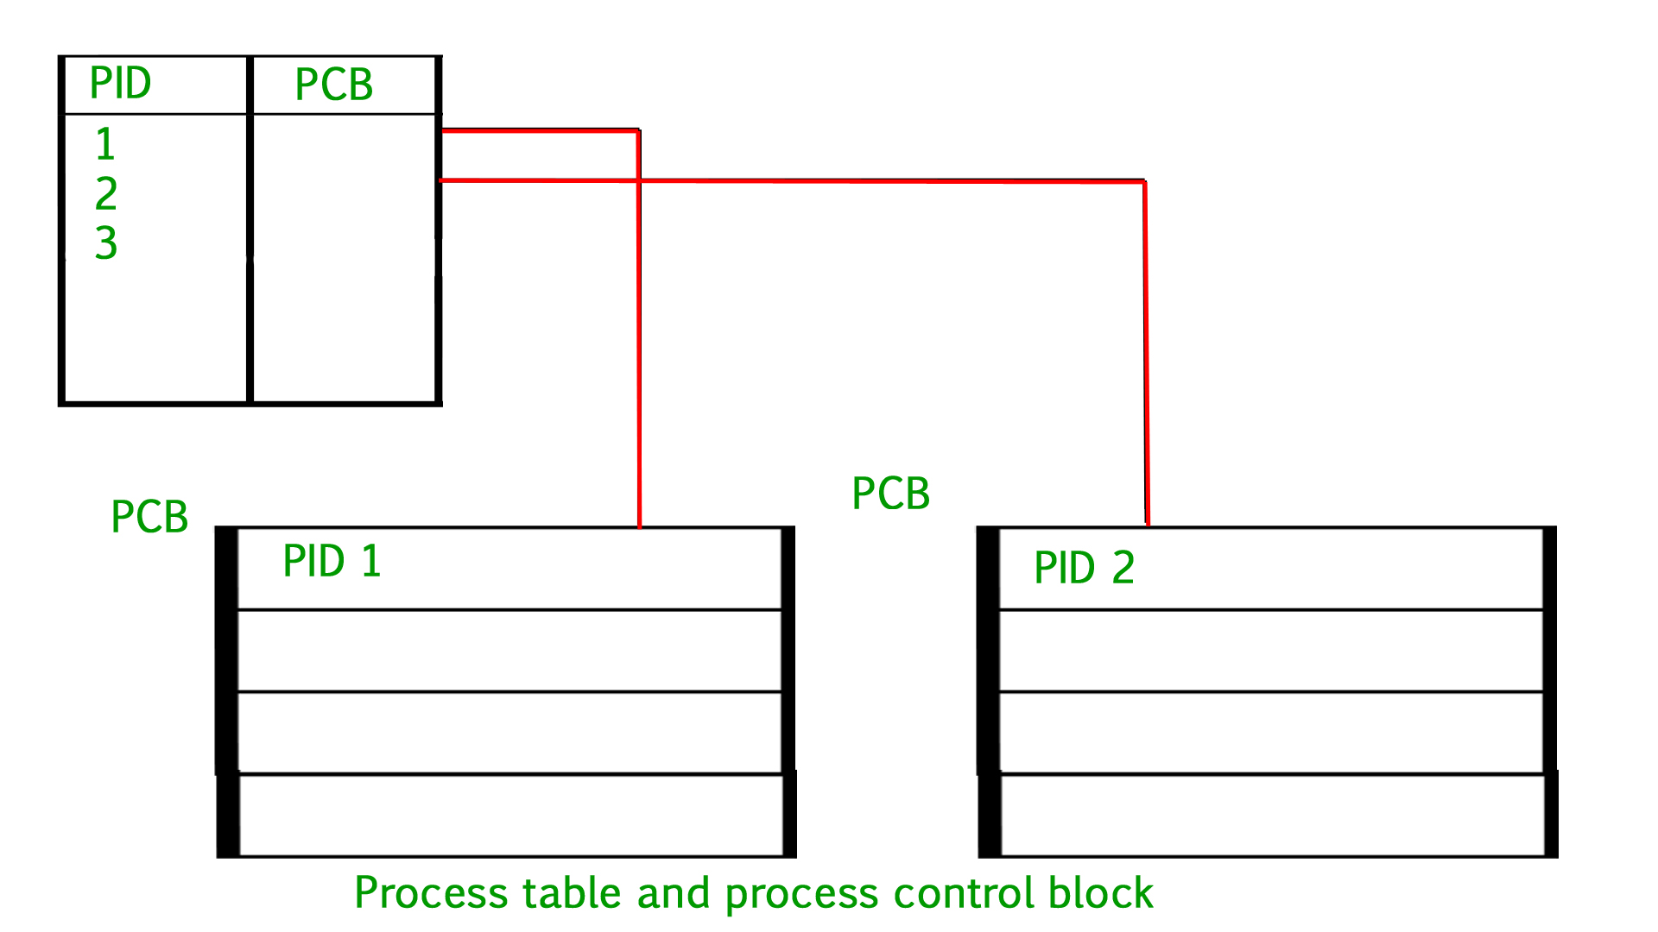

Process Management | CPU Scheduling
Arrival Time: Time at which the process arrives in the ready queue.
Completion Time: Time at which process completes its execution.
Burst Time: Time required by a process for CPU execution.
Turn Around Time: Time Difference between completion time and arrival time.
Turn Around Time = Completion Time - Arrival Time

Waiting Time(W.T): Time Difference between turn around time and burst time.
Waiting Time = Turn Around Time - Burst Time
Why do we need scheduling?
A typical process involves both I/O time and CPU time. In a uniprogramming system like MS-DOS, time spent waiting for I/O is wasted and CPU is free during this time. In multiprogramming systems, one process can use CPU while another is waiting for I/O. This is possible only with process scheduling.

Objectives of Process Scheduling Algorithm
Max CPU utilization [Keep CPU as busy as possible]
Fair allocation of CPU.
Max throughput [Number of processes that complete their execution per time unit]
Min turnaround time [Time taken by a process to finish execution]
Min waiting time [Time a process waits in ready queue]
Min response time [Time when a process produces first response]

Measure the time spent in context switch?
A Context switch is the time spent between two processes (i.e., bringing a waiting process into execution and sending an executing process into waiting state). This happens in multitasking.The operating system must bring the state information if waiting process into memory and save the state information of the currently running process.
In order to solve this problem, we would like to record the timestamps of the first and last instruction of the swapping processes.The context switch time is the difference between the two processes.
Let’s take an example: Assume there are only two processes, P1 and P2.
P1 is executing and P2 is waiting for execution. At some point, the operating system must swap P1 and P2, let’s assume it happens at the nth instruction of P1. If t(x, k) indicates the timestamp in microseconds of the kth instruction of process x, then the context switch would take t(2, 1) – t(1, n).
Another issue is that swapping is governed by the scheduling algorithm of the operating system and there may be many kernel level threads which are also doing context switches. Other processes could be contending for the CPU or the kernel handling interrupts. The user does not have any control over these extraneous context switches. For instance, if at time t(1, n) the kernel decides to handle an interrupt, then the context switch time would be overstated.
In order to avoid these obstacles, we must construct an environment such that after P1 executes, the task scheduler immediately selects P2 to run. This may be accomplished by constructing a data channel, such as a pipe between P1 and P2.

That is, let’s allow P1 to be the initial sender and P2 be the receiver. Initially, P2 is blocked(sleeping) as it awaits the data token. When P1 executes, it delivers the data token over the data channel to P2 and immediately attempts to read the response token. A context switch results and the task scheduler must selects another process to run.Since P2 is now in a ready-to-run state, it is a desirable candidate to be selected by the task scheduler for execution.When P2 runs, the role of P1 and P2 are swapped. P2 is now acting as the sender and P1 as the blocked receiver.
To summaries –
- P2 blocks awaiting data from P1
- P1 marks the starting time.
- P1 sends token to P2.
- P1 attempts to read a response token from P2. This induces a context switch.
- P2 is scheduled and receives the token.
- P2 sends a response token to P1.
- P2 attempts read a response token from P1. This induces a context switch.
- P1 is scheduled and receives the token.
- P1 marks the end time.
The key is that the delivery of a data token induces a context switch. Let Td and Tr be the time it takes to deliver and receive a data token, respectively, and let Tc be the amount of time spent in a context switch. At step 2, P1 records the timestamp of the delivery of the token, and at step 9, it records the timestamp of the response. The amount of time elapsed, T, between these events may be expressed by:
T = 2 * (Td + Tc + Tr)
This formula arises because of the following events:
- P1 sends the token (3)
- CPU context switches (4)
- P2 receives it (5)
- P2 then sends the response token (6)
- CPU context switches (7)
- and finally, P1 receives it (8)

Process Synchronization
Process Synchronization is a technique which is used to coordinate the process that use shared Data. There are two types of Processes in an Operating Systems:-
- Independent Process –
The process that does not affect or is affected by the other process while its execution then the process is called Independent Process. Example The process that does not share any shared variable, database, files, etc.
- Cooperating Process –
The process that affect or is affected by the other process while execution, is called a Cooperating Process. Example The process that share file, variable, database, etc are the Cooperating Process.
Process Synchronization is mainly used for Cooperating Process that shares the resources.Let us consider an example of
//racing condition image
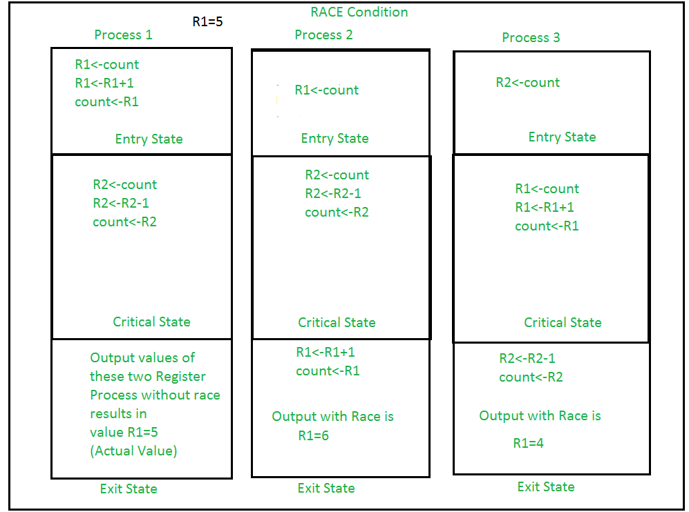

It is the condition where several processes tries to access the resources and modify the shared data concurrently and outcome of the process depends on the particular order of execution that leads to data inconsistency, this condition is called Race Condition.This condition can be avoided using the technique called Synchronization or Process Synchronization, in which we allow only one process to enter and manipulates the shared data in Critical Section.
//diagram of the view of CS
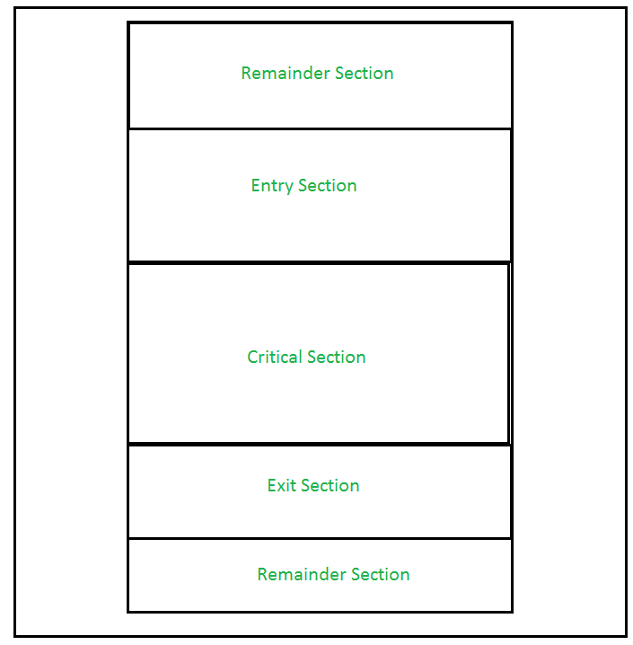

This setup can be defined in various regions like:
- Entry Section –
It is part of the process which decide the entry of a particular process in the Critical Section, out of many other processes.
- Critical Section –
It is the part in which only one process is allowed to enter and modify the shared variable.This part of the process ensures that only no other process can access the resource of shared data.
- Exit Section –
This process allows the other process that are waiting in the Entry Section, to enter into the Critical Sections. It checks that a process that after a process has finished execution in Critical Section can be removed through this Exit Section.
- Remainder Section –
The other parts of the Code other than Entry Section, Critical Section and Exit Section are known as Remainder Section.
Critical Section problems must satisfy these three requirements:
- Mutual Exclusion –
It states that no other process is allowed to execute in the critical section if a process is executing in critical section.
- Progress –
When no process is in the critical section, then any process from outside that request for execution can enter in the critical section without any delay. Only those process can enter that have requested and have finite time to enter the process.
- Bounded Waiting –
An upper bound must exist on the number of times a process enters so that other processes are allowed to enter their critical sections after a process has made a request to enter its critical section and before that request is granted.
Process Synchronization are handled by two approaches:
- Software Approach –
In Software Approach, Some specific Algorithm approach is used to maintain synchronization of the data. Like in Approach One or Approach Two, for a number of two process, a temporary variable like (turn) or boolean variable (flag) value is used to store the data. When the condition is True then the process in waiting State, known as Busy Waiting State. This does not satisfy all the Critical Section requirements.
Another Software approach known as Peterson’s Solution is best for Synchronization. It uses two variables in the Entry Section so as to maintain consistency, like Flag (boolean variable) and Turn variable(storing the process states). It satisfy all the three Critical Section requirements.
//Image of Peterson’s Algorithm
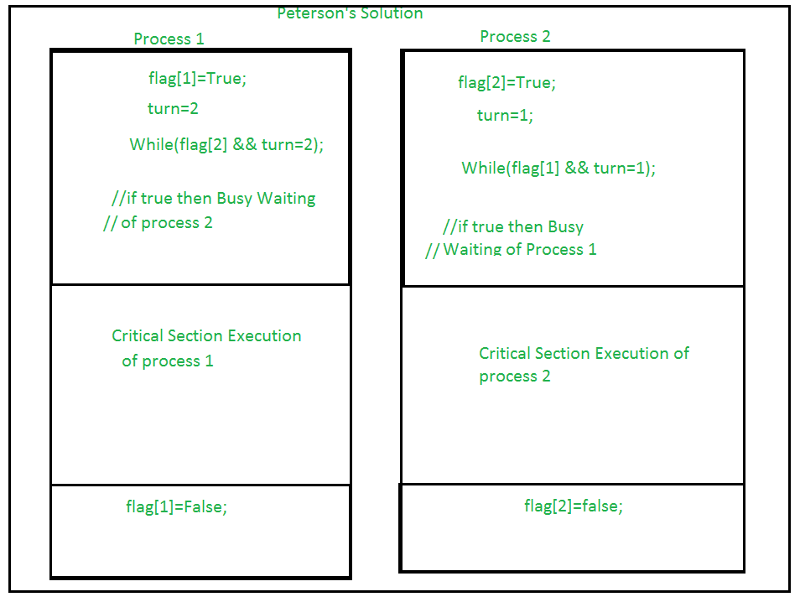
- Hardware Approach –
The Hardware Approach of synchronization can be done through Lock & Unlock technique.Locking part is done in the Entry Section, so that only one process is allowed to enter into the Critical Section, after it complete its execution, the process is moved to the Exit Section, where Unlock Operation is done so that another process in the Lock Section can repeat this process of Execution.This process is designed in such a way that all the three conditions of the Critical Sections are satisfied.
//Image of Lock
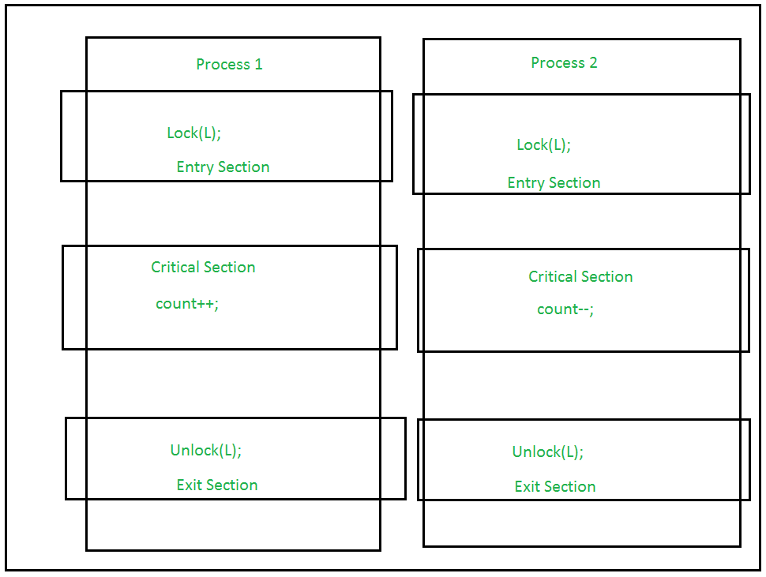
Using Interrupts –
These are easy to implement.When Interrupt are disabled then no other process is allowed to perform Context Switch operation that would allow only one process to enter into the Critical State.
//Image of Interrupts
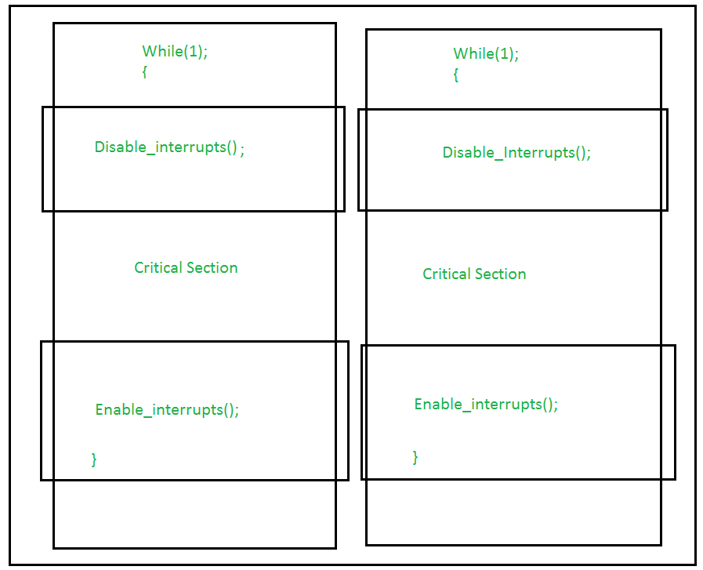
Test_and_Set Operation –
This allows boolean value (True/False) as a hardware Synchronization, which is atomic in nature i.e no other interrupt is allowed to access.This is mainly used in Mutual Exclusion Application. Similar type operation can be achieved through Compare and Swap function. In this process, a variable is allowed to accessed in Critical Section while its lock operation is ON.Till then, the other process is in Busy Waiting State. Hence Critical Section Requirements are achieved.

