- Array
- String
- Matrix
- Bitwise
- Linked List (Single, Double, Circular, Stack, Queue, Tree)

- After building the bin how to check which platform it is build for?
- How to find centre element of C?
- Delete linked list without head pointer
- Find nth to last element in linked list
- Volatile practical use cases
- What is Compiler optimization ? Why we need it ?
- Recursion vs Loop ?
- Static vs Dynamic linking
- Static vs shared library
- How to load library at 1) load time 2) compile time 3) run time
- Fifo stack linked list
- Reverse a linked list
- Delete a node in linked list
- Find nth node from last in linked list
- Find middle element in linked list
- I love prog – prog love i
- reverse words
- Find smallest and second smallest

- Memory Regions in C

Global = Data segment
Static = Data Segment
Const = Text / Code segment
Local var = Stack segment
Main fun var = Stack segment
Global / Static pointer = Data segment
Local pointer = Stack

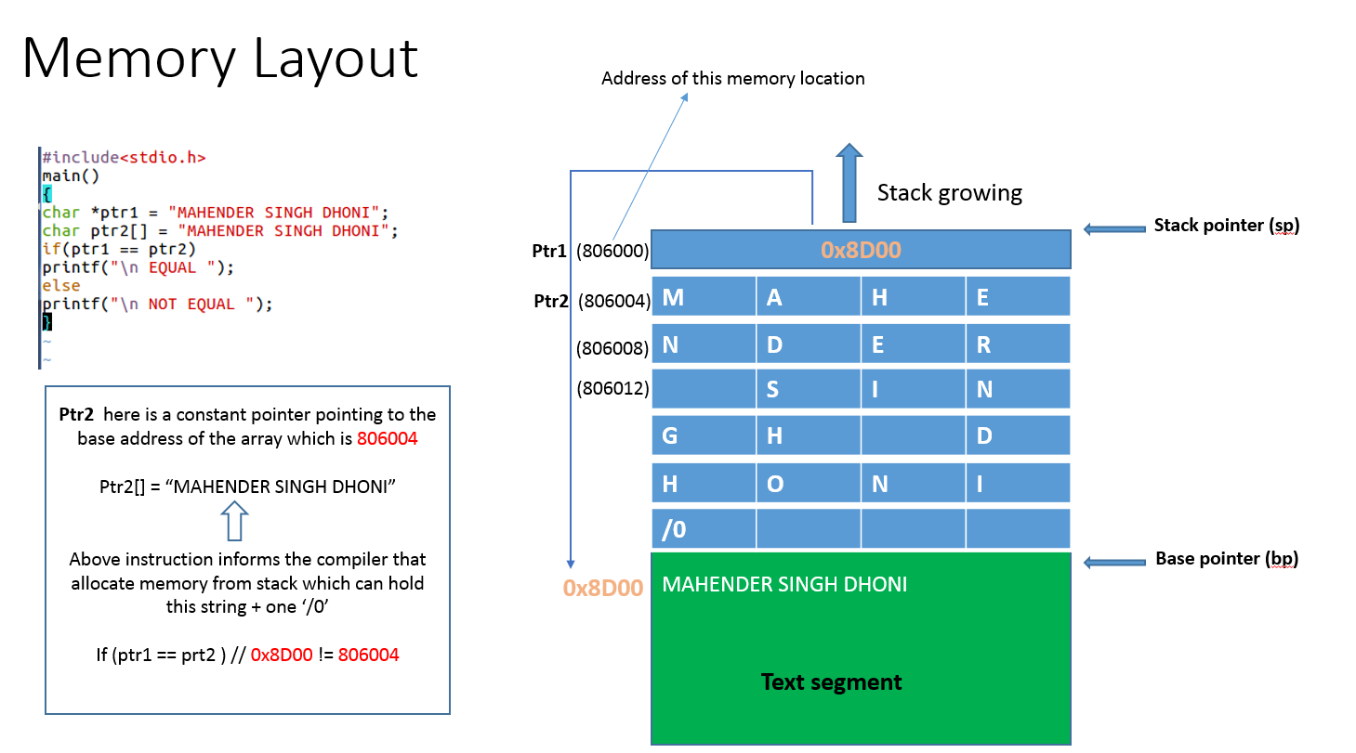

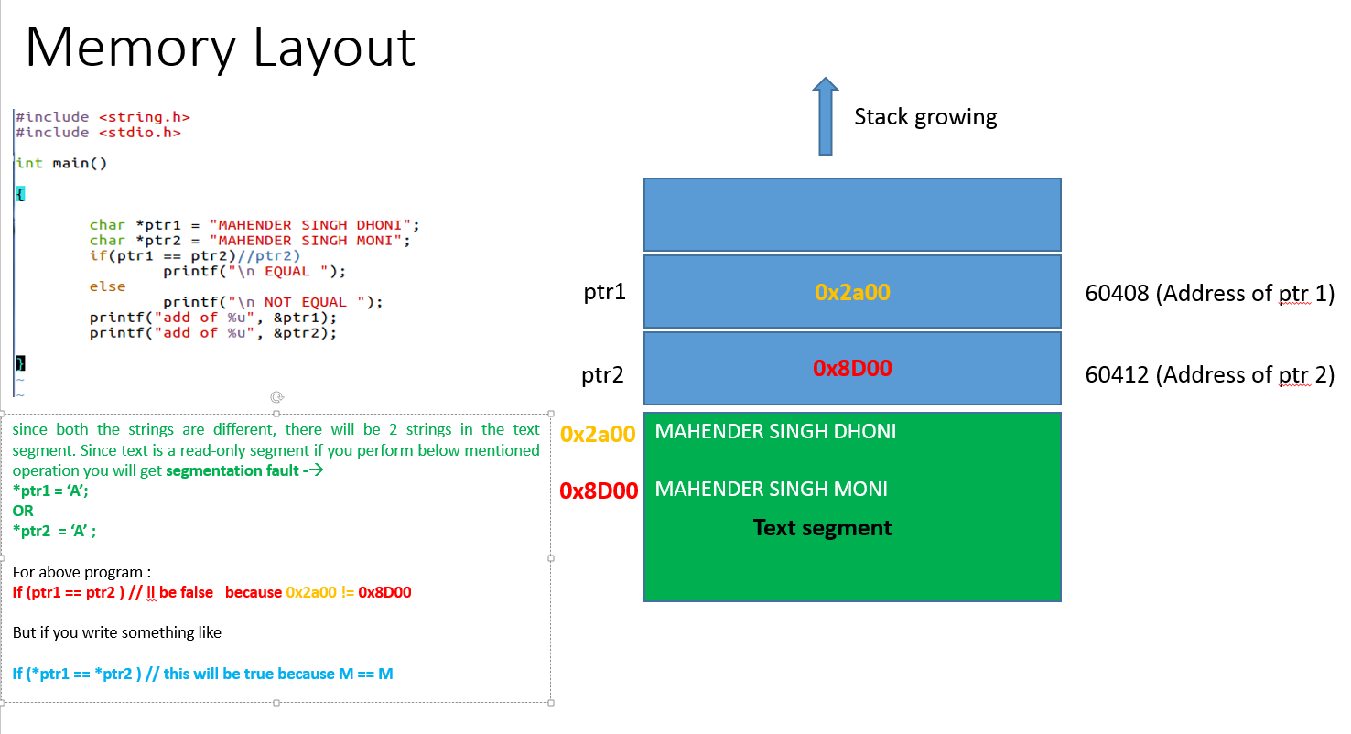
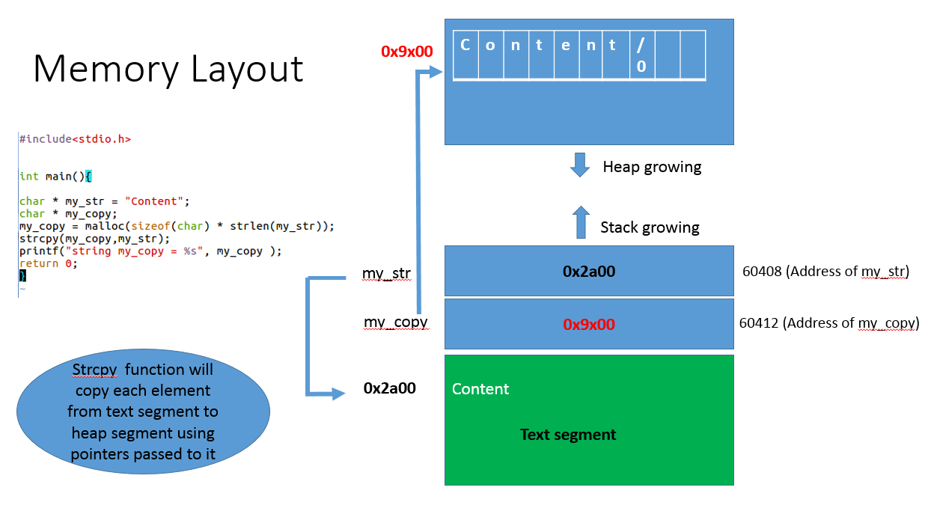
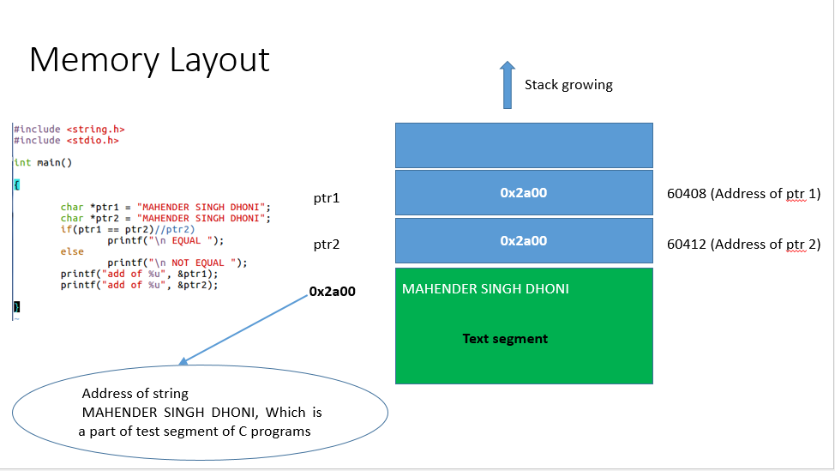

What is segmentation fault?

Access of illegal memory

In which scenerio it occurs ?

Causes
Case 1:
You are accessing array out of bound
Case 2:
Size of array is very large
Case 3:
Accessing NULL pointer
Case 4:
Calling recursion function very long to fill the stack memory

Case 5:
Working on a dangling pointer

Case 6:
Freeing a memory twice

Case 7:
Working on Returned address of a local variable

How to check and debug it ?

Valgrind
Gdb

How to find that error using gdb?

Step 1: Compile it
gcc -g Program1.c

Step 2: Run it
./a.out

Step 3:Debug it
gdb ./a.out core

How to prevent it?

two ways
Case 1:
Write the program carefully so it never happens
Case 2:
Let it happen and then take care of it using debugger like GDB
I prefer second one because while wrtng code focus on logic once logic goes wrong everything is in vain

Have you ever faced segmentation ?

Errors in C/C++

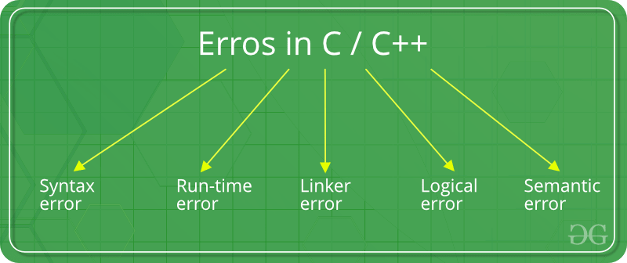
Syntax errors

When you do not follow the rules

Run-time Errors : Errors which occur during program execution(run-time) after successful compilation are called run-time errors. One of the most common run-time error is division by zero also known as Division error

Linker Errors: These error occurs when after compilation we link the different object files with main’s object

Logical Errors : On compilation and execution of a program, desired output is not obtained when certain input values are given. These types of errors which provide incorrect output but appears to be error free are called logical errors

Semantic errors : This error occurs when the statements written in the program are not meaningful to the compiler.

Error Handling in C programs

Different methods of Error handling in C
- Global Variable errno: When a function is called in C, a variable named as errno is automatically assigned a code (value) which can be used to identify the type of error that has been encountered. Its a global variable indicating the error occurred during any function call and defined in the header file errno.h.
- perror() and strerror(): The errno value got above indicate the types of error encountered.
If it is required to show the error description, then there are two functions that can be used to display a text message that is associated with errorno. The functions are:
- perror: It displays the string you pass to it, followed by a colon, a space, and then the textual representation of the current errno value.
- strerror(): returns a pointer to the textual representation of the current errno value.

