Array
Array in C is the collection of similar data type, all the elements are stored at the contiguous memory location. In c or c++ language we can create a static or dynamic array, the static array has the fixed size but the size of the dynamic array can be changed at runtime. The dynamic array is created using the pointer and library functions (malloc, calloc) or new operator which are used to allocate the memory from the heap or free store.
Use the memset to clear all block of the character array, it provides the surety that every block of the array contains zero.

a[i] = *(a + i);

*(a + i) = a[i];

(a + i) = &a[i];

If the value of i is 0.

( a + 0) = &a[0];

a = &a[0];

means that array name is the address of its first element.

a[i] [j] = *(*(a+i) + j)

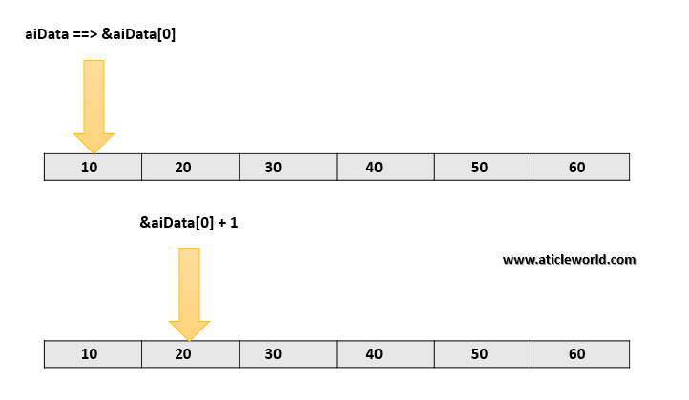

Note: But when you put the ampersand(&) before the array name then its type change.It becomes a pointer to the array.

In the short, we can say.

a = Pointer to the first element of the array .

&a = Pointer to an array of 6 elements.

&a + 1 = Address of next memory block (Address ahead of 6 integers)

*(&a + 1) = Dereferencing to *(&a + 1) gives the address of first element of second memory block.

*(&a + 1) – a = Since *(&a + 1) points to the address ahead of 6 integers , the difference between two is 6.

Ways to passing a 2D array as parameter to the function
Similar to the 1D array we can pass the 2D array as a parameter to the function. It is important to remember that when we pass a 2D array as a parameter decays into a pointer to an array, not a pointer to a pointer.

Passing 2d array to function in c using pointers
The first element of the multi-dimensional array is another array, so here, when we will pass a 2D array then it would be split into a pointer to the array.
For example,
If int aiData[3][3], is a 2D array of integers, it would be split into a pointer to the array of 3 integers (int (*)[3]).

