Critical Section:
In simple terms a critical section is group of instructions/statements or region of code that need to be executed atomically (read this post for atomicity), such as accessing a resource (file, input or output port, global data, etc.).
In concurrent programming, if one thread tries to change the value of shared data at the same time as another thread tries to read the value (i.e. data race across threads), the result is unpredictable.
The access to such shared variable (shared memory, shared files, shared port, etc…) to be synchronized. Few programming languages have built-in support for synchronization.
It is critical to understand the importance of race condition while writing kernel mode programming (a device driver, kernel thread, etc.). since the programmer can directly access and modifying kernel data structures.

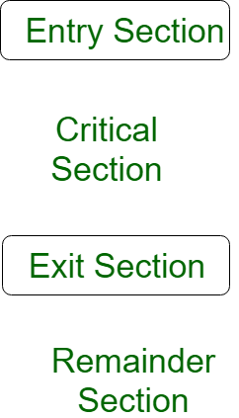

A simple solution to the critical section can be thought as shown below,
acquireLock();
Process Critical Section
releaseLock();
A thread must acquire a lock prior to executing a critical section. The lock can be acquired by only one thread. There are various ways to implement locks in the above pseudo code. Let us discuss them in future articles.
Please write comments if you find anything incorrect, or you want to share more information about the topic discussed above.
Critical Section Problem
Critical section is a code segment that can be accessed by only one process at a time. Critical section contains shared variables which need to be synchronized to maintain consistency of data variables.
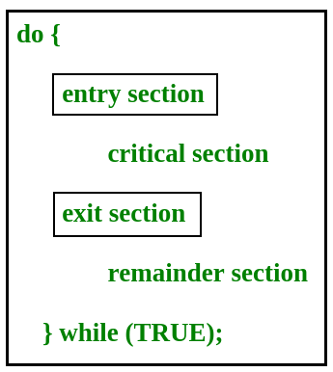

In the entry section, the process requests for entry in the Critical Section.
Any solution to the critical section problem must satisfy three requirements:
- Mutual Exclusion : If a process is executing in its critical section, then no other process is allowed to execute in the critical section.
- Progress : If no process is executing in the critical section and other processes are waiting outside the critical sectios, then only those processes that are not executing in their remainder section can participate in deciding which will enter in the critical section next, and the selection can not be postponed indefinitely.
- Bounded Waiting : A bound must exist on the number of times that other processes are allowed to enter their critical sections after a process has made a request to enter its critical section and before that request is granted.

Peterson’s Solution
Peterson’s Solution is a classical software based solution to the critical section problem.
In Peterson’s solution, we have two shared variables:
- boolean flag[i] :Initialized to FALSE, initially no one is interested in entering the critical section
- int turn : The process whose turn is to enter the critical section.
Peterson’s Solution preserves all three conditions :

- Mutual Exclusion is assured as only one process can access the critical section at any time.
- Progress is also assured, as a process outside the critical section does not blocks other processes from entering the critical section.
- Bounded Waiting is preserved as every process gets a fair chance.
Disadvantages of Peterson’s Solution
  - It involves Busy waiting
  - It is limited to 2 processes.

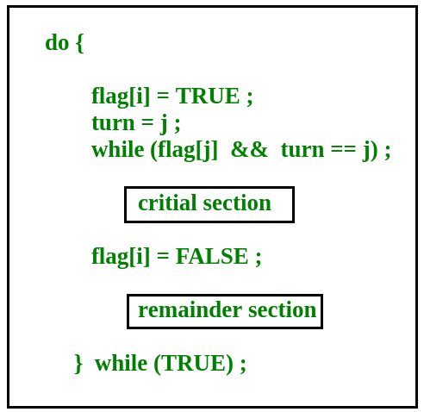
TestAndSet
TestAndSet is a hardware solution to the synchronization problem. In TestAndSet, we have a shared lock variable which can take either of the two values, 0 or 1.
0 Unlock
1 Lock
Before entering into the critical section, a process inquires about the lock. If it is locked, it keeps on waiting till it become free and if it is not locked, it takes the lock and executes the critical section.
In TestAndSet, Mutual exclusion and progress are preserved but bounded waiting cannot be preserved.

Semaphores
A Semaphore is an integer variable, which can be accessed only through two operations wait() and signal().
There are two types of semaphores : Binary Semaphores and Counting
Semaphores
- Binary Semaphores : They can only be either 0 or 1. They are also known as mutex locks, as the locks can provide mutual exclusion. All the processes can share the same mutex semaphore that is initialized to 1. Then, a process has to wait until the lock becomes 0. Then, the process can make the mutex semaphore 1 and start its critical section. When it completes its critical section, it can reset the value of mutex semaphore to 0 and some other process can enter its critical section.

- Counting Semaphores : They can have any value and are not restricted over a certain domain. They can be used to control access a resource that has a limitation on the number of simultaneous accesses. The semaphore can be initialized to the number of instances of the resource. Whenever a process wants to use that resource, it checks if the number of remaining instances is more than zero, i.e., the process has an instance available. Then, the process can enter its critical section thereby decreasing the value of the counting semaphore by 1. After the process is over with the use of the instance of the resource, it can leave the critical section thereby adding 1 to the number of available instances of the resource.

Mutex vs Semaphore

What are the differences between Mutex vs Semaphore? When to use mutex and when to use semaphore?

The producer-consumer problem:
Consider the standard producer-consumer problem. Assume, we have a buffer of 4096 byte length. A producer thread collects the data and writes it to the buffer. A consumer thread processes the collected data from the buffer. Objective is, both the threads should not run at the same time.
Using Mutex:
A mutex provides mutual exclusion, either producer or consumer can have the key (mutex) and proceed with their work. As long as the buffer is filled by producer, the consumer needs to wait, and vice versa.
At any point of time, only one thread can work with the entire buffer. The concept can be generalized using semaphore.
Using Semaphore:
A semaphore is a generalized mutex. In lieu of single buffer, we can split the 4 KB buffer into four 1 KB buffers (identical resources). A semaphore can be associated with these four buffers. The consumer and producer can work on different buffers at the same time.
Misconception:
There is an ambiguity between binary semaphore and mutex. We might have come across that a mutex is binary semaphore. But they are not! The purpose of mutex and semaphore are different. May be, due to similarity in their implementation a mutex would be referred as binary semaphore.
Strictly speaking, a mutex is locking mechanism used to synchronize access to a resource. Only one task (can be a thread or process based on OS abstraction) can acquire the mutex. It means there is ownership associated with mutex, and only the owner can release the lock (mutex).
Semaphore is signaling mechanism (“I am done, you can carry on” kind of signal). For example, if you are listening songs (assume it as one task) on your mobile and at the same time your friend calls you, an interrupt is triggered upon which an interrupt service routine (ISR) signals the call processing task to wakeup.

General Questions:
1. Can a thread acquire more than one lock (Mutex)?
Yes, it is possible that a thread is in need of more than one resource, hence the locks. If any lock is not available the thread will wait (block) on the lock.
2. Can a mutex be locked more than once?
A mutex is a lock. Only one state (locked/unlocked) is associated with it. However, a recursive mutex can be locked more than once (POSIX complaint systems), in which a count is associated with it, yet retains only one state (locked/unlocked). The programmer must unlock the mutex as many number times as it was locked.
3. What happens if a non-recursive mutex is locked more than once.
Deadlock. If a thread which had already locked a mutex, tries to lock the mutex again, it will enter into the waiting list of that mutex, which results in deadlock. It is because no other thread can unlock the mutex. An operating system implementer can exercise care in identifying the owner of mutex and return if it is already locked by same thread to prevent deadlocks.
4. Are binary semaphore and mutex same?
No. We suggest to treat them separately, as it is explained signalling vs locking mechanisms. But a binary semaphore may experience the same critical issues (e.g. priority inversion) associated with mutex. We will cover these in later article.
A programmer can prefer mutex rather than creating a semaphore with count 1.

5. What is a mutex and critical section?
Some operating systems use the same word critical section in the API. Usually a mutex is costly operation due to protection protocols associated with it. At last, the objective of mutex is atomic access. There are other ways to achieve atomic access like disabling interrupts which can be much faster but ruins responsiveness. The alternate API makes use of disabling interrupts.

6. What are events?
The semantics of mutex, semaphore, event, critical section, etc… are same. All are synchronization primitives. Based on their cost in using them they are different. We should consult the OS documentation for exact details.
7. Can we acquire mutex/semaphore in an Interrupt Service Routine?
An ISR will run asynchronously in the context of current running thread. It is not recommended to query (blocking call) the availability of synchronization primitives in an ISR. The ISR are meant be short, the call to mutex/semaphore may block the current running thread. However, an ISR can signal a semaphore or unlock a mutex.
8. What we mean by “thread blocking on mutex/semaphore” when they are not available?
Every synchronization primitive has a waiting list associated with it. When the resource is not available, the requesting thread will be moved from the running list of processor to the waiting list of the synchronization primitive. When the resource is available, the higher priority thread on the waiting list gets the resource (more precisely, it depends on the scheduling policies).
9. Is it necessary that a thread must block always when resource is not available?
Not necessary. If the design is sure ‘what has to be done when resource is not available‘, the thread can take up that work (a different code branch). To support application requirements the OS provides non-blocking API.
For example POSIX pthread_mutex_trylock() API. When mutex is not available the function returns immediately whereas the API pthread_mutex_lock() blocks the thread till resource is available.

Semaphores

Semaphore is simply a variable. This variable is used to solve the critical section problem and to achieve process synchronization in the multiprocessing environment.
The two most common kinds of semaphores are counting semaphores and binary semaphores. Counting semaphore can take non-negative integer values and Binary semaphore can take the value 0 & 1. only.
Now let us see how it do so.
First, look at two operations which can be used to access and change the value of the semaphore variable.

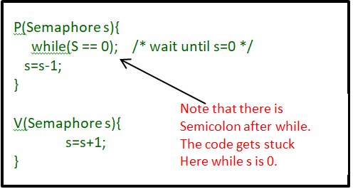

Some point regarding P and V operation
- P operation is also called wait, sleep or down operation and V operation is also called signal, wake-up or up operation.
- Both operations are atomic and semaphore(s) is always initialized to one.
- A critical section is surrounded by both operations to implement process synchronization.See below image.critical section of Process P is in between P and V operation.
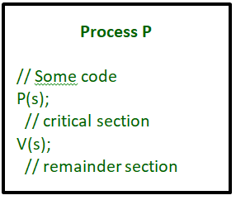

Now, let us see how it implements mutual exclusion. Let there be two processes P1 and P2 and a semaphore s is initialized as 1. Now if suppose P1 enters in its critical section then the value of semaphore s becomes 0. Now if P2 wants to enter its critical section then it will wait until s > 0, this can only happen when P1 finishes its critical section and calls V operation on semaphore s. This way mutual exclusion is achieved. Look at the below image for details.

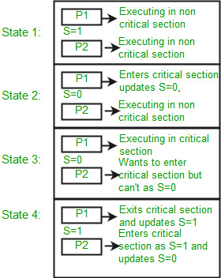
The description above is for binary semaphore which can take only two values 0 and 1. There is one other type of semaphore called counting semaphore which can take values greater than one.
Now suppose there is a resource whose number of instance is 4. Now we initialize S = 4 and rest is same as for binary semaphore. Whenever process wants that resource it calls P or wait function and when it is done it calls V or signal function. If the value of S becomes zero then a process has to wait until S becomes positive. For example, Suppose there are 4 process P1, P2, P3, P4 and they all call wait operation on S(initialized with 4). If another process P5 wants the resource then it should wait until one of the four processes calls signal function and value of semaphore becomes positive.
Problem in this implementation of semaphore
Whenever any process waits then it continuously checks for semaphore value (look at this line while (s==0); in P operation) and waste CPU cycle. To avoid this another implementation is provided below.

P(Semaphore s)
{
s = s - 1;
if (s <= 0) {

// add process to queue
block();
}
}

V(Semaphore s)
{
s = s + 1;
if (s <= 0) {

// remove process p from queue
wakeup(p);
}
}

In this implementation whenever process waits it is added to a waiting queue of processes associated with that semaphore. This is done through system call block() on that process. When a process is completed it calls signal function and one process in the queue is resumed. It uses wakeup() system call.

