**CHEF**

Chef is an automation company. Ever since it was founded in 2008, we’ve been bringing together developers and system administrators with our namesake product, Chef. Over the years, what we mean by automation has expanded. Today, Chef has a complete automation solution for both infrastructure and applications that takes you all the way from development to production. Here’s the complete Chef solution.

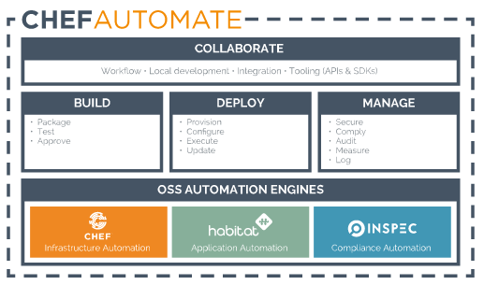

Chef is a powerful automation platform that transforms infrastructure into code. Whether you’re operating in the cloud, on-premises, or in a hybrid environment, Chef automates how infrastructure is configured, deployed, and managed across your network, no matter its size.

This diagram shows how you develop, test, and deploy your Chef code.

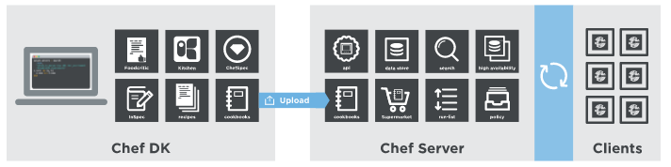

Practical:-

centos7_server 192.168.114.143 :-

Download chef-server latest package

# wget https://packages.chef.io/files/stable/chef-server/12.12.0/el/7/chef-server-core-12.12.0-1.el7.x86_64.rpm

# ls

# rpm -ivh chef-server-core-12.12.0-1.el7.x86_64.rpm

# chef-server-ctl reconfigure

# vi /etc/hosts ----- add client and workstation entries

If you want GUI :-

# chef-server-ctl install chef-manage

# chef-manage-ctl reconfigure

# cd /etc/chef

# chef-server-ctl user-create admin admin admin admin@abc.com password --filename admin.pem

# chef-server-ctl org-create cybage "cybage pvt ltd" --association_user admin -f cybage-validation.pem

==================================================================================================================================================

centos7_client 192.168.114.144 :-

Download chef-client latest package

# wget https://packages.chef.io/files/stable/chef/12.18.31/el/7/chef-12.18.31-1.el7.x86_64.rpm

# ls

# rpm -ivh chef-12.18.31-1.el7.x86_64.rpm

# vi /etc/hosts ----- add server and workstation entries

==================================================================================================================================================

centos7_workstation 192.168.114.145 :-

Download chef-client latest package

# wget https://packages.chef.io/files/stable/chef/12.18.31/el/7/chef-12.18.31-1.el7.x86_64.rpm

# ls

# rpm -ivh chef-12.18.31-1.el7.x86_64.rpm

# vi /etc/hosts ----- add server and client entries

Two options :- Manually and GUI

Manually :-

# mkdir .chef

# cd .chef/

# vi knife.rb

# cat knife.rb

log_level :debug # Can be :debug :warn or :info

log_location STDOUT # Can be STDERR

node_name 'admin'

client_key '~/.chef/admin.pem'

chef_server_url 'https://centos7_server'

cookbook_path [ '/var/chef/cookbooks/' ]

# mkdir -p /var/chef/cookbooks