**DOCKER SWARM CLUSTER**

**Installation and H/W requirement:-**

1. Install the Docker version >=1.12 via rpm or via source code on all the nodes.
2. Docker swarm is in built in Docker version >=1.12 so no other package is required.
3. Make sure you have at least 2GB of memory and 2 CPUs for smooth functioning.
4. All the nodes must be accessible on network and connected with each other via network.

**Docker repo access:**

1. Please create account on Docker hub [**https://hub.docker.com/login/**](https://hub.docker.com/login/) **.** It’s free and useful when you will try to download and upload Docker image across the nodes.

**Set up:**

1. **On server /manager:-**

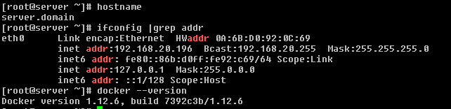

1. Initialize the docker swarm by below command

#docker swarm init --advertise-addr 192.168.20.196

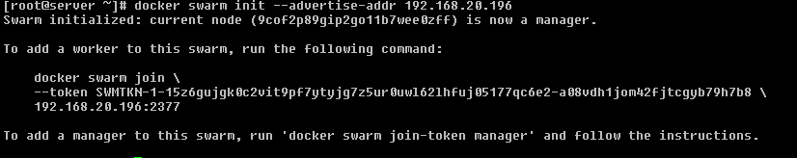

**Note** –This will generate a token to add worker to this cluster.

1. Check the status of cluster, as we can see only one node which is a manager. We need to add some worker node in this cluster.



1. **On Worker node:**
2. Run the token as shown in the above process.

# docker swarm join \

> --token SWMTKN-1-15z6gujgk0c2vit9pf7ytyjg7z5ur0uwl62lhfuj05177qc6e2-a08vdh1jom42fjtcgyb79h7b8 \

> 192.168.20.196:2377



**Note** – In case you forget the token to add worker you can run below command on server/manager to retrieve the token.

#docker swarm join-token worker # For worker node

#docker swarm join-token manager # For manager node

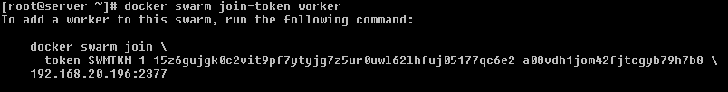

1. **Commands:**
2. To check the cluster status and node info.

#docker ps –l



1. To promote or demote a node in cluster.

# docker node promote client.domain



1. To demote a node in cluster.

#docker node demote client.domain

1. Login to Docker hub for images.

#docker login -u <username>

1. Download the images form the Docker hub.

#docker pull kufu/pjangra:v2

