Introduction
The <stdlib.h>-resident C programming language standard library functions srand() and rand() can be used to generate several types of randomly-chosen datums, namely, double-precision reals ∈ [0.0,1.0); int-egers ∈ [LB,UB]; bool-eans ∈ { false,true }with bias; and char-acters chosen from a fixed set of characters.

Implementation
//--------------------------------------------------
// Dr. Art Hanna
// Header file for random-related pseudo-library
// Random.h
//--------------------------------------------------
#ifndef RANDOM_H
#define RANDOM_H

#ifndef __cplusplus
#include <stdlib.h>
#include <time.h>
#include <stdbool.h>
#else
#include <cstdlib>
#include <ctime>
#endif

// Initialize the "seed" used by the <stdlib.h> "rand()" function.
void SetRandomSeed(void);

// Return a uniformly and randomly-chosen integer from [ LB,UB ].
int RandomInt(const int LB,const int UB);

// Return a uniformly and randomly-chosen real number from [ 0.0,1.0 ).
double RandomDouble(void);

// Return a biased and randomly-chosen bool from { false,true }.
bool RandomBool(const double bias);

// Return a uniformly and randomly-chosen character from chars[i], i in [ 0,(size-1) ].
char RandomChar(const char chars[],const int size);

#endif

//-----------------------------------------------------
// Dr. Art Hanna
// Function definition file for random-related pseudo-library
// Random.c
//-----------------------------------------------------

#include ".\Random.h"

//-----------------------------------------------------
void SetRandomSeed(void)
//-----------------------------------------------------
{
srand( (unsigned int) time(NULL) );
}

//-----------------------------------------------------
int RandomInt(const int LB,const int UB)
//-----------------------------------------------------
{
return( (int) ((UB-LB+1)*RandomDouble()) + LB );
}

//--------------------------------------------------
double RandomDouble()
//--------------------------------------------------
{
int R;

do
R = rand();
while ( R == RAND_MAX );
return( (double) R/RAND_MAX );
}

//-----------------------------------------------------
bool RandomBool(const double bias)
//-----------------------------------------------------
{
// Return true (0.0 <= bias <= 1.0)*100 percent of the time
return( ((double) RandomInt(1,1000000)/1000000) <= bias );
}

//-----------------------------------------------------
char RandomChar(const char chars[],const int size)
//-----------------------------------------------------
{
return( chars[RandomInt(0,(size-1))] );
}

Ideally, these random-related utility functions should be able to be used by an application program in exactly the same way as the ANSI C programming language standard library functions printf(), scanf(), pow(), et cetera, are used. Question How are these standard library functions provided to an application program? Answer Simply #include an appropriate (.h)eader file in the application program that references the standard library functions, then compile and link the application program. Great idea, but sorry, no can do! Using the random-related functions described above is not quite that easy, but there is a relatively simple way to use the functions in client application programs as pseudo-library functions. To do so, just follow these steps

(1) locate the header file Random.h that contains the utility function prototypes
(2) locate the source file Random.c that contains the utility function definitions
(3) place an #include "Random.h" in the application source file (ensuring that the path used in the #include correctly locates Random.h)
(4) create an IDE project that specifies both Random.c and the client application source file name
(5) build the client application load module by pre-processing, compiling, and linking all the requisite project source files
For example, here’s a sample client application—aptly named SampleRandom.c—that uses all of the random-related pseudo-library functions.

//--------------------------------------------------
// Dr. Art Hanna
// Sample random-related client application program
// SampleRandom.c
//--------------------------------------------------
#include <stdio.h>
#include <stdlib.h>
#include <stdbool.h>

#include ".\Random.h"

//--------------------------------------------------
int main()
//--------------------------------------------------
{
printf("RAND_MAX = %d\n\n",RAND_MAX);

SetRandomSeed();

for (int i = 1; i <= 7; i++)
{
printf("RandomInt(1,6) = %d\n",RandomInt(1,6));
printf("RandomDouble() = %.2f\n",RandomDouble());
printf("RandomBool(0.5) = %s\n",RandomBool(0.5) ? "true" : "false");
printf("RandomChar(\"ABCDE\",5) = %c\n\n",RandomChar("ABCDE",5));
}

system("PAUSE");
return( 0 );
}

Here’s what the IDE Dev-C++ 5.11 version of the SampleRandom.dev project file looks like (other IDEs will look different but consist of the same fundamental information).

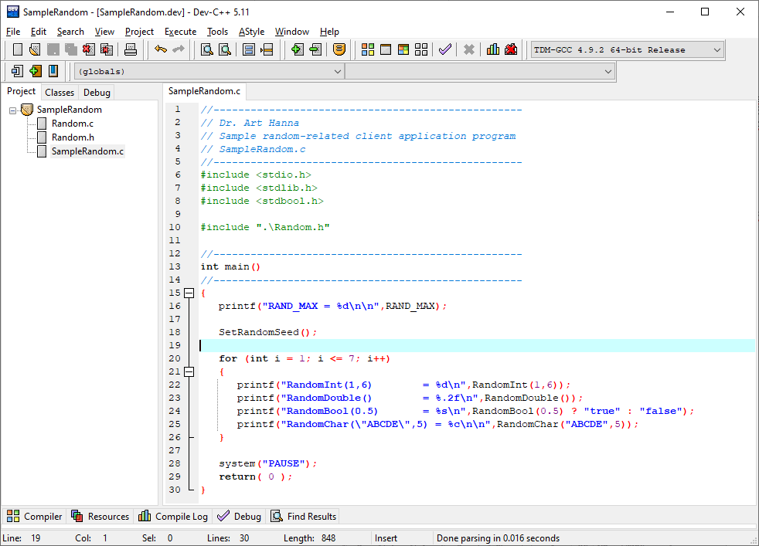
Here’s the “Sample Program Output” generated when SampleRandom.exe client application executes.

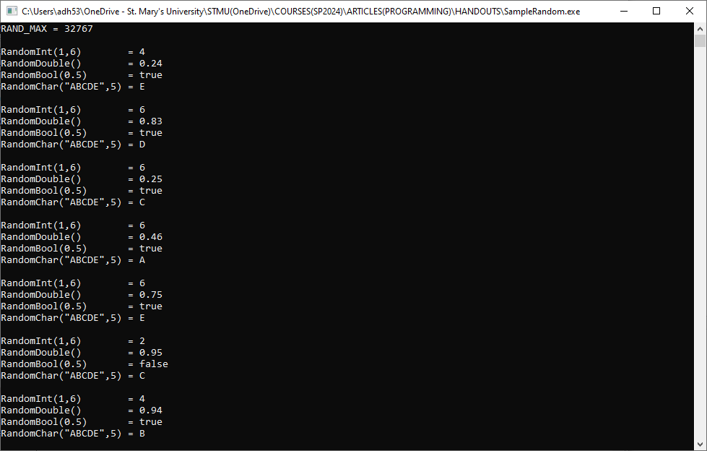

Computational and Critical Thinking Questions (15 points)
*FYI #1* Question Why does Random.h #include <time.h> or <ctime.h>? Answer The random-related function SetRandomSeed() calls the function time() to initialize the “seed” for the random-number generator “hidden inside” the <stdlib.h> function rand().

1. (Continuing *FYI #1*) Study Random.c. Which one of the random-related functions makes a reference to the <stdlib.h> function rand()?
A: SetRandomSeed() B: RandomInt() C: RandomDouble()
D: RandomBool() E: RandomChar()

2. (Continuing *FYI #1*) Concerning SetRandomSeed() To provide a “random” starting seed, SetRandomSeed() uses the value returned by the time() function: What does the time() function return when passed the actual parameter NULL? Hint See https://cplusplus.com/reference/ctime/ for details.

3. Concerning RandomInt() T or F? The RandomInt() formal parameters, LB and UB, are both IN parameters.

*FYI #2* (Continuing 3) When the pre-condition (LB<=UB) is true, the expression (UB-LB+1) computes the number of integers, n, in the closed interval [LB,UB]. For example, when LB=1 and UB=6, the n=(6-1+1)=6. Multiplying n by a random real number in the open interval [0.0,1.0) produces a real number in the open interval [0.0,n), which, when truncated using (int) casting operator, becomes an integer in the closed interval [0,n-1] or equivalently [0,UB-LB]. Adding LB yields the closed interval [LB,UB]. Tah-dah!

4. (Continuing *FYI #2*) The “randomness” of RandomDouble() is supplied by rand(), but T or F? the “randomness” of the RandomInt() return value is supplied by RandomDouble().

*FYI #3* Concerning RandomDouble() The <stdlib.h> rand() function returns an integer randomly chosen from the closed interval [0,RAND_MAX]. Dividing the rand() return value by RAND_MAX yields a real number randomly chosen from the closed interval [0.0,1.0]. Question What is the probability that rand() returns RAND_MAX? Answer 1/(RAND_MAX+1). Question What is RAND_MAX on your platform? Answer 32767 as “proved by the SampleRandom.exe “Sample Program Dialog”.

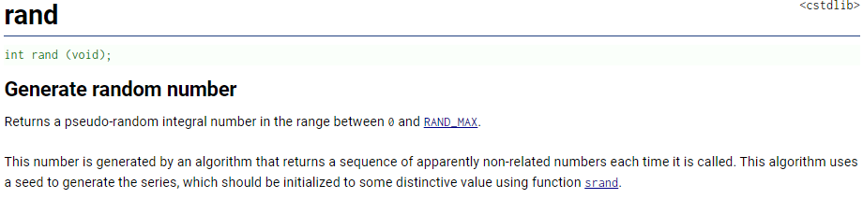

5. (Continuing *FYI #3*) Explain why RandomDouble() goes to so much “trouble”—that is, its use of a do/while-statement—to exclude RAND_MAX.

6. Concerning RandomBool() When bias parameter passed to RandomBool() is 0.75, RandomBool() returns true approximately _____% of the time.

7. Concerning RandomChar() Assume that you intend that every character in the string "ABCDEF" to be able to be randomly-chosen, what should the size parameter be when the chars parameter is "ABCDEF"?
A: 1 B: 3 C: 5 D: 6 E: 7

8. (Continuing 7) About how often should the char-acter 'A' be returned by the following reference to RandomChar()? A: 1-out-of-6 times B: 2-out-of-6 times C: 3-out-of-6 times D: every time E: never

RandomChar("ABCADE",strlen("ABCADE"))

9. (Continuing 7) The data type of the chars RandomChar() formal parameter is
A: an array-of char B: a pointer-to char C: a “string” D: A, B, and C E: a single char

10. The following two pre-processor statements are equivalent because the relative path ".\" means “path to the same directory that contains the source file that contains this #include”. What does the relative path "..\" mean?

#include ".\Random.h"
#include "Random.h"

*FYI #4* Question The following pre-processor code segment found in Random.h is interesting. Any idea why it is being used? Answer The macro __cplusplus must be #define-d by standards-supporting C++ compilers, but not by C compilers. These pre-processor statements #include the language appropriate standard header files.

#ifndef __cplusplus
#include <stdlib.h>
#include <time.h>
#include <stdbool.h>
#else
#include <cstdlib>
#include <ctime>
#endif

11. What does the phrase "uniformly and randomly-chosen" mean?

12. What are the following highlighted source code lines? Choose the best answer.
A: function definitions B: function references C: lines of documentation
D: function prototypes E: function headers

// Initialize the "seed" used by the <stdlib.h> "rand()" function.
void SetRandomSeed(void);

// Return a uniformly and randomly-chosen integer from [ LB,UB ].
int RandomInt(const int LB,const int UB);

13. Study the following SampleRandom.c statement. What must the return value of the highlighted RandomBool(0.5) reference be for the printf() to display the string "false"?

printf("RandomBool(0.5) = %s\n",RandomBool(0.5) ? "true" : "false");

14. Study the following SampleRandom.c statement. Why are the highlighted \" both necessary?

printf("RandomChar(\"ABCDE\",5) = %c\n\n",RandomChar("ABCDE",5));

15. The function header for RandomDouble() highlighted below T or F? can also be legally written double RandomDouble(void). Hint SetRandomSeed() is another example of a parameter-less function definition that is part of the random-related pseudo-library of functions.

//--------------------------------------------------
double RandomDouble()
//--------------------------------------------------

? From my dictionary, “utility [Latin utilis useful] fitness for some purpose or worth to some end; designed or adapted for general use.”
? From my dictionary, “pseudo [Greek combining form of pseûdos falsehood] almost, approaching, or trying to be; a combining form meaning false, pretended, or unreal that is used in the formation of compound words denoting close or deceptive resemblance to the following element. For example, pseudonym = a fictitious name used by an author to conceal his or her identity; a pen name.”
? The IDE project ensures that when the client application is compiled-and-linked to create the application load module (the Windows .exe file), both Random.o and the application’s .o-bject file are compiled-and-linked together.

