Name: Druthisha .B

Reg no: 24UG00309

**MODULES AND FEATURES:**

1.User Interface (Chatbot Interface)

* Basic text/console input for queries.
* Example: "Find path from Main Gate to Library using A*"
* Output: Path, distance, walking time, building info.
* Optional: GUI/visual map highlighting routes.

2. NLP & Bot Engine

* Handles user queries.
* Infers intent:

1. Navigation request → (source, destination, algorithm).
2. Information request → (building details, opening hours, services).

* Utilizes regex/keyword extraction (no need for heavy ML if simple).

3. Navigation & Pathfinding

* Implements search algorithms: BFS, DFS, UCS, A*.
* Utilizes graph data structure:

1. Nodes = Buildings.
2. Edges = Paths with distance/time weights.

* Outputs: Path found, total distance, estimated time.
* Supports path constraints (one-way, speed differences).

4.Database

Stores:

* Campus layout (graph: adjacency list/matrix).
* Building information (library hours, admin services, hostel information, etc.).
* FAQs for instant replies.
* Technology: JSON, SQLite, or plain Python dictionaries. 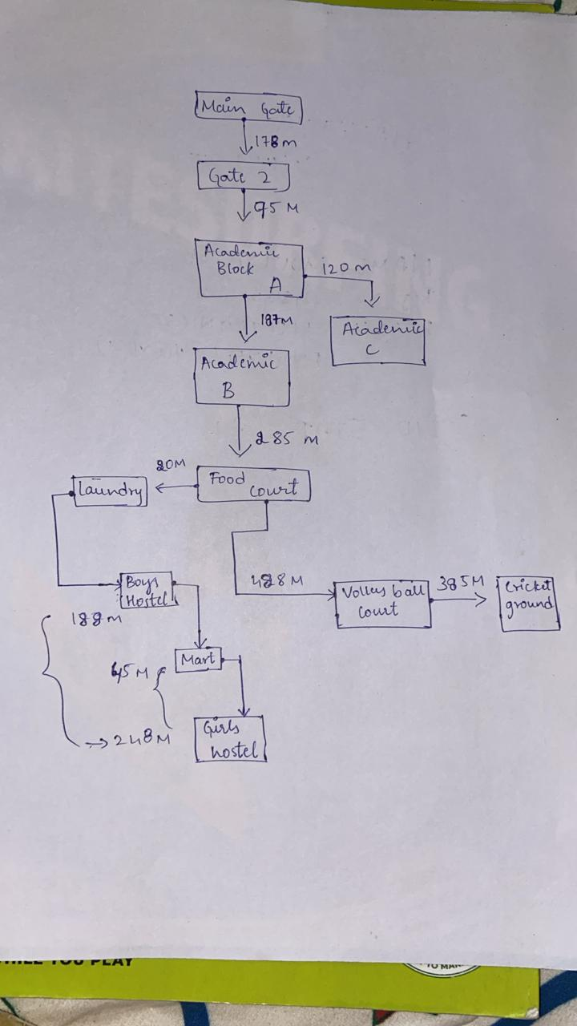

4. Methodology (for Synopsis)

Campus Representation:

Transferred campus map into graph model.

Nodes symbolize locations; edges symbolize distances.

Distance values gathered from given campus layout.

Search Algorithms:

Applied BFS, DFS, UCS, A*.

Algorithms tested on various source-destination pairs.

Results comprise path, distance, and estimated time.

Agent Design (PEAS Framework):

Performance: Optimize walking distance & time.

Environment: Campus map (nodes & paths).

Actuators: Route instructions printed to user.