## The following objects are masked from df (pos = 6):  
##   
## KFK10X, Kortizol10X, LN10X, Mochevina10X, Result,  
## Testosteron10X

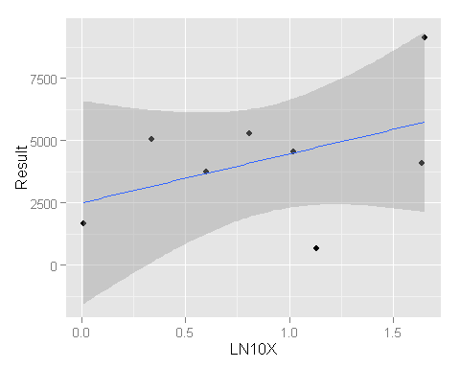 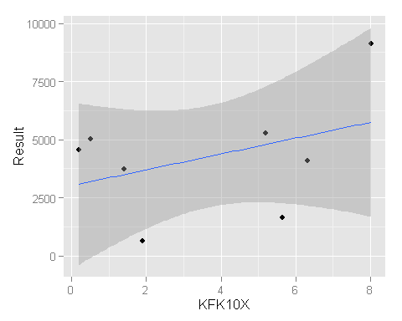 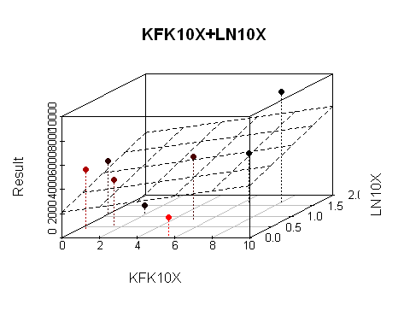

library(rgl)  
library(knitr)  
opts_chunk$set(cache = F)  
knit_hooks$set(rgl = hook_rgl)  
cat("<script type=\"text/javascript\">", readLines(system.file("WebGL", "CanvasMatrix.js",   
 package = "rgl")), "</script>", sep = "\n")

## <script type="text/javascript">  
## CanvasMatrix4=function(m){if(typeof m=='object'){if("length"in m&&m.length>=16){this.load(m[0],m[1],m[2],m[3],m[4],m[5],m[6],m[7],m[8],m[9],m[10],m[11],m[12],m[13],m[14],m[15]);return}else if(m instanceof CanvasMatrix4){this.load(m);return}}this.makeIdentity()};CanvasMatrix4.prototype.load=function(){if(arguments.length==1&&typeof arguments[0]=='object'){var matrix=arguments[0];if("length"in matrix&&matrix.length==16){this.m11=matrix[0];this.m12=matrix[1];this.m13=matrix[2];this.m14=matrix[3];this.m21=matrix[4];this.m22=matrix[5];this.m23=matrix[6];this.m24=matrix[7];this.m31=matrix[8];this.m32=matrix[9];this.m33=matrix[10];this.m34=matrix[11];this.m41=matrix[12];this.m42=matrix[13];this.m43=matrix[14];this.m44=matrix[15];return}if(arguments[0]instanceof CanvasMatrix4){this.m11=matrix.m11;this.m12=matrix.m12;this.m13=matrix.m13;this.m14=matrix.m14;this.m21=matrix.m21;this.m22=matrix.m22;this.m23=matrix.m23;this.m24=matrix.m24;this.m31=matrix.m31;this.m32=matrix.m32;this.m33=matrix.m33;this.m34=matrix.m34;this.m41=matrix.m41;this.m42=matrix.m42;this.m43=matrix.m43;this.m44=matrix.m44;return}}this.makeIdentity()};CanvasMatrix4.prototype.getAsArray=function(){return[this.m11,this.m12,this.m13,this.m14,this.m21,this.m22,this.m23,this.m24,this.m31,this.m32,this.m33,this.m34,this.m41,this.m42,this.m43,this.m44]};CanvasMatrix4.prototype.getAsWebGLFloatArray=function(){return new WebGLFloatArray(this.getAsArray())};CanvasMatrix4.prototype.makeIdentity=function(){this.m11=1;this.m12=0;this.m13=0;this.m14=0;this.m21=0;this.m22=1;this.m23=0;this.m24=0;this.m31=0;this.m32=0;this.m33=1;this.m34=0;this.m41=0;this.m42=0;this.m43=0;this.m44=1};CanvasMatrix4.prototype.transpose=function(){var tmp=this.m12;this.m12=this.m21;this.m21=tmp;tmp=this.m13;this.m13=this.m31;this.m31=tmp;tmp=this.m14;this.m14=this.m41;this.m41=tmp;tmp=this.m23;this.m23=this.m32;this.m32=tmp;tmp=this.m24;this.m24=this.m42;this.m42=tmp;tmp=this.m34;this.m34=this.m43;this.m43=tmp};CanvasMatrix4.prototype.invert=function(){var det=this._determinant4x4();if(Math.abs(det)<1e-8)return null;this._makeAdjoint();this.m11/=det;this.m12/=det;this.m13/=det;this.m14/=det;this.m21/=det;this.m22/=det;this.m23/=det;this.m24/=det;this.m31/=det;this.m32/=det;this.m33/=det;this.m34/=det;this.m41/=det;this.m42/=det;this.m43/=det;this.m44/=det};CanvasMatrix4.prototype.translate=function(x,y,z){if(x==undefined)x=0;if(y==undefined)y=0;if(z==undefined)z=0;var matrix=new CanvasMatrix4();matrix.m41=x;matrix.m42=y;matrix.m43=z;this.multRight(matrix)};CanvasMatrix4.prototype.scale=function(x,y,z){if(x==undefined)x=1;if(z==undefined){if(y==undefined){y=x;z=x}else z=1}else if(y==undefined)y=x;var matrix=new CanvasMatrix4();matrix.m11=x;matrix.m22=y;matrix.m33=z;this.multRight(matrix)};CanvasMatrix4.prototype.rotate=function(angle,x,y,z){angle=angle/180*Math.PI;angle/=2;var sinA=Math.sin(angle);var cosA=Math.cos(angle);var sinA2=sinA*sinA;var length=Math.sqrt(x*x+y*y+z*z);if(length==0){x=0;y=0;z=1}else if(length!=1){x/=length;y/=length;z/=length}var mat=new CanvasMatrix4();if(x==1&&y==0&&z==0){mat.m11=1;mat.m12=0;mat.m13=0;mat.m21=0;mat.m22=1-2*sinA2;mat.m23=2*sinA*cosA;mat.m31=0;mat.m32=-2*sinA*cosA;mat.m33=1-2*sinA2;mat.m14=mat.m24=mat.m34=0;mat.m41=mat.m42=mat.m43=0;mat.m44=1}else if(x==0&&y==1&&z==0){mat.m11=1-2*sinA2;mat.m12=0;mat.m13=-2*sinA*cosA;mat.m21=0;mat.m22=1;mat.m23=0;mat.m31=2*sinA*cosA;mat.m32=0;mat.m33=1-2*sinA2;mat.m14=mat.m24=mat.m34=0;mat.m41=mat.m42=mat.m43=0;mat.m44=1}else if(x==0&&y==0&&z==1){mat.m11=1-2*sinA2;mat.m12=2*sinA*cosA;mat.m13=0;mat.m21=-2*sinA*cosA;mat.m22=1-2*sinA2;mat.m23=0;mat.m31=0;mat.m32=0;mat.m33=1;mat.m14=mat.m24=mat.m34=0;mat.m41=mat.m42=mat.m43=0;mat.m44=1}else{var x2=x*x;var y2=y*y;var z2=z*z;mat.m11=1-2*(y2+z2)*sinA2;mat.m12=2*(x*y*sinA2+z*sinA*cosA);mat.m13=2*(x*z*sinA2-y*sinA*cosA);mat.m21=2*(y*x*sinA2-z*sinA*cosA);mat.m22=1-2*(z2+x2)*sinA2;mat.m23=2*(y*z*sinA2+x*sinA*cosA);mat.m31=2*(z*x*sinA2+y*sinA*cosA);mat.m32=2*(z*y*sinA2-x*sinA*cosA);mat.m33=1-2*(x2+y2)*sinA2;mat.m14=mat.m24=mat.m34=0;mat.m41=mat.m42=mat.m43=0;mat.m44=1}this.multRight(mat)};CanvasMatrix4.prototype.multRight=function(mat){var m11=(this.m11*mat.m11+this.m12*mat.m21+this.m13*mat.m31+this.m14*mat.m41);var m12=(this.m11*mat.m12+this.m12*mat.m22+this.m13*mat.m32+this.m14*mat.m42);var m13=(this.m11*mat.m13+this.m12*mat.m23+this.m13*mat.m33+this.m14*mat.m43);var m14=(this.m11*mat.m14+this.m12*mat.m24+this.m13*mat.m34+this.m14*mat.m44);var m21=(this.m21*mat.m11+this.m22*mat.m21+this.m23*mat.m31+this.m24*mat.m41);var m22=(this.m21*mat.m12+this.m22*mat.m22+this.m23*mat.m32+this.m24*mat.m42);var m23=(this.m21*mat.m13+this.m22*mat.m23+this.m23*mat.m33+this.m24*mat.m43);var m24=(this.m21*mat.m14+this.m22*mat.m24+this.m23*mat.m34+this.m24*mat.m44);var m31=(this.m31*mat.m11+this.m32*mat.m21+this.m33*mat.m31+this.m34*mat.m41);var m32=(this.m31*mat.m12+this.m32*mat.m22+this.m33*mat.m32+this.m34*mat.m42);var m33=(this.m31*mat.m13+this.m32*mat.m23+this.m33*mat.m33+this.m34*mat.m43);var m34=(this.m31*mat.m14+this.m32*mat.m24+this.m33*mat.m34+this.m34*mat.m44);var m41=(this.m41*mat.m11+this.m42*mat.m21+this.m43*mat.m31+this.m44*mat.m41);var m42=(this.m41*mat.m12+this.m42*mat.m22+this.m43*mat.m32+this.m44*mat.m42);var m43=(this.m41*mat.m13+this.m42*mat.m23+this.m43*mat.m33+this.m44*mat.m43);var m44=(this.m41*mat.m14+this.m42*mat.m24+this.m43*mat.m34+this.m44*mat.m44);this.m11=m11;this.m12=m12;this.m13=m13;this.m14=m14;this.m21=m21;this.m22=m22;this.m23=m23;this.m24=m24;this.m31=m31;this.m32=m32;this.m33=m33;this.m34=m34;this.m41=m41;this.m42=m42;this.m43=m43;this.m44=m44};CanvasMatrix4.prototype.multLeft=function(mat){var m11=(mat.m11*this.m11+mat.m12*this.m21+mat.m13*this.m31+mat.m14*this.m41);var m12=(mat.m11*this.m12+mat.m12*this.m22+mat.m13*this.m32+mat.m14*this.m42);var m13=(mat.m11*this.m13+mat.m12*this.m23+mat.m13*this.m33+mat.m14*this.m43);var m14=(mat.m11*this.m14+mat.m12*this.m24+mat.m13*this.m34+mat.m14*this.m44);var m21=(mat.m21*this.m11+mat.m22*this.m21+mat.m23*this.m31+mat.m24*this.m41);var m22=(mat.m21*this.m12+mat.m22*this.m22+mat.m23*this.m32+mat.m24*this.m42);var m23=(mat.m21*this.m13+mat.m22*this.m23+mat.m23*this.m33+mat.m24*this.m43);var m24=(mat.m21*this.m14+mat.m22*this.m24+mat.m23*this.m34+mat.m24*this.m44);var m31=(mat.m31*this.m11+mat.m32*this.m21+mat.m33*this.m31+mat.m34*this.m41);var m32=(mat.m31*this.m12+mat.m32*this.m22+mat.m33*this.m32+mat.m34*this.m42);var m33=(mat.m31*this.m13+mat.m32*this.m23+mat.m33*this.m33+mat.m34*this.m43);var m34=(mat.m31*this.m14+mat.m32*this.m24+mat.m33*this.m34+mat.m34*this.m44);var m41=(mat.m41*this.m11+mat.m42*this.m21+mat.m43*this.m31+mat.m44*this.m41);var m42=(mat.m41*this.m12+mat.m42*this.m22+mat.m43*this.m32+mat.m44*this.m42);var m43=(mat.m41*this.m13+mat.m42*this.m23+mat.m43*this.m33+mat.m44*this.m43);var m44=(mat.m41*this.m14+mat.m42*this.m24+mat.m43*this.m34+mat.m44*this.m44);this.m11=m11;this.m12=m12;this.m13=m13;this.m14=m14;this.m21=m21;this.m22=m22;this.m23=m23;this.m24=m24;this.m31=m31;this.m32=m32;this.m33=m33;this.m34=m34;this.m41=m41;this.m42=m42;this.m43=m43;this.m44=m44};CanvasMatrix4.prototype.ortho=function(left,right,bottom,top,near,far){var tx=(left+right)/(left-right);var ty=(top+bottom)/(top-bottom);var tz=(far+near)/(far-near);var matrix=new CanvasMatrix4();matrix.m11=2/(left-right);matrix.m12=0;matrix.m13=0;matrix.m14=0;matrix.m21=0;matrix.m22=2/(top-bottom);matrix.m23=0;matrix.m24=0;matrix.m31=0;matrix.m32=0;matrix.m33=-2/(far-near);matrix.m34=0;matrix.m41=tx;matrix.m42=ty;matrix.m43=tz;matrix.m44=1;this.multRight(matrix)};CanvasMatrix4.prototype.frustum=function(left,right,bottom,top,near,far){var matrix=new CanvasMatrix4();var A=(right+left)/(right-left);var B=(top+bottom)/(top-bottom);var C=-(far+near)/(far-near);var D=-(2*far*near)/(far-near);matrix.m11=(2*near)/(right-left);matrix.m12=0;matrix.m13=0;matrix.m14=0;matrix.m21=0;matrix.m22=2*near/(top-bottom);matrix.m23=0;matrix.m24=0;matrix.m31=A;matrix.m32=B;matrix.m33=C;matrix.m34=-1;matrix.m41=0;matrix.m42=0;matrix.m43=D;matrix.m44=0;this.multRight(matrix)};CanvasMatrix4.prototype.perspective=function(fovy,aspect,zNear,zFar){var top=Math.tan(fovy*Math.PI/360)*zNear;var bottom=-top;var left=aspect*bottom;var right=aspect*top;this.frustum(left,right,bottom,top,zNear,zFar)};CanvasMatrix4.prototype.lookat=function(eyex,eyey,eyez,centerx,centery,centerz,upx,upy,upz){var matrix=new CanvasMatrix4();var zx=eyex-centerx;var zy=eyey-centery;var zz=eyez-centerz;var mag=Math.sqrt(zx*zx+zy*zy+zz*zz);if(mag){zx/=mag;zy/=mag;zz/=mag}var yx=upx;var yy=upy;var yz=upz;xx=yy*zz-yz*zy;xy=-yx*zz+yz*zx;xz=yx*zy-yy*zx;yx=zy*xz-zz*xy;yy=-zx*xz+zz*xx;yx=zx*xy-zy*xx;mag=Math.sqrt(xx*xx+xy*xy+xz*xz);if(mag){xx/=mag;xy/=mag;xz/=mag}mag=Math.sqrt(yx*yx+yy*yy+yz*yz);if(mag){yx/=mag;yy/=mag;yz/=mag}matrix.m11=xx;matrix.m12=xy;matrix.m13=xz;matrix.m14=0;matrix.m21=yx;matrix.m22=yy;matrix.m23=yz;matrix.m24=0;matrix.m31=zx;matrix.m32=zy;matrix.m33=zz;matrix.m34=0;matrix.m41=0;matrix.m42=0;matrix.m43=0;matrix.m44=1;matrix.translate(-eyex,-eyey,-eyez);this.multRight(matrix)};CanvasMatrix4.prototype._determinant2x2=function(a,b,c,d){return a*d-b*c};CanvasMatrix4.prototype._determinant3x3=function(a1,a2,a3,b1,b2,b3,c1,c2,c3){return a1*this._determinant2x2(b2,b3,c2,c3)-b1*this._determinant2x2(a2,a3,c2,c3)+c1*this._determinant2x2(a2,a3,b2,b3)};CanvasMatrix4.prototype._determinant4x4=function(){var a1=this.m11;var b1=this.m12;var c1=this.m13;var d1=this.m14;var a2=this.m21;var b2=this.m22;var c2=this.m23;var d2=this.m24;var a3=this.m31;var b3=this.m32;var c3=this.m33;var d3=this.m34;var a4=this.m41;var b4=this.m42;var c4=this.m43;var d4=this.m44;return a1*this._determinant3x3(b2,b3,b4,c2,c3,c4,d2,d3,d4)-b1*this._determinant3x3(a2,a3,a4,c2,c3,c4,d2,d3,d4)+c1*this._determinant3x3(a2,a3,a4,b2,b3,b4,d2,d3,d4)-d1*this._determinant3x3(a2,a3,a4,b2,b3,b4,c2,c3,c4)};CanvasMatrix4.prototype._makeAdjoint=function(){var a1=this.m11;var b1=this.m12;var c1=this.m13;var d1=this.m14;var a2=this.m21;var b2=this.m22;var c2=this.m23;var d2=this.m24;var a3=this.m31;var b3=this.m32;var c3=this.m33;var d3=this.m34;var a4=this.m41;var b4=this.m42;var c4=this.m43;var d4=this.m44;this.m11=this._determinant3x3(b2,b3,b4,c2,c3,c4,d2,d3,d4);this.m21=-this._determinant3x3(a2,a3,a4,c2,c3,c4,d2,d3,d4);this.m31=this._determinant3x3(a2,a3,a4,b2,b3,b4,d2,d3,d4);this.m41=-this._determinant3x3(a2,a3,a4,b2,b3,b4,c2,c3,c4);this.m12=-this._determinant3x3(b1,b3,b4,c1,c3,c4,d1,d3,d4);this.m22=this._determinant3x3(a1,a3,a4,c1,c3,c4,d1,d3,d4);this.m32=-this._determinant3x3(a1,a3,a4,b1,b3,b4,d1,d3,d4);this.m42=this._determinant3x3(a1,a3,a4,b1,b3,b4,c1,c3,c4);this.m13=this._determinant3x3(b1,b2,b4,c1,c2,c4,d1,d2,d4);this.m23=-this._determinant3x3(a1,a2,a4,c1,c2,c4,d1,d2,d4);this.m33=this._determinant3x3(a1,a2,a4,b1,b2,b4,d1,d2,d4);this.m43=-this._determinant3x3(a1,a2,a4,b1,b2,b4,c1,c2,c4);this.m14=-this._determinant3x3(b1,b2,b3,c1,c2,c3,d1,d2,d3);this.m24=this._determinant3x3(a1,a2,a3,c1,c2,c3,d1,d2,d3);this.m34=-this._determinant3x3(a1,a2,a3,b1,b2,b3,d1,d2,d3);this.m44=this._determinant3x3(a1,a2,a3,b1,b2,b3,c1,c2,c3)}  
## </script>

x <- sort(rnorm(1000))  
y <- rnorm(1000)  
z <- rnorm(1000) + atan2(x,y)

plot3d(x, y, z, col=rainbow(1000))

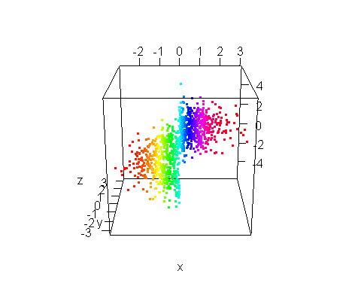

spheres3d(x, y, z, col = rainbow(1000))

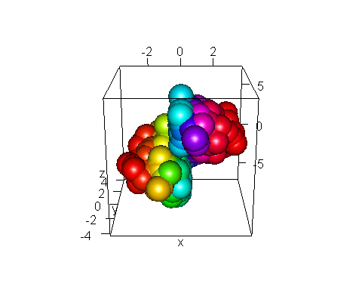

plot3d(KFK10X,LN10X,Result, col=rainbow(1000))

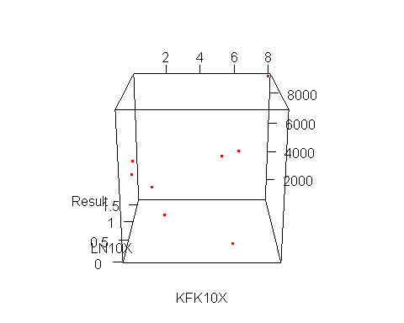

library(rsm)  
swiss2.lm <- lm(Fertility ~ poly(Agriculture, Education, degree=2), data=swiss)  
open3d()  
persp3d.lm(swiss2.lm, Education ~ Agriculture, zlab = "Fertility")

sessionInfo()

## R version 3.1.2 (2014-10-31)  
## Platform: i386-w64-mingw32/i386 (32-bit)  
##   
## locale:  
## [1] LC_COLLATE=Russian_Russia.1251 LC_CTYPE=Russian_Russia.1251   
## [3] LC_MONETARY=Russian_Russia.1251 LC_NUMERIC=C   
## [5] LC_TIME=Russian_Russia.1251   
##   
## attached base packages:  
## [1] stats graphics grDevices utils datasets methods base   
##   
## other attached packages:  
## [1] scatterplot3d_0.3-35 ggplot2_1.0.0 knitr_1.8.2   
## [4] rgl_0.95.1158 rsm_2.07   
##   
## loaded via a namespace (and not attached):  
## [1] colorspace_1.2-4 digest_0.6.4 evaluate_0.5.5 formatR_1.0   
## [5] grid_3.1.1 gtable_0.1.2 htmltools_0.2.6 labeling_0.3   
## [9] MASS_7.3-35 munsell_0.4.2 plyr_1.8.1 proto_0.3-10   
## [13] Rcpp_0.11.3 reshape2_1.4 rmarkdown_0.3.3 scales_0.2.4   
## [17] stringr_0.6.2 tools_3.1.1 yaml_2.1.13