QRSathi
QR Code, Barcode and Inventory Management System
A Mini Project Report
submitted in partial fulfilment of the requirements for the award of the degree of
[Degree, e.g. Bachelor of Technology] in [Branch, e.g. Computer Science and Engineering]
Submitted by
[Student Name]
Roll No. [Roll Number]
Under the guidance of
[Guide Name], [Designation]
[Institution logo]
[Department Name]
[Institution Name]
[University Name]
[City, State]
[Month Year]

A Mini Project Report on
QRSathi
QR Code, Barcode and Inventory Management System
A full-stack web application for generating QR codes and barcodes, managing products and stock, and administering subscriptions, built with Next.js, TypeScript and Prisma
by
[Student Name] ([Roll Number])
Guide: [Guide Name]
[Department Name]
[Institution Name]
[University Name]
Academic year [Academic Year]

Certificate
This is to certify that the mini project report entitled "QRSathi — QR Code, Barcode and Inventory Management System" is a bonafide record of the work carried out by [Student Name] (Roll No. [Roll Number]) in partial fulfilment of the requirements for the award of the degree of [Degree and Branch] of [University Name], during the academic year [Academic Year], under my supervision and guidance.
The work embodied in this report has not been submitted, in part or in full, to any other university or institution for the award of any degree or diploma.
Project Guide  [Guide Name], [Designation] | Head of the Department  [HoD Name], [Department]
Internal Examiner  Name and signature | External Examiner  Name and signature
Date: [Date of submission] Place: [Place]
Declaration
I, [Student Name], Roll No. [Roll Number], hereby declare that the mini project report entitled "QRSathi — QR Code, Barcode and Inventory Management System", submitted to [Department Name], [Institution Name], affiliated to [University Name], is a record of original work carried out by me under the guidance of [Guide Name].
I further declare that the source code, measurements and test results reported in this document were obtained from the project repository and test runs described in Chapter 5, that results which could not be verified are explicitly marked as such, and that this report has not been submitted elsewhere for the award of any degree or diploma.
Signature of the student  [Student Name] | Date  [Date]
Acknowledgement
I express my sincere gratitude to [Guide Name], [Designation], [Department Name], for guidance, encouragement and constructive feedback throughout the development of this project.
I am thankful to [HoD Name], Head of the [Department Name], and to [Principal / Director Name], [Institution Name], for providing the facilities and environment required to complete this work.
I also thank the faculty and laboratory staff of the department, and my family and friends, for their support. Finally, I acknowledge the maintainers of the open-source projects on which QRSathi is built — Next.js, React, Prisma, TypeScript, Tailwind CSS, bwip-js, zxing-wasm and the other libraries listed in Chapter 3 — whose documentation and software made this project possible.
[Student Name]
Abstract
Quick Response (QR) codes and one-dimensional barcodes are now the everyday interface between printed material and digital systems: shops display UPI payment QR codes, products carry EAN-13 barcodes, and marketing material links to websites through QR codes. Small businesses in India, however, typically depend on several unrelated tools for these tasks — a free QR generator, a separate barcode label tool, a spreadsheet for stock, and no means of changing a printed QR code's destination after it has been distributed. This fragmentation leads to duplicated data, invalid barcodes, untraceable stock movements and printed codes that cannot be corrected.
QRSathi is a web application that integrates these functions in one system. Its objectives are to generate standards-compliant QR codes and barcodes, to support editable ("dynamic") QR codes with privacy-respecting scan analytics, to manage products, barcodes and stock as an auditable inventory ledger, and to provide a secure administration console with role-based access control and an optional subscription billing module.
The system is implemented as a full-stack Next.js 15 application written in TypeScript 5.9, using React 19 for the user interface, Tailwind CSS 3.4 for styling and Prisma ORM 6.19 for data access. SQLite is used for development and a generated MySQL schema with versioned migrations is provided for production. The architecture is a layered monolith: App Router pages and 64 API route modules (89 HTTP method handlers) delegate to server-side domain modules (QR service, products, billing, entitlements), which access a relational schema of 22 models through Prisma. QR images are rendered as SVG in the browser; barcodes are rendered with bwip-js; scanning runs entirely in the browser using the zxing-wasm decoder.
The audit carried out for this report verified the following principal modules in source code and automated tests: a QR generator supporting 27 content types (URL, Wi-Fi, vCard, UPI payment, WhatsApp and others) with design customisation and export to PNG, JPG, SVG, PDF and ZIP; dynamic QR codes with short links, expiry, pause, UTM parameters and scan analytics; a barcode generator for 23 symbologies with check-digit validation and printable labels; a camera and image scanner with phishing and UPI-fraud heuristics; product and inventory management with per-user SKU and barcode uniqueness and an append-only stock ledger; bulk generation and spreadsheet import; an administration console with three roles (user, admin, super administrator), TOTP multi-factor authentication, audit logging and branding/pricing configuration; and Razorpay subscription billing with signature verification and idempotent webhooks.
Testing was performed by executing the project's own test suites against an isolated production build and a throw-away database: TypeScript type checking and linting completed without errors; the unit suites passed (134 security assertions, the QR rendering/decoding suite and 166 barcode assertions); and the API (73), administration/security (99), billing and browser suites were executed with the results reported in Chapter 5. The audit also identified defects and risks, the most significant being that uploads larger than 10 MB fail for paid plans that advertise 25–50 MB limits, and that a development database containing password hashes remains in the Git history.
QRSathi demonstrates that a single, well-structured web application can replace several disconnected tools while applying sound security engineering — server-side sessions, CSRF origin checks, rate limiting, encrypted secrets and audit trails. Its limitations, such as local-disk file storage, the absence of e-mail verification and the lack of a measured performance baseline, are documented together with future enhancements.
Keywords: QR code, barcode, GS1, inventory management, Next.js, TypeScript, Prisma, role-based access control, multi-factor authentication, Razorpay.
Table of Contents
Right-click and choose “Update Field” (or press F9) if page numbers are not shown.

List of Figures

List of Tables

List of Abbreviations
Abbreviation | Expansion
2FA / MFA | Two-factor / Multi-factor authentication
AES-GCM | Advanced Encryption Standard in Galois/Counter Mode
API | Application Programming Interface
CI | Continuous Integration
CRUD | Create, Read, Update, Delete
CSP | Content Security Policy
CSRF | Cross-Site Request Forgery
CSV | Comma-Separated Values
DFD | Data-Flow Diagram
DNT / GPC | Do Not Track / Global Privacy Control
DPDP | Digital Personal Data Protection (Act, 2023, India)
ECC | Error-Correction Capacity (QR code)
EAN | European Article Number (International Article Number)
ERD | Entity-Relationship Diagram
GS1 | Global standards organisation for supply-chain identification
GTIN | Global Trade Item Number
HMAC | Hash-based Message Authentication Code
HSTS | HTTP Strict Transport Security
HTTP(S) | Hypertext Transfer Protocol (Secure)
IDOR | Insecure Direct Object Reference
IFSC | Indian Financial System Code
ISBN / ISSN | International Standard Book / Serial Number
JSON | JavaScript Object Notation
JWT | JSON Web Token
MIME | Multipurpose Internet Mail Extensions
OIDC | OpenID Connect
ORM | Object-Relational Mapping
PDF | Portable Document Format
QR | Quick Response (code)
RBAC | Role-Based Access Control
RFC | Request for Comments (IETF standard)
RSC | React Server Components
RTM | Requirement Traceability Matrix
SKU | Stock-Keeping Unit
SMTP | Simple Mail Transfer Protocol
SQL | Structured Query Language
SVG | Scalable Vector Graphics
TLS | Transport Layer Security
TOTP | Time-based One-Time Password
UI / UX | User Interface / User Experience
UPC | Universal Product Code
UPI | Unified Payments Interface
URL | Uniform Resource Locator
UTM | Urchin Tracking Module (campaign parameters)
VPA | Virtual Payment Address (UPI ID)
WASM | WebAssembly
XSS | Cross-Site Scripting

CHAPTER 1
Introduction

1.1 Introduction to the Project
QRSathi ("Sathi" means "companion" in Hindi) is a web-based platform for creating QR codes and barcodes and for managing the products and stock those codes identify. It combines, in one authenticated workspace, a QR code generator, a dynamic (editable) QR service with scan analytics, a barcode and label generator, a browser-based scanner, a product catalogue with an inventory ledger, bulk generation tools, an administration console and an optional subscription billing module.
The project is implemented as a single Next.js application written in TypeScript. The browser renders QR codes and barcodes as SVG images and decodes codes from the camera using WebAssembly, while the server stores accounts, codes, products and stock movements in a relational database through the Prisma ORM. The application is designed for Indian small businesses — for example, it generates UPI payment QR codes, stores prices in paise and formats numbers in the Indian locale — but nothing in its architecture is specific to one country.
This report documents the project as it exists in the repository at the time of the audit (branch main, latest commit 9b5dae7, plus uncommitted working-tree changes — see Section 1.14) [30]. Every functional claim in this report was checked against the source code, and wherever possible against automated tests that were executed for this report (Chapter 5). The report distinguishes clearly between general background (Sections 1.2–1.4) and what QRSathi actually implements (Sections 1.12 onward).

1.2 Background of QR Code Technology
This section describes QR codes in general; it does not describe QRSathi specifically.
A QR (Quick Response) code is a two-dimensional matrix symbology invented in 1994 by Denso Wave, a Toyota group company, to track automotive parts. It was later standardised internationally as ISO/IEC 18004 [8], [11]. A QR symbol consists of dark and light square modules arranged in a grid; three large finder patterns in the corners allow a reader to locate the symbol and determine its orientation from any angle, and timing and alignment patterns help correct for distortion.
Key properties of QR codes relevant to this project are:
- Versions. Symbols range from version 1 (21 × 21 modules) to version 40 (177 × 177 modules). Larger versions hold more data.
- Error correction. Reed–Solomon error correction allows a symbol to be decoded even when part of it is damaged or covered. Four levels are defined — L, M, Q and H — recovering roughly 7%, 15%, 25% and 30% of the codewords respectively. Higher levels make it possible to place a logo in the centre of a QR code, at the cost of a denser symbol.
- Encoding modes. Numeric, alphanumeric, byte and Kanji modes allow efficient encoding of different kinds of content.
- Content conventions. A QR code only stores text. Phones interpret that text according to informal conventions: https://… opens a browser, WIFI:T:WPA;S:…;P:…;; joins a Wi-Fi network, BEGIN:VCARD… adds a contact, and upi://pay?pa=… opens a UPI payment app [23].
A distinction that is central to QRSathi is between static and dynamic QR codes. A static QR code encodes its final content directly; once printed it can never change. A dynamic QR code encodes a short URL controlled by a service; the service redirects the visitor to a destination that can be edited, paused or expired later, and can count scans. Dynamic codes are a service convention rather than a different symbology — the printed symbol is an ordinary QR code containing a URL.

1.3 Background of Barcode Technology
This section describes barcodes in general.
Linear (one-dimensional) barcodes encode data in the widths of parallel bars and spaces. The Universal Product Code (UPC) was adopted by the US grocery industry in 1973 and first scanned at a retail checkout in 1974; the European Article Number (EAN, now "International Article Number") followed in 1977. Today the GS1 organisation administers the global numbering system on which retail barcodes depend [9], [10].
Barcode symbologies differ in the characters they can encode and their intended use:
- EAN-13, EAN-8, UPC-A and UPC-E encode Global Trade Item Numbers (GTINs) for retail products. They are numeric-only and end with a check digit calculated with the GS1 modulo-10 algorithm, which lets a scanner reject most misreads.
- ITF-14 encodes GTINs for cartons and shipping units.
- GS1-128 encodes GS1 Application Identifiers such as (01) GTIN, (10) batch/lot and (17) expiry date.
- Code 128, Code 39, Code 93 and Codabar are general-purpose symbologies commonly used for internal labels, asset tags and libraries.
- Two-dimensional symbologies such as Data Matrix, PDF417 and Aztec store much more data in a small area and tolerate damage.
An important business rule is that GTINs used on goods sold through retail channels must be allocated by GS1 to the brand owner. Numbers beginning with the prefix 20–29 are reserved for restricted circulation (internal use within a company), which makes them safe for a business's own labels.

1.4 Introduction to Inventory and Product Identification Systems
An inventory system records which items an organisation holds and how many units of each are available. Its core concepts are:
- a product master (catalogue) describing each stock-keeping unit (SKU): name, code, category, price, supplier and attributes;
- identifiers linking a physical item to its record — SKUs, barcodes, QR codes or RFID tags;
- stock movements (receipts, issues and adjustments) that change the quantity on hand; and
- controls such as re-order (low-stock) levels, batch and expiry tracking, and an audit trail of who changed what and when.
Barcode scanning reduces manual data entry and transcription errors: scanning an item retrieves its record directly, after which a movement can be recorded. A well-designed system treats the stock quantity as the result of recorded movements rather than as a free-form number, so that every change can be explained.

1.5 Problem Statement
Small retailers, shops, creators and organisations increasingly need QR codes (for payments, menus, links and contact details) and barcodes (for products and labels), but commonly face the following problems:
- Fragmented tools. QR generation, barcode/label printing, scanning and stock tracking are performed in separate applications or spreadsheets with no shared data.
- Unchangeable printed codes. A static QR code printed on posters or packaging cannot be corrected when a URL changes; reprinting is costly.
- Invalid identifiers. Barcode numbers created by hand often have wrong check digits, duplicate other products, or use GTIN ranges that should be reserved for GS1-allocated numbers.
- Untraceable stock. Stock quantities kept in spreadsheets are overwritten without a history, so discrepancies cannot be explained.
- Scanning risks. QR-code fraud — fake payment QR codes, phishing links and malicious app downloads — is common, and generic scanner apps rarely warn the user.
- Security and privacy. Many free online tools require no account, offer no access control, and track scanners extensively.
The problem addressed by this project is therefore: to design and implement a secure, integrated web application through which a small business can generate valid QR codes and barcodes, keep printed QR codes editable, scan codes safely, and manage products and stock with a complete audit trail.

1.6 Motivation for Developing QRSathi
The motivation came from observing everyday use of codes in Indian retail: UPI QR standees at counters, hand-written price labels next to barcoded goods, and QR codes on menus and posters that lead to outdated pages. Building a single product that handles all of these use cases also provided an opportunity to study, in a realistic codebase, topics central to a computer-science curriculum: relational database design, web application architecture, authentication and authorization, input validation, secure handling of payments and secrets, automated testing and deployment.

1.7 Project Objectives
The objectives of QRSathi, as reflected in its implementation, are:
- O1. Generate QR codes for common content types with validation of the content and customisable, scannable designs.
- O2. Provide dynamic QR codes whose destination can be edited, paused or expired after printing, with privacy-preserving scan analytics.
- O3. Generate barcodes in standard symbologies with correct check digits and printable labels.
- O4. Scan QR codes and barcodes from a camera or image in the browser, and warn users about risky content.
- O5. Manage products, their barcodes and stock through an auditable inventory ledger with low-stock indication.
- O6. Support bulk generation and spreadsheet import for larger catalogues.
- O7. Protect accounts and data with secure authentication, role-based access control and a separate, MFA-protected administration console.
- O8. Offer configurable plans with server-enforced limits and optional online subscription payments.
- O9. Support SQLite for development and MySQL for production from one schema.
- O10. Verify behaviour through automated tests.
Section 7.2 evaluates each objective against the audit evidence.

1.8 Project Scope
In scope (implemented): web user interface for desktop and mobile browsers; account registration and sign-in (password and optional Google sign-in); QR generation, saving, editing and export; dynamic QR codes and hosted landing pages; scan analytics; barcode and label generation; in-browser scanning; products, barcodes and stock movements; bulk QR/barcode generation and product import; plan entitlements; administration console; Razorpay subscriptions; SQLite and MySQL database support; automated tests and a CI workflow.
Out of scope: native mobile applications; point-of-sale billing (sales invoices, GST); multi-warehouse inventory; purchase orders and suppliers; hardware integration with dedicated barcode printers or scanners beyond what the browser supports; and GS1 number allocation itself (QRSathi validates GS1 numbers but cannot issue official ones).

1.9 Significance of the Project
The project is significant in three ways. Practically, it gives small businesses one tool for tasks that otherwise require several, and it enforces correctness (check digits, unique SKUs, non-negative stock) that ad-hoc tools do not. Socially, its scanner warns about common QR-code frauds such as "scan to receive money" UPI scams. Academically, it is a complete, tested example of a modern full-stack application that applies security practices — server-side sessions, CSRF defence, rate limiting, encrypted secrets, MFA and audit logging — which are often omitted from student projects.

1.10 Intended Users and Stakeholders
- Registered users — shop owners, small businesses, creators and organisations who create codes and manage products.
- Visitors — members of the public who scan a QR code produced with QRSathi and are redirected or shown a hosted page; they need no account.
- Administrators — platform staff who moderate users and content, view statistics and configure the site.
- Super administrators — owners of the platform who additionally manage roles, pricing plans, payment credentials and account deletion.
- External service providers — Razorpay (payments), Google (sign-in) and an SMTP provider (e-mail), each optional.
- Academic stakeholders — the project guide and examiners evaluating the work.

1.11 Existing System Overview
Before QRSathi, the typical "system" used by the target users is a combination of: free online QR generators (often static-only, sometimes with expiring "dynamic" codes that require a paid plan), separate barcode generator websites, generic phone camera scanners, and spreadsheets for stock. Section 2.2 analyses this approach in detail. No claim is made in this report about the internal behaviour of any specific commercial product.

1.12 Proposed System Overview
QRSathi replaces the fragmented approach with one web application. Its verified modules are:
- QR Generator and Design Studio — 27 content types in five categories (essentials, payments, social, business, files & events), with colours, module shapes, logos, frames and export to PNG, JPG, SVG, PDF and ZIP.
- Dynamic QR and hosted pages — short links of the form /r/{code} and landing pages at /p/{code}, with pause, expiry, custom aliases, UTM parameters and scan analytics.
- Barcode Generator — 23 symbologies with validation and six label sizes.
- Universal Scanner — camera and image scanning in the browser with content classification and safety warnings, and an on-device scan history.
- Products and Inventory — product catalogue with multiple barcodes per product, stock in/out/adjust movements, low-stock flags and a per-product activity ledger.
- Bulk tools — batch QR and barcode generation and CSV/XLSX product import.
- Administration console — a separate sign-in at /admin with roles, MFA, user and content moderation, audit log, analytics, branding, pricing, e-mail and payment configuration.
- Billing — plans and entitlements stored in the database, with Razorpay subscription checkout and signed webhooks.

1.13 Advantages of the Proposed System
- One account and one data store for codes, products and stock.
- Printed dynamic QR codes remain correctable.
- Barcodes are validated (check digits, restricted-circulation ranges, per-user uniqueness) before being stored.
- Stock changes only through recorded movements, giving a complete history.
- Scanning happens on the user's device; images are not uploaded to a server.
- Scan analytics avoid storing raw IP addresses and honour Do-Not-Track signals.
- Administration is separated from the workspace and protected by MFA.
- The same code runs on SQLite (easy local set-up) and MySQL (production).
These are design advantages derived from the implementation; no comparative user study or benchmark was conducted.

1.14 Project Limitations
Limitations identified in the audit (detailed in Sections 6.24 and 7.4) include: uploaded files are stored on the local disk of a single server; uploads over 10 MB fail even where a plan allows more (defect D-01); e-mail addresses are not verified at sign-up; the in-memory rate limiter is per process unless the database store is enabled; there is no measured performance baseline; real Razorpay, Google and SMTP integrations were not exercised against live services in this audit; and a large part of the most recent work (billing, branding, pricing administration) was uncommitted in Git at the time of the audit.

1.15 Organization of the Report
- Chapter 2 — System Analysis analyses the existing approach, feasibility, stakeholders, requirements, roles, use cases, business rules and risks.
- Chapter 3 — System Requirements lists hardware and software requirements, detailed functional and non-functional requirements, the access-control matrix, configuration and the requirement traceability matrix.
- Chapter 4 — System Design presents the architecture, data-flow diagrams, flowcharts, database design, UML diagrams, UI, API and security design.
- Chapter 5 — System Testing reports the tests actually executed, test cases, results and defects.
- Chapter 6 — Implementation and Evaluation explains how each module is implemented, with code excerpts, set-up and deployment procedures and screenshots.
- Chapter 7 — Conclusion and Future Enhancements evaluates the objectives and proposes future work.
- References and Appendices provide sources, the directory structure, API inventory, data dictionary, test cases, installation guide, configuration reference, screenshot index, traceability matrix and glossary.

CHAPTER 2
System Analysis

2.1 Introduction to System Analysis
System analysis is the study of a problem domain and of the existing way of working, carried out to define what a new system must do before deciding how it will do it. For QRSathi the analysis was performed in two directions. First, the everyday workflow of the target users (Section 1.10) was examined to identify problems and requirements. Second, because the system already exists, the analysis was validated against the implementation: every requirement, role and business rule stated in this chapter corresponds to code that was located in the repository, and the source location is recorded in the traceability matrix (Section 3.16 and Appendix H).

2.2 Analysis of the Existing System
The "existing system" for a typical small shop or creator is not a single product but a set of manual steps and unrelated tools:
- QR codes are made with a free web generator. The resulting image is downloaded and printed. The generator usually keeps no account history, so the same code is recreated when needed again.
- UPI payment QR codes are obtained from a payment app or bank and printed. Creating a standee with a fixed amount or a merchant note requires another tool.
- Barcodes are created on a separate website by typing a number. Whether the number is valid, unique, or allowed for internal use is left to the user.
- Labels are designed in a word processor or image editor.
- Stock is tracked in a spreadsheet or notebook; the quantity cell is overwritten when goods arrive or are sold.
- Scanning uses the phone camera app, which opens links or payment apps without much warning.
- Changing a printed QR code requires creating and reprinting a new one.

2.3 Problems and Limitations of the Existing Approach
Table 2.1: Problems of the existing approach
# | Problem | Consequence
P1 | Data is spread across tools with no shared identity | Product, barcode and QR information is duplicated and diverges
P2 | Static QR codes cannot be edited | Reprinting cost; broken links in circulation
P3 | No validation of barcode numbers | Wrong check digits, duplicates, misuse of GS1 ranges
P4 | Stock overwritten without history | Discrepancies cannot be explained or audited
P5 | No scan statistics, or invasive tracking | Either no insight into campaigns, or privacy concerns
P6 | No access control on shared spreadsheets | Any person with the file can change everything
P7 | Scanning without safety warnings | Exposure to UPI "collect" scams and phishing links
P8 | Manual, one-at-a-time creation | Large catalogues are slow to label

2.4 Proposed System
The proposed system, QRSathi, addresses these problems as follows:
Table 2.2: How the proposed system addresses each problem
Problem | How QRSathi addresses it (verified in source)
P1 | One account owns QR codes, products, barcodes and stock records in a single relational database (prisma/schema.prisma).
P2 | Dynamic QR codes encode a short link (/r/{code}); the destination can be edited, paused or expired (src/lib/qr-service.ts, src/app/r/[code]/route.ts).
P3 | Each symbology validates length, character set and check digit; internal GTINs must use the 20–29 prefix; SKUs and barcodes are unique per user (src/lib/barcodes.ts, src/lib/products.ts).
P4 | Stock changes only through in, out and adjust movements, each recorded in InventoryTransaction with a signed quantity and resulting balance.
P5 | Scans record device type, browser, OS and country but never raw IP addresses; Do-Not-Track and Global Privacy Control reduce a scan to a count (src/lib/scans.ts).
P6 | Sessions, roles and ownership checks on every API route (src/lib/session.ts).
P7 | The scanner classifies content and runs heuristics for phishing URLs and UPI fraud (src/lib/content-safety.ts).
P8 | Bulk QR/barcode generation and CSV/XLSX product import (src/app/(app)/bulk, src/app/api/products/import).

2.5 Feasibility Study

2.5.1 Technical Feasibility
The project uses mature, widely documented open-source technologies: Next.js 15.5 and React 19 for the web application, TypeScript 5.9 for static typing, Prisma 6.19 as the ORM, and SQLite/MySQL as databases. Specialised functions are provided by established libraries — qrcode for QR matrices, bwip-js for barcode encoding, and zxing-wasm for decoding. The technical feasibility is demonstrated by the fact that the application builds successfully (next build completed in 67 seconds during the audit) and passes its type checks and automated tests (Chapter 5). The only runtime requirement is Node.js 22.5 or later.

2.5.2 Economic Feasibility
All libraries in the dependency tree are open source; the licence report script (npm run license:check) ran successfully during the audit. Development requires only a personal computer. A small production deployment can run on a single virtual server with MySQL. Optional services have usage-based costs: Razorpay charges a fee per transaction, and an SMTP provider may charge for e-mail volume. No cost estimate for hosting was measured in this project; the statements above are qualitative.

2.5.3 Operational Feasibility
The user interface follows familiar patterns: a sidebar with grouped navigation (Workspace, Business, More tools, Account), a command palette, light/dark themes and responsive layouts that the browser test suite checks at 375, 768 and 1280 pixel widths. Administrators are created with a command-line tool (npm run admin), and operational documents for deployment, backup and recovery exist in docs/. No formal usability study with real users was conducted.

2.5.4 Schedule Feasibility
The Git history shows five commits, all dated 2026-10-25, followed by a large set of uncommitted changes. The repository history therefore does not provide a reliable project timeline, and no schedule data is reported. A recommended plan for completing outstanding work is given in Chapter 7.

2.5.5 Security and Maintenance Considerations
Security requirements are significant because the system stores personal data (e-mail addresses), payment records and administrator credentials. The implementation addresses them with server-side sessions, role checks, rate limits, CSRF origin checks, encrypted secrets and an audit log (Section 4.17). Maintainability is supported by TypeScript, a modular src/lib layer, ESLint, a CI workflow and Dependabot configuration (.github/). Maintenance risks include dependency vulnerabilities that are currently accepted with an expiry date (security/audit-allowlist.json), and the need to keep the SQLite and MySQL schemas synchronised — which is automated by npm run db:mysql:schema -- --check.

2.6 Stakeholder Analysis
Table 2.3: Stakeholder analysis
Stakeholder | Interest | Influence | Key needs
Registered user (shop owner, creator) | High | Medium | Fast, valid codes; editable QR; simple stock tracking; data privacy
Visitor scanning a code | Medium | Low | Fast redirect; safe destination; no tracking without consent
Administrator | High | High | Moderation tools; visibility; protection against account takeover
Super administrator / owner | High | High | Control of roles, pricing, payments; audit trail
Payment provider (Razorpay) | Medium | Medium | Correct API use; webhook acknowledgement
Project guide / examiners | High | High | Correct, evidenced documentation; working demonstration

2.7 Functional Requirements Overview
The functional requirements are grouped into modules. Detailed specifications with identifiers appear in Section 3.11.
Table 2.4: Functional requirements by module
Module | Summary of functions
Accounts | Sign up, sign in (password, Google), sign out, forgot/reset password, profile and password change, sign out other devices, delete account
QR codes | Create static/dynamic/hosted QR codes for 27 types; design; export; save; list, search, favourite, edit, pause, duplicate, delete
Dynamic QR | Short-link redirect, hosted page, expiry, UTM, abuse reporting
Analytics | Scan counts by day, device, browser, OS, country; CSV export (plan-dependent)
Barcodes | Generate 23 symbologies; validate; labels; export
Scanner | Camera/image decoding; classification; safety notes; local history; product lookup
Products & inventory | Product CRUD with barcodes; archive/restore; stock in/out/adjust; low stock; history; import
Bulk | Batch QR and barcode generation from tables
Billing | View plans; subscribe; verify; cancel; payment history
Administration | Users, roles, suspension, sessions; QR moderation; abuse reports; analytics; audit and security events; settings, branding, appearance, e-mail, pricing, payment configuration; system status; MFA

2.8 Non-Functional Requirements Overview
- Security: authenticated access to private data; role checks on administrative functions; protection against CSRF, XSS, brute force and session fixation; secrets never sent to the browser.
- Privacy: no raw IP storage in scan analytics or audit logs; honour Do-Not-Track/GPC.
- Reliability: atomic quota checks and stock movements; idempotent webhook processing; startup configuration validation that refuses unsafe production configurations.
- Usability: responsive layout without horizontal scrolling at common widths; accessible names for controls; light and dark themes.
- Maintainability: typed code, shared validation schemas, automated tests and CI.
- Portability: SQLite and MySQL from one schema; runs anywhere Node.js 22 runs.
- Performance: no measured targets exist in the repository; Section 3.12 lists proposed targets, explicitly marked as unmeasured.

2.9 User Roles and Permissions
The roles are defined in src/lib/roles.ts and enforced in src/lib/session.ts, src/lib/guard.ts and src/lib/admin-users.ts.
Table 2.5: User roles
Role | How assigned | Permissions (summary)
Visitor (no account) | — | Open public pages, use the client-side generators and scanner, follow dynamic links, view hosted pages, submit abuse reports
user | Every sign-up (forced server-side) | Manage own QR codes, products, stock, uploads, analytics and subscription
admin | npm run admin CLI or a super administrator | Separate console sign-in; view statistics; suspend/reactivate users, revoke sessions, send reset links, change plans of ordinary users; moderate QR codes and reports; edit settings and branding
super_admin | CLI only (or promotion by another super admin) | Everything an admin can do, plus role changes, account deletion, pricing plans, payment credentials and subscription cancellation; must enable MFA before using the console

A workspace session never grants administrative access, even for administrators: the console requires a separate sign-in that creates a distinct qs_admin session.

2.10 Use Cases and User Interactions
The principal use cases are shown in Figure 4.2 (Chapter 4). Their textual descriptions are:
Table 2.6: Use-case descriptions
ID | Use case | Primary actor | Description
UC1 | Sign up / sign in | User | Create an account or authenticate with e-mail/password or Google
UC2 | Reset password | User | Request a one-hour, single-use reset link by e-mail
UC3 | Generate static QR | User / visitor | Choose a type, fill the form, style and export; signed-in users can save
UC4 | Create dynamic QR / hosted page | User | Create a QR whose destination can change; optionally a hosted landing page
UC5 | Generate barcodes and labels | User / visitor | Validate and render a barcode, lay out labels, export
UC6 | Scan a code | User / visitor | Decode from camera or image; see classification and warnings
UC7 | Manage products | User | Create/edit/archive/delete products with barcodes
UC8 | Record stock movement | User | Stock in, stock out or stock-take adjustment
UC9 | Bulk generate / import | User | Generate many codes or import products from CSV/XLSX
UC10 | View analytics | User | View scan statistics; export CSV where the plan allows
UC11 | Subscribe to a paid plan | User | Checkout through Razorpay; plan upgraded after verification
UC12 | Open dynamic QR / hosted page | Visitor | Be redirected or shown the hosted page; scan recorded
UC13 | Report abusive QR | Visitor | Report phishing, scams, malware etc.
UC14 | Moderate | Admin | Manage users, QR codes and abuse reports
UC15 | Configure site | Admin | Edit settings and branding
UC16 | Manage pricing | Super admin | Create, edit, publish, archive and reorder plans; sync provider plans
UC17 | Manage privileged settings | Super admin | Change roles, delete accounts, manage payment credentials
UC18 | Enrol MFA | Admin / super admin | Set up TOTP and recovery codes
UC19 | Deliver payment events | Razorpay | Send signed webhooks that update subscriptions and payments

2.11 Business Rules
The following rules are enforced by the implementation:
- BR1 Public sign-up always creates role user; any submitted role field is ignored (src/app/api/auth/signup/route.ts).
- BR2 Passwords must have at least 8 characters including a letter and a digit; administrator passwords created by the CLI need at least 12 characters (src/lib/auth-helpers.ts, scripts/admin.mts).
- BR3 A super administrator must enable MFA before using the console, cannot disable it, and the last super administrator cannot be demoted or deleted.
- BR4 An SKU is unique per user; a barcode value is unique per user and format; equivalent GTIN forms (e.g. UPC-A and its EAN-13 form) are treated as duplicates through the lookupKey.
- BR5 "Internal" EAN/UPC/ITF-14 numbers must use the restricted-circulation prefix 2 (20–29); numbers outside that range must be marked as GS1 "assigned".
- BR6 Stock never becomes negative through a stock-out; scanning never changes stock; archived products cannot have stock changes and must be archived before permanent deletion.
- BR7 Prices are stored as integers in minor units (paise); currencies are limited to INR, USD, EUR, GBP, AED and SGD.
- BR8 Plan limits (saved QR codes, dynamic codes, hosted pages, products, barcodes, bulk rows, upload size, storage, analytics days and features) are checked on the server inside a transaction.
- BR9 Dynamic QR codes require an http(s) destination; aliases are 3–40 characters and some words are reserved (admin, api, login, …).
- BR10 A paid plan is granted only after server-side confirmation — a captured payment fetched from Razorpay or a signature-verified webhook — and duplicate webhook events have no effect.
- BR11 Raw IP addresses are never stored; audit logs keep a salted hash of the IP and redact secrets.
- BR12 A paid plan whose planExpiresAt has passed falls back to Free on the user's next authenticated request (load() in src/lib/session.ts).

2.12 Assumptions and Constraints
Assumptions: users access the system through a modern browser with JavaScript enabled; camera scanning requires a device camera and HTTPS (or localhost); production deployments set NEXT_PUBLIC_APP_URL, a strong AUTH_SECRET and HTTPS; an administrator installs and operates the server.
Constraints: Node.js 22.5 or later (declared in package.json engines); a single relational database; uploaded files on local disk (UPLOAD_DIR); Razorpay is the only payment provider implemented; Google is the only external identity provider; the in-memory rate limiter is per process unless RATE_LIMIT_STORE=database.

2.13 Risk Analysis
Table 2.7: Risk analysis
Risk | Likelihood | Impact | Mitigation in the system / recommendation
Account takeover by password guessing | Medium | High | Per-IP, per-account and global rate limits; generic errors; bcrypt cost 12; MFA for administrators
Dynamic QR used for phishing | Medium | High | Abuse reports, admin moderation (pause/disable); recommendation: URL reputation checks
Personal data leaked from repository history | Present | High | Database backup exists in Git history (finding S-01); history rewrite and credential rotation recommended
Loss of uploaded files on server failure | Medium | Medium | Local-disk storage; backup procedure documented; recommendation: object storage
Payment state inconsistency | Low | High | Signature verification, API re-fetch, idempotent ledger
Rate limits ineffective across instances | Medium | Medium | RATE_LIMIT_STORE=database option
Dependency vulnerabilities | Medium | Medium | npm run audit:check with time-limited allowlist
Schema drift between SQLite and MySQL | Low | Medium | Generated MySQL schema with CI check
Concurrent edits to the codebase without commits | Present | Medium | Work was uncommitted during the audit; commit and tag a release before submission

2.14 Comparative Analysis of Existing and Proposed Systems
The comparison below is between the manual multi-tool approach described in Section 2.2 and QRSathi as implemented. It is not a comparison with any specific commercial product, and no claim of superior performance is made because no benchmark was performed.
Table 2.8: Comparison of the existing approach and QRSathi
Criterion | Existing approach | QRSathi (verified)
Integration of QR, barcode, scanning and stock | Separate tools | One application and database
Editable printed QR codes | Not possible with static codes | Dynamic short links with edit/pause/expiry
Barcode validation | Depends on tool; often none | Format rules, check digits, GS1 ranges, uniqueness
Stock history | Usually none | Append-only ledger with balances
Access control | File sharing | Accounts, roles, admin console with MFA
Scan analytics | None, or third-party tracking | Built-in, privacy-preserving
Scam warnings while scanning | Rarely | Heuristic warnings for URLs and UPI
Bulk operations | Manual | Batch generation and import
Cost | Free tools; time-consuming | Open-source stack; hosting and payment fees apply
Offline use | Spreadsheets work offline | Requires network for the server; generation and scanning run client-side once loaded

CHAPTER 3
System Requirements

3.1 Introduction
This chapter specifies the requirements of QRSathi. Requirements that are verified (observed in the repository or in the audit environment) are distinguished from recommended values (judgements for a comfortable deployment that were not measured). Functional requirements are given identifiers (FR-xx) that are traced to source files and test evidence in Section 3.16, Appendix H and the accompanying spreadsheet QRSathi_Requirement_Traceability_Matrix.xlsx.

3.2 Hardware Requirements
Table 3.1: Hardware requirements
Component | Verified in audit environment | Recommended minimum (not measured)
Development machine | Windows 11 Pro (10.0.26200) workstation on which the build and all tests ran | 4-core CPU, 8 GB RAM, 5 GB free disk (dependencies ~1 GB, builds, browser)
Production server | Not deployed during the audit | 2 vCPU, 2–4 GB RAM for one Node.js instance; SSD storage sized for uploads and database
Database server | MySQL 8.4 in a local Docker container (for the migration test) | Managed or self-hosted MySQL 8 with automated backups
Client device | Desktop Edge/Chrome (automated browser tests) | Any device running a current browser; a camera for live scanning

3.3 Software Requirements
Official documentation for the main technologies is listed in the references: Next.js [1], [2], React [3], TypeScript [4], Prisma [5], Tailwind CSS [6], MySQL [7], SQLite [28], zod [24] and node-qrcode [27].
Table 3.2: Software requirements (versions verified from `package.json`, `npm ls` and the environment)
Software | Version verified | Purpose
Node.js | 22.22.3 (engine requirement >=22.5.0; .nvmrc = 22) | JavaScript runtime for build, server and scripts
npm | 10.9.8 (requirement >=10) | Package manager
Next.js | 15.5.28 | Full-stack React framework (App Router, route handlers, middleware)
React / React DOM | 19.3.1 | User-interface library
TypeScript | 5.9.3 | Static typing
Prisma CLI / @prisma/client | 6.19.3 | ORM, schema, migrations
SQLite | via Prisma's bundled engine | Development database (prisma/dev.db)
MySQL | 8.x (CI uses 8.4; audit test used mysql:8.4 image) | Production database target
Tailwind CSS | 3.4.19 (+ PostCSS 8.5.31, Autoprefixer 10.6.1) | Utility-first styling
ESLint | 9.39.5 with eslint-config-next 15.5.28 | Linting
tsx | 4.23.15 | Running TypeScript test and admin scripts
Browser | Microsoft Edge / Google Chrome (Chromium) | Runtime for the UI; headless browser tests
Git / GitHub Actions | — | Version control and CI (.github/workflows/ci.yml)

3.4 Development Environment
Development uses npm run dev (Next.js development server on port 3000) with a SQLite database at prisma/dev.db. Before starting, a predev script copies the zxing WebAssembly decoder into public/zxing/. Visual Studio Code was the editor in the audited environment. Code quality tools are npm run typecheck (TypeScript --noEmit), npm run lint (ESLint 9 flat config) and the test scripts listed in Chapter 5.

3.5 Runtime Environment
The production runtime is next build followed by next start on Node.js 22. At start-up, src/instrumentation.ts validates the configuration with checkEnv() and refuses to start a production server with unsafe settings (for example a short AUTH_SECRET, a non-HTTPS public URL, DEMO_MODE=true, or a secret exposed through a NEXT_PUBLIC_ variable). The server is stateless apart from the database, uploaded files on disk and (by default) in-memory rate-limit counters.

3.6 Frontend Requirements
- React 19 components rendered by the Next.js App Router; client components for interactive tools (generator, scanner, editors).
- Tailwind CSS with CSS variables for brand colours, light/dark themes (src/components/providers.tsx).
- Icons from lucide-react; charts with recharts; toast notifications with sonner.
- Client-side libraries: qrcode (QR matrix), bwip-js (barcodes), zxing-wasm (decoding), jspdf and jszip (PDF/ZIP export), jsqr (verifying exported QR images), papaparse, read-excel-file and write-excel-file (CSV/XLSX).
- Browser APIs: getUserMedia for the camera (Permissions-Policy allows the camera only for the same origin), Canvas, Blob downloads, localStorage for theme and scan history.

3.7 Backend Requirements
- Next.js route handlers (src/app/**/route.ts) and server components; middleware for CSRF origin checks.
- Validation with zod 4.6.7 shared between client and server.
- Authentication: bcryptjs (cost 12) for passwords, jose for HS256-signed session tokens, Node crypto for TOTP, AES-256-GCM and HMAC.
- nodemailer for SMTP; fetch for Razorpay and Google APIs.
- Local file storage under UPLOAD_DIR.

3.8 Database Requirements
- A relational database supported by Prisma: SQLite (development) or MySQL 8 (production). The schema has 22 models (Section 4.9).
- MySQL must use a case-sensitive collation for identifier columns where required; the generated schema and migrations handle this (scripts/db/mysql-schema.mjs, verified by npm run test:mysql).
- Transactions are required for quota checks, stock movements and billing updates.
- Backups: documented in docs/BACKUP-RECOVERY.md (not automated by the application).

3.9 Network and Connectivity Requirements
- HTTPS in production (enforced by start-up validation unless the host is local). HSTS is sent automatically when the public URL uses HTTPS.
- Outbound HTTPS to api.razorpay.com, accounts.google.com, oauth2.googleapis.com, openidconnect.googleapis.com and the SMTP host — only if those optional integrations are enabled.
- Inbound HTTPS for Razorpay webhooks at /api/billing/webhook.
- Behind a reverse proxy, TRUST_PROXY must be set so that client IP addresses used for rate limiting are taken from trusted headers.

3.10 Browser Compatibility
The automated browser suite runs on Chromium (Edge or Chrome) using the DevTools protocol. Firefox and Safari were not tested in this audit. Camera scanning requires a browser that supports getUserMedia and WebAssembly; the scanner also accepts uploaded images when no camera is available.

3.11 Functional Requirements
Each requirement lists the actor, preconditions, normal flow, alternative flows and postconditions. "Implementation" names the main source location.

FR-01 User registration
- Description: A visitor creates an account with name, e-mail and password.
- Actor: Visitor.
- Preconditions: Sign-ups are enabled in site settings.
- Normal flow: (1) Visitor submits the sign-up form and accepts the terms. (2) The server rate-limits by IP, validates input, checks that the e-mail is not registered, hashes the password and creates a user-role account. (3) A session cookie is set and the user is redirected to the dashboard.
- Alternative flows: invalid input → 400 with the first validation message; e-mail exists → 409; sign-ups closed → 403; too many attempts → 429.
- Postconditions: User and Session rows exist; auth.signup is audited.
- Implementation: src/app/api/auth/signup/route.ts.

FR-02 User sign-in and sign-out
- Description: A user authenticates with e-mail and password, or Google; and can sign out.
- Actor: User.
- Preconditions: Account exists and is active.
- Normal flow: credentials verified (verifyCredentials), new Session row and qs_session cookie created, lastLoginAt updated.
- Alternative flows: wrong password, unknown e-mail or password-less account → identical 401 message; suspended → 403; rate limit → 429. Google: state mismatch, unverified e-mail or closed sign-ups → redirect to /login?error=….
- Postconditions: session valid for 30 days or until sign-out, password change, suspension or revocation.
- Implementation: src/app/api/auth/login, logout, google, google/callback; src/lib/auth-flow.ts, src/lib/session.ts.

FR-03 Password reset
- Description: A user requests a reset link and sets a new password.
- Actor: User.
- Normal flow: e-mail submitted → same response whether or not the account exists → for active accounts a random token is generated, only its SHA-256 hash stored, valid for one hour → user opens link and submits a new password → token claimed atomically, password updated, all sessions revoked, new session created.
- Alternative flows: invalid/used/expired token → 400; more than 3 mails per account per hour are silently skipped.
- Implementation: src/app/api/auth/forgot, reset; src/lib/password-reset.ts.

FR-04 Account management
- Description: Change name or password, sign out other devices, delete account.
- Actor: User.
- Normal flow: password change requires the current password, increments sessionVersion, revokes other sessions and keeps the current one. Deletion requires typing the account e-mail.
- Alternative flows: wrong current password → 400; last super administrator cannot delete their own account → 400.
- Implementation: src/app/api/account/route.ts, account/sessions/route.ts.

FR-05 Static QR code generation
- Description: Generate a QR code for one of 27 content types and export it.
- Actor: Visitor or user.
- Normal flow: select type → fill the type-specific form (validated by the type's zod schema) → customise design → preview is rendered in the browser → export PNG, JPG, SVG or PDF (ZIP for batches).
- Alternative flows: invalid field → inline error; low contrast or logo too large → design warning.
- Postconditions: nothing stored unless the user saves (FR-06).
- Implementation: src/lib/qr-types.ts, src/lib/qr-render.ts, src/lib/qr-export.ts, src/components/qr/*.

FR-06 Save and manage QR codes
- Description: Signed-in users save QR codes and list, search, filter, favourite, edit, pause/resume, duplicate and delete them.
- Actor: User.
- Preconditions: Signed in; within plan quota.
- Normal flow: POST /api/qrcodes validates content again on the server, checks quotas in a transaction, stores the code.
- Alternative flows: quota exceeded → 403 naming the plan limit; QR disabled by an administrator cannot be re-activated by the owner → 403.
- Implementation: src/lib/qr-service.ts, src/app/api/qrcodes/**.

FR-07 Dynamic QR codes and hosted pages
- Description: Create a QR code whose printed short link redirects to an editable destination, or shows a hosted landing page.
- Actor: User (creates), visitor (scans).
- Normal flow: short code (random 7 characters or a custom alias where the plan allows) is allocated; visitors are redirected by /r/{code} with UTM parameters, or served /p/{code}.
- Alternative flows: destination not http(s) → 400; alias reserved or taken → 400/409; paused, disabled, expired or owner suspended → explanatory 410 page; unknown code → 404 page.
- Implementation: src/lib/qr-service.ts, src/app/r/[code]/route.ts, src/app/p/[code]/page.tsx.

FR-08 Scan analytics
- Description: Record scans of dynamic codes and display statistics.
- Actor: Visitor (generates), user (views).
- Normal flow: each non-bot scan, limited to 20 per client per code per 10 minutes, is stored with device, browser, OS and country and a salted daily visitor hash; DNT/GPC or tracking-off produce count-only rows. Users view charts limited to their plan's analyticsDays; CSV export requires the analyticsExport feature.
- Implementation: src/lib/scans.ts, src/lib/analytics.ts, src/app/api/analytics/**.

FR-09 Barcode generation and labels
- Description: Generate barcodes in 23 formats and printable labels.
- Actor: Visitor or user.
- Normal flow: select format → enter value → validation (length, characters, check digit; computed when omitted where applicable) → SVG rendered by bwip-js → optional label layout in one of six sizes → export.
- Alternative flows: invalid value → error explaining the rule.
- Implementation: src/lib/barcodes.ts, src/components/barcode/*, src/lib/barcode-export.ts.

FR-10 Universal scanner
- Description: Decode QR codes and barcodes from the camera or an image.
- Actor: Visitor or user.
- Normal flow: zxing-wasm decodes frames or an uploaded image (multiple codes per image supported) → content classified (URL, UPI, Wi-Fi, contact, product barcode …) → safety notes shown → entry saved to the on-device history.
- Alternative flows: no code found → hints; signed-in users can look up a product by the scanned code (read-only).
- Implementation: src/app/(app)/scanner/scanner.tsx, src/lib/zxing-client.ts, src/lib/scan-classify.ts, src/lib/content-safety.ts, src/lib/scan-history.ts.

FR-11 Product management
- Description: Create, view, edit, archive, restore and delete products, each with up to 10 barcodes.
- Actor: User.
- Normal flow: validate fields → validate and normalise barcodes → check SKU and barcode uniqueness → check product and barcode quotas → create product, barcodes and an initial created ledger entry.
- Alternative flows: duplicates → 409; invalid barcode or internal GTIN outside 20–29 → 400; delete of an active product → 400 ("archive first").
- Implementation: src/lib/products.ts, src/app/api/products/**.

FR-12 Stock movements and inventory
- Description: Record stock in, stock out and stock-take adjustments; show low stock and history.
- Actor: User.
- Normal flow: movement validated → applied atomically → ledger entry with signed quantity and balance → product flagged low when stock <= lowStockAt.
- Alternative flows: stock-out larger than stock → 400 with available quantity; quantity 0 for in/out → 400; archived product → 400.
- Implementation: moveStock() in src/lib/products.ts, src/app/api/products/[id]/stock, src/app/api/inventory.

FR-13 Bulk generation and import
- Description: Generate many QR codes or barcodes from a table and import products from CSV/XLSX.
- Actor: User.
- Normal flow: file parsed in the browser → rows validated → codes generated or POST /api/products/import with mode skip or update → per-row report (created/updated/skipped/error).
- Alternative flows: more rows than the plan's bulkRows → 403; duplicate SKU in the file or unknown barcode format → row error.
- Implementation: src/app/(app)/bulk/*, src/lib/table-file.ts, src/app/api/products/import/route.ts.

FR-14 File uploads for QR content
- Description: Upload files (PDF, images, Office documents, text) to be linked from "File" QR codes.
- Actor: User.
- Normal flow: size checked against the plan limit → extension allow-list → magic-byte check → stored under a random name → served at /f/{name} with restrictive headers.
- Alternative flows: unsupported type or content mismatch → 415; over limit → 413; storage quota exceeded → 403.
- Known defect: uploads above 10 MB fail with 400 even when the plan allows 25 or 50 MB (D-01, Chapter 5).
- Implementation: src/app/api/uploads/route.ts, src/lib/storage.ts, src/app/f/[name]/route.ts.

FR-15 Plans and entitlements
- Description: Enforce plan limits and features on the server.
- Actor: System.
- Normal flow: planForUser() loads the plan (database-backed catalogue with defaults Free, Pro and Business) → quota checks run inside withQuota, which first increments the user's quotaLock to serialise concurrent requests.
- Implementation: src/lib/entitlements.ts, src/lib/plan-store.ts, src/lib/plans.ts.

FR-16 Subscription billing
- Description: Users subscribe to a paid plan through Razorpay, see their billing status and cancel.
- Actor: User; Razorpay.
- Preconditions: checkout enabled by a super administrator with verified credentials; provider plan synchronised.
- Normal flow: see Figure 4.12 and Figure 4.24.
- Alternative flows: existing live subscription → 409; signature invalid → 400; amount mismatch → plan unchanged; webhook duplicate → no effect.
- Implementation: src/lib/billing.ts, src/lib/razorpay.ts, src/app/api/billing/**.

FR-17 Administrator authentication and MFA
- Description: Administrators sign in through /admin/login, with TOTP MFA (mandatory for super administrators) and recovery codes.
- Actor: Admin, super admin.
- Normal flow: password step → if MFA enabled, a 5-minute ticket → TOTP or recovery code → qs_admin session (12 h, 2 h idle, SameSite=Strict).
- Alternative flows: non-admin → same generic 401; replayed TOTP → 401; super admin without MFA → forced enrolment.
- Implementation: src/app/api/admin/auth/**, src/app/api/admin/mfa, src/lib/mfa.ts, src/lib/admin-auth.ts.

FR-18 User administration
- Description: Search users; suspend/reactivate; revoke sessions; send reset links; change plan; (super admin) change role and delete.
- Actor: Admin, super admin.
- Alternative flows: admin acting on an administrator, changing roles or deleting → 403; acting on oneself → 400; last super admin → 400.
- Implementation: src/app/api/admin/users/**, src/lib/admin-users.ts.

FR-19 Content moderation
- Description: View and pause/disable/delete dynamic QR codes; triage abuse reports submitted by visitors.
- Actor: Admin; visitor (report).
- Implementation: src/app/api/admin/qrcodes/**, src/app/api/admin/reports/**, src/app/api/reports/route.ts.

FR-20 Site configuration
- Description: Edit general settings (announcement, sign-ups), branding (names, colours, logos, favicon, social image; draft → publish), appearance, e-mail test, pricing plans and payment credentials.
- Actor: Admin (settings, branding); super admin (pricing, payments).
- Implementation: src/app/api/admin/settings, branding, branding/assets, email, plans/**, payments/config; src/lib/branding.ts, src/lib/payment-config.ts, src/lib/secret-box.ts.

FR-21 Audit, logs and system status
- Description: Record security events and administrator actions; show logs, security events and configuration status.
- Actor: System; admin.
- Implementation: src/lib/audit.ts, src/lib/log.ts, src/lib/system-status.ts, src/app/api/admin/security, logs, system; /api/health.

FR-22 UPI payment QR
- Description: Create UPI payment QR codes (upi://pay) for a VPA or bank account + IFSC, with optional amount and note, and printable standees.
- Actor: Visitor or user.
- Alternative flows: invalid VPA, IFSC or amount → validation error; amounts above ₹1,00,000 produce a warning and above ₹5,00,000 are rejected.
- Implementation: src/lib/upi.ts, src/app/(app)/upi/*, src/lib/poster.ts.

3.12 Non-Functional Requirements
Table 3.3: Non-functional requirements
ID | Category | Requirement | Status / evidence
NFR-01 | Security | All private API routes require an authenticated session; admin routes require an admin-console session | Verified (test:api, test:admin)
NFR-02 | Security | State-changing API requests from other origins are rejected | Verified ("cross-site POST blocked (403)")
NFR-03 | Security | Passwords hashed with bcrypt (cost 12); reset tokens and recovery codes stored as SHA-256 hashes; MFA and payment secrets AES-256-GCM encrypted | Verified in source and tests
NFR-04 | Security | Security headers (CSP, nosniff, frame options, referrer policy, permissions policy, COOP, HSTS on HTTPS) | Verified (header test); sandbox CSP on /f and /brand defective in the first audited build (D-02)
NFR-05 | Privacy | No raw IP addresses stored; DNT/GPC honoured | Verified in source; scan cap verified by test
NFR-06 | Reliability | Quotas, stock-outs, token claims and webhook effects are atomic or idempotent | Verified in source; duplicate-webhook test passed
NFR-07 | Reliability | Production server refuses unsafe configuration | Verified (unit tests of checkEnv)
NFR-08 | Usability | Pages fit 375/768/1280 px without horizontal scrolling | Verified for public and workspace pages by test:browser
NFR-09 | Accessibility | Controls, links and images have accessible names | Verified automatically at 1280 px for tested pages; no manual WCAG audit
NFR-10 | Maintainability | Type-checked, linted code; CI workflow | Verified (0 type errors, 0 lint errors, 5 warnings)
NFR-11 | Portability | SQLite and MySQL from one schema | Verified (test:mysql 32/32 on MySQL 8.4)
NFR-12 | Performance | Target (not measured): dynamic redirect < 200 ms server time; dashboard pages interactive < 3 s on 4G | Not measured
NFR-13 | Scalability | Multiple instances supported with MySQL and RATE_LIMIT_STORE=database | Implemented; not load-tested

3.13 User Roles and Access-Control Matrix
Table 3.4: Access-control matrix (✓ allowed, ✗ denied, own = only the actor's own records)
Function | Visitor | User | Admin | Super admin
Public pages, client-side generators, scanner | ✓ | ✓ | ✓ | ✓
Follow dynamic link / hosted page; report abuse | ✓ | ✓ | ✓ | ✓
Save/edit QR codes, products, stock, uploads, analytics | ✗ | own | own (workspace session) | own (workspace session)
Subscribe / cancel subscription | ✗ | own | own | own
Admin console (requires separate admin sign-in) | ✗ | ✗ | ✓ | ✓ (MFA required)
Suspend/reactivate, revoke sessions, reset link, change plan | ✗ | ✗ | ordinary users only | ✓ (not self for status)
Change roles, delete accounts | ✗ | ✗ | ✗ | ✓ (not self; not last super admin)
Moderate QR codes and reports | ✗ | ✗ | ✓ | ✓
Settings, branding, appearance, e-mail test | ✗ | ✗ | ✓ | ✓
Pricing plans (create/edit/reorder/sync) | ✗ | ✗ | view | ✓
Payment credentials, enable checkout | ✗ | ✗ | view status | ✓ (recent re-authentication)
Cancel a user's subscription | ✗ | ✗ | ✗ | ✓

3.14 External Dependencies and Third-Party Services
Table 3.5: External services
Service | Use | Required? | Integration point
Razorpay | Subscription plans, checkout, payment fetch, cancellation, webhooks | Optional | src/lib/razorpay.ts, src/lib/billing.ts
Google OAuth 2.0 / OpenID Connect | "Continue with Google" sign-in | Optional | src/app/api/auth/google/**
SMTP server | Password-reset e-mails; admin test mail | Optional (required in practice for resets) | src/lib/mail.ts
GitHub Actions | CI | Development only | .github/workflows/ci.yml
Hosting platform headers (x-vercel-ip-country, cf-ipcountry) | Country of scans, if present | Optional | src/lib/scans.ts

3.15 Configuration and Environment Variables
Only variable names and purposes are listed; no values from any environment file were copied into this report.
Table 3.6: Environment variables (from `.env.example` and `src/lib/env-check.ts`)
Variable | Purpose | Required
DATABASE_URL | Prisma connection string (file: for SQLite, mysql:// for MySQL) | Yes
AUTH_SECRET | Signs session tokens; ≥ 32 random characters | Yes
NEXT_PUBLIC_APP_URL | Public origin used for short links, reset links, OAuth callbacks and CSRF origin checks | Yes in production
SETTINGS_ENCRYPTION_KEY | Key for encrypting payment credentials stored in the database (≥ 32 chars, ≠ AUTH_SECRET) | Only to store credentials in DB
MFA_ENCRYPTION_KEY | Key for encrypting TOTP secrets (falls back to a key derived from AUTH_SECRET) | Recommended
TRUST_PROXY | true or cloudflare when behind a trusted proxy | Deployment-specific
RATE_LIMIT_STORE | memory (default) or database | Recommended database for multiple instances
AUDIT_IP_SALT | Salt for hashed IPs in the audit log | Optional
LOG_LEVEL, LOG_FORMAT | Logging verbosity and format | Optional
GOOGLE_CLIENT_ID, GOOGLE_CLIENT_SECRET | Google sign-in | Optional (both or neither)
SMTP_HOST, SMTP_PORT, SMTP_USER, SMTP_PASS, MAIL_FROM | Outgoing e-mail | Optional
RAZORPAY_KEY_ID, RAZORPAY_KEY_SECRET, RAZORPAY_WEBHOOK_SECRET | Razorpay credentials via environment (alternative to encrypted DB storage) | Optional; webhook secret mandatory if keys set
RAZORPAY_API_BASE | Override of the Razorpay API address for automated tests only | Never in production
UPLOAD_DIR | Directory for uploaded files | Optional (default ./uploads)
DEMO_MODE | Enables demo data in development; rejected in production | Development only
NEXT_DIST_DIR | Alternative build directory (used for isolated test builds) | Optional
ADMIN_EMAILS | Obsolete; grants nothing and triggers a warning | Should be removed

The local .env file in the audited workspace still defines ADMIN_EMAILS; the application warns that this variable is obsolete (its value was not inspected).

3.16 Requirement Traceability Matrix
Table 3.7: Requirement traceability matrix (summary; full matrix in Appendix H and the XLSX file)
Req. | Module | Main source | Test evidence | Status
FR-01 | Accounts | api/auth/signup/route.ts | TC-AUTH-01..04 (test:admin, test:api) | Verified
FR-02 | Accounts | lib/auth-flow.ts, lib/session.ts | TC-AUTH-05..10 | Verified (Google not exercised)
FR-03 | Accounts | api/auth/forgot, reset | TC-AUTH-11..14 | Verified (SMTP delivery not exercised)
FR-04 | Accounts | api/account/** | TC-AUTH-15..17 | Verified
FR-05 | QR | lib/qr-types.ts, lib/qr-render.ts | TC-QR-01..03 (test:qr) | Verified
FR-06 | QR | lib/qr-service.ts | TC-QR-04..06 | Verified
FR-07 | Dynamic QR | app/r/[code]/route.ts | TC-DYN-01..03 | Verified (redirect by suite; pause/expiry/unknown by audit probe)
FR-08 | Analytics | lib/scans.ts | TC-DYN-04 | Partially verified
FR-09 | Barcodes | lib/barcodes.ts | TC-BC-01..04 (test:barcodes) | Verified
FR-10 | Scanner | scanner/scanner.tsx | TC-SCN-01..03 (test:browser) | Verified (Chromium)
FR-11 | Products | lib/products.ts | TC-PRD-01..09 | Verified
FR-12 | Inventory | moveStock() | TC-INV-01..05 | Verified
FR-13 | Bulk/import | api/products/import | TC-PRD-10..11 | Verified (import); bulk UI not individually asserted
FR-14 | Uploads | api/uploads, lib/storage.ts | TC-UPL-01..03 | Partially verified; defect D-01
FR-15 | Entitlements | lib/entitlements.ts | TC-BIL-05 (test:billing) | Verified
FR-16 | Billing | lib/billing.ts | TC-BIL-01..04 (mock Razorpay) | Verified against mock only
FR-17 | Admin auth | api/admin/auth/**, lib/mfa.ts | TC-ADM-01..08 | Verified
FR-18 | Admin users | api/admin/users/** | TC-ADM-09..14 | Verified
FR-19 | Moderation | api/admin/qrcodes, reports | — | Implemented, not independently verified
FR-20 | Configuration | api/admin/settings, branding, plans, payments/config | TC-ADM-15..17, TC-BIL-06 | Verified
FR-21 | Audit/logs | lib/audit.ts | TC-ADM-18 | Verified
FR-22 | UPI QR | lib/upi.ts | TC-QR-07..08 | Verified

CHAPTER 4
System Design

4.1 Introduction to System Design
System design translates the requirements of Chapter 3 into a structure of components, data and interactions. This chapter presents QRSathi's design at several levels: the overall architecture (Sections 4.2–4.5), behavioural models — use cases, data-flow diagrams, flowcharts and sequence diagrams (Sections 4.6–4.8 and 4.12), the database design (Sections 4.9–4.10), structural UML views (Sections 4.11, 4.13, 4.14), and the user-interface, API and security design (Sections 4.15–4.17). All diagrams were drawn from the audited source code; their editable Mermaid [29] sources are in docs/mini-project-report/diagrams/, and PlantUML equivalents are provided for the use-case, deployment and login-sequence diagrams.

4.2 System Architecture
QRSathi is a layered monolithic web application built on Next.js. One deployable unit contains the user interface, the HTTP API and the business logic; data is held in one relational database and one directory of uploaded files.
Table 4.1: Architectural layers
Layer | Responsibility | Main locations
Presentation (client) | Interactive tools: QR workbench, barcode generator, scanner, product editor, admin views; SVG rendering; export; camera decoding | src/components/**, client components in src/app/**
Presentation (server) | Server-rendered pages and layouts, page guards, metadata | src/app/**/page.tsx, layout.tsx, src/lib/guard.ts
Edge of the API | CSRF origin check for state-changing API calls; request path header for admin redirects | src/middleware.ts
API | Route handlers: parse and validate input, authenticate, call domain services, map errors to HTTP | src/app/api/**/route.ts, src/lib/api.ts
Domain services | QR, products, barcodes, entitlements, billing, scans, branding, settings | src/lib/*.ts
Cross-cutting | Sessions/RBAC, rate limiting, audit, logging, redaction, encryption, configuration checks | src/lib/session.ts, rate-limit.ts, audit.ts, logger.ts, redact.ts, mfa.ts, secret-box.ts, env-check.ts
Data access | Prisma Client singleton | src/lib/db.ts
Persistence | SQLite or MySQL; local file storage | prisma/, src/lib/storage.ts

An important characteristic is that several modules are isomorphic: the QR type registry (qr-types.ts), the QR renderer (qr-render.ts), the barcode module (barcodes.ts), the plan schema (plans.ts) and branding helpers run in both the browser and the server. The same zod schema that shows an error message in the form is used again by the API to reject invalid data, so the client cannot bypass validation.

4.3 Architectural Style and Rationale
The architecture combines three styles, as supported by the Next.js App Router [1]:
- Client–server with server-side rendering. Next.js renders pages on the server (React Server Components) and hydrates interactive parts in the browser.
- Layered architecture. Route handlers depend on services, services depend on the data-access layer; there are no calls in the opposite direction. This keeps HTTP concerns (status codes, cookies) out of the domain logic and makes the logic reusable from scripts (the admin CLI and the tests import src/lib modules directly).
- Client-heavy processing for media. Rendering QR/barcode images and decoding camera frames happen in the browser. This removes server load for the most frequent operations and keeps scanned images on the user's device.
The main alternative considered implicitly by this design — a separate single-page application and REST back-end, or microservices — would add deployment complexity without benefit at the project's scale. The trade-offs are discussed in Section 4.18.

4.4 High-Level System Architecture Diagram

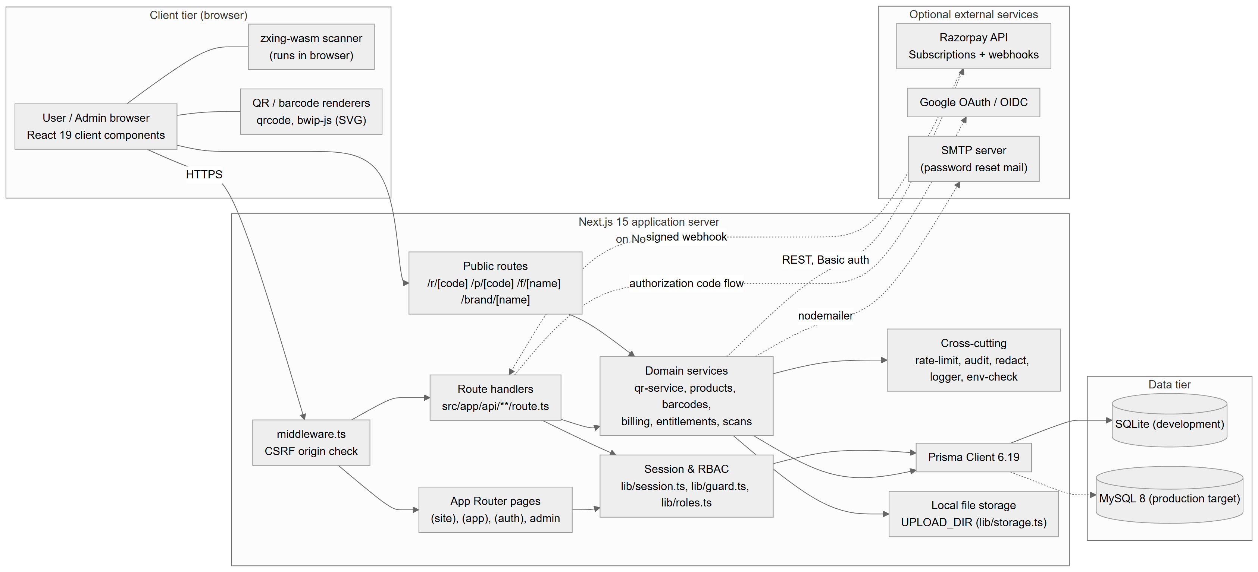
Figure 4.1: High-level system architecture of QRSathi

Figure 4.1 shows the verified components. The browser runs React client components, the zxing-wasm scanner and the QR/barcode renderers. All requests reach the Next.js server; for /api routes, the middleware first enforces the CSRF origin rule. App Router pages and API route handlers authenticate through the session/RBAC module and call domain services, which use cross-cutting services (rate limiting, audit, redaction, logging) and access the database through Prisma. SQLite is used in development; MySQL is the production target (dashed line, because no production deployment was verified). Public routes (/r, /p, /f, /brand) serve redirects, hosted pages, uploaded files and brand images. External services are optional: Razorpay (REST calls and signed webhooks), Google OAuth and SMTP.

4.5 Module Decomposition
Table 4.2: Module decomposition
Module | Responsibilities | Inputs | Outputs | Depends on
Authentication & sessions | Sign-up, sign-in, Google OAuth, reset, sessions, logout | Credentials, cookies | Session cookie, user DTO | Prisma, bcrypt, jose, rate limit, audit
Authorization (RBAC) | Roles, page and API guards, admin permission rules, recent-auth | Session, role | Allow / 401 / 403 / redirect | Sessions
Admin auth & MFA | Admin login, TOTP, recovery codes, re-authentication | Password, TOTP, ticket | qs_admin session | Node crypto, Prisma
QR types & rendering | 27 type definitions, payload builders, SVG renderer, design warnings | Form data, design | Payload text, SVG | qrcode, zod
QR service | Persist, update, duplicate QR codes; short codes; UTM | Validated input | QrCode rows | Entitlements, Prisma
Dynamic resolution & scans | /r/[code], /p/[code], scan recording | Short code, request headers | 302 / page / 410; Scan rows | Prisma, rate limit, UA parser
Analytics | Aggregate scans; CSV export | Date range | Chart data, CSV | Prisma, entitlements
Barcodes | 23 formats: validation, check digits, GS1 parsing, rendering, labels, lookup keys | Format, value | SVG, normalised value | bwip-js
Scanner | Camera/image decoding, classification, safety notes, history | Video frames, images | Decoded results | zxing-wasm, content safety
Products & inventory | Product CRUD, barcodes, stock movements, lookup, import | Product data, movements | Products, ledger entries | Barcodes, entitlements, Prisma
Bulk | Batch generation, CSV/XLSX parsing and export | Spreadsheet rows | ZIP/PDF of codes, import report | papaparse, read/write-excel-file, jszip, jspdf
Uploads | Validate and store files; serve safely | Multipart file | Upload row, /f/{name} | Storage, entitlements
Plans & entitlements | Plan catalogue (DB with defaults), quota checks, feature flags | User plan | Allow / 403 | Prisma
Billing | Provider plan sync, subscriptions, checkout verification, webhooks, refunds, cancellation | Plan id, Razorpay payloads | Subscription/Payment rows, plan changes | Razorpay client, payment config
Configuration & branding | Settings, branding draft/publish, assets, theme CSS | Admin input, images | Setting/BrandAsset rows | image-check, Prisma
Payment configuration | Store sealed credentials, verify, enable checkout | Keys, mode | Status (never secrets) | secret-box, Razorpay
Audit & logging | Audit events, system log, structured logs | Events | AuditLog, Log, stdout | redact
Admin console | Dashboards for users, codes, reports, products, analytics, subscriptions, payments, security, settings, system | Admin requests | Views | All of the above

4.6 Use-Case Diagram
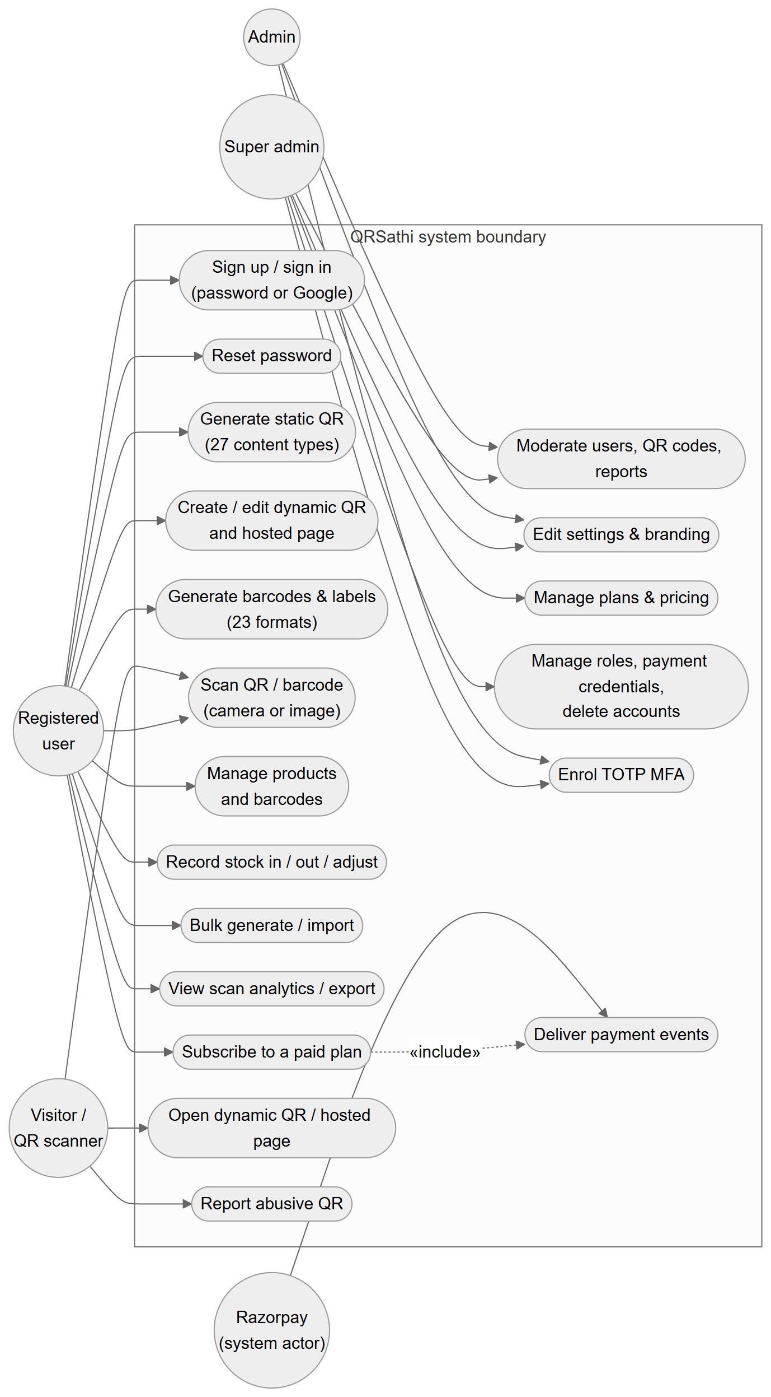
Figure 4.2: Use-case diagram (actors and principal use cases)
Figure 4.2 shows five actors. The Visitor (no account) opens dynamic links and hosted pages, reports abusive codes and can use the scanner. The Registered user performs the workspace use cases UC1–UC11. The Admin moderates and configures (UC14, UC15, UC18); the Super admin additionally manages pricing and privileged settings (UC16, UC17) — in UML terms the super admin specialises the admin (shown explicitly in the PlantUML source use-case-diagram.puml). Razorpay is a system actor that delivers payment events (UC19), which the subscription use case includes. The diagram is drawn with Mermaid flowchart shapes: circles are actors and rounded boxes are use cases inside the system boundary.

4.7 Data-Flow Diagrams

4.7.1 Context-Level DFD (Level 0)
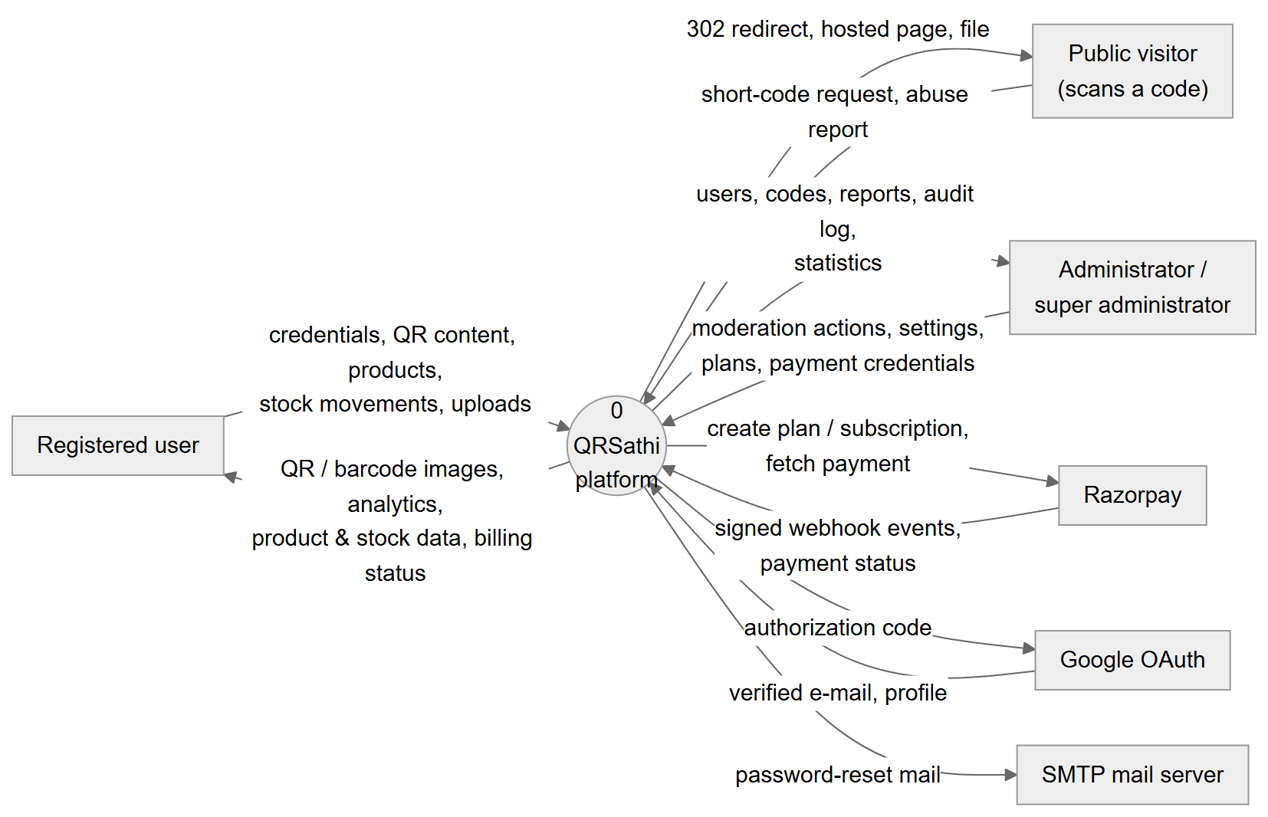
Figure 4.3: Context-level data-flow diagram (Level 0)
At the context level (Figure 4.3) QRSathi is a single process exchanging data with six external entities. Users send credentials, QR content, products, stock movements and uploads, and receive images, analytics and billing status. Visitors send short-code requests and abuse reports and receive redirects, hosted pages and files. Administrators send moderation and configuration actions and receive reports and audit data. Razorpay, Google and the SMTP server exchange the data shown on the arrows.

4.7.2 Level-1 DFD

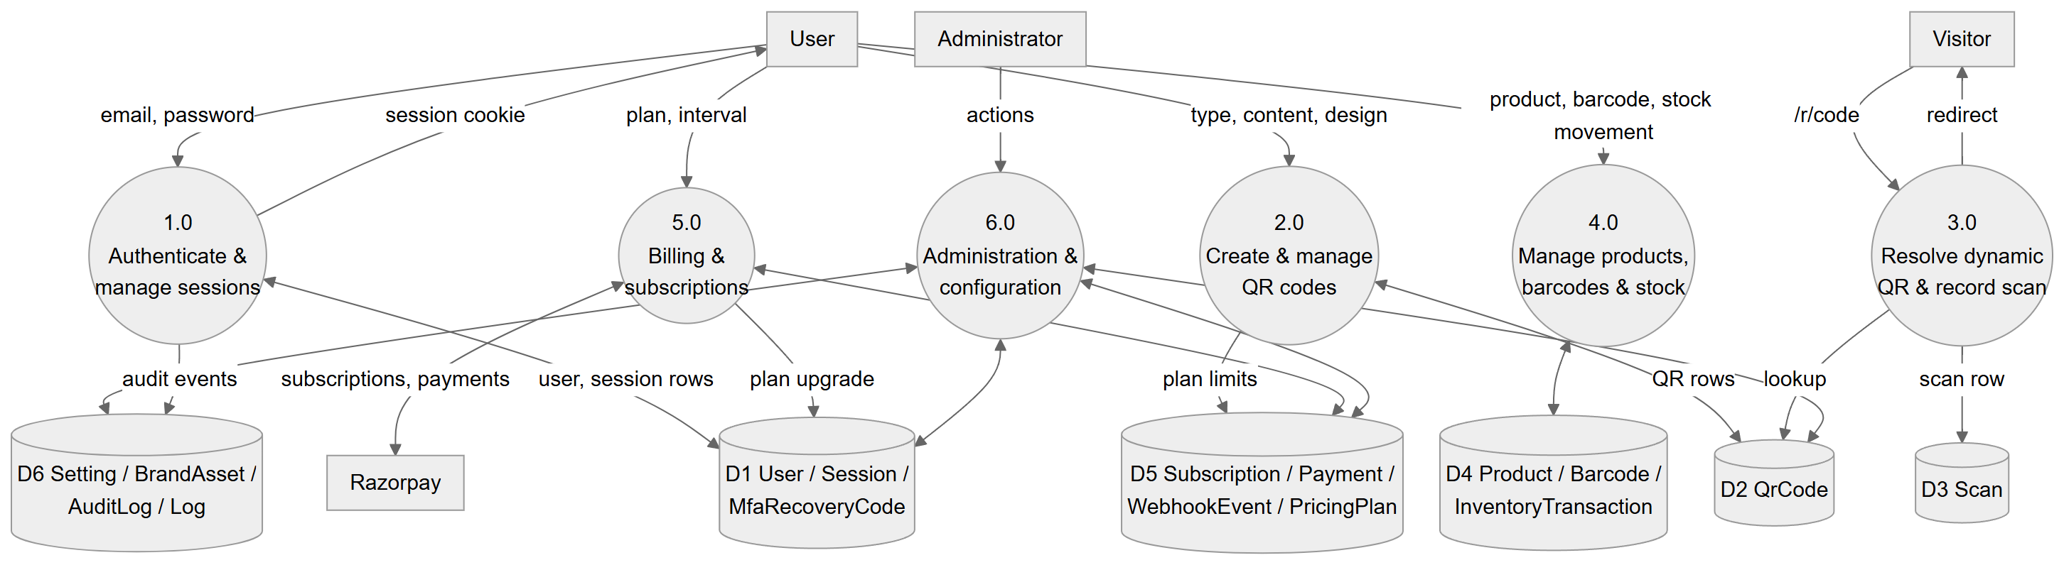
Figure 4.4: Level-1 data-flow diagram

Figure 4.4 decomposes the system into six processes and six data stores. Process 1.0 authenticates users against D1 (users, sessions, recovery codes) and writes audit events to D6. Process 2.0 creates QR codes in D2 after reading plan limits from D5. Process 3.0 serves visitors: it reads D2 and appends to D3 (scans). Process 4.0 maintains D4 (products, barcodes and the inventory ledger). Process 5.0 exchanges subscription and payment data with Razorpay and D5, and upgrades the user's plan in D1. Process 6.0, administration, reads and writes most stores.

4.7.3 Level-2 DFD: QR Creation and Dynamic Resolution
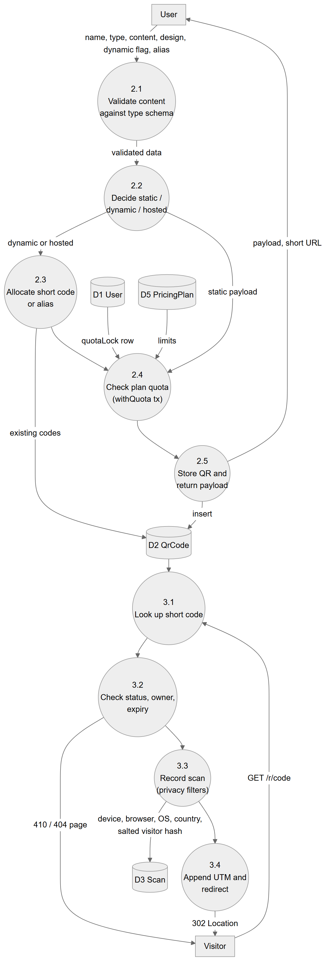
Figure 4.5: Level-2 DFD: QR code creation and dynamic resolution (processes 2.0 and 3.0)
Figure 4.5 refines processes 2.0 and 3.0. Creation (2.1–2.5) validates the content against the type schema, decides whether the code is static, dynamic or hosted, allocates a short code or alias for dynamic codes, checks quotas inside a transaction that locks the user's quotaLock row, and stores the code. Resolution (3.1–3.4) looks up the short code, checks status, owner and expiry, records the scan with privacy filters, appends UTM parameters and redirects.

4.8 Flowcharts

4.8.1 User Registration and Login

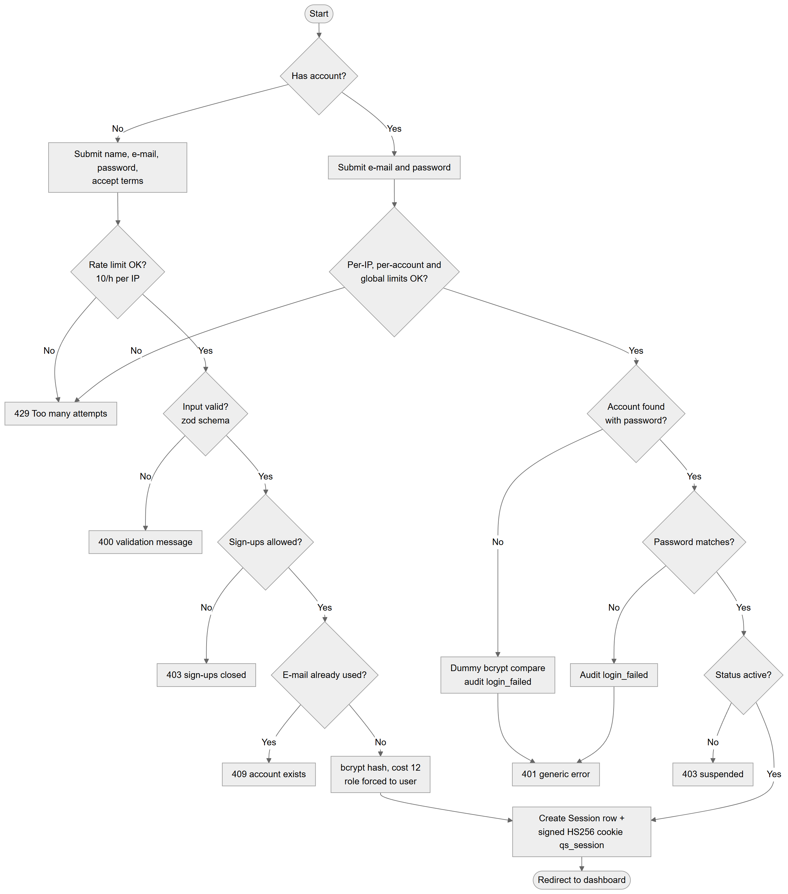
Figure 4.6: Flowchart: user registration and login

Figure 4.6 shows both paths. Registration is rate-limited, validated, checks whether sign-ups are open and whether the e-mail exists, then hashes the password and forces the role to user. Login applies three rate limits, performs a dummy bcrypt comparison for unknown accounts (so response time does not reveal whether an account exists), returns one generic error for all credential failures, and blocks suspended accounts. Both paths end by creating a server-side session.

4.8.2 Authentication and Authorization of a Request
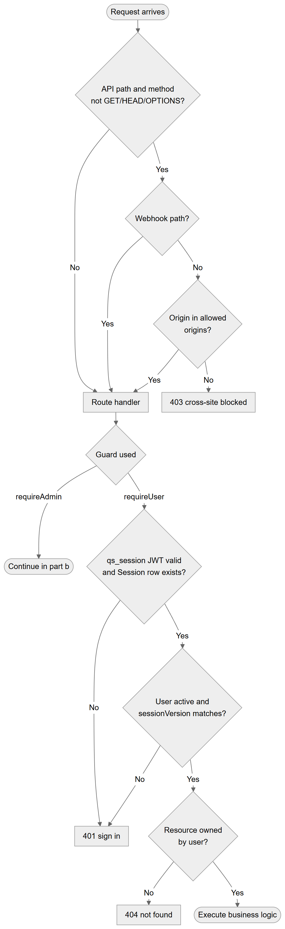
Figure 4.7(a): Request authorization — CSRF check and workspace guard
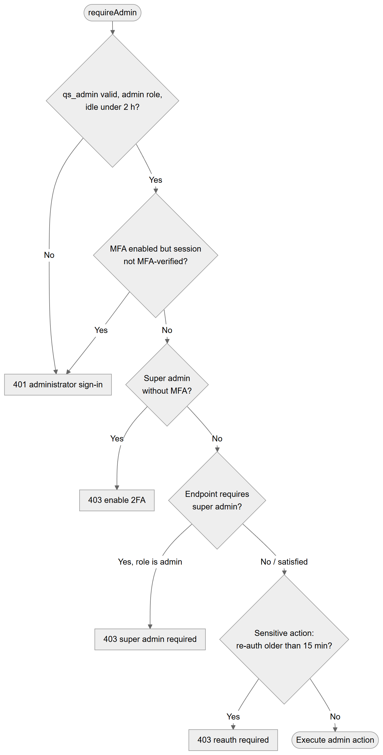
Figure 4.7(b): Request authorization — administrator guard
Every request passes the checks in Figure 4.7 (parts a and b). The middleware rejects cross-origin state-changing API calls (except the webhook, which is authenticated by signature). Workspace handlers call requireUser(), which verifies the signed cookie, the session row, the account status and the sessionVersion; resource ownership is then checked, and resources of other users produce 404 (not 403) to avoid revealing their existence. Admin handlers call requireAdmin(), which additionally enforces the admin role, a two-hour idle timeout, MFA verification of the session, mandatory MFA for super administrators, super-admin-only endpoints and — for payment credentials — re-authentication within 15 minutes.

4.8.3 QR Code Generation
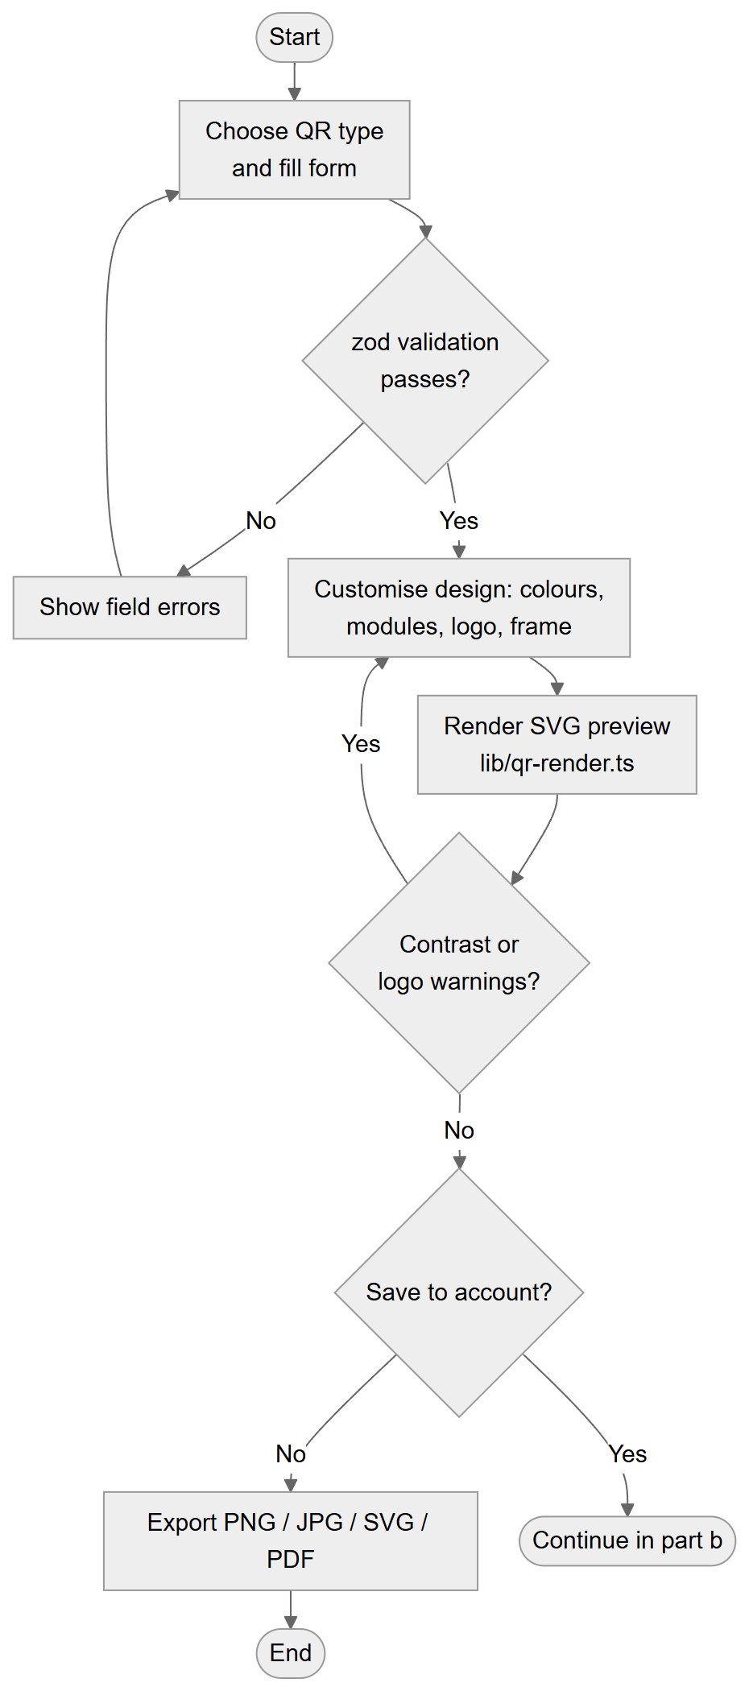
Figure 4.8(a): QR generation in the browser
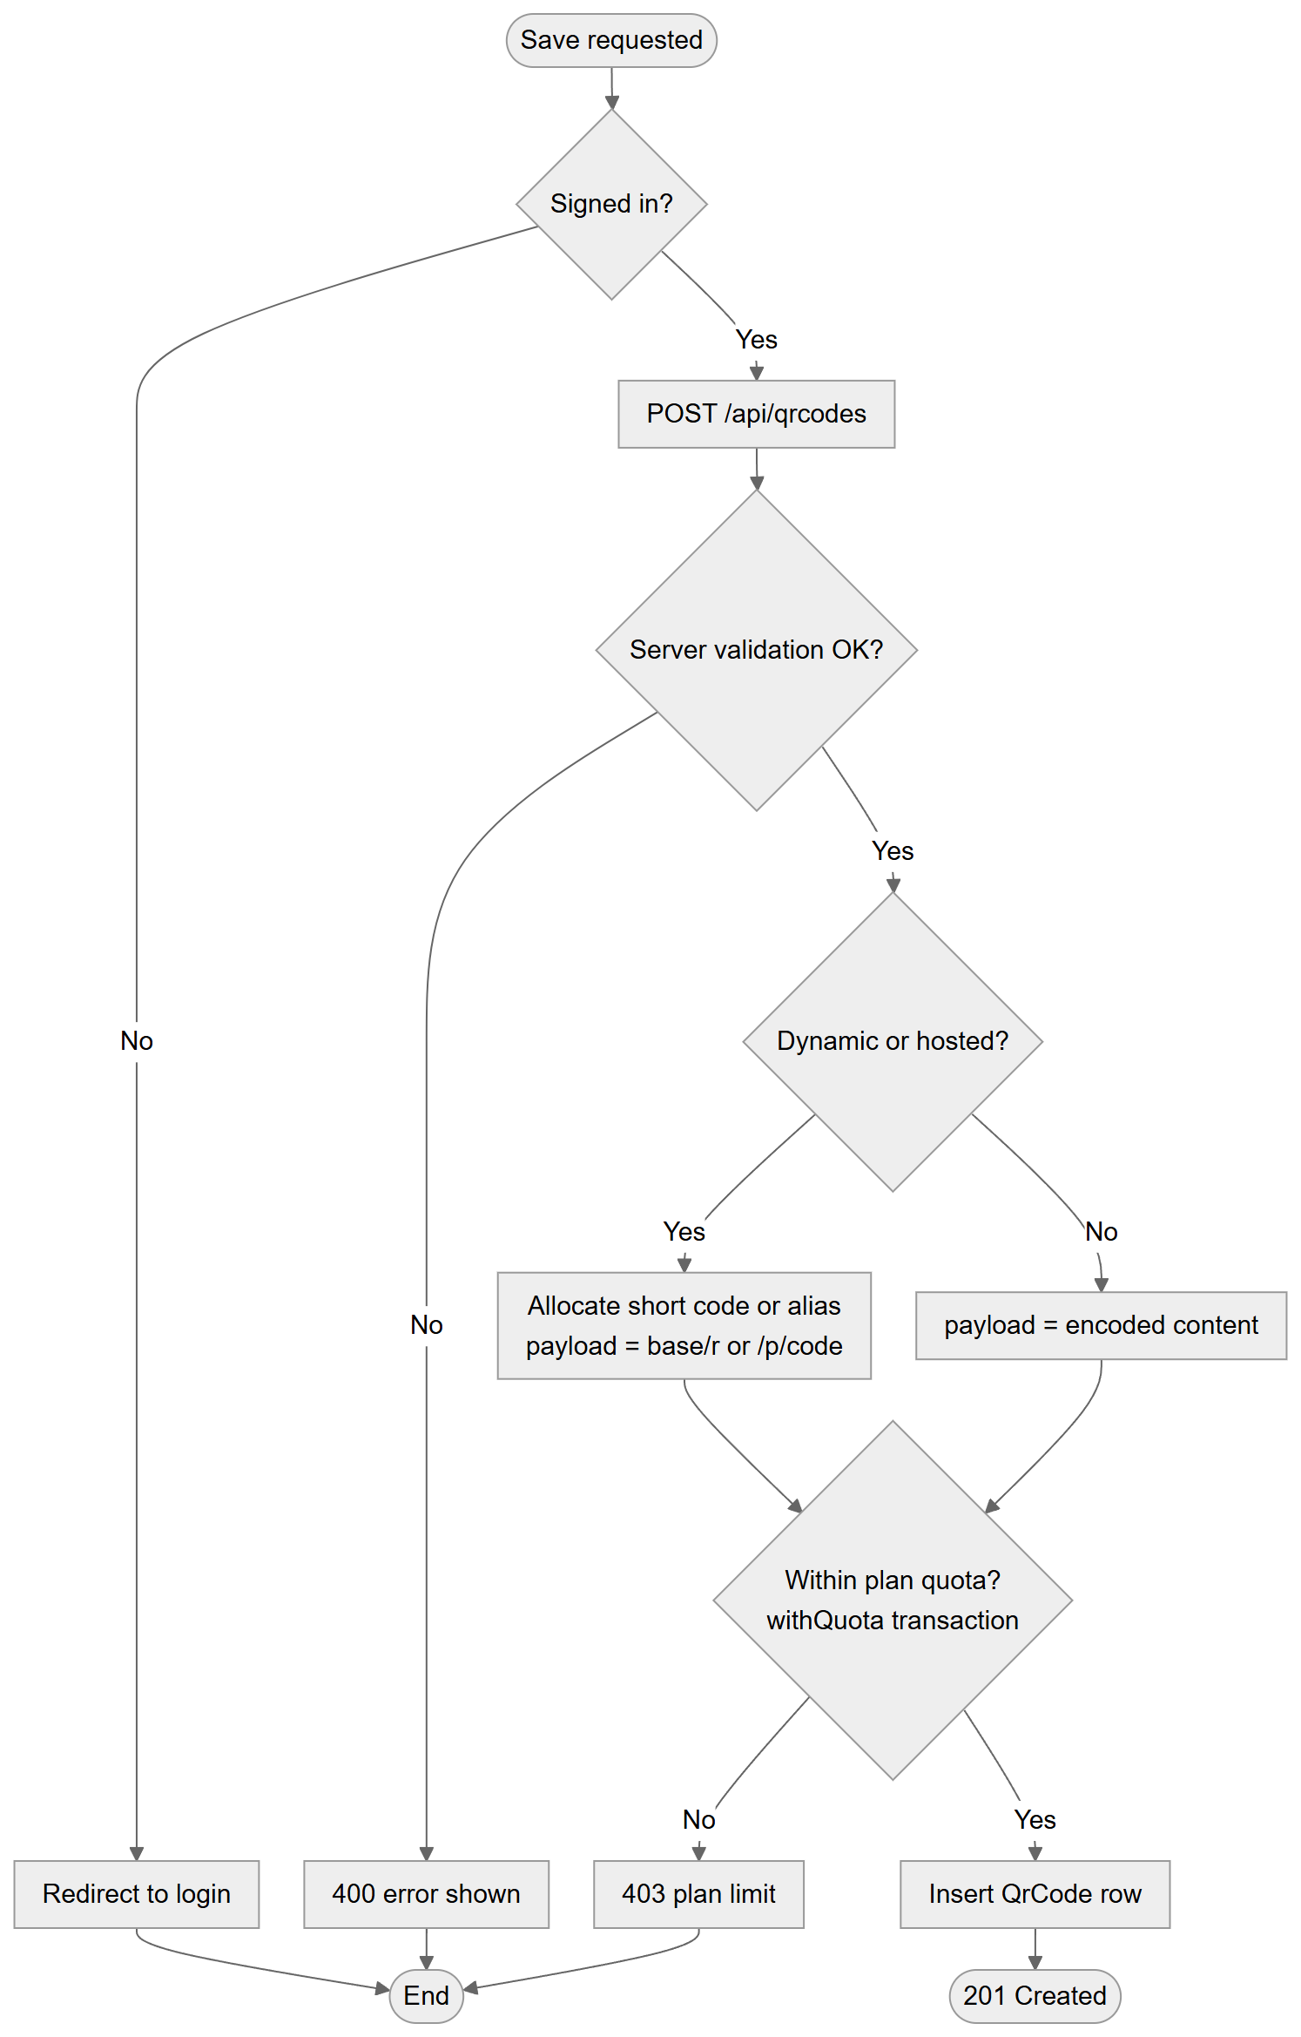
Figure 4.8(b): Saving a QR code on the server
Figure 4.8 shows that generation and export are fully client-side; the server is involved only when a signed-in user saves the code. Server-side validation is repeated before the quota check and insert.

4.8.4 Barcode Generation and Scanning
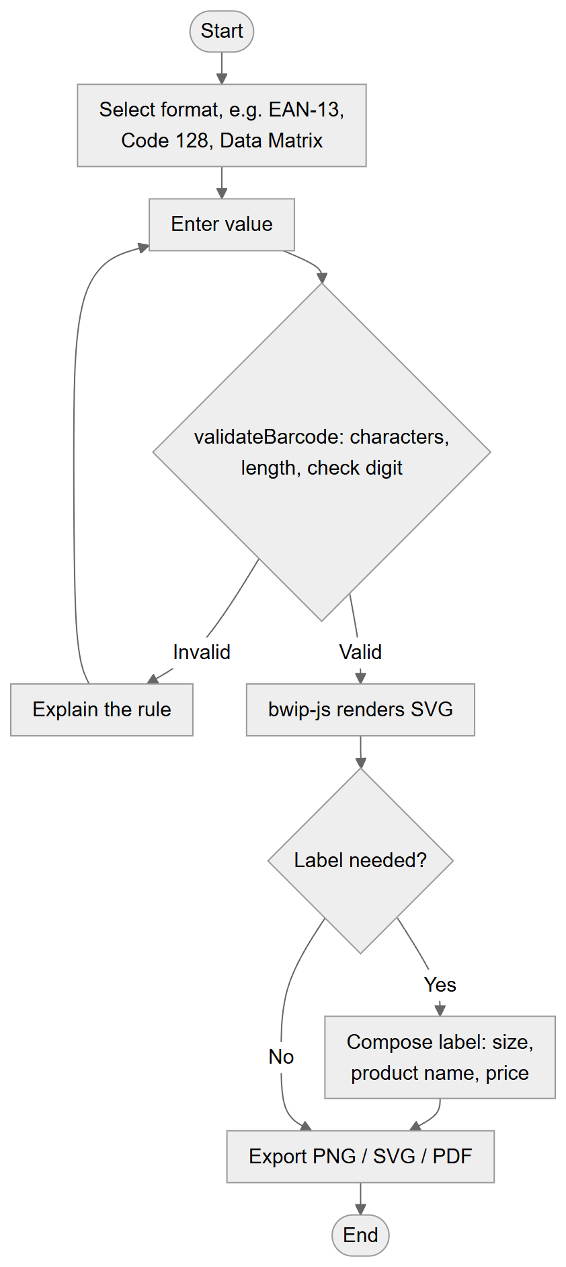
Figure 4.9(a): Barcode generation
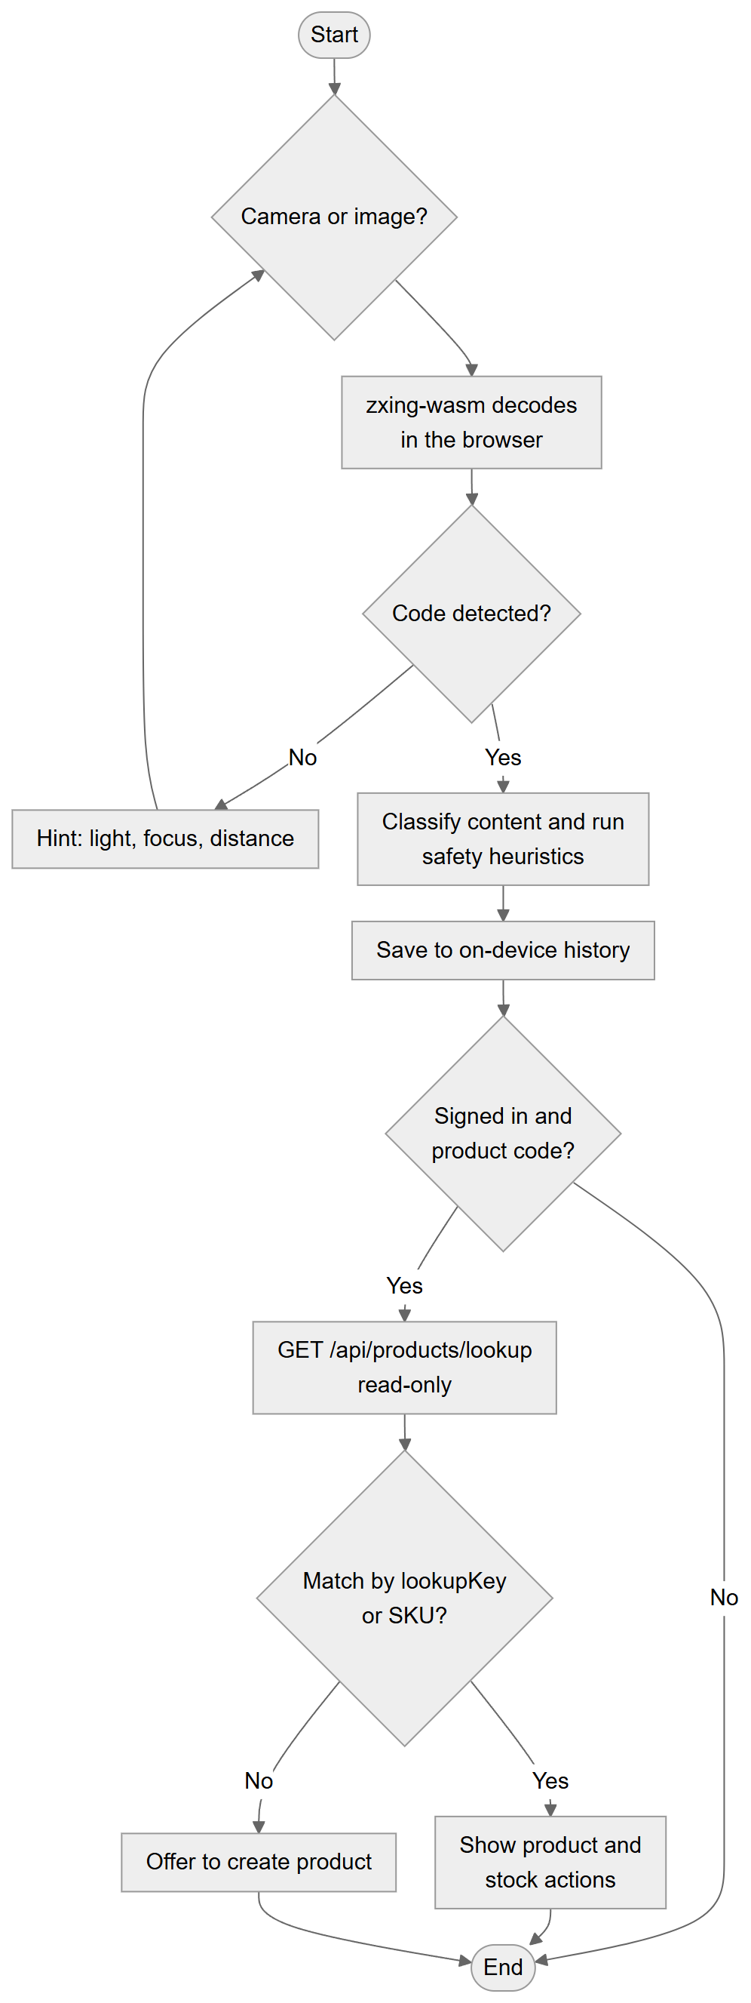
Figure 4.9(b): Barcode and QR scanning
Figure 4.9 has two branches. Generation validates the value for the chosen symbology before rendering with bwip-js and optionally composing a label. Scanning decodes in the browser, classifies the result, runs safety heuristics, stores the entry in the device's local history and — only for signed-in users — performs a read-only product lookup.

4.8.5 Product and Inventory Workflow
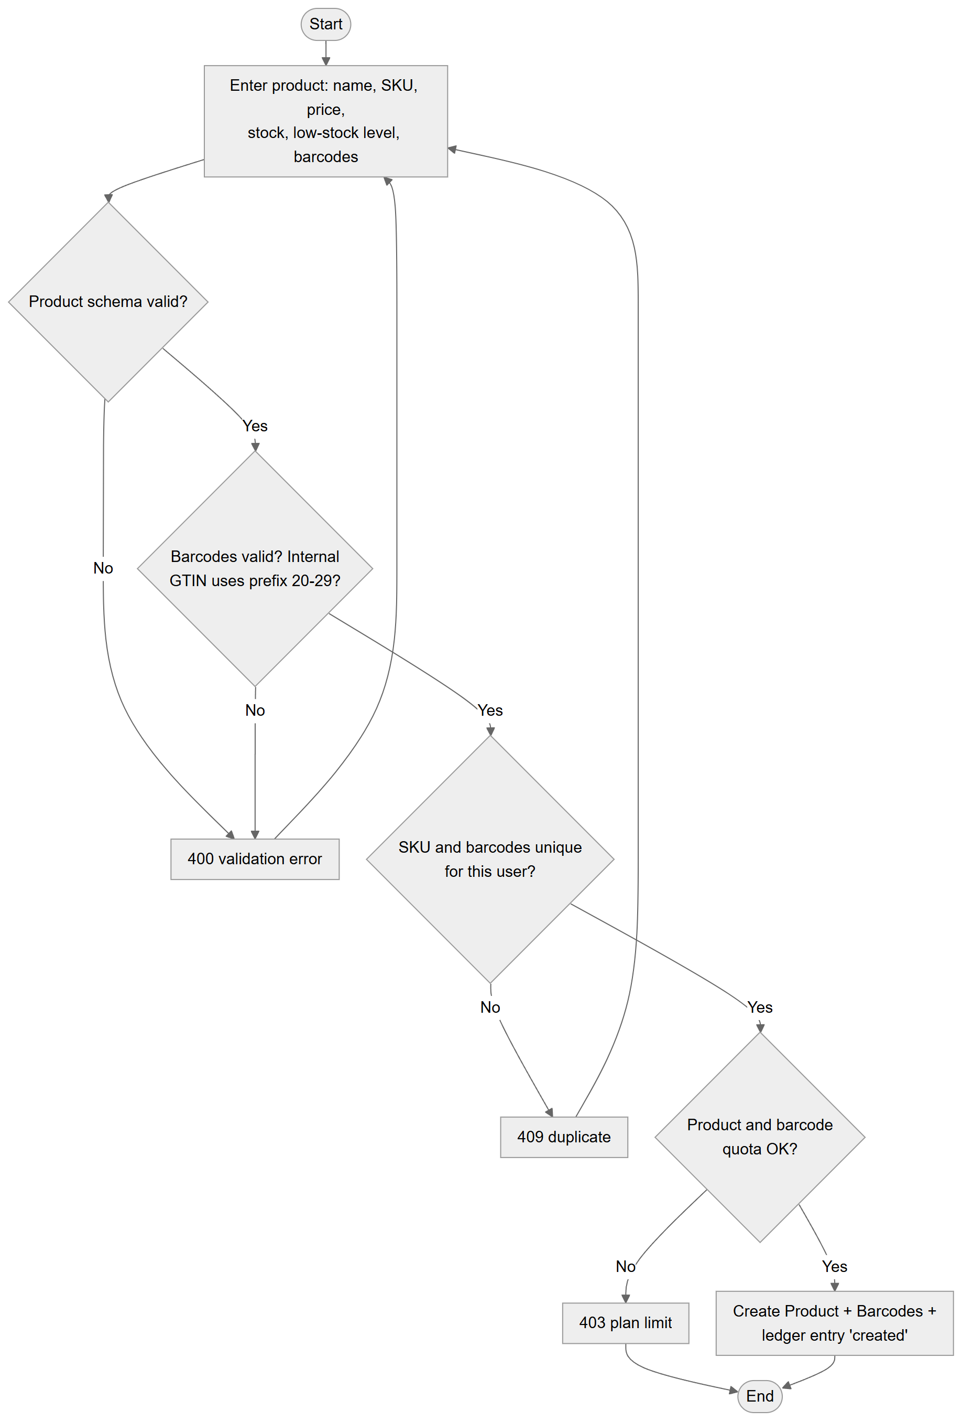
Figure 4.10(a): Product creation
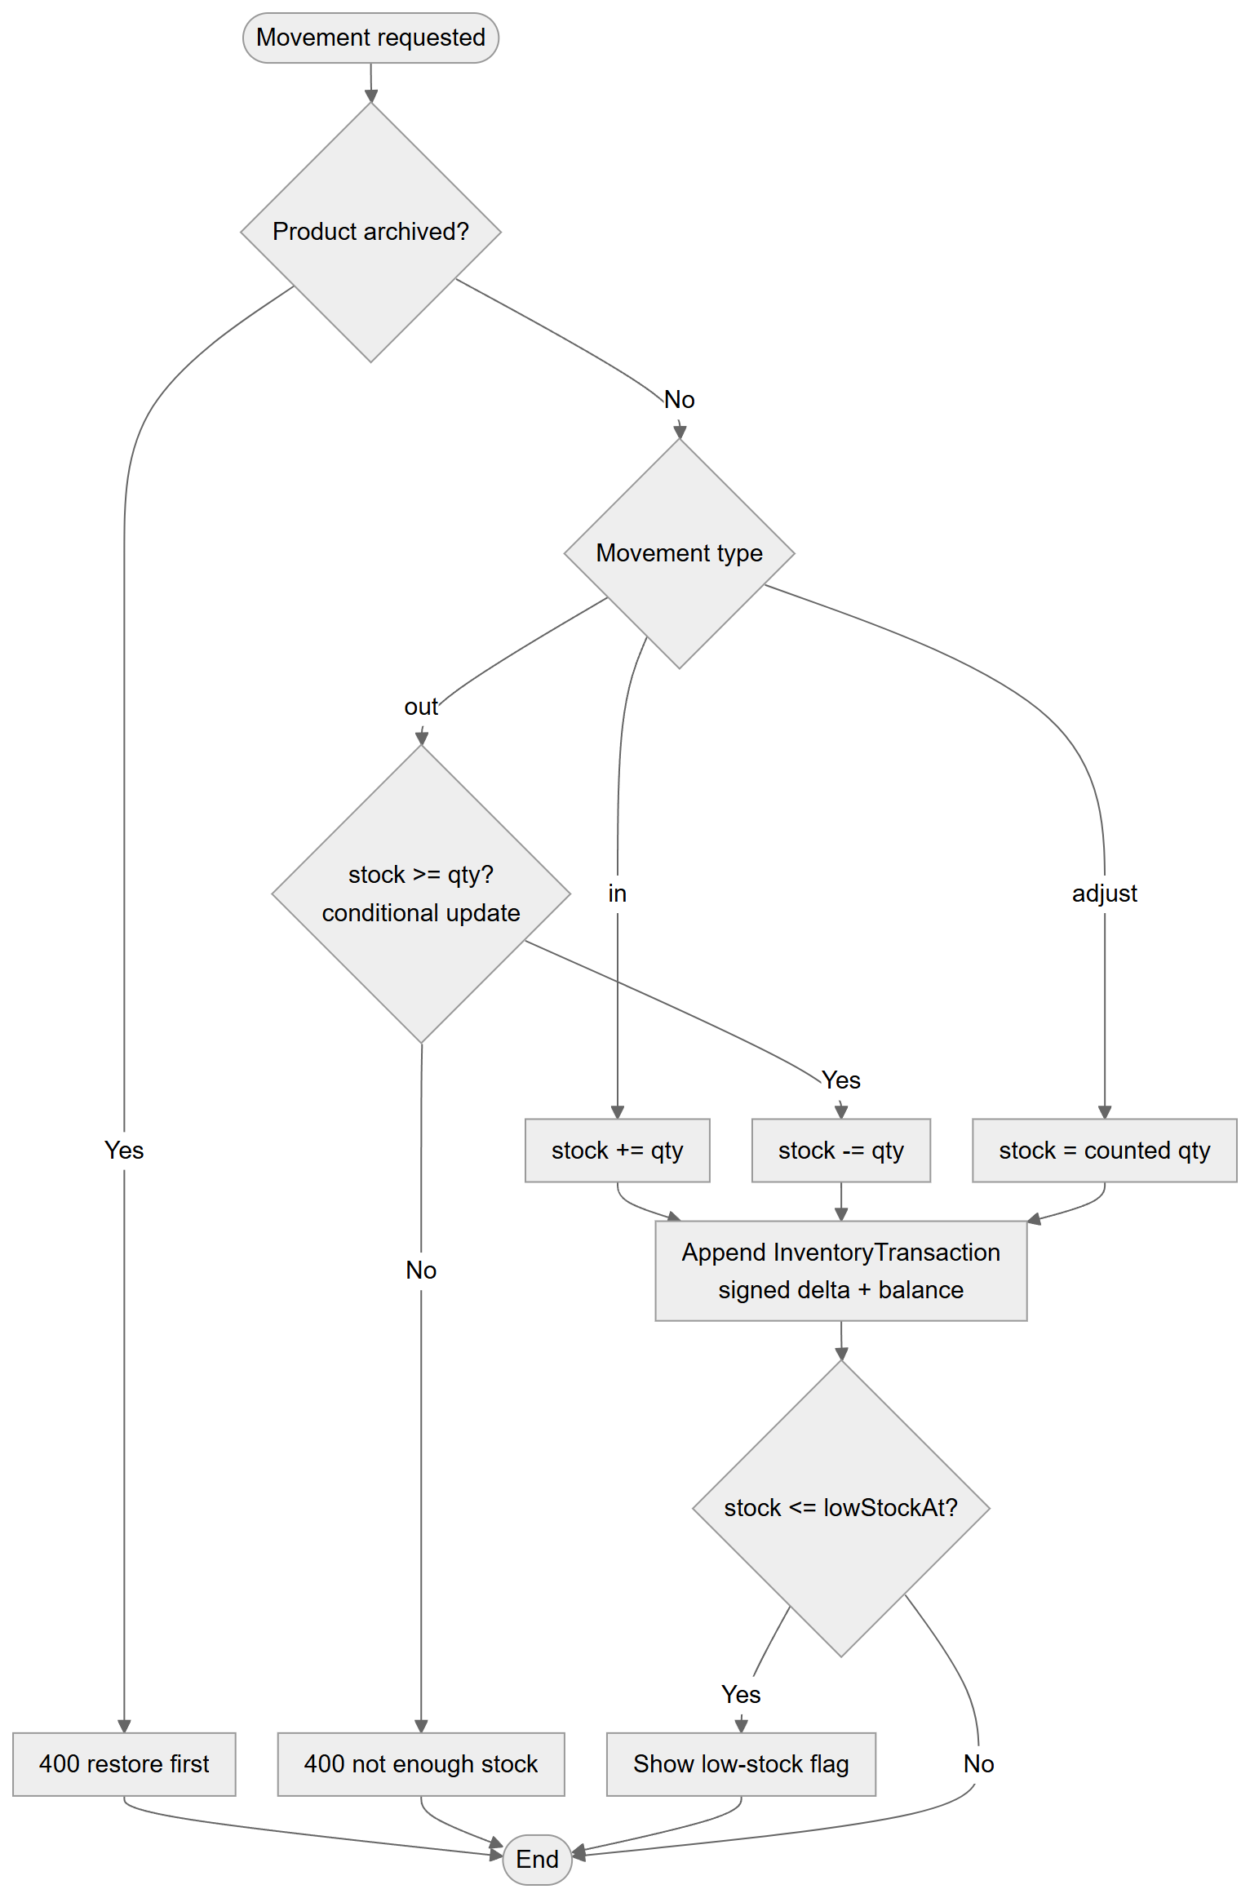
Figure 4.10(b): Stock movement
Figure 4.10 shows that a product is created only after field validation, barcode validation, uniqueness checks and quota checks. Stock then changes exclusively through movements; a stock-out uses a conditional update (stock >= quantity) so concurrent requests cannot drive stock negative. Every movement appends a ledger entry.

4.8.6 Dynamic QR Resolution
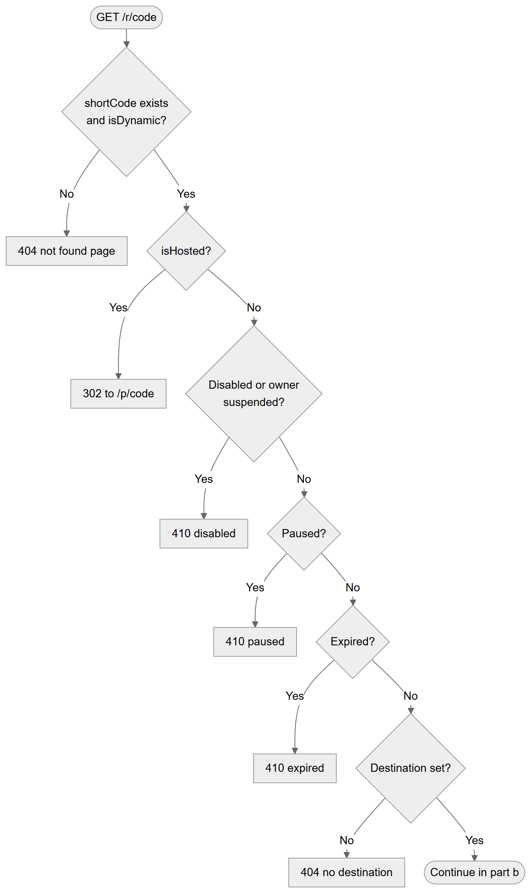
Figure 4.11(a): Dynamic QR resolution — status checks
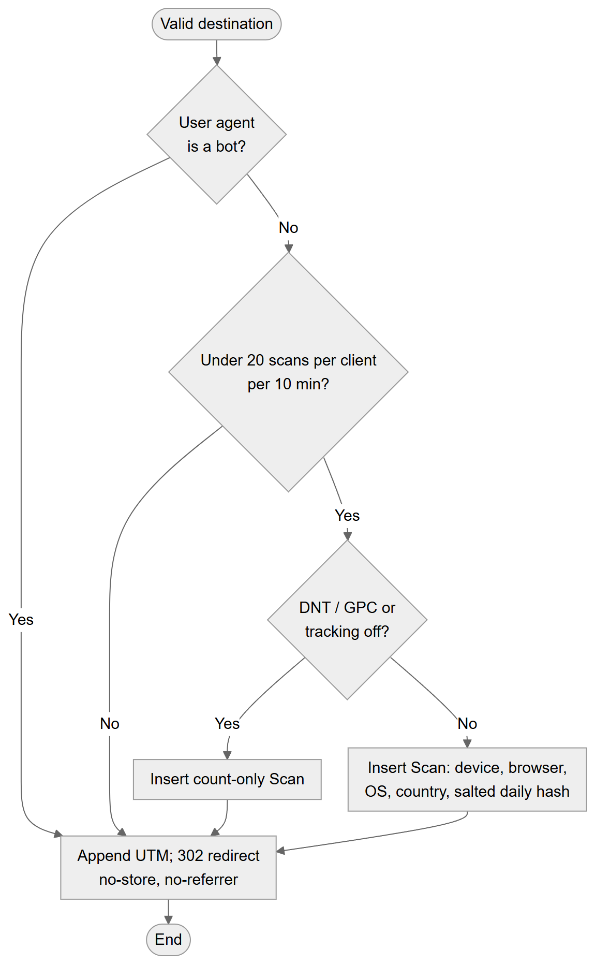
Figure 4.11(b): Dynamic QR resolution — scan recording and redirect
Figure 4.11 shows the order of checks in src/app/r/[code]/route.ts. Visitors are always served (redirected or shown an explanatory page); bots, rate-limited clients and privacy signals only affect what is recorded.

4.8.7 Subscription and Payment Workflow
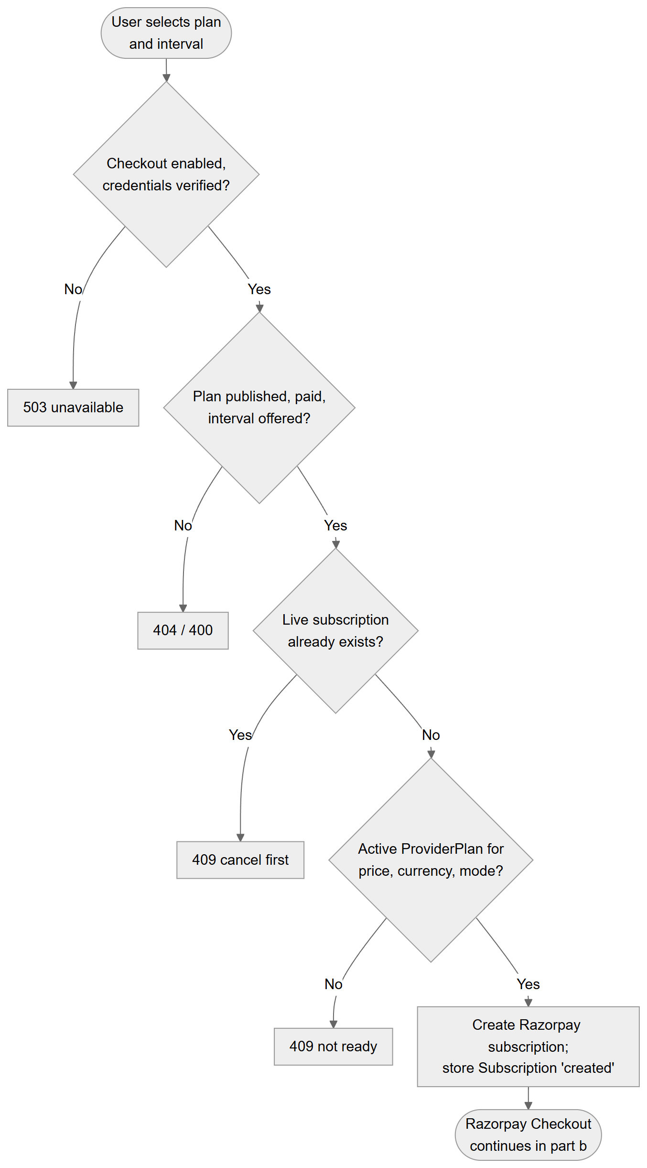
Figure 4.12(a): Subscription checkout — starting checkout
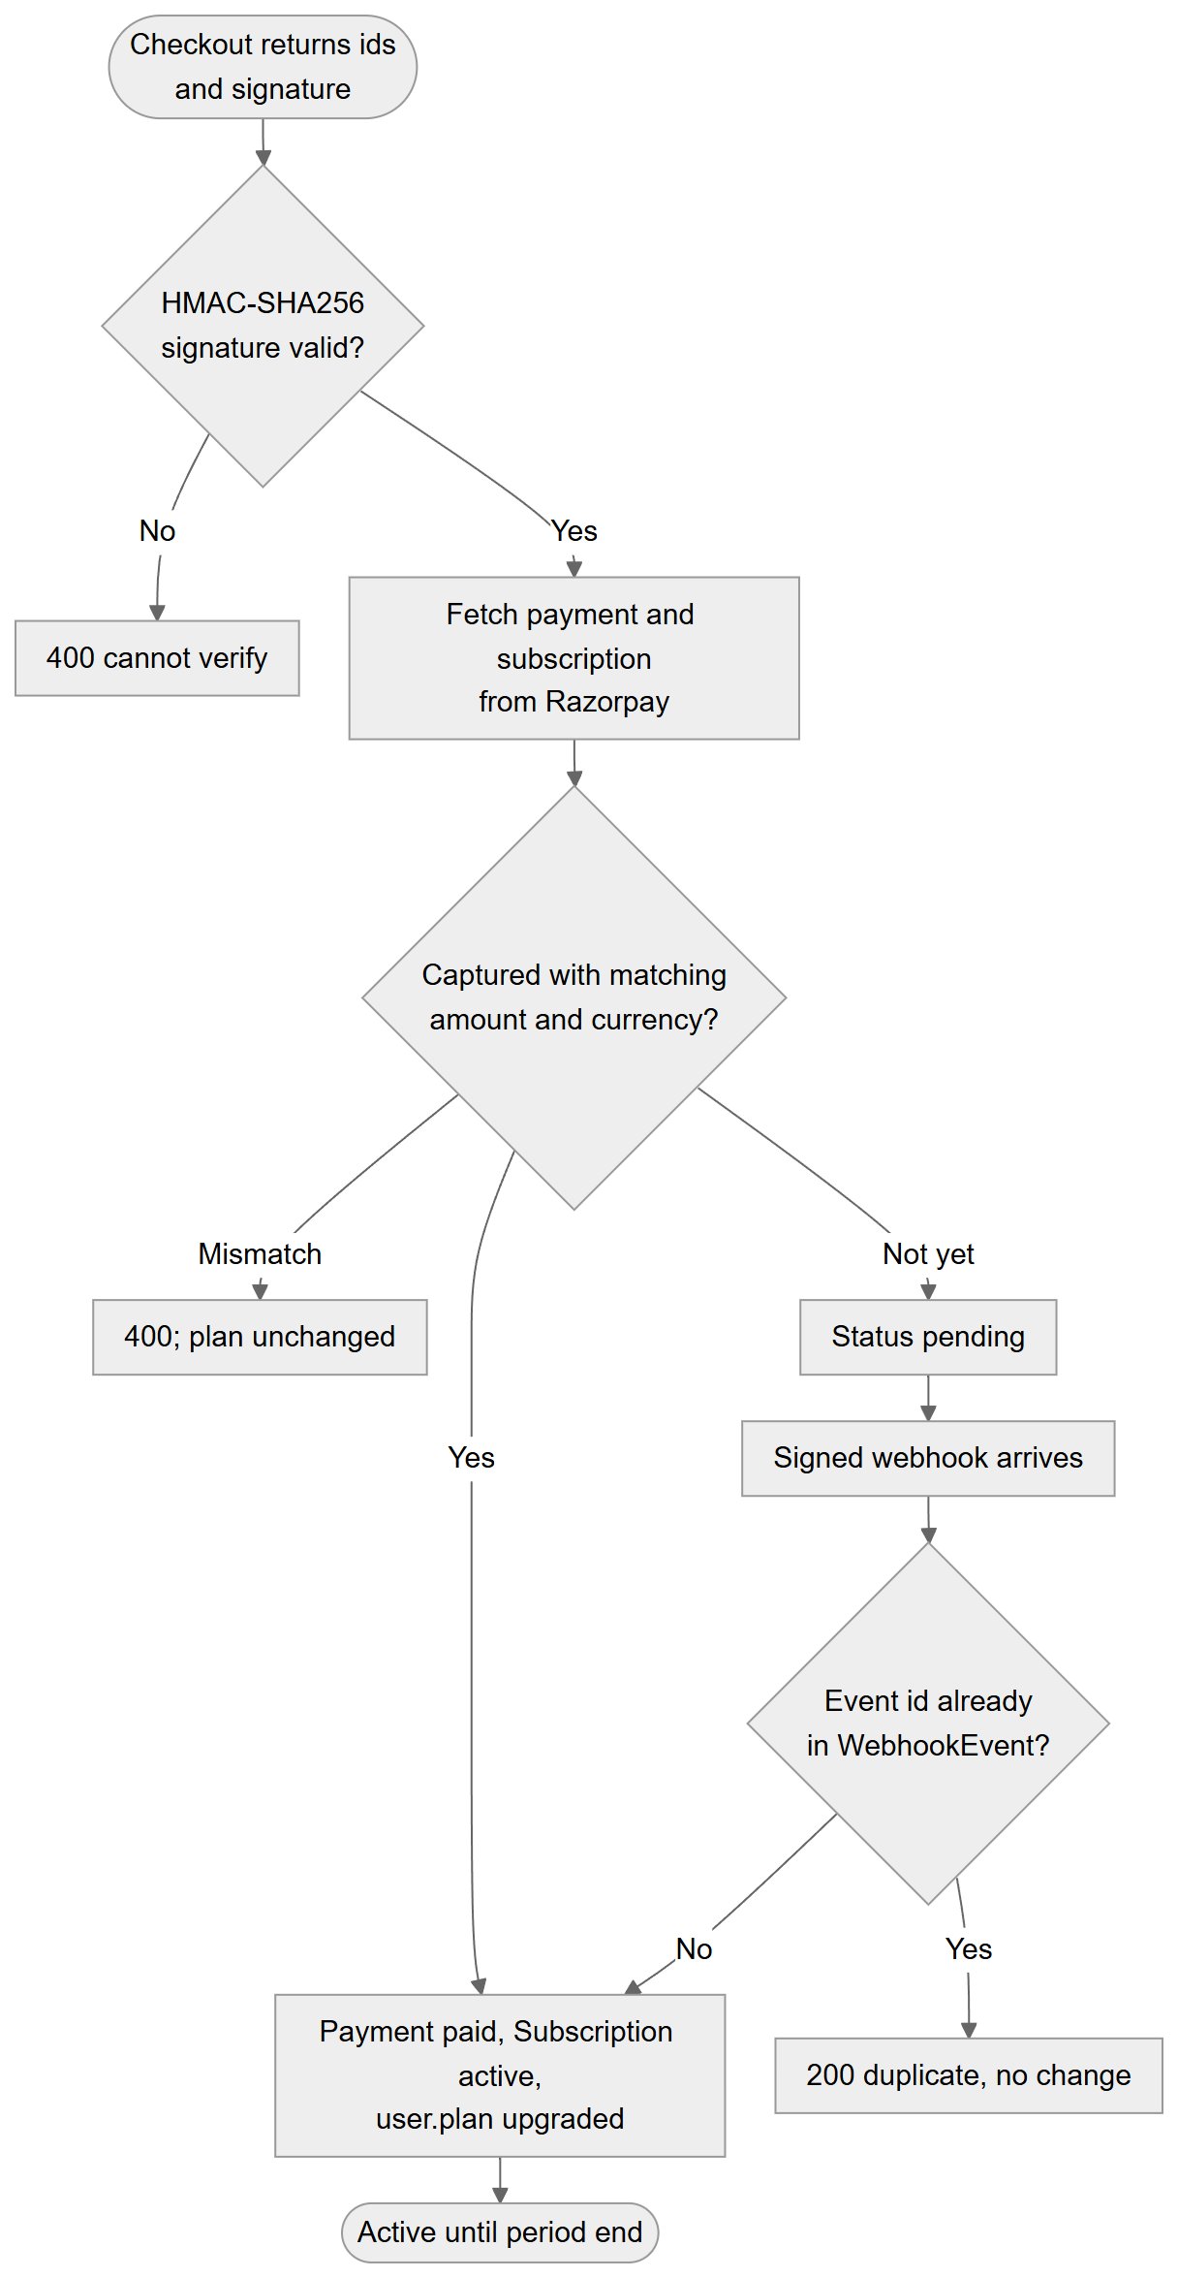
Figure 4.12(b): Subscription checkout — confirmation and webhook
Figure 4.12 shows that the client never supplies a price: it sends a plan identifier and interval, and the server looks up the amount and the active provider plan. The plan is upgraded only after verification of the checkout signature and an API fetch showing a captured payment of the right amount, or after a signed webhook. Duplicate webhook deliveries are detected through the WebhookEvent ledger.

4.8.8 Administrator Configuration Workflow
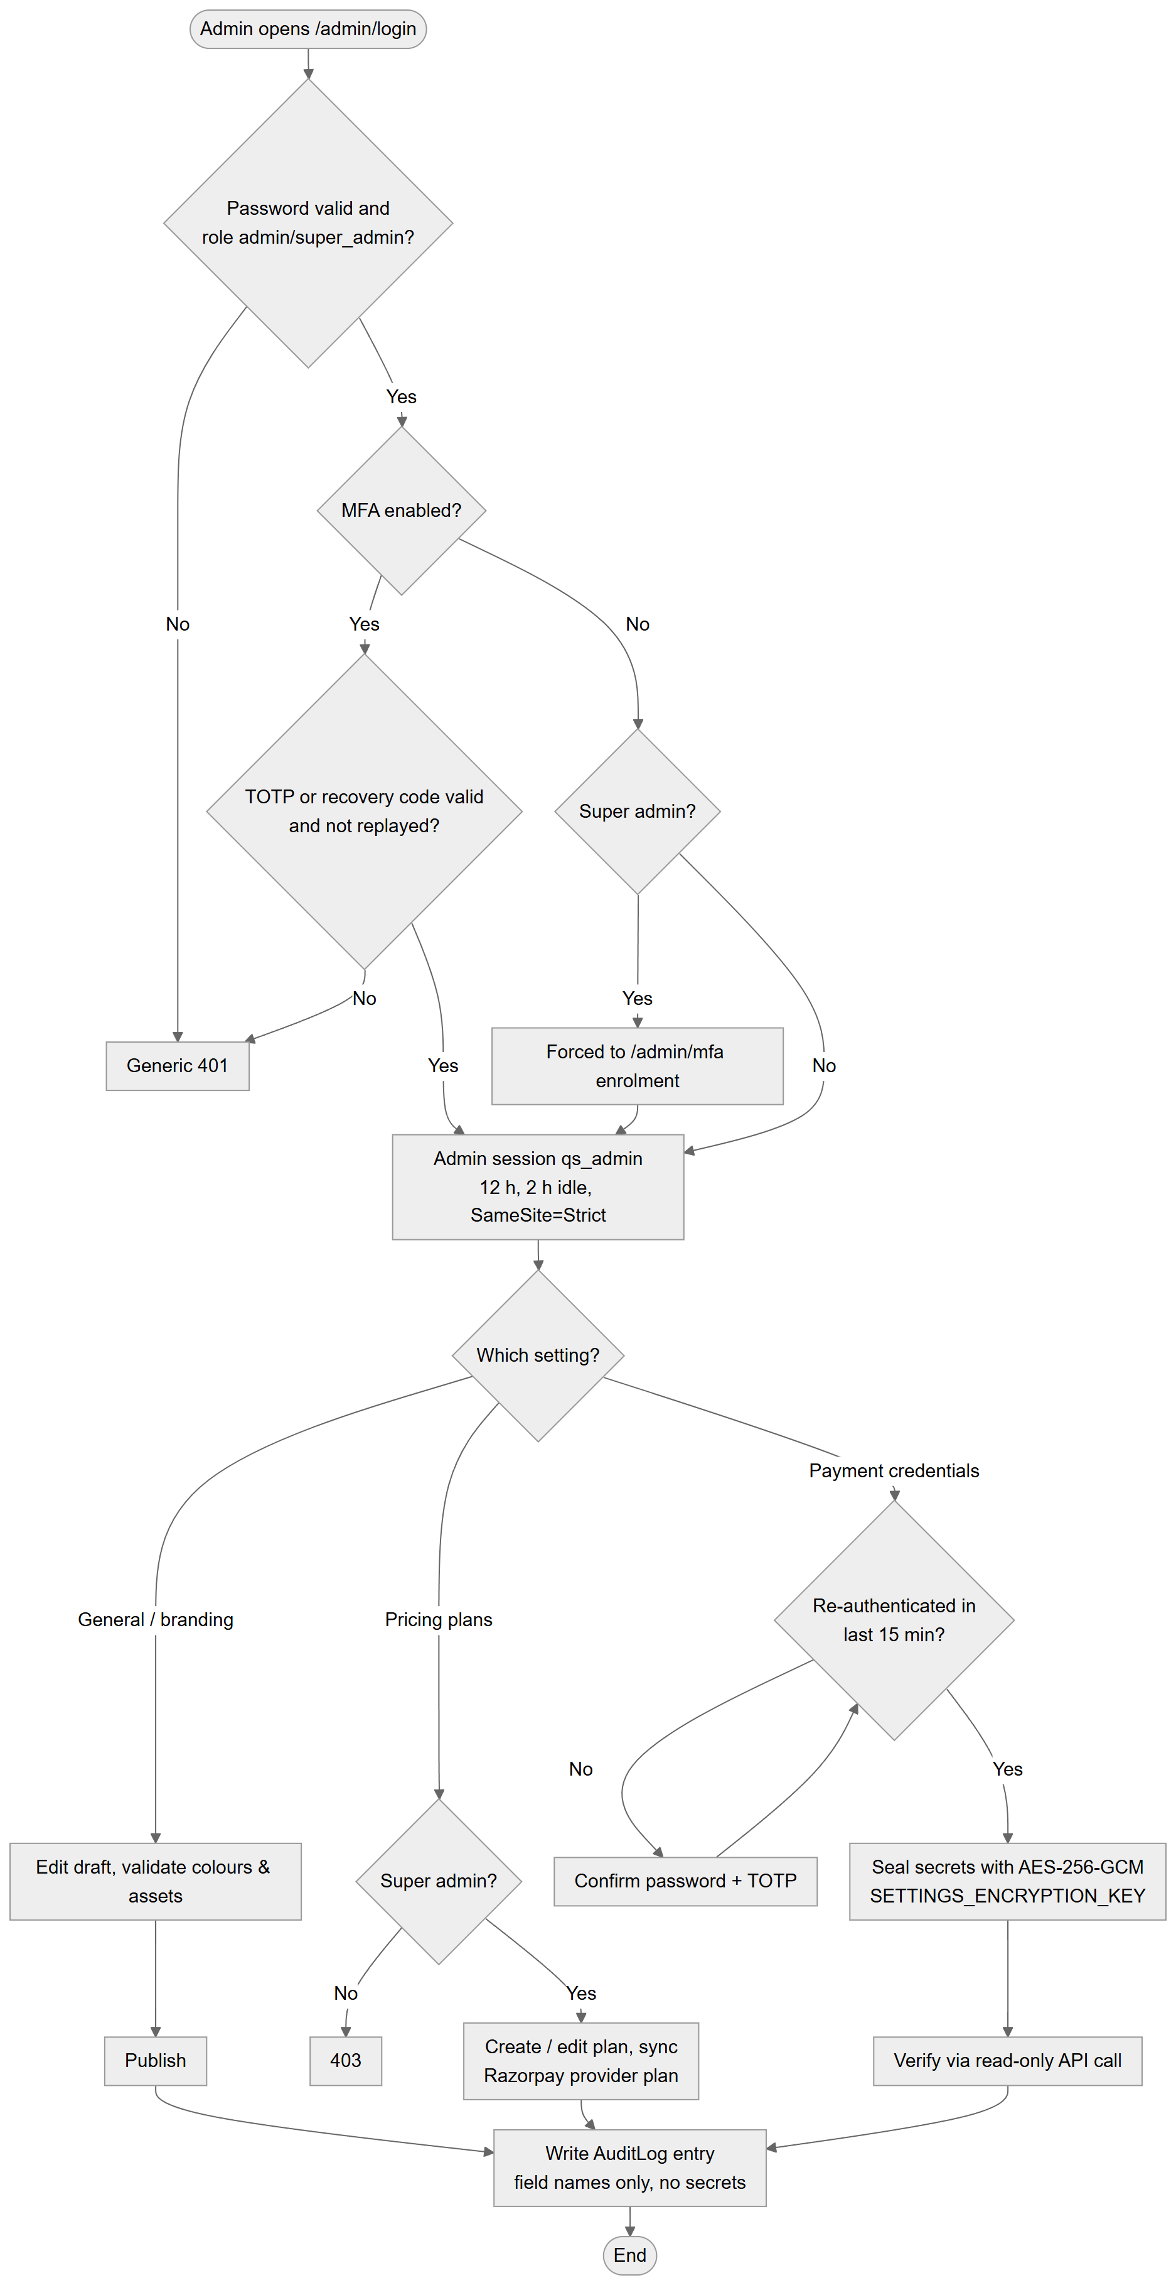
Figure 4.13: Flowchart: administrator configuration workflow
Figure 4.13 shows the admin sign-in (with MFA), the separation between settings any admin may change and super-admin-only settings, the re-authentication requirement for payment credentials, sealing of secrets with AES-256-GCM and the audit entry written for each change.

4.9 Database Design

4.9.1 Conceptual Data Model
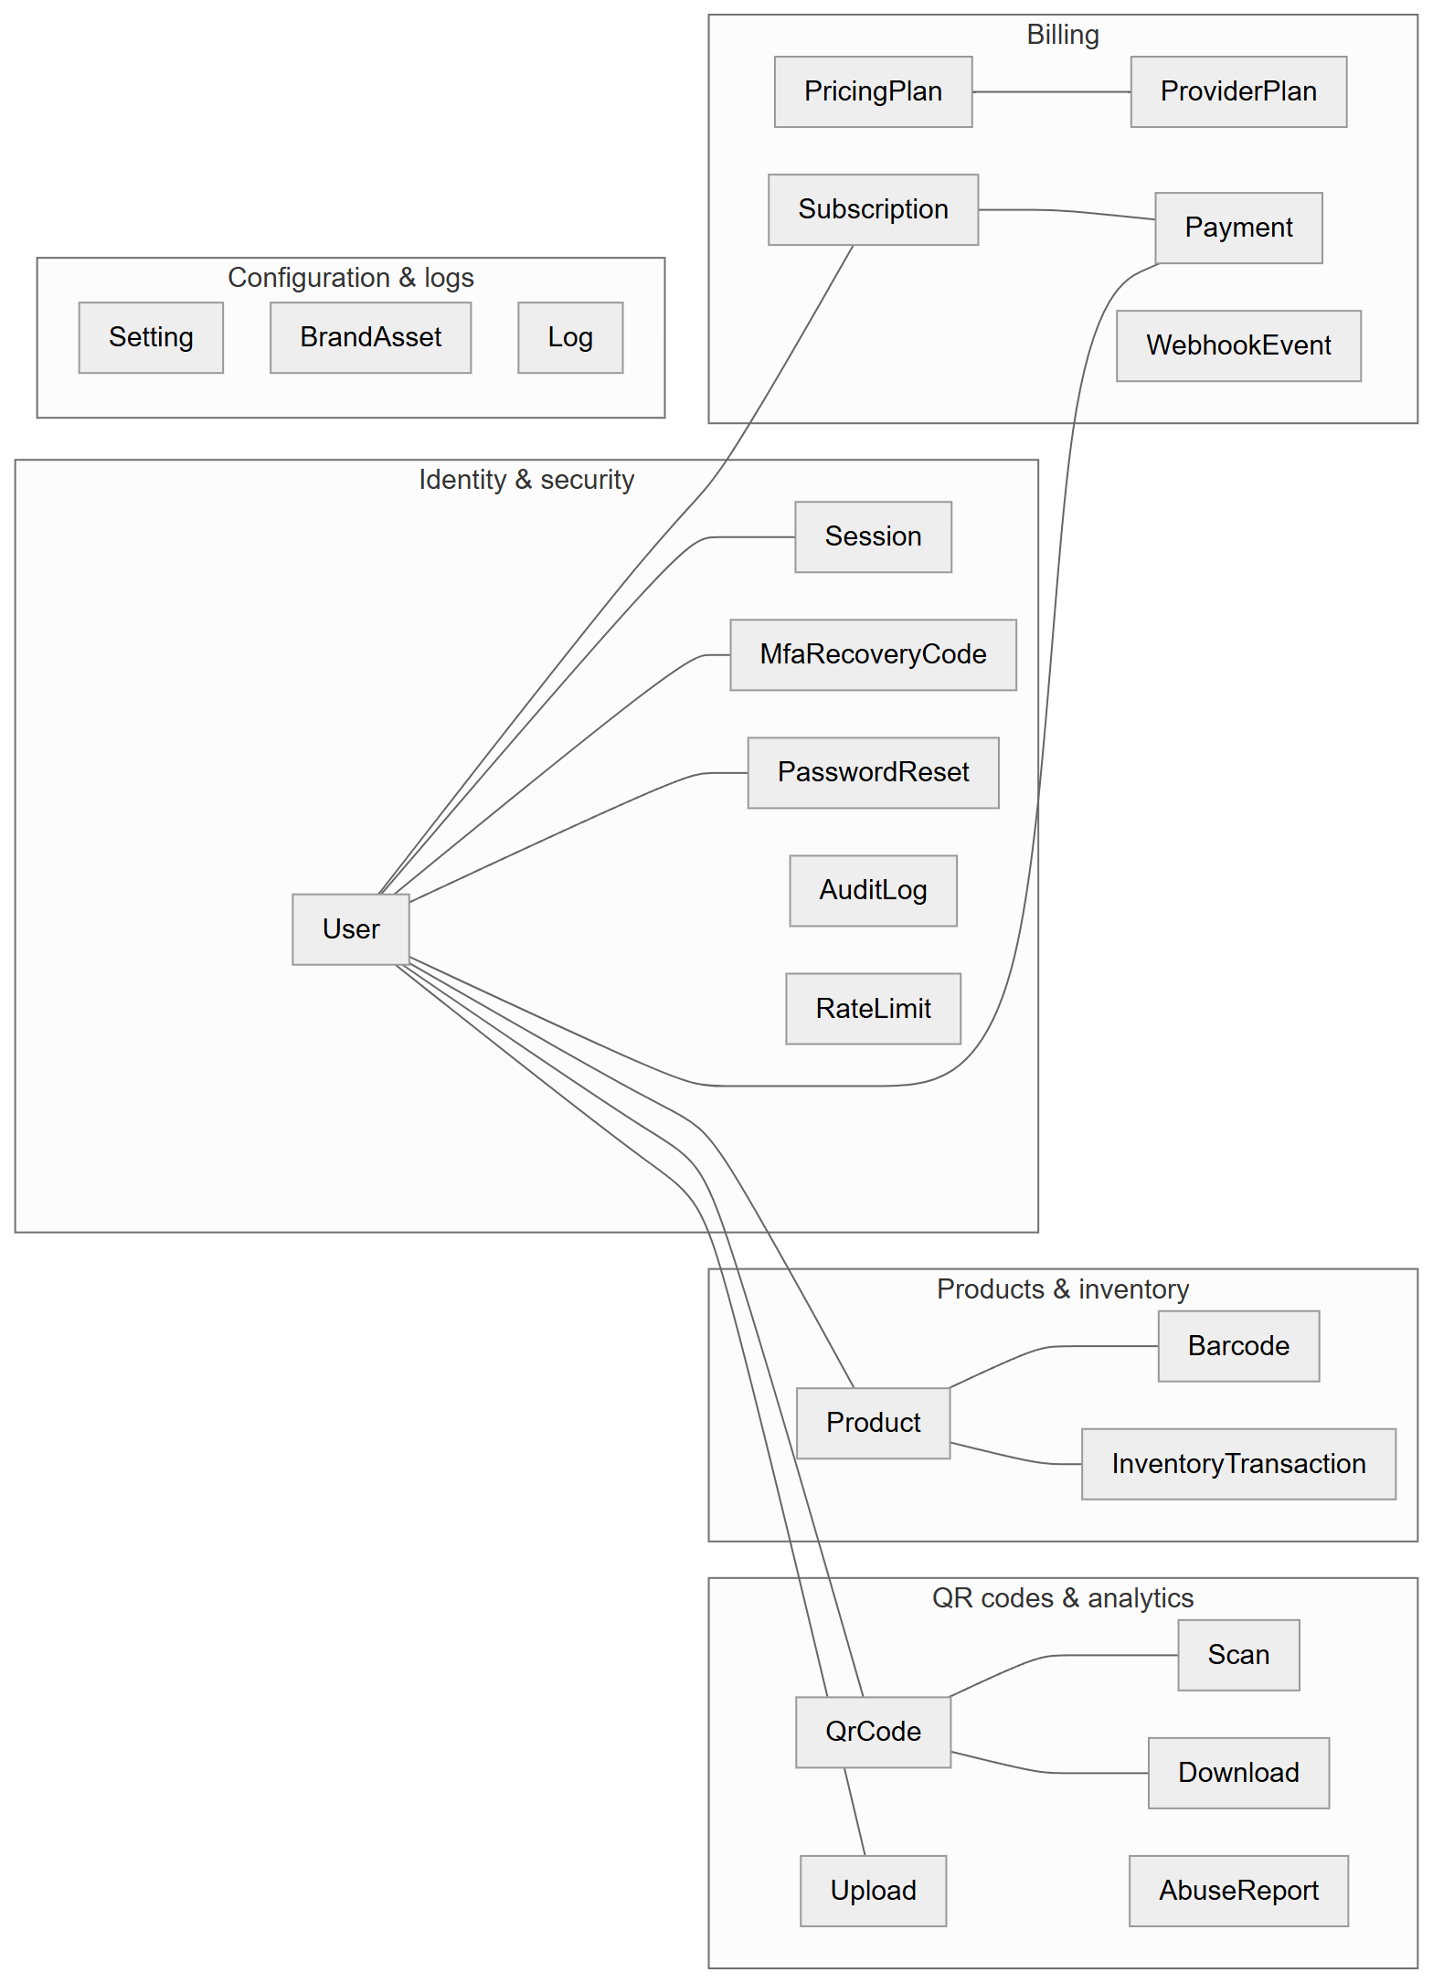
Figure 4.14: Conceptual data model (entity groups)
The conceptual model (Figure 4.14) groups the 22 entities into five areas: identity and security; QR codes and analytics; products and inventory; billing; and configuration and logs. The User entity is the hub: almost all business data is owned by a user, which implements multi-tenancy at the row level.

4.9.2 Entity-Relationship Diagrams

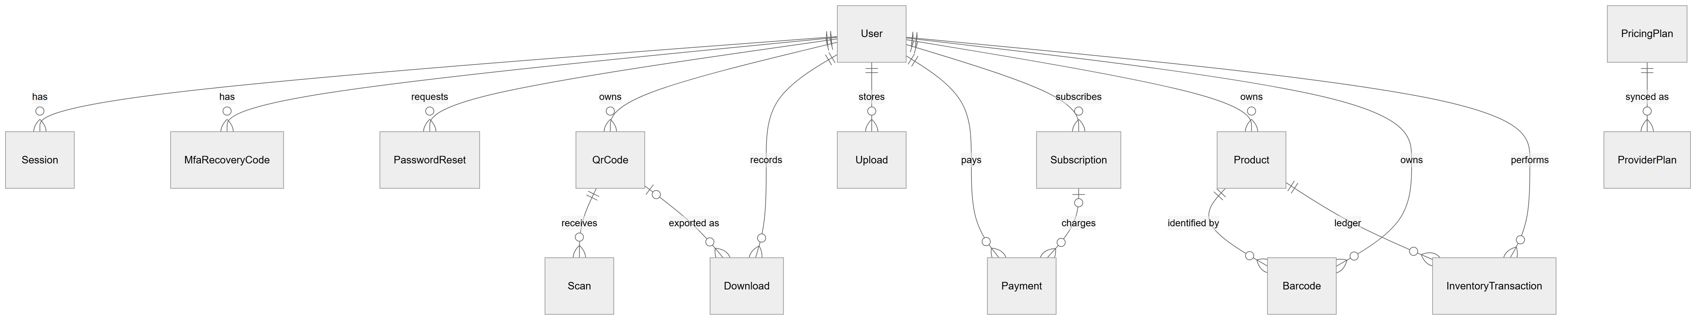
Figure 4.15: Entity-relationship overview (15 related models; 7 standalone models listed in Table 4.6)

Figure 4.15 shows all foreign-key relationships. Crow's-foot notation is used: ||--o{ means "exactly one to zero or more" and |o--o{ "zero or one to zero or more" (an optional foreign key). The detailed ERDs below include the main attributes of each entity.

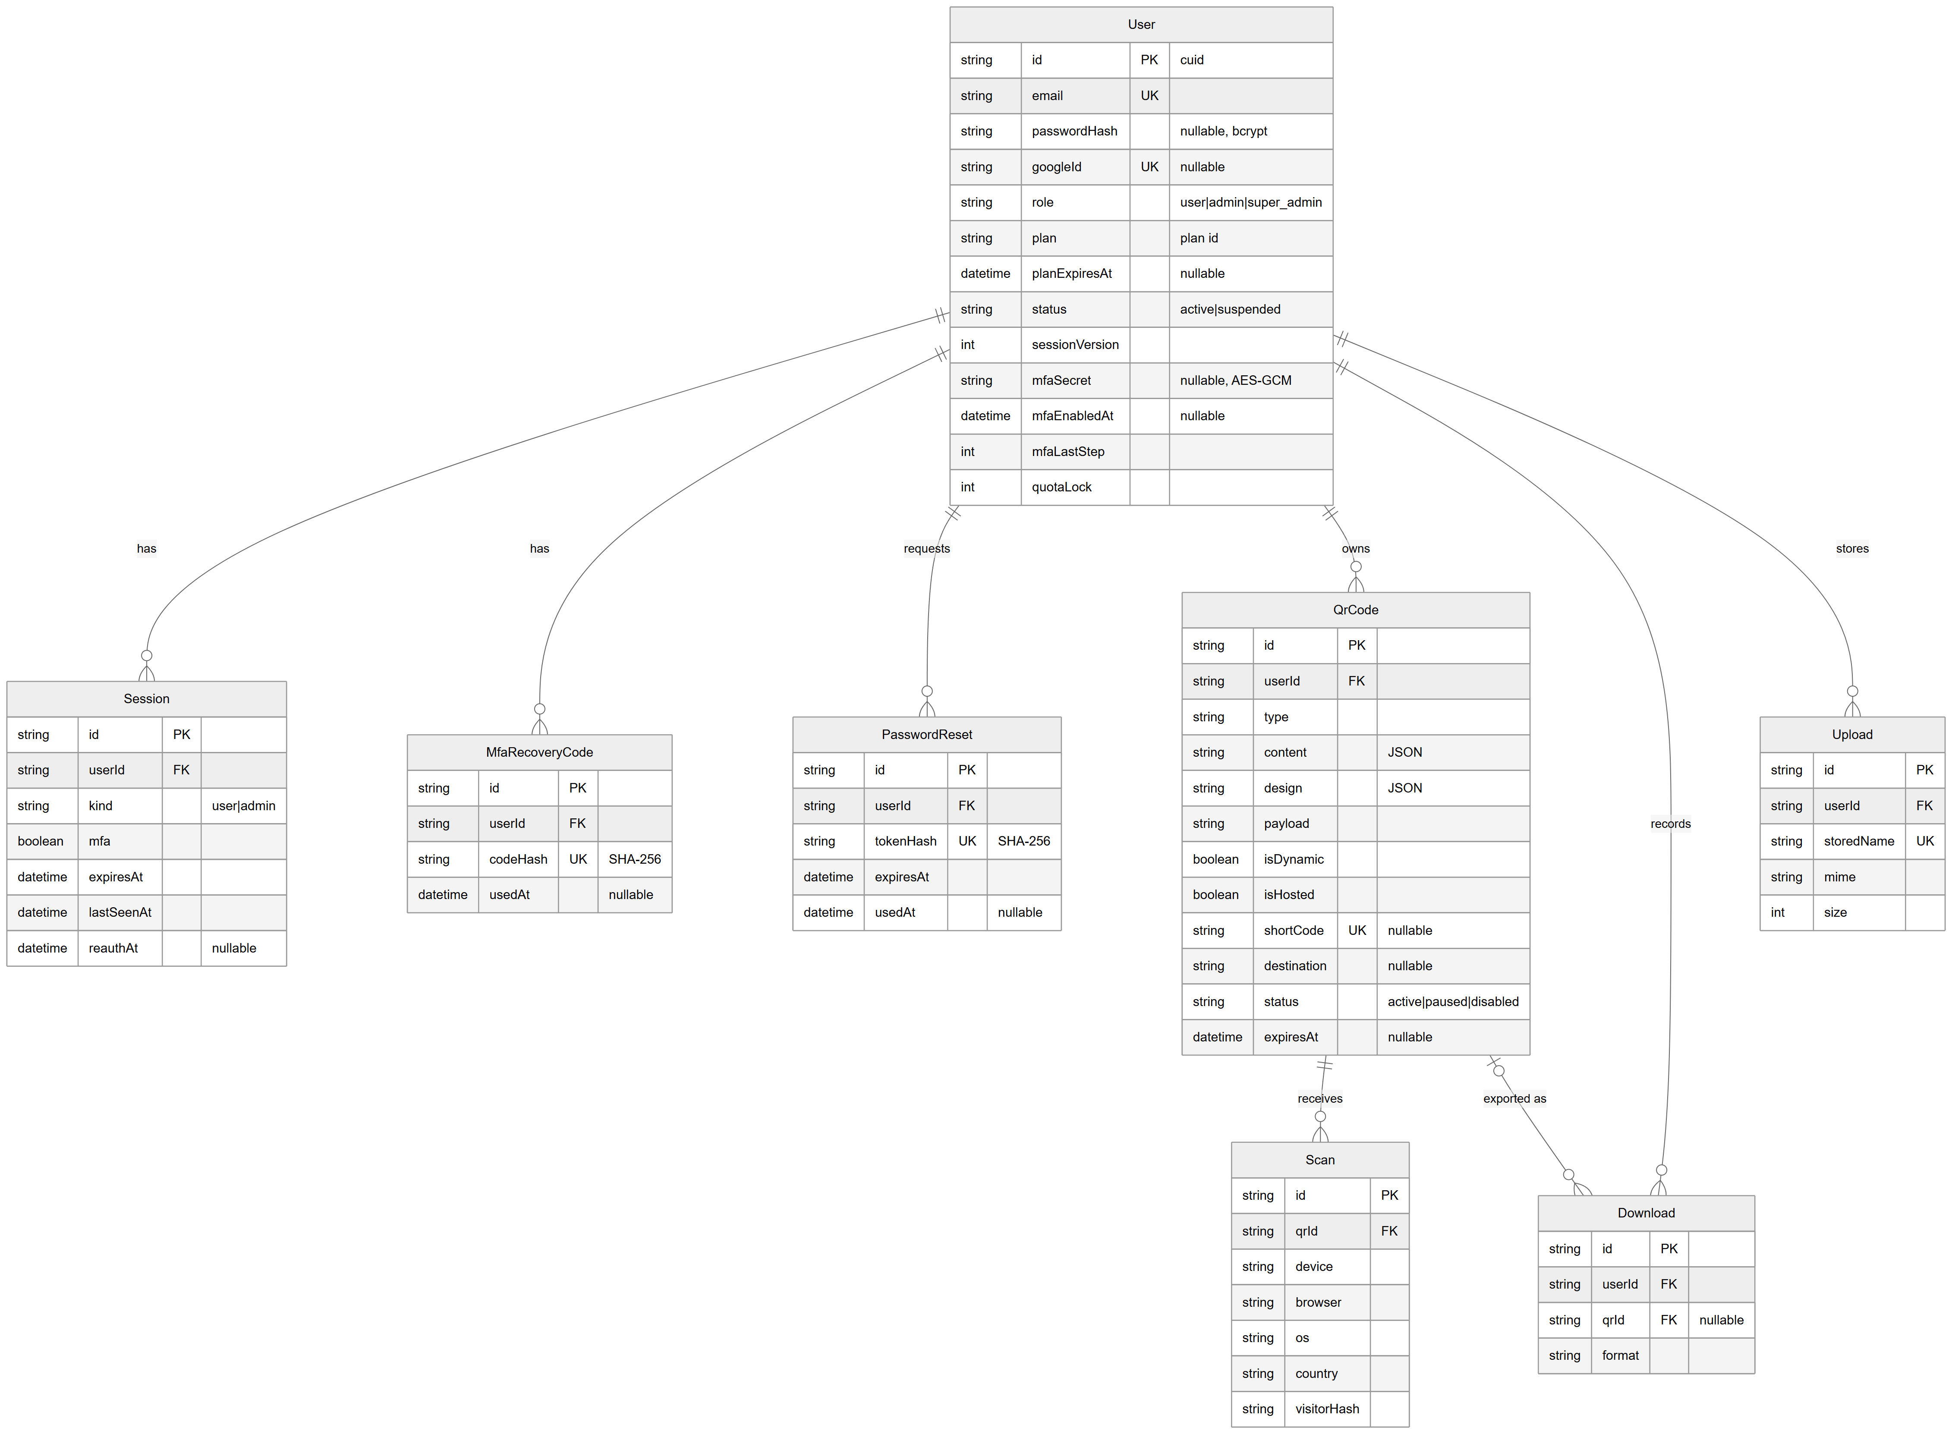
Figure 4.16: ERD detail: accounts, sessions, QR codes and analytics

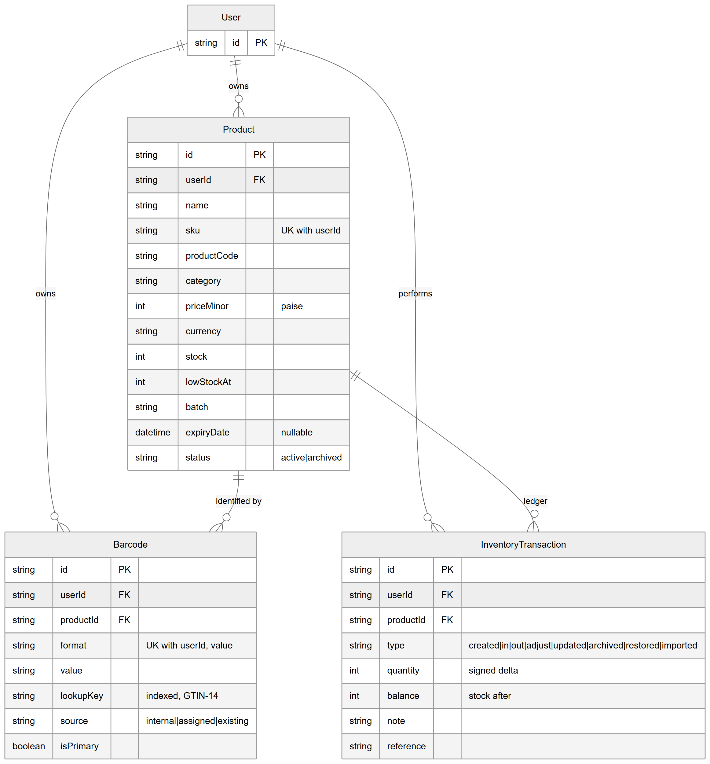
Figure 4.17: ERD detail: products, barcodes and inventory ledger

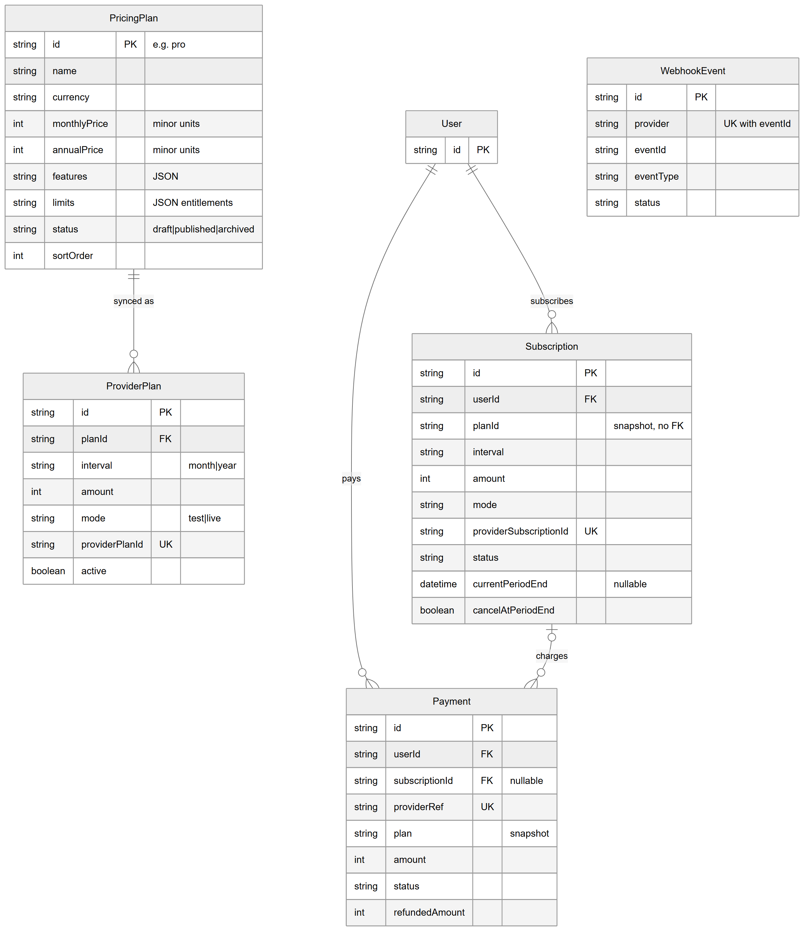
Figure 4.18: ERD detail: pricing plans, subscriptions and payments

Figures 4.16–4.18 were checked field by field against prisma/schema.prisma. Note that Subscription.planId and Payment.plan are deliberately snapshots without a foreign key to PricingPlan, so that later plan edits or archiving never rewrite payment history.

4.9.3 Logical Design: Entities and Relationships
Table 4.3: Relationships and cardinalities
Parent | Child | Cardinality | Foreign key | On delete
User | Session, MfaRecoveryCode, PasswordReset | 1 : N | userId | Cascade
User | QrCode, Download, Upload | 1 : N | userId | Cascade
User | Product, Barcode, InventoryTransaction | 1 : N | userId | Cascade
User | Subscription, Payment | 1 : N | userId | Cascade
QrCode | Scan | 1 : N | qrId | Cascade
QrCode | Download | 0..1 : N | qrId (nullable) | Set null
Product | Barcode, InventoryTransaction | 1 : N | productId | Cascade
Subscription | Payment | 0..1 : N | subscriptionId (nullable) | Set null
PricingPlan | ProviderPlan | 1 : N | planId | Restrict

4.9.4 Physical Design
The canonical schema is prisma/schema.prisma (SQLite provider) managed with Prisma ORM [5]. The MySQL schema prisma/mysql/schema.prisma is generated from it by scripts/db/mysql-schema.mjs, which adds MySQL column types (TEXT, MEDIUMTEXT, VARCHAR(n)) for long strings and relationMode = "foreignKeys". MySQL has two versioned migrations: 20261025000000_init and 20261025180000_billing_branding. SQLite development databases are synchronised with prisma db push and have no migration history. Primary keys are CUID strings generated by Prisma (@default(cuid())), except PricingPlan.id (a readable plan identifier such as pro), Setting.key and RateLimit.key. Money is stored as integers in minor units. JSON documents (QR content and design, UTM, plan features and limits, audit details) are stored as text and validated by zod in the application.
Table 4.4: Physical model summary (generated from `prisma/schema.prisma`)
Model | Scalar columns | Unique constraints | Secondary indexes | Foreign keys to
User | 17 | 2 | 0 | —
PasswordReset | 6 | 1 | 0 | User
QrCode | 20 | 1 | 1 | User
Scan | 9 | 0 | 1 | QrCode
Download | 6 | 0 | 1 | User, QrCode
Upload | 7 | 1 | 0 | User
AbuseReport | 8 | 0 | 0 | —
Payment | 16 | 1 | 2 | User, Subscription
PricingPlan | 13 | 0 | 0 | —
ProviderPlan | 9 | 1 | 1 | PricingPlan
Subscription | 16 | 1 | 1 | User
WebhookEvent | 7 | 1 | 1 | —
BrandAsset | 9 | 1 | 1 | —
Log | 6 | 0 | 1 | —
Setting | 2 | 0 | 0 | —
Product | 20 | 1 | 2 | User
Barcode | 9 | 1 | 2 | User, Product
InventoryTransaction | 9 | 0 | 2 | User, Product
Session | 9 | 0 | 2 | User
MfaRecoveryCode | 5 | 1 | 1 | User
AuditLog | 9 | 0 | 3 | —
RateLimit | 3 | 0 | 1 | —

4.9.5 Indexes and Constraints
Table 4.5: Unique constraints and indexes, and their purpose
Model | Constraint / index | Purpose
User | email UNIQUE; googleId UNIQUE | One account per e-mail; link Google identity
QrCode | shortCode UNIQUE; index userId | Global short-link namespace; list a user's codes
Scan | index (qrId, createdAt) | Time-range analytics per code
Download | index (userId, createdAt) | Download history
Upload | storedName UNIQUE | Serve file by random name
Product | UNIQUE (userId, sku); index (userId, status); index (userId, category) | Per-user SKU uniqueness; filtered lists
Barcode | UNIQUE (userId, format, value); index (userId, lookupKey); index productId | Per-user barcode uniqueness; scan lookup
InventoryTransaction | index (productId, createdAt); index (userId, createdAt) | Product history; user activity
Payment | providerRef UNIQUE; index (userId, createdAt); index subscriptionId | Idempotent payment recording
Subscription | providerSubscriptionId UNIQUE; index (userId, status) | Map provider events; find live subscription
ProviderPlan | providerPlanId UNIQUE; index (planId, interval, mode, active) | Find active provider plan for checkout
WebhookEvent | UNIQUE (provider, eventId); index receivedAt | Duplicate delivery detection
Session | index userId; index expiresAt | Revoke all sessions; clean-up
MfaRecoveryCode | codeHash UNIQUE; index userId | One-time code lookup
PasswordReset | tokenHash UNIQUE | Token lookup by hash
AuditLog | index createdAt; action; actorId | Filter audit log
BrandAsset | storedName UNIQUE; index (kind, createdAt) | Serve and list assets
Log, RateLimit | index createdAt / resetAt | Pagination; expiry clean-up

4.9.6 Standalone Models
Table 4.6: Models without foreign-key relationships
Model | Role | Why standalone
AbuseReport | Reports from visitors about a short code or URL | Reporter is anonymous; reported code may be deleted later
WebhookEvent | Ledger of processed provider events | Exists before any matching subscription may be found
BrandAsset | Uploaded logos, favicon, social image | Site-level, not user-owned; createdBy stores the admin id as text
Log | System log shown in the console | Must survive user deletion; userId kept as plain text
Setting | Key–value site settings (including sealed credentials and branding JSON) | Global configuration
AuditLog | Security and admin events | Must survive deletion of the actor; actorId kept as plain text
RateLimit | Fixed-window counters (database store) | Keyed by arbitrary strings

4.9.7 Enumerated and Status Fields
Status fields are stored as strings (SQLite has no native enum type); permitted values are enforced by zod schemas and code.
Table 4.7: Enumerated fields
Field | Values
User.role | user, admin, super_admin
User.status | active, suspended
User.plan | Plan identifier, default free (defaults: free, pro, business)
Session.kind | user, admin
QrCode.status | active, paused, disabled (admin only)
Scan.device | mobile, tablet, desktop, bot, unknown
Product.status | active, archived
Barcode.source | internal, assigned, existing
InventoryTransaction.type | created, in, out, adjust, updated, archived, restored, imported
AbuseReport.status | open, resolved, dismissed
Payment.status | created, pending, paid, failed, expired, refunded, partially_refunded
Subscription.status | created, authenticated, active, pending, halted, cancelled, completed, expired
PricingPlan.status | draft, published, archived
ProviderPlan.mode / Subscription.mode | test, live
WebhookEvent.status | processed, ignored, rejected

4.9.8 Audit-Related Fields
Most tables carry createdAt (and mutable ones updatedAt, maintained by Prisma). Security-relevant history is kept in AuditLog (actor, action, target, redacted JSON details, hashed IP), Log, InventoryTransaction (business audit of stock), Session.lastSeenAt/reauthAt, User.lastLoginAt, and WebhookEvent. The full table-by-table data dictionary is in Appendix C.

4.10 Database Normalization
The schema was assessed against the normal forms using the actual columns:
Table 4.8: Normalization assessment
Normal form | Assessment
First normal form (1NF) | Each column holds a single value at the database level, and each table has a primary key. However, several columns store JSON documents (QrCode.content, QrCode.design, QrCode.utm, PricingPlan.features, PricingPlan.limits, AuditLog.details, branding in Setting.value). The database treats them as opaque strings; they are never queried by their internal fields. Strictly, these are non-atomic attributes; the design accepts this to store type-specific, schema-less data that is always read and written as a whole.
Second normal form (2NF) | All primary keys are single-column surrogate keys (or a single natural key), so no partial dependency on part of a composite key can exist. 2NF holds for every table.
Third normal form (3NF) | Non-key attributes depend on the key. Deliberate exceptions are snapshots for history: Payment.plan, planName, interval, amount and Subscription.planName, amount copy plan data at the time of payment so history does not change when a plan is edited. InventoryTransaction.balance is a derived value stored for an immutable ledger. Product.stock is redundant with the sum of ledger quantities, kept for fast reads and protected by atomic updates. Barcode.userId duplicates Product.userId so that uniqueness can be enforced per user by a database constraint.
BCNF | Candidate keys in tables with composite unique constraints (Product(userId, sku), Barcode(userId, format, value), WebhookEvent(provider, eventId)) determine the remaining attributes, and no other non-trivial functional dependencies were found; apart from the intentional redundancies listed above, the design is consistent with BCNF.

In summary, the schema is normalised to 3NF for its relational data, with documented, intentional denormalisation for history snapshots, ledger balances and per-tenant constraints, and with JSON columns for flexible documents.

4.11 Class Diagram

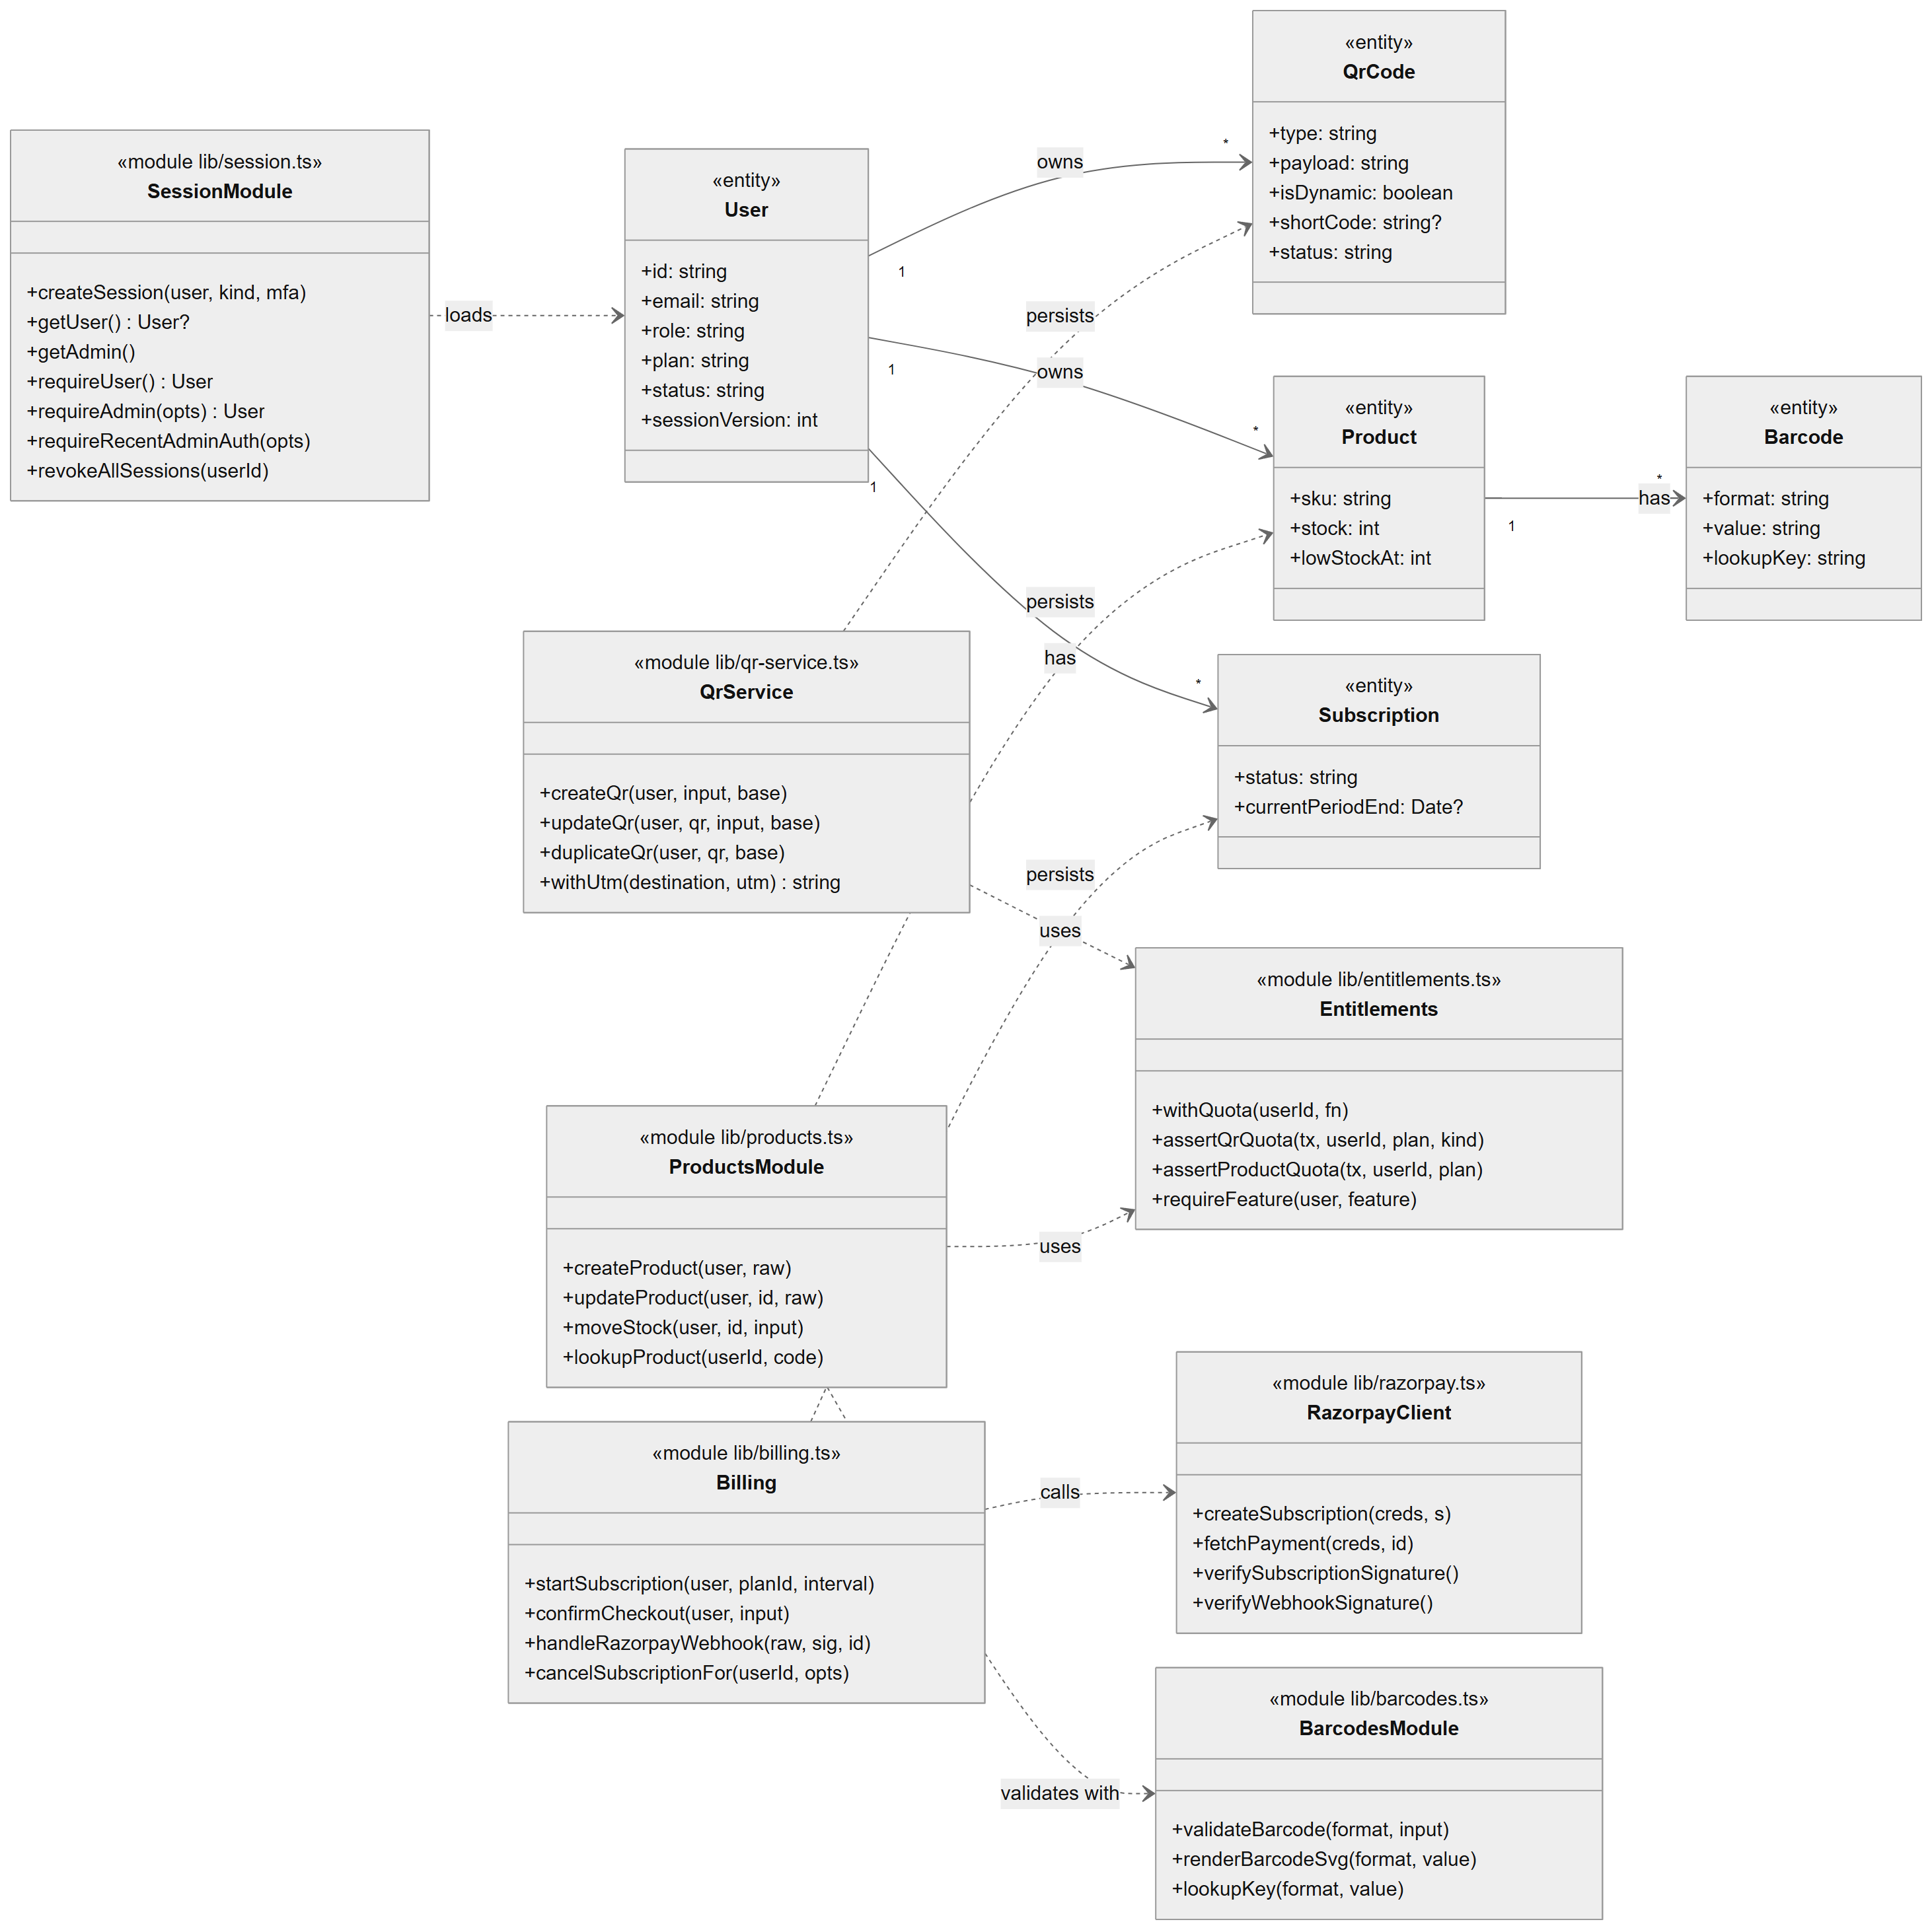
Figure 4.19: Class diagram: domain entities and server-side service modules

QRSathi is written in a functional TypeScript style: the server-side "classes" are ES modules exporting functions, and database entities are Prisma-generated types. Figure 4.19 therefore uses two stereotypes. <<entity>> classes are Prisma models (only key attributes are shown). <<module ...>> classes are server modules with their main exported functions. Solid arrows with multiplicities are associations between entities; dashed arrows are "uses" dependencies of modules. The only true TypeScript classes in the server code are small error types (ApiError, RazorpayError), which are omitted.

4.12 Sequence Diagrams

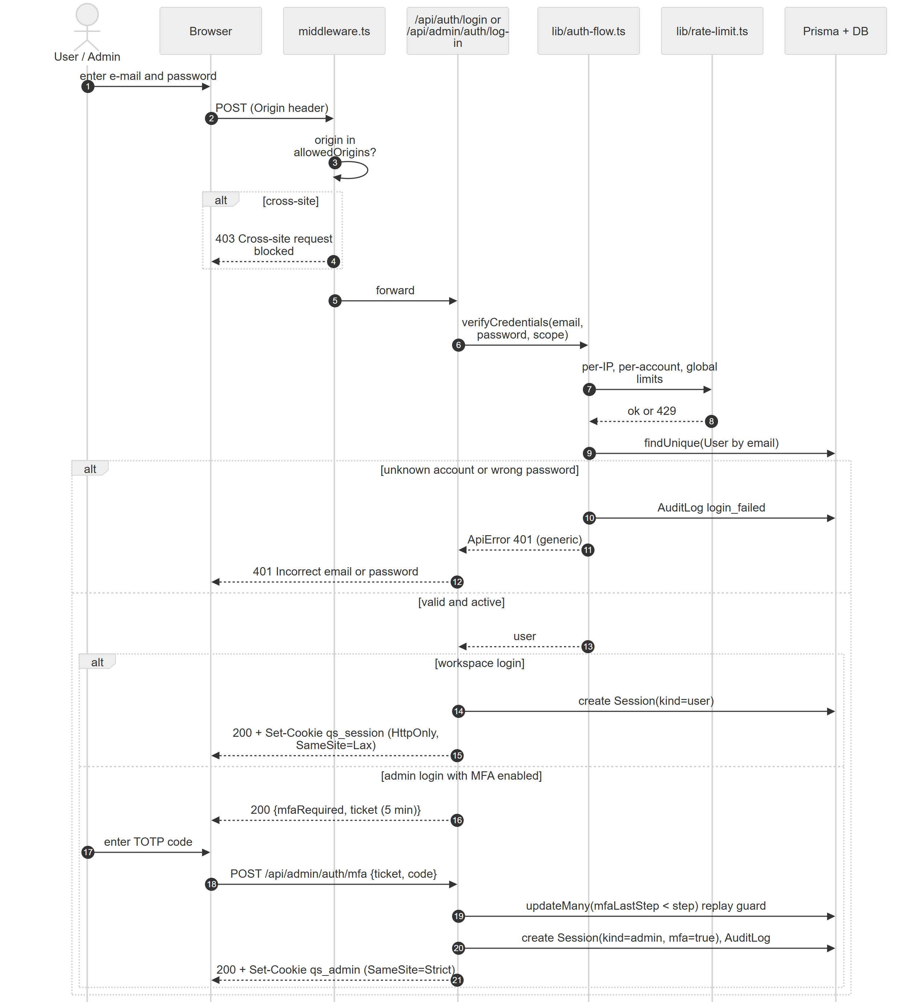
Figure 4.20: Sequence diagram: workspace login and administrator MFA login

Figure 4.20 traces a login through the middleware, the login route, the shared credential check and the database. The alt fragments show the generic failure path and the two success paths: a workspace session, or — for an MFA-enabled administrator — a short-lived ticket followed by TOTP verification with an atomic replay guard.

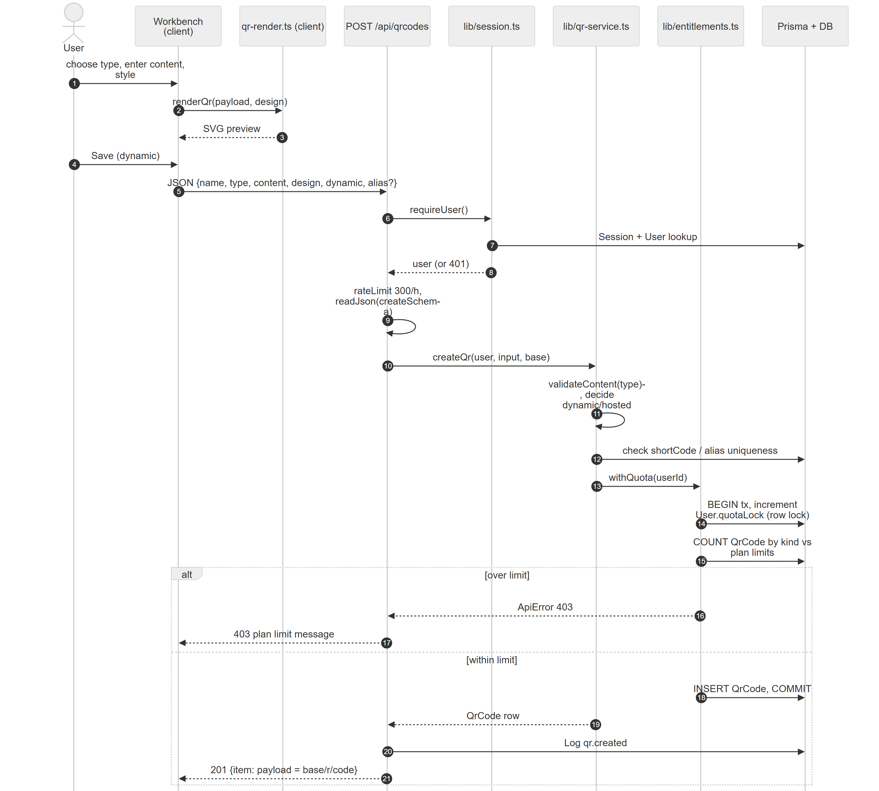
Figure 4.21: Sequence diagram: saving a dynamic QR code

Figure 4.21 shows client-side rendering followed by the save request. Note the transaction in withQuota: the first statement increments User.quotaLock, which takes a row lock in MySQL (or the write lock in SQLite) so that two concurrent saves by the same user are serialised and cannot both pass the limit check.

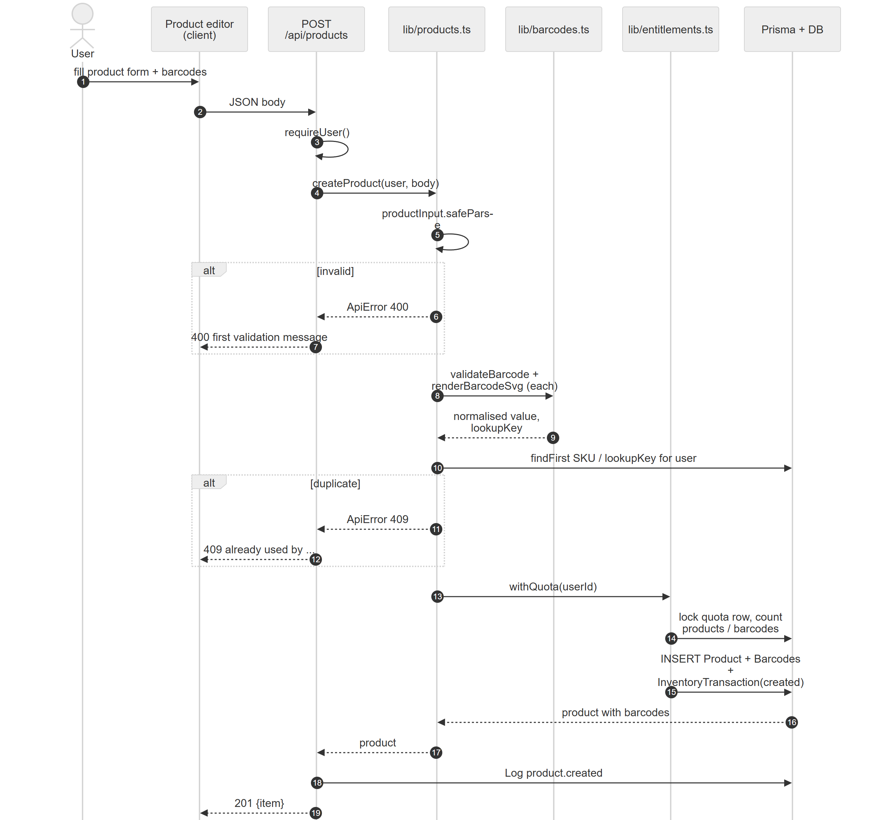
Figure 4.22: Sequence diagram: database-backed product creation

Figure 4.22 shows validation, barcode normalisation, uniqueness checks and the nested insert of a product with its barcodes and first ledger entry in one transaction.

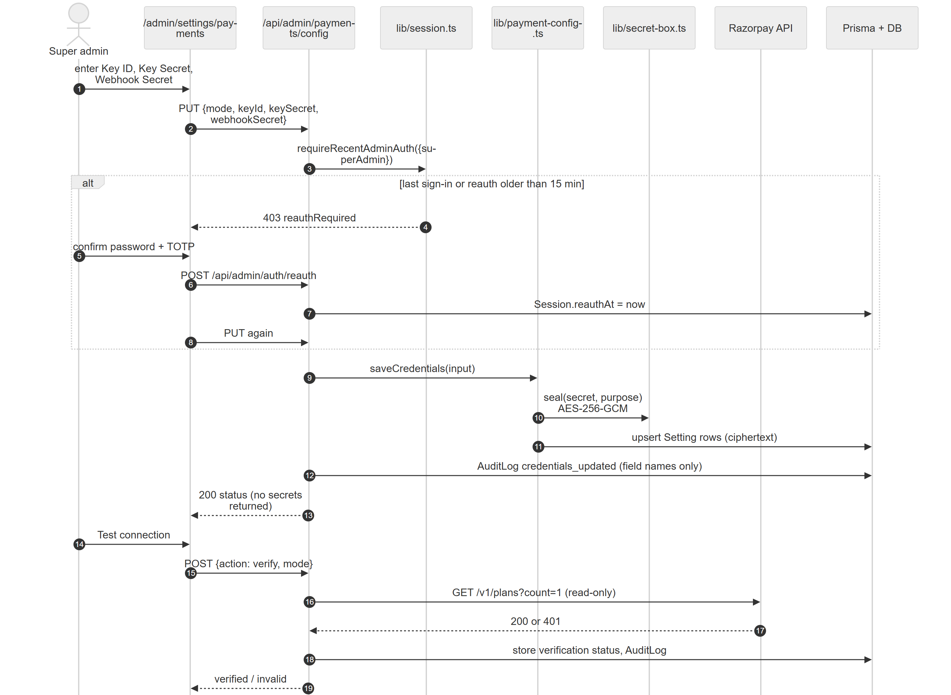
Figure 4.23: Sequence diagram: super administrator saves payment-gateway credentials

Figure 4.23 shows the re-authentication loop, sealing of secrets, audit logging of field names only, and a read-only verification call to Razorpay that creates nothing.

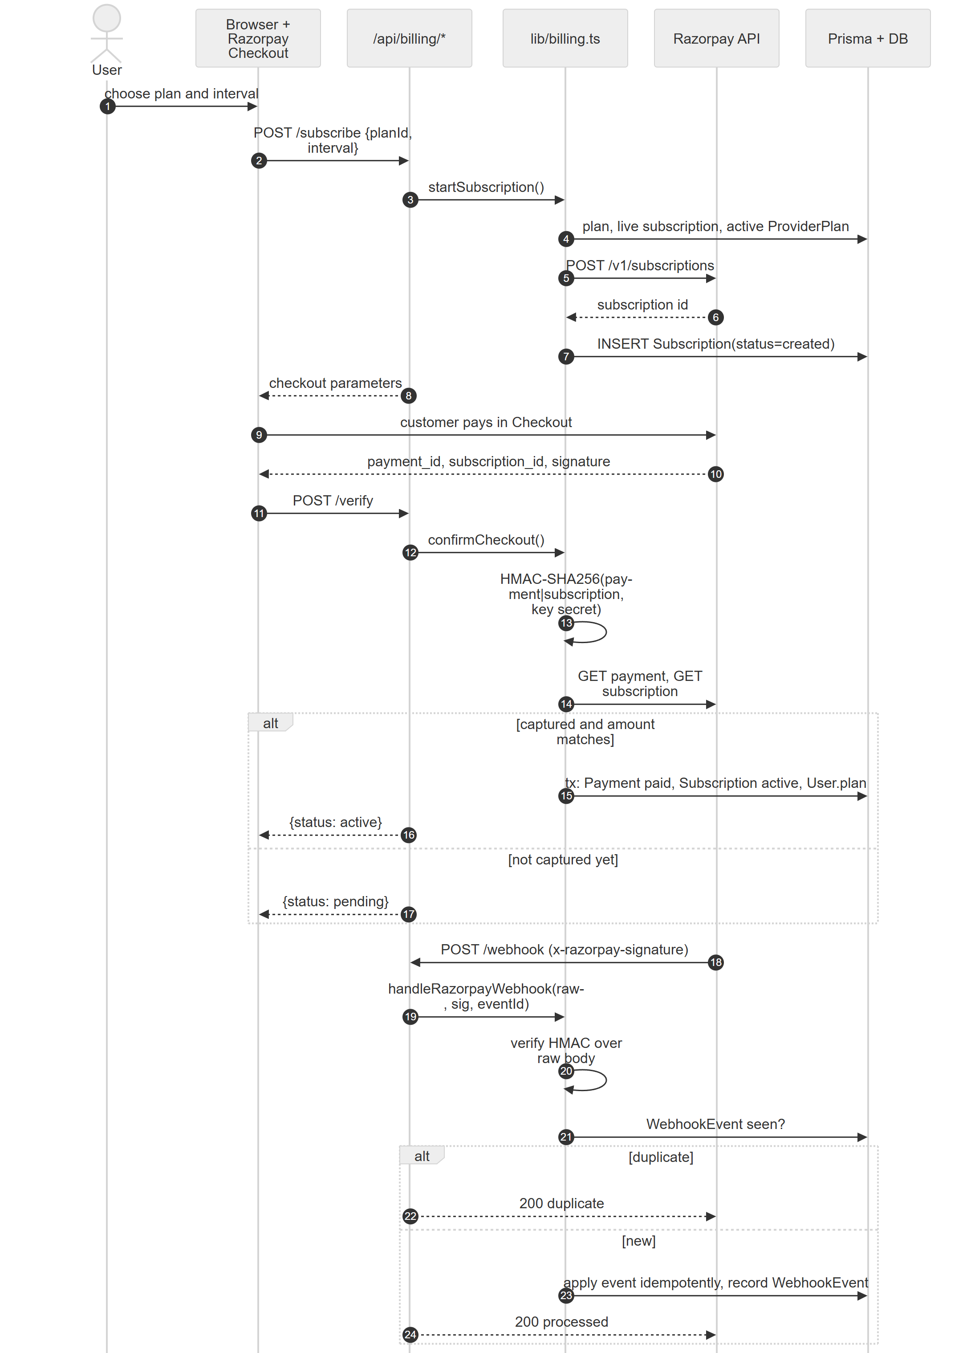
Figure 4.24: Sequence diagram: subscription checkout, verification and webhook

Figure 4.24 shows the two independent confirmation paths (client callback with server verification, and the signed webhook) and how idempotency prevents a payment from being applied twice.

4.13 Component Diagram

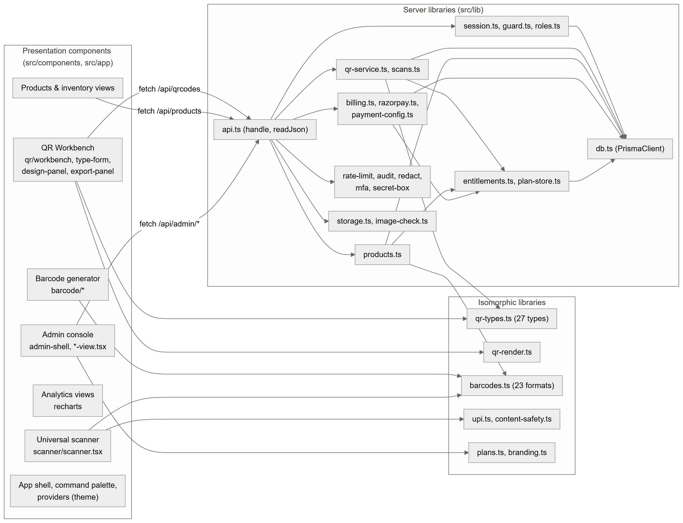
Figure 4.25: Component diagram

Figure 4.25 groups the code into presentation components, isomorphic libraries shared by client and server, and server-only libraries. Presentation components call the server only through fetch to API routes; they never import server modules. Isomorphic libraries contain no React or database imports, which allows the same validation and rendering code to run on both sides.

4.14 Deployment Diagram

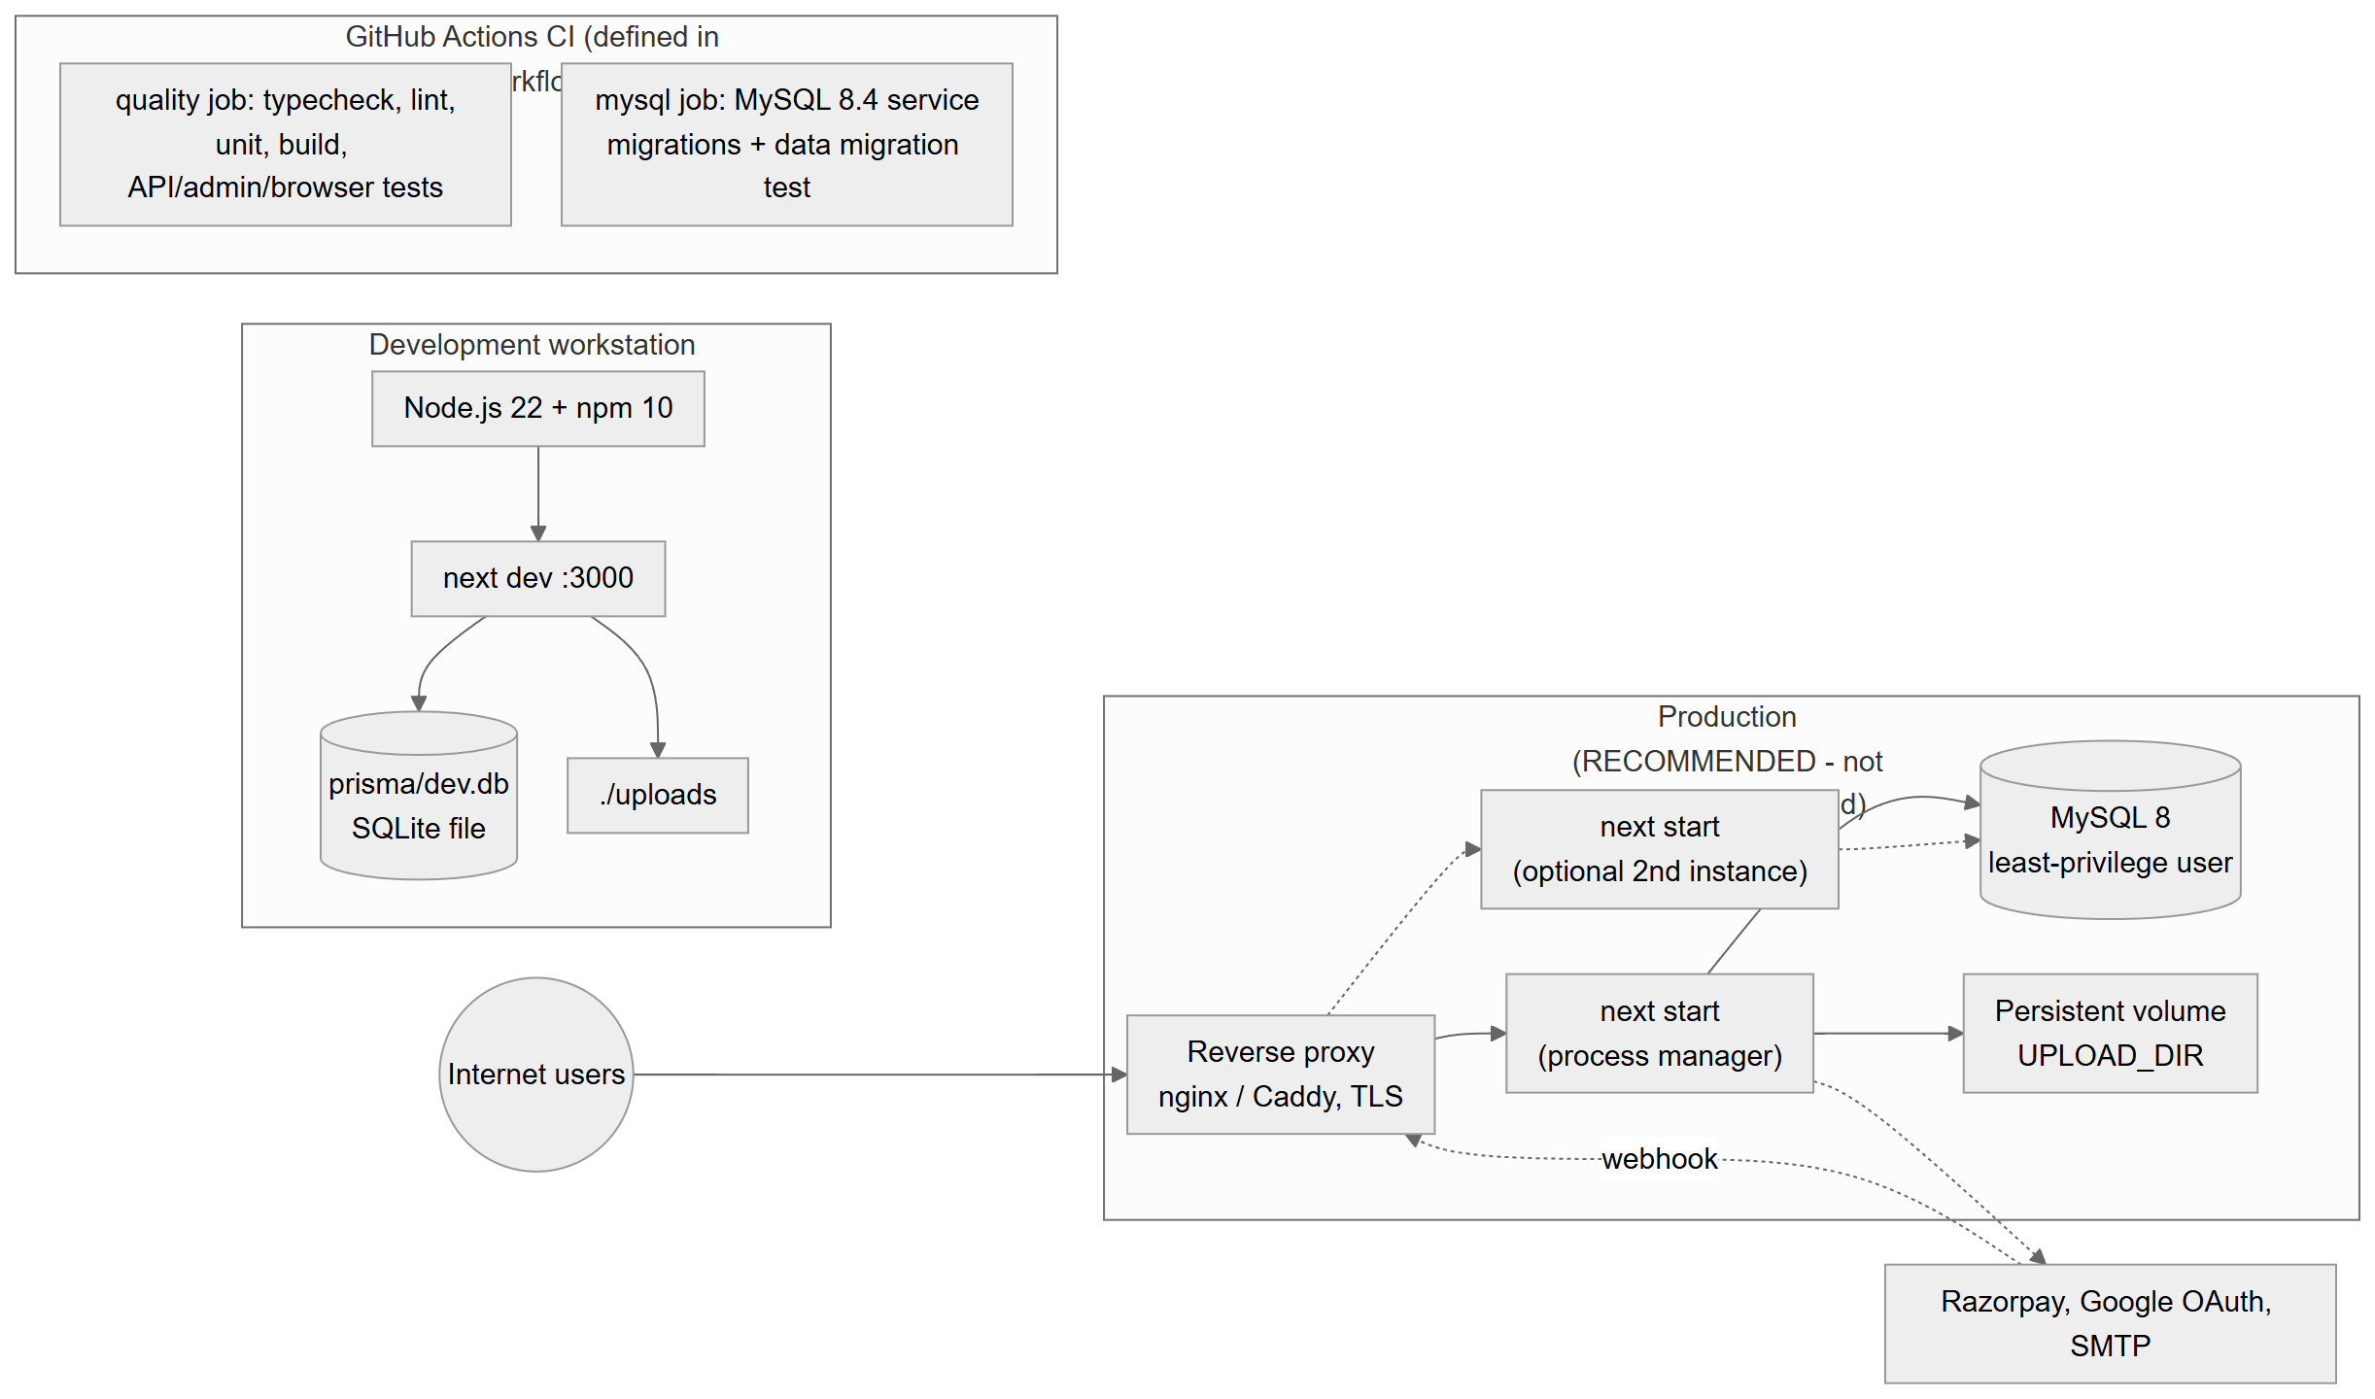
Figure 4.26: Deployment diagram: verified development set-up and recommended production topology

Figure 4.26 distinguishes what was verified from what is recommended. Verified: the development set-up (Node.js 22, next dev, SQLite file, local uploads) and the isolated production build used for testing (next start on port 3100 with a throw-away SQLite database), and the CI workflow definition. Recommended (not deployed or verified in this audit): a reverse proxy terminating TLS in front of one or more next start processes, a MySQL 8 server with a least-privilege user, and a persistent volume for uploads, as described in docs/DEPLOYMENT.md.

4.15 UI/UX Design
Navigation. The workspace uses a sidebar with four groups defined in src/components/nav-config.ts: Workspace (Overview, QR Generator, Barcode Generator, Universal Scanner, Scan History), Business (Products, Inventory, Bulk Generator, Analytics), More tools (My QR Codes, Dynamic QR, UPI Payment QR, Design Studio, Plans & Pricing; collapsed by default) and Account (Settings, Help & Support). A command palette offers keyword search across these destinations. The public site has marketing pages (home, features, tools, pricing, about, contact, help, privacy, terms, report). The admin console has its own shell and navigation (src/components/admin/admin-nav.ts) and never shows workspace navigation (verified by the admin test suite).
Table 4.9: Principal pages
Area | Routes
Public site | /, /features, /tools, /pricing, /about, /contact, /help, /privacy, /terms, /report
Authentication | /login, /signup, /forgot-password, /reset-password
Workspace | /dashboard, /generator, /barcodes, /scanner, /scan-history, /codes, /dynamic, /upi, /studio, /bulk, /analytics, /analytics/[id], /products, /products/new, /products/[id], /inventory, /billing/status, /dashboard/settings, /dashboard/history
Public QR endpoints | /r/[code] (redirect), /p/[code] (hosted page), /f/[name] (file), /brand/[name] (brand image)
Admin console | /admin (overview), /admin/users, /admin/qr-codes, /admin/reports, /admin/products, /admin/barcodes, /admin/inventory, /admin/analytics, /admin/subscriptions, /admin/payments, /admin/security (+ /admins, /events), /admin/settings (+ /branding, /appearance, /email, /pricing, /payments), /admin/system, /admin/mfa, /admin/login, /admin/forgot-password

Design principles. The interface uses a consistent component library (src/components/ui.tsx), clear empty states, inline validation messages from the shared zod schemas, warnings before risky actions (for example, "archive before delete"), and toast notifications for outcomes.
Responsiveness. Layouts use Tailwind responsive utilities. The automated browser suite loads every public and workspace page at 375, 768 and 1280 px and fails if the page scrolls horizontally; all such checks passed for public and workspace pages in the final audit run.
Accessibility. At 1280 px the browser suite checks that every control, link and image has an accessible name. A "Skip to content" link is present in the admin shell. No manual audit against WCAG 2.2 [20] was performed.
Themes and branding. Users can choose light, dark or system themes (stored in localStorage). Administrators can change brand colours, which are converted into CSS variables (themeCss() in src/lib/branding.ts), and the editor checks colour contrast.

4.16 API Design
The API follows a resource-oriented JSON-over-HTTP design implemented with Next.js route handlers. There are 64 API route modules with 89 method handlers (full inventory in Appendix B and QRSathi_API_Documentation.md).
Conventions.
- Requests and responses are JSON (Content-Type: application/json), except file uploads (multipart), the CSV export, the webhook (raw text) and public HTML routes.
- Every handler is wrapped in handle() (src/lib/api.ts), which converts an ApiError(status, message) into { "error": message, "details"?: … } with that status, and any other exception into a generic 500 message while logging the details server-side. Responses carry Cache-Control: no-store.
- Input is parsed by readJson(req, schema, maxBytes), which enforces a body-size limit, rejects malformed JSON with 400 and returns the first zod validation message.
- Resources of other users return 404.
Table 4.10: HTTP status codes used by the API
Status | Meaning in QRSathi
200 / 201 | Success / resource created
400 | Invalid input or business-rule violation (e.g. not enough stock)
401 | Not signed in, or credentials/MFA code invalid
403 | Signed in but not allowed (role, plan limit, MFA required, re-authentication required, cross-site request)
404 | Not found or not owned
409 | Conflict (duplicate e-mail, SKU, barcode, alias; existing subscription)
410 | Dynamic QR paused, disabled or expired (HTML page)
413 / 415 | Body too large / unsupported or mismatched file type
429 | Rate limit exceeded
500 / 502 / 503 | Unexpected error / payment provider error / payments or webhook not configured

Example. Creating a product:
POST /api/products
Cookie: qs_session=<signed token>
Origin: https://app.example.com
Content-Type: application/json

{"name":"Masala Chai 250g","sku":"CHAI-250","price":"149.00","stock":10,
"barcodes":[{"format":"ean13","value":"2001234567893","source":"internal"}]}

201 Created
{"item":{"id":"…","sku":"CHAI-250","price":"149.00","priceMinor":14900,"stock":10,
"lowStock":false,"barcodes":[{"format":"ean13","value":"2001234567893","isPrimary":true,…}],…}}

4.17 Security Design
The controls below map to common guidance such as the OWASP Cheat Sheet Series [16], OWASP Top 10 [17] and NIST SP 800-63B [18].
Table 4.11: Security controls present in the implementation
Concern | Control | Location
Password storage | bcrypt, cost 12; dummy hash for unknown accounts | src/lib/auth-helpers.ts
Sessions | Server-side Session rows referenced by HS256-signed JWT [15], HttpOnly cookies; new id on every login; sessionVersion invalidates all tokens on password change, suspension or role change | src/lib/session.ts
Admin separation | Separate qs_admin cookie (SameSite=Strict, 12 h, 2 h idle); workspace session never grants admin access | src/lib/session.ts
MFA | RFC 6238 TOTP [12], [13], ±1 step, replay guard via mfaLastStep; 10 single-use recovery codes stored as SHA-256 hashes; secrets AES-256-GCM encrypted | src/lib/mfa.ts
Re-authentication | Payment credentials require password (+TOTP) within 15 minutes | requireRecentAdminAuth()
Authorization | Deny-by-default guards; ownership checks; admin permission rules; last-super-admin protection | session.ts, guard.ts, admin-users.ts
CSRF | Origin check for non-GET API requests; SameSite cookies | src/middleware.ts
Brute force / abuse | Fixed-window rate limits per IP, per account and global; scan recording cap | src/lib/rate-limit.ts
Input validation | zod schemas; body-size limits; type-specific validation for QR content and barcodes | src/lib/api.ts, qr-types.ts, products.ts
SQL injection | All queries through Prisma's parameterised API; no raw SQL in application code | src/lib/**
XSS | React escaping; branding/settings validation rejects markup; JSON-LD escaping; CSP | branding.ts, next.config.mjs
Uploads | Extension allow-list, magic-byte check, random names, stored outside public/, served with nosniff, attachment disposition for Office files and a sandboxing CSP | storage.ts, app/f/[name]/route.ts
Branding images | Header parsing for PNG/JPEG/WebP dimensions; SVG reject-list for scripts and external references | src/lib/image-check.ts
Open redirects | safeNextPath() allows only same-origin relative paths | src/lib/safe-redirect.ts
Secrets | Server-only environment variables; startup check rejects secrets in NEXT_PUBLIC_*; payment credentials sealed with a key not stored in the database; status APIs never return secrets | env-check.ts, secret-box.ts, payment-config.ts
Payments | HMAC-SHA256 checkout and webhook signatures with constant-time comparison; amounts from the database; API re-fetch; idempotent ledger | razorpay.ts, billing.ts
Privacy | Salted, truncated IP hashes; no raw IPs; DNT/GPC respected; log redaction of e-mails and tokens | audit.ts, scans.ts, redact.ts
Headers | CSP [19], X-Content-Type-Options, X-Frame-Options, Referrer-Policy, Permissions-Policy, COOP, HSTS (HTTPS) | next.config.mjs
Fail-closed configuration | Production server exits on unsafe configuration | src/instrumentation.ts

Table 4.12: Security gaps identified by the audit
ID | Gap | Severity
S-01 | A SQLite backup containing user records and bcrypt hashes is present in Git history (commit 21277e0) | High (if the repository is or becomes public)
S-02 | Sandboxing CSP for /f/* and /brand/* was overridden by the global CSP in the first audited build; a fix exists in the working tree and was re-tested (Chapter 5) | Medium
S-03 | E-mail addresses are not verified at sign-up | Low–Medium
S-04 | MFA mandatory only for super administrators | Medium
S-05 | CSP allows 'unsafe-inline' scripts | Low–Medium
S-06 | No breached-password check | Low
S-07 | In-memory rate limiting by default; IP-based limits are spoofable without TRUST_PROXY | Medium (deployment-dependent)
S-08 | Dynamic QR destinations are not checked against URL reputation services | Medium
S-09 | Uploaded files are publicly readable by anyone who knows the random 128-bit name (by design, for File QR codes) | Low
S-10 | Dependency advisories accepted until 2027-01-31 (postcss, deepmerge-ts) | Low–Medium

4.18 Design Decisions and Trade-offs
Table 4.13: Design decisions
Decision | Rationale | Trade-off / alternative
Next.js full-stack monolith | One language, one deployment, server rendering and API together | Less independent scaling than separate services
TypeScript + zod shared schemas | Same validation on client and server; compile-time safety | Build step; schema code duplication avoided but schemas grow large (qr-types.ts ≈ 800 lines)
Prisma ORM | Type-safe queries, migrations, multi-database support | Some database features (native enums, JSON queries) unused to stay portable
SQLite for development, MySQL for production | Zero-setup local development; robust production database | Two providers must be kept compatible; solved by a generated schema and a CI check
Server-side sessions instead of stateless JWT | Immediate revocation on logout, password change, suspension | One database read per request (mitigated by per-request caching)
Client-side rendering and decoding of codes | No server cost; privacy for scanned images; works with any data | Depends on browser capabilities (WebAssembly, camera)
JSON text columns for QR content/design and plan limits | Each QR type has different fields; plans are editable without migrations | Not queryable by SQL; validated in the application
Snapshots in payments/subscriptions | History remains correct after plan edits | Denormalised data
Local-disk uploads | Simple, no external dependency | Not suitable for multiple servers without shared storage
Fixed-window rate limiter with memory/database stores | Simple and dependency-free | Bursts at window edges; memory store per process
Razorpay Subscriptions | Indian payment methods and recurring billing | Provider lock-in; only one provider implemented

CHAPTER 5
System Testing

5.1 Introduction
This chapter reports how QRSathi was tested for this report. A strict distinction is kept between executed tests — commands that were actually run during the audit, with their real output — and proposed tests, which are documented procedures marked "Not executed". No result in this chapter is estimated or assumed.
The repository contains its own automated suites (scripts/test-*.mts). The audit executed all of them; added a small number of probe checks for scenarios the suites do not assert; and recorded every command, environment detail, pass/fail count and failure explanation.

5.2 Testing Objectives
- Confirm that the code compiles, type-checks and satisfies the lint rules.
- Confirm that core logic (QR payloads, barcode validation, security utilities) behaves correctly in isolation.
- Confirm that the HTTP API enforces authentication, authorization, validation and business rules.
- Confirm security properties: session handling, RBAC, MFA, CSRF, rate limiting, secret handling, webhook verification.
- Confirm database portability between SQLite and MySQL.
- Confirm that the user interface renders without layout overflow, CSP violations or missing accessible names, and that the scanner decodes real codes.
- Identify and record defects.

5.3 Testing Strategy
The strategy follows the test pyramid:
- Static analysis — TypeScript (tsc --noEmit) and ESLint.
- Unit tests — pure functions tested without a server (npm test).
- Integration/API tests — real HTTP requests against a production build with a throw-away database (test:api, test:admin, test:billing).
- Database tests — migrations and data migration on a real MySQL server (test:mysql).
- End-to-end browser tests — headless Chromium driven through the DevTools protocol (test:browser).
- Audit probes — short scripts written by the auditor for gaps (Section 5.16), run against the same isolated server.
Black-box techniques used by the suites include equivalence partitioning (valid/invalid inputs), boundary-value analysis (stock exactly zero, sixth login attempt, 25 visits vs a 20-scan cap, upload just over a limit) and negative/unauthorized-access testing. White-box knowledge was used to target transactions and idempotency (concurrent creates, duplicate webhooks).

5.4 Testing Environment
Table 5.1: Test environment
Item | Value
Operating system | Windows 11 Pro 10.0.26200
Node.js / npm | 22.22.3 / 10.9.8
Code under test | Git HEAD 9b5dae7 plus uncommitted working-tree changes (115 entries in git status at the final run)
Build | next build into an isolated directory .next-audit (NEXT_DIST_DIR), production mode
Server | next start -p 3100, NODE_ENV=production, freshly generated random secrets, no SMTP, no real payment keys
Database (integration) | Throw-away SQLite file in a temporary folder (never prisma/dev.db)
Database (MySQL test) | mysql:8.4 Docker container on 127.0.0.1:33306, removed after the run
Browser | Microsoft Edge (Chromium), headless, driven by scripts/test-browser.mts
Payment provider | Deterministic mock Razorpay server started by test:billing (no real payments)
Final run window | 2026-10-25 18:41:35 to 18:46:32 IST (integration suites); unit checks re-run afterwards

Important note on the code snapshot. The working tree was being modified while the audit was in progress (for example next.config.mjs changed at 18:27:25 and scripts/test-browser.mts at 18:34). An earlier run therefore differed from the final run; both are reported in Section 5.16 so that the effect is transparent. All headline numbers in this chapter come from the final run on the tree as it stood at 18:41 IST.

5.5 Unit Testing
npm test runs three suites without a server:
- scripts/test-security.mts — open-redirect guard, log redaction, JSON-LD escaping, start-up configuration validation, TOTP against RFC 6238 test vectors, MFA secret encryption, recovery codes, rate limiting, IP-spoofing rules, CSRF origin rules, RBAC rules, and the MySQL schema generator. Result: 134 passed, 0 failed.
- scripts/test-qr.mts — every QR content type and design style is rendered and decoded again. Result: "All QR checks passed" (this suite prints no assertion count).
- scripts/test-barcodes.mts — check digits, invalid-input rejection, generate → render → decode with zxing-wasm for every format, label scannability, multi-code images, lookup-key normalisation and PDF export. Result: 166 passed, 0 failed.

5.6 Integration Testing
test:api exercises authentication and CSRF, products, barcode lookup, stock movements, isolation between users, edit/archive, import and the existing QR/UPI/dynamic features over HTTP. Final result: 73 passed, 0 failed.
test:billing starts a mock Razorpay server and tests the payment gateway configuration, re-authentication, pricing administration, server-side pricing at checkout, webhooks (signature, ledger, duplicates, mismatches), renewal, failure, halt, cancellation and refunds, price changes, server-side entitlements, branding and secret leakage. Final result: 128 passed, 0 failed. (First run: 126 passed, 2 failed — see D-02.)

5.7 System Testing
System testing exercised the complete production build through its public interfaces: HTTP APIs, public routes (/r, /p, /f, /brand) and pages, together with the start-up configuration checks. The smoke checks in test:api confirm that the main pages return HTTP 200, that private pages redirect guests to the login page, and that the WebAssembly decoder is served.

5.8 End-to-End Testing
test:browser drives a real browser:
- Camera scanning — a generated EAN-13, Code 128, QR code and Data Matrix are fed to the page as a fake webcam video; each must be decoded and classified.
- Image upload — one image containing four codes must produce four results, and a UPI QR must show a payment warning.
- Responsive layout — public and workspace pages at 375, 768 and 1280 px must not scroll horizontally, must produce no CSP violations or console errors, and (at 1280 px) all controls must have accessible names.
- Admin console — an administrator created with the CLI signs in through the real form; every console page is checked the same way.
Final result: 445 passed, 7 failed. All camera, upload, public-page and workspace-page checks passed. The seven failures are all in the admin-console section: six are heading checks that look for the text "Paid accounts" and "Payment records", which no longer exists anywhere in src/ after the admin console was redesigned (stale test expectations, D-04), and one is a genuine horizontal overflow of /admin/settings/pricing at 768 px (scroll width 825 px, D-03).

5.9 Database Testing
- npx prisma validate — schema valid.
- npm run db:mysql:schema -- --check — the committed MySQL schema matches the canonical schema.
- npm run test:mysql against MySQL 8.4 — applies both MySQL migrations to a new database, migrates an edge-case SQLite database with the real migration script, and checks exact round-trips of IDs, foreign keys, millisecond timestamps, NULLs, booleans, Unicode, 1,500-character barcodes and money values; case-sensitive short codes; case-insensitive search; and that the migration refuses non-empty targets and writes nothing when pre-flight checks fail. Result: 32 passed, 0 failed (74 s).
- Business-level database behaviour (unique constraints, transactions, cascade rules) is exercised through the API suites (duplicate SKU/barcode → 409, concurrent quota checks, idempotent payments).

5.10 Authentication and Authorization Testing
test:admin focuses on identity and access control: public endpoint headers; sign-up never creating administrators; admin APIs denying by default; separate admin sign-in; mandatory MFA enrolment for super administrators; logout and MFA sign-in including replayed and forged codes; user management and RBAC rules; audit logging; settings validation and stored XSS; sessions, password changes and reset tokens; IDOR and uploads; webhook signature and idempotency; rate limiting; and a scan of the client bundle for secrets. Final result: 99 passed, 0 failed.

5.11 Security Testing
Security testing in this audit consisted of (a) the automated security assertions above, (b) source-code review of authentication, authorization, validation, upload handling, payment verification and secret handling (Section 4.17 and QRSathi_Project_Audit.md), (c) dependency checks (npm run audit:check: passed, with five advisories explicitly accepted until 2027-01-31) and (d) the probe scripts in Section 5.16. No formal penetration test was performed, and the real Google, SMTP and Razorpay integrations were not exercised.

5.12 Usability and Responsive Testing
Responsive behaviour was tested automatically at three widths (Section 5.8). Visual inspection of the captured screenshots (Appendix G) was performed by the auditor. No usability study with real users, no task-completion measurements and no manual screen-reader testing were performed.

5.13 Performance Testing
Not executed. No load-testing tool or production-like environment was available, and the repository contains no performance tests. The only timing data collected are incidental: the production build took 30–67 seconds and the server started in under 0.5 seconds on the audit machine. These are not performance measurements of the application under load. A proposed procedure is listed as TC-SYS-08.

5.14 Regression Testing
Re-running the suites after the working tree changed acted as regression testing. Two failures in the first billing run (D-02) disappeared in the final run after a configuration change made concurrently by the developer, while defect D-01 was confirmed to persist on the final build. The CI workflow (.github/workflows/ci.yml) is designed to run these suites on every push and pull request; CI execution on GitHub was not observed in this audit.

5.15 Compatibility Testing
Only Chromium (Edge) was tested automatically. Firefox, Safari and real mobile devices were not tested (TC-SYS-09, not executed). Database compatibility (SQLite ↔ MySQL 8.4) was tested (Section 5.9).

5.16 Test Cases and Test Results
Table 5.2: Commands executed and results (final run unless stated)
# | Command | Result | Notes
1 | npm run typecheck | Pass (0 errors) | 9 s
2 | npm run lint | Pass (0 errors, 5 warnings) | warnings: unused eslint-disable directives, a missing hook dependency in scanner.tsx, an unused expression in products-list.tsx, anonymous default export in postcss.config.mjs
3 | npm test | Pass: 134 + QR suite + 166 | security, QR, barcodes
4 | npx prisma validate | Pass | —
5 | npm run db:mysql:schema -- --check | Pass | schemas in sync
6 | npm run audit:check | Pass | 5 advisories accepted until 2027-01-31
7 | npm run license:check | Pass | licence report produced
8 | next build (isolated) | Pass | 30 s final; 67 s first build
9 | npm run test:api | 73 passed, 0 failed | —
10 | npm run test:admin | 99 passed, 0 failed | first attempt aborted by a broken server log pipe in the audit harness; re-run passed
11 | npm run test:billing | 128 passed, 0 failed | first run 126/2 (D-02)
12 | npm run test:browser | 445 passed, 7 failed | D-03, D-04; earlier runs also had environment-related connection failures
13 | npm run test:mysql | 32 passed, 0 failed | MySQL 8.4 container
14 | Audit probe: upload sizes | 5 MB ✓, 9.5 MB ✓, 12 MB ✗ (Pro plan) | D-01
15 | Audit probe: gap cases | 7 of 7 passed | TC-AUTH-03/04, TC-QR-06, TC-DYN-03, TC-UPL-04

In total, 745 integration and end-to-end assertions passed in the final runs (73 + 99 + 128 + 445), plus 300 counted unit assertions (134 + 166), the uncounted QR suite and 32 MySQL assertions, against 7 failures, all in the browser suite.
Table 5.3: Test-case summary (full detail in Appendix D)
ID | Module | Scenario | Type | Status
TC-AUTH-01 | Auth | Sign-up creates an ordinary user even if a role is injected | positive / security | Pass
TC-AUTH-02 | Auth | Sign-up response and session cookie are safe | security | Pass
TC-AUTH-03 | Auth | Duplicate e-mail rejected at sign-up | negative / duplicate | Pass
TC-AUTH-04 | Auth | Weak password rejected | negative / boundary | Pass
TC-AUTH-05 | Auth | Private API requires sign-in | unauthorized | Pass
TC-AUTH-06 | Auth | Cross-site state-changing request blocked | security / CSRF | Pass
TC-AUTH-07 | Auth | Generic error for wrong password, unknown e-mail and non-admin | negative / enumeration | Pass
TC-AUTH-08 | Auth | Session fixation prevented | security | Pass
TC-AUTH-09 | Auth | Logout invalidates token server-side | expired / revoked session | Pass
TC-AUTH-10 | Auth | Suspended user cannot sign in; sessions end immediately | role restriction | Pass
TC-AUTH-11 | Auth | Forgot-password does not reveal accounts | security | Pass
TC-AUTH-12 | Auth | Reset token works once and is stored hashed | positive / negative | Pass
TC-AUTH-13 | Auth | Expired reset token rejected | boundary / expired | Pass
TC-AUTH-14 | Auth | Reset signs out existing sessions | security | Pass
TC-AUTH-15 | Account | Password change signs out other devices but keeps current | positive | Pass
TC-AUTH-16 | Auth | Brute-force limit on admin sign-in | boundary / abuse | Pass
TC-AUTH-17 | Auth | Google sign-in (OAuth) end-to-end | integration | Not executed
TC-QR-01 | QR | Every QR type and style renders and decodes | positive | Pass
TC-QR-02 | QR | Generator page loads | smoke | Pass
TC-QR-03 | QR | Generator page fits mobile/tablet/desktop with no CSP errors | usability | Pass
TC-QR-04 | QR | User B cannot read or delete A's QR code | unauthorized / IDOR | Pass
TC-QR-05 | QR | Dynamic-QR quota enforced under concurrency | boundary / concurrency | Pass
TC-QR-06 | QR | Custom alias collision / reserved word | negative | Pass
TC-QR-07 | UPI | UPI QR saved with correct URI | positive | Pass
TC-QR-08 | UPI | Invalid UPI ID rejected | negative | Pass
TC-DYN-01 | Dynamic QR | Dynamic QR created | positive | Pass
TC-DYN-02 | Dynamic QR | Dynamic QR redirects | positive | Pass
TC-DYN-03 | Dynamic QR | Paused / expired code shows 410 page | negative / boundary | Pass
TC-DYN-04 | Analytics | Scan recording capped per client | boundary / abuse | Pass
TC-BC-01 | Barcodes | All 23 formats render and decode with the app's scanner | positive | Pass
TC-BC-02 | Barcodes | Wrong EAN-13 check digit rejected | negative | Pass
TC-BC-03 | Barcodes | Internal GTIN outside restricted range rejected | negative / business rule | Pass
TC-BC-04 | Barcodes | Internal EAN-13 generated in restricted range | positive | Pass
TC-SCN-01 | Scanner | Camera scan of EAN-13, Code 128, QR and Data Matrix | positive | Pass
TC-SCN-02 | Scanner | Image with several codes decoded | positive | Pass
TC-SCN-03 | Scanner | UPI QR shows payment warning | security / usability | Pass
TC-PRD-01 | Products | Create product with barcodes; price in paise | positive | Pass
TC-PRD-02 | Products | Duplicate SKU rejected | duplicate | Pass
TC-PRD-03 | Products | Duplicate barcode rejected (incl. UPC-A/EAN-13 equivalence) | duplicate | Pass
TC-PRD-04 | Products | Missing name / invalid price rejected | negative | Pass
TC-PRD-05 | Products | Other user cannot read, edit or move stock | unauthorized / IDOR | Pass
TC-PRD-06 | Products | Same SKU allowed for a different user | positive / tenancy | Pass
TC-PRD-07 | Products | Partial edit keeps untouched fields | positive | Pass
TC-PRD-08 | Products | Delete requires archive first | business rule | Pass
TC-PRD-09 | Products | Barcode lookup is read-only and finds equivalents | positive | Pass
TC-PRD-10 | Import | CSV/XLSX import with per-row report | positive / negative | Pass
TC-PRD-11 | Import | Import update mode logs stock as adjustment | positive | Pass
TC-INV-01 | Inventory | Stock in increases stock | positive | Pass
TC-INV-02 | Inventory | Stock out decreases stock | positive | Pass
TC-INV-03 | Inventory | Stock out beyond available rejected | boundary | Pass
TC-INV-04 | Inventory | Zero quantity rejected; adjust sets value and flags low stock | boundary | Pass
TC-INV-05 | Inventory | History records every movement with balances; archived blocks movement | positive / negative | Pass
TC-UPL-01 | Uploads | Oversized upload rejected before parsing (Free plan) | boundary | Pass
TC-UPL-02 | Uploads | Paid-plan upload between 10 MB and plan limit | boundary / defect | Fail
TC-UPL-03 | Uploads | Uploaded files served with sandboxing CSP | security / regression | Pass
TC-UPL-04 | Uploads | File whose content does not match its extension | negative | Pass
TC-BIL-01 | Billing | Forged webhook signature rejected | security / signature | Pass
TC-BIL-02 | Billing | Underpaid payment does not upgrade | negative | Pass
TC-BIL-03 | Billing | Duplicate webhook deliveries applied once | idempotency | Pass
TC-BIL-04 | Billing | Subscription checkout lifecycle against mock Razorpay | integration (mock) | Pass
TC-BIL-05 | Entitlements | Plan features enforced on server (alias, analytics, export) | role / plan restriction | Pass
TC-BIL-06 | Billing | Live Razorpay payment in test mode | integration | Not executed
TC-ADM-01 | Admin | All admin APIs deny without admin session | unauthorized | Pass
TC-ADM-02 | Admin | User token replayed as admin cookie rejected | security | Pass
TC-ADM-03 | Admin | Admin cookie flags | security | Pass
TC-ADM-04 | Admin | Super admin forced to enrol MFA | role restriction | Pass
TC-ADM-05 | Admin | MFA enrolment stores encrypted secret and hashed recovery codes | security | Pass
TC-ADM-06 | Admin | Wrong, replayed or forged MFA input rejected | negative | Pass
TC-ADM-07 | Admin | Recovery code single use | boundary | Pass
TC-ADM-08 | Admin | Admin CLI refuses weak or command-line passwords | negative | Pass
TC-ADM-09 | Admin | Admin cannot change roles, touch super admin or delete | role restriction | Pass
TC-ADM-10 | Admin | Admin changes ordinary user's plan; unknown fields ignored | positive | Pass
TC-ADM-11 | Admin | Super admin promotes/demotes; cannot change own role | role restriction | Pass
TC-ADM-12 | Admin | Bulk action skips own account | business rule | Pass
TC-ADM-13 | Admin | Admin triggers reset e-mail without seeing token | security | Pass
TC-ADM-14 | Admin | User search returns no secrets; pagination | security | Pass
TC-ADM-15 | Settings | Settings validation rejects invalid e-mail/colour | negative | Pass
TC-ADM-16 | Settings | Stored XSS via brand name / announcement rejected | security / XSS | Pass
TC-ADM-17 | Branding | Branding publish, assets and SVG sandboxing | security | Pass
TC-ADM-18 | Audit | Audit log records admin actions without secrets | security | Pass
TC-ADM-19 | Admin UI | Admin sign-in through real form and console pages render | usability / regression | Fail
TC-SYS-01 | Platform | Health endpoint reveals only status | security | Pass
TC-SYS-02 | Platform | Security headers present; no X-Powered-By | security | Pass
TC-SYS-03 | Platform | No secrets in client bundle | security | Pass
TC-SYS-04 | Platform | Unsafe production configuration refused | security | Pass
TC-SYS-05 | Database | MySQL migrations and SQLite→MySQL data migration | database | Pass
TC-SYS-06 | Database | MySQL schema in sync with canonical schema | database | Pass
TC-SYS-07 | Responsive | Public and workspace pages fit 375/768/1280 px without CSP or console errors | usability / accessibility | Pass
TC-SYS-08 | Performance | Redirect latency and page load under load | performance | Not executed
TC-SYS-09 | Compatibility | Firefox and Safari | compatibility | Not executed
TC-SYS-10 | Database | Database unavailable | negative / database error | Not executed

5.17 Defect Log
Table 5.4: Defect log
ID | Severity | Module | Description | Evidence | Status
D-01 | Medium | Uploads | Uploads larger than 10 MB fail with "No file received." even when the user's plan allows 25 MB (Pro) or 50 MB (Business). The middleware matches /api/:path*, and Next.js buffers at most 10 MB of a request body that passes through middleware, so the multipart body is truncated. | Probe: 12 MB PDF as Pro user → 400, on first and final builds; server log "Request body exceeded 10MB for /api/uploads" | Open
D-02 | Medium (security) | Headers | The sandboxing CSP set by /f/[name] and /brand/[name] was replaced by the global CSP from next.config.mjs, so uploaded SVG/PDF files did not get the sandbox directive. | test:billing first run: 2 failures | Fixed in working tree (new header rules in next.config.mjs); final run passed. Not yet committed
D-03 | Low | Admin UI | /admin/settings/pricing scrolls horizontally at 768 px (scroll width 825 px). | test:browser final run | Open
D-04 | Low (test) | Test suite | Browser test expects headings "Paid accounts" and "Payment records" that no longer exist in the redesigned admin pages. | test:browser final run (6 failures); grep finds the strings only in the test | Open
D-05 | Low | Admin API | PATCH /api/admin/users/[id] accepts only the plan ids free, pro, business, although plans are now administrator-defined in the database; custom plans cannot be assigned manually. | Source review (z.enum(["free","pro","business"])) | Open
D-06 | Low | Code quality | 5 ESLint warnings, including a missing useEffect dependency in the scanner. | npm run lint | Open
D-07 | High (repository) | Security | A SQLite backup with user records and bcrypt hashes is present in Git history (commit 21277e0). | git log --all --name-only | Open (documented by the developer in docs/OPEN-SOURCE-READINESS.md)
D-08 | Info | Configuration | The local .env still defines the obsolete ADMIN_EMAILS, which produces a start-up warning. | Variable names in .env; env-check.ts | Open

5.18 Test Coverage and Limitations
- No code-coverage tool is configured, so line or branch coverage is unknown. Coverage is described functionally by the requirement traceability matrix: of 22 functional requirements, 17 are verified by executed tests, 4 are partially verified and 1 (moderation, FR-19) is implemented but not independently verified.
- External integrations (Google OAuth, SMTP delivery, live Razorpay) were not tested.
- Only Chromium was tested; no real mobile devices.
- No performance, load, soak or penetration testing.
- The code under test included uncommitted changes that were still being edited; the results describe the snapshot at 18:41 IST on 2026-10-25.
- Browser runs before the final one were affected by intermittent ERR_CONNECTION_REFUSED errors whose cause was not determined (the final run had none); those runs are not counted.

5.19 Testing Summary
The project has an unusually complete automated test set for a mini project, and it was executed end-to-end in an isolated environment. All type, lint, unit, API, administration/security, billing and MySQL tests passed in the final run. The browser suite passed 445 checks, with seven admin-console failures traced to one minor layout defect and stale test expectations. Independent probes confirmed seven additional behaviours and uncovered one functional defect (D-01, large uploads on paid plans). Of the 91 documented test cases, 84 passed, 2 failed and 5 were not executed because they require external services, other browsers or a load-testing environment.

CHAPTER 6
Implementation and Evaluation

6.1 Introduction
This chapter explains how the design of Chapter 4 is realised in code. It describes the development set-up, the folder structure and the implementation of each module, with short excerpts from the real source files (file paths are given for each excerpt; excerpts are abridged only where marked). It then gives the installation, execution and deployment procedures, presents screenshots captured from the running application, and evaluates the implementation against the objectives.
The audited code base contains about 20,200 lines of TypeScript/TSX in src/ (57 pages, 67 route handlers — 64 under /api — and 31 component files), 22 database models, and about 2,700 lines of test and tooling scripts.

6.2 Development Environment Setup
- Install Node.js 22 (the repository's .nvmrc pins major version 22; package.json requires >=22.5.0) and npm 10.
- Clone the repository and run npm install. The postinstall script generates the Prisma client (scripts/db/prisma.mjs generate) and copies the zxing WebAssembly file into public/zxing/.
- Copy .env.example to .env and set at least DATABASE_URL="file:./dev.db", a random AUTH_SECRET of 32+ characters and NEXT_PUBLIC_APP_URL="http://localhost:3000".
- Create the development database with npm run db:push.
- Create the first administrator with npm run admin -- create --email you@example.com --super (the password is read from standard input, never from the command line).
- Start the development server with npm run dev and open http://localhost:3000.
Optional: npm run seed:demo loads demo data when DEMO_MODE=true (development only).

6.3 Installation and Configuration
Configuration is entirely through environment variables (Table 3.6). The application validates them at start-up (src/lib/env-check.ts); in production any error stops the server, and warnings are logged. Secrets are never committed: .gitignore excludes .env* (except .env.example), databases, backups, uploads and logs. Optional integrations are enabled simply by setting their variables: Google sign-in (GOOGLE_CLIENT_ID/SECRET), SMTP (SMTP_*, MAIL_FROM) and Razorpay (environment variables, or encrypted database storage configured from the admin console when SETTINGS_ENCRYPTION_KEY is set).

6.4 Project Folder Structure
qrsathi/
├── .github/ CI workflow, Dependabot, issue/PR templates
├── docs/ ADMIN, BACKUP-RECOVERY, BARCODES, DATABASE, DEPLOYMENT,
│ LICENSING, OPEN-SOURCE-READINESS, SECURITY-AUDIT
├── prisma/
│ ├── schema.prisma canonical schema (SQLite provider)
│ ├── mysql/ generated MySQL schema + migrations
│ └── seed-demo.mjs development demo data
├── public/ static assets (zxing WASM copied at install)
├── scripts/ admin CLI, DB tools, test suites, audit/licence checks
├── security/ dependency-advisory allowlist
├── src/
│ ├── app/
│ │ ├── (site)/ public marketing pages
│ │ ├── (auth)/ login, signup, forgot/reset password
│ │ ├── (app)/ signed-in workspace (generator, products, …)
│ │ ├── admin/ admin console: (auth) sign-in, (console) pages
│ │ ├── api/ 64 API route modules
│ │ ├── r/ p/ f/ brand/ public redirect, hosted page, files, brand images
│ │ └── layout.tsx, globals.css, robots.ts, sitemap.ts
│ ├── components/ UI components (qr/, barcode/, admin/, pricing/, …)
│ ├── lib/ domain and infrastructure modules (58 files)
│ ├── middleware.ts CSRF origin check
│ └── instrumentation.ts start-up configuration validation
├── package.json, next.config.mjs, tailwind.config.ts, tsconfig.json
└── eslint.config.mjs, postcss.config.mjs
The full tree is in Appendix A. Route groups in parentheses (for example (app)) organise layouts without appearing in URLs.

6.5 Frontend Implementation
The frontend uses the Next.js App Router. Layouts provide three shells: the public site (src/app/(site)/layout.tsx), the workspace with sidebar and command palette (src/components/app-shell.tsx), and the admin console (src/components/admin/admin-shell.tsx). Pages that need data on first render are server components; interactive tools are client components ("use client").
The QR workbench (src/components/qr/workbench.tsx) composes four parts: the type selector, a generic form renderer (type-form.tsx) that draws fields from the type definition in qr-types.ts, the design panel, and the preview/export panel. Because each QR type declares its own fields and zod schema, adding a type requires no new form code. Styling uses Tailwind utility classes; brand colours are CSS variables so that administrators can re-brand the site without rebuilding. Charts use Recharts and notifications use Sonner.

6.6 Backend Implementation
Every API endpoint is a route handler wrapped in handle(), which centralises error handling. A typical handler authenticates, rate-limits, validates and delegates:
// src/app/api/qrcodes/route.ts (POST handler)
export const POST = handle(async (req) => {
const user = await requireUser();
await rateLimit(`qr-create:${user.id}`, 300, 60 * 60 * 1000);
const input = await readJson(req, createSchema);
const qr = await createQr(user, input, baseUrl(req));
await logEvent("info", "qr.created", `${qr.type}${qr.isDynamic ? " (dynamic)" : ""} ${qr.shortCode ?? ""}`, user.id);
return json({ item: serializeQr(qr) }, 201);
});
handle() converts domain errors to HTTP responses and hides unexpected errors from clients:
// src/lib/api.ts
export function handle<C = unknown>(fn: Handler<C>): Handler<C> {
return async (req, ctx) => {
try {
return await fn(req, ctx);
} catch (e) {
if (e instanceof ApiError) return json({ error: e.message, details: e.details }, e.status);
const msg = e instanceof Error ? e.message : String(e);
await logEvent("error", "api.unhandled", `${req.method} ${new URL(req.url).pathname}: ${msg}`.slice(0, 1000));
return json({ error: "Something went wrong. Please try again." }, 500);
}
};
}

6.7 Database Implementation
Prisma Client is created once per process (src/lib/db.ts) and reused (in development it is cached on globalThis to survive hot reloads). The canonical schema prisma/schema.prisma targets SQLite. npm run db:mysql:schema generates prisma/mysql/schema.prisma, adding MySQL column types; migrations for MySQL live in prisma/mysql/migrations and are applied with npm run db:mysql:deploy. npm run db:migrate-data copies an existing SQLite database into an empty MySQL database with pre-flight checks (orphaned foreign keys, case-only duplicate e-mails) and verification. Both paths were exercised by test:mysql (32/32 passed).
Transactions are used wherever several rows must change together: quota checks with inserts (withQuota), stock movements, product creation with barcodes and ledger entry, payment application and token claims.

6.8 Authentication Implementation
Sessions are stored in the database and referenced by a signed cookie. A request is authenticated only if the token is valid and the session row and user still match:
// src/lib/session.ts — load() (abridged)
const session = await db.session.findUnique({ where: { id: p.sid }, include: { user: true } });
const now = new Date();
if (!session || session.userId !== p.sub || session.kind !== kind || session.expiresAt < now) return null;
const user = session.user;
if (user.status !== "active" || user.sessionVersion !== p.sv) return null;
if (kind === "admin") {
if (!isAdminRole(user.role)) return null;
if (now.getTime() - session.lastSeenAt.getTime() > ADMIN_IDLE * 1000) { /* delete and */ return null; }
// MFA-enabled administrators must have verified MFA in this session.
if (user.mfaEnabledAt && !session.mfa) return null;
}
Incrementing sessionVersion (on password change, reset, suspension or role change) therefore invalidates every token at once. Login is protected by three rate limits and a dummy bcrypt comparison for unknown accounts (src/lib/auth-flow.ts). The TOTP verifier accepts one step of clock drift and returns the matched step so the caller can reject replays:
// src/lib/mfa.ts
export function verifyTotp(secret: string, code: string, lastStep = 0, now = Date.now()): number | null {
const c = code.replace(/\s/g, "");
if (!/^\d{6}$/.test(c)) return null;
const s = currentStep(now);
for (const step of [s - 1, s, s + 1]) {
if (step <= lastStep) continue;
const expected = Buffer.from(totpAt(secret, step));
if (timingSafeEqual(expected, Buffer.from(c))) return step;
}
return null;
}
The admin MFA route then advances mfaLastStep with a conditional updateMany(... mfaLastStep: { lt: step }), so two concurrent requests cannot both use the same code.
CSRF protection is implemented in the middleware by comparing the Origin header of state-changing API requests with the configured application origin:
// src/middleware.ts (abridged)
if (["GET", "HEAD", "OPTIONS"].includes(method)) return NextResponse.next();
if (req.nextUrl.pathname.startsWith("/api/billing/webhook")) return NextResponse.next();
const origin = req.headers.get("origin");
if (!origin) return NextResponse.json({ error: "Missing origin." }, { status: 403 });
if (!allowedOrigins(req).has(new URL(origin).origin))
return NextResponse.json({ error: "Cross-site request blocked." }, { status: 403 });

6.9 QR Code Module Implementation
src/lib/qr-types.ts is a registry of 27 types. Each entry declares fields, defaults, a zod schema and a build() function that produces the encoded text:
// src/lib/qr-types.ts (first entry)
{
id: "url", label: "Website URL", description: "Open any web page", category: "basic", icon: "Globe",
fields: [{ name: "url", label: "Website URL", kind: "url", placeholder: "https://yourwebsite.com", required: true }],
defaults: { url: "https://example.com" },
schema: z.object({ url: url("Website URL") }),
build: (d) => d.url,
dynamicCapable: true, logo: "link", caption: "SCAN ME",
},
The 27 types are: Website URL, Dynamic URL, Text, vCard, Phone, SMS, E-mail, Wi-Fi, WhatsApp, Instagram, Facebook, YouTube, LinkedIn, Maps, UPI, Bank (account + IFSC as UPI), Product, File, Event, App, Links (link-in-bio), Menu, Business, Feedback, Coupon and Landing page. Some types (for example menus and link lists) are hosted: the QR code points to /p/{code}, where the content is rendered as a mobile page.
src/lib/qr-render.ts turns a payload and a design into SVG using the qrcode library's module matrix. The design model supports foreground/background colours, transparency, linear/radial gradients, module styles, finder-eye shapes (square, rounded, circle, leaf), a centre logo, six frame styles with captions, background patterns, error-correction level and quiet-zone margin. When a logo is present, error correction is raised to H automatically:
// src/lib/qr-render.ts
export function effectiveEcc(design: QrDesign): Ecc {
if (design.logo && ECC_ORDER.indexOf(design.ecc) < 3) return "H";
return design.ecc;
}
designWarnings() warns about low contrast or oversized logos, and the export panel performs a scan test: the exported image is decoded again with jsqr and compared with the expected payload ("Scan test passed — decodes to your exact content", visible in Figure 6.3). Exports are produced in the browser: PNG/JPG via canvas, SVG directly, PDF via jsPDF and ZIP via JSZip (src/lib/qr-export.ts).

6.10 Barcode Module Implementation
src/lib/barcodes.ts defines 23 formats in four groups: retail (EAN-13, EAN-8, UPC-A, UPC-E, ISBN, ISSN), general (Code 128, Code 39, Code 93, Codabar), logistics (GS1-128, ITF, ITF-14, Standard 2 of 5, MSI) and 2D (Data Matrix, GS1 DataMatrix, PDF417, Aztec, Micro QR, GS1 QR). Each format has a validator; rendering uses bwip-js. GS1 check digits use the standard weighted modulo-10 algorithm [9], [10]; rendering uses bwip-js [25] and decoding zxing-wasm [26]:
// src/lib/barcodes.ts
export function gs1CheckDigit(body: string): number {
let sum = 0;
for (let i = body.length - 1, w = 3; i >= 0; i--, w = w === 3 ? 1 : 3) sum += Number(body[i]) * w;
return (10 - (sum % 10)) % 10;
}
To match scanned codes to products, every barcode also stores a lookup key. GTIN-family numbers are normalised to 14 digits, so a UPC-A label scanned as its 13-digit EAN form still matches:
// src/lib/barcodes.ts
export function lookupKey(formatId: string, value: string): string {
const v = value.trim();
if (formatId === "upce" && /^[01]\d{7}$/.test(v)) return upceToUpca(v).padStart(14, "0");
if (["ean13", "ean8", "upca", "itf14", "isbn", "issn"].includes(formatId) && /^\d{8,14}$/.test(v)) return v.padStart(14, "0");
const gs1 = parseGs1(v);
const gtin = gs1?.find((p) => p.ai === "01")?.value;
if (gtin) return gtin;
return v;
}
Internal numbers generated by the system always use the GS1 restricted-circulation prefix 2 (generateInternalNumber), and isRestrictedCirculation rejects "internal" numbers outside it. Labels are composed as SVG in six sizes from 38 × 25 mm to 100 × 150 mm and four layouts (barcode only, product, shelf, compact).
The scanner (src/app/(app)/scanner/scanner.tsx) loads zxing-wasm lazily (src/lib/zxing-client.ts), decodes camera frames or uploaded images (several codes per image), classifies the text (scan-classify.ts), merges duplicate detections (scan-merge.ts) and shows safety notes from content-safety.ts. History is kept only in the browser's localStorage (scan-history.ts) and can be exported to CSV.

6.11 Product and Inventory Implementation
src/lib/products.ts contains the product logic. Prices are parsed from strings such as "₹1,499.50" and stored in paise; integer fields reject non-integers and out-of-range values; barcodes are validated, rendered once (to apply encoder rules) and normalised. The stock-out movement uses a conditional update so that stock cannot become negative even under concurrent requests:
// src/lib/products.ts — moveStock() (abridged)
} else if (input.type === "out") {
delta = -input.quantity;
const res = await tx.product.updateMany({ where: { id, stock: { gte: input.quantity } }, data: { stock: { decrement: input.quantity } } });
if (res.count === 0) {
const cur = await tx.product.findUnique({ where: { id }, select: { stock: true } });
throw new ApiError(400, `Not enough stock: ${cur?.stock ?? 0} available, ${input.quantity} requested.`);
}
}
// … every movement then appends an InventoryTransaction with the signed delta and the resulting balance
Plan limits are enforced in the same transaction as the insert. withQuota first increments the user's quotaLock column, which serialises concurrent requests by the same user:
// src/lib/entitlements.ts
export async function withQuota<T>(userId: string, fn: (tx: Tx) => Promise<T>): Promise<T> {
return db.$transaction(async (tx) => {
await tx.user.update({ where: { id: userId }, data: { quotaLock: { increment: 1 } } });
return fn(tx);
}, { maxWait: 10_000, timeout: 20_000 });
}
The import endpoint accepts rows parsed in the browser from CSV or XLSX (snake_case headers), supports skip and update modes, rejects duplicates within the file, and records stock changes from imports as logged adjustments.

6.12 Administrative Functionality
The admin console (src/app/admin/(console)) has pages for the platform overview, users, QR codes, abuse reports, products and barcodes, inventory, analytics, subscriptions, payments, security (audit log, administrators, security events), settings (general, branding, appearance, e-mail, pricing, payment gateway), system health and the administrator's own MFA. Permission rules for actions on accounts are centralised in src/lib/admin-users.ts: administrators may act only on ordinary users; only super administrators may change roles or delete accounts; nobody may change their own status or role; and the last active super administrator can never be demoted, suspended or deleted. The command-line tool scripts/admin.mts creates, promotes, demotes and lists administrators and resets a lost MFA enrolment (reset-mfa), and refuses weak passwords or passwords passed as arguments.

6.13 Dynamic QR Implementation
When a dynamic code is created, createQr() allocates a short code (seven random characters, retried up to six times, or a validated alias), stores the destination separately from the payload, and sets the payload to {base}/r/{code}. The redirect handler (src/app/r/[code]/route.ts) checks existence, hosted status, administrator/owner status, pause, expiry and destination, records the scan and returns:
// src/app/r/[code]/route.ts
await recordScan(qr, req.headers, clientIp(req));
return new Response(null, {
status: 302,
headers: {
Location: withUtm(qr.destination, qr.utm),
"Cache-Control": "no-store, max-age=0",
"Referrer-Policy": "no-referrer",
"X-Robots-Tag": "noindex",
},
});
no-store prevents browsers and proxies from caching the redirect, so an edited destination takes effect immediately. recordScan() ignores bots, caps recording at 20 scans per client per code per 10 minutes, and stores only coarse device information and a salted per-day visitor hash — or only a count if the visitor sends Do-Not-Track/GPC or the owner disabled detailed tracking.

6.14 Subscription and Payment Implementation
Billing is implemented with Razorpay Subscriptions (src/lib/billing.ts, src/lib/razorpay.ts). Super administrators edit plans (/admin/settings/pricing); a plan's price is synchronised to an immutable Razorpay plan (ProviderPlan). At checkout the client sends only planId and interval; the server looks up the price. Signatures are verified with HMAC-SHA256 [14] and a constant-time comparison, following Razorpay's documented scheme [21], [22]:
// src/lib/razorpay.ts
function safeEqualHex(expected: string, given: string) {
const a = Buffer.from(expected, "utf8"), b = Buffer.from(given || "", "utf8");
return a.length === b.length && timingSafeEqual(a, b);
}
/** Webhooks: HMAC_SHA256(raw request body, webhook_secret). */
export function verifyWebhookSignature(rawBody: string, signature: string, webhookSecret: string) {
return safeEqualHex(createHmac("sha256", webhookSecret).update(rawBody).digest("hex"), signature);
}
A plan is upgraded only after the payment is fetched from Razorpay as captured with the expected amount, or after a signed webhook; each webhook event id is recorded in WebhookEvent so duplicates are ignored, and payments are unique by provider reference. Renewal, failure, halt, cancellation and refunds update subscription and payment status. Payment credentials can be stored in the database only in sealed form (AES-256-GCM, key from SETTINGS_ENCRYPTION_KEY, bound to the field by HKDF "purpose"), require recent re-authentication to change, and are never returned by any API. This module was verified against a mock Razorpay server only.

6.15 Branding and Configuration
Branding (src/lib/branding.ts, src/lib/settings.ts) supports a draft that can be previewed and then published, a reset to defaults, and assets (logo, dark logo, favicon, social image). Uploaded images are checked by src/lib/image-check.ts (magic bytes and dimensions for PNG, JPEG and WebP; a strict reject-list for SVG elements and attributes that could execute script or load external content). Colours are validated as hex values, converted to HSL CSS variables, and checked for contrast; text fields reject markup. General settings include an announcement banner and a switch to close sign-ups.

6.16 Error Handling and Validation
- Validation: zod schemas on every input; readJson() rejects oversized or malformed bodies; type-specific validators for QR content, UPI identifiers, IFSC codes, barcodes, prices and dates.
- Errors: domain code throws ApiError(status, message); handle() returns a JSON error; unexpected exceptions return a generic message and are logged with redaction.
- Logging: logger writes JSON lines in production; logEvent() also stores entries in the Log table shown in the admin console; audit() records security events. Neither throws if the database write fails.
- User-facing pages: dynamic-link errors render friendly HTML pages with appropriate status codes (404/410) and a link to report abuse; a custom not-found.tsx exists.

6.17 Important Code Walkthroughs
Table 6.1: Code walkthrough index
# | Excerpt | File | What it demonstrates
1 | POST /api/qrcodes | src/app/api/qrcodes/route.ts | Layered handler: authenticate → rate-limit → validate → service → response
2 | handle() | src/lib/api.ts | Central error mapping without leaking internals
3 | load() | src/lib/session.ts | Server-side session validation, idle timeout, MFA flag
4 | verifyTotp() | src/lib/mfa.ts | RFC 6238 verification with drift window and replay protection
5 | Origin check | src/middleware.ts | CSRF defence
6 | effectiveEcc() | src/lib/qr-render.ts | Automatic error-correction increase for logos
7 | gs1CheckDigit(), lookupKey() | src/lib/barcodes.ts | Standards-based validation and GTIN normalisation
8 | moveStock() | src/lib/products.ts | Concurrency-safe stock decrement and ledger
9 | withQuota() | src/lib/entitlements.ts | Serialising quota checks per user
10 | Redirect response | src/app/r/[code]/route.ts | Non-cacheable redirect with UTM
11 | Signature verification | src/lib/razorpay.ts | HMAC with constant-time comparison

6.18 Database Initialization and Migration
- Development (SQLite): npm run db:push creates or updates prisma/dev.db from the schema. npm run db:studio opens Prisma Studio.
- Production (MySQL): create a database and a least-privilege user; set DATABASE_URL; run npm run db:mysql:deploy (prisma migrate deploy with the MySQL schema); then npm run build.
- Schema changes: edit prisma/schema.prisma, run npm run db:mysql:schema to regenerate the MySQL schema, create a MySQL migration, and run the CI check npm run db:mysql:schema -- --check.
- Data migration: stop writes, back up, run npm run db:migrate-data (dry run first), switch DATABASE_URL, smoke-test (procedure in docs/DATABASE.md).
- Plans: on first use the default plans (Free, Pro, Business) are inserted only if the PricingPlan table is empty (src/lib/plan-store.ts).

6.19 Application Execution Procedure
Table 6.3: Execution commands
Purpose | Commands
Development | npm run dev → http://localhost:3000
Production build | npm run build (copies WASM, generates Prisma client, builds)
Production start | npm start (or next start -p <port>) behind HTTPS
Administrator | npm run admin -- create --email <e-mail> --super (password via stdin)
Checks | npm run typecheck, npm run lint, npm test
Integration tests | build, start against a throw-away DB, then test:api, test:admin, test:browser, test:billing (see README)

6.20 Deployment Procedure
Verified during this audit: building and running the production server locally (next build, next start) against a throw-away SQLite database, and applying the MySQL migrations to a MySQL 8.4 server in Docker.
Recommended (from docs/DEPLOYMENT.md; not performed in this audit):
- Provision a Linux server with Node.js 22 and a MySQL 8 database; create a least-privilege database user.
- Set production environment variables (strong random AUTH_SECRET, MFA_ENCRYPTION_KEY, SETTINGS_ENCRYPTION_KEY, NEXT_PUBLIC_APP_URL with https, TRUST_PROXY, RATE_LIMIT_STORE=database, SMTP).
- npm ci, npm run db:mysql:deploy, npm run build.
- Run npm start under a process manager (for example systemd or PM2).
- Put a reverse proxy (nginx or Caddy) in front for TLS and forward X-Forwarded-* headers.
- Point an uptime monitor at /api/health; configure log collection and database/upload backups (docs/BACKUP-RECOVERY.md).
- Create the first super administrator and enrol MFA; configure Razorpay webhooks to {APP_URL}/api/billing/webhook.
- Before deployment, fix D-01 (upload size) and commit the working tree.

6.21 User Interface Screenshots
All screenshots below were captured automatically from the actual running production build by the project's browser test (SHOT_DIR) during the final audit run, using throw-away accounts on an empty database. Workspace pages therefore show an empty account, and the admin pages show a test administrator (e-mail ui-admin-…@example.com) with the "2FA not enabled" banner that an ordinary admin without MFA sees. No screenshot was edited. The complete set (47 desktop and 47 mobile images) is in screenshots/ and indexed in Appendix G.
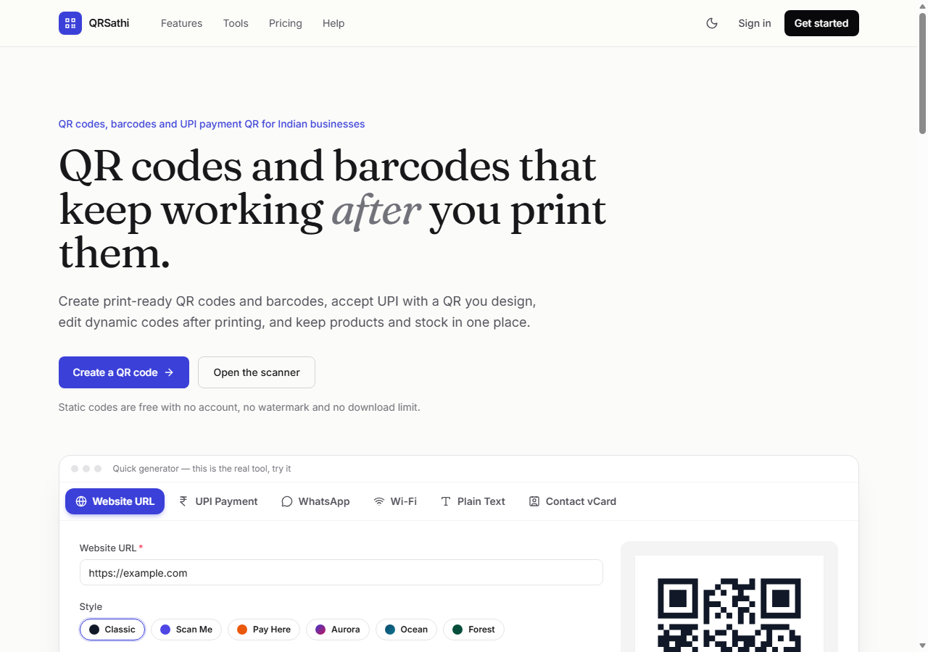
Figure 6.1: Landing page (desktop, 1280 px)
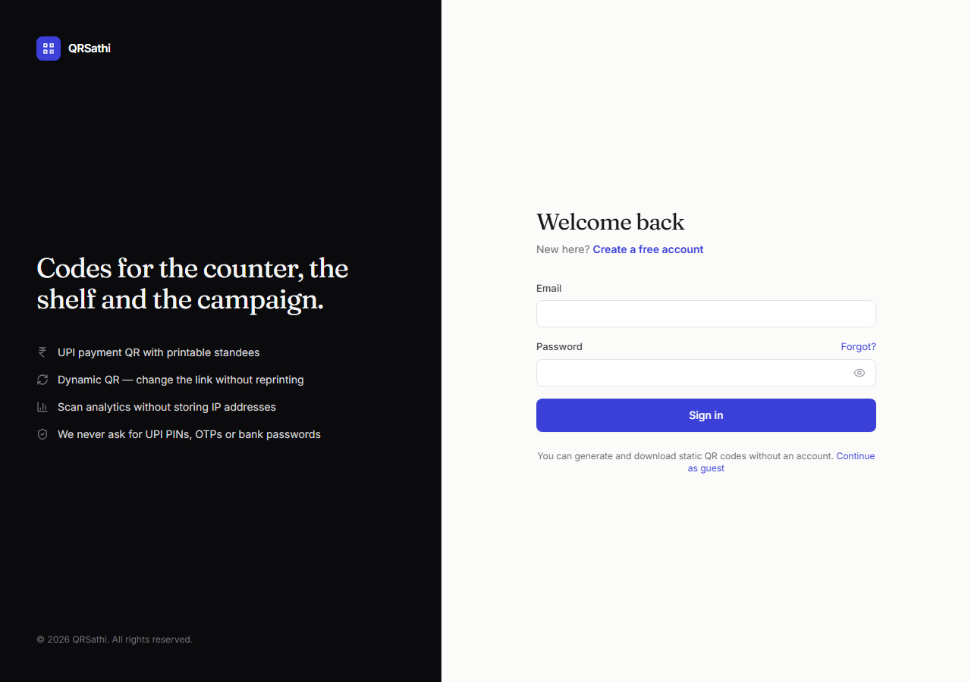
Figure 6.2: Sign-in page
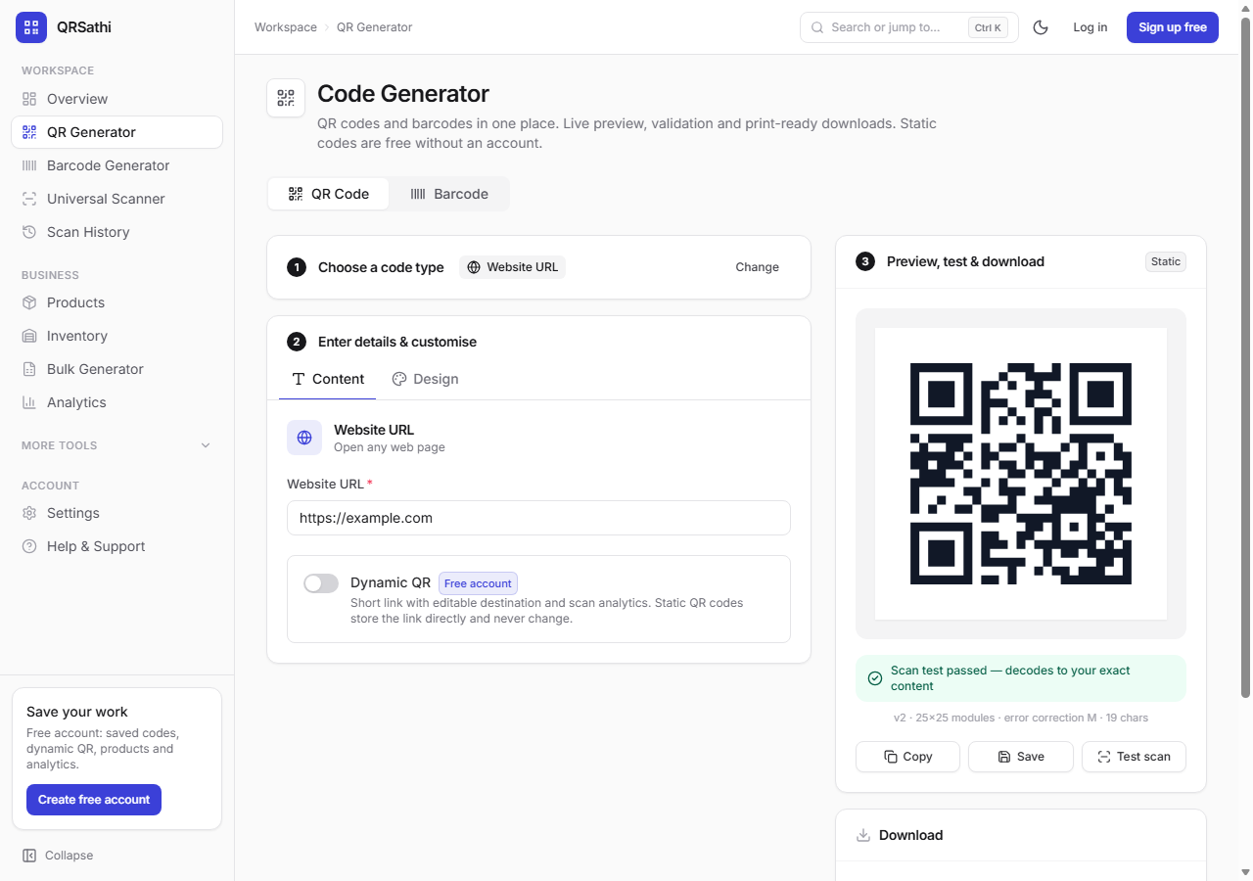
Figure 6.3: QR code generator with live preview and scan test
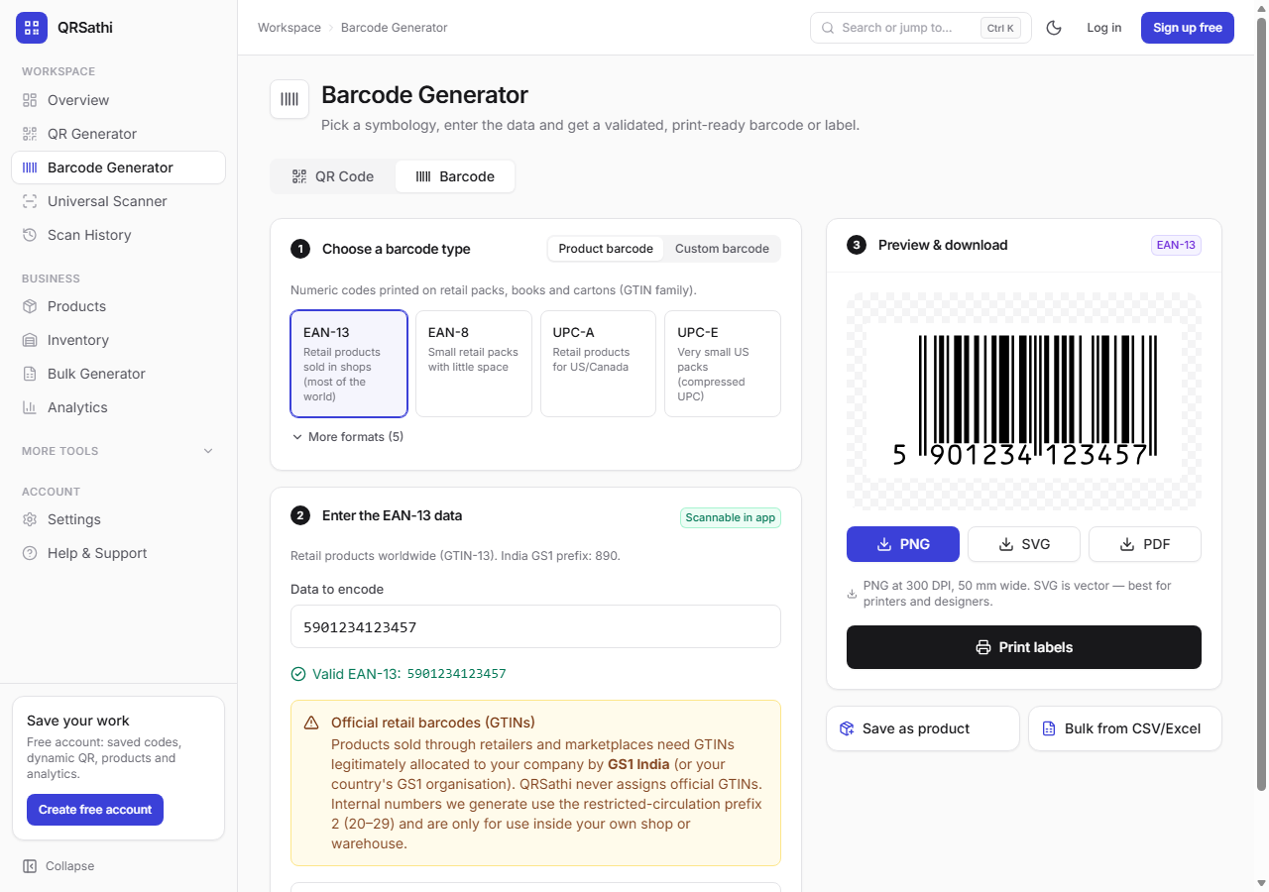
Figure 6.4: Barcode generator
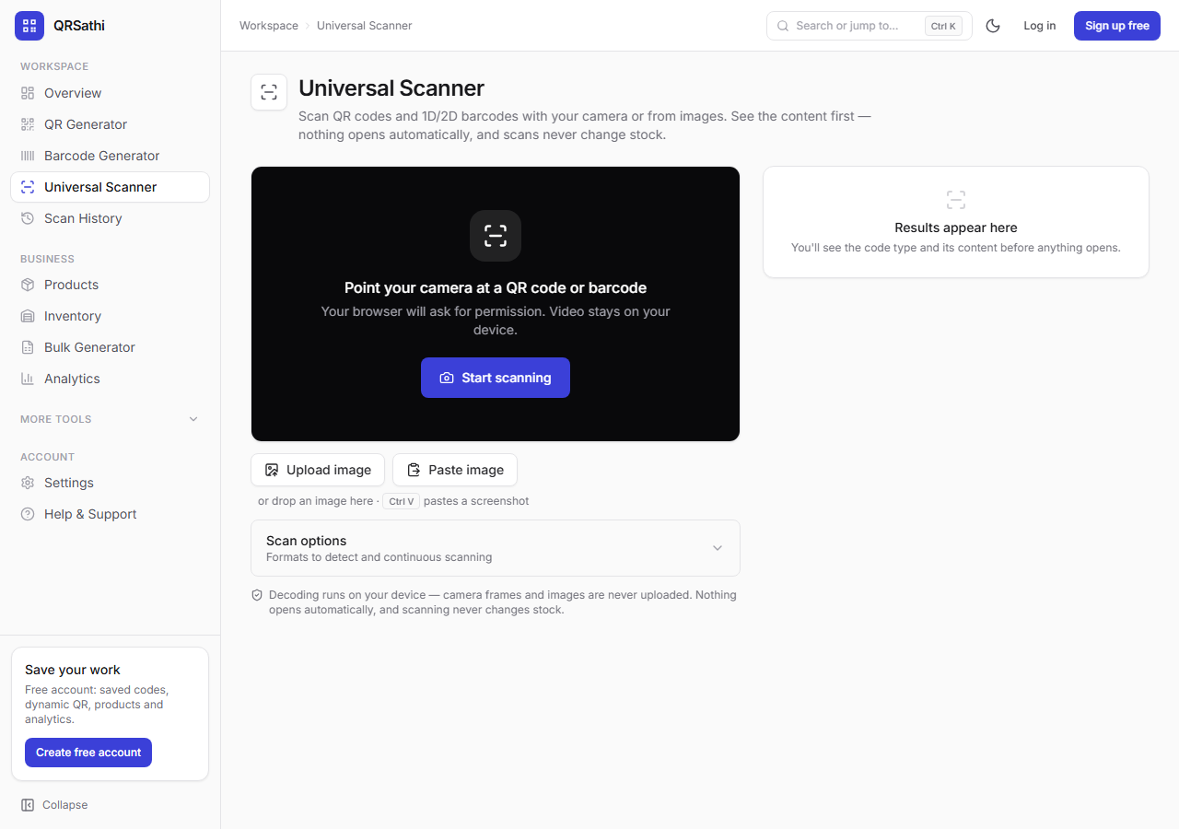
Figure 6.5: Universal scanner
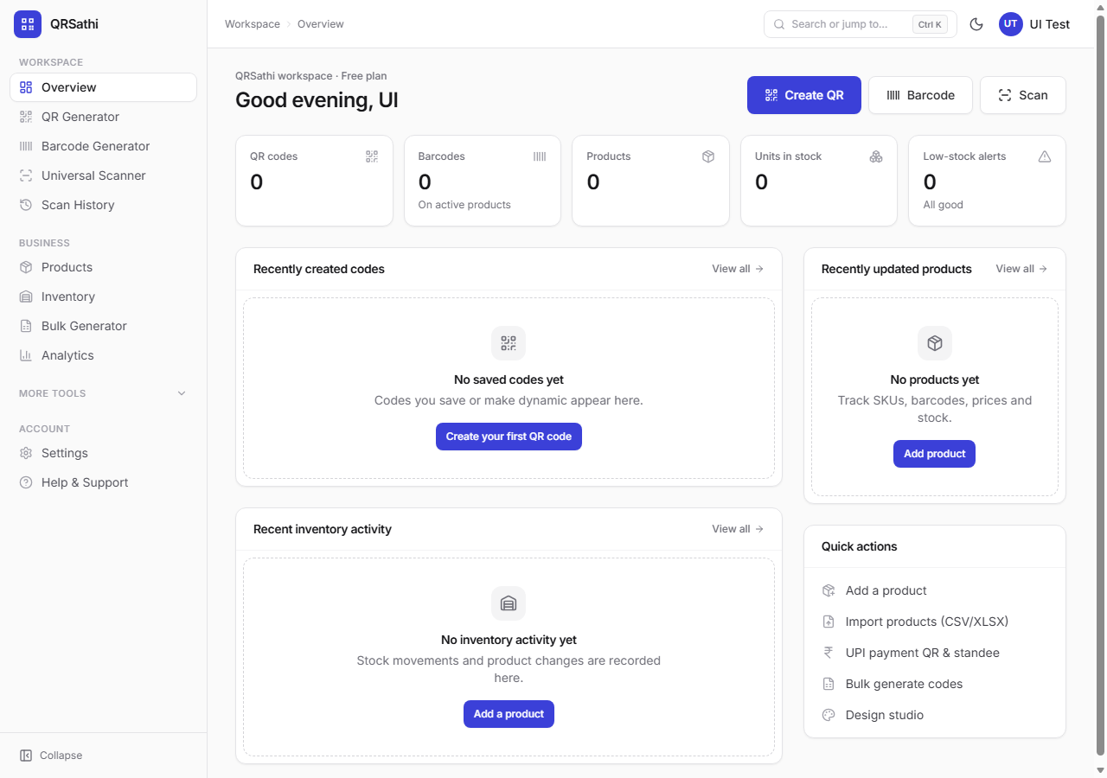
Figure 6.6: Workspace overview dashboard (new account)
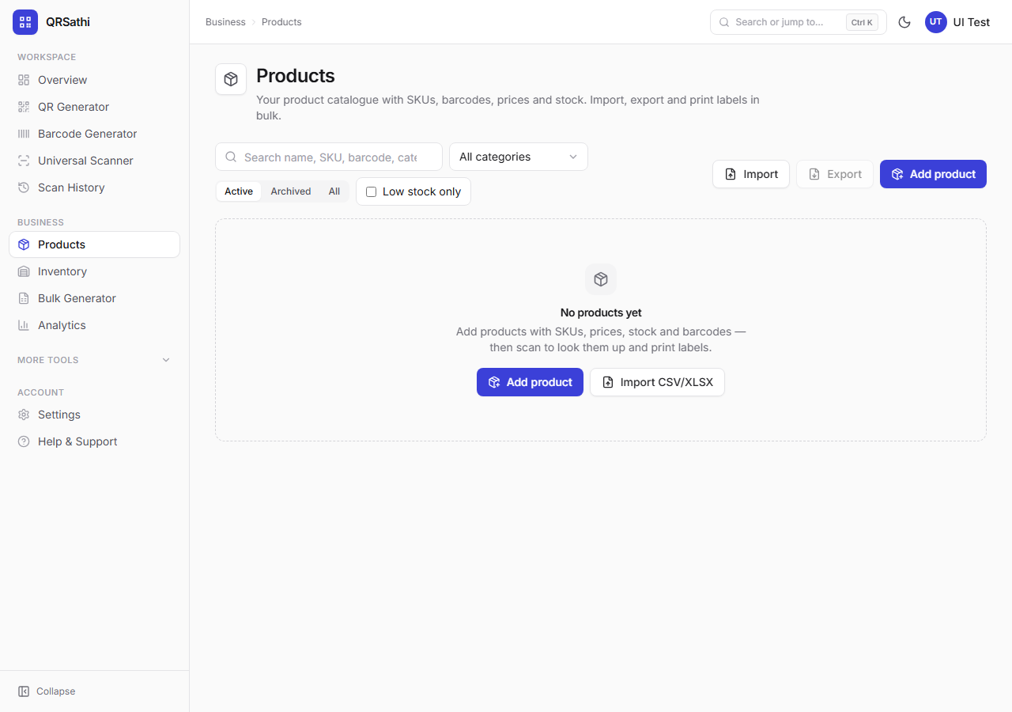
Figure 6.7: Products list (new account)
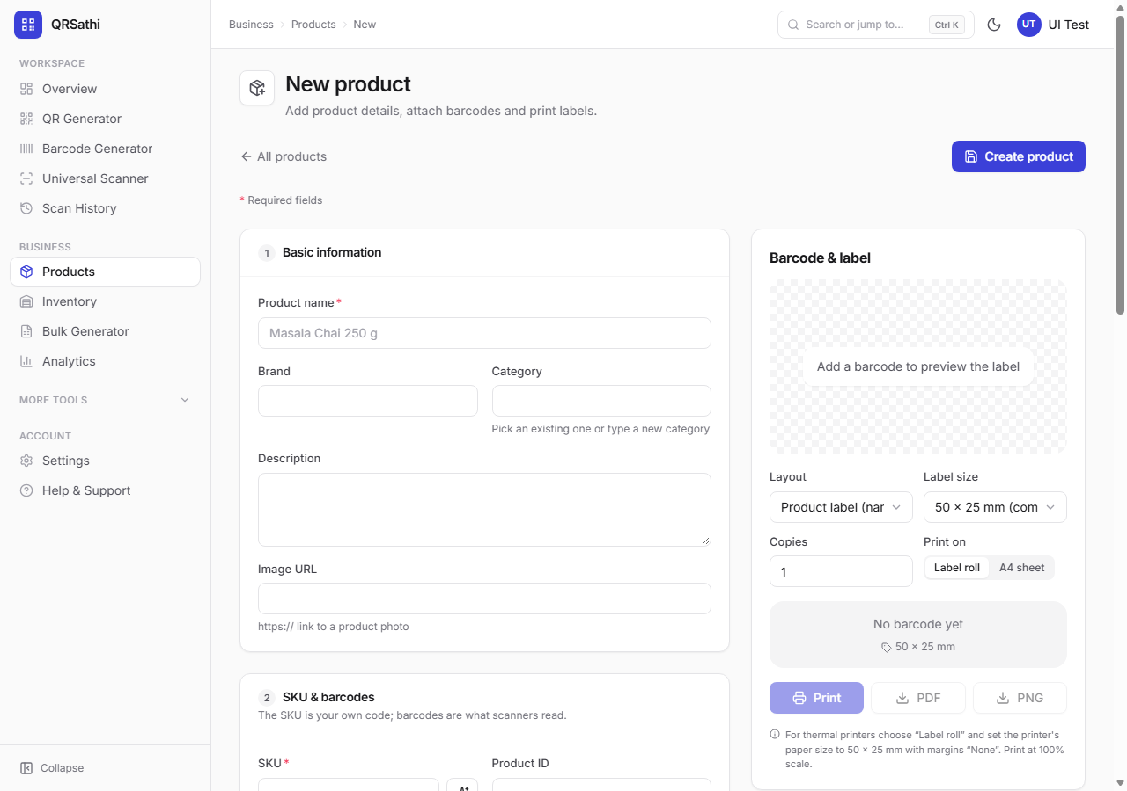
Figure 6.8: New product form
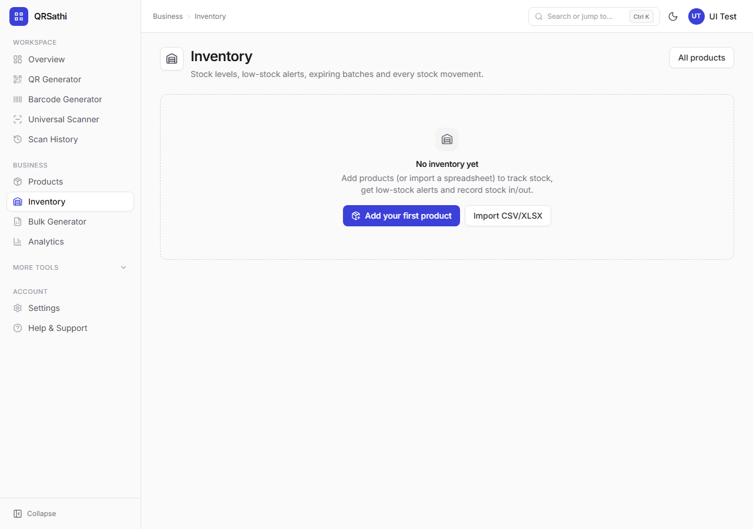
Figure 6.9: Inventory
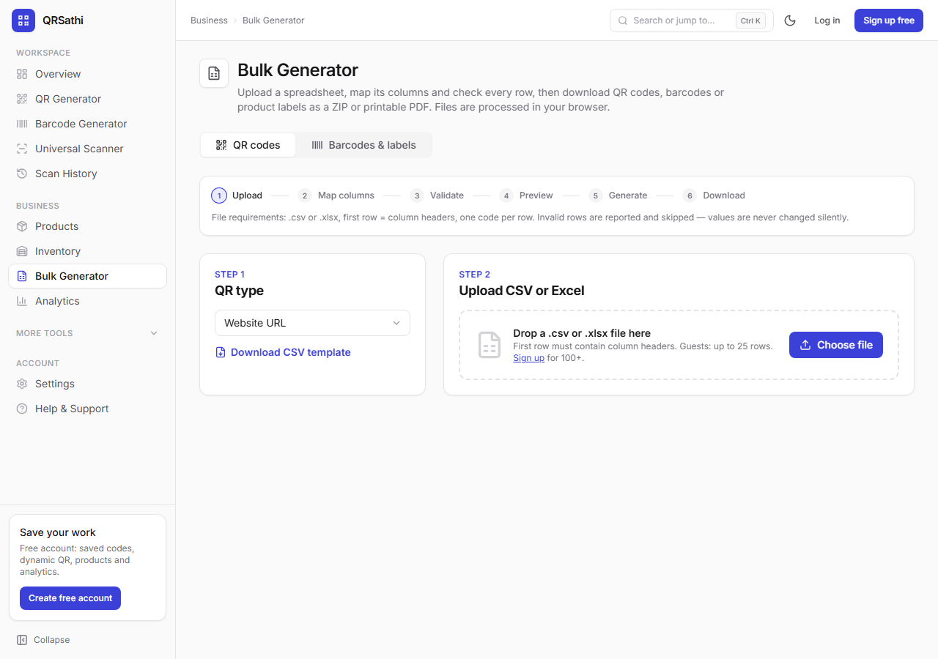
Figure 6.10: Bulk generator
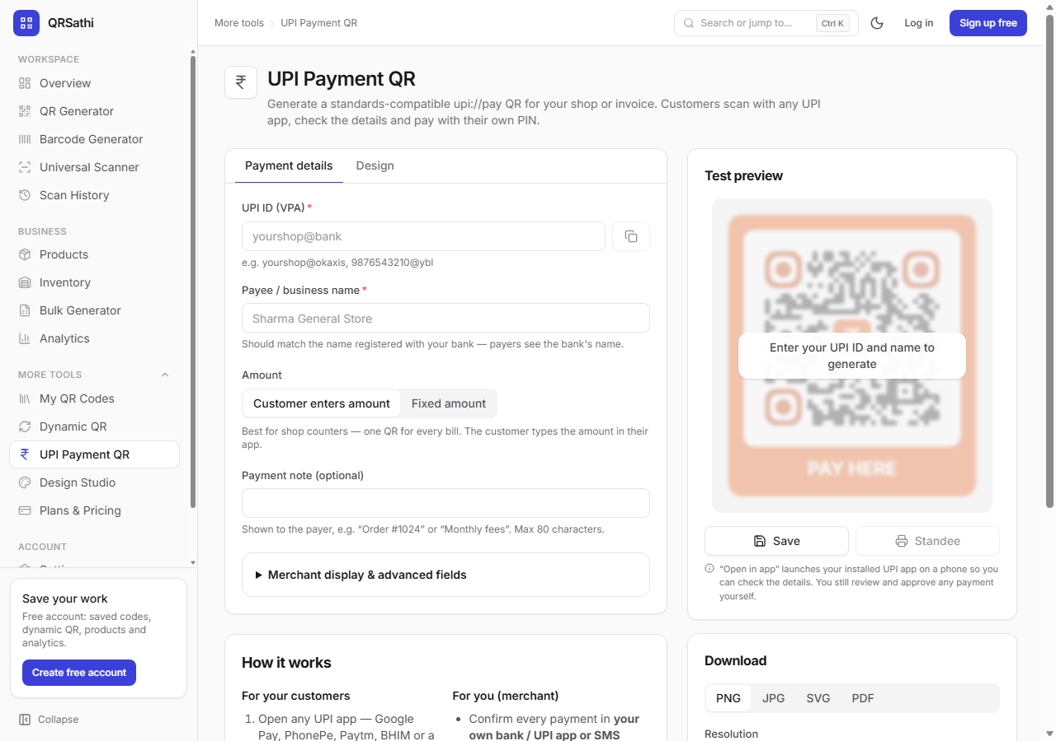
Figure 6.11: UPI payment QR tool
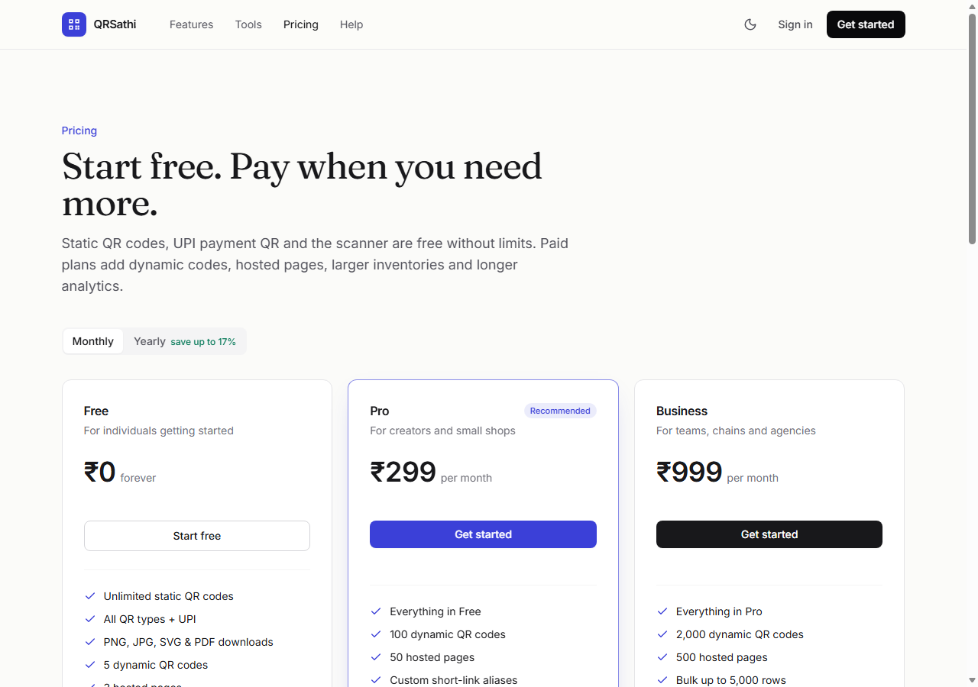
Figure 6.12: Pricing page
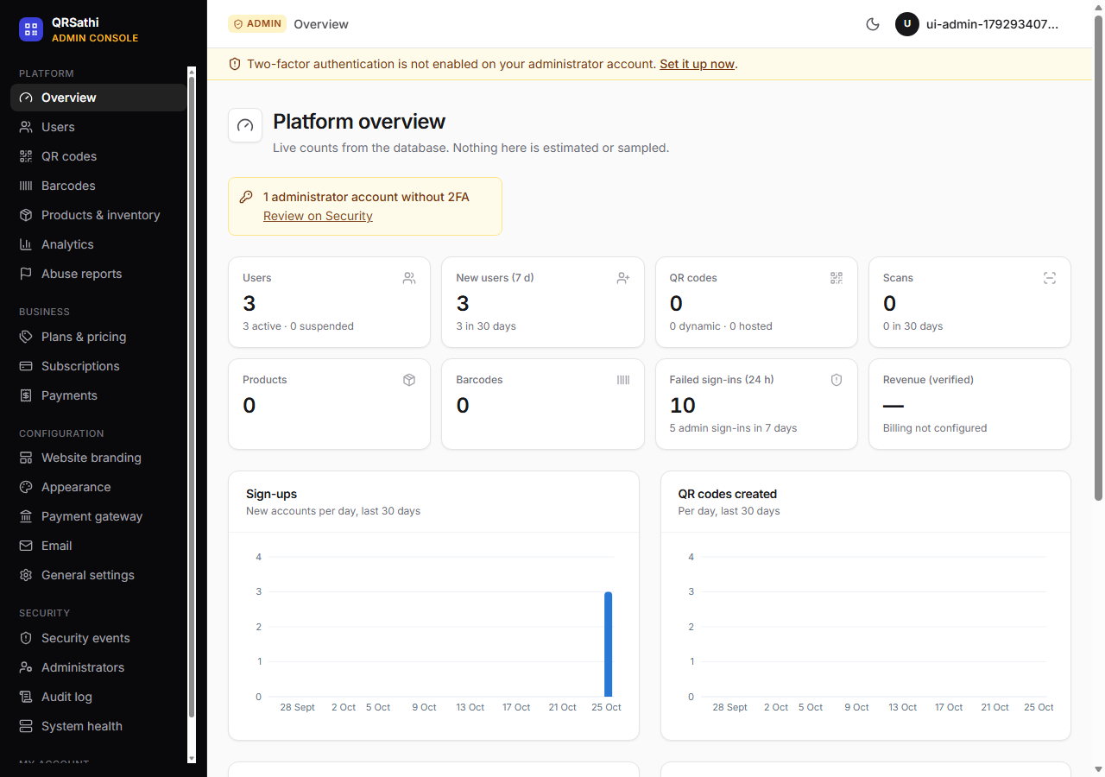
Figure 6.13: Admin console overview
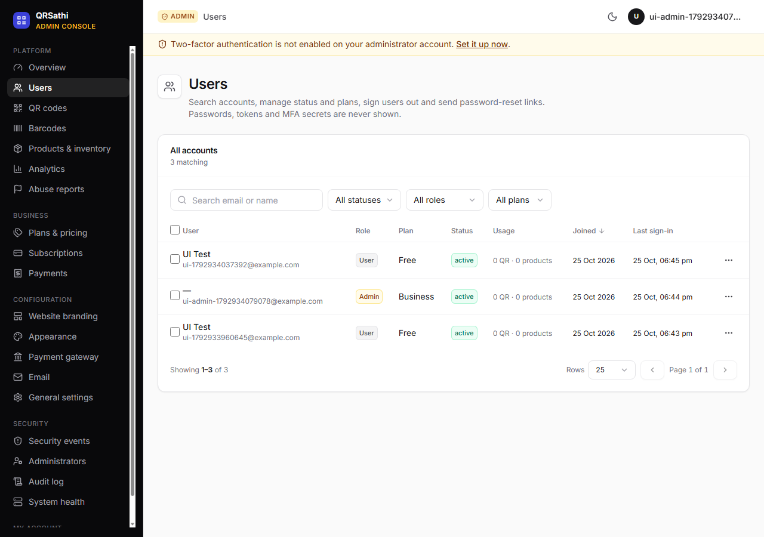
Figure 6.14: Admin user management
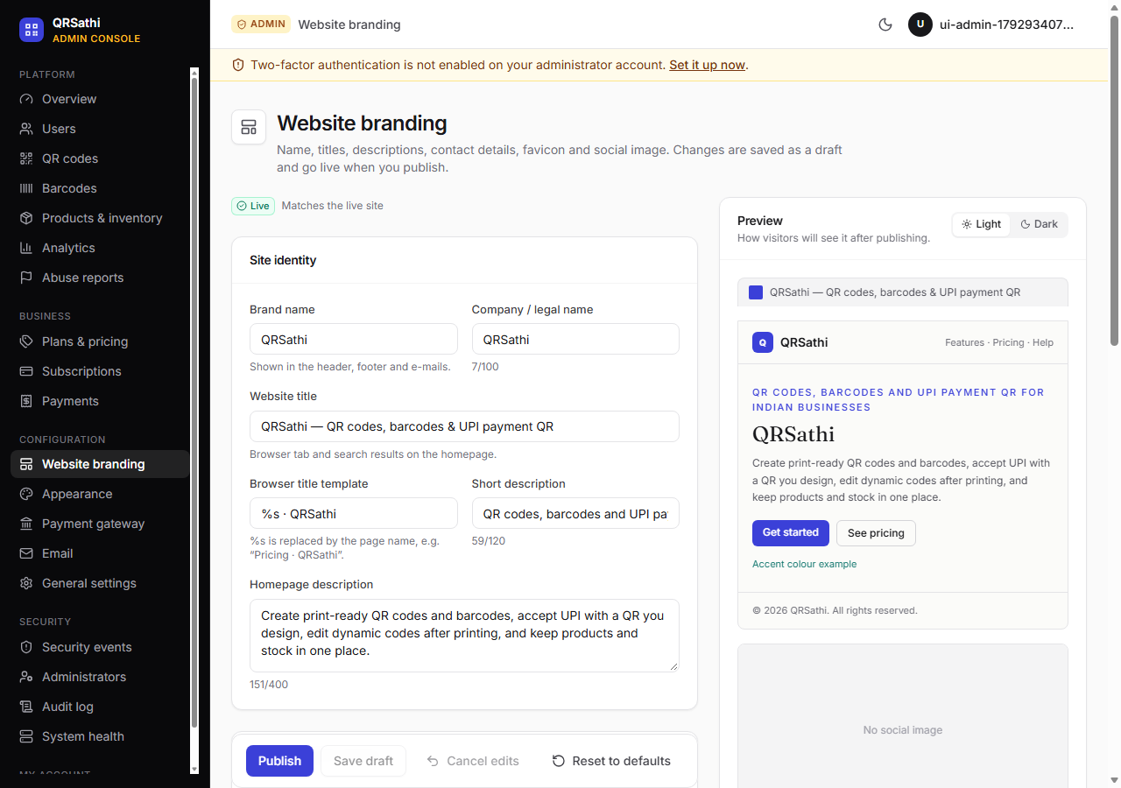
Figure 6.15: Admin branding settings
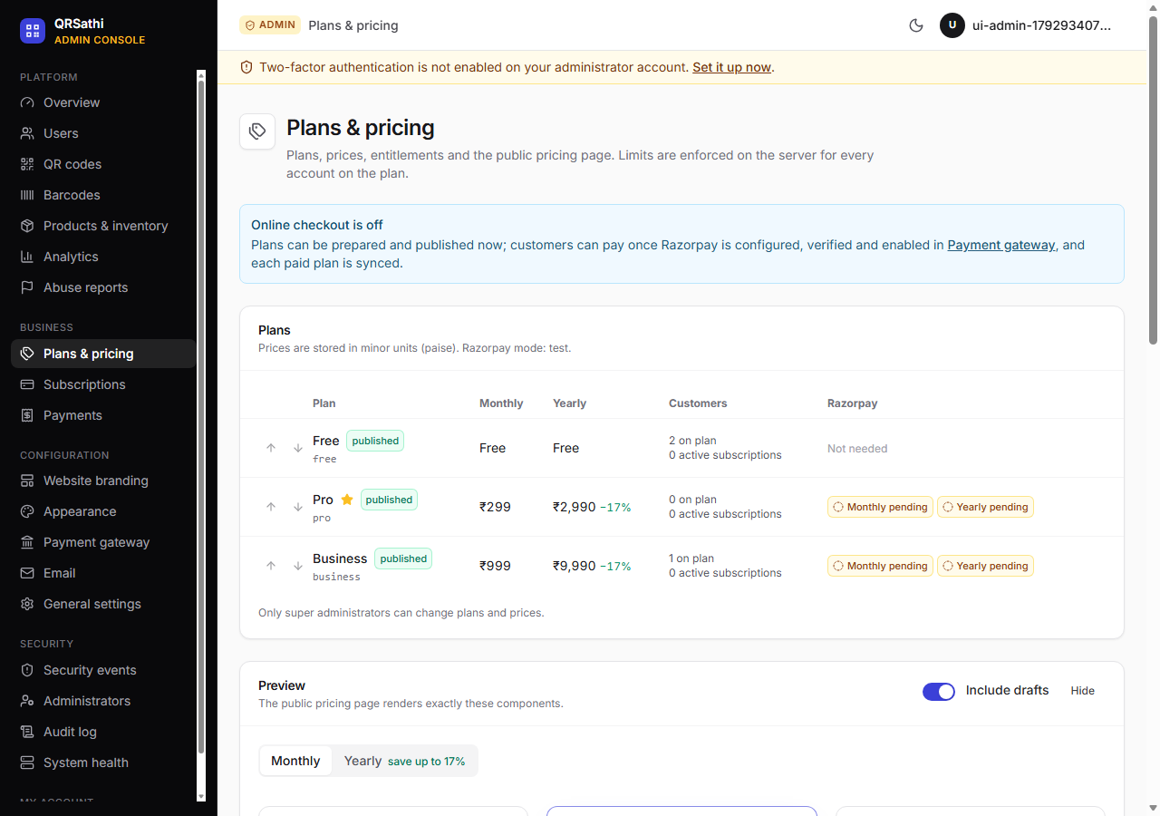
Figure 6.16: Admin pricing plans editor
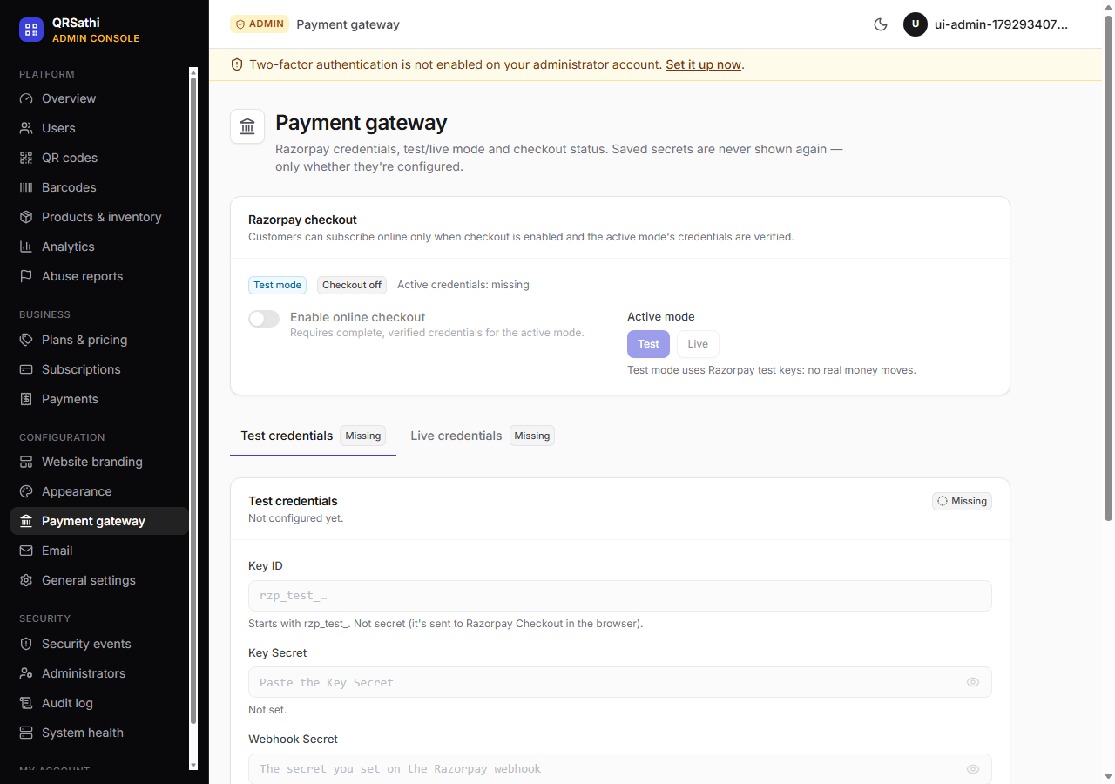
Figure 6.17: Admin payment-gateway configuration
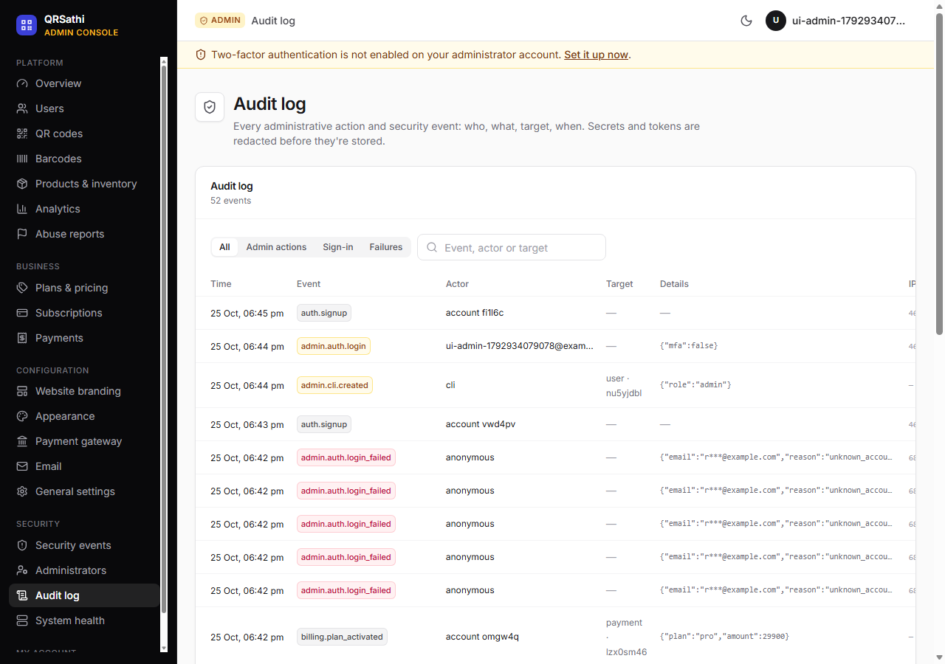
Figure 6.18: Admin security and audit log

Figure 6.19: Mobile views (375 px): landing page, generator and scanner

6.22 Evaluation of Implemented Features
Table 6.2: Feature verification matrix
Feature | Expected purpose | Implementation location | Status | Verification method | Findings
Account sign-up / sign-in / sign-out | User accounts with secure sessions | src/app/api/auth/*, src/lib/auth-flow.ts, src/lib/session.ts | Implemented and verified | test:admin, test:api, probe | Generic errors, three rate limits, server-side sessions
Google sign-in | Sign in with Google (OIDC) | src/app/api/auth/google/** | Implemented, not independently verified | Source review | No Google credentials in audit environment
Password reset | One-hour single-use e-mail link | src/app/api/auth/forgot|reset, src/lib/password-reset.ts | Implemented and verified | test:admin | E-mail delivery (SMTP) not exercised
Account settings / delete account | Profile, password change, sign out other devices, deletion | src/app/api/account/** | Implemented and verified | test:admin | Deletion requires typing the e-mail
Static QR generator (27 types) | Create QR codes for URL, Wi-Fi, vCard, UPI etc. | src/lib/qr-types.ts, src/components/qr/* | Implemented and verified | test:qr, test:api, test:browser | Every type/style decodes
QR design and export | Colours, shapes, logo, frames; PNG/JPG/SVG/PDF/ZIP | src/lib/qr-render.ts, src/lib/qr-export.ts | Implemented and verified | test:qr; screenshot | Automatic ECC H with logo; scan test after export
Saved QR library | List, search, favourite, edit, duplicate, delete | src/lib/qr-service.ts, src/app/api/qrcodes/** | Implemented and verified | test:admin (IDOR), test:billing (quota) | —
Dynamic QR (short links) | Editable destination, pause, expiry, alias, UTM | src/app/r/[code]/route.ts | Implemented and verified | test:api, probe (pause/expiry/404) | Redirects are no-store
Hosted landing pages | Menu, links, business, coupon etc. at /p/{code} | src/app/p/[code]/page.tsx, src/components/hosted-page.tsx | Implemented, not independently verified | Source review | No test asserts hosted page content
Scan analytics | Device/browser/OS/country charts; CSV export | src/lib/scans.ts, src/lib/analytics.ts, src/app/api/analytics/** | Implemented and verified | test:admin (scan cap), test:billing (plan gating) | No raw IPs; DNT/GPC honoured
UPI payment QR and standees | upi://pay QR for VPA or account+IFSC | src/lib/upi.ts, src/app/(app)/upi/* | Implemented and verified | test:api, test:qr | Limit warnings ₹1 lakh / ₹5 lakh
Barcode generator (23 formats) | Valid barcodes with check digits | src/lib/barcodes.ts, src/components/barcode/* | Implemented and verified | test:barcodes (166) | Render → decode round-trip for every format
Barcode labels | Printable labels in 6 sizes, 4 layouts | src/lib/barcodes.ts (renderLabelSvg), src/lib/barcode-export.ts | Implemented and verified | test:barcodes ('Labels stay scannable', PDF) | —
Universal scanner | Camera/image decoding with safety notes | src/app/(app)/scanner/scanner.tsx, src/lib/zxing-client.ts, src/lib/content-safety.ts | Implemented and verified | test:browser (camera, upload, UPI warning) | Chromium only
Scan history | On-device history with CSV export | src/lib/scan-history.ts | Implemented and verified | test:browser ('camera scan saved to on-device history') | Stored in localStorage, not in the account
Products | Catalogue with multiple barcodes per product | src/lib/products.ts, src/app/api/products/** | Implemented and verified | test:api | Per-user SKU/barcode uniqueness incl. GTIN equivalence
Inventory movements | Stock in/out/adjust, low stock, ledger | moveStock() in src/lib/products.ts, src/app/api/inventory | Implemented and verified | test:api | Stock never negative; scanning never changes stock
Product lookup by scan | Find product from scanned code | src/app/api/products/lookup | Implemented and verified | test:api | Read-only
Bulk QR / barcode generation | Generate many codes from a table | src/app/(app)/bulk/* | Implemented, not independently verified | Page renders (test:browser); no functional assertion | Plan bulkRows limit
Product import (CSV/XLSX) | Import or update products from spreadsheets | src/app/api/products/import, src/lib/table-file.ts | Implemented and verified | test:api | skip/update modes, per-row report
File uploads for File QR | Upload PDFs/images/Office files | src/app/api/uploads, src/lib/storage.ts, src/app/f/[name] | Partially implemented / defect | test:admin, probes | D-01: >10 MB uploads fail on paid plans; D-02 CSP fixed in working tree
Plans and entitlements | Server-enforced limits and features | src/lib/entitlements.ts, src/lib/plan-store.ts, src/lib/plans.ts | Implemented and verified | test:billing | Concurrency-safe via quotaLock
Pricing administration | Create/edit/publish/archive/reorder plans | src/app/api/admin/plans/**, src/lib/admin-plans.ts | Implemented and verified | test:billing | Super admin only; layout overflow at 768 px (D-03)
Razorpay subscriptions | Online payment for paid plans | src/lib/billing.ts, src/lib/razorpay.ts, src/app/api/billing/** | Implemented and verified | test:billing (mock Razorpay), test:admin (webhooks) | Not tested against live Razorpay
Payment gateway configuration | Sealed credentials, verification, enable checkout | src/lib/payment-config.ts, src/lib/secret-box.ts | Implemented and verified | test:billing | Secrets never returned; re-auth required
Admin console sign-in and MFA | Separate admin login with TOTP | src/app/api/admin/auth/**, src/lib/mfa.ts | Implemented and verified | test:admin | MFA mandatory for super admin only
User administration and RBAC | Suspend, roles, sessions, reset, delete | src/app/api/admin/users/**, src/lib/admin-users.ts | Implemented and verified | test:admin | D-05: plan enum hard-coded
QR moderation and abuse reports | Pause/disable codes; triage reports | src/app/api/admin/qrcodes/, admin/reports/, api/reports | Implemented, not independently verified | Source review; pages render | No functional assertion in suites
Branding and appearance | Names, colours, logos, favicon; draft/publish | src/lib/branding.ts, src/app/api/admin/branding/** | Implemented and verified | test:billing (branding), test:admin (XSS) | SVG sanitisation and sandboxing
Audit log and security events | Record security-relevant actions | src/lib/audit.ts, src/app/api/admin/security | Implemented and verified | test:admin | Redacted; IPs hashed
System health and logs | Health probe, config status, logs | src/app/api/health, src/lib/system-status.ts, src/lib/log.ts | Implemented and verified | test:admin (health) | Health reveals only ok/degraded
SQLite ↔ MySQL support | Dev on SQLite, production on MySQL | prisma/schema.prisma, prisma/mysql/**, scripts/db/* | Implemented and verified | test:mysql (32), schema check | MySQL production deployment itself not verified
Light/dark theme | User-selectable theme | src/components/providers.tsx | Implemented, not independently verified | Source review; DARK=1 mode exists in test but was not run | —
Command palette | Keyboard navigation (Ctrl K) | src/components/command-palette.tsx | Implemented, not independently verified | Visible in screenshots | —
E-mail verification at sign-up | Confirm e-mail ownership | — | Planned / not implemented | — | Recommended in docs/SECURITY-AUDIT.md
Object storage for uploads (S3/R2) | Scalable file storage | src/lib/storage.ts comment | Planned / not implemented | — | Storage functions designed to be replaceable

6.23 Evaluation Against Project Objectives
The objectives O1–O10 of Section 1.7 are evaluated in Table 7.1. In brief: objectives O1–O7, O9 and O10 are met with test evidence; O8 (plans and payments) is met for entitlements and verified against a mock payment provider, but not against live Razorpay; and the upload limits that are part of O8's plan model are affected by defect D-01.

6.24 Known Limitations
- Large uploads (D-01): files over 10 MB cannot be uploaded even on plans that allow 25–50 MB.
- Local file storage: uploads live on one server's disk; horizontal scaling needs shared or object storage.
- No e-mail verification at sign-up; password reset depends on SMTP being configured.
- Rate limiting defaults to per-process memory; multi-instance deployments must enable the database store and correct proxy settings.
- External integrations untested in this audit (Google, SMTP, live Razorpay).
- No performance baseline and no load testing.
- Browser coverage: automated tests only on Chromium.
- Single currency for UPI; payments only via Razorpay.
- Scan history is per device (browser storage) and is not synchronised to the account.
- Admin plan assignment limited to the three built-in plan ids (D-05).
- Repository hygiene: personal data in Git history (D-07) and a large amount of uncommitted work at audit time.

6.25 Maintenance and Operational Considerations
- Keep dependencies current (Dependabot is configured) and review the advisory allowlist before its 2027-01-31 expiry.
- Run the CI workflow on every change; add the audit probes (D-01 regression) to the suites.
- Back up the database and UPLOAD_DIR together; test restores (docs/BACKUP-RECOVERY.md).
- Rotate secrets carefully: MFA_ENCRYPTION_KEY and SETTINGS_ENCRYPTION_KEY are needed to decrypt stored secrets.
- Monitor /api/health, the system page and security events in the admin console; review the audit log.
- Periodically purge expired sessions, old logs and rate-limit rows (rate-limit rows are cleaned opportunistically; no scheduled job exists for sessions or logs).

6.26 Implementation Summary
QRSathi is implemented as a coherent, layered Next.js application in which validation, authorization and business rules live in a small set of server modules shared by all routes. The implementation goes beyond basic CRUD: it uses transactions for consistency, idempotency for payments, encryption for secrets and careful privacy defaults. The audit verified the large majority of features with executed tests and found one significant functional defect (D-01) and several minor issues, all of which are documented for correction.

CHAPTER 7
Conclusion and Future Enhancements

7.1 Conclusion
QRSathi set out to replace a fragmented set of tools — QR generators, barcode websites, phone scanners and stock spreadsheets — with one secure web application for small businesses. The audit carried out for this report confirms that the project achieves this aim to a substantial degree. The application integrates QR generation for 27 content types, dynamic QR codes with privacy-respecting analytics, barcode generation for 23 symbologies with standards-based validation, in-browser scanning with fraud warnings, a product catalogue with an append-only inventory ledger, bulk tools, a separate MFA-protected administration console, and plan-based billing through Razorpay.
The verified technical contribution lies less in any single feature than in the way the features are engineered: validation schemas shared by browser and server; server-side sessions that can be revoked instantly; deny-by-default authorization; transactions that keep quotas and stock consistent under concurrency; idempotent payment processing; encrypted storage of secrets; and a schema that runs on both SQLite and MySQL. These properties are not just claimed — 745 integration and end-to-end assertions, 300 unit assertions and 32 MySQL assertions passed in the final audit run.
The audit also found problems that must be addressed before production use: uploads above 10 MB fail on paid plans (D-01), a minor admin layout overflow and stale browser-test expectations (D-03, D-04), a hard-coded plan list in one admin endpoint (D-05), and — most importantly for publication — a development database with password hashes in the Git history (D-07). A large part of the latest work was also uncommitted at the time of the audit.

7.2 Achievement of Objectives
Table 7.1: Objectives versus results
Objective | Result | Evidence | Assessment
O1 QR generation with validation and scannable designs | 27 types; zod validation; design warnings; post-export scan test | test:qr; TC-QR-01..08 | Achieved
O2 Dynamic QR with privacy-preserving analytics | Short links with edit/pause/expiry/UTM; scan cap; no raw IPs; DNT/GPC | test:api, test:admin, probes | Achieved
O3 Standard barcodes with check digits and labels | 23 formats; GS1 check digits; labels in 6 sizes | test:barcodes (166) | Achieved
O4 Browser scanning with risk warnings | Camera and multi-code image decoding; URL/UPI heuristics | test:browser | Achieved (Chromium)
O5 Products and auditable inventory | Per-user uniqueness; ledger with balances; non-negative stock | test:api | Achieved
O6 Bulk generation and import | Import verified; bulk generation UI present | test:api; source review | Largely achieved
O7 Secure authentication, RBAC, MFA console | Separate admin sessions, TOTP, recovery codes, audit | test:admin (99) | Achieved
O8 Plans with server-enforced limits and payments | Entitlements and Razorpay lifecycle verified with mock provider | test:billing (128) | Partially achieved: live payments not verified; D-01 affects upload limits
O9 SQLite and MySQL from one schema | Generated schema, migrations, data migration | test:mysql (32) | Achieved
O10 Automated verification | Unit, API, admin, billing, browser and MySQL suites; CI workflow | Chapter 5 | Achieved (coverage percentage unknown)

7.3 Major Contributions
- An integrated, open-source-ready platform combining QR codes, barcodes, scanning and inventory for Indian small businesses.
- A type-registry design in which each QR type declares its own fields, validation and payload builder, shared by client and server.
- GTIN normalisation (lookup keys) so that equivalent barcode forms match the same product, and enforcement of GS1 restricted-circulation ranges for internal numbers.
- A privacy-preserving approach to scan analytics.
- A security architecture suitable as a teaching example: revocable sessions, separate admin console, TOTP with replay protection, CSRF origin checks, sealed secrets and audit logging.
- A comprehensive automated test set, including real-browser camera tests and real-MySQL migration tests.

7.4 Current Limitations
- File uploads above 10 MB fail (D-01); files are stored on local disk.
- No e-mail verification; resets require SMTP.
- External integrations (Google, SMTP, live Razorpay) unverified.
- No performance or load testing; no code-coverage measurement.
- Automated browser testing on Chromium only.
- Scan history not synchronised across devices.
- Personal data in Git history; much work uncommitted at the time of the audit.

7.5 Future Enhancements
The following are proposals; none of them is implemented unless stated.
Table 7.2: Proposed future enhancements
Area | Enhancement | Note
Correctness | Fix D-01 (exclude /api/uploads from the middleware matcher or raise the middleware body limit) and add a regression test | Highest priority
Analytics and reporting | Scheduled reports; campaign comparison; inventory valuation and movement reports | Scan analytics and CSV export already exist
Bulk processing | Background jobs for very large batches; progress tracking | Client-side bulk generation exists
Export formats | EPS/vector PDF labels for print shops; Excel export of inventory | PNG/JPG/SVG/PDF/ZIP exist
Inventory alerts | E-mail/WhatsApp low-stock and expiry alerts; multi-location stock | Low-stock flag exists in UI
Audit logs | Export and retention policies; tamper-evident hashing | Audit log exists
Permissions | Team workspaces with per-member roles (owner, editor, viewer) | Currently one owner per account
Authentication | E-mail verification; passkeys (WebAuthn); MFA for all users; breached-password checks | TOTP exists for admins
Accessibility | Manual WCAG 2.2 AA audit; screen-reader testing | Automated name checks exist
Performance | Load testing; caching of hosted pages; database indexes reviewed with real data | —
Backups and recovery | Automated scheduled backups and restore drills | Procedure documented only
Monitoring | Metrics and tracing (e.g. OpenTelemetry); alerting on health and errors | Health endpoint and logs exist
Payments | Additional providers; invoices with GST details; coupons | Razorpay subscriptions exist
Internationalisation | Hindi and regional-language UI; locale formatting | UI is English
API and integrations | Public REST API with API keys; OpenAPI documentation; webhooks for scans | Internal API only
Testing | Coverage reporting; Firefox/Safari/mobile device tests; contract tests against Razorpay test mode | Large suite exists
Storage | Object storage (S3-compatible) for uploads | storage.ts designed to be replaceable
Security | URL reputation checks for dynamic destinations; CSP nonces; Git history clean-up | See Table 4.12

7.6 Long-Term Scope
In the long term QRSathi could evolve into a small-business identification platform: a native or progressive-web mobile app for offline scanning and stock-taking, point-of-sale integration, GS1 Digital Link support (QR codes that carry GTINs and resolve to product information), supplier and purchase-order management, and analytics that connect scans to sales. Because the core is a typed, layered code base with a portable schema and automated tests, these extensions can be added incrementally.

7.7 Final Conclusion
QRSathi is a working, well-engineered mini project that meets most of its objectives with evidence. It demonstrates practical skills in full-stack web development, database design, security engineering and automated testing. With the documented defects fixed, the work committed and the repository history cleaned, it would be a sound foundation for a production service.

References
References follow the IEEE style. All web sources were accessed on 25 October 2026. URLs marked † returned HTTP 403 to the automated link check (bot protection on the publisher's site) and should be confirmed manually in a browser before submission; all other URLs returned HTTP 200.
[1] Vercel, "Next.js Documentation." [Online]. Available: https://nextjs.org/docs
[2] Vercel, "Next.js API Reference: middleware." [Online]. Available: https://nextjs.org/docs/app/api-reference/file-conventions/middleware
[3] Meta Open Source, "React Reference." [Online]. Available: https://react.dev/reference/react
[4] Microsoft, "TypeScript Documentation." [Online]. Available: https://www.typescriptlang.org/docs/
[5] Prisma Data, Inc., "Prisma ORM Documentation." [Online]. Available: https://www.prisma.io/docs
[6] Tailwind Labs, "Tailwind CSS v3 Documentation." [Online]. Available: https://v3.tailwindcss.com/docs
[7] Oracle Corporation, "MySQL 8.4 Reference Manual." [Online]. Available: https://dev.mysql.com/doc/refman/8.4/en/ †
[8] International Organization for Standardization, ISO/IEC 18004:2015 Information technology — Automatic identification and data capture techniques — QR Code bar code symbology specification. Geneva, Switzerland: ISO, 2015. [Online]. Available: https://www.iso.org/standard/62021.html †
[9] GS1, "GS1 General Specifications." [Online]. Available: https://www.gs1.org/standards/barcodes-epcrfid-id-keys/gs1-general-specifications †
[10] GS1, "Check Digit Calculator." [Online]. Available: https://www.gs1.org/services/check-digit-calculator †
[11] DENSO WAVE Inc., "History of QR Code." [Online]. Available: https://www.qrcode.com/en/history/
[12] D. M'Raihi, S. Machani, M. Pei and J. Rydell, "TOTP: Time-Based One-Time Password Algorithm," RFC 6238, IETF, May 2011. [Online]. Available: https://www.rfc-editor.org/rfc/rfc6238
[13] D. M'Raihi, M. Bellare, F. Hoornaert, D. Naccache and O. Ranen, "HOTP: An HMAC-Based One-Time Password Algorithm," RFC 4226, IETF, Dec. 2005. [Online]. Available: https://www.rfc-editor.org/rfc/rfc4226
[14] H. Krawczyk, M. Bellare and R. Canetti, "HMAC: Keyed-Hashing for Message Authentication," RFC 2104, IETF, Feb. 1997. [Online]. Available: https://www.rfc-editor.org/rfc/rfc2104
[15] M. Jones, J. Bradley and N. Sakimura, "JSON Web Token (JWT)," RFC 7519, IETF, May 2015. [Online]. Available: https://www.rfc-editor.org/rfc/rfc7519
[16] OWASP Foundation, "OWASP Cheat Sheet Series" (Authentication, Session Management, Cross-Site Request Forgery Prevention, Password Storage). [Online]. Available: https://cheatsheetseries.owasp.org/
[17] OWASP Foundation, "OWASP Top 10:2021." [Online]. Available: https://owasp.org/Top10/
[18] P. A. Grassi et al., "Digital Identity Guidelines: Authentication and Lifecycle Management," NIST SP 800-63B. [Online]. Available: https://pages.nist.gov/800-63-3/sp800-63b.html
[19] Mozilla, "Content-Security-Policy," MDN Web Docs. [Online]. Available: https://developer.mozilla.org/en-US/docs/Web/HTTP/Headers/Content-Security-Policy
[20] W3C, "Web Content Accessibility Guidelines (WCAG) 2.2," W3C Recommendation. [Online]. Available: https://www.w3.org/TR/WCAG22/
[21] Razorpay, "Subscriptions." [Online]. Available: https://razorpay.com/docs/payments/subscriptions/
[22] Razorpay, "Validate and Test Webhooks." [Online]. Available: https://razorpay.com/docs/webhooks/validate-test/
[23] National Payments Corporation of India, "Unified Payments Interface (UPI): Product Overview." [Online]. Available: https://www.npci.org.in/what-we-do/upi/product-overview †
[24] C. McDonnell, "Zod Documentation." [Online]. Available: https://zod.dev
[25] metafloor, "bwip-js: Barcode Writer in Pure JavaScript," GitHub repository. [Online]. Available: https://github.com/metafloor/bwip-js
[26] Sec-ant, "zxing-wasm: ZXing-C++ WebAssembly build," GitHub repository. [Online]. Available: https://github.com/Sec-ant/zxing-wasm
[27] soldair, "node-qrcode: QR code generator," GitHub repository. [Online]. Available: https://github.com/soldair/node-qrcode
[28] SQLite Consortium, "SQLite Documentation." [Online]. Available: https://www.sqlite.org/docs.html
[29] Mermaid contributors, "Mermaid: Diagramming and charting tool." [Online]. Available: https://mermaid.js.org
[30] QRSathi project repository, source code and documentation (README.md, docs/*.md), branch main, commit 9b5dae7 plus working-tree changes as of 25 Oct. 2026. Remote: https://github.com/druvemedia/qrsathi (not accessed during the audit; the local copy was used).

Appendix A: Project Directory Structure
The tree below lists source, configuration and documentation files. Dependencies (node_modules), build outputs (.next*), uploaded files, databases and backups, and secret files (.env) are excluded.
Files listed: 314 (tracked and untracked, excluding ignored files).
qrsathi/
├── .github/
│ ├── ISSUE_TEMPLATE/
│ │ ├── bug_report.yml
│ │ ├── config.yml
│ │ └── feature_request.yml
│ ├── workflows/
│ │ └── ci.yml
│ ├── dependabot.yml
│ └── PULL_REQUEST_TEMPLATE.md
├── docs/
│ ├── mini-project-report/
│ │ └── (this report package)
│ ├── ADMIN.md
│ ├── BACKUP-RECOVERY.md
│ ├── BARCODES.md
│ ├── BILLING.md
│ ├── DATABASE.md
│ ├── DEPLOYMENT.md
│ ├── LICENSING.md
│ ├── OPEN-SOURCE-READINESS.md
│ └── SECURITY-AUDIT.md
├── prisma/
│ ├── mysql/
│ │ ├── migrations/
│ │ │ ├── 20261025000000_init/
│ │ │ │ └── migration.sql
│ │ │ ├── 20261025180000_billing_branding/
│ │ │ │ └── migration.sql
│ │ │ └── migration_lock.toml
│ │ └── schema.prisma
│ ├── schema.prisma
│ └── seed-demo.mjs
├── scripts/
│ ├── db/
│ │ ├── mysql-schema.mjs
│ │ ├── prisma.mjs
│ │ └── sqlite-to-mysql.mts
│ ├── admin.mts
│ ├── audit-check.mjs
│ ├── copy-wasm.mjs
│ ├── license-report.mjs
│ ├── test-admin.mts
│ ├── test-api.mts
│ ├── test-barcodes.mts
│ ├── test-billing.mts
│ ├── test-browser.mts
│ ├── test-mysql.mts
│ ├── test-qr.mts
│ └── test-security.mts
├── security/
│ └── audit-allowlist.json
├── src/
│ ├── app/
│ │ ├── (app)/
│ │ │ ├── analytics/
│ │ │ │ ├── [id]/
│ │ │ │ │ └── page.tsx
│ │ │ │ └── page.tsx
│ │ │ ├── barcodes/
│ │ │ │ └── page.tsx
│ │ │ ├── billing/
│ │ │ │ └── status/
│ │ │ │ ├── checkout-status.tsx
│ │ │ │ └── page.tsx
│ │ │ ├── bulk/
│ │ │ │ ├── barcode-bulk.tsx
│ │ │ │ ├── bulk-modes.tsx
│ │ │ │ ├── bulk-tool.tsx
│ │ │ │ └── page.tsx
│ │ │ ├── codes/
│ │ │ │ ├── library.tsx
│ │ │ │ └── page.tsx
│ │ │ ├── dashboard/
│ │ │ │ ├── history/
│ │ │ │ │ ├── history.tsx
│ │ │ │ │ └── page.tsx
│ │ │ │ ├── settings/
│ │ │ │ │ ├── billing.tsx
│ │ │ │ │ ├── page.tsx
│ │ │ │ │ └── settings.tsx
│ │ │ │ ├── overview.tsx
│ │ │ │ └── page.tsx
│ │ │ ├── dynamic/
│ │ │ │ ├── dynamic-list.tsx
│ │ │ │ └── page.tsx
│ │ │ ├── generator/
│ │ │ │ └── page.tsx
│ │ │ ├── inventory/
│ │ │ │ ├── inventory-view.tsx
│ │ │ │ └── page.tsx
│ │ │ ├── products/
│ │ │ │ ├── [id]/
│ │ │ │ │ └── page.tsx
│ │ │ │ ├── new/
│ │ │ │ │ └── page.tsx
│ │ │ │ ├── page.tsx
│ │ │ │ └── products-list.tsx
│ │ │ ├── scan-history/
│ │ │ │ ├── history-view.tsx
│ │ │ │ └── page.tsx
│ │ │ ├── scanner/
│ │ │ │ ├── page.tsx
│ │ │ │ └── scanner.tsx
│ │ │ ├── studio/
│ │ │ │ └── page.tsx
│ │ │ ├── upi/
│ │ │ │ ├── page.tsx
│ │ │ │ └── upi-tool.tsx
│ │ │ └── layout.tsx
│ │ ├── (auth)/
│ │ │ ├── forgot-password/
│ │ │ │ └── page.tsx
│ │ │ ├── login/
│ │ │ │ └── page.tsx
│ │ │ ├── reset-password/
│ │ │ │ └── page.tsx
│ │ │ ├── signup/
│ │ │ │ └── page.tsx
│ │ │ ├── auth-ui.tsx
│ │ │ └── layout.tsx
│ │ ├── (site)/
│ │ │ ├── about/
│ │ │ │ └── page.tsx
│ │ │ ├── contact/
│ │ │ │ └── page.tsx
│ │ │ ├── features/
│ │ │ │ └── page.tsx
│ │ │ ├── help/
│ │ │ │ └── page.tsx
│ │ │ ├── pricing/
│ │ │ │ ├── page.tsx
│ │ │ │ └── pricing-view.tsx
│ │ │ ├── privacy/
│ │ │ │ └── page.tsx
│ │ │ ├── report/
│ │ │ │ ├── page.tsx
│ │ │ │ └── report-form.tsx
│ │ │ ├── terms/
│ │ │ │ └── page.tsx
│ │ │ ├── tools/
│ │ │ │ └── page.tsx
│ │ │ ├── layout.tsx
│ │ │ └── page.tsx
│ │ ├── admin/
│ │ │ ├── (auth)/
│ │ │ │ ├── forgot-password/
│ │ │ │ │ └── page.tsx
│ │ │ │ ├── login/
│ │ │ │ │ └── page.tsx
│ │ │ │ ├── admin-auth-ui.tsx
│ │ │ │ └── layout.tsx
│ │ │ ├── (console)/
│ │ │ │ ├── analytics/
│ │ │ │ │ ├── analytics-view.tsx
│ │ │ │ │ └── page.tsx
│ │ │ │ ├── barcodes/
│ │ │ │ │ ├── barcodes-view.tsx
│ │ │ │ │ └── page.tsx
│ │ │ │ ├── inventory/
│ │ │ │ │ └── page.tsx
│ │ │ │ ├── mfa/
│ │ │ │ │ ├── mfa-view.tsx
│ │ │ │ │ └── page.tsx
│ │ │ │ ├── payments/
│ │ │ │ │ ├── page.tsx
│ │ │ │ │ └── payments-view.tsx
│ │ │ │ ├── products/
│ │ │ │ │ ├── catalog-view.tsx
│ │ │ │ │ └── page.tsx
│ │ │ │ ├── qr-codes/
│ │ │ │ │ ├── page.tsx
│ │ │ │ │ └── qr-codes-view.tsx
│ │ │ │ ├── reports/
│ │ │ │ │ ├── page.tsx
│ │ │ │ │ └── reports-view.tsx
│ │ │ │ ├── security/
│ │ │ │ │ ├── admins/
│ │ │ │ │ │ └── page.tsx
│ │ │ │ │ ├── events/
│ │ │ │ │ │ └── page.tsx
│ │ │ │ │ ├── page.tsx
│ │ │ │ │ └── security-view.tsx
│ │ │ │ ├── settings/
│ │ │ │ │ ├── appearance/
│ │ │ │ │ │ └── page.tsx
│ │ │ │ │ ├── branding/
│ │ │ │ │ │ ├── branding-editor.tsx
│ │ │ │ │ │ └── page.tsx
│ │ │ │ │ ├── email/
│ │ │ │ │ │ ├── email-view.tsx
│ │ │ │ │ │ └── page.tsx
│ │ │ │ │ ├── payments/
│ │ │ │ │ │ ├── page.tsx
│ │ │ │ │ │ └── payments-config.tsx
│ │ │ │ │ ├── pricing/
│ │ │ │ │ │ ├── page.tsx
│ │ │ │ │ │ └── pricing-admin.tsx
│ │ │ │ │ ├── page.tsx
│ │ │ │ │ └── settings-view.tsx
│ │ │ │ ├── subscriptions/
│ │ │ │ │ ├── page.tsx
│ │ │ │ │ └── subscriptions-view.tsx
│ │ │ │ ├── system/
│ │ │ │ │ ├── page.tsx
│ │ │ │ │ └── system-view.tsx
│ │ │ │ ├── users/
│ │ │ │ │ ├── page.tsx
│ │ │ │ │ └── users-view.tsx
│ │ │ │ ├── layout.tsx
│ │ │ │ ├── overview-view.tsx
│ │ │ │ └── page.tsx
│ │ │ └── layout.tsx
│ │ ├── api/
│ │ │ ├── account/
│ │ │ │ ├── sessions/
│ │ │ │ │ └── route.ts
│ │ │ │ └── route.ts
│ │ │ ├── admin/
│ │ │ │ ├── analytics/
│ │ │ │ │ └── route.ts
│ │ │ │ ├── auth/
│ │ │ │ │ ├── login/
│ │ │ │ │ │ └── route.ts
│ │ │ │ │ ├── logout/
│ │ │ │ │ │ └── route.ts
│ │ │ │ │ ├── me/
│ │ │ │ │ │ └── route.ts
│ │ │ │ │ ├── mfa/
│ │ │ │ │ │ └── route.ts
│ │ │ │ │ └── reauth/
│ │ │ │ │ └── route.ts
│ │ │ │ ├── branding/
│ │ │ │ │ ├── assets/
│ │ │ │ │ │ └── route.ts
│ │ │ │ │ └── route.ts
│ │ │ │ ├── catalog/
│ │ │ │ │ └── route.ts
│ │ │ │ ├── email/
│ │ │ │ │ └── route.ts
│ │ │ │ ├── logs/
│ │ │ │ │ └── route.ts
│ │ │ │ ├── mfa/
│ │ │ │ │ └── route.ts
│ │ │ │ ├── payments/
│ │ │ │ │ ├── config/
│ │ │ │ │ │ └── route.ts
│ │ │ │ │ └── route.ts
│ │ │ │ ├── plans/
│ │ │ │ │ ├── [id]/
│ │ │ │ │ │ └── route.ts
│ │ │ │ │ ├── reorder/
│ │ │ │ │ │ └── route.ts
│ │ │ │ │ └── route.ts
│ │ │ │ ├── qrcodes/
│ │ │ │ │ ├── [id]/
│ │ │ │ │ │ └── route.ts
│ │ │ │ │ └── route.ts
│ │ │ │ ├── reports/
│ │ │ │ │ ├── [id]/
│ │ │ │ │ │ └── route.ts
│ │ │ │ │ └── route.ts
│ │ │ │ ├── security/
│ │ │ │ │ └── route.ts
│ │ │ │ ├── settings/
│ │ │ │ │ └── route.ts
│ │ │ │ ├── stats/
│ │ │ │ │ └── route.ts
│ │ │ │ ├── subscriptions/
│ │ │ │ │ ├── [id]/
│ │ │ │ │ │ └── route.ts
│ │ │ │ │ └── route.ts
│ │ │ │ ├── system/
│ │ │ │ │ └── route.ts
│ │ │ │ └── users/
│ │ │ │ ├── [id]/
│ │ │ │ │ └── route.ts
│ │ │ │ ├── bulk/
│ │ │ │ │ └── route.ts
│ │ │ │ └── route.ts
│ │ │ ├── analytics/
│ │ │ │ ├── export/
│ │ │ │ │ └── route.ts
│ │ │ │ └── route.ts
│ │ │ ├── auth/
│ │ │ │ ├── forgot/
│ │ │ │ │ └── route.ts
│ │ │ │ ├── google/
│ │ │ │ │ ├── callback/
│ │ │ │ │ │ └── route.ts
│ │ │ │ │ └── route.ts
│ │ │ │ ├── login/
│ │ │ │ │ └── route.ts
│ │ │ │ ├── logout/
│ │ │ │ │ └── route.ts
│ │ │ │ ├── me/
│ │ │ │ │ └── route.ts
│ │ │ │ ├── reset/
│ │ │ │ │ └── route.ts
│ │ │ │ └── signup/
│ │ │ │ └── route.ts
│ │ │ ├── billing/
│ │ │ │ ├── cancel/
│ │ │ │ │ └── route.ts
│ │ │ │ ├── status/
│ │ │ │ │ └── route.ts
│ │ │ │ ├── subscribe/
│ │ │ │ │ └── route.ts
│ │ │ │ ├── verify/
│ │ │ │ │ └── route.ts
│ │ │ │ ├── webhook/
│ │ │ │ │ └── route.ts
│ │ │ │ └── route.ts
│ │ │ ├── downloads/
│ │ │ │ └── route.ts
│ │ │ ├── health/
│ │ │ │ └── route.ts
│ │ │ ├── inventory/
│ │ │ │ └── route.ts
│ │ │ ├── overview/
│ │ │ │ └── route.ts
│ │ │ ├── products/
│ │ │ │ ├── [id]/
│ │ │ │ │ ├── history/
│ │ │ │ │ │ └── route.ts
│ │ │ │ │ ├── stock/
│ │ │ │ │ │ └── route.ts
│ │ │ │ │ └── route.ts
│ │ │ │ ├── import/
│ │ │ │ │ └── route.ts
│ │ │ │ ├── lookup/
│ │ │ │ │ └── route.ts
│ │ │ │ ├── next-code/
│ │ │ │ │ └── route.ts
│ │ │ │ └── route.ts
│ │ │ ├── qrcodes/
│ │ │ │ ├── [id]/
│ │ │ │ │ ├── duplicate/
│ │ │ │ │ │ └── route.ts
│ │ │ │ │ └── route.ts
│ │ │ │ └── route.ts
│ │ │ ├── reports/
│ │ │ │ └── route.ts
│ │ │ └── uploads/
│ │ │ └── route.ts
│ │ ├── brand/
│ │ │ └── [name]/
│ │ │ └── route.ts
│ │ ├── f/
│ │ │ └── [name]/
│ │ │ └── route.ts
│ │ ├── p/
│ │ │ └── [code]/
│ │ │ └── page.tsx
│ │ ├── r/
│ │ │ └── [code]/
│ │ │ └── route.ts
│ │ ├── globals.css
│ │ ├── icon.svg
│ │ ├── layout.tsx
│ │ ├── not-found.tsx
│ │ ├── robots.ts
│ │ └── sitemap.ts
│ ├── components/
│ │ ├── admin/
│ │ │ ├── admin-nav.ts
│ │ │ ├── admin-shell.tsx
│ │ │ ├── data.tsx
│ │ │ └── guards.tsx
│ │ ├── barcode/
│ │ │ ├── barcode-generator.tsx
│ │ │ └── barcode-ui.tsx
│ │ ├── home/
│ │ │ └── quick-generator.tsx
│ │ ├── pricing/
│ │ │ └── pricing-cards.tsx
│ │ ├── products/
│ │ │ └── product-editor.tsx
│ │ ├── qr/
│ │ │ ├── code-type-selector.tsx
│ │ │ ├── design-panel.tsx
│ │ │ ├── export-panel.tsx
│ │ │ ├── preview.tsx
│ │ │ ├── save-dialog.tsx
│ │ │ ├── type-form.tsx
│ │ │ └── workbench.tsx
│ │ ├── analytics-view.tsx
│ │ ├── app-shell.tsx
│ │ ├── brand.tsx
│ │ ├── charts.tsx
│ │ ├── command-palette.tsx
│ │ ├── generator-tabs.tsx
│ │ ├── hosted-page.tsx
│ │ ├── icon.tsx
│ │ ├── legal.tsx
│ │ ├── marketing.tsx
│ │ ├── nav-config.ts
│ │ ├── providers.tsx
│ │ ├── site-chrome.tsx
│ │ ├── ui.tsx
│ │ └── user-menu.tsx
│ ├── lib/
│ │ ├── admin-auth.ts
│ │ ├── admin-plans.ts
│ │ ├── admin-query.ts
│ │ ├── admin-users.ts
│ │ ├── analytics.ts
│ │ ├── api.ts
│ │ ├── audit.ts
│ │ ├── auth-flow.ts
│ │ ├── auth-helpers.ts
│ │ ├── barcode-export.ts
│ │ ├── barcodes.ts
│ │ ├── billing.ts
│ │ ├── brand.ts
│ │ ├── branding.ts
│ │ ├── config.ts
│ │ ├── content-safety.ts
│ │ ├── db.ts
│ │ ├── entitlements.ts
│ │ ├── env-check.ts
│ │ ├── fetcher.ts
│ │ ├── guard.ts
│ │ ├── image-check.ts
│ │ ├── log.ts
│ │ ├── logger.ts
│ │ ├── logos.ts
│ │ ├── mail.ts
│ │ ├── mfa.ts
│ │ ├── password-reset.ts
│ │ ├── payment-config.ts
│ │ ├── plan-store.ts
│ │ ├── plans.ts
│ │ ├── poster.ts
│ │ ├── preferences.ts
│ │ ├── products.ts
│ │ ├── qr-export.ts
│ │ ├── qr-render.ts
│ │ ├── qr-service.ts
│ │ ├── qr-types.ts
│ │ ├── rate-limit.ts
│ │ ├── razorpay.ts
│ │ ├── redact.ts
│ │ ├── roles.ts
│ │ ├── safe-redirect.ts
│ │ ├── scan-classify.ts
│ │ ├── scan-history.ts
│ │ ├── scan-merge.ts
│ │ ├── scans.ts
│ │ ├── secret-box.ts
│ │ ├── session.ts
│ │ ├── settings.ts
│ │ ├── storage.ts
│ │ ├── system-status.ts
│ │ ├── table-file.ts
│ │ ├── templates.ts
│ │ ├── ua.ts
│ │ ├── upi.ts
│ │ ├── utils.ts
│ │ └── zxing-client.ts
│ ├── instrumentation.ts
│ └── middleware.ts
├── .env.example
├── .gitignore
├── .nvmrc
├── CODE_OF_CONDUCT.md
├── CONTRIBUTING.md
├── eslint.config.mjs
├── next.config.mjs
├── package-lock.json
├── package.json
├── postcss.config.mjs
├── README.md
├── SECURITY.md
├── tailwind.config.ts
└── tsconfig.json

Appendix B: API Endpoint Inventory
Methods and guards were extracted automatically from each route.ts file at build time; purposes were written by the auditor after reading each handler. "Guard" lists the authentication/authorization and rate-limit calls found in the file. All /api POST/PUT/PATCH/DELETE requests (except the webhook) must come from the application's own origin.
Table B.1: API endpoint inventory
# | Route | Methods | Guard | Purpose | Source
1 | /api/account | GET, PATCH, DELETE | user, rate-limited | GET own profile; PATCH name/password (current password required; other sessions revoked); DELETE account (type e-mail to confirm) | src/app/api/account/route.ts
2 | /api/account/sessions | POST | user | POST sign out all other devices | src/app/api/account/sessions/route.ts
3 | /api/admin/analytics | GET | admin | Platform analytics (admin) | src/app/api/admin/analytics/route.ts
4 | /api/admin/auth/login | POST | rate-limited | Admin sign-in step 1 (password); returns MFA ticket when MFA enabled | src/app/api/admin/auth/login/route.ts
5 | /api/admin/auth/logout | POST | admin session (checked in handler) | End admin-console session | src/app/api/admin/auth/logout/route.ts
6 | /api/admin/auth/me | GET | admin session (checked in handler) | Current administrator | src/app/api/admin/auth/me/route.ts
7 | /api/admin/auth/mfa | POST | rate-limited | Admin sign-in step 2 (TOTP or recovery code) | src/app/api/admin/auth/mfa/route.ts
8 | /api/admin/auth/reauth | POST | admin session (checked in handler), rate-limited | Re-confirm password (+TOTP) for sensitive actions | src/app/api/admin/auth/reauth/route.ts
9 | /api/admin/branding | GET, PUT, POST | admin, rate-limited | GET branding state; PUT draft; POST publish / discard / reset | src/app/api/admin/branding/route.ts
10 | /api/admin/branding/assets | POST | admin, rate-limited | Upload logo/favicon/social image (validated) | src/app/api/admin/branding/assets/route.ts
11 | /api/admin/catalog | GET | admin | Products and barcodes overview (admin) | src/app/api/admin/catalog/route.ts
12 | /api/admin/email | GET, POST | admin, rate-limited | GET SMTP status (no credentials); POST test mail to own address | src/app/api/admin/email/route.ts
13 | /api/admin/logs | GET | admin | System log entries | src/app/api/admin/logs/route.ts
14 | /api/admin/mfa | GET, POST | admin (MFA not required), rate-limited | GET MFA status; POST setup / enable / disable / regenerate recovery codes | src/app/api/admin/mfa/route.ts
15 | /api/admin/payments | GET | admin | Payment records | src/app/api/admin/payments/route.ts
16 | /api/admin/payments/config | GET, PUT, PATCH, POST | admin, super admin, recent re-auth (super admin), rate-limited | GET gateway status (never secrets); PUT credentials (super admin + re-auth); PATCH enable/mode; POST verify | src/app/api/admin/payments/config/route.ts
17 | /api/admin/plans | GET, POST | admin, super admin, rate-limited | GET plans; POST create plan (super admin) | src/app/api/admin/plans/route.ts
18 | /api/admin/plans/[id] | PATCH, POST | super admin, rate-limited | PATCH edit plan (confirm if live subscribers); POST action: duplicate, publish, unpublish, archive, restore or sync provider plans | src/app/api/admin/plans/[id]/route.ts
19 | /api/admin/plans/reorder | POST | super admin | Reorder plans (super admin) | src/app/api/admin/plans/reorder/route.ts
20 | /api/admin/qrcodes | GET | admin | List dynamic and hosted QR codes | src/app/api/admin/qrcodes/route.ts
21 | /api/admin/qrcodes/[id] | PATCH, DELETE | admin | PATCH status active/paused/disabled; DELETE QR code | src/app/api/admin/qrcodes/[id]/route.ts
22 | /api/admin/reports | GET | admin | List abuse reports | src/app/api/admin/reports/route.ts
23 | /api/admin/reports/[id] | PATCH | admin | PATCH report status: open, resolved or dismissed (audited) | src/app/api/admin/reports/[id]/route.ts
24 | /api/admin/security | GET | admin | Audit log and security events | src/app/api/admin/security/route.ts
25 | /api/admin/settings | GET, PUT | admin, rate-limited | GET/PUT general settings | src/app/api/admin/settings/route.ts
26 | /api/admin/stats | GET | admin | Overview statistics | src/app/api/admin/stats/route.ts
27 | /api/admin/subscriptions | GET | admin | List subscriptions | src/app/api/admin/subscriptions/route.ts
28 | /api/admin/subscriptions/[id] | POST | super admin, rate-limited | Cancel a subscription (super admin) | src/app/api/admin/subscriptions/[id]/route.ts
29 | /api/admin/system | GET | admin | Configuration and health status | src/app/api/admin/system/route.ts
30 | /api/admin/users | GET | admin | Search and page users (no secrets) | src/app/api/admin/users/route.ts
31 | /api/admin/users/[id] | PATCH, POST, DELETE | admin, super admin | PATCH role/plan/status; POST revoke sessions / send reset; DELETE account (super admin) | src/app/api/admin/users/[id]/route.ts
32 | /api/admin/users/bulk | POST | admin | Bulk suspend / reactivate / revoke sessions (≤100 ids) | src/app/api/admin/users/bulk/route.ts
33 | /api/analytics | GET | user | Scan statistics limited to plan's analyticsDays | src/app/api/analytics/route.ts
34 | /api/analytics/export | GET | user, plan feature | CSV export of scans (requires analyticsExport feature) | src/app/api/analytics/export/route.ts
35 | /api/auth/forgot | POST | rate-limited | Request password-reset e-mail (same response for any e-mail) | src/app/api/auth/forgot/route.ts
36 | /api/auth/google | GET | public | Start Google OAuth flow | src/app/api/auth/google/route.ts
37 | /api/auth/google/callback | GET | public | Google OAuth callback (state check, verified e-mail) | src/app/api/auth/google/callback/route.ts
38 | /api/auth/login | POST | rate-limited | Workspace sign-in | src/app/api/auth/login/route.ts
39 | /api/auth/logout | POST | public | Workspace sign-out | src/app/api/auth/logout/route.ts
40 | /api/auth/me | GET | optional user | Current user (or null) | src/app/api/auth/me/route.ts
41 | /api/auth/reset | POST | rate-limited | Set new password with a reset token | src/app/api/auth/reset/route.ts
42 | /api/auth/signup | POST | rate-limited | Create account (role always 'user') | src/app/api/auth/signup/route.ts
43 | /api/billing | GET | user | Own billing overview and payment history | src/app/api/billing/route.ts
44 | /api/billing/cancel | POST | user, rate-limited | Cancel own subscription (at period end by default) | src/app/api/billing/cancel/route.ts
45 | /api/billing/status | GET | user | Status of a subscription after checkout | src/app/api/billing/status/route.ts
46 | /api/billing/subscribe | POST | user, rate-limited | Start subscription checkout (planId + interval only) | src/app/api/billing/subscribe/route.ts
47 | /api/billing/verify | POST | user, rate-limited | Verify Checkout signature and confirm payment | src/app/api/billing/verify/route.ts
48 | /api/billing/webhook | POST | HMAC signature | Razorpay webhook (HMAC over raw body; CSRF-exempt) | src/app/api/billing/webhook/route.ts
49 | /api/downloads | GET, POST, DELETE | user | Record / list / clear download history | src/app/api/downloads/route.ts
50 | /api/health | GET | public | Liveness/readiness: {status: ok|degraded} | src/app/api/health/route.ts
51 | /api/inventory | GET | user | Inventory summary and low-stock list | src/app/api/inventory/route.ts
52 | /api/overview | GET | user | Dashboard counts (real data) | src/app/api/overview/route.ts
53 | /api/products | GET, POST | user | GET list/search/filter; POST create product | src/app/api/products/route.ts
54 | /api/products/[id] | GET, PATCH, DELETE | user | GET / PATCH / DELETE product (delete only when archived) | src/app/api/products/[id]/route.ts
55 | /api/products/[id]/history | GET | user | Inventory ledger of a product | src/app/api/products/[id]/history/route.ts
56 | /api/products/[id]/stock | POST | user | POST stock in / out / adjust | src/app/api/products/[id]/stock/route.ts
57 | /api/products/import | POST | user | Import products from parsed CSV/XLSX rows (skip/update) | src/app/api/products/import/route.ts
58 | /api/products/lookup | GET | user | Find product by scanned code or SKU (read-only) | src/app/api/products/lookup/route.ts
59 | /api/products/next-code | GET | user | Generate unused internal barcode number | src/app/api/products/next-code/route.ts
60 | /api/qrcodes | GET, POST | user, rate-limited | GET list/search/filter; POST create QR code | src/app/api/qrcodes/route.ts
61 | /api/qrcodes/[id] | GET, PATCH, DELETE | user | GET / PATCH / DELETE own QR code | src/app/api/qrcodes/[id]/route.ts
62 | /api/qrcodes/[id]/duplicate | POST | user | Duplicate a QR code (quota-checked) | src/app/api/qrcodes/[id]/duplicate/route.ts
63 | /api/reports | POST | rate-limited | Public abuse report (rate-limited) | src/app/api/reports/route.ts
64 | /api/uploads | GET, POST, DELETE | user, rate-limited | GET list; POST upload (multipart); DELETE ?id= | src/app/api/uploads/route.ts
65 | /brand/[name] | GET | public | Public branding image (immutable, sandboxed SVG) | src/app/brand/[name]/route.ts
66 | /f/[name] | GET | public | Uploaded file with safe headers | src/app/f/[name]/route.ts
67 | /r/[code] | GET | public | Dynamic QR redirect (records scan) | src/app/r/[code]/route.ts

Appendix C: Database Data Dictionary
Generated from prisma/schema.prisma; the MySQL column type is taken from the generated prisma/mysql/schema.prisma (Prisma's default mapping VARCHAR(191) applies where no explicit type is given). No data from any database was read for this dictionary.

User
Table C.1: Data dictionary — User
Field | Prisma type | MySQL column | Null | Key / constraint | Default | Notes
id | String | VARCHAR(191) | No | PK | cuid()
email | String | VARCHAR(191) | No | UNIQUE
name | String | VARCHAR(191) | No |  | ""
passwordHash | String | VARCHAR(191) | Yes
googleId | String | VARCHAR(191) | Yes | UNIQUE
role | String | VARCHAR(191) | No |  | "user" | user / admin / super_admin (assigned only server-side)
plan | String | VARCHAR(191) | No |  | "free" | free / pro / business
planExpiresAt | DateTime | DATETIME(3) | Yes |  |  | null = no expiry (free or admin-assigned)
status | String | VARCHAR(191) | No |  | "active" | active / suspended
sessionVersion | Int | INT | No |  | 0
createdAt | DateTime | DATETIME(3) | No |  | now()
updatedAt | DateTime | DATETIME(3) | No |  | auto (updatedAt)
lastLoginAt | DateTime | DATETIME(3) | Yes
mfaSecret | String | TEXT | Yes
mfaEnabledAt | DateTime | DATETIME(3) | Yes
mfaLastStep | Int | INT | No |  | 0 | last accepted TOTP time-step (replay protection)
quotaLock | Int | INT | No |  | 0 | bumped inside quota transactions to serialise concurrent creates per user

Relations: sessions → Session (one-to-many); subscriptions → Subscription (one-to-many); recoveryCodes → MfaRecoveryCode (one-to-many); qrCodes → QrCode (one-to-many); downloads → Download (one-to-many); uploads → Upload (one-to-many); resets → PasswordReset (one-to-many); payments → Payment (one-to-many); products → Product (one-to-many); barcodes → Barcode (one-to-many); inventoryTx → InventoryTransaction (one-to-many).

PasswordReset
Table C.2: Data dictionary — PasswordReset
Field | Prisma type | MySQL column | Null | Key / constraint | Default | Notes
id | String | VARCHAR(191) | No | PK | cuid()
userId | String | VARCHAR(191) | No | FK → User.id
tokenHash | String | VARCHAR(191) | No | UNIQUE
expiresAt | DateTime | DATETIME(3) | No
usedAt | DateTime | DATETIME(3) | Yes
createdAt | DateTime | DATETIME(3) | No |  | now()

Relations: user → User (many-to-one), on delete Cascade.

QrCode
Table C.3: Data dictionary — QrCode
Field | Prisma type | MySQL column | Null | Key / constraint | Default | Notes
id | String | VARCHAR(191) | No | PK | cuid()
userId | String | VARCHAR(191) | No | FK → User.id
name | String | VARCHAR(191) | No
type | String | VARCHAR(191) | No
content | String | MEDIUMTEXT | No |  |  | JSON: form data for the QR type
design | String | MEDIUMTEXT | No |  |  | JSON: design settings
payload | String | TEXT | No |  |  | exact text encoded in the QR image
isDynamic | Boolean | TINYINT(1) | No |  | false
isHosted | Boolean | TINYINT(1) | No |  | false | landing page served at /p/[shortCode]
shortCode | String | VARCHAR(191) | Yes | UNIQUE
destination | String | TEXT | Yes |  |  | dynamic redirect target
status | String | VARCHAR(191) | No |  | "active" | active / paused / disabled (admin)
expiresAt | DateTime | DATETIME(3) | Yes
utm | String | TEXT | Yes |  |  | JSON: { source, medium, campaign, term, content }
campaign | String | VARCHAR(191) | No |  | ""
trackScans | Boolean | TINYINT(1) | No |  | true
favorite | Boolean | TINYINT(1) | No |  | false
isDemo | Boolean | TINYINT(1) | No |  | false
createdAt | DateTime | DATETIME(3) | No |  | now()
updatedAt | DateTime | DATETIME(3) | No |  | auto (updatedAt)

Relations: user → User (many-to-one), on delete Cascade; scans → Scan (one-to-many); downloads → Download (one-to-many).
Composite constraints / indexes: @@index([userId]).

Scan
Table C.4: Data dictionary — Scan
Field | Prisma type | MySQL column | Null | Key / constraint | Default | Notes
id | String | VARCHAR(191) | No | PK | cuid()
qrId | String | VARCHAR(191) | No | FK → QrCode.id
createdAt | DateTime | DATETIME(3) | No |  | now()
device | String | VARCHAR(191) | No |  | "unknown" | mobile / tablet / desktop / bot / unknown
browser | String | VARCHAR(191) | No |  | "unknown"
os | String | VARCHAR(191) | No |  | "unknown"
country | String | VARCHAR(191) | No |  | "" | ISO code from hosting platform header, if any
visitorHash | String | VARCHAR(191) | No |  | "" | salted daily hash, never raw IP
isDemo | Boolean | TINYINT(1) | No |  | false

Relations: qr → QrCode (many-to-one), on delete Cascade.
Composite constraints / indexes: @@index([qrId, createdAt]).

Download
Table C.5: Data dictionary — Download
Field | Prisma type | MySQL column | Null | Key / constraint | Default | Notes
id | String | VARCHAR(191) | No | PK | cuid()
userId | String | VARCHAR(191) | No | FK → User.id
qrId | String | VARCHAR(191) | Yes | FK → QrCode.id
name | String | VARCHAR(191) | No
format | String | VARCHAR(191) | No
createdAt | DateTime | DATETIME(3) | No |  | now()

Relations: user → User (many-to-one), on delete Cascade; qr → QrCode (optional many-to-one), on delete SetNull.
Composite constraints / indexes: @@index([userId, createdAt]).

Upload
Table C.6: Data dictionary — Upload
Field | Prisma type | MySQL column | Null | Key / constraint | Default | Notes
id | String | VARCHAR(191) | No | PK | cuid()
userId | String | VARCHAR(191) | No | FK → User.id
filename | String | VARCHAR(255) | No
storedName | String | VARCHAR(191) | No | UNIQUE
mime | String | VARCHAR(191) | No
size | Int | INT | No
createdAt | DateTime | DATETIME(3) | No |  | now()

Relations: user → User (many-to-one), on delete Cascade.

AbuseReport
Table C.7: Data dictionary — AbuseReport
Field | Prisma type | MySQL column | Null | Key / constraint | Default | Notes
id | String | VARCHAR(191) | No | PK | cuid()
shortCode | String | VARCHAR(191) | No |  | ""
url | String | VARCHAR(2000) | No |  | ""
reason | String | VARCHAR(191) | No
details | String | VARCHAR(2000) | No |  | ""
reporterEmail | String | VARCHAR(191) | No |  | ""
status | String | VARCHAR(191) | No |  | "open" | open / resolved / dismissed
createdAt | DateTime | DATETIME(3) | No |  | now()

Payment
Table C.8: Data dictionary — Payment
One money movement. Amount, currency and plan are snapshots taken when the payment happened — later plan or price edits never rewrite history.
Field | Prisma type | MySQL column | Null | Key / constraint | Default | Notes
id | String | VARCHAR(191) | No | PK | cuid()
userId | String | VARCHAR(191) | No | FK → User.id
provider | String | VARCHAR(191) | No |  |  | razorpay
providerRef | String | VARCHAR(191) | No | UNIQUE |  | payment link id (legacy) or razorpay payment id
kind | String | VARCHAR(191) | No |  | "payment_link" | payment_link / subscription
plan | String | VARCHAR(191) | No |  |  | plan id snapshot
planName | String | VARCHAR(191) | No |  | "" | display-name snapshot
interval | String | VARCHAR(191) | No |  | "" | month / year / "" (30-day pass)
amount | Int | INT | No |  |  | minor units (paise)
currency | String | VARCHAR(191) | No |  | "INR"
status | String | VARCHAR(191) | No |  | "created" | created / pending / paid / failed / expired / refunded / partially_refunded
refundedAmount | Int | INT | No |  | 0
failureReason | String | VARCHAR(500) | No |  | ""
subscriptionId | String | VARCHAR(191) | Yes | FK → Subscription.id
createdAt | DateTime | DATETIME(3) | No |  | now()
updatedAt | DateTime | DATETIME(3) | No |  | auto (updatedAt)

Relations: user → User (many-to-one), on delete Cascade; subscription → Subscription (optional many-to-one), on delete SetNull.
Composite constraints / indexes: @@index([userId, createdAt]), @@index([subscriptionId]).

PricingPlan
Table C.9: Data dictionary — PricingPlan
Admin-managed plan definition (catalogue). Entitlements live in limits (JSON). Plans are archived, never deleted, so history and existing subscribers keep a reference.
Field | Prisma type | MySQL column | Null | Key / constraint | Default | Notes
id | String | VARCHAR(191) | No | PK |  | internal identifier, e.g. "pro"
name | String | VARCHAR(191) | No
description | String | VARCHAR(500) | No |  | ""
currency | String | VARCHAR(191) | No |  | "INR"
monthlyPrice | Int | INT | No |  | 0 | minor units; 0 = not offered monthly (paid plans)
annualPrice | Int | INT | No |  | 0 | minor units per year; 0 = not offered yearly
features | String | VARCHAR(4000) | No |  | "[]" | JSON string[] shown on pricing cards
limits | String | VARCHAR(4000) | No |  | "{}" | JSON entitlements (see src/lib/plans.ts)
featured | Boolean | TINYINT(1) | No |  | false
status | String | VARCHAR(191) | No |  | "draft" | draft / published / archived
sortOrder | Int | INT | No |  | 0
createdAt | DateTime | DATETIME(3) | No |  | now()
updatedAt | DateTime | DATETIME(3) | No |  | auto (updatedAt)

Relations: providerPlans → ProviderPlan (one-to-many).

ProviderPlan
Table C.10: Data dictionary — ProviderPlan
A Razorpay plan created for one (plan, interval, price, currency, mode). Price changes create a new provider plan; existing subscriptions keep theirs.
Field | Prisma type | MySQL column | Null | Key / constraint | Default | Notes
id | String | VARCHAR(191) | No | PK | cuid()
planId | String | VARCHAR(191) | No | FK → PricingPlan.id
interval | String | VARCHAR(191) | No |  |  | month / year
amount | Int | INT | No |  |  | minor units
currency | String | VARCHAR(191) | No
mode | String | VARCHAR(191) | No |  |  | test / live
providerPlanId | String | VARCHAR(191) | No | UNIQUE
active | Boolean | TINYINT(1) | No |  | true | used for new checkouts
createdAt | DateTime | DATETIME(3) | No |  | now()

Relations: plan → PricingPlan (many-to-one), on delete Restrict.
Composite constraints / indexes: @@index([planId, interval, mode, active]).

Subscription
Table C.11: Data dictionary — Subscription
Customer subscription (Razorpay Subscriptions). Status mirrors the provider and changes only from verified server-side confirmations (API fetch or signed webhook).
Field | Prisma type | MySQL column | Null | Key / constraint | Default | Notes
id | String | VARCHAR(191) | No | PK | cuid()
userId | String | VARCHAR(191) | No | FK → User.id
planId | String | VARCHAR(191) | No |  |  | PricingPlan id snapshot
planName | String | VARCHAR(191) | No |  | ""
interval | String | VARCHAR(191) | No |  |  | month / year
amount | Int | INT | No |  |  | minor units per period (snapshot)
currency | String | VARCHAR(191) | No |  | "INR"
provider | String | VARCHAR(191) | No |  | "razorpay"
mode | String | VARCHAR(191) | No |  | "test" | test / live
providerSubscriptionId | String | VARCHAR(191) | No | UNIQUE
providerPlanId | String | VARCHAR(191) | No
status | String | VARCHAR(191) | No |  | "created" | created / authenticated / active / pending / halted / cancelled / completed / expired
currentPeriodEnd | DateTime | DATETIME(3) | Yes
cancelAtPeriodEnd | Boolean | TINYINT(1) | No |  | false
createdAt | DateTime | DATETIME(3) | No |  | now()
updatedAt | DateTime | DATETIME(3) | No |  | auto (updatedAt)

Relations: user → User (many-to-one), on delete Cascade; payments → Payment (one-to-many).
Composite constraints / indexes: @@index([userId, status]).

WebhookEvent
Table C.12: Data dictionary — WebhookEvent
Ledger of processed provider webhooks. The unique key makes duplicate deliveries no-ops.
Field | Prisma type | MySQL column | Null | Key / constraint | Default | Notes
id | String | VARCHAR(191) | No | PK | cuid()
provider | String | VARCHAR(191) | No
eventId | String | VARCHAR(191) | No
eventType | String | VARCHAR(191) | No
status | String | VARCHAR(191) | No |  | "processed" | processed / ignored / rejected
summary | String | VARCHAR(500) | No |  | "" | short redacted description, never the raw payload
receivedAt | DateTime | DATETIME(3) | No |  | now()

Composite constraints / indexes: @@unique([provider, eventId]), @@index([receivedAt]).

BrandAsset
Table C.13: Data dictionary — BrandAsset
Uploaded branding image (logo, favicon, social image). Served from /brand/[name].
Field | Prisma type | MySQL column | Null | Key / constraint | Default | Notes
id | String | VARCHAR(191) | No | PK | cuid()
kind | String | VARCHAR(191) | No |  |  | logo / logoDark / favicon / ogImage
storedName | String | VARCHAR(191) | No | UNIQUE
mime | String | VARCHAR(191) | No
width | Int | INT | No |  | 0
height | Int | INT | No |  | 0
size | Int | INT | No
createdBy | String | VARCHAR(191) | No |  | ""
createdAt | DateTime | DATETIME(3) | No |  | now()

Composite constraints / indexes: @@index([kind, createdAt]).

Log
Table C.14: Data dictionary — Log
Field | Prisma type | MySQL column | Null | Key / constraint | Default | Notes
id | String | VARCHAR(191) | No | PK | cuid()
level | String | VARCHAR(191) | No |  |  | info / warn / error
event | String | VARCHAR(191) | No
message | String | VARCHAR(2000) | No |  | ""
userId | String | VARCHAR(191) | Yes
createdAt | DateTime | DATETIME(3) | No |  | now()

Composite constraints / indexes: @@index([createdAt]).

Setting
Table C.15: Data dictionary — Setting
Field | Prisma type | MySQL column | Null | Key / constraint | Default | Notes
key | String | VARCHAR(191) | No | PK
value | String | TEXT | No

Product
Table C.16: Data dictionary — Product
Field | Prisma type | MySQL column | Null | Key / constraint | Default | Notes
id | String | VARCHAR(191) | No | PK | cuid()
userId | String | VARCHAR(191) | No | FK → User.id
name | String | VARCHAR(191) | No
sku | String | VARCHAR(191) | No
productCode | String | VARCHAR(191) | No |  | "" | internal product ID
brand | String | VARCHAR(191) | No |  | ""
category | String | VARCHAR(191) | No |  | ""
variant | String | VARCHAR(191) | No |  | "" | size / colour / variant
description | String | VARCHAR(2000) | No |  | ""
manufacturer | String | VARCHAR(191) | No |  | ""
imageUrl | String | VARCHAR(1000) | No |  | ""
priceMinor | Int | INT | No |  | 0 | price in minor units (paise)
currency | String | VARCHAR(191) | No |  | "INR"
stock | Int | INT | No |  | 0
lowStockAt | Int | INT | No |  | 5
batch | String | VARCHAR(191) | No |  | ""
expiryDate | DateTime | DATETIME(3) | Yes
status | String | VARCHAR(191) | No |  | "active" | active / archived
createdAt | DateTime | DATETIME(3) | No |  | now()
updatedAt | DateTime | DATETIME(3) | No |  | auto (updatedAt)

Relations: user → User (many-to-one), on delete Cascade; barcodes → Barcode (one-to-many); transactions → InventoryTransaction (one-to-many).
Composite constraints / indexes: @@unique([userId, sku]), @@index([userId, status]), @@index([userId, category]).

Barcode
Table C.17: Data dictionary — Barcode
Field | Prisma type | MySQL column | Null | Key / constraint | Default | Notes
id | String | VARCHAR(191) | No | PK | cuid()
userId | String | VARCHAR(191) | No | FK → User.id
productId | String | VARCHAR(191) | No | FK → Product.id
format | String | VARCHAR(32) | No |  |  | id from src/lib/barcodes.ts
value | String | VARCHAR(1500) | No |  |  | exact encoded text
lookupKey | String | VARCHAR(1500) | No |  |  | canonical key for scan matching (GTIN-14 for EAN/UPC family)
source | String | VARCHAR(191) | No |  | "internal" | internal / assigned (GS1-allocated) / existing
isPrimary | Boolean | TINYINT(1) | No |  | false
createdAt | DateTime | DATETIME(3) | No |  | now()

Relations: user → User (many-to-one), on delete Cascade; product → Product (many-to-one), on delete Cascade.
Composite constraints / indexes: @@unique([userId, format, value]), @@index([userId, lookupKey]), @@index([productId]).

InventoryTransaction
Table C.18: Data dictionary — InventoryTransaction
Field | Prisma type | MySQL column | Null | Key / constraint | Default | Notes
id | String | VARCHAR(191) | No | PK | cuid()
userId | String | VARCHAR(191) | No | FK → User.id
productId | String | VARCHAR(191) | No | FK → Product.id
type | String | VARCHAR(191) | No |  |  | created / in / out / adjust / updated / archived / restored / imported
quantity | Int | INT | No |  | 0 | signed change in stock
balance | Int | INT | No |  | 0 | stock after this entry
note | String | VARCHAR(500) | No |  | ""
reference | String | VARCHAR(191) | No |  | ""
createdAt | DateTime | DATETIME(3) | No |  | now()

Relations: user → User (many-to-one), on delete Cascade; product → Product (many-to-one), on delete Cascade.
Composite constraints / indexes: @@index([productId, createdAt]), @@index([userId, createdAt]).

Session
Table C.19: Data dictionary — Session
Server-side session. The cookie holds a signed token naming this row, so logout and revocation take effect immediately.
Field | Prisma type | MySQL column | Null | Key / constraint | Default | Notes
id | String | VARCHAR(191) | No | PK | cuid()
userId | String | VARCHAR(191) | No | FK → User.id
kind | String | VARCHAR(191) | No |  | "user" | user / admin (admin = created through /admin/login)
mfa | Boolean | TINYINT(1) | No |  | false | MFA verified for this session
createdAt | DateTime | DATETIME(3) | No |  | now()
expiresAt | DateTime | DATETIME(3) | No
lastSeenAt | DateTime | DATETIME(3) | No |  | now()
reauthAt | DateTime | DATETIME(3) | Yes |  |  | last password(+MFA) re-confirmation, for sensitive admin actions
userAgent | String | VARCHAR(255) | No |  | ""

Relations: user → User (many-to-one), on delete Cascade.
Composite constraints / indexes: @@index([userId]), @@index([expiresAt]).

MfaRecoveryCode
Table C.20: Data dictionary — MfaRecoveryCode
Field | Prisma type | MySQL column | Null | Key / constraint | Default | Notes
id | String | VARCHAR(191) | No | PK | cuid()
userId | String | VARCHAR(191) | No | FK → User.id
codeHash | String | VARCHAR(191) | No | UNIQUE |  | SHA-256 of a high-entropy one-time code
usedAt | DateTime | DATETIME(3) | Yes
createdAt | DateTime | DATETIME(3) | No |  | now()

Relations: user → User (many-to-one), on delete Cascade.
Composite constraints / indexes: @@index([userId]).

AuditLog
Table C.21: Data dictionary — AuditLog
Security-relevant events and administrator actions (secrets never stored).
Field | Prisma type | MySQL column | Null | Key / constraint | Default | Notes
id | String | VARCHAR(191) | No | PK | cuid()
actorId | String | VARCHAR(191) | Yes
actorEmail | String | VARCHAR(191) | No |  | ""
action | String | VARCHAR(191) | No |  |  | e.g. admin.user.suspend, auth.login_failed, auth.mfa_enabled
targetType | String | VARCHAR(191) | No |  | ""
targetId | String | VARCHAR(191) | No |  | ""
details | String | VARCHAR(4000) | No |  | "" | JSON, redacted
ip | String | VARCHAR(191) | No |  | "" | truncated / hashed per privacy settings
createdAt | DateTime | DATETIME(3) | No |  | now()

Composite constraints / indexes: @@index([createdAt]), @@index([action]), @@index([actorId]).

RateLimit
Table C.22: Data dictionary — RateLimit
Fixed-window counters for RATE_LIMIT_STORE=database (multi-instance deployments).
Field | Prisma type | MySQL column | Null | Key / constraint | Default | Notes
key | String | VARCHAR(191) | No | PK
count | Int | INT | No |  | 0
resetAt | DateTime | DATETIME(3) | No

Composite constraints / indexes: @@index([resetAt]).

Appendix D: Detailed Test Cases
Status values: Pass — executed and met the expected result; Fail — executed and did not; Not executed — documented procedure, not run (reason given). Evidence quotes the assertion text printed by the suite in the final run, or names the audit probe.

Table D.1: Detailed test cases
Test case ID | Module | Test scenario | Preconditions | Test steps | Input | Expected result | Actual result | Status | Evidence or reason
TC-AUTH-01 | Auth | Sign-up creates an ordinary user even if a role is injected | Sign-ups enabled | POST /api/auth/signup with extra field role=super_admin | name, e-mail, valid password, role=super_admin | 201; DB role = user | 201; role stored as 'user' | Pass | test:admin: "sign-up with injected role succeeds as a normal user"; test:admin: "database row has role 'user'"
TC-AUTH-02 | Auth | Sign-up response and session cookie are safe | — | Sign up; inspect response body and Set-Cookie | valid data | No hash/token fields; cookie HttpOnly, SameSite=Lax | As expected | Pass | test:admin: "sign-up response has no hash, token or secret fields"; test:admin: "workspace cookie is HttpOnly + SameSite=Lax"
TC-AUTH-03 | Auth | Duplicate e-mail rejected at sign-up | Account exists | POST /api/auth/signup with the same e-mail | existing e-mail | 409 Conflict | 409 'An account with this email already exists. Try signing in.' | Pass | Audit probe (probe-cases.mts) on the final isolated build: duplicate e-mail → 409
TC-AUTH-04 | Auth | Weak password rejected | — | POST /api/auth/signup with 'abcdefgh' | 8 letters, no digit | 400 'Use at least one letter and one number' | 400 'password: Use at least one letter and one number' | Pass | Audit probe (probe-cases.mts) on the final isolated build: weak password → 400
TC-AUTH-05 | Auth | Private API requires sign-in | No session | GET/POST /api/products, /lookup, /inventory, /overview, /import | no cookie | 401 for each | 401 for each | Pass | test:api: "GET /api/products requires sign-in (401)" (+5 similar)
TC-AUTH-06 | Auth | Cross-site state-changing request blocked | Signed in | POST with Origin of another site | Origin: https://evil.example | 403 | 403 | Pass | test:api: "cross-site POST blocked (403)"
TC-AUTH-07 | Auth | Generic error for wrong password, unknown e-mail and non-admin | Accounts exist | POST /api/admin/auth/login three ways | wrong pw; unknown e-mail; ordinary user | Identical 401 message | Identical | Pass | test:admin: "same generic error for non-admin, wrong password and unknown e-mail"
TC-AUTH-08 | Auth | Session fixation prevented | Signed in | Sign in again in same browser | — | New session id; old revoked | As expected | Pass | test:admin: "re-login issues a new session id (fixation)"; test:admin: "the replaced session is revoked"
TC-AUTH-09 | Auth | Logout invalidates token server-side | Signed in | POST /api/auth/logout; reuse old cookie | old cookie | 401 | 401 | Pass | test:admin: "user logout invalidates the token server-side"
TC-AUTH-10 | Auth | Suspended user cannot sign in; sessions end immediately | Admin suspends user | Use old cookie; then sign in | valid credentials | 401 on old session; 403 on login | As expected | Pass | test:admin: "suspension ends the user's sessions immediately"; test:admin: "suspended user cannot sign in"
TC-AUTH-11 | Auth | Forgot-password does not reveal accounts | — | POST /api/auth/forgot for existing and unknown e-mail | two e-mails | Identical responses | Identical | Pass | test:admin: "forgot-password: identical response for existing and unknown e-mail"
TC-AUTH-12 | Auth | Reset token works once and is stored hashed | Token issued | POST /api/auth/reset twice | valid token, new password | 1st 200; 2nd 400; DB holds only hash | As expected | Pass | test:admin: "reset token is single-use"; test:admin: "token is stored only as a hash"
TC-AUTH-13 | Auth | Expired reset token rejected | Token past expiresAt | POST /api/auth/reset | expired token | 400 | 400 | Pass | test:admin: "expired token rejected"
TC-AUTH-14 | Auth | Reset signs out existing sessions | Two sessions | Reset password; reuse other session | — | Other session 401 | As expected | Pass | test:admin: "reset signs out existing sessions"
TC-AUTH-15 | Account | Password change signs out other devices but keeps current | Two sessions | PATCH /api/account with current + new password | valid passwords | Other session 401; current works | As expected | Pass | test:admin: "password change signs out other sessions"; test:admin: "…but keeps the current browser signed in"
TC-AUTH-16 | Auth | Brute-force limit on admin sign-in | — | 6 failed admin sign-ins for one account | wrong password ×6 | 6th → 429 | 429 | Pass | test:admin: "6th admin sign-in attempt for one account → 429"
TC-AUTH-17 | Auth | Google sign-in (OAuth) end-to-end | Google client configured | Click 'Continue with Google', consent, return | Google account | Account created/linked; session | Not run (no Google credentials in audit) | Not executed | Requires live Google OAuth client
TC-QR-01 | QR | Every QR type and style renders and decodes | — | npm run test:qr renders each type/style and decodes with a scanner | type defaults | Decoded text equals payload | 'All QR checks passed' | Pass | test:qr (npm test) output: All QR checks passed
TC-QR-02 | QR | Generator page loads | Server running | GET /generator | — | 200 | 200 | Pass | test:api: "GET /generator → 200"
TC-QR-03 | QR | Generator page fits mobile/tablet/desktop with no CSP errors | Browser | Load /generator at 375/768/1280 px | — | No overflow, no CSP violation | As expected | Pass | test:browser: "375px /generator fits the screen" (+ 768/1280, CSP)
TC-QR-04 | QR | User B cannot read or delete A's QR code | Two users | GET/DELETE /api/qrcodes/{A's id} as B | — | 404 | 404 | Pass | test:admin: "user B can't read A's QR code (404)"; test:admin: "user B can't delete A's QR code"
TC-QR-05 | QR | Dynamic-QR quota enforced under concurrency | Free plan (5 dynamic) | Concurrent POST /api/qrcodes dynamic=true beyond the limit | valid dynamic QRs | At most 5 created; clear 403 | As expected | Pass | test:billing: "concurrent creates can't exceed the Free dynamic limit (5)"; test:billing: "over-limit request gets a clear 403"
TC-QR-06 | QR | Custom alias collision / reserved word | Pro plan | POST /api/qrcodes alias='admin' | alias=admin | 400 reserved | 400 'That alias is reserved. Try another.' | Pass | Audit probe (probe-cases.mts) on the final isolated build: reserved alias 'admin' → 400
TC-QR-07 | UPI | UPI QR saved with correct URI | Signed in | POST /api/qrcodes type=upi | valid VPA, amount | upi://pay?… payload | As expected | Pass | test:api: "UPI QR saved with correct URI"
TC-QR-08 | UPI | Invalid UPI ID rejected | Signed in | POST /api/qrcodes type=upi | pa='not-a-vpa' | 400 | 400 | Pass | test:api: "invalid UPI ID rejected"
TC-DYN-01 | Dynamic QR | Dynamic QR created | Signed in | POST /api/qrcodes dynamic=true | https URL | 201 with /r/{code} payload | 201 | Pass | test:api: "dynamic QR created"
TC-DYN-02 | Dynamic QR | Dynamic QR redirects | Code exists | GET /r/{code} | — | 302 to destination | 302 | Pass | test:api: "dynamic QR redirects (302)"
TC-DYN-03 | Dynamic QR | Paused / expired code shows 410 page | Code paused or expired | GET /r/{code} | — | 410 explanatory page | Paused → 410; expired (2.5 s expiry) → 410; unknown code → 404 | Pass | Audit probe (probe-cases.mts) on the final isolated build: paused 410, expired 410, unknown 404
TC-DYN-04 | Analytics | Scan recording capped per client | Code exists | 25 visits from one client | — | All redirected; 20 scans stored | As expected | Pass | test:admin: "scan recording capped per client (25 visits → 20 scans; every visitor still redirected)"
TC-BC-01 | Barcodes | All 23 formats render and decode with the app's scanner | — | npm run test:barcodes | format examples | Decoded value matches | 166 assertions passed | Pass | test:barcodes (npm test): 166 passed, 0 failed
TC-BC-02 | Barcodes | Wrong EAN-13 check digit rejected | Signed in | POST /api/products with bad EAN-13 | EAN-13 with wrong check digit | 400 | 400 | Pass | test:api: "wrong EAN-13 check digit rejected (400)"
TC-BC-03 | Barcodes | Internal GTIN outside restricted range rejected | Signed in | POST /api/products source=internal | EAN-13 starting 89… | 400 | 400 | Pass | test:api: "'internal' barcode outside restricted range rejected (400)"
TC-BC-04 | Barcodes | Internal EAN-13 generated in restricted range | Signed in | GET /api/products/next-code?format=ean13 | — | Starts with 2 | As expected | Pass | test:api: "internal EAN-13 is generated in restricted range (starts with 2)"
TC-SCN-01 | Scanner | Camera scan of EAN-13, Code 128, QR and Data Matrix | Chromium with fake webcam | Open /scanner?camera=1 with Y4M video | 4 generated codes | Each decoded and classified | All 4 decoded | Pass | test:browser: "camera → ean13 "8901234567890" shown as Product barcode" (+3)
TC-SCN-02 | Scanner | Image with several codes decoded | Chromium | Upload one image with 4 codes | PNG | '4 codes detected' | As expected | Pass | test:browser: "upload → "4 codes detected""
TC-SCN-03 | Scanner | UPI QR shows payment warning | Chromium | Upload UPI QR image | upi://pay… | Warning text, not a payment | As expected | Pass | test:browser: "UPI QR from upload shows payment warning, not a payment"
TC-PRD-01 | Products | Create product with barcodes; price in paise | Signed in | POST /api/products | name, SKU, price 149.00, 2 barcodes | 201; priceMinor 14900; EAN-13 primary | As expected | Pass | test:api: "create product (201)"; test:api: "price stored in paise"
TC-PRD-02 | Products | Duplicate SKU rejected | Product exists | POST same SKU | duplicate SKU | 409 | 409 | Pass | test:api: "duplicate SKU rejected (409)"
TC-PRD-03 | Products | Duplicate barcode rejected (incl. UPC-A/EAN-13 equivalence) | Product exists | POST same barcode / EAN-13 form of a UPC-A | barcode | 409 | 409 | Pass | test:api: "EAN-13 equivalent of an existing UPC-A rejected as duplicate (409)"
TC-PRD-04 | Products | Missing name / invalid price rejected | Signed in | POST /api/products | name=''; price='abc' | 400 | 400 | Pass | test:api: "missing name rejected (400)"; test:api: "invalid price rejected (400)"
TC-PRD-05 | Products | Other user cannot read, edit or move stock | Users A and B | B calls A's product endpoints | — | 404 | 404 | Pass | test:api: "user B cannot read A's product (404)" (+edit, stock)
TC-PRD-06 | Products | Same SKU allowed for a different user | Users A and B | B creates product with A's SKU | same SKU | 201 | 201 | Pass | test:api: "same SKU/barcode allowed for a different user"
TC-PRD-07 | Products | Partial edit keeps untouched fields | Product exists | PATCH price & category only | partial body | Other fields unchanged | As expected | Pass | test:api: "partial edit keeps untouched fields and barcodes"
TC-PRD-08 | Products | Delete requires archive first | Active product | DELETE then archive then DELETE | — | 400, then 200 | As expected | Pass | test:api: "deleting an active product is refused (400)"; test:api: "delete archived product"
TC-PRD-09 | Products | Barcode lookup is read-only and finds equivalents | Products exist | GET /api/products/lookup?code=… | EAN-13 / UPC-A / SKU / unknown | Found / found:false; stock unchanged | As expected | Pass | test:api: "scanned EAN-13 form finds UPC-A product"; test:api: "lookups did not change stock"
TC-PRD-10 | Import | CSV/XLSX import with per-row report | Signed in | POST /api/products/import mode=skip | rows incl. invalid | created/skipped/error statuses | As expected | Pass | test:api: "import report statuses"; test:api: "import summary"
TC-PRD-11 | Import | Import update mode logs stock as adjustment | SKU exists | POST import mode=update | changed name, stock | Updated; ledger 'adjust' | As expected | Pass | test:api: "import stock change recorded as adjustment"
TC-INV-01 | Inventory | Stock in increases stock | Stock 10 | POST stock type=in qty=5 | 5 | 15 | 15 | Pass | test:api: "stock in +5 → 15"
TC-INV-02 | Inventory | Stock out decreases stock | Stock 15 | POST type=out qty=3 | 3 | 12 | 12 | Pass | test:api: "stock out −3 → 12"
TC-INV-03 | Inventory | Stock out beyond available rejected | Stock 12 | POST type=out qty=999 | 999 | 400; stock unchanged | 400 | Pass | test:api: "stock out beyond available rejected (400)"
TC-INV-04 | Inventory | Zero quantity rejected; adjust sets value and flags low stock | Product | POST qty=0; POST adjust=2 | 0; 2 | 400; stock 2, lowStock true | As expected | Pass | test:api: "zero quantity rejected (400)"; test:api: "adjust (stock-take) sets 2, low-stock flagged"
TC-INV-05 | Inventory | History records every movement with balances; archived blocks movement | Movements made | GET history; archive; POST stock | — | Ledger complete; 400 when archived | As expected | Pass | test:api: "activity history records every movement with balances"; test:api: "archived product: stock changes refused (400)"
TC-UPL-01 | Uploads | Oversized upload rejected before parsing (Free plan) | Free plan (10 MB) | POST /api/uploads > limit | >10 MB body | 413 | 413 | Pass | test:admin: "oversized upload rejected before parsing (413)"
TC-UPL-02 | Uploads | Paid-plan upload between 10 MB and plan limit | Pro plan (25 MB) | POST /api/uploads with 5, 9.5 and 12 MB PDFs (audit probe) | valid %PDF- files | 201 for all three | 201, 201, then 400 'No file received.' for 12 MB | Fail | Audit probe scripts/probe-upload (logs/probe-upload.log); defect D-01
TC-UPL-03 | Uploads | Uploaded files served with sandboxing CSP | File exists | GET /f/{name}; check CSP | — | CSP contains 'sandbox' | First build: global CSP (fail); final tree: sandbox present | Pass | test:billing: "user uploads (/f) are also served with a sandboxing CSP" — failed in run 1, passed in final run (D-02 fixed in working tree)
TC-UPL-04 | Uploads | File whose content does not match its extension | Signed in | Upload an HTML file renamed .pdf | text/html bytes | 415 | 415 'The file content doesn't match its extension.' | Pass | Audit probe (probe-cases.mts) on the final isolated build: HTML renamed .pdf → 415
TC-BIL-01 | Billing | Forged webhook signature rejected | Webhook secret set | POST /api/billing/webhook with bad signature | payload + wrong HMAC | 400 | 400 | Pass | test:admin: "forged signature rejected (400)"
TC-BIL-02 | Billing | Underpaid payment does not upgrade | Payment link | Signed webhook with lower amount | amount 100 vs 29900 | Plan unchanged | As expected | Pass | test:admin: "underpaid link does not upgrade"
TC-BIL-03 | Billing | Duplicate webhook deliveries applied once | Valid event | Send same event concurrently | duplicate eventId | Plan extended once | As expected | Pass | test:admin: "concurrent duplicate deliveries extend the plan only once (~30 days)"
TC-BIL-04 | Billing | Subscription checkout lifecycle against mock Razorpay | Mock server, sealed creds | npm run test:billing | plans, subscriptions, payments, refunds | All assertions | 128 passed, 0 failed | Pass | test:billing final run (mock Razorpay; no real payments)
TC-BIL-05 | Entitlements | Plan features enforced on server (alias, analytics, export) | Free plan | Use custom alias; open analytics; export analytics | — | 403 for each | 403 for each | Pass | test:billing: "custom alias blocked on Free (403)"; test:billing: "analytics export disabled by plan → 403"
TC-BIL-06 | Billing | Live Razorpay payment in test mode | Real Razorpay test keys | Subscribe and pay with test card/UPI | — | Plan active after webhook | Not run (no Razorpay account in audit) | Not executed | Requires real Razorpay test account and public webhook URL
TC-ADM-01 | Admin | All admin APIs deny without admin session | — | Call 13 admin GET endpoints and mutations | no cookie / user cookie | 401 | 401 | Pass | test:admin: "all 13 admin GET endpoints → 401 without a session"; test:admin: "a workspace (user) session is rejected by every admin endpoint"
TC-ADM-02 | Admin | User token replayed as admin cookie rejected | User session | Send qs_session value as qs_admin | — | 401 | 401 | Pass | test:admin: "user token replayed as the admin cookie is rejected"
TC-ADM-03 | Admin | Admin cookie flags | Admin login | Inspect Set-Cookie | — | HttpOnly, SameSite=Strict, ≤12 h | As expected | Pass | test:admin: "admin cookie is HttpOnly + SameSite=Strict, 12 h max"
TC-ADM-04 | Admin | Super admin forced to enrol MFA | Super admin without MFA | Sign in; call admin API; open console page | — | 403 / redirect to /admin/mfa | As expected | Pass | test:admin: "super admin without MFA: admin APIs → 403"
TC-ADM-05 | Admin | MFA enrolment stores encrypted secret and hashed recovery codes | Admin | setup → enable with valid TOTP | TOTP | 10 recovery codes once; secret encrypted | As expected | Pass | test:admin: "secret stored encrypted (not plaintext)"; test:admin: "recovery codes stored only as hashes"
TC-ADM-06 | Admin | Wrong, replayed or forged MFA input rejected | MFA enabled | Submit wrong TOTP, reused TOTP, forged ticket | — | 401 | 401 | Pass | test:admin: "replayed TOTP (already used to enable) rejected"; test:admin: "forged ticket rejected"
TC-ADM-07 | Admin | Recovery code single use | MFA enabled | Sign in with recovery code twice | code | 1st OK, 2nd 401 | As expected | Pass | test:admin: "used recovery code can't be reused"
TC-ADM-08 | Admin | Admin CLI refuses weak or command-line passwords | — | npm run admin create | short pw; --password arg | Refused | Refused | Pass | test:admin: "CLI refuses a weak administrator password"
TC-ADM-09 | Admin | Admin cannot change roles, touch super admin or delete | Admin session | PATCH role; PATCH super admin; DELETE user | — | 403 | 403 | Pass | test:admin: "admin cannot change roles (403)" (+2)
TC-ADM-10 | Admin | Admin changes ordinary user's plan; unknown fields ignored | Admin | PATCH plan | plan=pro, extra fields | 200; extras ignored | As expected | Pass | test:admin: "admin can change an ordinary user's plan"
TC-ADM-11 | Admin | Super admin promotes/demotes; cannot change own role | Super admin | PATCH role on self and others | — | Self 400; others 200, audited | As expected | Pass | test:admin: "super admin cannot change own role"; test:admin: "super admin can promote (role change audited)"
TC-ADM-12 | Admin | Bulk action skips own account | Admin | POST /api/admin/users/bulk incl. self | ids | Self skipped | As expected | Pass | test:admin: "bulk action skips the actor's own account"
TC-ADM-13 | Admin | Admin triggers reset e-mail without seeing token | Admin | POST action=send_password_reset | — | 200; no token in response | As expected | Pass | test:admin: "admin can trigger a reset e-mail (never sees the token)"
TC-ADM-14 | Admin | User search returns no secrets; pagination | Admin | GET /api/admin/users?q= | query | No hashes/secrets | As expected | Pass | test:admin: "user search works and returns no secrets"
TC-ADM-15 | Settings | Settings validation rejects invalid e-mail/colour | Admin | PUT /api/admin/settings | bad e-mail, bad colour | 400 | 400 | Pass | test:admin: "invalid support e-mail rejected"; test:admin: "invalid brand colour rejected"
TC-ADM-16 | Settings | Stored XSS via brand name / announcement rejected | Admin | PUT with markup | <script>… | 400; JSON-LD safe | As expected | Pass | test:admin: "markup in the brand name rejected"; test:admin: "site name can't break out of the JSON-LD script"
TC-ADM-17 | Branding | Branding publish, assets and SVG sandboxing | Super admin | Upload assets, publish, fetch /brand/{name} | SVG/PNG | Published; SVG sandboxed + nosniff | First build failed sandbox check; final run passed | Pass | test:billing: "SVG asset served sandboxed with nosniff" (final run)
TC-ADM-18 | Audit | Audit log records admin actions without secrets | Actions performed | Inspect AuditLog rows | — | Entries present; no passwords/codes | As expected | Pass | test:admin: "audit records contain no passwords, codes or secrets"
TC-ADM-19 | Admin UI | Admin sign-in through real form and console pages render | Chromium; admin created by CLI | Sign in at /admin/login; visit each admin console page at 3 widths | — | All pages render expected headings, fit screen | 445 browser assertions passed; 6 heading checks failed (stale expectations 'Paid accounts', 'Payment records'); 1 overflow at 768 px on /admin/settings/pricing | Fail | test:browser final run: 445 passed, 7 failed; defects D-03, D-04
TC-SYS-01 | Platform | Health endpoint reveals only status | Server running | GET /api/health | — | {status:'ok'} only | As expected | Pass | test:admin: "health returns only {status:'ok'}"
TC-SYS-02 | Platform | Security headers present; no X-Powered-By | Server running | Inspect response headers | — | CSP, nosniff, frame, referrer; no X-Powered-By | As expected | Pass | test:admin: "CSP set (object-src none, frame-ancestors, only Razorpay Checkout as remote script)"; test:admin: "no X-Powered-By"
TC-SYS-03 | Platform | No secrets in client bundle | Production build | Scan .next-audit/static files | 208 files | No secret values or names | As expected | Pass | test:admin: "no server secrets or secret env names in 208 client files"
TC-SYS-04 | Platform | Unsafe production configuration refused | — | Unit tests of checkEnv() | short secret, http URL, DEMO_MODE… | Errors reported | As expected | Pass | test:security (npm test): 134 passed, 0 failed
TC-SYS-05 | Database | MySQL migrations and SQLite→MySQL data migration | MySQL 8.4 container | npm run test:mysql | edge-case SQLite source | Exact round-trip; failures write nothing | 32 passed, 0 failed | Pass | test:mysql run against mysql:8.4 (Docker), 74 s
TC-SYS-06 | Database | MySQL schema in sync with canonical schema | — | npm run db:mysql:schema -- --check | — | Up to date | Up to date | Pass | unit-db_mysql_schema log
TC-SYS-07 | Responsive | Public and workspace pages fit 375/768/1280 px without CSP or console errors | Chromium | test:browser responsive section | 24 public and workspace pages × 3 widths | No overflow / CSP / console errors; accessible names | All public & workspace checks passed | Pass | test:browser final run
TC-SYS-08 | Performance | Redirect latency and page load under load | Production-like server | Load test /r/{code} (e.g. k6, 50 VUs, 5 min) | — | p95 < 200 ms (target) | Not run | Not executed | No load-testing tool or environment in the audit
TC-SYS-09 | Compatibility | Firefox and Safari | Browsers installed | Manual walkthrough of main flows | — | Same behaviour as Chromium | Not run | Not executed | Only Chromium automated
TC-SYS-10 | Database | Database unavailable | Stop DB | GET /api/health | — | 503 'degraded' | Not run | Not executed | checkDatabase() in src/lib/system-status.ts

Appendix E: Installation and Execution Guide
Prerequisites. Node.js ≥ 22.5 and npm ≥ 10; Git; a Chromium-based browser for the browser tests; optionally MySQL 8 (or Docker) and SMTP, Google and Razorpay accounts.
Development set-up.
git clone https://github.com/druvemedia/qrsathi.git
cd qrsathi
npm install # also generates Prisma client and copies the scanner WASM
cp .env.example .env # then edit: DATABASE_URL, AUTH_SECRET (32+ random chars), NEXT_PUBLIC_APP_URL
npm run db:push # create the SQLite database
npm run admin -- create --email you@example.com --super # password via stdin
npm run dev # http://localhost:3000
Quality checks.
npm run typecheck && npm run lint && npm test
Integration tests (isolated, as performed in this audit).
# build into a separate folder and use a throw-away database
export NEXT_DIST_DIR=.next-test DATABASE_URL="file:/absolute/path/test.db" \
NEXT_PUBLIC_APP_URL=http://localhost:3100 AUTH_SECRET=<random 32+ chars>
npx prisma db push --skip-generate
npx next build
NODE_ENV=production npx next start -p 3100 &
BASE_URL=http://localhost:3100 npm run test:api
BASE_URL=http://localhost:3100 npm run test:admin
BASE_URL=http://localhost:3100 npm run test:browser
# billing: restart the server with RAZORPAY_API_BASE=http://127.0.0.1:3999 and SETTINGS_ENCRYPTION_KEY set,
# without RAZORPAY_* keys, then: BASE_URL=http://localhost:3100 npm run test:billing
MYSQL_TEST_URL="mysql://root:<pw>@127.0.0.1:3306/" npm run test:mysql
Never point the integration tests at a real database: they create and delete accounts.
Production (summary). npm ci → set production variables → npm run db:mysql:deploy → npm run build → npm start behind an HTTPS reverse proxy → create the super administrator and enrol MFA. See Section 6.20 and docs/DEPLOYMENT.md.

Appendix F: Configuration Reference
The complete list of environment variables with purposes is Table 3.6. Additional configuration lives in:
Table F.1: Configuration files
File | Purpose
next.config.mjs | Security headers (CSP etc.), separate build directory, server-external packages, admin no-store/noindex headers, sandbox CSP for /f and /brand
src/middleware.ts | CSRF origin rule; matcher /api/:path*, /admin, /admin/:path*
src/lib/env-check.ts | Start-up validation rules
prisma/schema.prisma | Canonical database schema (SQLite)
prisma/mysql/schema.prisma | Generated MySQL schema (do not edit by hand)
src/lib/plans.ts | Default plan catalogue (seeded only into an empty table) and limit schema
tailwind.config.ts, postcss.config.mjs | Styling
tsconfig.json, eslint.config.mjs | TypeScript and lint rules
.github/workflows/ci.yml | CI pipeline (quality job and MySQL job)
.github/dependabot.yml | Dependency update automation
security/audit-allowlist.json | Accepted dependency advisories with expiry
Admin console → Settings | Runtime settings stored in the Setting table (announcement, sign-ups, branding, sealed payment credentials)

Appendix G: Screenshot Index
All screenshots were captured by scripts/test-browser.mts (with SHOT_DIR) from the production build during the final audit run (2026-10-25, 18:41–18:47 IST) using throw-away test accounts. They are stored unmodified in screenshots/desktop-1280/ and screenshots/mobile-375/. Screenshots of 768 px widths were captured but not included.
Table G.1: Screenshot index
# | Desktop file | Mobile file | Route | Used in report
1 | desktop-1280/about.png | mobile-375/about.png | /about | —
2 | desktop-1280/admin.png | mobile-375/admin.png | /admin | Figure 6.13
3 | desktop-1280/admin_analytics.png | mobile-375/admin_analytics.png | /admin/analytics | —
4 | desktop-1280/admin_barcodes.png | mobile-375/admin_barcodes.png | /admin/barcodes | —
5 | desktop-1280/admin_forgot-password.png | mobile-375/admin_forgot-password.png | /admin/forgot-password | —
6 | desktop-1280/admin_login.png | mobile-375/admin_login.png | /admin/login | —
7 | desktop-1280/admin_mfa.png | mobile-375/admin_mfa.png | /admin/mfa | —
8 | desktop-1280/admin_payments.png | mobile-375/admin_payments.png | /admin/payments | —
9 | desktop-1280/admin_products.png | mobile-375/admin_products.png | /admin/products | —
10 | desktop-1280/admin_qr-codes.png | mobile-375/admin_qr-codes.png | /admin/qr-codes | —
11 | desktop-1280/admin_reports.png | mobile-375/admin_reports.png | /admin/reports | —
12 | desktop-1280/admin_security.png | mobile-375/admin_security.png | /admin/security | Figure 6.18
13 | desktop-1280/admin_security_admins.png | mobile-375/admin_security_admins.png | /admin/security/admins | —
14 | desktop-1280/admin_security_events.png | mobile-375/admin_security_events.png | /admin/security/events | —
15 | desktop-1280/admin_settings.png | mobile-375/admin_settings.png | /admin/settings | —
16 | desktop-1280/admin_settings_appearance.png | mobile-375/admin_settings_appearance.png | /admin/settings/appearance | —
17 | desktop-1280/admin_settings_branding.png | mobile-375/admin_settings_branding.png | /admin/settings/branding | Figure 6.15
18 | desktop-1280/admin_settings_email.png | mobile-375/admin_settings_email.png | /admin/settings/email | —
19 | desktop-1280/admin_settings_payments.png | mobile-375/admin_settings_payments.png | /admin/settings/payments | Figure 6.17
20 | desktop-1280/admin_settings_pricing.png | mobile-375/admin_settings_pricing.png | /admin/settings/pricing | Figure 6.16
21 | desktop-1280/admin_subscriptions.png | mobile-375/admin_subscriptions.png | /admin/subscriptions | —
22 | desktop-1280/admin_system.png | mobile-375/admin_system.png | /admin/system | —
23 | desktop-1280/admin_users.png | mobile-375/admin_users.png | /admin/users | Figure 6.14
24 | desktop-1280/analytics.png | mobile-375/analytics.png | /analytics | —
25 | desktop-1280/barcodes.png | mobile-375/barcodes.png | /barcodes | Figure 6.4
26 | desktop-1280/bulk.png | mobile-375/bulk.png | /bulk | Figure 6.10
27 | desktop-1280/codes.png | mobile-375/codes.png | /codes | —
28 | desktop-1280/contact.png | mobile-375/contact.png | /contact | —
29 | desktop-1280/dashboard.png | mobile-375/dashboard.png | /dashboard | Figure 6.6
30 | desktop-1280/dashboard_settings.png | mobile-375/dashboard_settings.png | /dashboard/settings | —
31 | desktop-1280/dynamic.png | mobile-375/dynamic.png | /dynamic | —
32 | desktop-1280/features.png | mobile-375/features.png | /features | —
33 | desktop-1280/forgot-password.png | mobile-375/forgot-password.png | /forgot-password | —
34 | desktop-1280/generator.png | mobile-375/generator.png | /generator | Figure 6.3
35 | desktop-1280/help.png | mobile-375/help.png | /help | —
36 | desktop-1280/home.png | mobile-375/home.png | / | Figure 6.1
37 | desktop-1280/inventory.png | mobile-375/inventory.png | /inventory | Figure 6.9
38 | desktop-1280/login.png | mobile-375/login.png | /login | Figure 6.2
39 | desktop-1280/pricing.png | mobile-375/pricing.png | /pricing | Figure 6.12
40 | desktop-1280/products.png | mobile-375/products.png | /products | Figure 6.7
41 | desktop-1280/products_new.png | mobile-375/products_new.png | /products/new | Figure 6.8
42 | desktop-1280/scan-history.png | mobile-375/scan-history.png | /scan-history | —
43 | desktop-1280/scanner.png | mobile-375/scanner.png | /scanner | Figure 6.5
44 | desktop-1280/signup.png | mobile-375/signup.png | /signup | —
45 | desktop-1280/studio.png | mobile-375/studio.png | /studio | —
46 | desktop-1280/tools.png | mobile-375/tools.png | /tools | —
47 | desktop-1280/upi.png | mobile-375/upi.png | /upi | Figure 6.11

Appendix H: Requirement Traceability Matrix

Table H.1: Requirement traceability matrix
Requirement ID | Requirement description | Module | Source file(s) | Test case(s) | Verification status | Notes
FR-01 | User registration with validated input; role always 'user' | Accounts | src/app/api/auth/signup/route.ts | TC-AUTH-01, TC-AUTH-02, TC-AUTH-03, TC-AUTH-04 | Verified | Duplicate and weak-password cases by audit probe
FR-02 | Sign-in (password, Google) and sign-out with revocable sessions | Accounts | src/lib/auth-flow.ts; src/lib/session.ts; src/app/api/auth/login|logout|google | TC-AUTH-05..10, TC-AUTH-16, TC-AUTH-17 | Verified | Google flow not executed (TC-AUTH-17)
FR-03 | Password reset by one-hour single-use token | Accounts | src/lib/password-reset.ts; src/app/api/auth/forgot|reset | TC-AUTH-11..14 | Verified | SMTP delivery not exercised
FR-04 | Account management (name, password, other sessions, delete) | Accounts | src/app/api/account/route.ts; account/sessions | TC-AUTH-15 | Verified | —
FR-05 | Static QR generation for 27 types with design and export | QR | src/lib/qr-types.ts; qr-render.ts; qr-export.ts | TC-QR-01..03 | Verified | —
FR-06 | Save and manage QR codes within plan quota | QR | src/lib/qr-service.ts; src/app/api/qrcodes/** | TC-QR-04, TC-QR-05, TC-QR-06 | Verified | —
FR-07 | Dynamic QR codes and hosted pages | Dynamic QR | src/app/r/[code]/route.ts; src/app/p/[code]/page.tsx | TC-DYN-01..03 | Verified | Hosted page content not asserted
FR-08 | Privacy-preserving scan analytics and export | Analytics | src/lib/scans.ts; src/lib/analytics.ts; api/analytics/** | TC-DYN-04, TC-BIL-05 | Partially verified | Charts not asserted
FR-09 | Barcode generation (23 formats) and labels | Barcodes | src/lib/barcodes.ts; src/components/barcode/* | TC-BC-01..04 | Verified | —
FR-10 | Camera/image scanner with safety notes and history | Scanner | src/app/(app)/scanner/scanner.tsx; src/lib/zxing-client.ts; content-safety.ts | TC-SCN-01..03 | Verified | Chromium only
FR-11 | Product management with per-user unique SKU/barcodes | Products | src/lib/products.ts; src/app/api/products/** | TC-PRD-01..09 | Verified | —
FR-12 | Stock in/out/adjust with ledger and low-stock flag | Inventory | moveStock() in src/lib/products.ts; api/products/[id]/stock; api/inventory | TC-INV-01..05 | Verified | —
FR-13 | Bulk generation and CSV/XLSX import | Bulk/Import | src/app/(app)/bulk/*; src/app/api/products/import/route.ts | TC-PRD-10, TC-PRD-11 | Partially verified | Bulk generation UI not functionally asserted
FR-14 | File uploads for File QR codes | Uploads | src/app/api/uploads/route.ts; src/lib/storage.ts; src/app/f/[name]/route.ts | TC-UPL-01..04 | Partially verified | Defect D-01 (>10 MB); D-02 fixed in working tree
FR-15 | Server-enforced plan entitlements | Plans | src/lib/entitlements.ts; plan-store.ts; plans.ts | TC-QR-05, TC-BIL-05 | Verified | —
FR-16 | Razorpay subscription billing | Billing | src/lib/billing.ts; razorpay.ts; src/app/api/billing/** | TC-BIL-01..04, TC-BIL-06 | Partially verified | Mock provider only; live Razorpay not executed
FR-17 | Administrator sign-in with TOTP MFA | Admin auth | src/app/api/admin/auth/**; api/admin/mfa; src/lib/mfa.ts | TC-ADM-01..08 | Verified | —
FR-18 | User administration with RBAC rules | Admin | src/app/api/admin/users/**; src/lib/admin-users.ts | TC-ADM-09..14 | Verified | D-05 plan enum
FR-19 | QR moderation and abuse reports | Moderation | src/app/api/admin/qrcodes/; admin/reports/; api/reports | — | Implemented, not verified | No assertions in suites
FR-20 | Site configuration: settings, branding, pricing, payment gateway | Configuration | api/admin/settings|branding|plans|payments/config; src/lib/branding.ts; payment-config.ts | TC-ADM-15..17, TC-BIL-04 | Verified | D-03 layout at 768 px
FR-21 | Audit log, system log and health | Audit | src/lib/audit.ts; log.ts; system-status.ts; api/health | TC-ADM-18, TC-SYS-01 | Verified | —
FR-22 | UPI payment QR with validation and limits | UPI | src/lib/upi.ts; src/app/(app)/upi/* | TC-QR-07, TC-QR-08 | Verified | —
NFR-01 | Authenticated access to private data; admin-only admin APIs | Security | src/lib/session.ts; guard.ts | TC-AUTH-05, TC-ADM-01, TC-ADM-02 | Verified | —
NFR-02 | CSRF protection | Security | src/middleware.ts | TC-AUTH-06 | Verified | —
NFR-03 | Secure storage of passwords, tokens and secrets | Security | auth-helpers.ts; mfa.ts; secret-box.ts; password-reset.ts | TC-AUTH-12, TC-ADM-05, TC-SYS-03 | Verified | —
NFR-04 | Security headers incl. sandbox CSP for files | Security | next.config.mjs; app/f, app/brand | TC-SYS-02, TC-UPL-03, TC-ADM-17 | Verified | After D-02 fix in working tree
NFR-05 | Privacy: no raw IPs; DNT/GPC | Privacy | src/lib/scans.ts; audit.ts | TC-DYN-04 | Partially verified | DNT path not asserted
NFR-06 | Atomic/idempotent quotas, stock and payments | Reliability | entitlements.ts; products.ts; billing.ts | TC-QR-05, TC-INV-03, TC-BIL-03 | Verified | —
NFR-07 | Fail-closed production configuration | Reliability | src/lib/env-check.ts; src/instrumentation.ts | TC-SYS-04 | Verified | —
NFR-08 | Responsive layout at 375/768/1280 px | Usability | UI components | TC-SYS-07, TC-ADM-19 | Partially verified | D-03 on one admin page
NFR-09 | Accessible names for controls | Accessibility | UI components | TC-SYS-07 | Verified (automated) | No manual WCAG audit
NFR-10 | Type-checked, linted, CI | Maintainability | tsconfig.json; eslint.config.mjs; .github/workflows/ci.yml | Commands 1–2 (Table 5.2) | Verified | 5 lint warnings
NFR-11 | SQLite and MySQL portability | Portability | prisma/**; scripts/db/* | TC-SYS-05, TC-SYS-06 | Verified | —
NFR-12 | Performance targets | Performance | — | TC-SYS-08 | Not verified | Not measured
NFR-13 | Multi-instance scalability | Scalability | rate-limit.ts (database store) | — | Not verified | Not load-tested

Appendix I: Glossary
Table I.1: Glossary of terms
Term | Meaning
Alias | A user-chosen short code for a dynamic QR (paid plans)
App Router | The Next.js routing system based on the src/app directory
Check digit | A digit computed from the others to detect misreads (GS1 modulo-10)
Dynamic QR | A QR code that encodes a short link whose destination can be changed
Entitlement | A plan limit or feature checked by the server
GTIN | Global Trade Item Number (8, 12, 13 or 14 digits)
Hosted page | A mobile landing page served by QRSathi at /p/{code}
Idempotent | Producing the same result when repeated (e.g. a webhook delivered twice)
Ledger | Append-only list of stock movements with resulting balances
Lookup key | Normalised form of a barcode used to match scans to products
Middleware | Code that runs before route handlers for matching paths
Prisma | Type-safe ORM used for database access and migrations
Quiet zone | Blank margin around a code needed by scanners
Restricted circulation | GS1 prefix range 20–29 reserved for internal numbering
Route handler | A Next.js server function handling an HTTP method for a path
Sealed secret | A credential encrypted with AES-256-GCM using a key held only in the environment
Session version | Counter on the user that invalidates all tokens when incremented
Short code | The random identifier in a dynamic link /r/{code}
Snapshot | A copy of data (e.g. plan price) stored with a record so history does not change
Super administrator | Highest role; manages roles, pricing and payment credentials
TOTP | Six-digit code that changes every 30 seconds (RFC 6238)
UPI | India's real-time payment system; QR codes use upi://pay links
UTM parameters | Campaign tags appended to destination URLs
Webhook | An HTTP callback from a provider (Razorpay) to the application
zod | Schema library used to validate input on client and server

