# 

# 

# **Understanding the perceptions and factors that influence student engagement with formative assessment in mathematics education.**

### 

### PCUTL Module 3 Group Project

**September 2013**

### 

### Authors:

**Philip Anderson  
Federica Dragoni**

**Vincent Knight**

**Nikos Savva**

## Table of Contents

1 Introduction

2 Methodology

3 Results and Analysis

3.1 Responses and distribution

3.2 Correlation between variables

Correlation between variables 6 and 7:

Correlation between variables 8 and 9:

3.3 Correlations with student profile

3.3.1 Non Marked homework is helpful to me

3.3.2 I mostly care about the mark received

3.3.3 I am more likely to do homework if it is linked to employability

3.3.4 I am more likely to do homework if it is to be done before a lecture on the subject

3.3.5 I a more likely to do homework if it is to be done in groups

3.3.6 I a more likely to do homework if it contains past exam questions

3.3.7 I am more likely to do homework if it is peer assessed

3.3.8 I am more likely to do homework if it can be completed online

3.4 Most influential factors in engaging with formative activities

4 Discussion

4.1 Interpreting Data

4.2 Feedback and Formative Assessment

4.3 Marks vs feedback

4.4 Social Learning

4.5 Computer-based assessment

4.6 Most influential factors in engaging with formative activities

5 Concluding remarks

5.1 General Conclusions

5.2 Engaging students in formative activities

References

Appendix 1: Student Questionnaire

Appendix 2: Peer assessment

## 

## 

## 1 Introduction

Assessments are an integral part of the student experience in HE, mostly as a means to both judge academic performance and monitor student learning in HE and both QAA (QAA,2011) and Cardiff University (Cardiff University) developed specific documents for assessments . Cardiff University Assessment Strategy in the very first line highlights how the purpose of assessments is to help staff and students to monitor and improve learning.

While QAA Assessment Strategy focuses mainly on summative assessments (whose first purpose is to monitor learning), in our project we have decided to put our attention on formative assessments. Whilst summative assessments award a grade, i.e. a judgement on performance formative assessments can be used to monitor learning/the attainment of ILOs etc. Both types can be used to monitor learning in some sense, but the clear distinction is that the summative one results in a grade that is used to judge student performance (Irons, 2008)

Formative activities play a key role in learning mathematics. Practising through solving problems and trying things out without pressure are essential to develop mathematical and computational skills and to gain new knowledge by applying the theoretical notions and techniques introduced during lectures to speciﬁc cases. This is especially true for formative exercises that students are often offered as part of their non-contact time activities.

A plethora of studies at all stages of education and across a broad spectrum of disciplines support the view that formative assessments are beneﬁcial for student learning (see, for example, the seminal work of Black & Wiliam (1998) who conducted a thorough review of the literature on the subject). Yet, we have routinely observed in our teaching and discussion with colleagues that very few students actually engage in formative activities outside the classroom. One of the primary reasons is the so-called hidden curriculum (Snyder, 1971), where students tend to focus their study on what is assessed, or, rather, what they perceive the assessment system to require. Hence, students use their time strategically and are ‘selectively negligent’ in avoiding content that they believe is unlikely to be assessed (Gibbs & Simpson, 2004-05). Even worse, students can become less willing to devote non-contact time to study for things that do not contribute to the ﬁnal mark or if they perceive they are not getting any reward for engaging in those. As a result, an appreciable number of students seem to bunch all their learning hours together in the time immediately preceding the ﬁnal exam, which naturally does not lead to same type of learning both in terms of quality and future retention compared to the type of learning that occurs if a student engages with coursework consistently throughout the term (see Gibbs & Simpson, 2004-05, and the references therein).

The quick ﬁx for the lack of student engagement in formative activities would be to make them summative with some formative intention, e.g. through the provision of feedback. However, if we rely too much on assessment to motivate our students to work it can potentially lead to surface learning approaches. While the importance of motivation to engage in formative activities is widely acknowledged, it can only be partly cultivated by the lecturer; for the most part, motivation to engage in learning should come from within the students and their aspirations for their future. Besides, part of our goal as academics is to help students develop the capacity to act autonomously in a self-regulated manner (Yorke, 2003) and formative activities can be viewed as a means towards attaining this goal.

This project reviews some of the literature on formative assessment and reports on a study into students’ conceptions of assessment in mathematics through a questionnaire administered to students in the Schools of Engineering and Mathematics which generated a large statistical sample with over 200 respondents. By gaining an understanding of their preferences, the ultimate aim is to best inform our teaching practices and assessment strategies so that more students engage with formative activities.

## 2 Methodology

A questionnaire (shown in full in appendix 1 and in screenshot in figure 1) was designed using Google Drive Forms which could be administered online and take approximately 5 minutes to complete. Students from all years and schemes of study in the Schools of Engineering and Mathematics were invited to complete the form anonymously by email (following ethical approval from both schools). Respondents were invited to enter their email address into a prize draw for a £20 Amazon voucher in order to encourage participation.

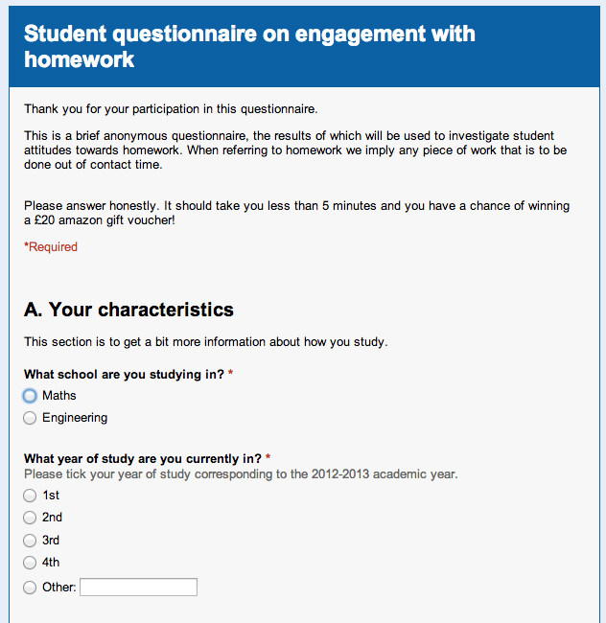

Figure 1: Screenshot of the questionnaire on Google Drive

The form was divided into 4 sections. Section A was designed to elicit details of the student and their characteristics with regard to homework (or work during non-contact hours), in particular the amount of time spent on these activities.

Section B questioned the students on their attitudes and perception of homework. The rationale behind this section was twofold. Firstly, to gain understanding of the students’ perceived benefits from completing non-contact time activities. Secondly, to try to discover the motivating factors required to engage the students in homework. All questions in this section were answered on a Likert scale ranging from strongly disagree (1) to strongly agree (5).

The questions in section C focused on highlighting the attitudes towards formative homework activities and once again were designed to discover the motivations required for engagement.

Finally section D contained 1 question inviting the student to select a single element from a list that would make formative homework activities most appealing.

## 3 Results and Analysis

### 3.1 Responses and distribution

The data file contained 205 responses to 28 questions asked to students from the schools of Engineering and Mathematics. The responses were equally distributed between the two schools with the distribution shown in figure 2 across the years of study. To allow for a certain level of comparison between the schools, it was decided to consider all Masters (MENg and MMath) responses as 4th year courses and also to not consider the MSc and Foundation respondents (not coherent across schools).

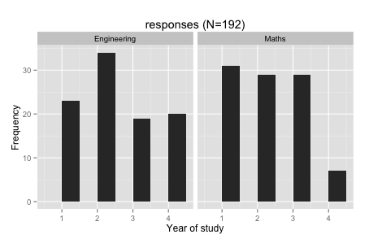

Figure 2: Distribution of responses between schools and years of study (MSc and Foundation not displayed)

The distribution across the years of study is a good representation of the real distribution of students in the School (e.g very few MMath students, and reasonable uniformity for years 1, 2 and 3) increasing the likelihood of the results offering a fair picture of the perception of all students in the two Schools. Results on perceived academic performance also mirror the distribution of degree classification which further increases confidence that this a representative sample

The data and analysis presented below is a subset which is relevant to the discussion and conclusions later in this report. The complete data set is available digitally and will be distributed with this report.

### 3.2 Correlation between variables

An initial correlation investigation was carried out in an attempt to identify any statistically significant relationships between responses to questions which could be represented as numeric variables (for example, the school is not considered), shown below.

## [1] "year"   
## [2] "average_self_study_hours"   
## [3] "self_described_academic_performance"   
## [4] "compulsory_hw_completion_percent"   
## [5] "non_compulsory_hw_completion_percent"   
## [6] "completing_hw_led_to_an_improvement_of_final_mark"   
## [7] "completing_hw_helps_understanding_material"   
## [8] "more_likely_to_do_hw_if_marked"   
## [9] "more_likely_to_do_hw_if_counts"   
## [10] "more_likely_to_do_hw_if_aware_of_time"   
## [11] "more_likely_to_do_hw_if_timetabled"   
## [12] "more_likely_to_do_hw_if_mcq"   
## [13] "more_likely_to_do_hw_if_was_going_to_recieve_feedback"   
## [14] "more_likely_to_do_hw_if_linked_to_employability"   
## [15] "more_likely_to_do_hw_if_past_exams"   
## [16] "non_marked_hw_is_helpful"   
## [17] "more_likely_to_do_non_cumpolsory_hw_if_peer_assessed"   
## [18] "more_likely_to_do_non_marked_hw_if_they_were_shorter"   
## [19] "more_likely_to_do_non_marked_hw_if_would_improve_overall_performance"  
## [20] "more_likely_to_do_non_marked_hw_if_to_be_done_before"   
## [21] "more_likely_to_do_non_marked_hw_if_online"   
## [22] "mostly_care_about_mark_received"   
## [23] "adequate_feedback"   
## [24] "hw_helps_identify_strengths_and_weaknesses"   
## [25] "more_likely_to_do_hw_if_group"

The result of this analysis is conveniently represented graphically with the correlogram shown in figure 3.

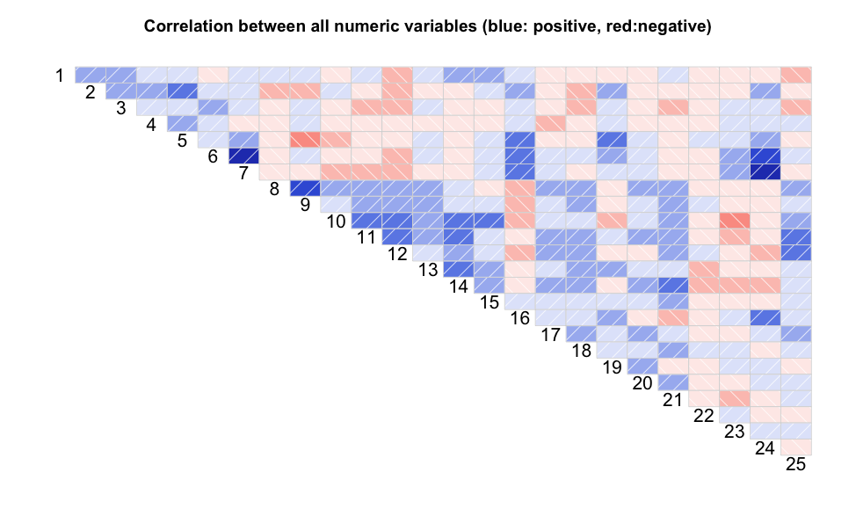

Figure 3: Correlogram of numeric responses to questionnaire

Blue shading represents a positive correlation and red shading, a negative correlation. So for example we see that variables 6 and 7 are positively correlated. Recalling the variables this is to be expected as it is shows that students who agree/disagree with the statement “homework leads to better understanding” also agree/disagree with the statement “homework helps with obtaining a better mark”.

In the the remainder of this section we will investigate whether or not correlations observed on the correlogram are statistically significant. The significance of correlations are tested using two well known coefficients. The Pearson Correlation Coefficient (r) has a value between -1 and +1 where 1 is a perfect positive correlation, -1 a perfect negative correlation and 0 no correlation. The p-value tests the null hypothesis, i.e. the probability that the correlation between variables was coincidental. A p-value of less than 0.05 (5%) indicates that correlations are statistically significant.

#### Correlation between variables 6 and 7:

A positive correlation coefficient of 0.561 with a p-value of 2.2 x 10-16 shows that students who feel that homework helps with marks will also feel that it helps with understanding and importantly vice versa. An immediate implication of this is the need to encourage students to understand the relationship between understanding and marks as well as homework and understanding.

Note that these two variables are also correlated to whether or not students feel that homework helps identify strengths and weaknesses. (Correlation between 6 and 24: p = 1.24 x 10-4, r= 0.52; Correlation between 7 and 24: p = 3.71 x 10-16, r= 0.54)

#### Correlation between variables 8 and 9:

A correlation coefficient of 0.4952 with a p-value of 2.9 x 10-13 again shows a significant positive correlation between whether or not students are more likely to do homework if it is to be marked and if it counts towards their final mark.

Various other observed correlations were considered but none were found to be statistically significant.

### 3.3 Correlations with student profile

In this section particular attention was given to the following statements:

1. Non marked homework is helpful to me;

2. I mostly care about the mark received;

3. I am more likely to do homework if it is linked to employability;

4. I am more likely to do homework if it is to be done before a lecture on the subject;

5. I am more likely to do homework if it is to be done in groups;

6. I am more likely to do homework if it contains past exam questions;

7. I am more likely to do homework if it is to be peer assessed;

8. I am more likely to do homework if it can be completed online.

Responses to the above were considered against various dimensions which profiled the student.

1. Year of study;

2. School of study;

3. How good I consider my academic performance to be;

4. I feel that the feedback I have received has been adequate;

5. How many average hours a week I spend self studying;

#### 3.3.1 Non Marked homework is helpful to me

This statement is quite an important one as positive responses indicate that students are aware that non marked homework has a positive effect on their work. The mean score for this statement was 3.3854 indicating a slight trend towards a positive result.

The distribution against school of study is shown below (the mean value is

shown in red):

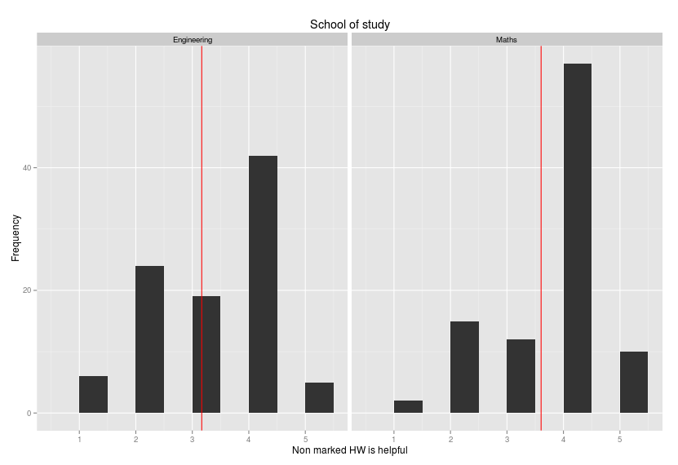

Figure 4: Non marked homework is helpful to me by school

We see that students from the School of Mathematics seem to find non marked homework slightly more helpful (an average of 3.6042 versus 3.1667). This difference is statistically significant (as the Kruskall-Wallis test gives a p value of 0.0026).

There is only one further factor that seems to affect this (in particular the year of study or academic performance seem to have no effect): the amount of time that students spend on self study (figure 5). It seems that the response increases with the amount of time spent self studying. This is confirmed to be statistically significant with a p-value of 0.014. The perceived adequacy of feedback does not have an influence on this parameter.

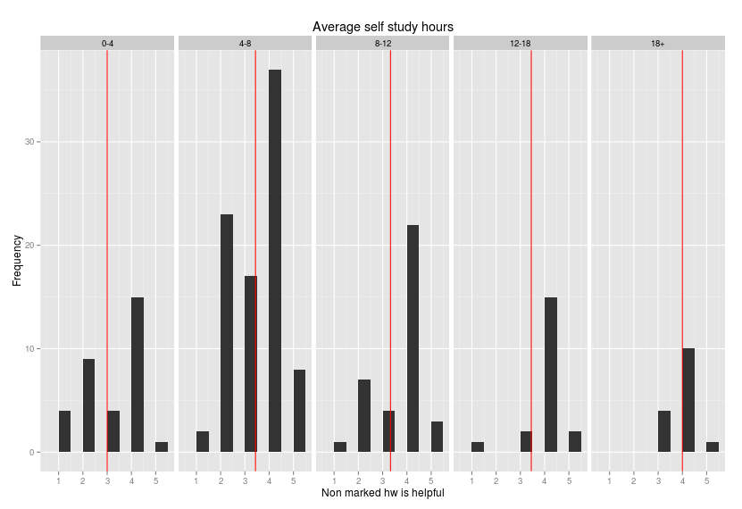

Figure 5: Non marked homework is helpful to me by number of hours of self study

A difference was identified between schools of study (with students from the school of Mathematics finding homework more helpful than students from the school of Engineering). Further analysis (Figure 6) shows that there is a significant difference between between Maths 2nd year students and the rest (p-value of .02). Students find homework less helpful in their second year. Interestingly this is also the year of the mathematics degree scheme during which students have less summative assessment.

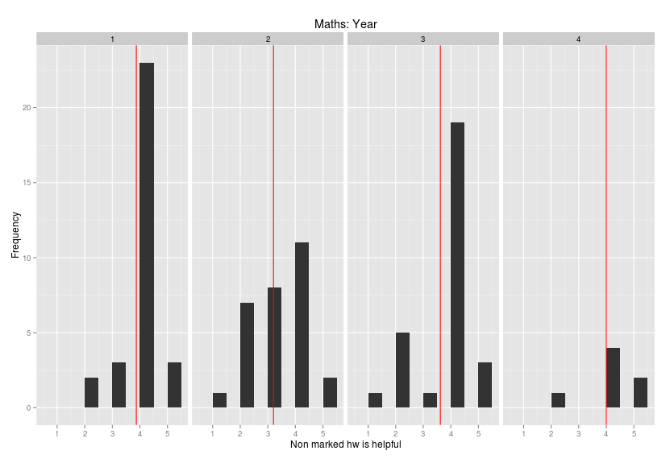

Figure 6: Non marked homework is helpful to me by year of study for Maths students

To summarise:

* Student opinion does not change across years (slight difference for Mathematicians);
* Student opinion does not change across perception of feedback;
* Student opinion does not change across academic performance;
* Students who spend more time self studying find homework more helpful.

#### 3.3.2 I mostly care about the mark received

This statement is motivated by the general perception that students care more about a mark than about feedback. A mean score for this question of 2.78 is inconclusive and the responses to this question to not seem to be significantly affected by any of the dimensions considered.

#### 3.3.3 I am more likely to do homework if it is linked to employability

The current landscape of student interests in education and a growing call for employability skills to be embedded throughout the curriculum led to the inclusion of this question which gave a mean score of 3.33.

The distribution of the responses separated by each school is shown in figure 7.

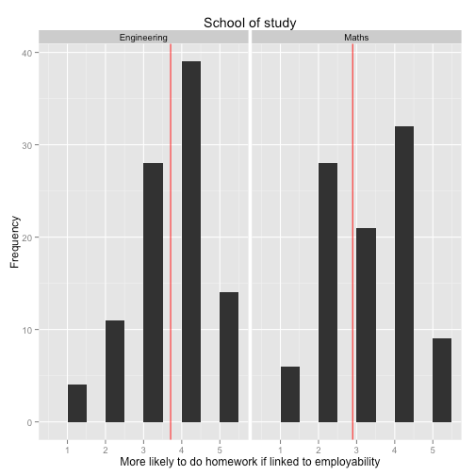

*Figure 7: I am more likely to do homework if it is linked to employability by school*

A statistically significant difference between the schools, p-value of 2.5 x 10-7, becomes apparent (a bi-modal response is seen for mathematics students with some claiming that employability is less likely to make them participate in homework).

No other factors seem to affect students responses to this statement.

#### 3.3.4 I am more likely to do homework if it is to be done before a lecture on the subject

This statement is in line with certain constructivist teaching methodologies which include flipped classrooms. The mean response for this question was 2.87 with the distributions by school shown in figure 8.

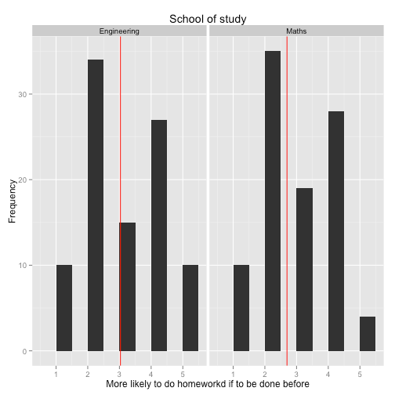

*Figure 8: I am more likely to do homework if it is to be done before a lecture on the subject by School*

We see that engineering students seem slightly more likely to do homework before lectures on a subject (with a p value of 0.0492 on the Kruskall-Wallis test) but further analysis failed to reveal anything of significance.

#### 3.3.5 I a more likely to do homework if it is to be done in groups

The emphasis on group work is investigated through this statement. The mean score of 3.39

indicates a tendency that students are more likely to do homework if it is to be done in groups. This trend is not uniform across the years of study.

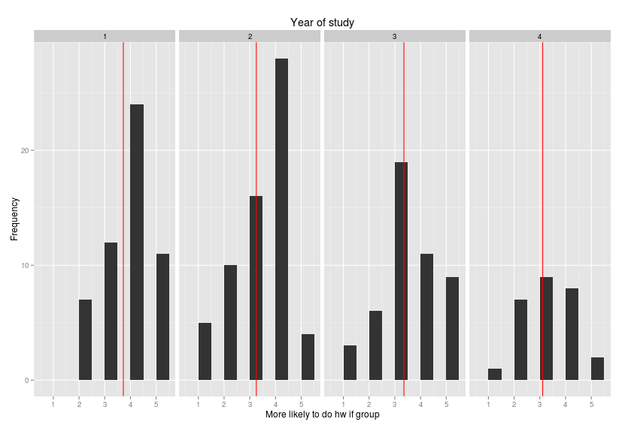

*Figure 9: I am more likely to do homework if it is to be done in groups by year of study*

There is a statistically significant difference between year groups (a p value of 0.0422) and a further multi criterion test shows that there is a difference between year groups 1 and 4 showing that as students progress through their education they become less favorable to group work. There seems to be no difference for this particular aspect with regards to school of study however, self described academic performance does have an effect (a p value of 2.1174 × 10-4) as shown in figure 10. A further multi criterion test shows stronger students are less likely to want to work in groups.

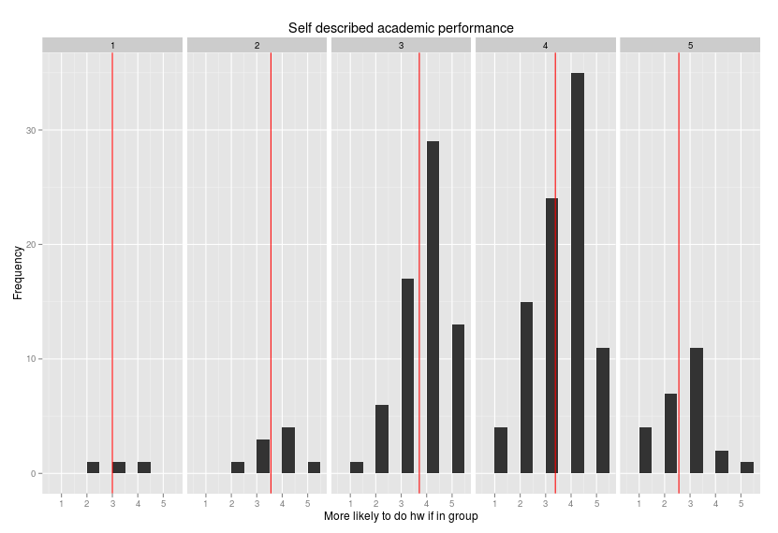

*Figure 10: I am more likely to do homework if it is to be done in groups by self described academic performance*

In summary:

1. Stronger students are less inclined to want to do group work;
2. Students in later years do not like group work.

#### 3.3.6 I a more likely to do homework if it contains past exam questions

It is often assumed that students ‘work to the test’. A mean score of 3.95 seems to indicate that this is indeed the case. There is a very slight (but significant: p value of 0.0066) tendency for later year students to attach more importance to the exam.

No other significant effects were noted.

#### 3.3.7 I am more likely to do homework if it is peer assessed

A mean score of 2.27 seems to indicate that students are less likely to see the benefits that are recognized in some educational literature. When considering schools it can be seen that engineering students are slightly more receptive to peer assessment as shown in figure 11 (p value of 0.0034)

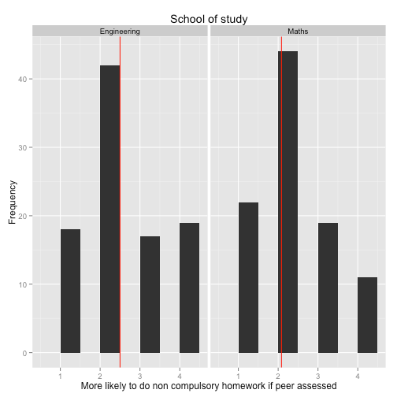

*Figure 11: I am more likely to do homework if it is peer assessed by school*

Furthermore it can also be concluded that students who spend more time self studying are less inclined to want to use peer assessment, figure 12 (p value of 0.0034)

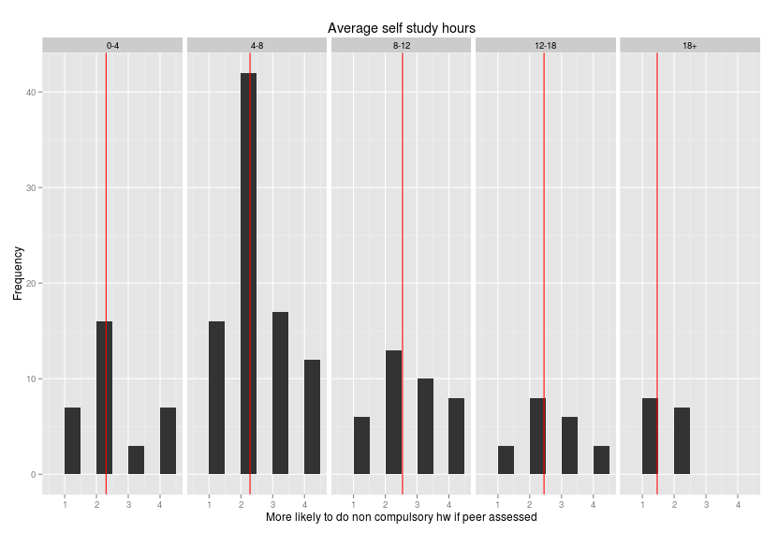

*Figure 12: I am more likely to do homework if it is peer assessed by average self study hours*

Interestingly, there is a statistically significant effect (p value of 0.0128) which shows that students who like group work are more likely to want to be peer assessed, figure 13.



*Figure 12: I am more likely to do homework if it is peer assessed by group study preference and school*

#### 3.3.8 I am more likely to do homework if it can be completed online

This last statement considered in this study aims to evaluate the attractiveness of the use of modern e-learning resources. With a mean score of 2.651 it would seem that students are not that encouraged by online resources. A significant difference is to be seen between the schools however (p value of 5.7961 × 10-6)

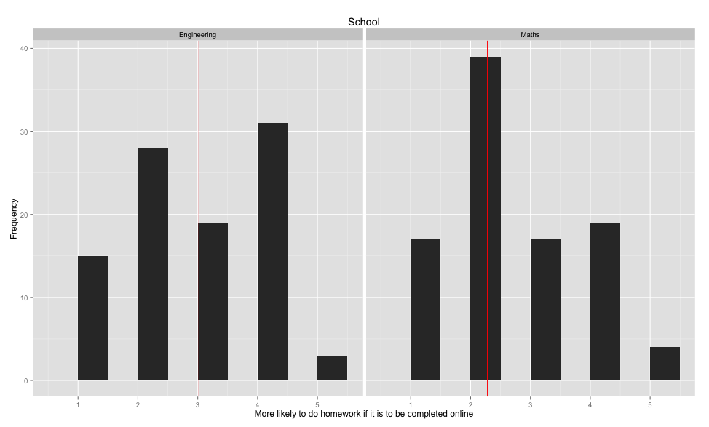

*Figure 13: I am more likely to do homework if it is to be completed online by group study preference and school*

### 3.4 Most influential factors in engaging with formative activities

Section D of the questionnaire asked students to select a single element that would make NON-MARKED and/or NON-COMPULSORY homework most appealing. The distribution of responses are shown in figure 14.

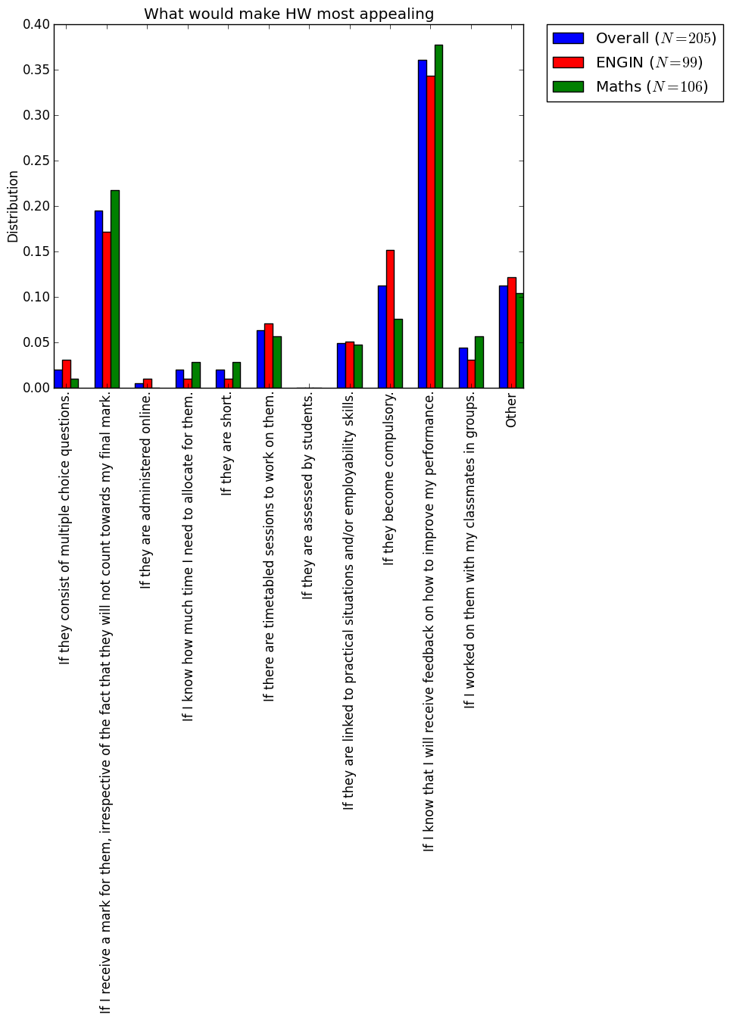

*Figure 14: Student responses to “what would make homework more appealing”*

## 4 Discussion

### 4.1 Interpreting Data

A more detailed data analysis of the data analysis reveals several interesting and original findings. However, it is important to first make clear the limitations of the study. The questionnaire was designed to elicit student perceptions of formative assessment in an effort to further understand the motivating factors to their engagement. The results do not necessarily imply that the methods which score strongly will be the most effective in improving the learning experience, but merely indicate student preferences. Moreover, we should also acknowledge the possibility that some students may have no familiarity with certain assessment methods. Secondly, despite the rigorous statistical methods employed in determining the significance of correlations care must still be taken in ascribing causal links.

### 4.2 Feedback and Formative Assessment

The role of feedback as a fundamental part of promoting student learning (QAA). In particular feedback is a key element in formative assessment (Sadler, 1989), since, as Yorke (2003) suggests, the basic principle of formative assessment is to `contribute to student learning through the provision of information about performance'. More specifically, feedback should provide students with an indication of their progress in relation to achieving the intended learning outcomes, where they need to put more effort to troubleshoot their performance to enable them to attain the expected level of learning (Nicol & Macfarlane-Dick, 2006; Irons, 2008).

The overwhelmingly positive effects that feedback has on learning compared to other aspects of teaching has been reported in the work of Black & Wiliam (1998). This is also reflected in our survey, where a large proportion of students is favourably inclined towards formative feedback. Nevertheless, while providing our students with plenty of quality feedback is highly desirable, it can become unrealistic when teaching large classes and the lecturer is solely responsible for this task. Hence one of the major challenges in feedback provision is managing the whole process so that the lecturer's workload is not dominated by creating feedback. Besides, a related important issue has to do with the timeliness of feedback: if feedback provision takes a long time, it can become ineffective, especially when students have moved to new material and feedback is no longer relevant to their ongoing studies, thus becoming unlikely to be acted upon (Gibbs & Simpson, 2004-05). More importantly, no matter how much effort is invested in providing feedback, it is not always the case that students benefit from feedback, especially if it is not constructive and explicit, if it is not understood by the students, if it does not provide students with an opportunity to enter into dialogue about their feedback, if it is not appropriate (e.g. providing positive feedback irrespective of the quality of the work), if it is provided merely to justify the mark the students are given and, lastly, if students do not use feedback to enhance their learning (see Irons, 2008, and the references therein). All these suggest that if providing students with feedback is indeed feasible in terms of workload, it is crucial to ensure that what will provide will actually enhance student learning and enter into a dialogue with our students about the kind of feedback they would like to receive. Besides, once feedback is provided, it should be the students’ responsibility to decide what to do with it.

The findings of this study seem to indicate that for the students in the schools of Engineering and Mathematics their engagement in formative homework activities is not influenced by feedback. This can be attributed to the way mathematical skills are assessed. Undeniably, conceptual and procedural knowledge are critical in mathematics learning (Baroody et al. 2007; Star 2007), but apparently greater emphasis is placed to assess procedural knowledge (Star 2005). Thus, feedback commonly comes in the form of identifying errors in calculations or faults in the approach undertaken and rarely identifies specific developmental needs for the student to address, losing some of its value once model solutions are provided.

A possibility could be to use the problem-solving structure of mathematics assignments to provide feedback through students’ group discussions on the solutions.

Also, the use of the students themselves to provide feedback on formative assessments is an attractive alternative and warrants further discussion inside our Schools and across Cardiff University. These ideas, however, could face resistance from students which will be covered further in the later section on social learning.

The value of feedback is significantly enhanced if it is timely. When teaching large groups providing feedback before the focus of the teaching has moved on to another section of the curriculum can be difficult. The notion of the flipped classroom whereby home study takes place before the contact time teaching creates a situation where feedback can be provided in a more timely fashion. The student response to this approach did not deliver a clear indication of its value with strong positive and negative responses however there was a statistically significant difference between schools with Engineers appearing more . This is perhaps influenced by their experience with homework being given on previously learnt mathematical techniques which will be useful in upcoming classes.

### 4.3 Marks vs feedback

The students that participated in our survey had mixed views when they were asked whether they were interested more on the marks they are given rather than the feedback they receive. We found that a large number of students was more interested in receiving marks, which resonates with previous research on the subject (see, e.g., Gibbs & Simpson, 2004-05; Irons, 2008, and the references therein). Gibbs & Simpson (2004-05) argue that ‘students can tackle assignments that are intended as learning activities so as to maximize the marks they obtain rather than maximising the learning achieved from engaging with the assignment’. When marks are absent, research has shown that students shift their focus to the feedback they receive in order to gauge their performance and read feedback much more carefully (Black & Wiliam, 1998) and this makes it more likely to use it to guide their learning. However, while it is tempting to only provide feedback in formative work, it is important to communicate to our students the pedagogic beneﬁts of feedback, because the absence of marks might make the formative activity less appealing to students who favour marks as a means of monitoring their progress and the degree of attainment of the learning outcomes.

This is also linked to the findings related to exam questions where a clear trend is evident showing that students become more motivated by tasks that are directly linked to their summative assessments as they progress through the years of study.

### 4.4 Social Learning

The responses regarding the perceptions of group working activities show clear divisions in the cohort surveyed. Giving students the option to work in self-selected groups is perhaps one of the easiest measures to implement in formative assessments and it has the added beneﬁt of reduced marking in case a group submission is allowed. More importantly, students with different learning preferences (solitary vs group work) can engage with the activity. However, it could be problematic if there are disparities in the quality and amount of contributions from each group member. At the same time, we need to acknowledge that students who would not have otherwise engaged with the activity will have the opportunity to learn through the interactions with their peers.

Peer- and self-assessment can be a solution to cope with marking and providing feedback to a growing number of students. Drawing from related research in the literature, Gielen (2007), identiﬁed a number of beneﬁts of peer assessment for students:

It can be used indirectly to increase social pressure on students to put more effort into the assignment.

Students receive feedback on time and it is sometimes perceived to be more understandable compared to the feedback they receive from the lecturer.

Peer assessment can be used as a tool for learning. Apart from learning by being exposed to different perspectives and ideas, students develop their abilities to understand and appreciate the usefulness of feedback.

However, there are also a number of important caveats associated with peer assessment: it can increase student stress levels due to the aforementioned peer pressure (Pope, 2001); it presupposes student engagement with the activity so that not only a handful of students out of a whole cohort participate; it will not function properly if students are not persuaded that this activity is also for their own beneﬁt and it is not merely passing work from the teacher to the students; if students do not take the process seriously, they will not make an effort to offer quality feedback or it is also possible that students are not competent enough to offer feedback (see MacDonald, 2004-05; Sluijsmans & Prins, 2006).

Peer assessment in mathematics and engineering is perhaps more straightforward to implement, since marking is based on more or less objective criteria compared to, say, more subjective judgements one must make when assessing an essay. It has been largely successful in a case study presented by Forbes & Spence (1991), where the authors made peer marking a course requirement for an engineering module without the marks contributing summatively. They found that students performed better than what was achieved previously, when the lecturers were doing the marking. These promising results indicate that even though peer assessment is a welcome development, at least when it comes to the workload of a lecturer, it requires a lot of preparatory work to address all the aforementioned pitfalls and takes considerable brieﬁng, training and rehearsal if they are to be effective (Brown, 2004-05).

One of the most interesting findings presented here is the perception of social learning activities. In particular for those who spend long periods in non-contact time study. If we assume that this group represents the most engaged and motivated students then their apparent dissatisfaction with activities such as group working and peer assessment requires further attention. The literature shows clear benefits of these types of activities. However, if the students with the greatest understanding of the subject area are excluding themselves from these opportunities then their value becomes limited. This raises the question of what incentives could be provided to encourage their participation. Principal amongst these will be demonstrating the benefits of such activity through clearly communicated learning outcomes which focus on transferable skills vital for graduates.

Students also perceive the usefulness of social activities to decrease as they progress through the year groups. If we also consider that a similar pattern is displayed with the interest in exam type questions then a picture of a student who becomes more focused on their own performance begins to build. Again it is interesting to compare this with the group discussed above who fit this profile in all years of study i.e. highly focused on individual performance and blinkered as to the wider benefits offered by social engagement.

### 4.5 Computer-based assessment

The participants in our study had mixed views about computer-assessed assignments. Even though there seemed to be no general trend regarding their preferences about multiple choice questions (MCQs), an important difference arose when students were asked about the appeal of online formative activities. Engineering students tended to prefer online formative assessments, whereas maths students tended to favour them less. This could perhaps be indicative of a different degree of integration of computer use in the Maths and Engineering curricula with Engineering having recently been trialling online assessments for first year maths courses. Online homework would also necessarily focus on the final answer instead of the single step in the reasoning. Therefore small mistakes in computations would end giving a very low score. Moreover proof-type questions would require a huge amount of time, if completed online. Whilst this could be envisaged as penalising both groups it is understandable that maths students would have stronger negative connotations towards this approach.

It is important to emphasise that even though MCQs and online assessment tools are relatively easy to administer and assess once a carefully created question bank is available, this type of formative activities can be used primarily as a diagnostic tool to test the understanding of key principles and is not appropriate for testing high-level cognitive learning.

MCQs could therefore be used alongside traditional problem sheets in order for students to self-assess the understanding of key concepts and identify problem areas before attempting the problem sheets.

Noteworthy is also a modiﬁed type of MCQ testing, which was introduced by Garner-Medwin (2006) as a means to encourage students to think more carefully about questions by differentiating conﬁdent responses from lucky guesses. Moreover, despite the technological advances which led to the development of more sophisticated online assessment tools for mathematics (see, for example Pitcher et al., 2002; Barr et al., 2012), research on the efficiency of online testing produced mixed results (see Jenkins, 2004-05; Sim et al., 2004, and the references therein), which suggests that the design of formative activities of this type is highly non-trivial and one needs to ensure that they are ﬁt for purpose.

### 4.6 Most influential factors in engaging with formative activities

The responses shown in figure 14 clearly identify two significant areas which the students surveyed felt would provide the greatest motivation to completing homework. FIrstly if they received a mark for the work which reinforces the conclusions from section 4.3 whereby students utilise marks to self assess their progress.

The largest response however was for “if I know that I will receive feedback on how to improve my performance”. This finding reflects those of the National Student Survey and the guidance from the University. However, the statistical analysis performed on the data from the previous sections of the questionnaire showed that the dimension “I feel that the feedback I have received has been adequate” did not correlate with any statistical significance to any of the responses considered, which indicates that the perception that feedback is important is not deeply held.

## 5 Concluding remarks

### 5.1 General Conclusions

Formative assessment is essentially assessment for learning. It is a developmental activity that helps students monitor their own progress, but also identiﬁes problem areas to be addressed both by the students through additional effort and study and by the lecturers by informing their teaching practice.

However, if students are to become independent, lifelong learners, they must learn to take full responsibility of their learning and develop the capacity to self-regulate their learning as they progress in their studies, thus becoming less reliant on teachers to evaluate their performance (Sadler, 1989). This gradual transition to self-reliance requires the necessary support so that through feedback and formative activities students develop the necessary self-monitoring skills to evaluate the quality of their own work. Hence, it is no surprise that a large number of the students who participated in the survey indicated that the provision of feedback could motivate them to engage in formative activities.

Students who participated in the questionnaire indicated that they are not particularly willing to embrace innovative approaches to assessment despite the abundance of studies which highlight their beneﬁts to learning if administered properly. This can be attributed at least in part to their reluctance to engage in types of assessment they are not familiar with or think they will take more time (Gibbs, 2006). Moreover, such alternative formative assessment methods could be of different format compared to the summative assessment (e.g. MCQs compared to a typical problem-based written examination), which is likely to make formative activities less appealing, since they may be perceived as being unhelpful in preparing them for the ﬁnal test.

Apparently, the diversity of student responses indicates that it might be idealistic to expect to develop a single assessment methodology that appeals to every student, so some diversity in formative activities is preferable in order to engage a larger number of students with different learning preferences. Gibbs & Simpson (2004-05) and Irons (2008) propose a framework that can be utilised in the development, design and implementation of formative activities and how these can be integrated in our teaching practice, which can be brieﬂy summarised as follows: the formative assessments take appropriate learning time and encourage students to study the things we wish them to learn; the tasks engage students in productive learning of an appropriate kind; the objectives, assessment criteria and how the activities contribute to learning are made explicit; feedback is provided often enough, on time and in enough detail and focuses on student performance and on actions under their control and not on the students themselves; feedback is acted upon by the students. Above all, we need to be realistic of the workload involved in the implementation and administration of such activities, the amount, quality and timeliness of feedback that can be realistically provided as well as the degree that such activities can provide opportunities for enhancing student learning.

### 

### 5.2 Engaging students in formative activities

The key findings of this study can be finally summarised in a series of recommendations to engage students in formative activities.

1. If we wish to utilise the students’ current perceptions of formative activities then the focus should be on social learning exercises in the early years with a shift toward individual activities in later years which are strongly linked to summative assessments.

2. If, as educators, we have strong feelings on the use of certain learning opportunities such as group working or peer assessment then we have to demonstrate their efficacy in order to challenge student perceptions.

3. The optimal solution will clearly vary by individual student and flexibility of approach in terms of the range of formative activities on offer.

4. Highly engaged students need further encouragement to engage in group activities if these are to be part of the core values of the degree scheme.

5. For contact-time intensive degree programmes such as Engineering formative activities could be considered as a timetabled activity in place of traditional contact time.

6. The belief that personalised feedback is the most significant factor in student satisfaction may not be as deeply held as is widely understood. Further study into the nature of feedback required is warranted before committing to practises of time consuming individual responses.

## References

Baroody, A. J., Feil, Y., and Johnson, A. 2007 An alternative reconceptualization of

procedural and conceptual knowledge. Journal for Research in Mathematics Education, 38,115–131.

Barr, N., Milne, S. & Neve, P. 2012 Contextualizing formative assessment in

mathematics and statistics. The Higher Education Academy, STEM .

Black, P. & Wiliam, D. 1998 Assessment and classroom learning. Assessment in Education, Principles, Policy and Practice 5 (1), 773.

Brown, S. 2004-05 Assessment for learning. Learning and Teaching in Higher Education 1 (1), 81–89.

Forbes, D. & Spence, J. 1991 An experiment in assessment for a large class. In Innovations in Engineering Education (ed. R. Smith), pp. 97–101. Ellis Norwood.

Garner-Medwin, A. R.. 2006 Conﬁdence-based marking: towards deeper learning and better exams. In Innovative assessment in Higher Education (ed. C. Bryan & K. Clegg). Routledge.

Gibbs, G. 2006 Why assessment is changing. In Innovative assessment in Higher Education (ed. C. Bryan & K. Clegg). Routledge.

Gibbs, G. & Simpson, C. 2004-05 Conditions under which assessment supports student learning. Learning and Teaching in Higher Education 1 (1), 3–31.

Gielen, S. 2007 Peer assessment as a tool for learning. PhD thesis, Katholieke Universiteit Leuven.

Irons, A. 2008 Enhancing learning through Formative Assessment and Feedback. Routledge.

Jenkins, M. 2004-05 Unfullﬁlled promise: formative assessment using computer-aided assessment. Learning and Teaching in Higher Education 1 (1), 102–107.

MacDonald, A. 2004-05 Student self-evaluation of coursework assignments: a route to better perception of quality. Learning and Teaching in Higher Education 1 (1), 102–107.

Nicol, D. J. & Macfarlane-Dick, D. 2006 Formative assessment and self-regulated learning: a model and seven principles of good feedback practice. Studies in Higher Education 31 (2), 199–218.

Pitcher, N., Goldﬁnch, J. & Beevers, C. 2002 Aspects of computer-based assessment in mathematics. Active Learning in Higher Education 3 (2), 159–176.

Pope, N. 2001 An examination of the use of peer rating for formative assessment in the context of the theory of consumption values. Assessment & Evaluation in Higher Education 26, 235–236.

Sadler, D. R. 1989 Formative assessment and the design of instructional systems. Instructional Science 18, 119–144.

Sim, G., Holiﬁeld, P. & Brown, M. 2004 Implementation of computer assisted assessment: lessons from the literature. Research in Learning Technology 12, 215–229.

Sluijsmans, D. & Prins, F. 2006 A conceptual framework for integrating peer assessment in teacher education. Studies in Educational Evaluation 32, 6–22.

Snyder, B. R. 1971 The hidden curriculum. Knopf.

Star, J. R. 2005 Reconceptualizing procedural knowledge. Journal for Research in Mathematics Education, 36, 404–411.

Star, J. R. 2007 Foregrounding procedural knowledge. Journal for Research in Mathematics Education, 38, 132–135.

Yorke 2003 Formative assessment in higher education: its signiﬁcance for employability and steps towards its enhancement. Tertiary Education and Management 11, 219–238.

Understanding assessment: its role in safeguarding academic standards and quality in higher education. QAA. September 2011.

Cardiff University Assessment Strategy.

## 

## Appendix 1: Student Questionnaireore

## A. Your characteristics

**This section is to get a bit more information about how you study.**

**What school are you studying in?\***

* **Maths**
* **Engineering**

**What year of study are you currently in? *Please tick your year of study corresponding to the 2012-2013 academic year.**

* **1st**
* **2nd**
* **3rd**
* **4th**
* **Other:**

**On average, how many hours do you spend self studying per week? \***

* **0-4**
* **4-8**
* **8-12**
* **12-16**
* **16+**

**Based on your marks to date, how would you describe your academic performance? \***

* **Well above average**
* **Above average**
* **Average**
* **Below average**
* **Well below average**

**On average, what percentage of COMPULSORY homework assignments have you completed? \***

* **0-20%**
* **20-40%**
* **40-60%**
* **60-80%**
* **80-100%**
* **Not applicable**

**On average, what percentage of NON-COMPULSORY homework assignments have you completed? \***

* **0-20%**
* **20-40%**
* **40-60%**
* **60-80%**
* **80-100%**
* **Not applicable**

B. Your attitude toward homework in general.

**This section is to identify your attitude toward homework in general. When referring to homework we imply any piece of work that is to be done out of contact time.   
  
Rate the following statements on a scale of 1 - 5 where 1 is "strongly disagree" and 5 is "strongly agree".**

**Completing homework assignments led to an improvement of my final mark. \***

* **1. Strongly disagree**
* **2. Disagree**
* **3. Undecided**
* **4. Agree**
* **5. Strongly agree**

**Doing homework assignments helps in understanding the lecture material. \***

* **1. Strongly disagree**
* **2. Disagree**
* **3. Undecided**
* **4. Agree**
* **5. Strongly agree**

**Homework assignments help me identify strengths and weaknesses in my knowledge and skills. \***

* **1. Strongly disagree**
* **2. Disagree**
* **3. Undecided**
* **4. Agree**
* **5. Strongly agree**

**I am more likely to do homework assignments if they are marked. \***

* **1. Strongly disagree**
* **2. Disagree**
* **3. Undecided**
* **4. Agree**
* **5. Strongly agree**

**I am more likely to do homework assignments if they count towards my final mark. \***

* **1. Strongly disagree**
* **2. Disagree**
* **3. Undecided**
* **4. Agree**
* **5. Strongly agree**

**I am more likely to work on homework assignments, if I can collaborate in groups with my classmates. \***

* **1. Strongly disagree**
* **2. Disagree**
* **3. Undecided**
* **4. Agree**
* **5. Strongly agree**

**I am more likely to do homework assignments if I am told in advance roughly how much time they will take. \***

* **1. Strongly disagree**
* **2. Disagree**
* **3. Undecided**
* **4. Agree**
* **5. Strongly agree**

**I am more likely to do homework assignments if I was given timetabled sessions in which to complete them. \***

* **1. Strongly disagree**
* **2. Disagree**
* **3. Undecided**
* **4. Agree**
* **5. Strongly agree**

**I am more likely to do homework assignments if they were multiple choice type questions. \***

* **1. Strongly disagree**
* **2. Disagree**
* **3. Undecided**
* **4. Agree**
* **5. Strongly agree**

**I am more likely to do homework assignments if I knew I was going to receive personalised feedback. \***

* **1. Strongly disagree**
* **2. Disagree**
* **3. Undecided**
* **4. Agree**
* **5. Strongly agree**

**I am more likely to do homework assignments if they were linked to practical situations and/or employability skills. \***

* **1. Strongly disagree**
* **2. Disagree**
* **3. Undecided**
* **4. Agree**
* **5. Strongly agree**

**I am more likely to do homework assignments if problems were taken from past examination papes. \***

* **1. Strongly disagree**
* **2. Disagree**
* **3. Undecided**
* **4. Agree**
* **5. Strongly agree**

## C. your attitude toward optional/non-compulsory homework

**This section is to identify your attitudes toward NON-COMPULSORY homework i.e. homework which does not count towards your final mark. Non-compulsory homework can be either MARKED or NON-MARKED. MARKED homeworks are those for which you receive a grade and/or feedback and NON-MARKED homeworks are those for which you receive no feedback.   
  
When referring to homework we imply any piece of work that is to be done out of contact time.  
  
Rate the following statements on a scale of 1 - 5 where 1 is "strongly disagree" and 5 is "strongly agree".**

**I feel that NON-MARKED homework is helpful to me. \***

* **1. Strongly disagree**
* **2. Disagree**
* **3. Undecided**
* **4. Agree**
* **5. Strongly agree**

**I am more likely to do NON-COMPULSORY homework assignments if they were assessed by my classmates. \***

* **1. Strongly disagree**
* **2. Disagree**
* **3. Undecided**
* **4. Agree**
* **5. Strongly agree**

**I am more likely to do NON-MARKED homework assignments if they were shorter. \***

* **1. Strongly disagree**
* **2. Disagree**
* **3. Undecided**
* **4. Agree**
* **5. Strongly agree**

**I am more likely to do NON-MARKED homework assignments if I knew that it would improve my overall performance. \***

* **1. Strongly disagree**
* **2. Disagree**
* **3. Undecided**
* **4. Agree**
* **5. Strongly agree**

**I am more likely to do NON-MARKED homework assignments if it was to be done before a lecture on the subject. \***

* **1. Strongly disagree**
* **2. Disagree**
* **3. Undecided**
* **4. Agree**
* **5. Strongly agree**

**I am more likely to do NON-MARKED homework assignments if it could be completed online. \***

* **1. Strongly disagree**
* **2. Disagree**
* **3. Undecided**
* **4. Agree**
* **5. Strongly agree**

**In marked homework assignments, I mostly care about the mark I receive and not about the feedback I am given. \***

* **1. Strongly disagree**
* **2. Disagree**
* **3. Undecided**
* **4. Agree**
* **5. Strongly agree**

**I feel that the feedback I receive in marked homework assignments is adequate. \***

* **1. Strongly disagree**
* **2. Disagree**
* **3. Undecided**
* **4. Agree**
* **5. Strongly agree**

## D. Your suggestions.

**This section contains 1 question inviting you to select a single element that would make NON-MARKED and/or NON-COMPULSORY homework most appealing. When referring to homework we imply any piece of work that is to be done out of contact time.**

**What would make homework most appealing for you? \***

* **If they consist of multiple choice questions.**
* **If I receive a mark for them, irrespective of the fact that they will not count towards my final mark.**
* **If they are administered online.**
* **If I know how much time I need to allocate for them.**
* **If they are short.**
* **If there are timetabled sessions to work on them.**
* **If they are assessed by students.**
* **If they are linked to practical situations and/or employability skills.**
* **If they become compulsory.**
* **If I know that I will receive feedback on how to improve my performance.**
* **If I worked on them with my classmates in groups.**
* **None of the above. Assignments should count towards the final mark to be worthy of doing.**
* **Other:**

## E. Enter to win!

**Feel free to enter an email address which we will use in a prize draw, for a chance to win a £20 Amazon voucher.**

**Email adress:We will not use your email address for anything else but this prize draw. You can of course choose to not enter anything here.**

## Appendix 2: Peer assessments.

Student self- and peer-assessment have become increasingly popular in higher education (Tan and Leng, 2005). Peer assessments are assessments of students by other students, both formative reviews to provide feedback and summative grading (Bostock, 2001).

Peer assessments are usually used in combination with self-assessments (i.e. each student assesses the work of all the other students and her/his own work as well) to avoid generously marking students being penalised in the overall marks they receive. The idea of using peer/self assessments to provide summative grading is highly controversial (see Tan and Leng, 2005 et al.).

Many studies (see Tan and Leng, 2005 et al.) show that peer/self assessments tend to underrate or overrate and rarely agree with tutor/teachers grates. In particular students who are poorer academically have a higher tendency to inflate their scores when compared to students who are stronger academically. Thus self/peer assessment needs to be used very carefully when providing summative grading. We do not further investigate this problem since, in this specific case, peer assessment is used to provide only feedback by formative grading and comments. Still our findings tend to confirm the danger of the use of peer assessment for summative assignments.

Moreover since we are mainly interested in providing formative feedback, we can avoid considering self-assessment.

The benefit of formative peer/self assessments are largely discussed in the literature (Brown, Rust and Gibbs 1994, Zariski 1996, Race 1998 and others). We are particularly interested in the peer assessments as a method to seek feedback by peers and to “own the assessment process” (Bostock, 2001). As a teacher, this is an opportunity to both develop our own marking criteria and reflect on how those same marking criteria assess our own work (e.g. will we feel that these criteria fairly “mark” our effort on the project?).

Moreover according to our questionnaire many students dislike peer assessments while our group could not find a consensus when asked to answer the same question (some of us strongly disagree with the idea of peer assessments, whilst others strongly agreed).

For most of us, as for most of our students, the response was a a-priori judgment since we did not experience peer assessments before. Therefore it is extremely useful to match our a-priori feeling with the reality of being peer assessed.

### Methodology chosen:

We decided to use a peer assessment divided into three parts:

-Part A (Peer assessment of product): we implement a classic peer assessment for our project presentation.

-Part B (Peer assessment of process): we run an each-other peer assessment to evaluate our group working skills.

-Part C (Combined final peer assessment marking): we briefly show how it is possible to combine the first two peer assessments in order to get individual marks which would take into account both the value of the project and our personal contribution to the process.

### PART A: Peer assessment of the product via peer assessment of the presentation.

There are two main reasons why we have chosen this specific peer assessment method.

* One of the main purposes of assessments is to improve learning through feedback. We worked on our project using Google Drive, by the use of continuous comments on each other’s work. Thus we have already got all possible feedback from each member of the group. Therefore each other peer assessing would not lead to any new constructive feedback.
* Our project is about how students perceive assessments. According to the response to our questionnaire (Question n.20) many students dislike peer assessments. According to some literature (reference), one of reasons of that is students tend to under-mark their peers whenever they misunderstand the real time and effort spent on a task. With this peer assessment-choice we try to put ourselves in a situation as similar as possible to the situation experienced by our students.

### Marking criteria and outcome:

We used a modification of the marking criteria developed by the School of Mathematics to assess projects. The main difficulty was to adapt those criteria to a situation when the assessors could assess only by coming to the presentation without reading the report. Therefore the final marking criteria and the weight of each of them look quite different from the original ones. The criteria assessments form will be added at the end of this appendix.

Cohort 21 participants coming to the presentation were given a copy of the marking criteria (see Group Project, Peer Assessment Marking Criteria 1) and they were asked to hand-in the assessment at the end of the presentation. In spite of our effort to involve as much peers as possible, at the end only 4 Cohort 21 participants assessed our presentation. The scores are shown in the following table (being the score from 1 to 6=maximum score).

|  |  |  |  |  |  |
| --- | --- | --- | --- | --- | --- |
|  | **Assessor 1** | **Assessor 2** | **Assessor 3** | **Assessor 4** | **Mean** |
| **ANALYSIS AND UNDERSTANDING**  (50%) | 5 | 6 | 5 | 6 | 5.5 |
| **ORIGINALITY**  (15%) | 4 | 5 | 4 | 4 | 4.25 |
| **PRESENTATION**  (35%) | 4 | 6 | 6 | 5 | 5.25 |
| **FINAL MARK** | 4.5 | 5.85 | 5.2 | 5.35 | 5.225 |

|  |  |  |  |  |  |
| --- | --- | --- | --- | --- | --- |
| **Comments:** | ----- | Very nice use of stats. very well presented. Good job! | Can you use median to demonstrate the difference of some non-normalised data. | Some of the graphics were not clear. Your research question may need + be addressed and focused. Vincent knew his data very well. |  |

### Discussion of the results:

If we examine the peer assessments, we can point out some reflections:

1-validity of peer assessments: marks from peers are diverse.

Even if we focus only on the presentation, there is no consensus between the assessors (in fact the scores vary from 4 to 6). This seems to confirm the tendency observed in many studies (Boud and Falchikov, 1989).

2-the comments provided very constructive and useful feedback.

3-a small number of participants decided to engage with peer assessing, i.e. a very poor engagement in the assessing task from our peers. This leads to question ourselves on the difficulties of implement peer assessments in HE: how can we motivate our students to take part in a procedure that we (=teachers in HE) are not willing to do?

### Limit of the chosen method: the specific case of peer assessment for group work:

The primary limit of this method is that the work can only be assessed through the presentation, hence the “assessors” will not have the knowledge of the entire piece work.

Another limit is that peer assessments of group work are often used to give individual marks. Academic staff often cannot confidently give the same mark to each member of the group (Loddington 2008). This peer assessment method fails in this point since it does not assess individual contribution to product produced.

### PART B: Peer assessment of group working skills.

In thesecond peer assessment each member of the group assessed the others (including self-assessment).

The assessment criteria used, were taken from “Peer assessment of group work: a review of the literature”(Loddington, 2008) and were applied without any modification (see Group Project, Peer Assessment Marking Criteria 2). The scores are summarized in the following table.

|  |  |  |  |  |
| --- | --- | --- | --- | --- |
|  | **Phil (P)** | **Federica (F)** | **Vince (V)** | **Nikos (N)** |
| **Time management** | |  |  | | --- | --- | | **P** | **4** | | **F** | **4** | | **V** | **4** | | **N** | **5** | | |  |  | | --- | --- | | **P** | **4** | | **F** | **4** | | **V** | **4** | | **N** | **5** | | |  |  | | --- | --- | | **P** | **4** | | **F** | **4** | | **V** | **4** | | **N** | **5** | | |  |  | | --- | --- | | **P** | **4** | | **F** | **4** | | **V** | **4** | | **N** | **5** | |
| **Problem solving** | |  |  | | --- | --- | | **P** | **4** | | **F** | **4** | | **V** | **5** | | **N** | **4** | | |  |  | | --- | --- | | **P** | **4** | | **F** | **4** | | **V** | **5** | | **N** | **4** | | |  |  | | --- | --- | | **P** | **4** | | **F** | **4** | | **V** | **5** | | **N** | **4** | | |  |  | | --- | --- | | **P** | **4** | | **F** | **4** | | **V** | **5** | | **N** | **4** | |
| **Communication** | |  |  | | --- | --- | | **P** | **5** | | **F** | **4** | | **V** | **4** | | **N** | **5** | | |  |  | | --- | --- | | **P** | **5** | | **F** | **4** | | **V** | **4** | | **N** | **5** | | |  |  | | --- | --- | | **P** | **5** | | **F** | **4** | | **V** | **4** | | **N** | **5** | | |  |  | | --- | --- | | **P** | **5** | | **F** | **4** | | **V** | **4** | | **N** | **5** | |
| **Reflection** | |  |  | | --- | --- | | **P** | **5** | | **F** | **4** | | **V** | **3** | | **N** | **4** | | |  |  | | --- | --- | | **P** | **5** | | **F** | **4** | | **V** | **3** | | **N** | **4** | | |  |  | | --- | --- | | **P** | **5** | | **F** | **4** | | **V** | **3** | | **N** | **4** | | |  |  | | --- | --- | | **P** | **5** | | **F** | **4** | | **V** | **3** | | **N** | **4** | |

The total score for each of us has been calculated by total average, e.g.

Phil’s score= sum all the score and divide by 16= 4.5

A quick look at the table shows that the peer assessment of the process failed in providing individual score since each member of the group achieved identical overall scores. This can be read as “each member of the group felt that all the other member of the groups equally contributed to the final report produced”. It is also worthwhile mentioning that the fact of equally marking each member of the group could be influenced by the professional and personal relationship between the members of a group and an anonymous peer marking could have provided a different outcome.

### PART C: Final grading: combined marks?

Usually any assessment should provide feedback and grading about all the learning outcomes. The learning outcomes of a group project can be usually divided in two groups:

I: learning outcomes related to the project itself (in our case the learning outcome of PCUTL module 3)

II: learning outcomes related to group work developing skills.

In Part A we peer assessed learning outcomes I, since we assessed the task produced via presentation.

In Part B we assessed learning outcomes II by peer assessment each others contributions to the process.

Constructive feedback for each student in a large cohort is a difficult and time consuming task.

Loddington (2008) presents different methodologies for determining individual marks (see also Lejk, Wyvill and Farrow 1996) for group work, see in particular the WebPA method: For each question/learning outcome the group as a whole receives a mark, and for each question the contribution of each member of the group is marked by the other group members, and this is used as weight for computing the individual mark for each group member. This method provides a very nice algorithm for mathematicians to play with but it appears over-complicated in particular in the case of formative assessments which are not summative. A similar but easier model to provide an individual mark from a group project can be obtained by combining the mark from peer assessment of the product with the mark from assessing individual contribution to the process (part B). The individual marks coming from part B, once suitably renormalized go to multiply the group mark from part C, providing a different mark for each member of the group. We do not apply this scheme in our case since the peer assess in part B failed in providing different marks for different members of the group. We would nevertheless like to suggest this combined method in situations where there is the intent to use peer assessing to provide summative grading.

**References for Appendix B**

Bostock, S. 2001 Student peer assessment, in The Higher Education Academy

Brown,S., Rust, C. & Gibbs, G. 1994: Involving Students in the Assessment Process, in Strategies for Diversifying Assessments in Higher Education, Oxford: Oxford Centre for Staff Development.

Boud, D. & Falchikov,N. 1989: Student Self-Assessment in Higher Education: A Meta-Analysis, in Review of Educational Research vol 50 no 4 pp. 395-430

Loddington, S. 2008. Peer assessment of group work: a review of the literature

Race, P. 1998: Practical Pointers in PEer Assessment, in Peer Assessment in Practice, Brown, S., (ed.) (SEDA paper 102) Birmingham SEDA, pp. 113-122.

Root, L. S. Faculty Evaluation: Reliability of Peer Assessments of Research, Teaching, and Service, in Research in Higher Education 26:1 (1987).

Tan, K., & Leng, H.K. 2005. Self and Peer Assessment as an Assessment Tool in Problem-Based Learning.

Lejk. M. & Wyvill, M. & Farrow, S. 1996. A survey of methods of deriving individual grades from group assessments, in Assessments & Evaluation in Higher Education Vol. 21, No 3.

Zariski,A. 1996 Student peer assessment in tertiary education: Promise,perils and practice, in Abbott, J. and Willcoxson, L. (Eds.), Teaching and Learning Within and Across Disciplines, p. 189-200. Proceedings of the 5th Annual Teaching and Learning Forum, Murdoch University, Perth.