CASE STUDY

OPINION

RESEARCH ARTICLE

RESOURCE REVIEW

SHORT UPDATE

WORKSHOP REPORT

Please choose one category above that best reflects the focus of your submission and leave only that line. Delete the rest of the above lines and also delete these five lines before submitting. Please use Arial font and formatting as specified below throughout. Contact us if you prefer to use alternative formatting for readability and/or accessibility reasons.

Paper title 16pt bold blue font, single line spacing with 12pt after

Firstname(s)1 Familyname1, department/centre, organization, city, country. Email: email address

Firstname(s)2 Familyname2, department/centre, organization, city, country. Email: email address

etc.(all 11pt font, stating author names as required)

Abstract

Include if appropriate such as in research articles or case studies etc. Leave the title “Abstract” as is using 14pt bold blue font, line spacing multiple 1.1 with 3pt after. The abstract should be written in a single paragraph of 100-200 words. Use 11pt, line spacing multiple 1.1. Do not put equations or references in the abstract. Keywords should follow the last line of the abstract. Leave the title “Keywords” as is in 12pt bold blue font.

**Keywords:** List up to 5 key words punctuated with commas and a full stop.

# Title of each section 14pt bold blue font, line spacing multiple 1.1 with 3pt after

Articles should be prepared using Word and submitted electronically as a “.docx” file to allow the editors to make minor corrections. These should be no more than 3,000 words in length and ideally include illustrations of some kind. Text should be in clear, concise, grammatical English, using English and not US spelling. Use Arial 11pt font with line spacing multiple 1.1 as used here. Use margins as in this document 2cm all round, gutter zero, A4 paper size. All text except any reference list or titles for figures or table should be left and right justified. Omit all page numbers. Use section numbering throughout as indicated. Do not format the section numbers in any way.

Paragraphs are followed by a 12pt space instead of a double carriage return with no indent. Where acronyms are used, a full explanation should appear the first time they appear in the text. Do not use footnotes use only endnotes.

All references should be listed at the end of the document and presented using the Harvard system of citation e.g. Cox and Bidgood (1993).

All figures and diagrams should be legible on a computer screen at standard zoom and when printed. All illustrations, photographs, figures, and diagrams should be included within the text (along with a legend) and submitted as separate files. Every image and diagram should have a caption or title above the figure. They should also be referenced clearly within the text (along with a legend). Figure 1 shows an example figure (use black and white if possible).

Figure 1. Figure title centred immediately below figure, 11pt font, line spacing multiple 1.1 with 24pt after using the ‘Caption’ style.

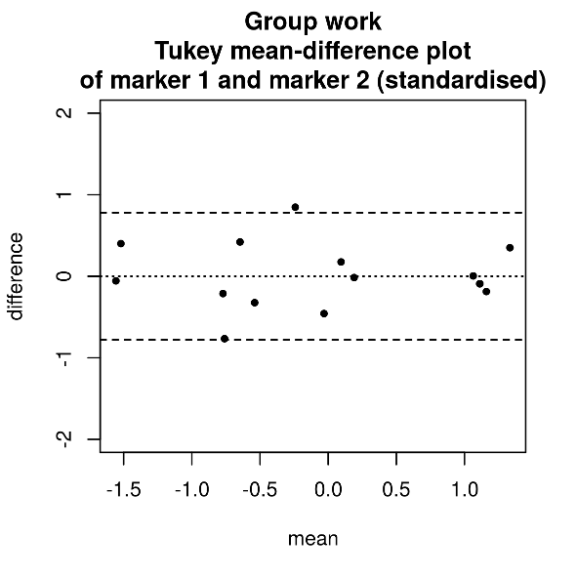

For tables, all data that needs to be presented in a fixed form must be within a table, and tables should be kept as simple as possible. Authors must not use spaces or tabs to achieve the desired layout. Table titles should be formatted the same as Figure titles with the caption situated above the table.

Equations should be written within your word document using either the standard Equation Editor or MathType, numbered where appropriate, centred as below, and properly punctuated:

$$\text{var}\left(Y\right)=σ_{T}^{2}+T^{2}\frac{1-F_{X}\left(T\right)}{{\left\{F_{X}\left(T\right)\right\}}^{2}}$$

Where equations are not on a separate line but in the paragraph text as for example, $μ=T/{F_{X}(T)}$, ensure equations’ font size is 11pt for main symbols, 8pt for subscripts, 6pt for sub-subscripts.

## Sub section titles should be non-bold italic and use 12pt blue font

Sub-subsections should be avoided, but if necessary use same title format as subsections. Bulleted and numbered lists should be formatted as main text with bullet and number symbol indented by 0.63cm as below:

* Text on first and subsequent lines ended by a semi–colon;
* Ensure that text in bullets is properly punctuated with a full stop on last bullet.

# Copyright

Authors are solely responsible for ensuring that the material submitted to the journal may be published in the journal. This includes obtaining permission for the inclusion of any material from third parties. You must ensure that you have permission to publish the material you submit, and that appropriate acknowledgements are given. Please note that contributions are accepted on the full understanding that the authors are solely responsible for the accuracy and contents of all published material. The Editors do not accept any liability for the accuracy of articles, breaches of copyright, or responsibility for mistakes, be they editorial or typographical, nor for any consequences that may arise from them.

# Appendix

If required, any appendices should precede the references but follow an acknowledgements section if applicable. Leave the title “Appendix” as is (or change to “Appendices” if appropriate) using 14pt bold blue font, line spacing multiple 1.1. Text in the appendix should be formatted using 11pt font, line spacing multiple 1.1 unless you wish to use an alternative format for style reasons.

# References

The reference list should be formatted as below and listed in alphabetical order of the first named author. Leave the title “References” as is using 14pt bold blue font, line spacing multiple 1.1. When citing references you should include: author(s), date, title, where published, publisher and edition. Include DOI or a URL if available. Titles should be presented in *italics*. Examples are listed below for an electronic source, a book, a journal article, and a chapter within a book.Text below formatted using 11pt font, line spacing multiple 1.1.

Cox, B. and Bidgood, P. (2003). Widening participation in mathematics, Statistics and Operational Research. Available via via <http://mathstore.ac.uk/publications/wp.pdf> (last accessed 15 June 2006)

Davison, R. and Croft, A. (1999). Mathematics for Engineers: A Modern Interactive Approach. London: Addison Wesley.

Croft, A.C. and Grove, M.J. (2006). Mathematics Support: Support for the specialist mathematician and the more able student. *MSOR Connections*, 6(2), pp. 39-43.

Hibberd, S. (2002). Mathematical modelling skills. In P. Kahn and J. Kyle, eds. *Effective learning and teaching in Mathematics & its applications*. London: Kogan Page, pp. 158-174.