# Computing for Mathematics: Class test

## Instructions

* You have 50 minutes to carry out the following 3 questions;
* You are allowed access to the internet and any books/notes you may have with you. **However, YOU ARE NOT PERMITTED TO COMMUNICATE WITH ANY OTHER STUDENT**. As such you are simply not allowed to log in to an email client, facebook etc... If you are caught using any site that an invigilator suspects you may be able to use to communicate with another student you will be asked to stop working on this class test and reported.
* Write three separate scripts for each question naming them as follows: `ma1003-studentnumber-q1.py' (replacing student number by your actual student number). Submission details are given at the end of this sheet.

## Q1

Consider the Fibonacci sequence defined by:

Define a function fib(n) that returns **using a recursive approach**.

Use this function to print to screen for .

## Q2

The data file [classtestdata.csv](./Data/classtestdata.csv) contains a collections of names. Write a script that:

* Imports the data;
* Prints to screen how many total names are in the data file;
* Prints to screen the mean length of names in the file;
* Prints to screen the number of unique names in the file.

## Q3

Consider the rectangle on a grid with dimensions as shown:

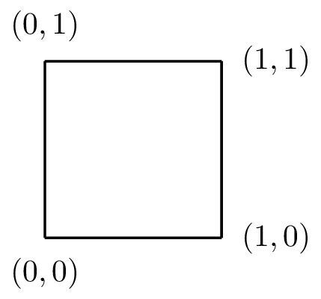

On this grid, consider the graph of .

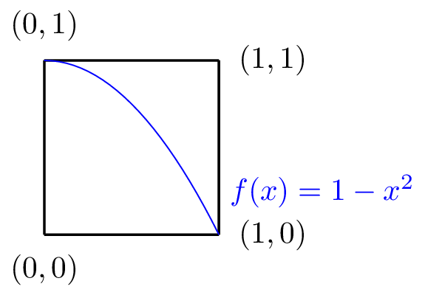

If we draw points of random coordinates in this rectangle, the probability of a point landing under the graph would be:

Importantly, from basic Calculus we know that:

Use the random library to approximate the value of .

## Submission instructions

Do both of the following (if in any doubt ask an invigilator):

* Save your 3 files to the directory xyz. You will not be able to see your file when it is saved there but be sure to save it there (perhaps do this twice).
* Email your file in an attachment to me: knightva@cf.ac.uk