Executive Summary
- Privacy Impact Assessment conducted for Application.
- Project processes customer and order data, performing ETL (Extract, Transform, Load) pipelines using Delta Live Tables.
- Data sources are CSVs ingested and transformed, with SCD Type 2 applied to maintain historical record lineage.

Project Overview and Purpose of Processing
- Ingest customer and order CSVs into Delta tables.
- Cleanse, transform, and join data to create enriched datasets for analytics and reporting.

Description of Personal Data Categories Processed
- Names (customer)
- EmailId (customer)
- Region (customer)
- Purchase details: OrderId, ItemName, PricePerUnit, Qty, Date, CustId (order)

Data Flow Architecture (collection, storage, processing, sharing)
- Data collected from CSV files at defined file system locations.
- Loaded into Delta tables for customer and order datasets.
- Data cleansing (removal of "Null" values and duplicates).
- Computed columns (TotalAmount) and joins to build summary and aggregate tables.
- No explicit external data sharing defined; stored and processed within the Delta Live Tables environment.

Data Flow Diagram — Mermaid Syntax
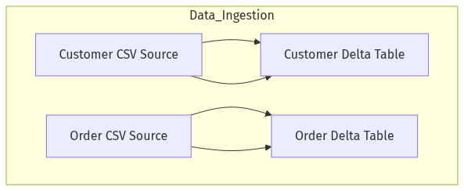

subgraph Data_Cleansing
B --> E["Cleaned Customer Table"]
D --> F["Cleaned Order Table"]
end
subgraph Transformation
F --> G["Order with TotalAmount"]
E --> H["Enriched Customer Table"]
end
subgraph Processing
G --> I["OrderSummary SCD Type 2 Joined Table"]
H --> I
end
subgraph Aggregation
I --> J["CustomerAggregateSpend"]
end
J --> K["Reporting/Analytics"]
style B fill:#f9f,stroke:#333,stroke-width:2px
style D fill:#f9f,stroke:#333,stroke-width:2px
style E fill:#bbf,stroke:#333,stroke-width:2px
style F fill:#bbf,stroke:#333,stroke-width:2px
style G fill:#bfb,stroke:#333,stroke-width:2px
style I fill:#ffd,stroke:#333,stroke-width:2px
style J fill:#dfd,stroke:#333,stroke-width:2px
style K fill:#eee,stroke:#333,stroke-width:2px

Lawful Basis for Processing
- Processing based on business needs for analytical reporting.
- Lawful basis likely: Legitimate Interest or Contract Fulfillment.

Data Minimization Approach
- Only necessary fields ingested, cleansed, and aggregated as per requirements.
- Attributes not present in CSVs or required for processing are excluded.

Consent Management Controls
- No consumer-facing consent workflow; presumed backend processing on business data.
- Consent and fair processing information to be further defined by business owner if personal data sources are expanded.

Third-Party / Vendor Data Sharing Implications
- No explicit third-party sharing specified.
- Data processed and retained within internal system boundaries defined for the ETL/Delta Live Tables pipeline.

Risk Identification
- Confidentiality risks: Unauthorized access to tables.
- Integrity risks: Data corruption during pipeline transformations.
- Re-identification risks: Via EmailId, Name, or region if datasets are combined externally.
- Access management risks: Insufficient table/data access controls.

Impact Assessment with Severity & Likelihood Scoring
- Confidentiality Risk: Moderate severity, moderate likelihood if access not hardened.
- Integrity Risk: Low to moderate severity, low likelihood with validated pipelines.
- Re-identification Risk: Low severity, low likelihood within prescribed use.
- Access Risk: Moderate severity, moderate likelihood if controls are not defined.

Mitigation Strategies & Security Controls (Encryption, DLP, IAM, Logging)
- Ensure storage encryption at rest and transit within Delta infrastructure.
- Implement role-based access on Delta tables.
- Establish data access logging and periodic review.
- Data Loss Prevention: Restrict export and external sharing.
- Audit logs for all ETL operations and data transformations.

Residual Risk Evaluation
- If above controls are implemented, residual risk reduced to low.
- Unmitigated risks remain where controls are not documented in current requirements.

Compliance Mapping (GDPR Articles, Local Regulations)
- Article 5 (Data Processing Principles: data minimization, purpose limitation)
- Article 6 (Lawful Basis)
- Article 25 (Data Protection by Design/Default)
- Article 32 (Security of Processing)
- Data subject rights provisions are not directly implemented.

Approval & Sign‑off Matrix
- Data Owner: Assign business stakeholder for sign-off.
- IT/Data Engineering Lead: Pipeline/process implementation sign-off.
- Compliance/DP Officer: Regulatory review and controls validation.
- Stakeholders: Not explicitly provided; identify during project delivery.

