- Conceptual Data Model
- Entities:
- Customer
- A party that has made at least one order and is tracked for order and spend analytics.
- Order
- A purchase transaction for one item by a customer.
- OrderSummary
- Historical record combining customer and order data; supports change tracking with SCD Type 2 logic.
- CustomerAggregateSpend
- Daily aggregated spend totals per customer.
- Relationships:
- Each Order is linked to one Customer (cust_id).
- Each OrderSummary is produced by joining Customer and Order (on cust_id), with SCD Type 2 logic.
- Each CustomerAggregateSpend is derived by grouping OrderSummary by name and date.
- Logical Data Model
- Customer
- cust_id [Primary Key]
- name
- email_id
- region
- Order
- order_id [Primary Key]
- item_name
- price_per_unit
- qty
- date
- cust_id [Foreign Key → Customer.cust_id]
- OrderSummary
- cust_id [Foreign Key → Customer.cust_id]
- name
- email_id
- region
- order_id
- item_name
- price_per_unit
- qty
- date
- start_date [for SCD Type 2 handling]
- end_date [for SCD Type 2 handling]
- active [for SCD Type 2 handling]
- CustomerAggregateSpend
- name
- total_amount
- date
- Cardinality:
- Customer (1) — (0..N) Order
- Customer (1) — (0..N) OrderSummary
- Order (1) — (1) OrderSummary
- OrderSummary (0..N) — (1) CustomerAggregateSpend
- Normalization:
- All tables are normalized for atomicity (1NF), full non-key dependency (2NF), and no transitive dependency (3NF), except for intentional denormalization in aggregation.
- Business Rules:
- TotalAmount = price_per_unit × qty
- Remove "Null"/Null literals from base tables
- Remove duplicate records from base tables
- SCD Type 2 tracking in OrderSummary
- Physical Data Model
- Table: customer
- cust_id: STRING, PRIMARY KEY, NOT NULL
- name: STRING, NOT NULL
- email_id: STRING, NULLABLE
- region: STRING, NULLABLE
- Table: order
- order_id: STRING, PRIMARY KEY, NOT NULL
- item_name: STRING, NOT NULL
- price_per_unit: DECIMAL(18,2), NOT NULL
- qty: INTEGER, NOT NULL
- date: DATE, NOT NULL
- cust_id: STRING, FOREIGN KEY, NOT NULL
- total_amount: DECIMAL(18,2), NOT NULL (computed)
- Table: ordersummary
- cust_id: STRING, FOREIGN KEY, NOT NULL
- name: STRING, NOT NULL
- email_id: STRING, NULLABLE
- region: STRING, NULLABLE
- order_id: STRING, NOT NULL
- item_name: STRING, NOT NULL
- price_per_unit: DECIMAL(18,2), NOT NULL
- qty: INTEGER, NOT NULL
- date: DATE, NOT NULL
- start_date: DATE, NULLABLE
- end_date: DATE, NULLABLE
- active: BOOLEAN, NOT NULL
- Table: customeraggregatespend
- name: STRING, NOT NULL
- total_amount: DECIMAL(18,2), NOT NULL
- date: DATE, NOT NULL
- Indexing & Constraints:
- All PKs indexed
- FK: order.cust_id → customer.cust_id
- FK: ordersummary.cust_id → customer.cust_id
- Composite index/partition by date for large tables
Naming Conventions
- snake_case for tables and columns
- PKs: suffixed with _id
- Foreign keys: prefixed with +
- Computed/derived: explicitly named (total_amount)
- SCD tracking: start_date, end_date, active
Data Dictionary
Entity | Attribute | Definition | Type | Notes
customer | cust_id | Unique customer identifier | STRING | PK
customer | name | Customer name | STRING
customer | email_id | Customer email | STRING | Nullable
customer | region | Sales region | STRING | Nullable
order | order_id | Order identifier | STRING | PK
order | item_name | Name of item ordered | STRING
order | price_per_unit | Unit price | DECIMAL(18,2)
order | qty | Quantity ordered | INTEGER
order | date | Order date | DATE
order | cust_id | Customer reference | STRING | FK to customer
order | total_amount | price_per_unit × qty | DECIMAL(18,2) | Computed
ordersummary | cust_id | Customer reference | STRING | FK to customer
ordersummary | name | Customer name | STRING
ordersummary | email_id | Email address | STRING | Nullable
ordersummary | region | Sales region | STRING | Nullable
ordersummary | order_id | Order identifier | STRING
ordersummary | item_name | Name of item | STRING
ordersummary | price_per_unit | Unit price | DECIMAL(18,2)
ordersummary | qty | Quantity | INTEGER
ordersummary | date | Date | DATE
ordersummary | start_date | SCD2: Start date of record | DATE
ordersummary | end_date | SCD2: End date of record | DATE
ordersummary | active | SCD2: Indicates active record | BOOLEAN
customeraggregatespend | name | Customer name | STRING | Grouped
customeraggregatespend | total_amount | Aggregated spend | DECIMAL(18,2) | SUM of TotalAmount
customeraggregatespend | date | Spend date | DATE | Grouped
Text-Based ERD
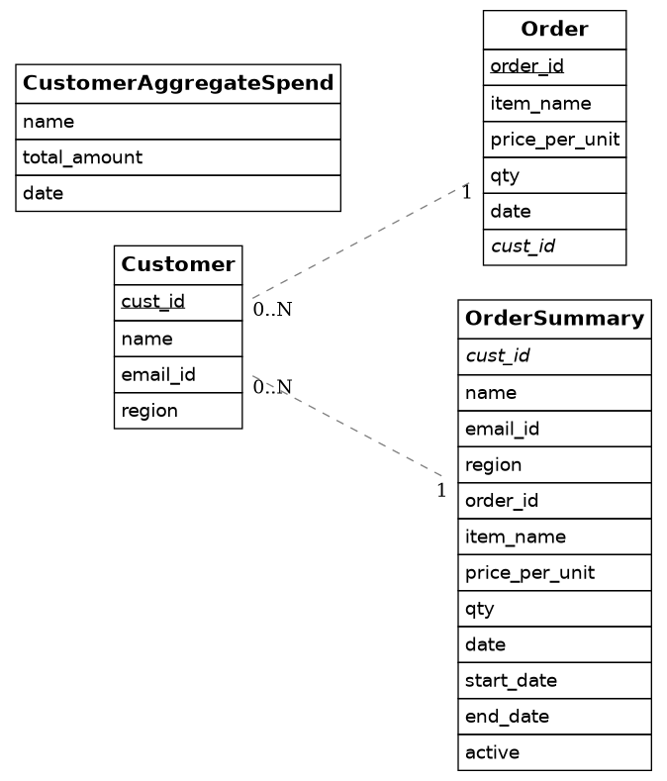

Order 1--1 OrderSummary
OrderSummary *--1 CustomerAggregateSpend

