Concise Functional Requirements Document (FRD) for the "Application"

Introduction:
The Application is designed to integrate and aggregate customer and order data from source CSV files, performing data cleansing, transformation, and loading it into Delta tables for reporting purposes.

Functional Requirements:

- Read CSV data from specified volumes: `/Volumes/gen_ai_poc_databrickscoe/sdlc_wizard/customerdata` and `/Volumes/gen_ai_poc_databrickscoe/sdlc_wizard/orderdata`
- Load data into Delta tables for customer and order data
- Remove "Null"/null and duplicate records from both customer and order tables
- Create an "ordersummary" table with schema: `CustId`, `Name`, `EmailId`, `Region`, `OrderId`, `ItemName`, `PricePerUnit`, `Qty`, `Date`
- Join customer and order data using the "CustId" field and load the data into an SCD Type 2 table ("ordersummary")
- Update the SCD Type 2 table ("ordersummary") whenever there is a change in the customer table
- Old records should be made inactive and new records should be made active, with corresponding changes to `StartDate` and `EndDate`
- Create a new table "customeraggregatespend" with columns "Name", "TotalAmount", and "Date"
- Aggregate the "TotalAmount" column from the "ordersummary" table and group by "Name" and "Date" columns
- Load the aggregated data into the "customeraggregatespend" table
- **Data Ingestion Module**
- **Data Cleansing Module**
- **Data Transformation Module**
- **SCD Type 2 Implementation Module**
- **Aggregated Reporting Module**

System Flow Diagram
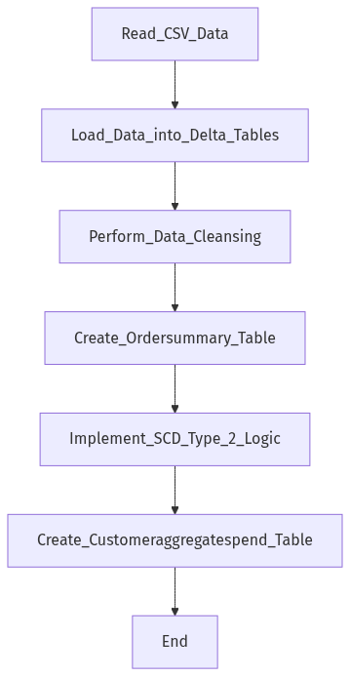

Process Flow / Flowchart
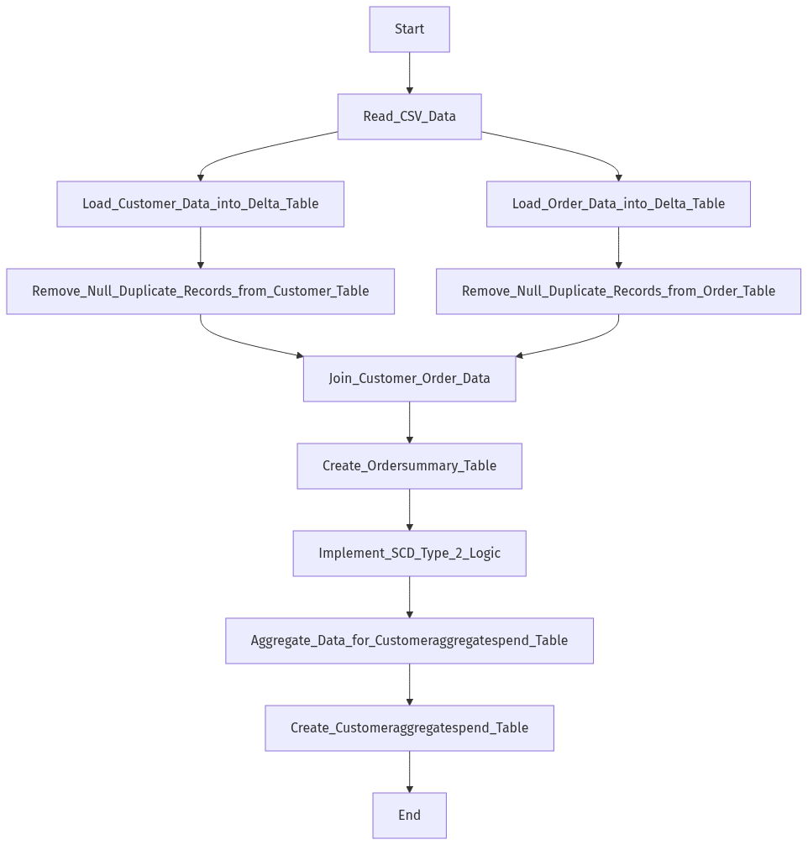

Data Flow Diagram (DFD)
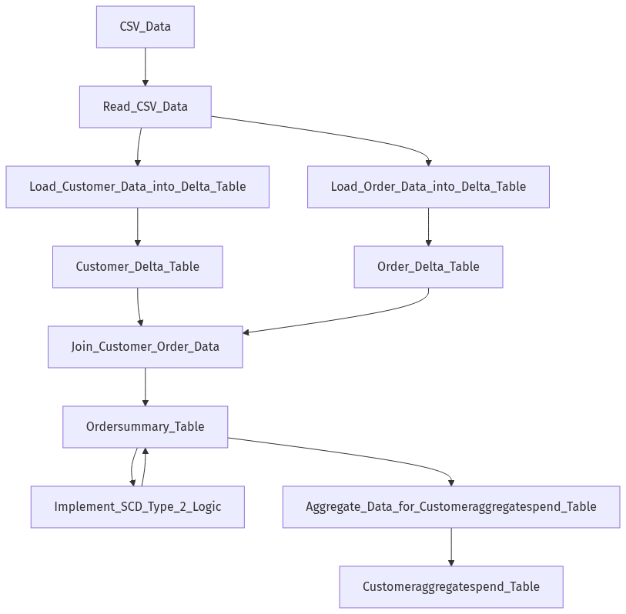

Sequence Diagram
[Diagram failed: Kroki render failed (HTTP 400): Error 400: SyntaxError: Parse error on line 2:
...aph TD;participant Application as &quot;Appl
----------------------^
Expecting &#x27;SEMI&#x27;, &#x27;NEWLINE&#x27;, &#x27;EOF&#x27;, &#x27;AMP&#x27;, &#x27;START_LINK&#x27;, &#x27;LINK&#x27;, &#x27;LINK_ID&#x27;, got &#x27;NODE_STRING&#x27;
Error: Syntax error in graph
at Worker.convert (file:///usr/local/kroki/src/worker.js:44:15)
at async file:///usr/local/kroki/src/index.js:31:28]

High-Level Architecture Diagram
