Concise Functional Requirements Document (FRD)

Introduction:
The purpose of this FRD is to outline the functional requirements for the "Application", a data integration and reporting solution that consolidates customer order data from CSV files into a structured database.

Functional Requirements:

- Read CSV data from specified locations and load it into Delta tables "customer" and "order".
- Handle exceptions for file not found or invalid file format.
- Remove "Null"/null and duplicate records from "customer" and "order" tables.
- Validate data types and schema of ingested data.
- Create "ordersummary" table if it does not exist and load joined data into an SCD Type 2 table.
- Update SCD Type 2 "ordersummary" table whenever there is a change in the "customer" table.
- Create "customeraggregatespend" table if it does not exist and load aggregated data into it.
- Aggregate "TotalAmount" column from "ordersummary" table and group it by "Name" and "Date" columns.
- **Data Ingestion Module**
- **Data Transformation Module**
- **Data Integration Module**
- **Data Aggregation Module**

Detailed Functional Requirements:

- The system should be able to read CSV data from `/Volumes/gen_ai_poc_databrickscoe/sdlc_wizard/customerdata` and `/Volumes/gen_ai_poc_databrickscoe/sdlc_wizard/orderdata`.
- The system should be able to create Delta tables "customer" and "order" with the correct schema.
- The system should be able to join "customer" and "order" data using the "CustId" field.
- The system should be able to update the SCD Type 2 "ordersummary" table by making old records inactive and new records active, and updating `StartDate` and `EndDate` accordingly.

System Flow Diagram
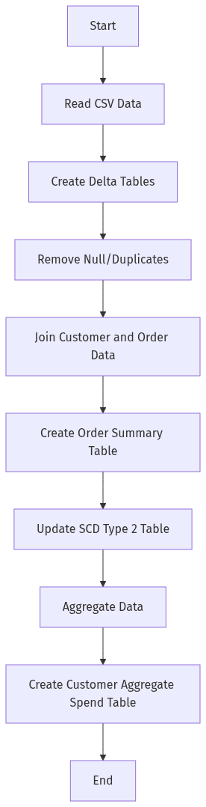

Process Flow / Flowchart
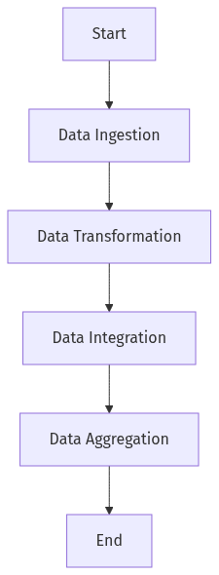

Data Flow Diagram (DFD)
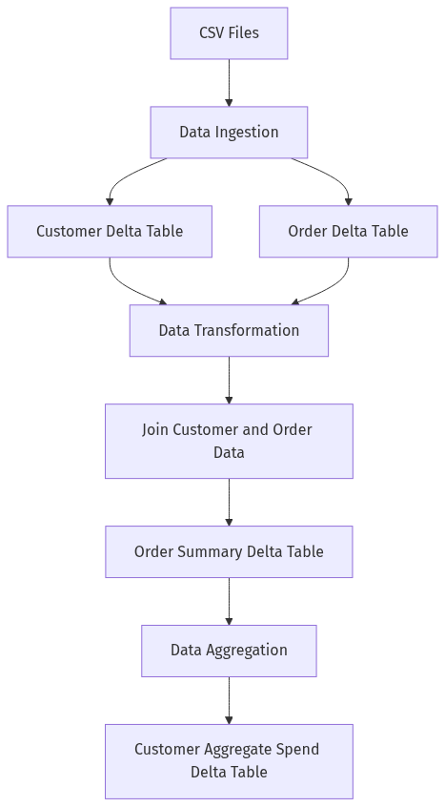

Sequence Diagram
[Diagram failed: Kroki render failed (HTTP 400): Error 400: SyntaxError: Parse error on line 2:
...aph TD;participant Application as &quot;Appl
----------------------^
Expecting &#x27;SEMI&#x27;, &#x27;NEWLINE&#x27;, &#x27;EOF&#x27;, &#x27;AMP&#x27;, &#x27;START_LINK&#x27;, &#x27;LINK&#x27;, &#x27;LINK_ID&#x27;, got &#x27;NODE_STRING&#x27;
Error: Syntax error in graph
at Worker.convert (file:///usr/local/kroki/src/worker.js:44:15)
at async file:///usr/local/kroki/src/index.js:31:28]

High-Level Architecture Diagram
