Concise Functional Requirements Document (FRD) for the "Application"
====================================================================

Overview

The "Application" is a data processing pipeline designed to load customer and order data from CSV files into Delta tables, perform data cleansing, and create aggregated summaries.

Functional Requirements

- Read CSV data from specified locations and load it into Delta tables "customer" and "order".
- CSV file paths: `/Volumes/gen_ai_poc_databrickscoe/sdlc_wizard/customerdata` and `/Volumes/gen_ai_poc_databrickscoe/sdlc_wizard/orderdata`.
- Remove "Null"/null and duplicate records from "customer" and "order" tables.
- Create "ordersummary" table if it does not exist in catalog "gen_ai_poc_databrickscoe" and schema "sdlc_wizard".
- Join "customer" and "order" data using "CustId" field and load into SCD type 2 table "ordersummary".
- Update SCD type 2 "ordersummary" table when there are changes in "customer" table.
- Make old records inactive and new records active.
- Update `StartDate` and `EndDate` accordingly.
- Create "customeraggregatespend" table if it does not exist in catalog "gen_ai_poc_databrickscoe" and schema "sdlc_wizard".
- Aggregate "TotalAmount" from "ordersummary" table and group by "Name" and "Date" columns.
- Load aggregated data into "customeraggregatespend" table.
- **Data Ingestion**
- **Data Cleansing**
- **Data Transformation and Loading**
- **SCD Type 2 Implementation**
- **Aggregated Summary**

Diagrams

#### System Flow Diagram
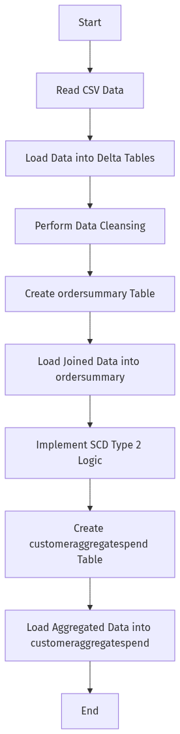

#### Process Flow / Flowchart
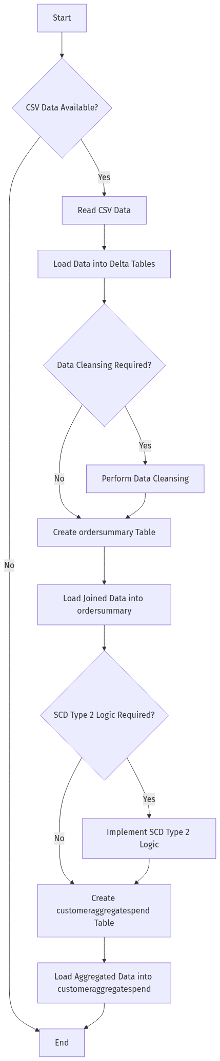

#### Data Flow Diagram (DFD)
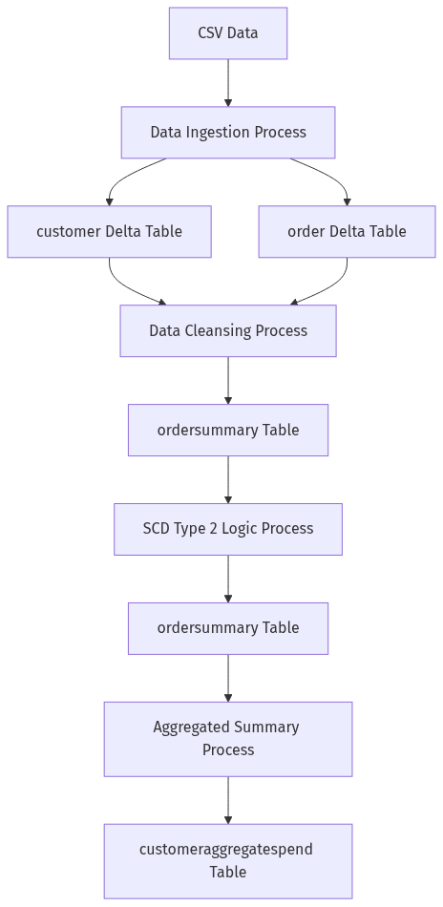

#### Sequence Diagram
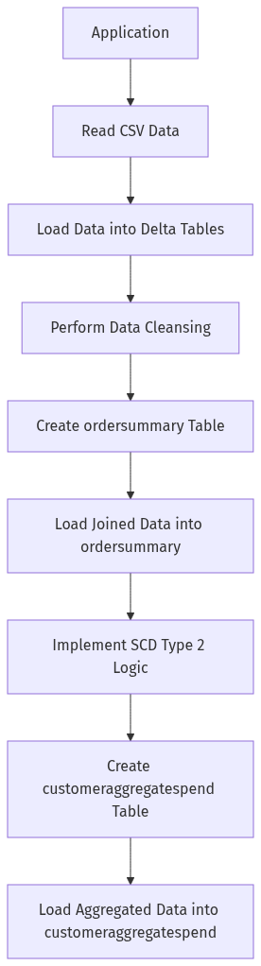

#### High-Level Architecture Diagram
