Document Control
- System Name: Application

Executive Summary
- This Business Requirements Document (BRD) defines all requirements for the Application system, focusing on ingesting customer and order CSV data into Delta tables.
- The document outlines processes for cleansing, transforming, and aggregating data, including SCD Type 2 handling and pipeline orchestration using Delta Live Tables.

Business Objectives
- Load source customer and order CSV files into Delta tables.
- Cleanse data by removing "Null" values and duplicates.
- Compute TotalAmount for orders by multiplying PricePerUnit and Qty.
- Join customer and order data to form an ordersummary table with SCD Type 2 history for customers.
- Aggregate customer spend per day in the customeraggregatespend table.
- Implement the pipeline via Delta Live Tables.

In-Scope
- Ingestion of customer and order CSVs from specified file paths.
- Creation and management of Delta tables: customer, order, ordersummary, customeraggregatespend.
- Data cleansing operations.
- Calculation logic for TotalAmount.
- Join processing and SCD Type 2 implementation for customer data.
- Aggregation of customer spend by Name and Date.
- All orchestration via Delta Live Tables.

Out-of-Scope
- Integration with any data sources, systems, or data fields not listed in the source content.
- Security, user access, SLAs, performance tuning, monitoring, and alerts.
- Scheduling, orchestration, or DevOps details beyond implementation in Delta Live Tables.
- Data quality metrics beyond specified cleansing steps.
- User interface, reporting, and analytics consumption layers.

Stakeholders
- Information not present in source content.

Business Requirements

BR-APP-001 — Source Ingestion
- Description: Load source CSVs into Delta tables for customer and order data from specified paths.
- Business Value: Enables structured ingestion and consistency of data for downstream processes.
- Priority: High

BR-APP-002 — Data Schema Enforcement
- Description: Enforce defined schemas for customer and order tables.
- Business Value: Ensures data integrity and enables trusted analytics.
- Priority: High

BR-APP-003 — Computed Attribute Creation
- Description: Compute TotalAmount in order table as PricePerUnit × Qty.
- Business Value: Provides necessary metric for aggregation and reporting.
- Priority: High

BR-APP-004 — Data Cleansing
- Description: Remove records with "Null" values and duplicates in customer and order tables.
- Business Value: Improves data quality and reliability.
- Priority: High

BR-APP-005 — ordersummary Table Creation
- Description: Join customer and order tables on CustId and implement SCD Type 2 for customer changes.
- Business Value: Maintains historical accuracy for analytic reporting.
- Priority: High

BR-APP-006 — SCD Type 2 Maintenance
- Description: Ensure previous customer versions are marked Inactive and new versions Active; manage StartDate and EndDate.
- Business Value: Supports historical data tracking and auditability.
- Priority: High

BR-APP-007 — Aggregate Table Creation
- Description: Create customeraggregatespend table aggregating spend per customer per date.
- Business Value: Delivers actionable spend analytics for business stakeholders.
- Priority: High

BR-APP-008 — End-to-End Pipeline Automation
- Description: Implement the above business requirements using Delta Live Tables.
- Business Value: Enables automated, reliable, and maintainable data processing.
- Priority: High

Assumptions & Constraints
- No additional assumptions are made beyond content provided.
- Only Delta Live Tables to be used for implementation.
- Specific definitions for SCD tracking fields (StartDate, EndDate, Active) are not provided.

Success Metrics
- All target Delta tables are created and populated correctly per requirements.
- Cleansing removes 100% of duplicate and "Null" records.
- ordersummary contains accurate SCD Type 2 customer history.
- customeraggregatespend produces daily spend totals for all customers without data loss.

Risks & Mitigations
- Potential ambiguity due to unspecified data types or SCD attribute fields; mitigate by clarifying with stakeholders before implementation.
- Data quality beyond defined cleansing rules is not addressed; propose proactive data profiling.
- Lack of details for error handling or monitoring; recommend reviewing in Technical design.

Approval
- Approval section to be completed based on stakeholder input.

Appendix
Appendix A: Source Definitions
Source Name | Type | Location | Format | Notes
Customer source | CSV | /Volumes/gen_ai_poc_databrickscoe/sdlc_wizard/customerdata | CSV | Loaded to customer table
Order source | CSV | /Volumes/gen_ai_poc_databrickscoe/sdlc_wizard/orderdata | CSV | Loaded to order table
Appendix B: Target Definitions
Target Name | Layer | Table | Columns | Notes
customer | Bronze | customer | CustId, Name, EmailId, Region | Loaded from source
order | Bronze | order | OrderId, ItemName, PricePerUnit, Qty, Date, CustId | Loaded from source
ordersummary | Silver | ordersummary | CustId, Name, EmailId, Region, OrderId, ItemName, PricePerUnit, Qty, Date | SCD Type 2 join
customeraggregatespend | Gold | customeraggregatespend | Name, TotalAmount, Date | Aggregated spend
Appendix C: Transformations
Step | Transformation | Input | Output | Logic
1 | Remove Nulls and duplicates | customer, order | cleansed tables | Drop records with "Null" or duplicate values
2 | Calculate TotalAmount | order | order | TotalAmount = PricePerUnit × Qty
3 | Join with SCD Type 2 | customer, order | ordersummary | Join on CustId, preserve history
4 | Aggregate spend | ordersummary | customeraggregatespend | Group by Name, Date; sum TotalAmount
Appendix D: Business Rules
Rule ID | Area | Description | Source
BR-1 | Aggregation | For each customer per Date, sum TotalAmount | Ordersummary
BR-2 | SCD Type 2 | Maintain history with StartDate, EndDate, Active fields | Customer changes
BR-3 | Cleansing | Remove "Null"/Null values and duplicates | Ingestion
Appendix E: Process Flow
Step | Description | Dependency
1 | Load customer and order CSVs to Delta tables | Source files
2 | Cleanse customer and order data | Load step
3 | Calculate TotalAmount in orders | Cleanse step
4 | Join and create ordersummary with SCD Type 2 logic | Calculation step
5 | Aggregate daily spend to customeraggregatespend | ordersummary
Appendix F: Entity-Relationship Diagram (ERD)
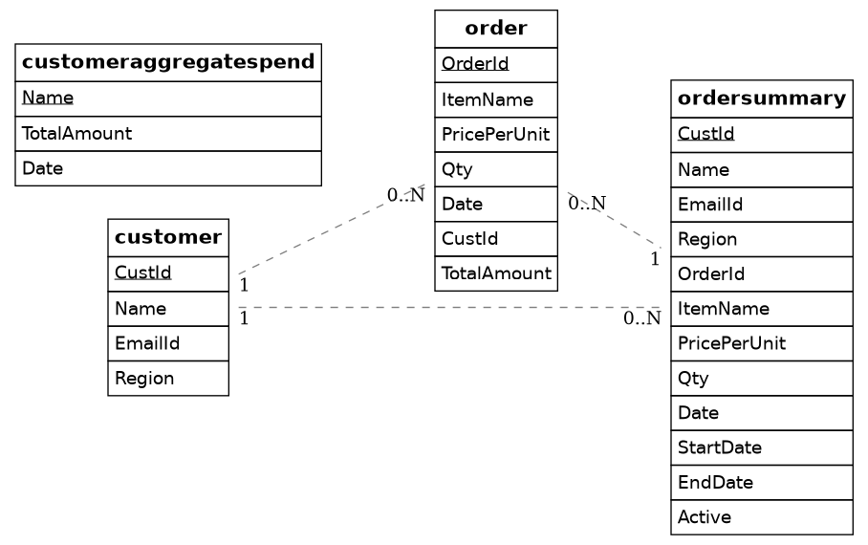

ordersummary -- customeraggregatespend

