Document Control
- Document Title: Business Requirements Document (BRD)
- System Name: Application
- Version: 1.0
- Author: Not present in source JSON
- Date: Not present in source JSON

Executive Summary
- This BRD outlines business needs for the Application, specifically ingesting customer and order CSV data into Delta tables.
- The solution will include data cleansing, computation of TotalAmount, joining logic with SCD Type 2 history, and daily customer spend aggregation, all implemented via Delta Live Tables.

Business Objectives
- Load customer and order CSV data into Delta tables.
- Cleanse data by removing null literals and duplicates.
- Compute TotalAmount in the order table.
- Join customer and order data applying SCD Type 2 for customers.
- Aggregate daily spend in a customeraggregatespend table.
- Implement the pipeline using Delta Live Tables.

In-Scope
- Source ingestion from specified file system locations.
- Creation and management of Delta tables for customer, order, ordersummary, and customeraggregatespend.
- Data cleansing according to requirements.
- Addition of computed TotalAmount.
- Implementation of SCD Type 2 logic for historical tracking.
- Aggregation for spend reporting.
- Guided by Delta Live Tables instructions.

Out-of-Scope
- Sources, systems, or fields not in source requirements.
- Security, access control, SLAs, monitoring, and alerting.
- Performance tuning and scaling (beyond stated cleansing and aggregation).
- Scheduling, orchestration, DevOps outside "Implement steps 1–10 using Delta Live Tables".
- Data quality metrics other than listed cleansing.
- Analytics/reporting UI layers.

Stakeholders
- Not present in source JSON

Business Requirements

BR-APP-001 — Source Ingestion
- Description: Load customer and order CSVs from specified file system paths into Delta tables.
- Business Value: Ensures reliable intake and storage as structured data.
- Priority: High

BR-APP-002 — Data Schemas
- Description: Define required columns for customer (CustId, Name, EmailId, Region) and order (OrderId, ItemName, PricePerUnit, Qty, Date, CustId).
- Business Value: Standardizes data for downstream processing.
- Priority: High

BR-APP-003 — Data Cleansing
- Description: Remove "Null"/Null literals and duplicate records from customer and order data.
- Business Value: Improves data quality and trustworthiness.
- Priority: High

BR-APP-004 — Computation of TotalAmount
- Description: Add computed column TotalAmount (PricePerUnit × Qty) to order data.
- Business Value: Enables financial metrics for orders.
- Priority: High

BR-APP-005 — Target Table Creation: ordersummary
- Description: Create table ordersummary in gen_ai_poc_databrickscoe.sdlc_wizard as the join of customer and order data.
- Business Value: Provides unified view of customer and order info.
- Priority: High

BR-APP-006 — SCD Type 2 Customer Dimension Logic
- Description: For customer attribute changes, close past records (Inactive), add new (Active), update StartDate and EndDate, and keep all history in ordersummary.
- Business Value: Maintains compliance and historical traceability.
- Priority: High

BR-APP-007 — ordersummary Schema Enforcement
- Description: Populate ordersummary with CustId, Name, EmailId, Region, OrderId, ItemName, PricePerUnit, Qty, Date.
- Business Value: Ensures data consistency for reporting/analytics.
- Priority: High

BR-APP-008 — Spend Aggregation: customeraggregatespend
- Description: Aggregate ordersummary by Name and Date to produce customeraggregatespend with sum(TotalAmount).
- Business Value: Delivers actionable insights on customer spending.
- Priority: High

BR-APP-009 — Implementation Modality
- Description: All above requirements are implemented using Delta Live Tables as per guided steps.
- Business Value: Ensures managed and reproducible pipeline operations.
- Priority: High

Assumptions & Constraints
- No assumptions beyond provided requirements.
- All implementation to be carried out using Delta Live Tables.
- SCD tracking fields such as StartDate, EndDate, Active are logically used but not explicitly listed in schema.

Success Metrics
- All listed tables are created in Delta format as specified.
- Cleansing requirements (nulls, duplicates) are fully applied.
- ordersummary holds complete SCD Type 2 history for customer data.
- customeraggregatespend delivers correct aggregations.
- The end-to-end pipeline executes successfully using Delta Live Tables.

Risks & Mitigations
- Ambiguous field definitions for SCD Type 2 attributes (StartDate, EndDate, Active) — Mitigation: clarify in future design.
- Only basic data quality checks in scope — Mitigation: escalate if further metrics needed.
- Error handling, retries, and monitoring are not explicitly defined — Mitigation: flag for design and operational teams.

Approval
- Approver(s): Not present in source JSON

Appendix
Appendix A: Source Definitions
Source Name | Type | Location | Format | Notes
customerdata | CSV | /Volumes/gen_ai_poc_databrickscoe/sdlc_wizard/customerdata | CSV | Loaded to Delta table customer
orderdata | CSV | /Volumes/gen_ai_poc_databrickscoe/sdlc_wizard/orderdata | CSV | Loaded to Delta table order
Appendix B: Target Definitions
Target Name | Layer | Table | Columns | Notes
customer | Bronze | customer | CustId, Name, EmailId, Region | Ingested from customerdata
order | Bronze | order | OrderId, ItemName, PricePerUnit, Qty, Date, CustId | Ingested from orderdata
ordersummary | Silver | ordersummary | CustId, Name, EmailId, Region, OrderId, ItemName, PricePerUnit, Qty, Date | Joins customer and order, SCD Type 2
customeraggregatespend | Gold | customeraggregatespend | Name, TotalAmount, Date | Aggregated spend
Appendix C: Transformations
Step | Transformation | Input | Output | Logic
1 | Cleansing | customer/order | customer/order | Remove "Null"/Null & duplicates
2 | Computation | order | order | TotalAmount = PricePerUnit × Qty
3 | Join & SCD2 | customer, order | ordersummary | Join on CustId, SCD Type 2 tracking
4 | Aggregation | ordersummary | customeraggregatespend | group by Name, Date; sum(TotalAmount)
Appendix D: Business Rules
Rule ID | Area | Description | Source
BR-01 | Computation | TotalAmount = PricePerUnit × Qty | Requirements Input
BR-02 | Cleansing | Remove null literals and duplicates | Requirements Input
BR-03 | Join | Join customer–order on CustId | Requirements Input
BR-04 | SCD2 | Maintain SCD Type 2 (history, flags, dates) | Requirements Input
BR-05 | Aggregation | Spend aggregated by Name and Date | Requirements Input
Appendix E: Process Flow
Step | Description | Dependency
1 | Load customerdata to Delta table customer | Source file path
2 | Load orderdata to Delta table order | Source file path
3 | Apply cleansing (null/duplicate removal) | Step 1, Step 2
4 | Add TotalAmount computed column | Step 2
5 | Join customer with order to create ordersummary | Step 1, Step 4
6 | Apply SCD Type 2 change tracking on ordersummary | Step 5
7 | Create customeraggregatespend as spend aggregation | Step 6
Appendix F: Entity Relationship Diagram (ERD)
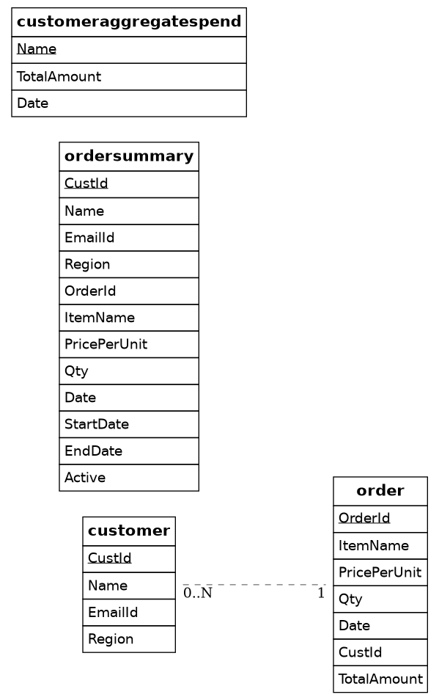

customer *--1 ordersummary
order *--1 ordersummary
ordersummary -- customeraggregatespend

